PWG Meeting Notes – January 17th, 2023
Via WebEx 1:30 PM
Attendees:
Sam Pak - Oncor | Erin Wasik-Gutierrez – ERCOT | Diana Rehfeldt - TNMP | Austin Board – LP&L
Sheri Wiegand - TXUE | Angela Ghormley – Calpine | Randy Roberts - ERCOT | Ramya Ramaswamy - PUCT
Kathy Scott - CNP | Eric Lotter – Grid Monitor | David Blankenship - CNP
Steven Pliler - TXUE | Calvin Opheim - ERCOT | Jesse Macias - AEP

- 2023 PWG leadership elections
  - Chair: Sam Pak, Oncor
  - Vice Chair: Steve Pliler, Vistra Energy

- Meeting notes for November 30th were reviewed and approved with no revisions.

- 2021/2022 Weather Sensitivity Progress
  - TNMP advised that completion of the TNMP count was confirmed internally on 1/17.
  - Counts are noticeably lower for Oncor and AEP as most of their applicable ESIs have transitioned from BUSIDDRQ to BUSLRG profiles.
  - ERCOT to provide additional update via PWG listserv in early Feb 2023.

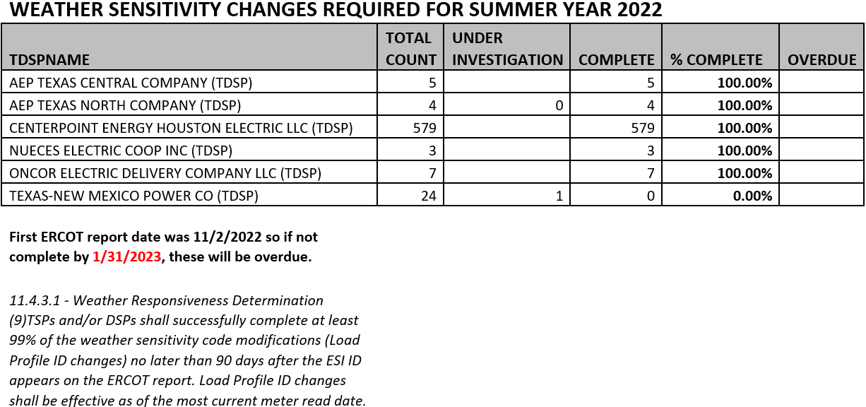

- IDR/AMS BUSLRG Updates from TDSPs
  - Oncor - has scheduled transitions for the 251 cases left to complete. Access issues are common among the ESIs remaining.
  - CenterPoint – will transition 52% of the BUSIDRRQ ESIs (~2,512) to BUSLRG at the end of March/beginning of April. CenterPoint will update the market on the specific execution date. The remaining BUSIDRRQ ESIs will remain on BUSIDRRQ due to kvar readings, dedicated phone lines EPS, and/or transmission related services.
  - TNMP - status quo due to 3G remediation.

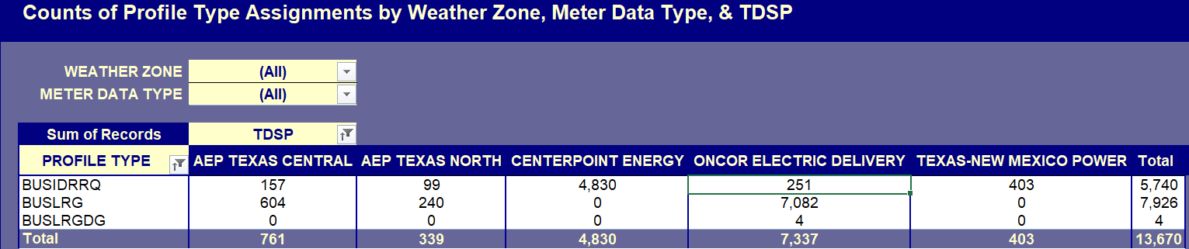

- Proposal to Discontinue Weather Sensitivity Requirement
- Discontinuation of Weather Sensitivity was discussed due to declining IDR Meter counts. ERCOT concurs with discontinuation and noted that the data supports using non-weather sensitive (NWS) as the default profile designation for IDR meters. For NOIEs, the default would be weather sensitive (WS) for profiles.
  - Competitive IDRs are more commercial/industrial customers calling for NWS.
  - NOIEs are station meters which capture load across all classes, thus WS is applicable.
- ERCOT stated that the same estimation process will be performed. The Business Case will be updated to reflect discussions broader than PWG.
- ERCOT sponsorship LPGRR will provide a shorter implementation path and was agreed to ensuring implementation by November. Erin is confirming that path.
- Some additional “clean up” will accompany changes including deletion of Question 7 from the Load Profile Guide, deletion of the FAQs on the Guide, and deletion of the Weather Sensitivity row from the Profile Decision Tree.

- Future Business: Annual Validation Processing
- CenterPoint advised that competing 2023 priorities such as TX SET 5.0 called for a market suspension of Annual Validations for 2023 and 2024.
- To preserve the market value of Annual Validation and accommodate market flexibility, it was decided to perform business validations in 2023 and to suspend 2024 residential and business validations. Normal AV processes will resume in 2025.
- It made sense to postpone the residential AV process for 2024, which would have used data from 2021, 2022, and 2023. Moving to 2025 will “skip” the anomaly year of 2021 (Covid) and use data from 2022, 2023, and 2024 for a more typical representation of consumption.

- Goals 2023 and Accomplishments 2022
- Sam provided context for the Accomplishments of 2022 and 2023 Goals.

- Parking Lot item for future discussion:
- Conversion of the Profile Decision Tree from Excel to Word format (LPGRR) remains on hold while Jordan Troublefield is on leave.

- Future Meeting Dates:
- Cancelled Feb 8^{th.}

- DRAFT Agenda for March 8th meeting:
  - Review of LPGRR/NPRR (Discontinuation of the Weather Sensitivity process)
  - IDR/AMS BUSLRG Updates from TDSPs
  - Conversion of the Profile Decision Tree from Excel to Word format (LPGRR)

