RMTTF Meeting
Wednesday, February 1st, 2023
1:30 PM
WebEx only

RMTTF MEETING NOTES
Debbie opened the meeting, welcomed everyone and proceeded with reading the Antitrust Admonition.

Introductions:
- Sheri Wiegand TXU/Vistra
- Jordan Troublefield ERCOT
- Amy Sue Stirland LP&L
- Diana Rehfeldt TNMP
- Art Deller ERCOT
- Eric Lotter Grid Monitor
- Kathy Scott CenterPoint
- Debbie McKeever ONCOR
- Monica Jones CenterPoint
- Tomas Fernandez NRG
- Melinda Earnest AEP Texas
- Eric Broach Gexa
- Sheri Wiegand Vistra
Agenda Review
Debbie reviewed the agenda.
Meeting Minutes
Meeting notes from the last meeting were presented for comment. No comments/corrections, therefore, were approved.
ERCOT Learning Management System (LMS) Statistics
The numbers were provided today by Art Deller, Manager of Training for ERCOT that were update to date 1/31/23.

LMS STATS AS OF 1/31/23

LMS WBT Stats | In Progress | Complete | Total
MT YTD | 6 | 23 | 29
MT All Time | 559 | 1107 | 1666
Retail 101 YTD | 36 | 15 | 51
Retail 101 All Time | 1303 | 661 | 1964
Mass Tran YTD | 0 | 3 | 3
Mass Tran All Time | 46 | 74 | 120
Texas SET YTD | 5 | 4 | 9
Texas SET All Time | 47 | 33 | 80

TX SET Training Presenters
Debbie went over Texas SET presenters if we need to make change. Kathy mentioned that Monica and Melinda took Jim Lee’s responsibilities.
MVI – Monica Jones
Switch – Melinda Earnest

TX SET In Person Training Plan for 2023

Tomas asked if we will do a dry run in April. Amy (LP&L) and team will be on via WebEx for practice run. Team decided presenters will be in person in April.
- April 12th – Austin – ERCOT bldg. be in room at 11 AM start dry run at 12:30 PM
- April 13th – Austin – RMTTF meeting

Goals 2023 and Accomplishments 2022
Debbie went over 2022 Accomplishments and 2023 Goals.
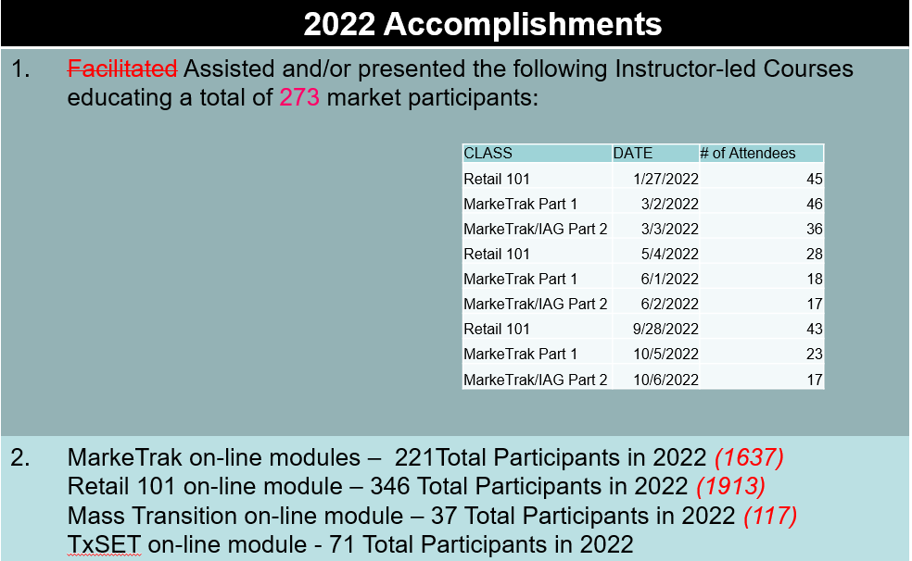
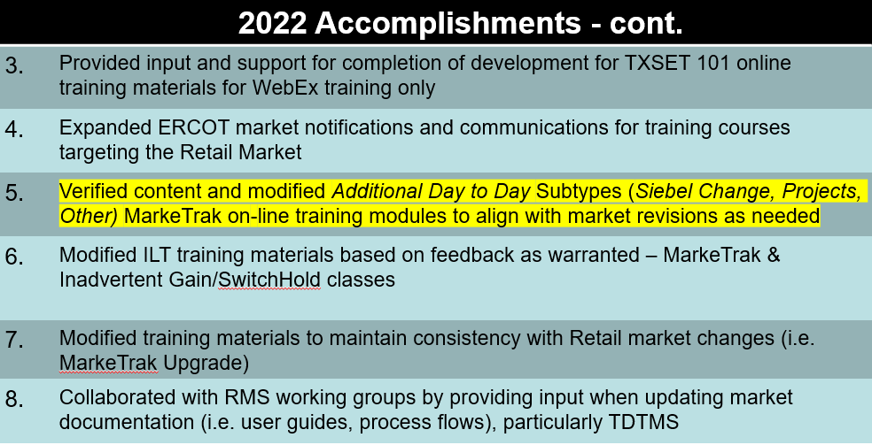

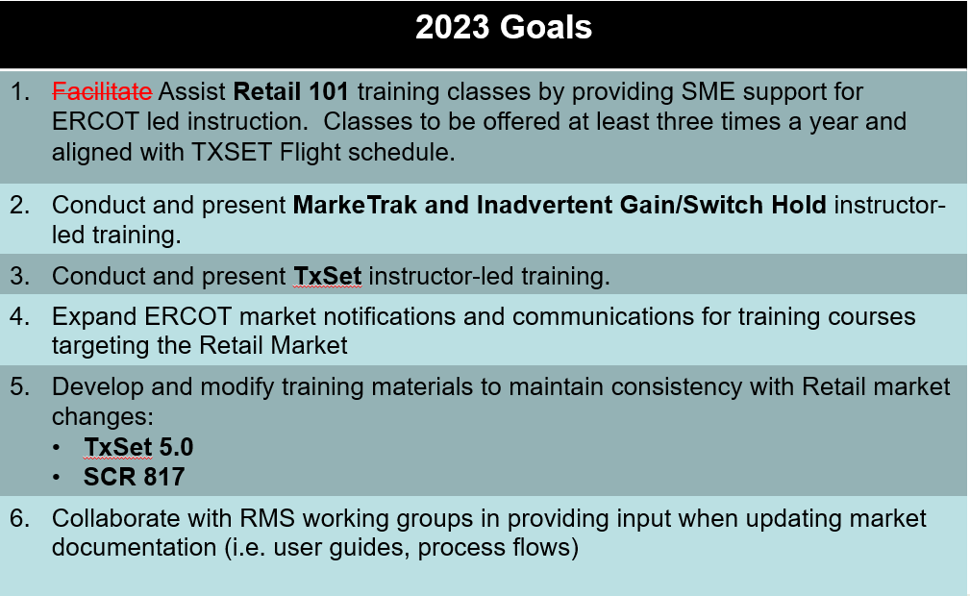

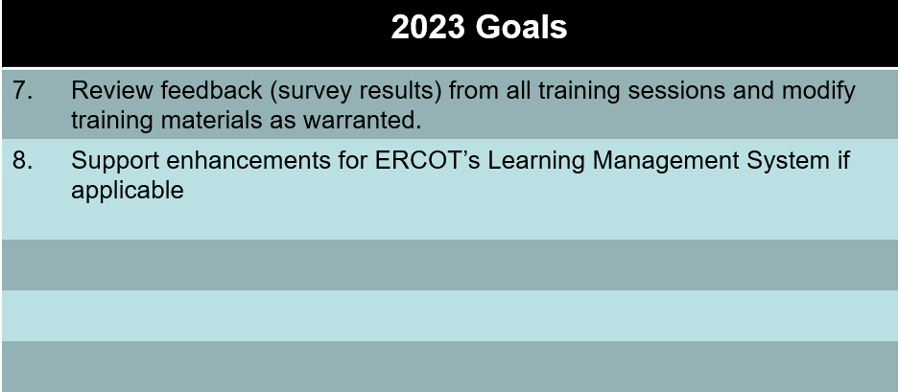

Debbie asked Sheri about Day to Day Subtypes. Sheri mentioned RMGRR170, we need to add comment into module. Debbie will review content.

Tomas To Do: Bulk Insert and IAG/IAL
Tomas mentioned that one our goals should be to update/verify training materials to make sure that it is in accordance of Inadvertents and Bulk Inserts.
Debbie asked if we can update Day 2 slide deck. Sheri suggested we add a new slides for the following reasons:
Invalid Use of the IAG Process (effective 1/1/2023). PowerPoint slide 37
Completion Timeline for Customer Rescission (SCR815) PowerPoint Slide 47
Bulk Inserts may only be used for submission of multiple IAGs for the same customer or in cases when a system processing issue occurred only with proper notification. PowerPoint Slide 64
Debbie asks about escalations emails if they will be sent. Sheri advises that yes, emails will be sent to Rolodex contacts.
Tomas updated slides 68 and 69 with new screen shots. Sheri states PowerPoint Slides 87 and 88 are the new escalation process in regards to Identity Theft.
Kathy reviewed the MarkeTrak Online Modules for Admin and Rolodex match SCR815 changes that went in Dec and confirmed all were updated.
Tomas updated Day 2 and provided new slide deck to Art to be posted.

TX SET PowerPoint
Tomas went over TX SET PowerPoint.
New screen shots for the following slides will be needed:
Governing Documents
24 Tomas updated
30
32
33 Tomas updated
Working Group
35 Tomas updated
36
Transactions
43 Updated to reflect 4.0A
MIS Portal
94
TX SET Training Group Exercise
116 Tomas updated
117 Tomas updated
Appendix
120 update links
121 update links
122 updated
123 Update links Guides / Examples
124 Update links Guides / Examples
125 Update links Guides / Examples
126 Updated added Contact ERCOT Client Relations for a full list of requirements
127 Update links 1st and 3rd items
128 Update link
129 Update links

Agenda Items for the next RMTTF meeting:
- Review TX SET PowerPoint
- Review online modules Usage/Billing and Bulk Insert

