January 2023 ERCOT Monthly Operations Report
Reliability and Operations Subcommittee Meeting
March 2, 2023

Table of Contents
1. Report Highlights 2
2. Frequency Control 3
2.1. Frequency Events 3
2.2. Responsive Reserve Events 4
2.3. Load Resource Events 4
3. Reliability Unit Commitment 4
4. IRR, Wind, and Solar Generation as a Percent of Load 5
5. Largest Net-Load Ramps 7
6. COP Error Analysis 8
7. Congestion Analysis 10
7.1. Notable Constraints 10
7.2. Generic Transmission Constraint Congestion 16
7.3. Manual Overrides 16
7.4. Congestion Costs for Calendar Year 2023 16
8. System Events 17
8.1. ERCOT Peak Load 17
8.2. Load Shed Events 17
8.3. Stability Events 17
8.4. Notable PMU Events 17
8.5. DC Tie Curtailment 18
8.6. TRE/DOE Reportable Events 18
8.7. New/Updated Constraint Management Plans 18
8.8. New/Modified/Removed RAS 18
8.9. New Procedures/Forms/Operating Bulletins 18
9. Emergency Conditions 19
9.1. OCNs 19
9.2. Advisories 19
9.3. Watches 19
9.4. Emergency Notices 19
10. Application Performance 19
10.1. TSAT/VSAT Performance Issues 19
10.2. Communication Issues 19
10.3. Market System Issues 19
11. Model Updates 20
Appendix A: Real-Time Constraints 22

Report Highlights
- The unofficial ERCOT peak load for the month was 65,632 MW and occurred on 1/31/2023, during hour ending 19:00.
- There were 3 frequency events.
- There was 1 instance where Responsive Reserves was deployed.
- There were 38 HRUC commitments.
- There were 30 days of congestion on the Bearkat GTC, 21 days on the North Edinburg to Lobo GTC, 20 days on the West Texas Export GTC, 15 days on the Valley Export GTC, 14 days on the Nelson Sharpe to Rio Hondo GTC, 11 days on the McCamey GTC, 7 days on the Treadwell GTC, 3 days on the Raymondville to Rio Hondo GTC, 3 days on the North to Houston GTC, and 2 days on the Panhandle GTC. There was no activity on the remaining GTCs during the month.
- There were 2 DC Tie Curtailments for DC_R and DC_L due to forced or unplanned outages.
- 2 OCNs issued for the potential freezing precipitation event for the Panhandle, North and West areas of the ERCOT Region from January 23, 2023 through January 25, 2023 and from January 31, 2023 through February 2, 2023. 1 OCN issued for taking manual action on the Panhandle IROL due to topology change.
- 1 Advisory issued for the potential freezing precipitation event for the Panhandle, North and West areas of the ERCOT Region January 30, 2023 through February 2, 2023.
- 1 Watch issued for the potential freezing precipitation event for the Panhandle, North and West areas of the ERCOT Region from January 30, 2023 through February 2, 2023.

Frequency Control

Frequency Events

The ERCOT Interconnection experienced 3 frequency events, which resulted from units’ trip. The event average event duration was 00:05:07.

A summary of the frequency events is provided below. The reported frequency events meet one of the following criteria: Delta Frequency is 60 mHz or greater; the MW loss is 350 MW or greater; resource trip event triggered RRS deployment. Frequency events that have been identified as Frequency Measurable Events (FME) for purposes of BAL-001-TRE-2 analysis are highlighted in blue. When analyzing frequency events, ERCOT evaluates PMU data according to industry standards. Events with an oscillating frequency of less than 1 Hz are inter-area, while higher frequencies indicate local events. Industry standards specify that damping ratio for inter-area oscillations should be 3.0% or greater. For the frequency events listed below, the ERCOT system met these standards and transitioned well after each disturbance. In the case of negative delta frequency, the MW Loss column could refer to load loss.

Date and Time | Delta Frequency | Max/Min Frequency | Duration of Event | PMU Data |  | MW Loss | Load | IRR | Inertia
 | (Hz) | (Hz) |  | Oscillation Mode (Hz) | Damping Ratio |  | (MW) | % | (GW-s)
1/2/2023 4:35:53 | -0.110 | 60.105 | 00:06:21 | 0.63 | 10% | 600 | 34,252 | 62% | 149,645
1/24/2023 7:12:31 | 0.105 | 59.910 | 00:04:19 | 1.7 | 7% | 350 | 48,373 | 28% | 275,315
1/24/2023 14:27:10 | 0.123 | 59.884 | 00:04:40 | 0.67 | 9% | 966 | 48,371 | 34% | 276,682

(Note: All data on this graph encompasses frequency event analysis based on BAL-001-TRE-2.)

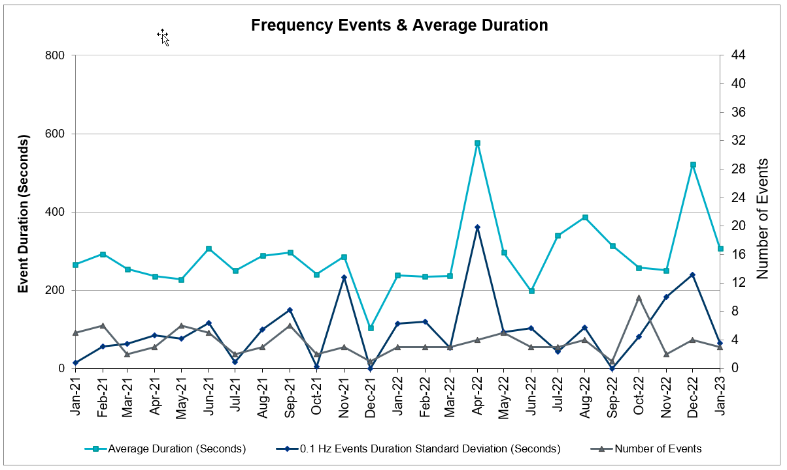

Responsive Reserve Events

There were 2 events where Responsive Reserve MWs were released to SCED. The events highlighted in blue were related to frequency events reported in Section 2.1 above.

Date and Time Released to SCED | Date and Time Recalled | Duration of Event | Maximum MWs Released | Comments
01/24/2023 14:27:24 | 01/24/2023 14:31:40 | 00:04:16 | 570

Load Resource Events
None.

Reliability Unit Commitment

ERCOT reports on Reliability Unit Commitments (RUC) monthly. Commitments are reported grouped by operating day and weather zone. The total number of hours committed is the sum of the hours for all the units in the specified region. Additional information on RUC commitments can be found on the MIS secure site at Grid Generation Reliability Unit Commitment.

There were no DRUC commitments.

There were 38 HRUC commitments

Resource Location | # of Resources | Operating Day | Total # of Hours Committed | Total MWhs | Reason for Commitment
EAST, NORTH_CENTRAL | 3 | 01/05/2023 | 6 | 2,800.0 | Capacity
COAST, EAST, NORTH_CENTRAL | 4 | 01/22/2023 | 12 | 4,286.0 | Capacity
COAST | 1 | 01/27/2023 | 2 | 682.0 | DKG_NB_5
COAST, EAST, NORTH, NORTH_CENTRAL, SOUTH_CENTRAL, SOUTHERN | 29 | 01/30/2023 | 274 | 70,427.9 | Capacity
NORTH | 1 | 01/31/2023 | 12 | 684.0 | Capacity

IRR, Wind, and Solar Generation as a Percent of Load
The graph below shows the maximum, minimum and average aggregate solar, wind and IRR output as a percentage of total ERCOT load when evaluated as 10-minute averaged intervals, over the past 13 months. Current wind and solar generation and penetration records are listed in the footnote below. Maximum IRR penetration for the month was 68.2% on 1/15/2023 interval ending 10:10 and minimum IRR penetration for the month was 3.4% on 1/22/2023 interval ending18:10.

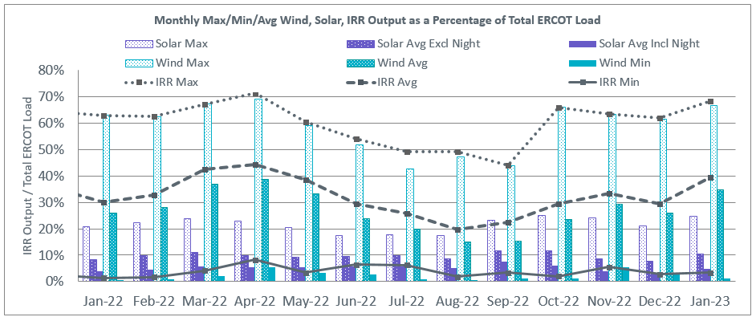

During the hour of peak load for the month, hourly integrated wind generation was 4,760 MW and solar generation was 1.5 MW. The graph below shows the wind and solar penetration percentage during the hour of the peak load in the last 13 months.

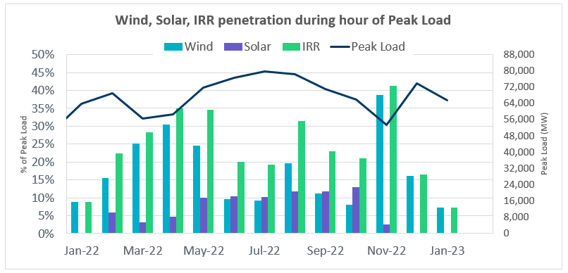

Lastly, the graph below shows the minimum wind, solar and IRR output during the peak load hour as a percentage of the daily peak load for every day in the month.

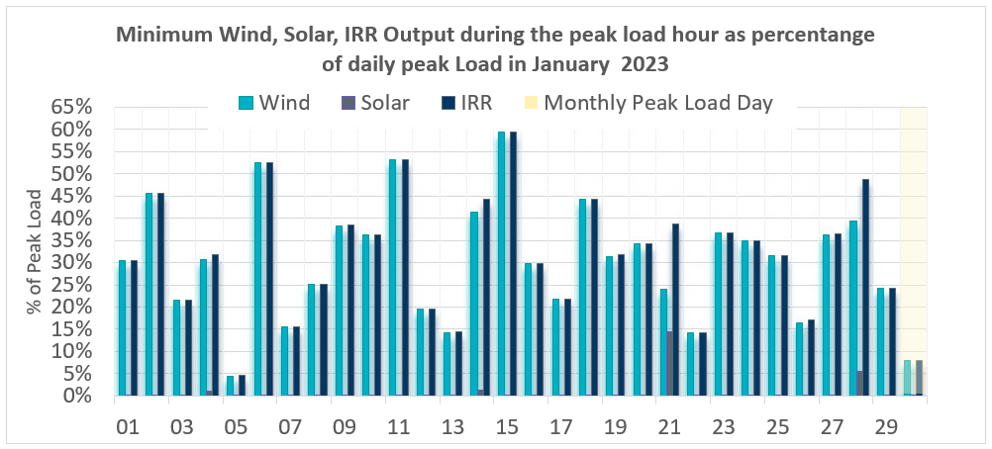

Largest Net-Load Ramps
The net-load ramp is defined as the change in net-load (load minus wind and PVGR generation) during the defined time horizon. Such a variation in net-load needs to be accommodated in grid operations to ensure that the reliability of the grid is satisfactorily maintained. The largest net-load ramp during 5-min, 10-min, 15-min, 30-min and 60-min in January 2023 are 1,296 MW, 2,506 MW, 3,431 MW, 6,468 MW, and 11,133 MW, respectively. The comparison with respect to the historical values is given in the table below.

Month and Year | 5 min | 10 min | 15 min | 30 min | 60 min
Jan 2014 | 891 MW | 1603 MW | 2082 MW | 3607 MW | 6340 MW
Jan 2015 | 1025 MW | 1609 MW | 2150 MW | 3737 MW | 6496 MW
Jan 2016 | 950 MW | 1547 MW | 2076 MW | 3736 MW | 6213 MW
Jan 2017 | 959 MW | 1680 MW | 2160 MW | 3511 MW | 6181 MW
Jan 2018 | 1091 MW | 1824 MW | 2497 MW | 3901 MW | 6824 MW
Jan 2019 | 1087 MW | 1718 MW | 2308 MW | 4033 MW | 7786 MW
Jan 2020 | 1009 MW | 1610 MW | 2124 MW | 3700 MW | 6100 MW
Jan 2021 | 966 MW | 1744 MW | 2359 MW | 4458 MW | 7842 MW
Jan 2022 | 1049 MW | 1879 MW | 2834 MW | 5455 MW | 10333 MW
January 2023 | 1,296 MW  1/12/2023  (IE 17:16) | 2,506 MW  1/12/2023  (IE 17:16) | 3,431 MW  1/12/2023  (IE 17:18) | 6,468 MW  1/12/2023  (IE 17:30) | 11,133 MW  1/12/2023  (IE 17:58)
All Months in 2014-2023 | 1,647 MW  05/25/22  (IE 17:06) | 2,506 MW  1/12/2023  (IE 17:16) | 3,431 MW  1/12/2023  (IE 17:18) | 6,468 MW  1/12/2023  (IE 17:30) | 11,133 MW  1/12/2023  (IE 17:58)

COP Error Analysis
COP Error is calculated as the capacity difference between the COP HSL and real-time HSL of the unit. Mean Absolute Error (MAE) stayed over 9,500 MW until Day-Ahead at 9:00, then dropped to 8,543 MW by Day-Ahead at 10:00 and significantly dropped to 4,350 MW by Day-Ahead at 13:00. In the following chart, Under-Scheduling Error indicates that COP had less generation capacity than real-time, and Over-Scheduling Error indicates that COP had more generation capacity than real-time.

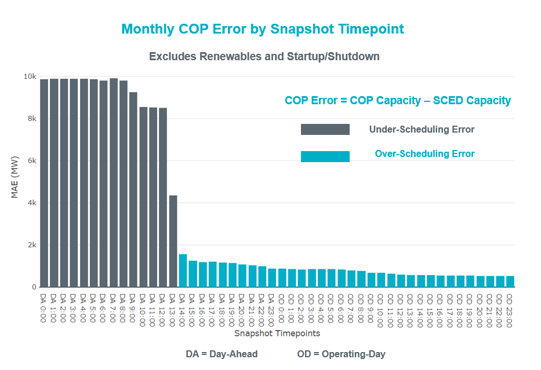

Monthly MAE for the Latest COP at the end of the Adjustment Period was 527 MW with medians ranging from -561 MW for Hour-Ending (HE) 19 to 466 MW for HE 15. HE 21 on 1/08/2023 had the largest Over-Scheduling Error (2,477 MW) and HE 8 on 1/30/2023 had the largest Under-Scheduling Error (-2,678 MW).
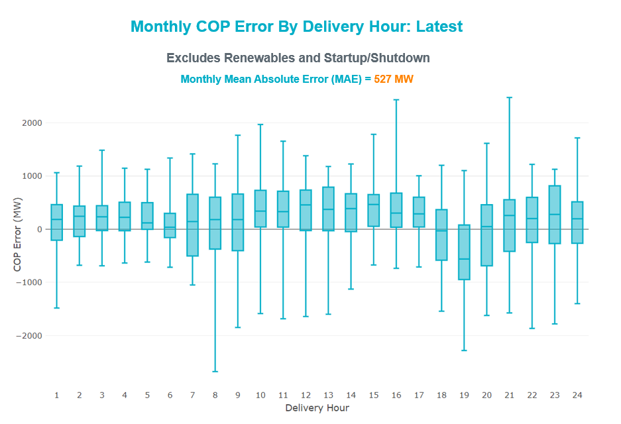

Monthly MAE for the Day-Ahead COP at 12:00 was 8,506 MW with median ranging from -12,700 MW for Hour-Ending (HE) 19 to -4,428 MW for HE 2. HE 24 on 1/1/2023 had the largest Over-Scheduling Error (2,959 MW) and HE 21 on 1/30/2023 had the largest Under-Scheduling Error (-31,808 MW).

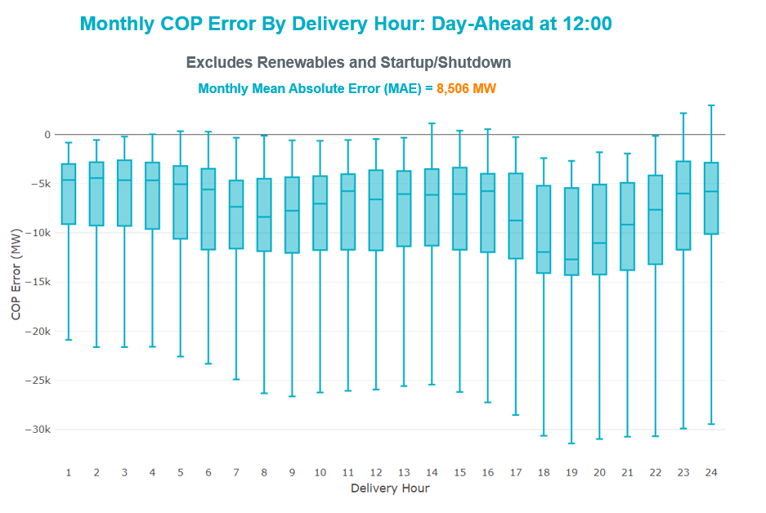

Congestion Analysis

Notable Constraints

Nodal protocol section 3.20 specifies that ERCOT shall identify transmission constraints that are binding in Real-Time three or more Operating Days within a calendar month. As part of this process, ERCOT reports congestion that meets this criterion to ROS. In addition, ERCOT also highlights notable constraints that have an estimated congestion rent exceeding $1,000 for a calendar month. These constraints are detailed in the table below, including approved transmission upgrades from TPIT that may provide some congestion relief based on ERCOT’s engineering judgement. Rows highlighted in blue indicate the congestion was affected by one or more outages. For a list of all constraints activated in SCED, please see Appendix A at the end of this report.

Contingency Name | Overloaded Element | Contingency Name | Overloaded Element | # of Days Constraint Binding | Congestion Rent | Transmission Project
SSKYSB28 | 15080__Z | SKYWEST to SPRABERRY SWITCH LIN 1 | Consavvy Switch - Cottonfield Sub 138kV | 10 | $44,628,271.32
BASE CASE | WESTEX | Basecase | WESTEX GTC | 16 | $17,008,708.69
BASE CASE | BEARKT | Basecase | BEARKT GTC | 29 | $6,603,931.37
DWAP_OB5 | WW_JN_25_A | TWR (345) OB-WAP98 & OB-WAP99 | Jeanetta - Westwood 138kV | 2 | $5,448,197.58
SLOBSA25 | CATARI_PILONC1_1 | Fowlerton to LOBO 345 LIN1 | Catarina - Piloncillo 138kV | 23 | $4,980,718.43
BASE CASE | NE_LOB | Basecase | NE_LOB GTC | 19 | $4,185,479.78 | The Lower Rio Grande Valley (LRGV) System Enhancement Project (21RPG017) will improve the NorthEd_LoboGTC to support up to 80% of total wind and solar generation capacity in the LRGV area.
DMCNDES8 | CKT_909_1 | McNeil-Decker&Dessau 138kV | Mcneil Aen - Dessau 138kV | 1 | $4,100,159.11
MRESMCM8 | RINCON_WHITE_2_1 | Manual for I_DUPS - RESNIK & MCCAMPBE 2 138KV | Whitepoint - Rincon 138kV | 3 | $3,471,217.28
SNATBEA8 | 6144__A | NATURAL DAM to BEALS CREEK SUB LIN _A | Big Spring West - Stanton East 138kV | 20 | $3,435,927.30 | Oncor FW Big Spring West - Stanton East 138 kV Line (71989)
SOBWAP5 | OB_WAP98_A | WA PARISH to OBRIEN LIN A | Wa Parish - Obrien 345kV | 5 | $3,222,125.81
DELMSAN5 | PAWNEE_SPRUCE_1 | Elmcreek-Sanmigl 345kV | Pawnee Switching Station - Calaveras 345kV | 7 | $2,799,292.79
BASE CASE | HHGTOM_1 | Basecase | Omega - Horse Hollow Generation Tie 345kV | 12 | $2,631,217.50
SSPJFS8 | CO_PL_84_A | JEFFERSON to COLLEGE LIN A | Conial - Philip 138kV | 2 | $2,511,561.88
DTWIDIV5 | COKEST_REDCRE1_1 | TWINBU-DVIDE 345KV | San Angelo Red Creek - San Angelo Coke Street 138kV | 10 | $2,435,424.98
SMDSODE5 | MDSSW_MR1L | ODESSA EHV SWITCH to MIDESSA SOUTH SW LIN _A | Midessa South Sw 138kV | 2 | $2,246,113.47
MHARNED5 | BURNS_RIOHONDO_1 | Manual dbl ckt for NEDIN-BONILLA 345kV & RIOH-PRIM138kV | Burns Sub - Rio Hondo 138kV | 12 | $2,118,257.34 | STEC RioHondo - Burns 138 kV Line Upgrade (71930)
DTWIDIV5 | 134T429_1 | TWINBU-DVIDE 345KV | Schkad - San Angelo Power Station 138kV | 9 | $1,988,613.06
DLYTTUR8 | CKT_943_1 | Lytton - Slaughtr & Turner 138 kV | Lytton Springs - Pilot Knob 138kV | 1 | $1,933,737.23
SW_GODE5 | 15060__B | wett_grelton to ODESSA EHV SWITCH LIN 1 | Koch Tap - Vealmoor 138kV | 9 | $1,665,770.47
MMDSQAL5 | MDSSW_MR1L | MAN_DBL_MDSSW-ODEHB_and_CONSW-QALSW_345kV_DBLCKT | Midessa South Sw 138kV | 5 | $1,540,398.87
DCHBJO25 | CBYCVN86_A | TWR(345) CHB-JOR97 & CBY-JOR99 | Chev - Cedar Bayou Plant 138kV | 2 | $1,357,983.51
XLY3T58 | LYTTON_S_AT1H | LYTTON SPRINGS TRX LYTTSP_AT3 345/138 | Lytton Springs 345kV | 1 | $1,242,033.38
MCONLNG5 | 6095__D | MAN_DBL_'CONSW-MGSES_and_CONSW-LNGSW_345kV_DBLCKT | Lamesa - Jim Payne Poi 138kV | 2 | $1,122,403.80
SBWDDBM5 | LPLMK_LPLNE_1 | BLACKWATER DRAW SWITCH to DOUBLE MOUNTAIN SWITCH LIN 1 | Mackenzie Substation - Northeast Substation 115kV | 4 | $1,013,154.73
SCARFRI8 | ATSO_SONR1_1 | Carver to FRIEND RANCH LIN 1 | Atlantic Sonora - Sonora 69kV | 9 | $943,772.51
DBIGKEN5 | TREADW_YELWJC1_1 | Bighil-Kendal 345kV | Yellow Jacket - Treadwell 138kV | 7 | $816,165.17
SCMNCPS5 | 651__B | COMANCHE SWITCH (Oncor) to COMANCHE PEAK SES LIN _A | Comanche Tap - Comanche Switch (Oncor) 138kV | 12 | $813,035.52
MCONQAL5 | 6471__A | MAN_DBL_CONSW-MDSSW_and_CONSW-QALSW_345kV_DBLCKT | Morgan Creek Ses - Forest Creek And Sand Bluff Wind Farms 138kV | 7 | $805,620.16
DMGSBTR5 | 6036__A | MGSES TO CCRSW 345 AND BTRCK TO MGSES 345 DBLCKT | Tonkawa Switch - Morgan Creek Ses 345kV | 3 | $628,720.10
SBRAUVA8 | HAMILT_MAVERI1_1 | ODLAW SWITCHYARD to ASPHALT MINES LIN 1 | Hamilton Road - Maverick 138kV | 16 | $582,227.72
DCAGCO58 | 656T656_1 | Cagnon-Kendal 345 & Cico-Comfor 138 | Bergheim - Kendall 345kV | 3 | $486,450.30 | LCRA TSP Hays Energy - Kendall Corridor RPG Project (22RPG0005)
SN_SLON5 | KINGSV_KLEBER1_1 | LON HILL to NELSON SHARPE LIN 1 | Kingsville - Kleberg Aep 138kV | 3 | $481,471.85
BASE CASE | VALEXP | Basecase | VALEXP GTC | 12 | $466,061.80 | The Lower Rio Grande Valley (LRGV) System Enhancement Project (21RPG017) will improve but not eliminate the need for this GTC.
SGRICOL5 | PAWNEE_TANGO1_1 | Grissom to COLETO CREEK LIN 1 | Pawnee Switching Station - Tango 345kV | 4 | $410,700.71
DBIGKEN5 | HEXT_MASONS1_1 | Bighil-Kendal 345kV | Mason Switching Station - Hext Lcra 69kV | 4 | $405,686.68
DTWIDIV5 | SAPOWE_SAST1_1 | TWINBU-DVIDE 345KV | San Angelo Power Station - San Angelo South Tap 138kV | 6 | $390,325.38
SBGLTWI8 | CONCHO_SANW0_1 | TWIN BUTTES to HARGROVE LIN 1 | San Angelo Concho - San Angelo Lake Nasworthy 69kV | 3 | $355,391.80
BASE CASE | MCCAMY | Basecase | MCCAMY GTC | 6 | $350,236.72
DWHICOT5 | FARMLAND_LONGD_1 | Wht_Rvr-Cottonwood 345kV | Farmland - Wett_Long_Draw 345kV | 3 | $347,101.93
SSPJFS8 | JFSSC_06_A | JEFFERSON to COLLEGE LIN A | Jefferson - South Channel 138kV | 3 | $338,044.90
DSALKLN5 | 630__B | SALSW TO KLNSW 345 DBLCKT | Harker Heights South - Killeen Switch 138kV | 5 | $276,608.07
DWISALV8 | MYRA_VAL_1 | WISECNTY TO JACKCNTY AND ALVRD TO CHITP 138 DBLCKT | Myra - Valley View Bepc 138kV | 5 | $230,153.15 | BEPC Myra - Spring 138 kV Line Rebuild (4645)
BASE CASE | RV_RH | Basecase | RV_RH GTC | 3 | $188,383.75
SCRMSAR8 | CONCHO_VRBS1_1 | SAN ANGELO RED CREEK to Weiss LIN 1 | San Angelo Concho - Veribest 69kV | 3 | $167,403.69 | AEP TNC Ballinger - Concho 69 kV Line Rebuild (20RPG004, MOD 55421)
DWLDSCO5 | 15060__B | LONG DRAW-FARADAY& SCOSW 345kV | Koch Tap - Vealmoor 138kV | 6 | $160,376.38
SOXYIN28 | I_DUPP_I_DUPS1_1 | INGLESIDE COGEN SWITCH to OXYCHEM INGLESIDE LIN 1 | Dupont Pp1 - Ingleside - Dupont Switch - Ingleside 138kV | 3 | $152,897.05
BASE CASE | NELRIO | Basecase | NELRIO GTC | 4 | $140,336.18 | The Lower Rio Grande Valley (LRGV) System Enhancement Project (21RPG017) will cause there to be no stability constraint for NelsonSharpe_RioHondoGTC under normal conditions.
DBIGKEN5 | HAMILT_MAXWEL1_1 | Bighil-Kendal 345kV | Hamilton Road - Maxwell 138kV | 8 | $134,644.03 | AEP TCC Hamilton Road - Maxwell Line Rebuild (20RPG022, MOD 61396)
SBTPBNT8 | MYRA_VAL_1 | BENNETT ROAD SWITCH to WISE COUNTY LIN _B | Myra - Valley View Bepc 138kV | 5 | $129,130.21 | BEPC Myra - Spring 138 kV Line Rebuild (4645)
BASE CASE | TRDWEL | Basecase | TRDWEL GTC | 7 | $121,415.92
SILLFTL8 | HAMILT_MAXWEL1_1 | FORT LANCASTER to ILLINOIS #4 LIN 1 | Hamilton Road - Maxwell 138kV | 5 | $117,062.97 | AEP TCC Hamilton Road - Maxwell Line Rebuild (20RPG022, MOD 61396)
SBRAUVA8 | ESCOND_GANSO1_1 | ODLAW SWITCHYARD to ASPHALT MINES LIN 1 | Escondido - Ganso 138kV | 5 | $114,531.90 | AEP TCC Escondido - Ganso 138 kV Line Rebuild (55624)
SALAN_28 | CELANE_KLEBER1_1 | BARNEY DAVIS to ALAZAN LIN 1 | Celanese Bishop - Kleberg Aep 138kV | 8 | $114,280.16
DBIGKEN5 | HEXT_YELWJC1_1 | Bighil-Kendal 345kV | Yellow Jacket - Hext Lcra 69kV | 4 | $94,391.78
SHEAKAT9 | MASNPH_MASN1_1 | Heartland to KATEMCY LIN 1 | Mason Aep - Mason Phillips Tap 69kV | 4 | $77,838.88
SBRAHAM8 | HAMILT_MAVERI1_1 | BRACKETTVILLE to HAMILTON ROAD LIN 1 | Hamilton Road - Maverick 138kV | 5 | $72,082.77
SKLELOY8 | LOYOLA_69_1 | KLEBERG AEP to LOYOLA SUB LIN 1 | Loyola Sub 138kV | 10 | $62,196.71
SSPUSLT8 | ASPM_69T2 | SPUR to SALT CREEK SS LIN 1 | Aspermont Aep 138kV | 7 | $58,379.64
SMADSAP8 | MADDUX_SAPOWE2_1 | MADDUX to SAN ANGELO POWER STATION LIN 1 | Maddux - San Angelo Power Station 138kV | 9 | $48,284.63
SHEAKAT9 | HEXT_MASONS1_1 | Heartland to KATEMCY LIN 1 | Mason Switching Station - Hext Lcra 69kV | 3 | $44,047.08
SSPUASP8 | SPUR_69_1 | ASPERMONT AEP to SPUR LIN 1 | Spur 138kV | 8 | $42,897.73
SCISPUT8 | ESTES_PECAN_1_1 | CISCO to PUTNAM 138kv LIN 1 | Estes - Pecan Bayou 138kV | 3 | $37,928.73 | AEP TNC AbileneSouth - Putnam 138 kV Rebuild Phase 1 (68150)
DKOCNUE8 | MCKENZ_WESTSI1_1 | Koch Upriver - Tortuga & Lon Hill - Nueces Bay 138KV | Mckenzie - Westside Aep 138kV | 4 | $37,715.11
SODLBRA8 | GANSO_MAVERI1_1 | BRACKETTVILLE to ODLAW SWITCHYARD LIN 1 | Ganso - Maverick 138kV | 3 | $35,582.90
DMOLLO58 | PAWNEE_TANGO1_1 | MOLINA - LOBO 138 & LOBO - CENIZO 345 | Pawnee Switching Station - Tango 345kV | 4 | $34,607.60
SN_SLON5 | LASPUL_RAYMND1_1 | LON HILL to NELSON SHARPE LIN 1 | Las Pulgas - Raymondville 2 138kV | 4 | $21,248.30
SLOBSA25 | LARDVN_LASCRU1_1 | Fowlerton to LOBO 345 LIN1 | Laredo Vft North - Las Cruces 138kV | 3 | $17,314.17 | AEP TCC Laredo VFT North - North Laredo Switch 138 kV Line Rebuild (58008)
SSPUASP8 | ROBY_ROTN1_1 | ASPERMONT AEP to SPUR LIN 1 | Roby - Rotan 69kV | 5 | $14,963.78 | AEP TNC Roby - Rotan 69 kV Line Rebuild (63579)
SLAQLOB8 | BRUNI_69_1 | LAQUINTA to LOBO LIN 1 | Bruni Sub 138kV | 5 | $9,227.42
SODLBRA8 | HAMILT_MAVERI1_1 | BRACKETTVILLE to ODLAW SWITCHYARD LIN 1 | Hamilton Road - Maverick 138kV | 3 | $5,551.67
DSLKSOL5 | 138_FLT_FXT_1 | Sand Lake - Solstice line 1 and 2 | Foxtail Tnp - Flat Top Tnp 138kV | 4 | $4,880.13

Generic Transmission Constraint Congestion
There were 30 days of congestion on the Bearkat GTC, 21 days on the North Edinburg to Lobo GTC, 20 days on the West Texas Export GTC, 15 days on the Valley Export GTC, 14 days on the Nelson Sharpe to Rio Hondo GTC, 11 days on the McCamey GTC, 7 days on the Treadwell GTC, 3 days on the Raymondville to Rio Hondo GTC, 3 days on the North to Houston GTC, and 2 days on the Panhandle GTC. There was no activity on the remaining GTCs during the month.

Note: This is how many times a constraint has been activated to avoid exceeding a GTC limit, it does not imply an exceedance of the GTC occurred or that the GTC was binding.

Manual Overrides
None

Congestion Costs for Calendar Year 2023
The following table represents the top twenty active constraints for the calendar year based on the estimated congestion rent attributed to the congestion. ERCOT updates this list on a monthly basis.

Contingency | Overloaded Element | # of 5-min SCED | Estimated | Transmission Project
SKYWEST to SPRABERRY SWITCH LIN 1 | Consavvy Switch - Cottonfield Sub 138kV | 2887 | $44,628,271.32
Basecase | WESTEX GTC | 2766 | $17,008,708.69
Basecase | BEARKT GTC | 5585 | $6,603,931.37
TWR (345) OB-WAP98 & OB-WAP99 | Jeanetta - Westwood 138kV | 213 | $5,073,807.74
Fowlerton to LOBO 345 LIN1 | Catarina - Piloncillo 138kV | 2065 | $4,452,107.36
Basecase | NE_LOB GTC | 2467 | $4,185,479.78
McNeil-Decker&Dessau 138kV | Mcneil Aen - Dessau 138kV | 184 | $4,100,159.11
Manual for I_DUPS - RESNIK & MCCAMPBE 2 138KV | Whitepoint - Rincon 138kV | 737 | $3,471,217.28
NATURAL DAM to BEALS CREEK SUB LIN _A | Big Spring West - Stanton East 138kV | 2196 | $3,435,927.30 | Oncor FW Big Spring West - Stanton East 138 kV Line (71989)
WA PARISH to OBRIEN LIN A | Wa Parish - Obrien 345kV | 527 | $3,213,400.93
Elmcreek-Sanmigl 345kV | Pawnee Switching Station - Calaveras 345kV | 1105 | $2,785,252.88
Basecase | Omega - Horse Hollow Generation Tie 345kV | 1395 | $2,631,217.50
JEFFERSON to COLLEGE LIN A | Conial - Philip 138kV | 231 | $2,511,561.88
TWINBU-DVIDE 345KV | San Angelo Red Creek - San Angelo Coke Street 138kV | 1473 | $2,435,424.98
ODESSA EHV SWITCH to MIDESSA SOUTH SW LIN _A | Midessa South Sw 138kV | 196 | $2,246,113.47
Manual dbl ckt for NEDIN-BONILLA 345kV & RIOH-PRIM138kV | Burns Sub - Rio Hondo 138kV | 1187 | $2,118,257.34 | STEC RioHondo - Burns 138 kV Line Upgrade (71930)
TWINBU-DVIDE 345KV | Schkad - San Angelo Power Station 138kV | 1279 | $1,988,613.06
Lytton - Slaughtr & Turner 138 kV | Lytton Springs - Pilot Knob 138kV | 91 | $1,933,737.23
wett_grelton to ODESSA EHV SWITCH LIN 1 | Koch Tap - Vealmoor 138kV | 737 | $1,665,770.47
MAN_DBL_MDSSW-ODEHB_and_CONSW-QALSW_345kV_DBLCKT | Midessa South Sw 138kV | 446 | $1,540,398.87

System Events

ERCOT Peak Load
The unofficial ERCOT peak load for the month was 65,632 MW and occurred on 01/31/2023, during hour ending 19:00.

Load Shed Events
None.

Stability Events
None.

Notable PMU Events
ERCOT analyzes PMU data for any significant system disturbances that do not fall into the Frequency Events category reported in section 2.1. The results are summarized in this section once the analysis has been completed.

There were no PMU events outside of those reported in section 2.1.

DC Tie Curtailment
There were two DC tie curtailments.

Date | DC Tie | Curtailing Period | # of Tags Curtailed | Initiating Event | Curtailment Reason
1/9/2023 | DC_R | HE 18 | 3 | Forced Outage | Planned or Unplanned Outage
1/25/2023 | DC_L | HE 14 - 16 | 1 | Forced Outage | Planned or Unplanned Outage

TRE/DOE Reportable Events
- Oncor submitted an EOP-004-4 for 1/03/2023. Reportable Event Type: Damage or destruction to its facility.
- Oncor submitted a DOE-OE-417 for 1/03/2023. Reportable Event Type: Damage or destruction to its facility.
- LCRA submitted a DOE-OE-417 for 1/17/2023. Reportable Event Type: Physical threat to its facility.
- CenterPoint submitted a DOE-OE-417 for 1/24/2023. Reportable Event Type: Loss of electric service.
- BPUB submitted a DOE-OE-417 for 1/26/2023. Reportable Event Type: Suspicious activity to its facility.

New/Updated Constraint Management Plans
There were two modified CMPs: MP_2021_02 and MP_2022_12

New/Modified/Removed RAS
None.

New Procedures/Forms/Operating Bulletins
Date | Subject | Bulletin No.
1/31/2023 | Transmission and Security Desk V1 Rev 99 | 1074
1/31/2023 | Shift Supervisor Desk V1 Rev 83 | 1073
1/31/2023 | Scripts V1 Rev 45 | 1072

Emergency Conditions

OCNs
Date and Time | Message
Jan 20, 2023 09:30 CPT | OCN issued due to a potential freezing precipitation event for the Panhandle, North and West areas of the ERCOT Region beginning on Monday evening, January 23, 2023 through Wednesday, January 25, 2023.
Jan 26, 2023 07:38 CPT | ERCOT is issuing an OCN for the Panhandle IROL due to a topology change.
Jan 27, 2023 09:30 CPT | OCN issued due to a potential freezing precipitation event for the Panhandle, North and West areas of the ERCOT Region beginning on Tuesday, January 31, 2023 through Thursday, February 2, 2023.

Advisories
Date and Time | Message
Jan 29, 2023 12:00 CPT | Advisory issued due to a potential freezing precipitation event for the Panhandle, North, West and Central areas of the ERCOT Region beginning on Monday, January 30, 2023 through Thursday, February 2, 2023.

Watches
Date and Time | Message
Jan 30, 2023 09:30 CPT | Watch issued due to a potential freezing precipitation event for the Panhandle, North, West and Central areas of the ERCOT Region beginning on Monday, January 30, 2023 through Thursday, February 2, 2023.

Emergency Notices
None.

Application Performance

TSAT/VSAT Performance Issues
None.

Communication Issues
None.

Market System Issues
None.

Model Updates
The Downstream Production Change (DPC) process allows ERCOT to make changes in the on-line Network Operations Model without loading a completely new model. The purpose of this process is to allow for reliable grid operations as system conditions change between designated Network Operations Model database loads. The DPC process is limited in scope to just those items listed below, with equipment ratings updates being the most common. ERCOT has seen a rise in the use of the DPC process to make on-line updates to the Network Operations Model in recent years, instead of through the standard Network Operations Model Change Request process.

- Static Line ratings (Interim Update)
- Dynamic Line ratings (non-Interim Update)
- Autotransformer ratings (non-Interim Update)
- Breaker and Switch Normal status (Interim Update)
- Contingency Definitions (Interim Update)
- RAP and RAS changes or additions (Interim Update)
- Net Dependable and Reactive Capability (NDCRC) values (Interim Update)
- Impedance Updates (non-Interim)

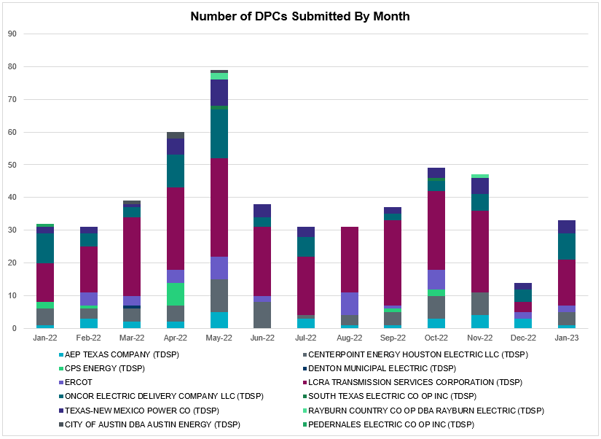

Transmission Operator | Number of DPCs
AEP TEXAS COMPANY (TDSP) | 1
BRAZOS ELECTRIC POWER CO OP INC (TDSP) | 2
BROWNSVILLE PUBLIC UTILITIES BOARD (TDSP) | 0
BRYAN TEXAS UTILITIES (TDSP) | 1
CENTERPOINT ENERGY HOUSTON ELECTRIC LLC (TDSP) | 4
CITY OF AUSTIN DBA AUSTIN ENERGY (TDSP) | 0
CITY OF COLLEGE STATION (TDSP) | 0
CITY OF GARLAND (TDSP) | 0
CPS ENERGY (TDSP) | 0
DENTON MUNICIPAL ELECTRIC (TDSP) | 0
ELECTRIC TRANSMISSION TEXAS LLC (TDSP) | 0
ERCOT | 2
LCRA TRANSMISSION SERVICES CORPORATION (TDSP) | 14
LONE STAR TRANSMISSION LLC (TSP) | 0
ONCOR ELECTRIC DELIVERY COMPANY LLC (TDSP) | 8
PEDERNALES ELECTRIC CO OP INC (TDSP) | 0
RAYBURN COUNTRY CO OP DBA RAYBURN ELECTRIC (TDSP) | 0
SHARYLAND UTILITIES LP (TDSP) | 0
SOUTH TEXAS ELECTRIC CO OP INC (TDSP) | 0
TEXAS MUNICIPAL POWER AGENCY (TDSP) | 0
TEXAS-NEW MEXICO POWER CO (TDSP) | 4

Appendix A: Real-Time Constraints
The following is a complete list of constraints activated in SCED. Full contingency descriptions can be found in the Standard Contingencies List located on the MIS secure site at Grid Generation Reliability Unit Commitment.
Year | Month of the Year | Contingency Name | Overloaded Element | From Station | To Station | Count of Days
2023 | 1 | BASE CASE | BEARKT | n/a | n/a | 30
2023 | 1 | SLOBSA25 | CATARI_PILONC1_1 | CATARINA | PILONCIL | 27
2023 | 1 | SLOBSA25 | CATARI_PILONC1_1 | PILONCIL | CATARINA | 27
2023 | 1 | SNATBEA8 | 6144__A | BSPRW | STASW | 22
2023 | 1 | BASE CASE | NE_LOB | n/a | n/a | 21
2023 | 1 | BASE CASE | WESTEX | n/a | n/a | 20
2023 | 1 | SBRAUVA8 | HAMILT_MAVERI1_1 | HAMILTON | MAVERICK | 16
2023 | 1 | SCMNCPS5 | 651__B | CMNSW | CMNTP | 16
2023 | 1 | BASE CASE | VALEXP | n/a | n/a | 15
2023 | 1 | BASE CASE | NELRIO | n/a | n/a | 14
2023 | 1 | BASE CASE | HHGTOM_1 | HHGT | OMEGA | 14
2023 | 1 | MHARNED5 | BURNS_RIOHONDO_1 | RIOHONDO | MV_BURNS | 14
2023 | 1 | DTWIDIV5 | COKEST_REDCRE1_1 | REDCREEK | COKESTRE | 12
2023 | 1 | DBIGKEN5 | TREADW_YELWJC1_1 | TREADWEL | YELWJCKT | 12
2023 | 1 | SKLELOY8 | LOYOLA_69_1 | LOYOLA | LOYOLA | 12
2023 | 1 | SALAN_28 | CELANE_KLEBER1_1 | CELANEBI | KLEBERG | 11
2023 | 1 | BASE CASE | MCCAMY | n/a | n/a | 11
2023 | 1 | DTWIDIV5 | 134T429_1 | SAPOWER | SCHKAD | 11
2023 | 1 | SSKYSB28 | 15080__Z | CONSW | CTFLD | 11
2023 | 1 | SCARFRI8 | ATSO_SONR1_1 | SONR | ATSO | 11
2023 | 1 | SBTPBNT8 | MYRA_VAL_1 | MYRA | VALYVIEW | 11
2023 | 1 | DELMSAN5 | PAWNEE_SPRUCE_1 | PAWNEE | CALAVERS | 10
2023 | 1 | SGRICOL5 | PAWNEE_TANGO1_1 | TANGO | PAWNEE | 10
2023 | 1 | DTWIDIV5 | SAPOWE_SAST1_1 | SAPOWER | SAST | 10
2023 | 1 | SLAQLOB8 | BRUNI_69_1 | BRUNI | BRUNI | 10
2023 | 1 | DSALKLN5 | 630__B | KLNSW | HHSTH | 10
2023 | 1 | DTWIDIV5 | SAPOWE_SAST1_1 | SAST | SAPOWER | 10
2023 | 1 | SW_GODE5 | 15060__B | VEALMOOR | KOCHTAP | 10
2023 | 1 | DMOLLO58 | PAWNEE_TANGO1_1 | TANGO | PAWNEE | 9
2023 | 1 | SSPUASP8 | SPUR_69_1 | SPUR | SPUR | 9
2023 | 1 | SMADSAP8 | MADDUX_SAPOWE2_1 | MADDUX | SAPOWER | 9
2023 | 1 | SFORYEL8 | HEXT_YELWJC1_1 | YELWJCKT | HEXT | 8
2023 | 1 | DBIGKEN5 | HAMILT_MAXWEL1_1 | MAXWELL | HAMILTON | 8
2023 | 1 | SN_SLON5 | LASPUL_RAYMND1_1 | LASPULGA | RAYMND2 | 8
2023 | 1 | MMDSQAL5 | MDSSW_MR1L | MDSSW | MDSSW | 8
2023 | 1 | SBRAHAM8 | HAMILT_MAVERI1_1 | HAMILTON | MAVERICK | 8
2023 | 1 | SILLFTL8 | HAMILT_MAXWEL1_1 | MAXWELL | HAMILTON | 8
2023 | 1 | SFORYEL8 | HEXT_YELWJC1_1 | HEXT | YELWJCKT | 8
2023 | 1 | MCONQAL5 | 6471__A | MGSES | MCDLD | 8
2023 | 1 | DBIGKEN5 | HEXT_MASONS1_1 | HEXT | MASONSW | 7
2023 | 1 | DBIGKEN5 | HEXT_MASONS1_1 | MASONSW | HEXT | 7
2023 | 1 | SSPUASP8 | ROBY_ROTN1_1 | ROTN | ROBY | 7
2023 | 1 | SLOBSA25 | ASHERT_CATARI1_1 | ASHERTON | CATARINA | 7
2023 | 1 | SODLBRA8 | HAMILT_MAVERI1_1 | HAMILTON | MAVERICK | 7
2023 | 1 | SLOBSA25 | ASHERT_CATARI1_1 | CATARINA | ASHERTON | 7
2023 | 1 | SSPUSLT8 | ASPM_69T2 | ASPM | ASPM | 7
2023 | 1 | BASE CASE | TRDWEL | n/a | n/a | 7
2023 | 1 | DWLDSCO5 | 15060__B | VEALMOOR | KOCHTAP | 7
2023 | 1 | SSPUASP8 | ROBY_ROTN1_1 | ROBY | ROTN | 7
2023 | 1 | SODLBRA8 | HAMILT_MAVERI1_1 | MAVERICK | HAMILTON | 7
2023 | 1 | SBRAUVA8 | ESCOND_GANSO1_1 | GANSO | ESCONDID | 6
2023 | 1 | DCAGCO58 | 656T656_1 | KENDAL | BERGHE | 6
2023 | 1 | SFORYEL8 | HEXT_MASONS1_1 | MASONSW | HEXT | 6
2023 | 1 | SSPJFS8 | JFSSC_06_A | JFS | SC | 6
2023 | 1 | MRESMCM8 | RINCON_WHITE_2_1 | WHITE_PT | RINCON | 6
2023 | 1 | SFORYEL8 | HEXT_MASONS1_1 | HEXT | MASONSW | 6
2023 | 1 | DWISALV8 | MYRA_VAL_1 | MYRA | VALYVIEW | 6
2023 | 1 | DCAGCI58 | 255T279_1 | PIPECR | MEDILA | 5
2023 | 1 | SBWDDBM5 | LPLMK_LPLNE_1 | LPLMK | LPLNE | 5
2023 | 1 | DCOLFA59 | PAWNEE_TANGO1_1 | TANGO | PAWNEE | 5
2023 | 1 | SOBWAP5 | OB_WAP98_A | WAP | OB | 5
2023 | 1 | DCAGCI58 | 656T656_1 | KENDAL | BERGHE | 5
2023 | 1 | SCENLOB5 | PAWNEE_TANGO1_1 | TANGO | PAWNEE | 4
2023 | 1 | SHEAKAT9 | MASNPH_MASN1_1 | MASN | MASNPHT | 4
2023 | 1 | SBIGTWI5 | TREADW_YELWJC1_1 | TREADWEL | YELWJCKT | 4
2023 | 1 | MMGSCON5 | 6471__A | MGSES | MCDLD | 4
2023 | 1 | SCRMSAR8 | CONCHO_VRBS1_1 | CONCHO | VRBS | 4
2023 | 1 | DKOCNUE8 | MCKENZ_WESTSI1_1 | WESTSIDE | MCKENZIE | 4
2023 | 1 | DWHILON5 | PAWNEE_TANGO1_1 | TANGO | PAWNEE | 4
2023 | 1 | DBIGKEN5 | HEXT_YELWJC1_1 | YELWJCKT | HEXT | 4
2023 | 1 | SLOBSA25 | LARDVN_LASCRU1_1 | LARDVNTH | LASCRUCE | 4
2023 | 1 | DSLKSOL5 | 138_FLT_FXT_1 | TNFXTAIL | FLAT_TOP | 4
2023 | 1 | MHARNED5 | HAINE__LA_PAL1_1 | LA_PALMA | HAINE_DR | 4
2023 | 1 | SKLEKLE8 | LOYOLA_69_1 | LOYOLA | LOYOLA | 4
2023 | 1 | SODLBRA8 | GANSO_MAVERI1_1 | GANSO | MAVERICK | 4
2023 | 1 | SSPUASP8 | GIRA_T_SPUR1_1 | SPUR | GIRA_TAP | 4
2023 | 1 | SHEAKAT9 | HEXT_MASONS1_1 | MASONSW | HEXT | 4
2023 | 1 | MCONLNG5 | 14040__A | PCTSW | DEWTP | 4
2023 | 1 | SSKYSB28 | 15081__Z | SMIDLAND | CONSW | 3
2023 | 1 | DMGSBIT5 | 6036__A | TKWSW | MGSES | 3
2023 | 1 | SBGLTWI8 | CONCHO_SANW0_1 | CONCHO | SANW | 3
2023 | 1 | DWHICOT5 | FARMLAND_LONGD_1 | FARMLAND | W_LD_345 | 3
2023 | 1 | SOXYIN28 | I_DUPP_I_DUPS1_1 | I_DUPP1 | I_DUPSW | 3
2023 | 1 | DCAGCO58 | 583T583_1 | BANDER | MASOCR | 3
2023 | 1 | SW_SBRN5 | CRTVLE_EINSTEN_1 | EINSTEIN | CRTRVLLE | 3
2023 | 1 | SBRAHAM8 | GANSO_MAVERI1_1 | GANSO | MAVERICK | 3
2023 | 1 | SN_SLON5 | KINGSV_KLEBER1_1 | KLEBERG | KINGSVIL | 3
2023 | 1 | SN_SLON5 | CELANE_KLEBER1_1 | CELANEBI | KLEBERG | 3
2023 | 1 | SMDOPHR5 | G138_10B_1 | SEMINOLE | MAGNO_TN | 3
2023 | 1 | BASE CASE | N_TO_H | n/a | n/a | 3
2023 | 1 | SN_SLON5 | BURNS_RIOHONDO_1 | RIOHONDO | MV_BURNS | 3
2023 | 1 | DGILHIW8 | KOCH_H_LON_HI1_1 | KOCH_HF | LON_HILL | 3
2023 | 1 | DMGSBTR5 | 6036__A | TKWSW | MGSES | 3
2023 | 1 | SASPPAI8 | ASPM_69T2 | ASPM | ASPM | 3
2023 | 1 | SLOBSA25 | BRUNI_69_1 | BRUNI | BRUNI | 3
2023 | 1 | SCISPUT8 | ESTES_PECAN_1_1 | PECAN_BY | ESTES | 3
2023 | 1 | DSWECBF5 | BLUF_C_MULBER1_1 | MULBERRY | BLUF_CRK | 3
2023 | 1 | BASE CASE | RV_RH | n/a | n/a | 3
2023 | 1 | SDIVAVI5 | CRTVLE_EINSTEN_1 | EINSTEIN | CRTRVLLE | 3
2023 | 1 | SFORYEL8 | MASNPH_MASN1_1 | MASN | MASNPHT | 3
2023 | 1 | DBIGKEN5 | MADDUX_TREADW1_1 | MADDUX | TREADWEL | 3
2023 | 1 | SN_SLON5 | HAINE__LA_PAL1_1 | LA_PALMA | HAINE_DR | 2
2023 | 1 | XTWI158 | HEXT_MASONS1_1 | MASONSW | HEXT | 2
2023 | 1 | SMCEABS8 | MERK_MKLT1_1 | MERK | MKLT | 2
2023 | 1 | SMCEABS8 | MERK_MKLT1_1 | MKLT | MERK | 2
2023 | 1 | MCONQAL5 | 14040__A | PCTSW | DEWTP | 2
2023 | 1 | SGRICOL5 | CALLIC_LON_HI1_1 | LON_HILL | CALLICOA | 2
2023 | 1 | SSANFOW5 | CATARI_PILONC1_1 | PILONCIL | CATARINA | 2
2023 | 1 | SW_SDIV5 | CRTVLE_EINSTEN_1 | EINSTEIN | CRTRVLLE | 2
2023 | 1 | DCALBEC8 | D5_J0_1 | J0 | LEON_CRK | 2
2023 | 1 | SJUNYEL9 | HEXT_YELWJC1_1 | YELWJCKT | HEXT | 2
2023 | 1 | SWCSAN8 | LAN_CT_PAVLOV1_1 | PAVLOV | LAN_CTY | 2
2023 | 1 | SBIGTWI5 | MADDUX_TREADW1_1 | MADDUX | TREADWEL | 2
2023 | 1 | SMDSODE5 | MDSSW_MR1L | MDSSW | MDSSW | 2
2023 | 1 | XWHT58 | WHTNY_MR2L | WHTNY | WHTNY | 2
2023 | 1 | MCONLNG5 | 6095__D | LMESA | JPPOI | 2
2023 | 1 | SSPJFS8 | CO_PL_84_A | PL | CO | 2
2023 | 1 | SCOMHA38 | HAMILT_MAXWEL1_1 | MAXWELL | HAMILTON | 2
2023 | 1 | SPLUMUL8 | MAGRUD_VICTOR2_1 | VICTORIA | MAGRUDER | 2
2023 | 1 | DMCEBUT8 | MKLT_TRNT1_1 | TRNT | MKLT | 2
2023 | 1 | MCOMPR28 | RYSSW_FMR2 | RYSSW | RYSSW | 2
2023 | 1 | STITSCA8 | SCARBI_STILLM1_1 | SCARBIDE | STILLMAN | 2
2023 | 1 | MCONLNG5 | 15010__B | BLISS | ESTILES | 2
2023 | 1 | DBIGKEN5 | CARVER_TINSLE1_1 | CARVER | TINSLEY | 2
2023 | 1 | DTWIDIV5 | CRMW5T_STER1_1 | CRMW5TP | STER | 2
2023 | 1 | XTWI158 | HEXT_MASONS1_1 | HEXT | MASONSW | 2
2023 | 1 | XTWI158 | HEXT_YELWJC1_1 | YELWJCKT | HEXT | 2
2023 | 1 | SN_SAJO5 | LASPUL_RAYMND1_1 | LASPULGA | RAYMND2 | 2
2023 | 1 | DWAP_OB5 | WW_JN_25_A | JN | WW | 2
2023 | 1 | DMTSCOS5 | 6437__F | SCRCV | KNAPP | 2
2023 | 1 | DTWIDIV5 | BENFIC_REDCRE1_1 | REDCREEK | BENFICKL | 2
2023 | 1 | SILLFTL8 | CARVER_TINSLE1_1 | CARVER | TINSLEY | 2
2023 | 1 | DMCNDES8 | CKT_909_1 | DESSAU | MCNEIL | 2
2023 | 1 | DTWIDIV5 | HARGRO_TWINBU1_1 | TWINBU | HARGROVE | 2
2023 | 1 | SCARLVO8 | HARGRO_TWINBU1_1 | TWINBU | HARGROVE | 2
2023 | 1 | SBIGTWI5 | HEXT_MASONS1_1 | MASONSW | HEXT | 2
2023 | 1 | SMCEESK8 | MERK_MKLT1_1 | MKLT | MERK | 2
2023 | 1 | SMCEESK8 | MKLT_TRNT1_1 | TRNT | MKLT | 2
2023 | 1 | SDIMBEV8 | UVALDE_W_BATE1_1 | W_BATESV | UVALDE | 2
2023 | 1 | MCONLNG5 | 6046__A | MGSES | FLCNS | 2
2023 | 1 | SE4BIG8 | BIG_FOOT_69A1 | BIG_FOOT | BIG_FOOT | 2
2023 | 1 | DKENNO89 | COLETO_ROSATA1_1 | COLETO | ROSATA | 2
2023 | 1 | DCALBEC8 | J0_P0_1 | P0 | J0 | 2
2023 | 1 | STANPAW5 | CALLIC_LON_HI1_1 | LON_HILL | CALLICOA | 2
2023 | 1 | DCHBJO25 | CBYCVN86_A | CBY | CVN | 2
2023 | 1 | DLYTTUR8 | CKT_943_1 | LYTTON_S | PILOT | 2
2023 | 1 | MBOGTID8 | CO_PL_84_A | PL | CO | 2
2023 | 1 | DTWIDIV5 | CRMW5T_STER1_1 | STER | CRMW5TP | 2
2023 | 1 | SBRAHAM8 | ESCOND_GANSO1_1 | GANSO | ESCONDID | 2
2023 | 1 | DBIGKEN5 | HAMILT_MAVERI1_1 | HAMILTON | MAVERICK | 2
2023 | 1 | SWCSAN8 | LAN_CT_PAVLOV1_1 | LAN_CTY | PAVLOV | 2
2023 | 1 | DODEMOS5 | ODEHV_MR2H | ODEHV | ODEHV | 2
2023 | 1 | SSGVTRC5 | 175__A | TRCNR | FORSW | 2
2023 | 1 | MCONQAL5 | 6095__D | LMESA | JPPOI | 2
2023 | 1 | SVEAW_L5 | 6217__A | WLVSW | GAILS | 2
2023 | 1 | DJFSIND8 | DPWPRS33_A | DPW | PRS | 2
2023 | 1 | SBIGTWI5 | HEXT_MASONS1_1 | HEXT | MASONSW | 2
2023 | 1 | DQABSRB8 | JFSSC_06_A | JFS | SC | 2
2023 | 1 | DMCEBUT8 | MERK_MKLT1_1 | MKLT | MERK | 2
2023 | 1 | SMCEABS8 | MKLT_TRNT1_1 | TRNT | MKLT | 2
2023 | 1 | BASE CASE | PNHNDL | n/a | n/a | 2
2023 | 1 | XBLE58 | SAR_FRAN_1 | FRANKC | SARGNTS | 2
2023 | 1 | MCONQAL5 | 6046__A | MGSES | FLCNS | 2
2023 | 1 | MCONLNG5 | 6144__A | BSPRW | STASW | 2
2023 | 1 | DBIGKEN5 | BONDRO_SONR1_1 | SONR | BONDROAD | 2
2023 | 1 | SLARDUS8 | BRUNI_69_1 | BRUNI | BRUNI | 2
2023 | 1 | SSANFOW5 | CATARI_PILONC1_1 | CATARINA | PILONCIL | 2
2023 | 1 | SCO2EUL8 | COLETO_ROSATA1_1 | COLETO | ROSATA | 2
2023 | 1 | DBIGKEN5 | ESCOND_GANSO1_1 | GANSO | ESCONDID | 2
2023 | 1 | DCENRI35 | PAWNEE_TANGO1_1 | TANGO | PAWNEE | 1
2023 | 1 | SCISPUT8 | SOUTHA_VINSON1_1 | SOUTHABI | VINSON | 1
2023 | 1 | DMDLSBY8 | 15081__Z | CONSW | SMIDLAND | 1
2023 | 1 | DSCOFAR5 | 6216__B | WLVSW | SHRNE | 1
2023 | 1 | DKENCA58 | 656T656_1 | KENDAL | BERGHE | 1
2023 | 1 | DCOLFA59 | CALLIC_LON_HI1_1 | LON_HILL | CALLICOA | 1
2023 | 1 | SSCHTWI8 | CONCHO_SANW0_1 | CONCHO | SANW | 1
2023 | 1 | DCBYJOR5 | CTRPHR97_A | CTR | PHR | 1
2023 | 1 | SW_SDIV5 | EILAND_CRTVLLE_1 | CRTRVLLE | EILAND | 1
2023 | 1 | DLONOR58 | HAINE__LA_PAL1_1 | LA_PALMA | HAINE_DR | 1
2023 | 1 | SSPUASP8 | HAMLIN_PLST1_1 | PLST | HAMLIN | 1
2023 | 1 | DJFSIND8 | HG_PRS33_A | HG | PRS | 1
2023 | 1 | DBECKIR8 | J0_P0_1 | P0 | J0 | 1
2023 | 1 | DHUGWR_8 | LANCTY_LAN_CT1_1 | LAN_CTY | LANCTYPM | 1
2023 | 1 | SSKYSB28 | 15010__B | BLISS | ESTILES | 1
2023 | 1 | SLCRCRA8 | 15080__Z | CONSW | CTFLD | 1
2023 | 1 | SW_GODE5 | 6095__D | LMESA | JPPOI | 1
2023 | 1 | DWHILON5 | BLESSI_LOLITA1_1 | BLESSING | LOLITA | 1
2023 | 1 | MHARRIO5 | BURNS_RIOHONDO_1 | RIOHONDO | MV_BURNS | 1
2023 | 1 | SSANFOW5 | COTULL_REVEIL1_1 | REVEILLE | COTULLA | 1
2023 | 1 | SGASMGS5 | CRMW5T_STER1_1 | CRMW5TP | STER | 1
2023 | 1 | SSPUASP8 | DKEC_GIRA_T1_1 | GIRA_TAP | DKEC | 1
2023 | 1 | DBIGKEN5 | FORTMA_YELWJC1_1 | YELWJCKT | FORTMA | 1
2023 | 1 | DWO5_EU8 | GT_GT_90_1 | GT | GT | 1
2023 | 1 | SMV_MV38 | HAINE__LA_PAL1_1 | LA_PALMA | HAINE_DR | 1
2023 | 1 | SFTLMES8 | HARGRO_TWINBU1_1 | TWINBU | HARGROVE | 1
2023 | 1 | BASE CASE | HWY511_COFEPRT_1 | COFFPORT | MV_HW511 | 1
2023 | 1 | BASE CASE | JN_AT1L | JN | JN | 1
2023 | 1 | XWHI58 | KOCH_H_LON_HI1_1 | LON_HILL | KOCH_HF | 1
2023 | 1 | XTWI158 | MASNPH_MASN1_1 | MASN | MASNPHT | 1
2023 | 1 | DSTNCPS8 | OLS_CLIF_1 | OLSEN | CLIFTON1 | 1
2023 | 1 | DCENREV5 | PAWNEE_TANGO1_1 | TANGO | PAWNEE | 1
2023 | 1 | SLOBSA25 | PAWNEE_TANGO1_1 | TANGO | PAWNEE | 1
2023 | 1 | MHARNED5 | SCARBI_STILLM1_1 | SCARBIDE | STILLMAN | 1
2023 | 1 | DSCOTKW5 | 15060__B | VEALMOOR | KOCHTAP | 1
2023 | 1 | SLCRCRA8 | 15080__B | CTFLD | PRONGHRN | 1
2023 | 1 | SREVDIL8 | BRUNI_69_1 | BRUNI | BRUNI | 1
2023 | 1 | SCOMHA38 | CARVER_TINSLE1_1 | CARVER | TINSLEY | 1
2023 | 1 | DTWIDIV5 | COKEST_RUSTHI1_1 | COKESTRE | RUSTHILL | 1
2023 | 1 | DHUGWR_8 | EL_CAM_LANCTY1_1 | LANCTYPM | EL_CAMPO | 1
2023 | 1 | DJFSIND8 | HG_PRS33_A | PRS | HG | 1
2023 | 1 | XTWI158 | MASNPH_MASONS1_1 | MASNPHT | MASONSW | 1
2023 | 1 | DLONWEI8 | MCKENZ_WESTSI1_1 | WESTSIDE | MCKENZIE | 1
2023 | 1 | DCENFAL5 | PAWNEE_TANGO1_1 | TANGO | PAWNEE | 1
2023 | 1 | SBONNED5 | SCARBI_STILLM1_1 | SCARBIDE | STILLMAN | 1
2023 | 1 | SSKYSB28 | 15080__B | CTFLD | PRONGHRN | 1
2023 | 1 | DBERAN58 | 85T329_1 | BERGHE | DEVIHI | 1
2023 | 1 | SBONRIO5 | BURNS_RIOHONDO_1 | RIOHONDO | MV_BURNS | 1
2023 | 1 | DMCEBUT8 | ESKSW_TRNT1_1 | ESKSW | TRNT | 1
2023 | 1 | DCALBEC8 | F1_O9_1 | F1 | SUTHRLND | 1
2023 | 1 | BASE CASE | MAXWEL_WHITIN1_1 | MAXWELL | WHITING | 1
2023 | 1 | SES2FRI8 | MIDW_OZONA1_1 | OZONA | MIDW | 1
2023 | 1 | DKENCA58 | 255T279_1 | PIPECR | MEDILA | 1
2023 | 1 | SFERSHE8 | 33T218_1 | WIRTZ | BURNET | 1
2023 | 1 | SBOMJC25 | 6085__E | WFSSW | NSTAR | 1
2023 | 1 | SALAN_28 | CELANE_N_SHAR1_1 | N_SHARPE | CELANEBI | 1
2023 | 1 | SWRDYN8 | EL_CAM_LANCTY1_1 | LANCTYPM | EL_CAMPO | 1
2023 | 1 | SBONNED5 | HAINE__LA_PAL1_1 | LA_PALMA | HAINE_DR | 1
2023 | 1 | SMV_RIO8 | HAINE__LA_PAL1_1 | LA_PALMA | HAINE_DR | 1
2023 | 1 | DLONOR58 | HAINE__OLEAND1_1 | HAINE_DR | OLEANDER | 1
2023 | 1 | SNEDLON5 | HAINE__OLEAND1_1 | HAINE_DR | OLEANDER | 1
2023 | 1 | SJNSWNT8 | OLS_CLIF_1 | OLSEN | CLIFTON1 | 1
2023 | 1 | SMARLAU8 | SCARBI_STILLM1_1 | SCARBIDE | STILLMAN | 1
2023 | 1 | DJFSIND8 | SC_AT1 | SC | SC | 1
2023 | 1 | MCONLNG5 | 15060__B | VEALMOOR | KOCHTAP | 1
2023 | 1 | DODEMOS5 | 15081__Z | CONSW | SMIDLAND | 1
2023 | 1 | DSWELNC5 | BLUF_C_MULBER1_1 | BLUF_CRK | MULBERRY | 1
2023 | 1 | SREVDIL8 | CATARI_PILONC1_1 | PILONCIL | CATARINA | 1
2023 | 1 | DAIRB_D8 | CELANE_KLEBER1_1 | CELANEBI | KLEBERG | 1
2023 | 1 | SGASMGS5 | CRMW5T_STER1_1 | STER | CRMW5TP | 1
2023 | 1 | SWCSAN8 | EL_CAM_LANCTY1_1 | LANCTYPM | EL_CAMPO | 1
2023 | 1 | SBONNED5 | HAINE__OLEAND1_1 | HAINE_DR | OLEANDER | 1
2023 | 1 | XLO2N58 | LON_HI_SERDEV1_1 | LON_HILL | LON_HILL | 1
2023 | 1 | SALAN_28 | LOYOLA_69_1 | LOYOLA | LOYOLA | 1
2023 | 1 | SBGLTWI8 | SAMATH_SANW1_1 | SANW | SAMATHIS | 1
2023 | 1 | SBE2ASH8 | TURTLECK_WCRYS_1 | TURTLCRK | WCRYSTS | 1
2023 | 1 | MCONQAL5 | 15010__B | BLISS | ESTILES | 1
2023 | 1 | SSPUSLT8 | ASPM_CONA1_1 | ASPM | CONA | 1
2023 | 1 | SN_SAJO5 | BURNS_RIOHONDO_1 | RIOHONDO | MV_BURNS | 1
2023 | 1 | DABPAB98 | CONAN_SANA1_1 | SANA_TAP | CONAN | 1
2023 | 1 | MEABBOG8 | CO_PL_84_A | PL | CO | 1
2023 | 1 | SMDOOAS5 | GN_PZ_08_A | GN | PZ | 1
2023 | 1 | SNEDLON5 | HAINE__LA_PAL1_1 | LA_PALMA | HAINE_DR | 1
2023 | 1 | SN_SAJO5 | HAINE__LA_PAL1_1 | LA_PALMA | HAINE_DR | 1
2023 | 1 | SF2KEN8 | KARNES_KENEDS1_1 | KENEDSW | KARNESCI | 1
2023 | 1 | SWHILON5 | LON_HI_SERDEV4_1 | LON_HILL | LON_HILL | 1
2023 | 1 | XLY3T58 | LYTTON_S_AT1H | LYTTON_S | LYTTON_S | 1
2023 | 1 | DBIGKEN5 | MASNPH_MASN1_1 | MASN | MASNPHT | 1
2023 | 1 | SHEAKAT9 | MASNPH_MASONS1_1 | MASNPHT | MASONSW | 1
2023 | 1 | SCOMHA38 | MAXWEL_WHITIN1_1 | MAXWELL | WHITING | 1
2023 | 1 | SKEYWLV8 | 15060__B | VEALMOOR | KOCHTAP | 1
2023 | 1 | DSTPANS5 | BLESSI_LOLITA1_1 | BLESSING | LOLITA | 1
2023 | 1 | SDAFAUS8 | CKT_1027_1 | DUNLAP | DECKER | 1
2023 | 1 | SDIMBEV8 | HAMILT_MAVERI1_1 | HAMILTON | MAVERICK | 1
2023 | 1 | UCFLU11 | HEXT_MASONS1_1 | MASONSW | HEXT | 1
2023 | 1 | SHEAKAT9 | HEXT_YELWJC1_1 | HEXT | YELWJCKT | 1
2023 | 1 | SLONLON8 | LON_HI_SERDEV4_1 | LON_HILL | LON_HILL | 1
2023 | 1 | BASE CASE | MCADO_SPUR_1A_1 | MWEC | SPUR | 1

Current Wind Generation Record: 27,044 MW on 05/29/2022 at 22:36 | Current Wind Penetration Record: 69.15% on 04/10/2022 at 01:43 Current Solar Generation Record: 10,100 MW on 10/01/2022 at 11:03 | Current Solar Penetration Record: 24.99% on 10/01/2022 at 10:06
This is the hourly integrated peak demand as published in the ERCOT D&E report.
All DC Tie Curtailments are posted publicly on the ERCOT Market Information System. See that posting for additional details for the event(s) in question.
See DC Tie Operating Procedure (http://www.ercot.com/mktrules/guides/procedures) for more details.

