NOGRR Number | 245 | NOGRR Title | Inverter-Based Resource (IBR) Ride-Through Requirements

Date | February 16, 2023

Submitter’s Information
Name | David Albers
E-mail Address | dalbers@brazoselectric.com
Company | Brazos Electric
Phone Number | 254-750-6358
Cell Number
Market Segment | Cooperative

Comments
Power Engineers provided the comments below at the request of Brazos Electric. Brazos is forwarding the comments for consideration.

- The majority of IBRs in operation in the world are grid following (GFL) resources, which use the local system as an operating reference. ERCOT has seen some stability concerns tied to this limitation of the technology as without the grid reference for local conventional machines the IBR operation can dominate operation and trigger unstable operation or control interaction. It may be a good process improvement to incorporate considerations of system strength assessments as part of the short circuit study phase of the interconnection process. This can identify potential weak grid conditions at the POI of the resource early in the interconnection process and is a trigger for the developer to contact their inverter manufacture to receive confirmation that their equipment can operate reliably under the identified grid conditions under realistic operating conditions, such as local line outage. NERC has provided guidance on assessing this using metrics such as the Short Circuit Ratio, and ERCOT introduced the Weighted Short Circuit Ratio to account for IBR clustering. Some manner of this assessment is recommended for incorporation into planning processes to be proactive about grid strength adjustments. This could potentially be incorporated into the VRT portion of the studies POWER performs as well but would require utility impedance provided by Brazos for testing in DMView.
- Per PRC-024 voltage protection models should be monitoring at POI bus, not inverter. This may be a potential modeling impact with regards to the received dynamic models and represents a potential additional check point.
- Brazos will need to update the ride through compliance test requirements and potentially reassess IBR interconnections within footprint within the six-month period, unless the requirement is being placed directly on the Generation Owner, but based on past ERCOT experience I believe this testing and validation will fall on the utility performing the VRT studies. Assuming this will affect the 10 MW and above Large Generator Interconnects. This can trigger a bit of iteration similar to the VRT process, testing and tuning controls of IBR projects to ensure compliance with new ride through requirements.
- Inverter manufacturers (OEMs) have been interpreting the ride through requirements indicated in NERC PRC-024-3 as being compatible with their equipment’s ability to permit momentary cessation, or power blocking. 2.6.2.1 (4) gets after this. Documentation would need to be provided from the OEM and/or PSCAD simulations or settings confirmation would need to be provided to ensure that momentary cessation is not enabled.
- 2.6.2.1 (3) draws attention to protection based on the IBR capability, rather than assuming that you can trip or must trip once you exceed the ride through requirements. This is an industry hurdle. For Brazos perspective, there can be a sanity check to the submitted RARF dynamic data to ensure that the protection settings aren’t just directly following the envelope identified in section 2.6.2.1(1).
- To comply with section 2.6.2.1(5) we would need to see something like PSCAD firmware to see if there are any of the stated protections enabled. Some of this, especially anti-islanding protection, comes from IBR first getting protection and operation standards at the distribution level in IEEE 1547. Brazos may have to change the interconnection application process to capture these requirements as part of the submittal process unless this is governed by ERCOT.
- This year is likely going to see a number of requests to confirm ride through settings for Generator Owners. Bit of a consideration if Brazos will be involved at all in this conversation, but realistically, for entities with SGIA in place, the responsibility is likely between them and ERCOT to validate and document. This seemed to be what was mentioned on the ERCOT IBRTF call in January, but is worth more clarification from ERCOT, especially pertaining to the requirements that Brazos would be held to.
- Brazos will continue to need to maintain VRT documentation and have this on hand to provide to ERCOT when requested. VRT will need to be compliant with new requirements introduced and have simulations demonstrating such compliance.
- There should be different protections established for the Generator and for the POI.
- Is there a need to clarify the period of limited charging operation for ESR’s following transient voltage disturbances?
- Language relating to current blocking mode in section 2.9.1 (1) can only be confirmed in a PSCAD model with sufficient level of visibility to the current blocking timer and was identified as an issue in the Odessa events. Would a statement of compliance from the manufacturer meet requirements?
- Section 2.9.1 (4) is to ensure that control mode has been established properly. This will require a more careful look at the Power Plant Controller Model and may have impacts during commissioning.
- Section 2.9.1 (5), similar to previous mention, this may come out of the model submission for commissioning if the Fortran firmware model is a requirement of submission with the post-commissioning tuning applied. This is also a conversation at the industry level as this level of detail into OEM models can represent visibility of proprietary control algorithms. NERC’s opinion is that if this gets incorporated as a submission requirement then this level of visibility should be easier to obtain.
- Section 2.9.1 (8) reads like it may be possible for the Generator Owner to state that they comply, and may not require VRT simulation, it depends on what ERCOT requires to demonstrate compliance.

The first Odessa Events happened in 2021 and NERC worked with ERCOT and TR and the facility owners to gather event recordings to identify what caused the unintended generation reductions that were observed across ERCOT. During the 2021 analysis they identified the following primary causes and specified what can be analyzed using phasor-domain software (such as PSS/E) and what requires EMT software to assess:

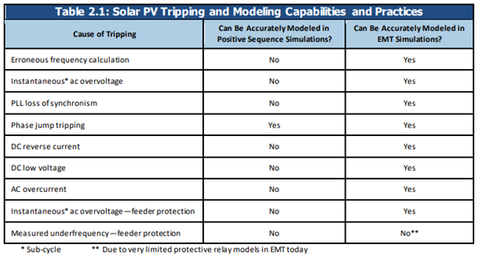

This Odessa style event happened twice in 2021, and then occurred again in 2022, which is what NERC’s most recent event report was focused on. They addressed some of the reasons for the unplanned generator reductions (green checks), but some new issues were identified (red x’s):

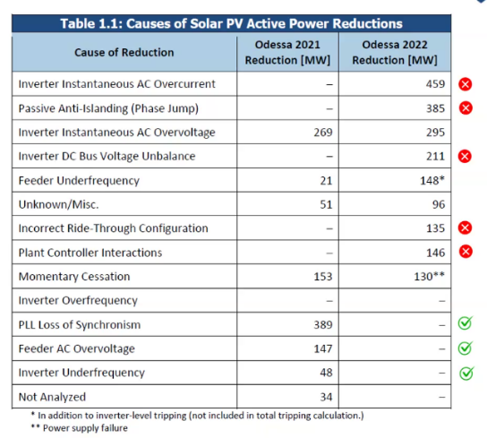

Revised Cover Page Language
None
Revised Proposed Guide Language
None

