PGRR Number | 103 | PGRR Title | Establish Time Limit for Generator Commissioning Following Approval to Synchronize

Date | January 30, 2023

Submitter’s Information
Name | Jay Teixeira
E-mail Address | Jay.teixeira@ercot.com
Company | ERCOT
Phone Number | 512-248-6582
Cell Number | 512-656-6734
Market Segment | Not Applicable

Comments

In response to Stakeholder requests at the January 19, 2023 Operations Working Group (OWG) and January 25, 2023 Planning Working Group (PLWG) meetings, ERCOT is providing the data below showing the number of days between approval for Part 2, Request for Initial Synchronization and approval for Part 3, Request to Commission a Resource, for all projects in the RIOO-IS database that have a Part 2 approval date from 2019 to January 26, 2023.

The map below shows the geographic locations for the 144 interconnection request (INR) projects included in the table above plotted on the county centroid (https://data.texas.gov/dataset/Texas-Counties-Centroid-Map/ups3-9e8m). The height of each project bar is in proportion to the number of days between Part 2 and Part 3. The map legend shows the color used for each technology. OTH is battery.

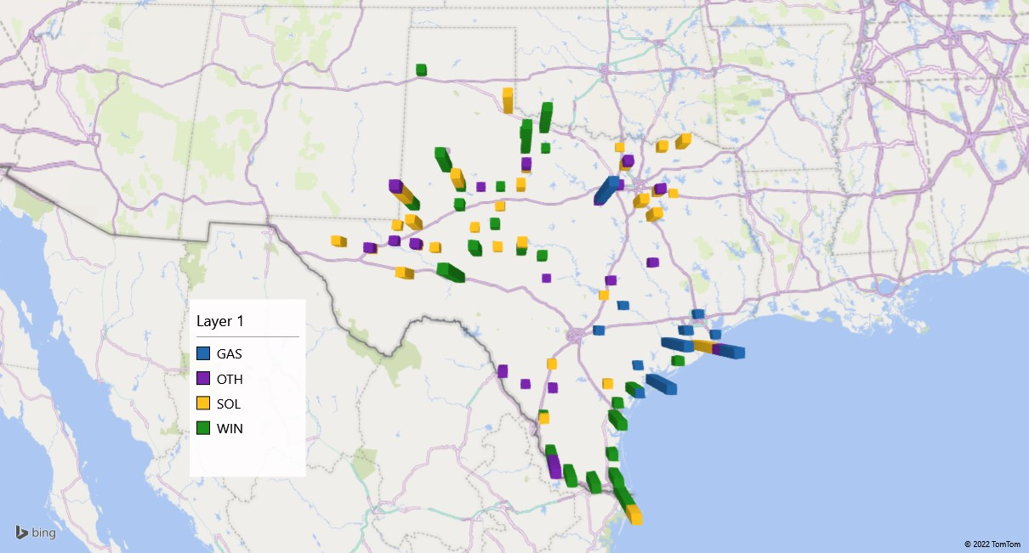

Below are the locations of the 55 INRs (as of 1/30/2023 – 11,267.59 MW) that have Part 2 but not Part 3 for over 180 days.

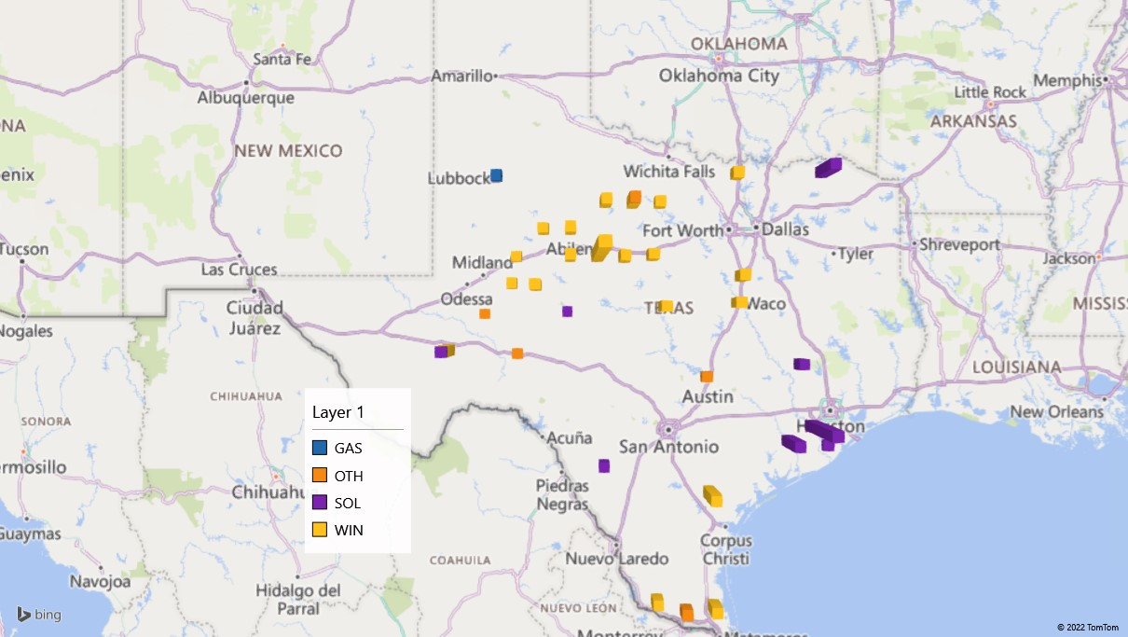

Revised Cover Page Language

None

Revised Proposed Guide Language

None

