December 2022 ERCOT Monthly Operations Report
Reliability and Operations Subcommittee Meeting
February 2, 2023

Table of Contents
1. Report Highlights 2
2. Frequency Control 3
2.1. Frequency Events 3
2.2. Responsive Reserve Events 4
2.3. Load Resource Events 4
3. Reliability Unit Commitment 4
4. IRR, Wind, and Solar Generation as a Percent of Load 7
5. Largest Net-Load Ramps 8
6. COP Error Analysis 9
7. Congestion Analysis 11
7.1. Notable Constraints 11
7.2. Generic Transmission Constraint Congestion 21
7.3. Manual Overrides 21
7.4. Congestion Costs for Calendar Year 2022 21
8. System Events 22
8.1. ERCOT Peak Load 22
8.2. Load Shed Events 22
8.3. Stability Events 22
8.4. Notable PMU Events 23
8.5. DC Tie Curtailment 23
8.6. TRE/DOE Reportable Events 23
8.7. New/Updated Constraint Management Plans 23
8.8. New/Modified/Removed RAS 23
8.9. New Procedures/Forms/Operating Bulletins 23
9. Emergency Conditions 24
9.1. OCNs 24
9.2. Advisories 24
9.3. Watches 24
9.4. Emergency Notices 24
10. Application Performance 24
10.1. TSAT/VSAT Performance Issues 24
10.2. Communication Issues 24
10.3. Market System Issues 24
11. Model Updates 25
Appendix A: Real-Time Constraints 27

Report Highlights
- The unofficial ERCOT peak load for the month was 74,427 MW and occurred on 12/23/2022, during hour ending 08:00.
- There were 4 frequency events.
- There were 2 instances where Responsive Reserves was deployed.
- There were 63 HRUC commitments.
- There were 17 days of congestion on the North Edinburg to Lobo GTC, 15 days on the West Texas Export GTC, 11 days on the Panhandle GTC, 19 days on the Treadwell GTC, 2 days on the Nelson Sharpe to Rio Hondo GTC, 1 day on the North to Houston GTC, 20 days on the Valley Export GTC, 4 days on the McCamey GTC, and 1 day on the Wharton GTC. There was no activity on the remaining GTCs during the month.
- There was 1 DC Tie Curtailments for the DC_L due to forced or unplanned outages.
- 1 OCN issued for taking manual action on the WESTEX IROL due to topology change. 1 OCN issued for predicted extreme cold weather event for the ERCOT Region from December 22, 2022 through December 26, 2022.
- 1 Advisory issued due to ERCOT postponed the deadline for the posting of the DAM solution for Operating Day 12/13/2022 due to a long running solution. 1 Advisory issued for the predicted extreme cold weather event for the ERCOT Region from December 22, 2022 through December 26, 2022.
- 1 Watch issued for the predicted extreme cold weather event for the ERCOT Region from December 22, 2022 through December 26, 2022.

Frequency Control

Frequency Events
The ERCOT Interconnection experienced 4 frequency events, which resulted from units’ trip. The event average event duration was 00:08:41.

A summary of the frequency events is provided below. The reported frequency events meet one of the following criteria: Delta Frequency is 60 mHz or greater; the MW loss is 350 MW or greater; resource trip event triggered RRS deployment. Frequency events that have been identified as Frequency Measurable Events (FME) for purposes of BAL-001-TRE-2 analysis are highlighted in blue. When analyzing frequency events, ERCOT evaluates PMU data according to industry standards. Events with an oscillating frequency of less than 1 Hz are inter-area, while higher frequencies indicate local events. Industry standards specify that damping ratio for inter-area oscillations should be 3.0% or greater. For the frequency events listed below, the ERCOT system met these standards and transitioned well after each disturbance. In the case of negative delta frequency, the MW Loss column could refer to load loss.

Date and Time | Delta Frequency | Max/Min Frequency | Duration of Event | PMU Data |  | MW Loss | Load | IRR | Inertia
 | (Hz) | (Hz) |  | Oscillation Mode (Hz) | Damping Ratio |  | (MW) | % | (GW-s)
12/7/2022 3:50:10 | -0.232 | 60.240 | 00:12:27 | 0.75 | 14% | 1400 | 35,387 | 24% | 198,703
12/8/2022 3:39:45 | 0.117 | 59.905 | 00:03:52 | 0.59 | 6% | 552 | 36,089 | 23% | 207,677
12/17/2022 18:53:50 | 0.089 | 59.895 | 00:07:01 | 0.68 | 10% | 713 | 46,164 | 10% | 270,548
12/23/2022 4:15:25 | 0.056 | 59.948 | 00:11:24 | 0.62 | 11% | 463 | 70,730 | 21% | 355,163

(Note: All data on this graph encompasses frequency event analysis based on BAL-001-TRE-2.)

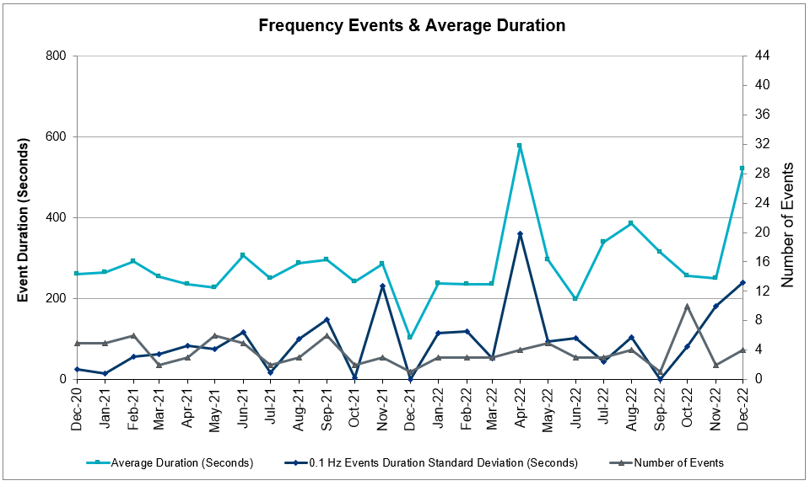

Responsive Reserve Events

There were 2 events where Responsive Reserve MWs were released to SCED. The events highlighted in blue were related to frequency events reported in Section 2.1 above.

Date and Time Released to SCED | Date and Time Recalled | Duration of Event | Maximum MWs Released
12/08/2022 3:39:52 | 12/08/2022 3:43:24 | 00:03:32 | 484
12/17/2022 18:54:04 | 12/17/2022 18:59:00 | 00:04:56 | 648

Load Resource Events
None.

Reliability Unit Commitment

ERCOT reports on Reliability Unit Commitments (RUC) monthly. Commitments are reported grouped by operating day and weather zone. The total number of hours committed is the sum of the hours for all the units in the specified region. Additional information on RUC commitments can be found on the MIS secure site at Grid Generation Reliability Unit Commitment.

There were no DRUC commitments.

There were 63 HRUC commitments

Resource Location | # of Resources | Operating Day | Total # of Hours Committed | Total MWhs | Reason for Commitment
NORTH_CENTRAL | 2 | 12/06/2022 | 4 | 1,688.0 | Capacity
COAST, EAST, NORTH_CENTRAL | 5 | 12/08/2022 | 19 | 6,261.0 | Capacity
COAST | 1 | 12/11/2022 | 3 | 1,014.0 | Capacity, Minimum Runtime
EAST, NORTH_CENTRAL | 3 | 12/16/2022 | 10 | 3,756.0 | Capacity
COAST, EAST, NORTH_CENTRAL, SOUTH_CENTRAL | 15 | 12/17/2022 | 73 | 16,207.5 | Capacity, VALEXP
NORTH_CENTRAL | 1 | 12/18/2022 | 1 | 122.0 | Minimum Runtime
COAST, EAST, NORTH, NORTH_CENTRAL, SOUTH_CENTRAL | 12 | 12/19/2022 | 56 | 12,908.7 | Capacity
EAST, FAR_WEST, NORTH_CENTRAL | 5 | 12/22/2022 | 76 | 11,764.0 | Capacity
FAR_WEST, SOUTHERN | 3 | 12/23/2022 | 4 | 572.0 | Capacity
EAST, NORTH_CENTRAL | 8 | 12/24/2022 | 113 | 36,549.0 | Capacity
EAST, NORTH_CENTRAL | 8 | 12/25/2022 | 96 | 32,712.0 | Capacity

IRR, Wind, and Solar Generation as a Percent of Load
The graph below shows the maximum, minimum and average aggregate solar, wind and IRR output as a percentage of total ERCOT load when evaluated as 10-minute averaged intervals, over the past 13 months. Current wind and solar generation and penetration records are listed in the footnote below. Maximum IRR penetration for the month was 62.1% on 12/28/2022 interval ending 12:30 and minimum IRR penetration for the month was 2.8% on 12/24/2022 interval ending18:10.

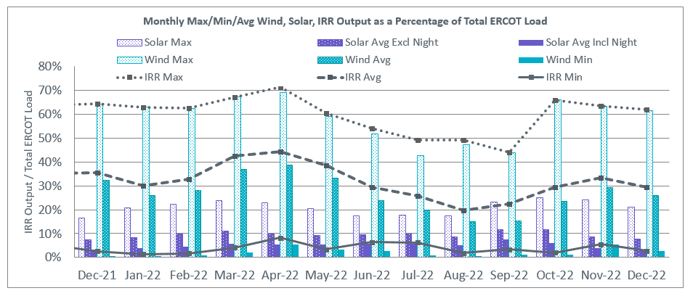

During the hour of peak load for the month, hourly integrated wind generation was 11,989 MW and solar generation was 161 MW. The graph below shows the wind and solar penetration percentage during the hour of the peak load in the last 13 months.

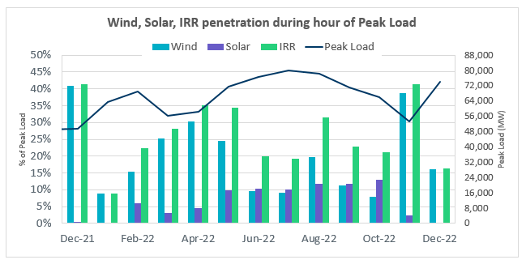

Lastly, the graph below shows the minimum wind, solar and IRR output during the peak load hour as a percentage of the daily peak load for every day in the month.

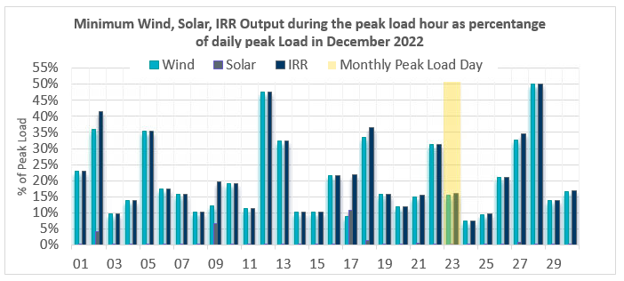

Largest Net-Load Ramps
The net-load ramp is defined as the change in net-load (load minus wind and PVGR generation) during the defined time horizon. Such a variation in net-load needs to be accommodated in grid operations to ensure that the reliability of the grid is satisfactorily maintained. The largest net-load ramp during 5-min, 10-min, 15-min, 30-min and 60-min in December 2022 are 1,138 MW, 1,981 MW, 2,841 MW, 5,459 MW, and 10,490 MW, respectively. The comparison with respect to the historical values is given in the table below.

Month and Year | 5 min | 10 min | 15 min | 30 min | 60 min
December 2014 | 1,014 MW | 1,689 MW | 2,112 MW | 3,034 MW | 5,296 MW
December 2015 | 962 MW | 1,637 MW | 1,995 MW | 3,241 MW | 5,516 MW
December 2016 | 857 MW | 1,404 MW | 1,827 MW | 3,166 MW | 5,866 MW
December 2017 | 964 MW | 1,581 MW | 2,078 MW | 3,393 MW | 5,708 MW
December 2018 | 923 MW | 1,553 MW | 2,148 MW | 4,109 MW | 7,218 MW
December 2019 | 1,014 MW | 1,689 MW | 2,112 MW | 3,034 MW | 5,296 MW
December 2020 | 1,083 MW | 1,780 MW | 2,479 MW | 5,882 MW | 10,364 MW
December 2021 | 933 MW | 1,518 MW | 2,154 MW | 4,103 MW | 7,128 MW
December 2022 | 1,138 MW  12/31/22  (IE 16:51) | 1,981 MW  12/14/22  (IE 16:48) | 2,841 MW  12/14/22  (IE 16:48) | 5,459 MW  12/14/22  (IE 17:10) | 10,490 MW  12/14/22  (IE 17:24)
All Months in 2014-2022 | 1,647 MW  05/25/22  (IE 17:06) | 2,155 MW  03/24/22  (IE 19:05) | 3,015 MW  03/24/22  (IE 19:10) | 5,882 MW  03/24/22  (IE 19:10) | 10,750 MW  03/24/22  (IE 19:27)

COP Error Analysis
COP Error is calculated as the capacity difference between the COP HSL and real-time HSL of the unit. Mean Absolute Error (MAE) stayed over 10,000 MW until Day-Ahead at 11:00, then dropped significantly to 6,273 MW by Day-Ahead at 13:00 and to 2,283 MW by Day-Ahead at 14:00. In the following chart, Under-Scheduling Error indicates that COP had less generation capacity than real-time, and Over-Scheduling Error indicates that COP had more generation capacity than real-time.

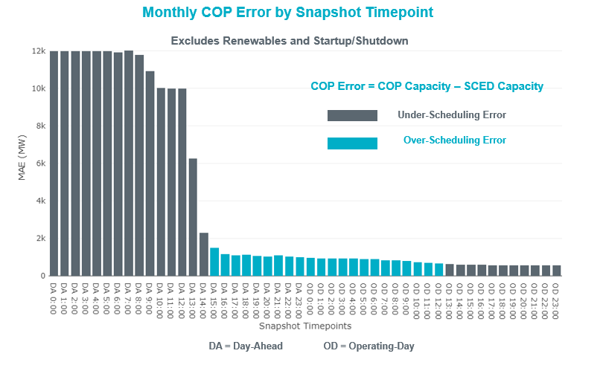

Monthly MAE for the Latest COP at the end of the Adjustment Period was 553 MW with medians ranging from -904 MW for Hour-Ending (HE) 19 to 357 MW for HE 16. HE 07 on 12/23/2022 had the largest Over-Scheduling Error (2,713 MW) and HE 19 on 12/23/2022 had the largest Under-Scheduling Error (-3,052 MW).
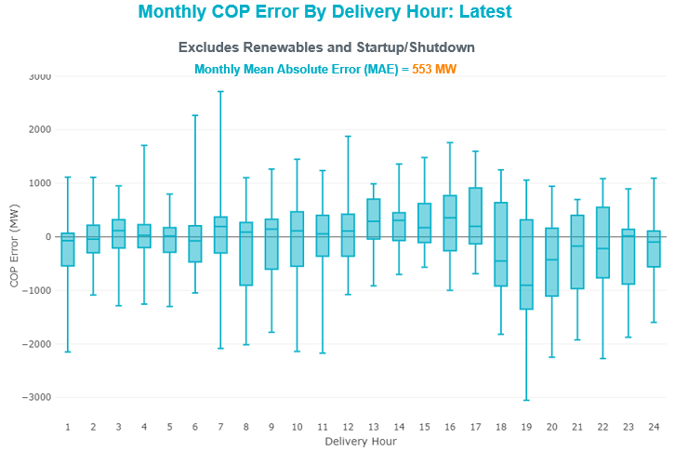
Monthly MAE for the Day-Ahead COP at 12:00 was 9,986 MW with median ranging from -13,543 MW for Hour-Ending (HE) 19 to -6,547 MW for HE 4. HE 23 on 12/31/2022 had the largest Over-Scheduling Error (4,713 MW) and HE 21 on 12/23/2022 had the largest Under-Scheduling Error (-25,031 MW).
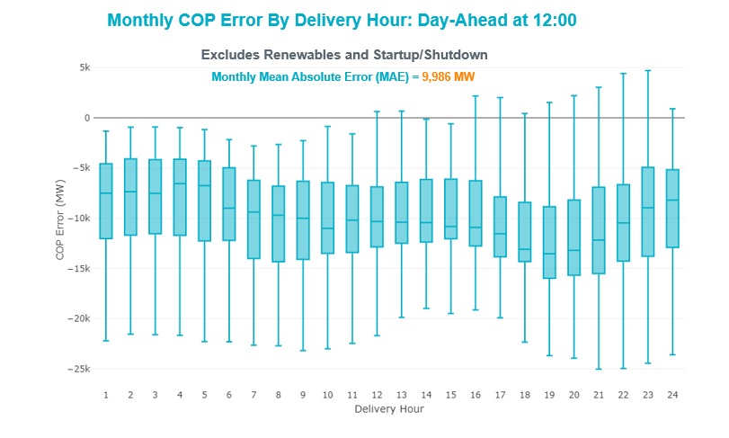

Congestion Analysis

Notable Constraints

Nodal protocol section 3.20 specifies that ERCOT shall identify transmission constraints that are binding in Real-Time three or more Operating Days within a calendar month. As part of this process, ERCOT reports congestion that meets this criterion to ROS. In addition, ERCOT also highlights notable constraints that have an estimated congestion rent exceeding $1,000 for a calendar month. These constraints are detailed in the table below, including approved transmission upgrades from TPIT that may provide some congestion relief based on ERCOT’s engineering judgement. Rows highlighted in blue indicate the congestion was affected by one or more outages. For a list of all constraints activated in SCED, please see Appendix A at the end of this report.

Contingency Name | Overloaded Element | Contingency Name | Overloaded Element | # of Days Constraint Binding | Congestion Rent | Transmission Project
DELMSAN5 | PAWNEE_SPRUCE_1 | Elmcreek-Sanmigl 345kV | Pawnee Switching Station - Calaveras 345kV | 8 | $21,394,155.11
SSKYSB28 | 15080__Z | SKYWEST to SPRABERRY SWITCH LIN 1 | Consavvy Switch - Cottonfield Sub 138kV | 2 | $17,487,381.47
SCONGDV8 | 1810__D | GRANDVIEW to LILLIAN LIN 1 | Midlothian Txi - Midlothian South 138kV | 2 | $13,215,217.68
SCRDJON5 | 1810__D | JOHNSON SWITCH (ONCOR) to CONCORD LIN G1 | Midlothian Txi - Midlothian South 138kV | 2 | $11,989,941.85
BASE CASE | WESTEX | Basecase | WESTEX GTC | 8 | $11,921,933.73
SSKYSB28 | 15080__B | SKYWEST to SPRABERRY SWITCH LIN 1 | Pronghorn - Cottonfield Sub 138kV | 2 | $10,817,426.72
BASE CASE | PNHNDL | Basecase | PNHNDL GTC | 8 | $10,369,500.81
MCOMPR28 | RYSSW_FMR2 | MANUAL COMSW-PRSSW 138&CRSSW-PRSSW 138 DBLCKT | Royse Switch 138kV | 4 | $9,465,053.17 | Commerce to Royse 69 kV to 138 kV Line Upgrade (57726, 20RPG023)
SBE2ASH8 | HAMILT_MAVERI1_1 | BEVO to ASHERTON LIN 1 | Hamilton Road - Maverick 138kV | 4 | $9,295,997.64
MRESMCM8 | RINCON_WHITE_2_1 | Manual for I_DUPS - RESNIK & MCCAMPBE 2 138KV | Whitepoint - Rincon 138kV | 3 | $8,421,100.13
SBWDDBM5 | LPLMK_LPLNE_1 | BLACKWATER DRAW SWITCH to DOUBLE MOUNTAIN SWITCH LIN 1 | Mackenzie Substation - Northeast Substation 115kV | 13 | $8,096,109.94
DMGSQAL5 | 6471__A | LNGSW TO MDSSW 345 AND MGSES TO QALSW 345 DBLCKT | Morgan Creek Ses - Forest Creek And Sand Bluff Wind Farms 138kV | 13 | $7,717,955.31
SETCENW8 | 1810__D | ENNIS WEST SWITCH to ENNIS TRACTEBEL LIN _A | Midlothian Txi - Midlothian South 138kV | 2 | $7,234,620.84
DCALBEC8 | J0_P0_1 | Calavers-Kirby&Beck_Rd 138kV | Harlanda - Southsan 138kV | 3 | $6,602,929.74
DMGSMDS5 | MDSSW_MR1L | Mgses-Qalsw&Odehv-Mdssw 345kV | Midessa South Sw 138kV | 6 | $6,504,710.84
SCRDJON5 | 915__E | JOHNSON SWITCH (ONCOR) to CONCORD LIN G1 | Decordova Dam - Carmichael Bend Switch 138kV | 1 | $6,009,394.78
SW_GODE5 | 15060__B | wett_grelton to ODESSA EHV SWITCH LIN 1 | Koch Tap - Vealmoor 138kV | 7 | $5,956,551.68
DBIGKEN5 | HAMILT_MAVERI1_1 | Bighil-Kendal 345kV | Hamilton Road - Maverick 138kV | 13 | $5,337,697.35
SN_SLON5 | CELANE_KLEBER1_1 | LON HILL to NELSON SHARPE LIN 1 | Celanese Bishop - Kleberg Aep 138kV | 9 | $4,960,944.31
XWHI58 | KOCH_H_LON_HI1_1 | WHITEPOINT TRX 345A 345/138 | Lon Hill - Koch Hearns Ferry 138kV | 3 | $4,945,194.06
SNATBEA8 | 6144__A | NATURAL DAM to BEALS CREEK SUB LIN _A | Big Spring West - Stanton East 138kV | 10 | $4,613,664.27
SWHILON5 | KOCH_H_LON_HI1_1 | LON HILL to WHITEPOINT LIN 1 | Lon Hill - Koch Hearns Ferry 138kV | 8 | $4,517,267.63
DMCNDES8 | CKT_909_1 | McNeil-Decker&Dessau 138kV | Mcneil Aen - Dessau 138kV | 1 | $4,188,991.13
SCMNCPS5 | 651__B | COMANCHE SWITCH (Oncor) to COMANCHE PEAK SES LIN _A | Comanche Tap - Comanche Switch (Oncor) 138kV | 9 | $4,061,652.12
SQALODE5 | CONSW_MR1H | ODESSA EHV SWITCH to QUAIL SWITCH LIN _A | Consavvy Switch 345kV | 2 | $3,781,121.42
SLOBSA25 | CATARI_PILONC1_1 | Fowlerton to LOBO 345 LIN1 | Catarina - Piloncillo 138kV | 10 | $3,759,117.99
DMGSBTR5 | 6036__A | MGSES TO CCRSW 345 AND BTRCK TO MGSES 345 DBLCKT | Tonkawa Switch - Morgan Creek Ses 345kV | 6 | $3,366,287.26
SLOBSA25 | LARDVN_LASCRU1_1 | Fowlerton to LOBO 345 LIN1 | Laredo Vft North - Las Cruces 138kV | 3 | $3,283,446.26 | Laredo VFT North to North Laredo Switch 138 kV Line Rebuild (58008)
DCHBJO25 | CTRPHR97_A | TWR(345) CHB-JOR97 & CBY-JOR99 | Center - Ph Robinson 345kV | 1 | $3,165,211.43
SMVRLA_8 | STEWAR_VERTRE1_1 | MVEC (RANGERVILLE) to LA PALMA LIN 1 | Stewart Road - Vertrees 138kV | 2 | $3,151,914.96
BASE CASE | BEARKT | Basecase | BEARKT GTC | 23 | $2,957,093.95
SCO2EUL8 | COLETO_ROSATA1_1 | COLETO CREEK to Euler LIN 1 | Coleto Creek - Rosata Tap 138kV | 2 | $2,703,644.07 | Coleto Creek to Rosata Tap 138 kV Line Rebuild (50870, 20RPG014)
DCRLLSW5 | 589_E_1 | CRLNW TO LWSSW 345 DBLCKT | Ti Tnp - South Tnp 138kV | 2 | $2,619,047.60
DTVWJON5 | 915__E | TVWSW TO CPSES 345 AND CPSES TO JONSW 345 DBLCKT | Decordova Dam - Carmichael Bend Switch 138kV | 1 | $2,549,316.39
DKENNO89 | COLETO_ROSATA1_1 | KENEDSW - TULETA (138) & PETTUS - NORMANNA (69) | Coleto Creek - Rosata Tap 138kV | 1 | $1,968,101.33 | Coleto Creek to Rosata Tap 138 kV Line Rebuild (50870, 20RPG014)
MKMPSAR8 | WILMR_FMR1 | MANUAL KMPSW-SARDIS 138 & SOPSW-CDHIL 138 DBLCKT | Wilmer 138kV | 1 | $1,802,420.00
SDIMBEV8 | CARVER_TINSLE1_1 | DIMMIT to BEVO LIN 1 | Carver - Tinsley Tap 138kV | 1 | $1,694,797.60
SWEILON8 | KOCH_H_LON_HI1_1 | WEIL TRACT to LON HILL LIN 1 | Lon Hill - Koch Hearns Ferry 138kV | 5 | $1,677,458.77
BASE CASE | NE_LOB | Basecase | NE_LOB GTC | 16 | $1,606,028.17 | The Lower Rio Grande Valley (LRGV) System Enhancement Project (21RPG017) will improve the NorthEd_Lobo GTC to support up to 80% of total wind and solar generation capacity in the LRGV area.
DZORHAY5 | BERGHE_AT1H | ZORN - HAYSEN 345KV | Bergheim 345kV | 2 | $1,605,117.35
SPAWCAL5 | COLETO_ROSATA1_1 | CALAVERAS to PAWNEE SWITCHING STATION LIN 1 | Coleto Creek - Rosata Tap 138kV | 1 | $1,605,032.43 | Coleto Creek to Rosata Tap 138 kV Line Rebuild (50870, 20RPG014)
MHARNED5 | BURNS_RIOHONDO_1 | Manual dbl ckt for NEDIN-BONILLA 345kV & RIOH-PRIM138kV | Burns Sub - Rio Hondo 138kV | 6 | $1,577,296.21
DELMSAN5 | COLETO_ROSATA1_1 | Elmcreek-Sanmigl 345kV | Coleto Creek - Rosata Tap 138kV | 1 | $1,493,579.31 | Coleto Creek to Rosata Tap 138 kV Line Rebuild (50870, 20RPG014)
DRNS_TB5 | THWZEN98_A | Rns-Rtw & Sng-Tb 345kV | Th Wharton - Zenith 345kV | 3 | $1,476,824.12
BASE CASE | VALEXP | Basecase | VALEXP GTC | 17 | $1,448,138.77
BASE CASE | HHGTOM_1 | Basecase | Omega - Horse Hollow Generation Tie 345kV | 5 | $1,355,354.04
DMOLLO58 | PAWNEE_TANGO1_1 | MOLINA - LOBO 138 & LOBO - CENIZO 345 | Pawnee Switching Station - Tango 345kV | 1 | $1,341,822.83
DCALBEC8 | F1_O9_1 | Calavers-Kirby&Beck_Rd 138kV | Stckdale - Sutherland Springs 138kV | 2 | $1,309,264.34
DTVWCPS5 | 6000__A | TVWSW TO CPSES 345 AND TVWSW TO CMBSW 345 DBLCKT | Benbrook Switch - Sycamore Creek 345kV | 1 | $1,228,204.05
SLGDSAP8 | HARGRO_TWINBU1_1 | SANTIAGO to LANGFORD WIND POWER LLC LIN 1 | Hargrove - Twin Buttes 138kV | 4 | $1,043,551.86
SKLEKLE8 | LOYOLA_69_1 | KLEBERG AEP to KLEBERG AEP LIN 1 | Loyola Sub 138kV | 8 | $1,038,573.23
XVI2C89 | VICTORIA_69A2 | VICTORIA TRX 69A1 138/69 | Victoria 138kV | 1 | $1,014,344.29
SI_DI_38 | I_DUPP_I_DUPS1_1 | DUPONT SWITCH - INGLESIDE to INGLESIDE COGEN SWITCH LIN 1 | Dupont Pp1 - Ingleside - Dupont Switch - Ingleside 138kV | 3 | $817,708.40
SBGLTWI8 | CONCHO_SANW0_1 | TWIN BUTTES to HARGROVE LIN 1 | San Angelo Concho - San Angelo Lake Nasworthy 69kV | 8 | $770,336.10
SLOBSA25 | BRUNI_69_1 | Fowlerton to LOBO 345 LIN1 | Bruni Sub 138kV | 5 | $657,884.32
DBIGKEN5 | HEXT_YELWJC1_1 | Bighil-Kendal 345kV | Yellow Jacket - Hext Lcra 69kV | 7 | $549,207.95
SGARBAT8 | 15010__B | CARTERVILLE to EINSTEIN LIN 1 | East Stiles - Blissard Sub 138kV | 4 | $423,186.17 | East Stiles to Blissard Sub 138 kV Line Rebuild (61516)
SMGIENW8 | TRU_UAT1 | ENNIS WEST SWITCH to WAXAHACHIE PUMP 1 LIN _C | Trumbull 138kV | 3 | $419,133.39
SWRDYN8 | EL_CAM_LANCTY1_1 | DYANN to CANEY LIN A | El Campo - Lane City Pump 138kV | 5 | $310,281.17
DBIGKEN5 | HEXT_MASONS1_1 | Bighil-Kendal 345kV | Mason Switching Station - Hext Lcra 69kV | 6 | $308,702.77
SCARFRI8 | ATSO_SONR1_1 | Carver to FRIEND RANCH LIN 1 | Atlantic Sonora - Sonora 69kV | 9 | $306,080.36
DWLDSCO5 | 15060__B | LONG DRAW-FARADAY& SCOSW 345kV | Koch Tap - Vealmoor 138kV | 6 | $288,594.58
DWLFMOS5 | 6485__B | WLFSW-MOSSW 345&WLFSW-ODEHV 345____TRPLCKT-1of3 | Red Lakes Switch - Penwell Pod 138kV | 3 | $269,841.41
DMGSLNG5 | 15010__B | MGSES TO QALSW 345 AND MGSES TO LNGSW 345 DBLCKT | East Stiles - Blissard Sub 138kV | 3 | $253,339.22 | East Stiles to Blissard Sub 138 kV Line Rebuild (61516)
SW_GW_L5 | 15060__B | wett_long_draw to wett_grelton LIN 1 | Koch Tap - Vealmoor 138kV | 3 | $251,141.74
SLGDSAP8 | ARROTT_CRIS1_1 | SANTIAGO to LANGFORD WIND POWER LLC LIN 1 | Arrott - Christoval 69kV | 4 | $232,264.33
DBCVPSA8 | HL_PSA08_A | TWR (138) BCV-CV03 & GBY-PSA03 | Highlands - Power Systems Arco Cogen 138kV | 5 | $222,476.41
BASE CASE | TRDWEL | Basecase | TRDWEL GTC | 17 | $197,013.48
SOXYING8 | I_DUPP_I_DUPS2_1 | INGLESIDE COGEN SWITCH to OXYCHEM INGLESIDE LIN 1 | Dupont Pp1 - Ingleside - Dupont Switch - Ingleside 138kV | 3 | $164,495.97
SFT_BAL8 | CONCHO_VRBS1_1 | OAK CREEK AEP to FORT CHADBOURNE TAP LIN 1 | San Angelo Concho - Veribest 69kV | 3 | $162,048.85
SWRDYN8 | LAN_CT_PAVLOV1_1 | DYANN to CANEY LIN A | Lane City - Pavlov 138kV | 5 | $138,003.02
SGARGA35 | GARFIELD_AT2 | GARFIELD LCRA to GARFIELD AEN LIN 1 | Garfield Aen 345kV | 3 | $135,642.99
DLONWEI8 | KOCH_H_LON_HI1_1 | LON_HILL - BUNSEN & WEIL_TRC 138 KV | Lon Hill - Koch Hearns Ferry 138kV | 5 | $130,556.82
SN_SLON5 | KINGSV_KLEBER1_1 | LON HILL to NELSON SHARPE LIN 1 | Kingsville - Kleberg Aep 138kV | 4 | $122,368.04
SHEAKAT9 | HEXT_YELWJC1_1 | Heartland to KATEMCY LIN 1 | Yellow Jacket - Hext Lcra 69kV | 3 | $121,235.71
DSTEDES8 | TRU_UAT1 | STERT TO SARDIS 138 AND STERT AND DESSW 138 DBLCKT | Trumbull 138kV | 3 | $52,305.99
SLAQLOB8 | BRUNI_69_1 | LAQUINTA to LOBO LIN 1 | Bruni Sub 138kV | 4 | $46,279.45
XBLE58 | SAR_FRAN_1 | BLESSING TRX 1382 345/138 | Sargent Sub - Franklins Camp Sub 69kV | 3 | $44,513.41
DBIGKEN5 | TREADW_YELWJC1_1 | Bighil-Kendal 345kV | Yellow Jacket - Treadwell 138kV | 4 | $36,793.13
SCREBRU8 | BRUNI_69_1 | BRUNI to CRESTONIO LIN 1 | Bruni Sub 138kV | 3 | $22,181.84
SSPUASP8 | GIRA_T_SPUR1_1 | ASPERMONT AEP to SPUR LIN 1 | Girard Tap - Spur 69kV | 3 | $15,114.17
SLOBSA25 | ASHERT_CATARI1_1 | Fowlerton to LOBO 345 LIN1 | Asherton - Catarina 138kV | 3 | $11,623.14
SES2FRI8 | MIDW_OZONA1_1 | Esmeralda to FRIEND RANCH LIN 1 | Midway Lane - Ozona 69kV | 3 | $10,060.18 | Bison to Ozona 69 kV Line Rebuild (55470)
MHARNED5 | HAINE__LA_PAL1_1 | Manual dbl ckt for NEDIN-BONILLA 345kV & RIOH-PRIM138kV | Haine Drive - La Palma 138kV | 3 | $6,870.02
SILLFTL8 | CARVER_TINSLE1_1 | FORT LANCASTER to ILLINOIS #4 LIN 1 | Carver - Tinsley Tap 138kV | 3 | $6,428.95
SLYNRIO8 | SOLSTICE_PST1 | Lynx to RIO PECOS LIN 1 | Solstice 138kV | 4 | $4,160.83

Generic Transmission Constraint Congestion
There were 17 days of congestion on the North Edinburg to Lobo GTC, 15 days on the West Texas Export GTC, 11 days on the Panhandle GTC, 19 days on the Treadwell GTC, 2 days on the Nelson Sharpe to Rio Hondo GTC, 1 day on the North to Houston GTC, 20 days on the Valley Export GTC, 4 days on the McCamey GTC, and 1 day on the Wharton GTC. There was no activity on the remaining GTCs during the month.

Note: This is how many times a constraint has been activated to avoid exceeding a GTC limit, it does not imply an exceedance of the GTC occurred or that the GTC was binding.

Manual Overrides
None

Congestion Costs for Calendar Year 2022
The following table represents the top twenty active constraints for the calendar year based on the estimated congestion rent attributed to the congestion. ERCOT updates this list on a monthly basis.

Contingency | Overloaded Element | # of 5-min SCED | Estimated | Transmission Project
Basecase | WESTEX GTC | 24639 | $304,163,812.26
Toksw-Gibcrk & Jk_Ck 345kV | Jewett - Singleton 345kV | 9281 | $164,069,608.80
Basecase | NE_LOB GTC | 37087 | $115,415,826.62 | The Lower Rio Grande Valley (LRGV) System Enhancement Project (21RPG017) will improve the NorthEd_LoboGTC to support up to 80% of total wind and solar generation capacity in the LRGV area.
Elmcreek-Sanmigl 345kV | Pawnee Switching Station - Calaveras 345kV | 8656 | $96,774,982.52
SALSW TO KLNSW 345 DBLCKT | Killeen Switch 345kV | 10779 | $92,294,055.67
Basecase | PNHNDL GTC | 19411 | $76,799,896.63
Basecase | N_TO_H GTC | 10992 | $76,776,945.72
Manual dbl ckt for NEDIN-BONILLA 345kV & RIOH-PRIM138kV | Burns Sub - Rio Hondo 138kV | 18932 | $66,137,744.18
TWR(345) JCK-REF27 & JCK-STP18 | Hillje - South Texas Project 345kV | 6637 | $62,964,035.25
PH ROBINSON to MEADOW LIN A | Magnolia Tnp - Seminole Tnp 138kV | 16693 | $55,733,804.60 | Magnolia to Seminole 138 kV Line Rebuild (4010)
WA PARISH to OBRIEN LIN A | Wa Parish - Obrien 345kV | 1485 | $48,095,593.23
MAN_SGL_ MDL-FLC_345_kV_w_MDL_XMFR1_FLC_AMR2 | Midland County Northwest Switch - Mockingbird 138kV | 4260 | $39,903,573.59 | Oncor Midland Area Project (57925, 21RPG003) - NOTE: This project removes the overloaded element and reconfigures lines in the area, amongst other topology changes.
BLACKWATER DRAW SWITCH to DOUBLE MOUNTAIN SWITCH LIN 1 | Mackenzie Substation - Northeast Substation 115kV | 7160 | $38,764,329.15
Fowlerton to LOBO 345 LIN1 | Laredo Vft North - Las Cruces 138kV | 10419 | $33,354,440.46 | Laredo VFT North to North Laredo Switch 138 kV Line Rebuild (58008)
OASIS to MEADOW LIN A | Grant - Plaza 138kV | 3745 | $32,866,665.55 | Plaza to Grant 138 kV Line Rebuild (70660)
Basecase | NELRIO GTC | 28134 | $32,662,722.65 | The Lower Rio Grande Valley (LRGV) System Enhancement Project (21RPG017) will cause there to be no stability constraint for NelsonSharpe_RioHondoGTC under normal conditions.
Fowlerton to LOBO 345 LIN1 | Catarina - Piloncillo 138kV | 11343 | $31,139,356.01
WDGSW TO MARSW 138 DBLCKT | Mistletoe Heights - Hemphill 138kV | 2078 | $30,437,608.94
COMANCHE SWITCH (Oncor) to COMANCHE PEAK SES LIN _A | Comanche Tap - Comanche Switch (Oncor) 138kV | 13487 | $29,256,975.09
STP SWITCH to Esperanza LIN 1 | Blessing - Pavlov 138kV | 7457 | $28,859,506.14

System Events

ERCOT Peak Load
The unofficial ERCOT peak load for the month was 74,427 MW and occurred on 12/23/2022, during hour ending 08:00.

Load Shed Events
None.

Stability Events
None.

Notable PMU Events
ERCOT analyzes PMU data for any significant system disturbances that do not fall into the Frequency Events category reported in section 2.1. The results are summarized in this section once the analysis has been completed.

There were no PMU events outside of those reported in section 2.1.

DC Tie Curtailment
There was one DC tie curtailment

Date | DC Tie | Curtailing Period | # of Tags Curtailed | Initiating Event | Curtailment Reason
12/25/2022 | DC_L | HE 8 – HE 9 | 3 | Forced Outage | Planned or Unplanned Outage

TRE/DOE Reportable Events
- Oncor submitted an EOP-004-4 for 12/17/2022. Reportable Event Type: Suspicious activity to its facility.
- BPUB submitted an OE-417 for 12/23/2022. Reportable Event Type: Suspicious activity to its facility.

New/Updated Constraint Management Plans
There was one new CMPs: MP_2022_12

There was one modified CMP: MP_2021_02

New/Modified/Removed RAS
BEARKAT RAS modification proposal was not approved in November and resulted in a retire on 12/01.

New Procedures/Forms/Operating Bulletins
Date | Subject | Bulletin No.
12/29/2022 | DC Tie V1 Rev 72 | 1064
12/29/2022 | Real Time Desk V1 Rev 85 | 1065
12/29/2022 | Reliability Risk Desk Operating Procedure V1 Rev 30 | 1066
12/29/2022 | Reliability Unit Commitment V1 Rev 72 | 1067
12/29/2022 | Resource Desk V1 Rev 74 | 1068
12/29/2022 | Scripts V1 Rev 43, Scripts V1 Rev 44 | 1069
12/29/2022 | Shift Supervisor Desk V1 Rev 82 | 1070
12/29/2022 | Transmission and Security Desk V1 Rev 98 | 1071

Emergency Conditions

OCNs
Date and Time | Message
Dec 14, 2022 07:44 CPT | OCN issued for the WESTEX IROL due to taking manual action for a topology change.
Dec 16, 2022 09:00 CPT | OCN issued for the predicted extreme cold weather event for the ERCOT Region Thursday morning, December 22, 2022 through Monday, December 26, 2022.

Advisories
Date and Time | Message
Dec 12, 2022 13:30 CPT | ERCOT has postponed the deadline for the posting of the DAM solution for Operating Day 12/13/2022 due to a long running solution.
Dec 19, 2022 13:30 CPT | Advisory issued for the predicted extreme cold weather event for the ERCOT Region Thursday morning, December 22, 2022 through Monday, December 26, 2022.

Watches
Date and Time | Message
Dec 21, 2022 10:00 CPT | Watch issued for the predicted extreme cold weather event for the ERCOT Region Thursday morning, December 22, 2022 through Monday, December 26, 2022.

Emergency Notices
None.

Application Performance

TSAT/VSAT Performance Issues
None.

Communication Issues
None.

Market System Issues
None.

Model Updates
The Downstream Production Change (DPC) process allows ERCOT to make changes in the on-line Network Operations Model without loading a completely new model. The purpose of this process is to allow for reliable grid operations as system conditions change between designated Network Operations Model database loads. The DPC process is limited in scope to just those items listed below, with equipment ratings updates being the most common. ERCOT has seen a rise in the use of the DPC process to make on-line updates to the Network Operations Model in recent years, instead of through the standard Network Operations Model Change Request process.

- Static Line ratings (Interim Update)
- Dynamic Line ratings (non-Interim Update)
- Autotransformer ratings (non-Interim Update)
- Breaker and Switch Normal status (Interim Update)
- Contingency Definitions (Interim Update)
- RAP and RAS changes or additions (Interim Update)
- Net Dependable and Reactive Capability (NDCRC) values (Interim Update)
- Impedance Updates (non-Interim)

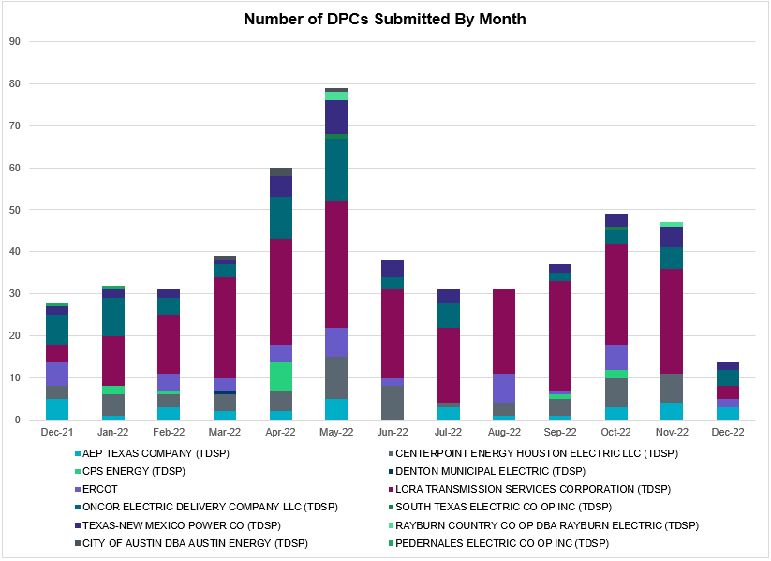

Transmission Operator | Number of DPCs
AEP TEXAS COMPANY (TDSP) | 3
BRAZOS ELECTRIC POWER CO OP INC (TDSP) | 0
BROWNSVILLE PUBLIC UTILITIES BOARD (TDSP) | 0
BRYAN TEXAS UTILITIES (TDSP) | 0
CENTERPOINT ENERGY HOUSTON ELECTRIC LLC (TDSP) | 0
CITY OF AUSTIN DBA AUSTIN ENERGY (TDSP) | 0
CITY OF COLLEGE STATION (TDSP) | 0
CITY OF GARLAND (TDSP) | 0
CPS ENERGY (TDSP) | 0
DENTON MUNICIPAL ELECTRIC (TDSP) | 0
ELECTRIC TRANSMISSION TEXAS LLC (TDSP) | 0
ERCOT | 2
LCRA TRANSMISSION SERVICES CORPORATION (TDSP) | 3
LONE STAR TRANSMISSION LLC (TSP) | 0
ONCOR ELECTRIC DELIVERY COMPANY LLC (TDSP) | 4
PEDERNALES ELECTRIC CO OP INC (TDSP) | 0
RAYBURN COUNTRY CO OP DBA RAYBURN ELECTRIC (TDSP) | 0
SHARYLAND UTILITIES LP (TDSP) | 0
SOUTH TEXAS ELECTRIC CO OP INC (TDSP) | 0
TEXAS MUNICIPAL POWER AGENCY (TDSP) | 0
TEXAS-NEW MEXICO POWER CO (TDSP) | 2

Appendix A: Real-Time Constraints
The following is a complete list of constraints activated in SCED. Full contingency descriptions can be found in the Standard Contingencies List located on the MIS secure site at Grid Generation Reliability Unit Commitment.
Year | Month of the Year | Contingency Name | Overloaded Element | From Station | To Station | Count of Days
2022 | 12 | BASE CASE | BEARKT | n/a | n/a | 25
2022 | 12 | BASE CASE | VALEXP | n/a | n/a | 20
2022 | 12 | BASE CASE | TRDWEL | n/a | n/a | 19
2022 | 12 | BASE CASE | NE_LOB | n/a | n/a | 16
2022 | 12 | SBWDDBM5 | LPLMK_LPLNE_1 | LPLMK | LPLNE | 15
2022 | 12 | BASE CASE | WESTEX | n/a | n/a | 14
2022 | 12 | DBIGKEN5 | HAMILT_MAVERI1_1 | HAMILTON | MAVERICK | 13
2022 | 12 | DMGSQAL5 | 6471__A | MGSES | MCDLD | 13
2022 | 12 | SLOBSA25 | CATARI_PILONC1_1 | PILONCIL | CATARINA | 11
2022 | 12 | BASE CASE | PNHNDL | n/a | n/a | 11
2022 | 12 | SCMNCPS5 | 651__B | CMNSW | CMNTP | 10
2022 | 12 | DBIGKEN5 | HEXT_MASONS1_1 | HEXT | MASONSW | 10
2022 | 12 | SCARFRI8 | ATSO_SONR1_1 | SONR | ATSO | 10
2022 | 12 | SNATBEA8 | 6144__A | BSPRW | STASW | 10
2022 | 12 | SN_SLON5 | CELANE_KLEBER1_1 | CELANEBI | KLEBERG | 10
2022 | 12 | DBIGKEN5 | HEXT_MASONS1_1 | MASONSW | HEXT | 10
2022 | 12 | DBIGKEN5 | HEXT_YELWJC1_1 | YELWJCKT | HEXT | 9
2022 | 12 | DLONWEI8 | KOCH_H_LON_HI1_1 | LON_HILL | KOCH_HF | 9
2022 | 12 | SKLEKLE8 | LOYOLA_69_1 | LOYOLA | LOYOLA | 9
2022 | 12 | SLOBSA25 | ASHERT_CATARI1_1 | CATARINA | ASHERTON | 9
2022 | 12 | SLOBSA25 | ASHERT_CATARI1_1 | ASHERTON | CATARINA | 9
2022 | 12 | SWHILON5 | KOCH_H_LON_HI1_1 | LON_HILL | KOCH_HF | 9
2022 | 12 | DELMSAN5 | PAWNEE_SPRUCE_1 | PAWNEE | CALAVERS | 9
2022 | 12 | DWLDSCO5 | 15060__B | VEALMOOR | KOCHTAP | 9
2022 | 12 | SBGLTWI8 | CONCHO_SANW0_1 | CONCHO | SANW | 9
2022 | 12 | SWEILON8 | KOCH_H_LON_HI1_1 | LON_HILL | KOCH_HF | 9
2022 | 12 | SGARBAT8 | 15010__B | BLISS | ESTILES | 8
2022 | 12 | DMGSMDS5 | MDSSW_MR1L | MDSSW | MDSSW | 8
2022 | 12 | SLOBSA25 | LARDVN_LASCRU1_1 | LARDVNTH | LASCRUCE | 7
2022 | 12 | DMGSBTR5 | 6036__A | TKWSW | MGSES | 7
2022 | 12 | SW_GODE5 | 15060__B | VEALMOOR | KOCHTAP | 7
2022 | 12 | DMGSBIT5 | 6036__A | TKWSW | MGSES | 6
2022 | 12 | MHARNED5 | BURNS_RIOHONDO_1 | RIOHONDO | MV_BURNS | 6
2022 | 12 | BASE CASE | HHGTOM_1 | HHGT | OMEGA | 6
2022 | 12 | XBLE58 | SAR_FRAN_1 | FRANKC | SARGNTS | 6
2022 | 12 | SLYNRIO8 | SOLSTICE_PST1 | SOLSTICE | SOLSTICE | 6
2022 | 12 | SILLFTL8 | CARVER_TINSLE1_1 | TINSLEY | CARVER | 6
2022 | 12 | DBCVPSA8 | HL_PSA08_A | PSA | HL | 6
2022 | 12 | SILLFTL8 | CARVER_TINSLE1_1 | CARVER | TINSLEY | 6
2022 | 12 | SWRDYN8 | EL_CAM_LANCTY1_1 | LANCTYPM | EL_CAMPO | 5
2022 | 12 | SOXYING8 | I_DUPP_I_DUPS2_1 | I_DUPP1 | I_DUPSW | 5
2022 | 12 | SWRDYN8 | LAN_CT_PAVLOV1_1 | LAN_CTY | PAVLOV | 5
2022 | 12 | SLOBSA25 | BRUNI_69_1 | BRUNI | BRUNI | 5
2022 | 12 | SHEAKAT9 | HEXT_MASONS1_1 | MASONSW | HEXT | 5
2022 | 12 | SN_SLON5 | KINGSV_KLEBER1_1 | KLEBERG | KINGSVIL | 5
2022 | 12 | SLGDSAP8 | HARGRO_TWINBU1_1 | TWINBU | HARGROVE | 5
2022 | 12 | DCPSST58 | 651__B | CMNSW | CMNTP | 5
2022 | 12 | SLAQLOB8 | BRUNI_69_1 | BRUNI | BRUNI | 5
2022 | 12 | SN_SLON5 | CELANE_N_SHAR1_1 | N_SHARPE | CELANEBI | 5
2022 | 12 | SSPUASP8 | GIRA_T_SPUR1_1 | GIRA_TAP | SPUR | 4
2022 | 12 | DWHILON5 | KOCH_H_LON_HI1_1 | LON_HILL | KOCH_HF | 4
2022 | 12 | SHEAKAT9 | HEXT_YELWJC1_1 | HEXT | YELWJCKT | 4
2022 | 12 | DWISALV8 | MYRA_VAL_1 | MYRA | VALYVIEW | 4
2022 | 12 | DBIGKEN5 | TREADW_YELWJC1_1 | TREADWEL | YELWJCKT | 4
2022 | 12 | SSPUASP8 | GIRA_T_SPUR1_1 | SPUR | GIRA_TAP | 4
2022 | 12 | XEIN58 | 6471__A | MGSES | MCDLD | 4
2022 | 12 | SLGDSAP8 | ARROTT_CRIS1_1 | CRIS | ARROTT | 4
2022 | 12 | SGRICOL5 | PAWNEE_TANGO1_1 | TANGO | PAWNEE | 4
2022 | 12 | SLGDSAP8 | ARROTT_CRIS1_1 | ARROTT | CRIS | 4
2022 | 12 | SBE2ASH8 | HAMILT_MAVERI1_1 | HAMILTON | MAVERICK | 4
2022 | 12 | SBE2ASH8 | HAMILT_MAVERI1_1 | MAVERICK | HAMILTON | 4
2022 | 12 | SCT2CAR8 | HAMILT_MAVERI1_1 | HAMILTON | MAVERICK | 4
2022 | 12 | BASE CASE | MCCAMY | n/a | n/a | 4
2022 | 12 | DRNS_TB5 | THWZEN98_A | ZEN | THW | 4
2022 | 12 | DMGSLNG5 | 6471__A | MGSES | MCDLD | 4
2022 | 12 | SBTPBNT8 | MYRA_VAL_1 | MYRA | VALYVIEW | 4
2022 | 12 | DBIGKEN5 | ESCOND_GANSO1_1 | GANSO | ESCONDID | 4
2022 | 12 | MCOMPR28 | RYSSW_FMR2 | RYSSW | RYSSW | 4
2022 | 12 | DGRMGRS8 | 6830__B | CRDSW | OLNEY | 3
2022 | 12 | SMGIENW8 | TRU_UAT1 | TRU | TRU | 3
2022 | 12 | SBIGTWI5 | TREADW_YELWJC1_1 | TREADWEL | YELWJCKT | 3
2022 | 12 | DSWECCR5 | 6036__A | TKWSW | MGSES | 3
2022 | 12 | BASE CASE | ESKSW_STRENT_1 | ESKSW | STWF | 3
2022 | 12 | SES2FRI8 | MIDW_OZONA1_1 | OZONA | MIDW | 3
2022 | 12 | DCALBEC8 | J0_P0_1 | P0 | J0 | 3
2022 | 12 | MRESMCM8 | RINCON_WHITE_2_1 | WHITE_PT | RINCON | 3
2022 | 12 | DWLFMOS5 | 6480__D | ECTHP | RLKSW | 3
2022 | 12 | SFT_BAL8 | CONCHO_VRBS1_1 | CONCHO | VRBS | 3
2022 | 12 | BASE CASE | ESKSW_STRENT_1 | STWF | ESKSW | 3
2022 | 12 | SW_SDIV5 | CRTVLE_EINSTEN_1 | EINSTEIN | CRTRVLLE | 3
2022 | 12 | MHARNED5 | HAINE__LA_PAL1_1 | LA_PALMA | HAINE_DR | 3
2022 | 12 | SI_DI_38 | I_DUPP_I_DUPS1_1 | I_DUPP1 | I_DUPSW | 3
2022 | 12 | SBWDDBM5 | LPLNW_LPLMD_1 | LPLNW | LPLMD | 3
2022 | 12 | DMGSLNG5 | 15010__B | BLISS | ESTILES | 3
2022 | 12 | SBIGTWI5 | CAMPWO_NEWBAR1_1 | CAMPWOOD | NEWBARKS | 3
2022 | 12 | SCRNJFS8 | JFSSC_06_A | JFS | SC | 3
2022 | 12 | DBIGKEN5 | GANSO_MAVERI1_1 | GANSO | MAVERICK | 3
2022 | 12 | MFLCMGS5 | MGSES_MR1H | MGSES | MGSES | 3
2022 | 12 | DMGSQAL5 | 14040__A | PCTSW | DEWTP | 3
2022 | 12 | SW_GW_L5 | 15060__B | VEALMOOR | KOCHTAP | 3
2022 | 12 | DWLFMOS5 | 6485__B | RLKSW | PWPOD | 3
2022 | 12 | SMDOPHR5 | G138_10B_1 | SEMINOLE | MAGNO_TN | 3
2022 | 12 | SGARGA35 | GARFIELD_AT2 | GARFIELD | GARFIELD | 3
2022 | 12 | XWHI58 | KOCH_H_LON_HI1_1 | LON_HILL | KOCH_HF | 3
2022 | 12 | DSTEDES8 | TRU_UAT1 | TRU | TRU | 3
2022 | 12 | SCREBRU8 | BRUNI_69_1 | BRUNI | BRUNI | 3
2022 | 12 | SBUNLON8 | CALALS_LON_HI1_1 | LON_HILL | CALALS | 2
2022 | 12 | SCO2EUL8 | COLETO_ROSATA1_1 | COLETO | ROSATA | 2
2022 | 12 | DSTEXP12 | COLETO_VICTOR2_1 | COLETO | VICTORIA | 2
2022 | 12 | DWHILON5 | COLETO_VICTOR2_1 | COLETO | VICTORIA | 2
2022 | 12 | MBOGTID8 | CO_PL_84_A | PL | CO | 2
2022 | 12 | SJUNYEL9 | HEXT_YELWJC1_1 | YELWJCKT | HEXT | 2
2022 | 12 | SMADSAP8 | MADDUX_SAPOWE2_1 | MADDUX | SAPOWER | 2
2022 | 12 | SBE2ASH8 | TURTLECK_WCRYS_1 | TURTLCRK | WCRYSTS | 2
2022 | 12 | DMGSQAL5 | 15010__B | BLISS | ESTILES | 2
2022 | 12 | SCONGDV8 | 1810__D | MDTXI | MDTHS | 2
2022 | 12 | MWIRJO28 | 33T218_1 | WIRTZ | BURNET | 2
2022 | 12 | DCHBJO25 | CTRPHR97_A | CTR | PHR | 2
2022 | 12 | SEBHUG8 | EL_CAM_LANCTY1_1 | LANCTYPM | EL_CAMPO | 2
2022 | 12 | DHARSOM8 | KARNES_KENEDS1_1 | KENEDSW | KARNESCI | 2
2022 | 12 | SMDSODE5 | MDSSW_MR1L | MDSSW | MDSSW | 2
2022 | 12 | DVICDUP8 | NCARBI_PV_TAP1_1 | NCARBIDE | PV_TAP | 2
2022 | 12 | DMCOPHA8 | NEDIN_SERDEV1_1 | NEDIN | NEDIN | 2
2022 | 12 | DMOLLO58 | NEDIN_SERDEV1_1 | NEDIN | NEDIN | 2
2022 | 12 | SCENLOB5 | NEDIN_SERDEV1_1 | NEDIN | NEDIN | 2
2022 | 12 | SMVRLA_8 | STEWAR_VERTRE1_1 | STEWART | VERTREES | 2
2022 | 12 | SLCRCRA8 | 15080__B | CTFLD | PRONGHRN | 2
2022 | 12 | DFERGRM8 | 33T218_1 | WIRTZ | BURNET | 2
2022 | 12 | DHENZOR8 | 85T329_1 | BERGHE | DEVIHI | 2
2022 | 12 | DFRIILL8 | CARVER_TINSLE1_1 | CARVER | TINSLEY | 2
2022 | 12 | SW_SBRN5 | CRTVLE_EINSTEN_1 | EINSTEIN | CRTRVLLE | 2
2022 | 12 | SCREFAL8 | FRE_BRUN_1 | BRUNI | FREERS | 2
2022 | 12 | DCAGCI58 | 255T279_1 | PIPECR | MEDILA | 2
2022 | 12 | SKOCBUZ8 | 6137__C | GUNSW | HWPOD | 2
2022 | 12 | SVEAW_L5 | 6217__A | WLVSW | GAILS | 2
2022 | 12 | SSCJFS8 | CRNJFS94_A | JFS | CRN | 2
2022 | 12 | DCALBEC8 | F1_O9_1 | F1 | SUTHRLND | 2
2022 | 12 | BASE CASE | HAMILT_MAVERI1_1 | HAMILTON | MAVERICK | 2
2022 | 12 | SWHILON5 | NUECES_WHITE_2_1 | NUECES_B | WHITE_PT | 2
2022 | 12 | SCRTEIL8 | 15010__B | BLISS | ESTILES | 2
2022 | 12 | STVWCRT5 | 6200__D | SHRSW | PRKRW | 2
2022 | 12 | DZORHAY5 | BERGHE_AT1H | BERGHE | BERGHE | 2
2022 | 12 | SOAKNIC8 | CONCHO_VRBS1_1 | CONCHO | VRBS | 2
2022 | 12 | SJUNYEL9 | HEXT_MASONS1_1 | HEXT | MASONSW | 2
2022 | 12 | DKG_NB_5 | JFSSC_06_A | JFS | SC | 2
2022 | 12 | SMCEABS8 | MKLT_TRNT1_1 | TRNT | MKLT | 2
2022 | 12 | SN_SLON5 | N_SHARPE_PS3 | N_SHARPE | N_SHARPE | 2
2022 | 12 | DWLDSCO5 | 15060__A | KOCHTAP | BUZSW | 2
2022 | 12 | SSKYSB28 | 15080__Z | CONSW | CTFLD | 2
2022 | 12 | DCRLLSW5 | 589_E_1 | LWVTI | LWSVS | 2
2022 | 12 | BASE CASE | 6064__A | TRENT | ESKSW | 2
2022 | 12 | SKOCBUZ8 | 6217__A | WLVSW | GAILS | 2
2022 | 12 | SASPPAI8 | ASPM_69T2 | ASPM | ASPM | 2
2022 | 12 | DZORHAY5 | BERGHE_AT1L | BERGHE | BERGHE | 2
2022 | 12 | DBIGKEN5 | BONDRO_SONR1_1 | SONR | BONDROAD | 2
2022 | 12 | DLONOR58 | CALALS_LON_HI1_1 | LON_HILL | CALALS | 2
2022 | 12 | SCE2CEL8 | CALALS_LON_HI1_1 | LON_HILL | CALALS | 2
2022 | 12 | SBLESTP5 | COLETO_VICTOR2_1 | COLETO | VICTORIA | 2
2022 | 12 | SHEAKAT9 | MASNPH_MASN1_1 | MASN | MASNPHT | 2
2022 | 12 | BASE CASE | NELRIO | n/a | n/a | 2
2022 | 12 | DRYSTR18 | RYSSW_FMR2 | RYSSW | RYSSW | 2
2022 | 12 | DSCOTKW5 | 15060__B | VEALMOOR | KOCHTAP | 2
2022 | 12 | SSKYSB28 | 15081__Z | CONSW | SMIDLAND | 2
2022 | 12 | SETCENW8 | 1810__D | MDTXI | MDTHS | 2
2022 | 12 | DLWSRNK5 | 584__A | KRMSW | ARGYL | 2
2022 | 12 | DCRLLSW5 | 589_C_1 | LWSVS | CRLNW | 2
2022 | 12 | DCAGCO58 | 656T656_1 | KENDAL | BERGHE | 2
2022 | 12 | DKENNO89 | COLETO_ROSATA1_1 | COLETO | ROSATA | 2
2022 | 12 | SFTLMES8 | CONCHO_SANW0_1 | CONCHO | SANW | 2
2022 | 12 | SCRMSAR8 | CONCHO_VRBS1_1 | CONCHO | VRBS | 2
2022 | 12 | SCOLPAW5 | KARNES_KENEDS1_1 | KENEDSW | KARNESCI | 2
2022 | 12 | SN_SAJO5 | LASPUL_RAYMND1_1 | LASPULGA | RAYMND2 | 2
2022 | 12 | SCOMHA38 | MAXWEL_WHITIN1_1 | MAXWELL | WHITING | 2
2022 | 12 | DSNG_TB5 | THWZEN98_A | ZEN | THW | 2
2022 | 12 | SLCRCRA8 | 15080__Z | CONSW | CTFLD | 2
2022 | 12 | SCRDJON5 | 1810__D | MDTXI | MDTHS | 2
2022 | 12 | DMGSLNG5 | 6095__D | LMESA | JPPOI | 2
2022 | 12 | SCMNCPS5 | 651__C | CMNTP | SHILO | 2
2022 | 12 | SBOEKEN8 | BERGHE_AT1L | BERGHE | BERGHE | 2
2022 | 12 | SWHILON5 | COLETO_VICTOR2_1 | COLETO | VICTORIA | 2
2022 | 12 | SQALODE5 | CONSW_MR1H | CONSW | CONSW | 2
2022 | 12 | SOAKOAK8 | CRMW5T_STER1_1 | CRMW5TP | STER | 2
2022 | 12 | SBIGTWI5 | GANSO_MAVERI1_1 | GANSO | MAVERICK | 2
2022 | 12 | DCS_CHS8 | JFSSC_06_A | JFS | SC | 2
2022 | 12 | MMDSQAL5 | MDSSW_MR1L | MDSSW | MDSSW | 2
2022 | 12 | XFL2C58 | MGSES_MR1H | MGSES | MGSES | 2
2022 | 12 | DBAKSOL5 | NEVILL_NORTMC_1 | NEVILLSW | NORTMC | 2
2022 | 12 | DMOLLO58 | PAWNEE_TANGO1_1 | TANGO | PAWNEE | 2
2022 | 12 | SJMCW_D8 | WD_RDWELLS_1 | W_DENT | RDWELLS | 2
2022 | 12 | SSKYSB28 | 15080__B | CTFLD | PRONGHRN | 2
2022 | 12 | SSAMTH35 | 506__A | SAMSW | FBRSW | 1
2022 | 12 | SW_GODE5 | 6095__D | LMESA | JPPOI | 1
2022 | 12 | DSCOFAR5 | 6216__B | WLVSW | SHRNE | 1
2022 | 12 | MMDSQAL5 | 6471__A | MGSES | MCDLD | 1
2022 | 12 | SWRDYN8 | BLESSI_PAVLOV1_1 | PAVLOV | BLESSING | 1
2022 | 12 | DSWELNC5 | BLUF_C_MULBER1_1 | BLUF_CRK | MULBERRY | 1
2022 | 12 | DCC1DUKE | BURNS_RIOHONDO_1 | RIOHONDO | MV_BURNS | 1
2022 | 12 | SNEDSTE5 | BURNS_RIOHONDO_1 | RIOHONDO | MV_BURNS | 1
2022 | 12 | SNICORN8 | CEDRHI_SILT1_1 | CEDRHILL | SILT | 1
2022 | 12 | SBIGTWI5 | ESCOND_GANSO1_1 | GANSO | ESCONDID | 1
2022 | 12 | SSCJFS8 | GP_NM_94_A | GP | NM | 1
2022 | 12 | SFORYEL8 | HEXT_MASONS1_1 | MASONSW | HEXT | 1
2022 | 12 | SWRDYN8 | LANCTY_LAN_CT1_1 | LAN_CTY | LANCTYPM | 1
2022 | 12 | SEBHUG8 | LAN_CT_PAVLOV1_1 | LAN_CTY | PAVLOV | 1
2022 | 12 | SKLELOY8 | LOYOLA_69_1 | LOYOLA | LOYOLA | 1
2022 | 12 | DBIGKEN5 | MADDUX_TREADW1_1 | MADDUX | TREADWEL | 1
2022 | 12 | SFORYEL8 | MASNPH_MASN1_1 | MASN | MASNPHT | 1
2022 | 12 | BASE CASE | NEDIN_SERDEV1_1 | NEDIN | NEDIN | 1
2022 | 12 | SMATBEE9 | NORMAN_PETTUS1_1 | PETTUS | NORMANNA | 1
2022 | 12 | SALIKIN8 | ORNGROV_69_1 | ORNGROV | ORNGROV | 1
2022 | 12 | SGEOORN8 | ORNGROV_69_1 | ORNGROV | ORNGROV | 1
2022 | 12 | SW_GW_L5 | 15060__A | KOCHTAP | BUZSW | 1
2022 | 12 | SSHKCRI8 | 1810__D | MDTXI | MDTHS | 1
2022 | 12 | SSTWESK8 | 6064__A | TRENT | ESKSW | 1
2022 | 12 | SQALODE5 | 6471__A | MGSES | MCDLD | 1
2022 | 12 | SSWDMGS8 | 6780__A | LONGWRTH | ESKSW | 1
2022 | 12 | DCC3_NED | ASHERT_CATARI1_1 | ASHERTON | CATARINA | 1
2022 | 12 | SDIMBEV8 | HAMILT_MAVERI1_1 | HAMILTON | MAVERICK | 1
2022 | 12 | DBECKIR8 | J0_P0_1 | P0 | J0 | 1
2022 | 12 | BASE CASE | MERK_MKLT1_1 | MKLT | MERK | 1
2022 | 12 | SSWDMGS8 | MKLT_TRNT1_1 | MKLT | TRNT | 1
2022 | 12 | DCENFAL5 | PAWNEE_TANGO1_1 | TANGO | PAWNEE | 1
2022 | 12 | DWHILON5 | REFUG_VICTO_1C_1 | VICTORIA | OCONNOR | 1
2022 | 12 | DLYTZOR5 | 106T200_1 | REDWOO | SANMAR | 1
2022 | 12 | SBAKCED5 | 15010__B | BLISS | ESTILES | 1
2022 | 12 | SBERBUR8 | 56T379_1 | GILLES | FREDER | 1
2022 | 12 | DMGSLNG5 | 6046__A | MGSES | FLCNS | 1
2022 | 12 | BASE CASE | CAPELL_MERK1_1 | MERK | CAPELLA | 1
2022 | 12 | SSWDMGS8 | CAPELL_MERK1_1 | CAPELLA | MERK | 1
2022 | 12 | XAB2M58 | CAPELL_MERK1_1 | MERK | CAPELLA | 1
2022 | 12 | DELMSAN5 | COLETO_ROSATA1_1 | COLETO | ROSATA | 1
2022 | 12 | STANPAW5 | COLETO_VICTOR2_1 | COLETO | VICTORIA | 1
2022 | 12 | SSTLEIN8 | CRTVLE_EINSTEN_1 | EINSTEIN | CRTRVLLE | 1
2022 | 12 | STREESK8 | ESKSW_STRENT_1 | STWF | ESKSW | 1
2022 | 12 | BASE CASE | ESKSW_TRNT1_1 | ESKSW | TRNT | 1
2022 | 12 | SSWDMGS8 | ESKSW_TRNT1_1 | ESKSW | TRNT | 1
2022 | 12 | SSWDMGS8 | ESKSW_TRNT1_1 | TRNT | ESKSW | 1
2022 | 12 | DGAUEA58 | FARMLAND_LONGD_1 | FARMLAND | W_LD_345 | 1
2022 | 12 | SILLFTL8 | HAMILT_MAVERI1_1 | MAVERICK | HAMILTON | 1
2022 | 12 | DMGSQAL5 | HARGRO_TWINBU1_1 | TWINBU | HARGROVE | 1
2022 | 12 | SFORYEL8 | HEXT_YELWJC1_1 | YELWJCKT | HEXT | 1
2022 | 12 | SSWDMGS8 | MKLT_TRNT1_1 | TRNT | MKLT | 1
2022 | 12 | DWHIGIB8 | NCARBI_SEADRF1_1 | NCARBIDE | SEADRFTC | 1
2022 | 12 | XOLS89 | WNTSP_FMR2 | WNTSP | WNTSP | 1
2022 | 12 | DTVWCPS5 | 6000__A | BNBSW | SYCRK | 1
2022 | 12 | DGRSPKR5 | 6377__A | BRTSW | ORANS | 1
2022 | 12 | DCC3_NED | ASHERT_CATARI1_1 | CATARINA | ASHERTON | 1
2022 | 12 | SBE2ASH8 | ASHERT_CATARI1_1 | ASHERTON | CATARINA | 1
2022 | 12 | DWHILON5 | BEEVIL_NORMAN1_1 | BEEVILLE | NORMANNA | 1
2022 | 12 | DBERWE58 | BERGHE_AT1H | BERGHE | BERGHE | 1
2022 | 12 | SNICORN8 | CONCHO_VRBS1_1 | CONCHO | VRBS | 1
2022 | 12 | STREESK8 | ESKSW_STRENT_1 | ESKSW | STWF | 1
2022 | 12 | DPHRAL58 | G138_10B_1 | SEMINOLE | MAGNO_TN | 1
2022 | 12 | SILLFTL8 | HAMILT_MAXWEL1_1 | MAXWELL | HAMILTON | 1
2022 | 12 | SLOBSA25 | MINES__NLARSW1_1 | MINES_RD | NLARSW | 1
2022 | 12 | SLOBSA25 | PAWNEE_TANGO1_1 | TANGO | PAWNEE | 1
2022 | 12 | SVANRAY8 | RAYBURN_69_2 | RAYBURN | RAYBURN | 1
2022 | 12 | DBWNAMO5 | SAPOWE_SAST1_1 | SAPOWER | SAST | 1
2022 | 12 | SCOMCYP8 | 122T122_1 | COMFOR | RAYBAR | 1
2022 | 12 | SMOUJOH8 | 33T218_1 | WIRTZ | BURNET | 1
2022 | 12 | DMGSQAL5 | 6046__A | MGSES | FLCNS | 1
2022 | 12 | DCPSST58 | 651__C | CMNTP | SHILO | 1
2022 | 12 | DTVWJON5 | 915__E | CMBSW | DCDAM | 1
2022 | 12 | STANPAW5 | BEEVIL_NORMAN1_1 | BEEVILLE | NORMANNA | 1
2022 | 12 | DVICDUP8 | BIGTRE_V_DUPS1_1 | V_DUPSW | BIGTRE | 1
2022 | 12 | SBURHIC8 | CKT_979_1 | MAGPLANT | NORTHLAN | 1
2022 | 12 | SRUSBIG8 | CONCHO_SANW0_1 | CONCHO | SANW | 1
2022 | 12 | DCALBEC8 | D5_J0_1 | J0 | LEON_CRK | 1
2022 | 12 | DCOUBO58 | FARMLAND_LONGD_1 | FARMLAND | W_LD_345 | 1
2022 | 12 | SI_DI_48 | I_DUPP_I_DUPS2_1 | I_DUPP1 | I_DUPSW | 1
2022 | 12 | DCRLLSW5 | LWSSW_FMR2 | LWSSW | LWSSW | 1
2022 | 12 | DBAKSOL5 | NEVILL_BAKESW_1 | BAKESW | NEVILLSW | 1
2022 | 12 | DSLKSOL5 | 138_FXT_PG1_1 | PIGCREEK | TNFXTAIL | 1
2022 | 12 | DSCOTKW5 | 15060__A | KOCHTAP | BUZSW | 1
2022 | 12 | SVEAW_L5 | 6137__C | GUNSW | HWPOD | 1
2022 | 12 | SSWDMGS8 | 6780__A | ESKSW | LONGWRTH | 1
2022 | 12 | SBE2ASH8 | CAMPWO_NEWBAR1_1 | CAMPWOOD | NEWBARKS | 1
2022 | 12 | DELMSAN5 | COLETO_VICTOR2_1 | COLETO | VICTORIA | 1
2022 | 12 | SCOLPAW5 | COLETO_VICTOR2_1 | COLETO | VICTORIA | 1
2022 | 12 | SSANFOW5 | COTULL_REVEIL1_1 | REVEILLE | COTULLA | 1
2022 | 12 | DBECKIR8 | F1_O9_1 | F1 | SUTHRLND | 1
2022 | 12 | SFTLMES8 | HARGRO_TWINBU1_1 | TWINBU | HARGROVE | 1
2022 | 12 | UIN2CTG1 | I_DUPP_I_DUPS2_1 | I_DUPSW | I_DUPP1 | 1
2022 | 12 | SBIGTWI5 | MADDUX_TREADW1_1 | TREADWEL | MADDUX | 1
2022 | 12 | BASE CASE | MCADO_SPUR_1A_1 | MWEC | SPUR | 1
2022 | 12 | SSWDMGS8 | MERK_MKLT1_1 | MERK | MKLT | 1
2022 | 12 | SSWDMGS8 | MERK_MKLT1_1 | MKLT | MERK | 1
2022 | 12 | XAB2M58 | MERK_MKLT1_1 | MKLT | MERK | 1
2022 | 12 | BASE CASE | MKLT_TRNT1_1 | TRNT | MKLT | 1
2022 | 12 | XAB2M58 | MKLT_TRNT1_1 | TRNT | MKLT | 1
2022 | 12 | SPORNCA9 | NCARBI_PV_TAP1_1 | NCARBIDE | PV_TAP | 1
2022 | 12 | DSTPANS5 | NCARBI_SEADRF1_1 | NCARBIDE | SEADRFTC | 1
2022 | 12 | BASE CASE | N_TO_H | n/a | n/a | 1
2022 | 12 | XVI2C89 | VICTORIA_69A2 | VICTORIA | VICTORIA | 1
2022 | 12 | XARA89 | WHITE_PT_69A1 | WHITE_PT | WHITE_PT | 1
2022 | 12 | SROBLON9 | CALALS_LON_HI1_1 | LON_HILL | CALALS | 1
2022 | 12 | XN_S58 | CALALS_LON_HI1_1 | LON_HILL | CALALS | 1
2022 | 12 | SSWDMGS8 | CAPELL_MERK1_1 | MERK | CAPELLA | 1
2022 | 12 | DMCNDES8 | CKT_909_1 | DESSAU | MCNEIL | 1
2022 | 12 | SPAWCAL5 | COLETO_ROSATA1_1 | COLETO | ROSATA | 1
2022 | 12 | SPAWCAL5 | COLETO_VICTOR2_1 | COLETO | VICTORIA | 1
2022 | 12 | SPAWSAN5 | COLETO_VICTOR2_1 | COLETO | VICTORIA | 1
2022 | 12 | SPGSAN8 | EL_CAM_LANCTY1_1 | LANCTYPM | EL_CAMPO | 1
2022 | 12 | DBRNSTR8 | F1_O9_1 | F1 | SUTHRLND | 1
2022 | 12 | SKINFAL8 | FALFUR_PREMON1_1 | FALFUR | PREMONT | 1
2022 | 12 | SALVTNN8 | G138_10B_1 | SEMINOLE | MAGNO_TN | 1
2022 | 12 | SZEPCMN8 | HLD_FMR1 | HLD | HLD | 1
2022 | 12 | DI_DRIN8 | INGLES_I_DUPS1_1 | I_DUPSW | INGLESID | 1
2022 | 12 | MSOUHAR8 | KARNES_KENEDS1_1 | KENEDSW | KARNESCI | 1
2022 | 12 | SPGSAN8 | LAN_CT_PAVLOV1_1 | LAN_CTY | PAVLOV | 1
2022 | 12 | BASE CASE | MCADO_SPUR_1A_1 | SPUR | MWEC | 1
2022 | 12 | SMCEESK8 | MKLT_TRNT1_1 | TRNT | MKLT | 1
2022 | 12 | DWHILON5 | NCARBI_SEADRF1_1 | NCARBIDE | SEADRFTC | 1
2022 | 12 | XWNT89 | OLS_CLIF_1 | OLSEN | CLIFTON1 | 1
2022 | 12 | MKMPSAR8 | WILMR_FMR1 | WILMR | WILMR | 1
2022 | 12 | DMGSQAL5 | 6095__D | LMESA | JPPOI | 1
2022 | 12 | SCRDJON5 | 915__E | CMBSW | DCDAM | 1
2022 | 12 | DSTEXP12 | BLESSI_LOLITA1_1 | LOLITA | BLESSING | 1
2022 | 12 | SNWEWES8 | BURNS_RIOHONDO_1 | RIOHONDO | MV_BURNS | 1
2022 | 12 | SDIMBEV8 | CARVER_TINSLE1_1 | CARVER | TINSLEY | 1
2022 | 12 | DLYTTUR8 | CKT_943_1 | LYTTON_S | PILOT | 1
2022 | 12 | SCMNCPS5 | CMNSW_MR1H | CMNSW | CMNSW | 1
2022 | 12 | DABPAB98 | CONAN_SANA1_1 | SANA_TAP | CONAN | 1
2022 | 12 | SFTLMES8 | CROSSO_NORTMC1_1 | NORTMC | CROSSOVE | 1
2022 | 12 | BASE CASE | CULBSN | n/a | n/a | 1
2022 | 12 | SILLFTL8 | GANSO_MAVERI1_1 | GANSO | MAVERICK | 1
2022 | 12 | SCARLVO8 | HARGRO_TWINBU1_1 | TWINBU | HARGROVE | 1
2022 | 12 | SBIGTWI5 | HEXT_MASONS1_1 | HEXT | MASONSW | 1
2022 | 12 | SBIGTWI5 | HEXT_YELWJC1_1 | YELWJCKT | HEXT | 1
2022 | 12 | SSEGKMJ9 | HEXT_YELWJC1_1 | HEXT | YELWJCKT | 1
2022 | 12 | STREMAD8 | HEXT_YELWJC1_1 | YELWJCKT | HEXT | 1
2022 | 12 | DRINMID9 | LON_HI_WWKS_T1_1 | LON_HILL | WWKS_TAP | 1
2022 | 12 | SILLFTL8 | MAXWEL_WHITIN1_1 | MAXWELL | WHITING | 1
2022 | 12 | DMCEBUT8 | MKLT_TRNT1_1 | TRNT | MKLT | 1
2022 | 12 | SPAWSAN5 | PAWNEE_SPRUCE_1 | PAWNEE | CALAVERS | 1
2022 | 12 | DENWSTE8 | TRU_UAT1 | TRU | TRU | 1
2022 | 12 | XRIN89 | WHITE_PT_69A1 | WHITE_PT | WHITE_PT | 1

Current Wind Generation Record: 27,044 MW on 05/29/2022 at 22:36 | Current Wind Penetration Record: 69.15% on 04/10/2022 at 01:43 Current Solar Generation Record: 10,100 MW on 10/01/2022 at 11:03 | Current Solar Penetration Record: 24.99% on 10/01/2022 at 10:06
This is the hourly integrated peak demand as published in the ERCOT D&E report.
All DC Tie Curtailments are posted publicly on the ERCOT Market Information System. See that posting for additional details for the event(s) in question.
See DC Tie Operating Procedure (http://www.ercot.com/mktrules/guides/procedures) for more details.

