**TDTMS**

**December 7th, 2022**

**WebEx only**

|  |  |  |  |  |  |
| --- | --- | --- | --- | --- | --- |
| Attendee | Company | Attendee | Company | Attendee | Company |
| Diana Rehfeldt | TNMP | Dave Michelson | ERCOT | Kyle Patrick | NRG |
| Sam Pak | Oncor | Tammy Stewart | ERCOT | Monica Jones | CNP |
| Jordan Troublefield | ERCOT | Lori Lee Barfield | Just | Eric Lotter | GridMonitor |
| Sheri Wiegand | Vistra | Debbie McKeever | Oncor | Kathy Scott | CNP |
| Steven Pliler | Vistra | Elizabeth Alvarado | PUC | Bill Snyder | AEP |
| Cindy Juarez | AEP | Jesse Macias | AEP | Terrance Walker | CNP |
| Rita Cardenas | AEP |  |  |  |  |
|  |  |  |  |  |  |

**MarkeTrak SCR815 -Training**

Tammy Stewart with ERCOT presented the changes associated with SCR815 – MarkeTrak Enhancements. Training materials may be found [here.](https://www.ercot.com/files/docs/2022/11/29/MarkeTrak%20Training_SCR815.pptx) In summary, below are the changes reviewed. There were a total of 59 participants on the call.

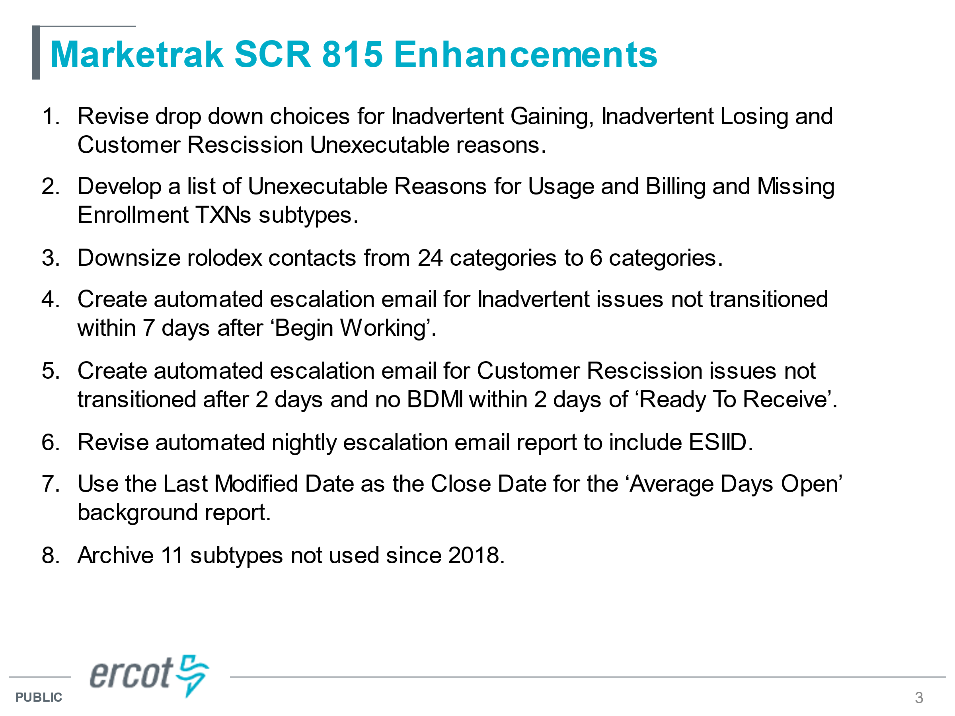

Some additional comments raised for suggested changes to be included in SCR817 (MarkeTrak revisions associated with TXSET 5.0) were:

1. Adding DUNS# to the email escalation template
2. New IAL unexecutable reasons

**Antitrust/Minutes**

* Antitrust Admonition was read by Sheri Wiegand
  + Minutes from 11/16/22 were reviewed and approved.

**ERCOT System Instances & MarkeTrak Monthly Performance Review**

* Dave presented **November performance reports** – all monthly and annual SLA targets have been met
  + - Reminder the ERCOT outage for December 10th -11th where MT revisions will be made
* MarkeTrak response times are good with averages coming down

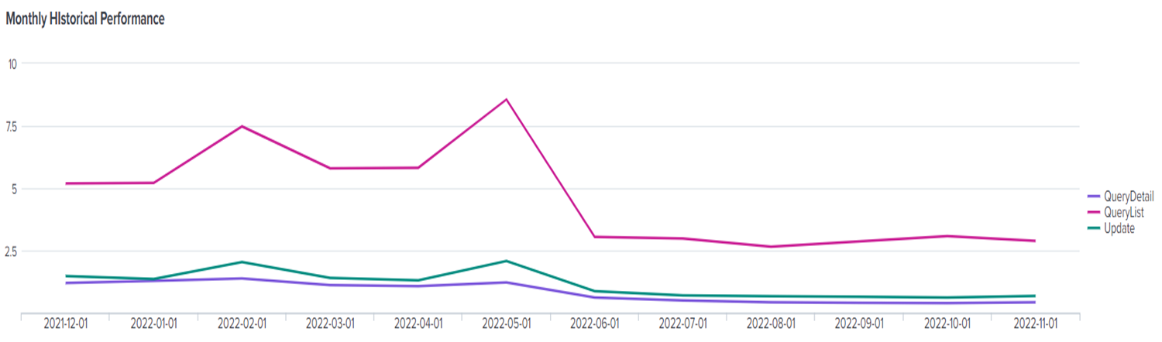

* **Listserv activity** – monitoring continued for the Weather Moratorium listserv, however, no users were ‘signed off’ and there were none auto-deleted. TDTMS will revisit next month if monitoring needed to continue.
* **MarkeTrak Upgrade and Stabilization** – the final item for “clean-up” will be added with the release on December 11th which will close out this item – New Users and Search functionality
* **SLAs for 2023** – Dave presented the SLA document indicating ERCOT will clean up the dates and post to the key documents. The structure/language of the document remained the same. The one extended release window is to align with LP&L market open (October timeframe). This will be presented and voted upon at RMS in January.

**SCR 817 MarkeTrak Validations –**

This will be a standing item on the agenda while the developers are finalizing and writing scripts to address any questions that arise.

1. *Usage & Billing Dispute* – post investigation by the TDU, the YES/NO radio button (for cancel/rebills) will be a required entry and it’s use will be clarified in training and the MT User’s Guide
2. *Meter Cycle Change Requests*- if the change request is approved by the TDU, the TDU may complete and close the MarkeTrak. If not approved, comments/notes may be added, and MT may be closed. The REP may submit a new MT if necessary to request a different cycle. This information will clarified in training and the MT User’s Guide.

**MarkeTrak Subtype Volume Analysis – Mid Year 2022**

Sam provided an analysis of various subtypes of data from July 2021 to December 2021 which did not include the New and Withdrawn (status) MTs. The goal was to review time spent on processing – from submit to close.



**PUCT Project 52796**

Sheri had asked market participants to begin thinking about the impacts of the proposed docket to shorten the timelines for complaints in 25.495 from 21 days down to 15 days. This timeline has served as a guideline for the expected completion of an IAG issue. Data from last analysis revealed the following performance:

**Accomplishments 2022 & Goals 2023**

Sheri will draft for January’s TDTMS review

**Meeting Schedule 2023**

Meeting dates will align with TXSET, typically TXSET in the mornings and TDTMS in the afternoons. Both working groups will remain flexible as TXSET v5.0 activities pick up or issues need to be addressed.

**NEXT MEETING scheduled – January 18th @ 1:00 PM WebEx only**

* Leadership Elections
* ERCOT Updates
  + System Instances & MT Performance
  + Listserv
  + MarkeTrak SCR815 follow up
* SCR817 Business Requirements discussion, *if needed*
* Goals 2023/Accomplishments 2022
* MarkeTrak Volume Subtype Analysis Discussion – any follow up items to be addressed