PWG Meeting Notes – November 30th, 2022
Via WebEx 9:30 AM
Attendees:
Sam Pak - Oncor | Jordan Troublefield – ERCOT | Eric Lotter – Grid Monitor | Diana Rehfeldt - TNMP
Sheri Wiegand - TXUE | Neeraja Dharme – EDFT | Amir Khalifeh - ERCOT | Randy Roberts - ERCOT
Kathy Scott - CNP | Angela Ghormley – Calpine | Calvin Opheim - ERCOT | Richard Beasley - CNP
Steven Pliler - TXUE | Bill Snyder - AEP | Jesse Macias - AEP

- Meeting notes for October 14th^{th} were reviewed and approved with one minor revision.

- 2021/2022 Weather Sensitivity Progress
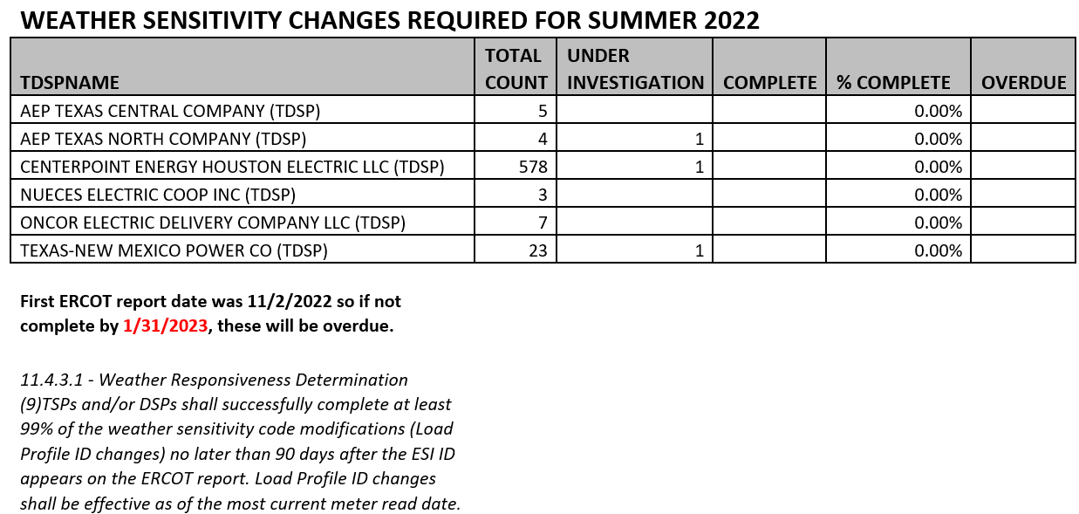

- Counts are noticeably lower for Oncor and AEP as most of their applicable ESIs have transitioned from BUSIDDRQ to BUSLRG profiles
- It was agreed the Weather Sensitivity process can be eliminated with both CNP and TNMP planning to convert their applicable ESIs from BUSIDDRQ to BUSLRG
- An NPRR addressing 11.4.3.1 will be drafted and an associated LPGRR addressing any downstream impacts for process elimination. This process will commence early next year to allow for RRs to be reviewed through the governance process prior to November 2023 (when the WS process would commence). It is anticipated the entire protocol section may be removed.
- One topic for additional thought is the default NWS/WS designation for new BUSIDRRQs. Randy can review data to see how many remain NWS or is WS the better default if the WS process will be eliminated
- Sam and Sheri will work offline with ERCOT to develop an NPRR and LPGRR for PWG’s review in January

- Business Annual Validation
- As of 11/29, all TDSPs had completed changes required for BUS AV excluding TNMP who had only 3 ESI revisions remaining. Amar will send applicable ESIs to Diana for review. However, 2022 Business Annual Validation is considered complete.

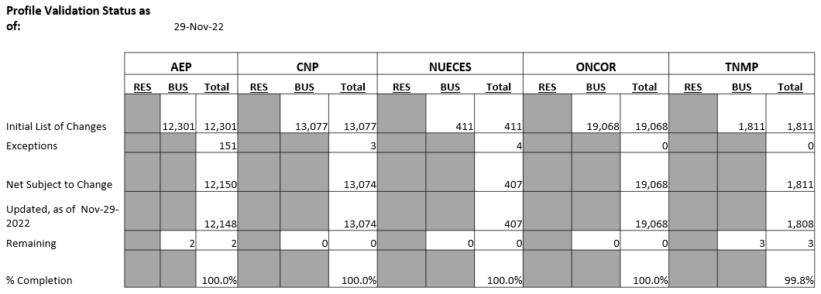

- Discussion was revisited regarding need for BUS AV on an annual basis. It was pointed out that ~46,600 ESIs were changed out of ~1,035,000 Business ESIs, representing ~ 4.5% of the population. For REPs, accurately assigned profiles is extremely valuable in offering standardization in the market particularly in terms of bidding/pricing this level of customer.
- Interestingly when reviewing BUS ESI counts, ~50% of the BUS population fall under a BUSNODEM load profile.

- IDR/AMS BUSLRG(DG) Update from TDSPs

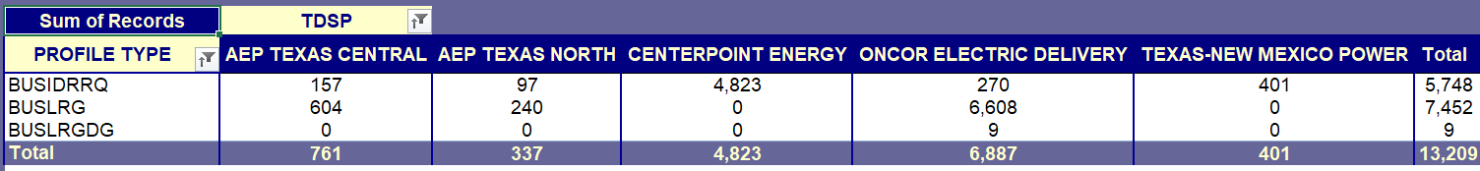
  - Transition Plans/Data Accessibility for BUSLRG profiles:
    - Oncor – 270 ESIs remain on BUSIDDRQ – slowly chipping away at outstanding cases with hopes of full completion by EOY. Interval data process in place via CRIP.
    - AEP - has changed out all applicable ESIs. AEP is still identifying applicable BUSLRGDG ESIs to transition. Thought is ~60 ESIs will transition to BUSLRGDG
    - CNP – remain on target for an April go live transition, with a Q1 database change dependency. IDR -> AMS will be ~47% of population (2133 ESIs) with the remaining 53% (2395 ESIs) to remain on BUSIDRRQ. Transition plan allows for both 867IDR as well as LSE files for settlement. Historical usage requests will remain the same as today for the BUSIDRRQ ESIs.
    - TNMP status quo due to 3G remediation and likely will not make the conversions until 2023.

- 2023 Meeting Dates & Leadership Nominations
  - Sam proposed meeting calendar for 2023 as typically the second Wednesday of the month and all are planned as WebEx. Sam will forward calendar to Stakeholder Services for posting.
  - Sam encouraged anyone interested in a leadership role to reach out to Jordan Troublefield prior to the elections in January. Sheri announced she will not be seeking a leadership position on the working group due to other ERCOT commitments.

- Goals 2023 & Accomplishments 2022
Sam and Sheri will work offline to develop a list for review at the January PWG meeting.

- LPGRR proposal converting Profile Decision Tree from Excel to Word format – Jordan stated no changes from last report… review will pick up again in February as Jordan is out most of January (paternity leave).

- DRAFT agenda for next meeting – January 11th, Wednesday @ 9:30 AM
  - Elections
  - Weather Sensitivity 2022
  - NPRR/LPGRR Elimination of Weather Sensitivity Annual Review
  - IDR/AMS BUSLRG Updates from TDSPs
  - Goals 2023 & Accomplishments 2022

