November 2022 ERCOT Monthly Operations Report
Reliability and Operations Subcommittee Meeting
January 5, 2023

Table of Contents
1. Report Highlights 2
2. Frequency Control 3
2.1. Frequency Events 3
2.2. Responsive Reserve Events 4
2.3. Load Resource Events 4
3. Reliability Unit Commitment 4
4. IRR, Wind, and Solar Generation as a Percent of Load 7
5. Largest Net-Load Ramps 8
6. COP Error Analysis 9
7. Congestion Analysis 11
7.1. Notable Constraints 11
7.2. Generic Transmission Constraint Congestion 21
7.3. Manual Overrides 21
7.4. Congestion Costs for Calendar Year 2022 21
8. System Events 22
8.1. ERCOT Peak Load 22
8.2. Load Shed Events 22
8.3. Stability Events 22
8.4. Notable PMU Events 23
8.5. DC Tie Curtailment 23
8.6. TRE/DOE Reportable Events 23
8.7. New/Updated Constraint Management Plans 23
8.8. New/Modified/Removed RAS 23
8.9. New Procedures/Forms/Operating Bulletins 23
9. Emergency Conditions 24
9.1. OCNs 24
9.2. Advisories 24
9.3. Watches 24
9.4. Emergency Notices 24
10. Application Performance 24
10.1. TSAT/VSAT Performance Issues 24
10.2. Communication Issues 24
10.3. Market System Issues 24
11. Model Updates 25
Appendix A: Real-Time Constraints 27

Report Highlights
- The unofficial ERCOT peak load for the month was 53,308 MW and occurred on 11/09/2022, during hour ending 16:00.
- There were 2 frequency events.
- There were 8 instances where Responsive Reserves was deployed.
- There were 20 HRUC commitments.
- There were 18 days of congestion on the North Edinburg to Lobo GTC, 17 days on the West Texas Export GTC, 17 days on the Panhandle GTC, 14 days on the Treadwell GTC, 13 days on the Nelson Sharpe to Rio Hondo GTC, 10 days on the North to Houston GTC, 10 days on the East Texas Export GTC, 10 days on the Valley Export GTC, 9 days on the McCamey GTC, and 1 day on the Wharton GTC. There was no activity on the remaining GTCs during the month. There were 2 DC Tie Curtailments for the DC_R due to forced or unplanned outages.
- 1 OCN issued for taking manual action on the WESTEX IROL due to topology change
- 1 AAN issued for possible future emergency condition
- 1 Advisory issued due to the unavailability of the Voltage Security Assessment tool.

Frequency Control

Frequency Events
The ERCOT Interconnection experienced 2 frequency events, which resulted from units’ trip. The event average event duration was 00:04:11.

A summary of the frequency events is provided below. The reported frequency events meet one of the following criteria: Delta Frequency is 60 mHz or greater; the MW loss is 350 MW or greater; resource trip event triggered RRS deployment. Frequency events that have been identified as Frequency Measurable Events (FME) for purposes of BAL-001-TRE-2 analysis are highlighted in blue. When analyzing frequency events, ERCOT evaluates PMU data according to industry standards. Events with an oscillating frequency of less than 1 Hz are inter-area, while higher frequencies indicate local events. Industry standards specify that damping ratio for inter-area oscillations should be 3.0% or greater. For the frequency events listed below, the ERCOT system met these standards and transitioned well after each disturbance. In the case of negative delta frequency, the MW Loss column could refer to load loss.

Date and Time | Delta Frequency | Max/Min Frequency | Duration of Event | PMU Data |  | MW Loss | Load | IRR | Inertia
 | (Hz) | (Hz) |  | Oscillation Mode (Hz) | Damping Ratio |  | (MW) | % | (GW-s)
11/16/2022 13:14:41 | 0.064 | 59.921 | 00:02:02 | 0.6 | 11% | 629 | 44,444 | 25% | 253,681
11/18/2022 1:02:16 | 0.077 | 59.936 | 00:06:20 | 0.67 | 9% | 329 | 40,427 | 42% | 220,447

(Note: All data on this graph encompasses frequency event analysis based on BAL-001-TRE-2.)

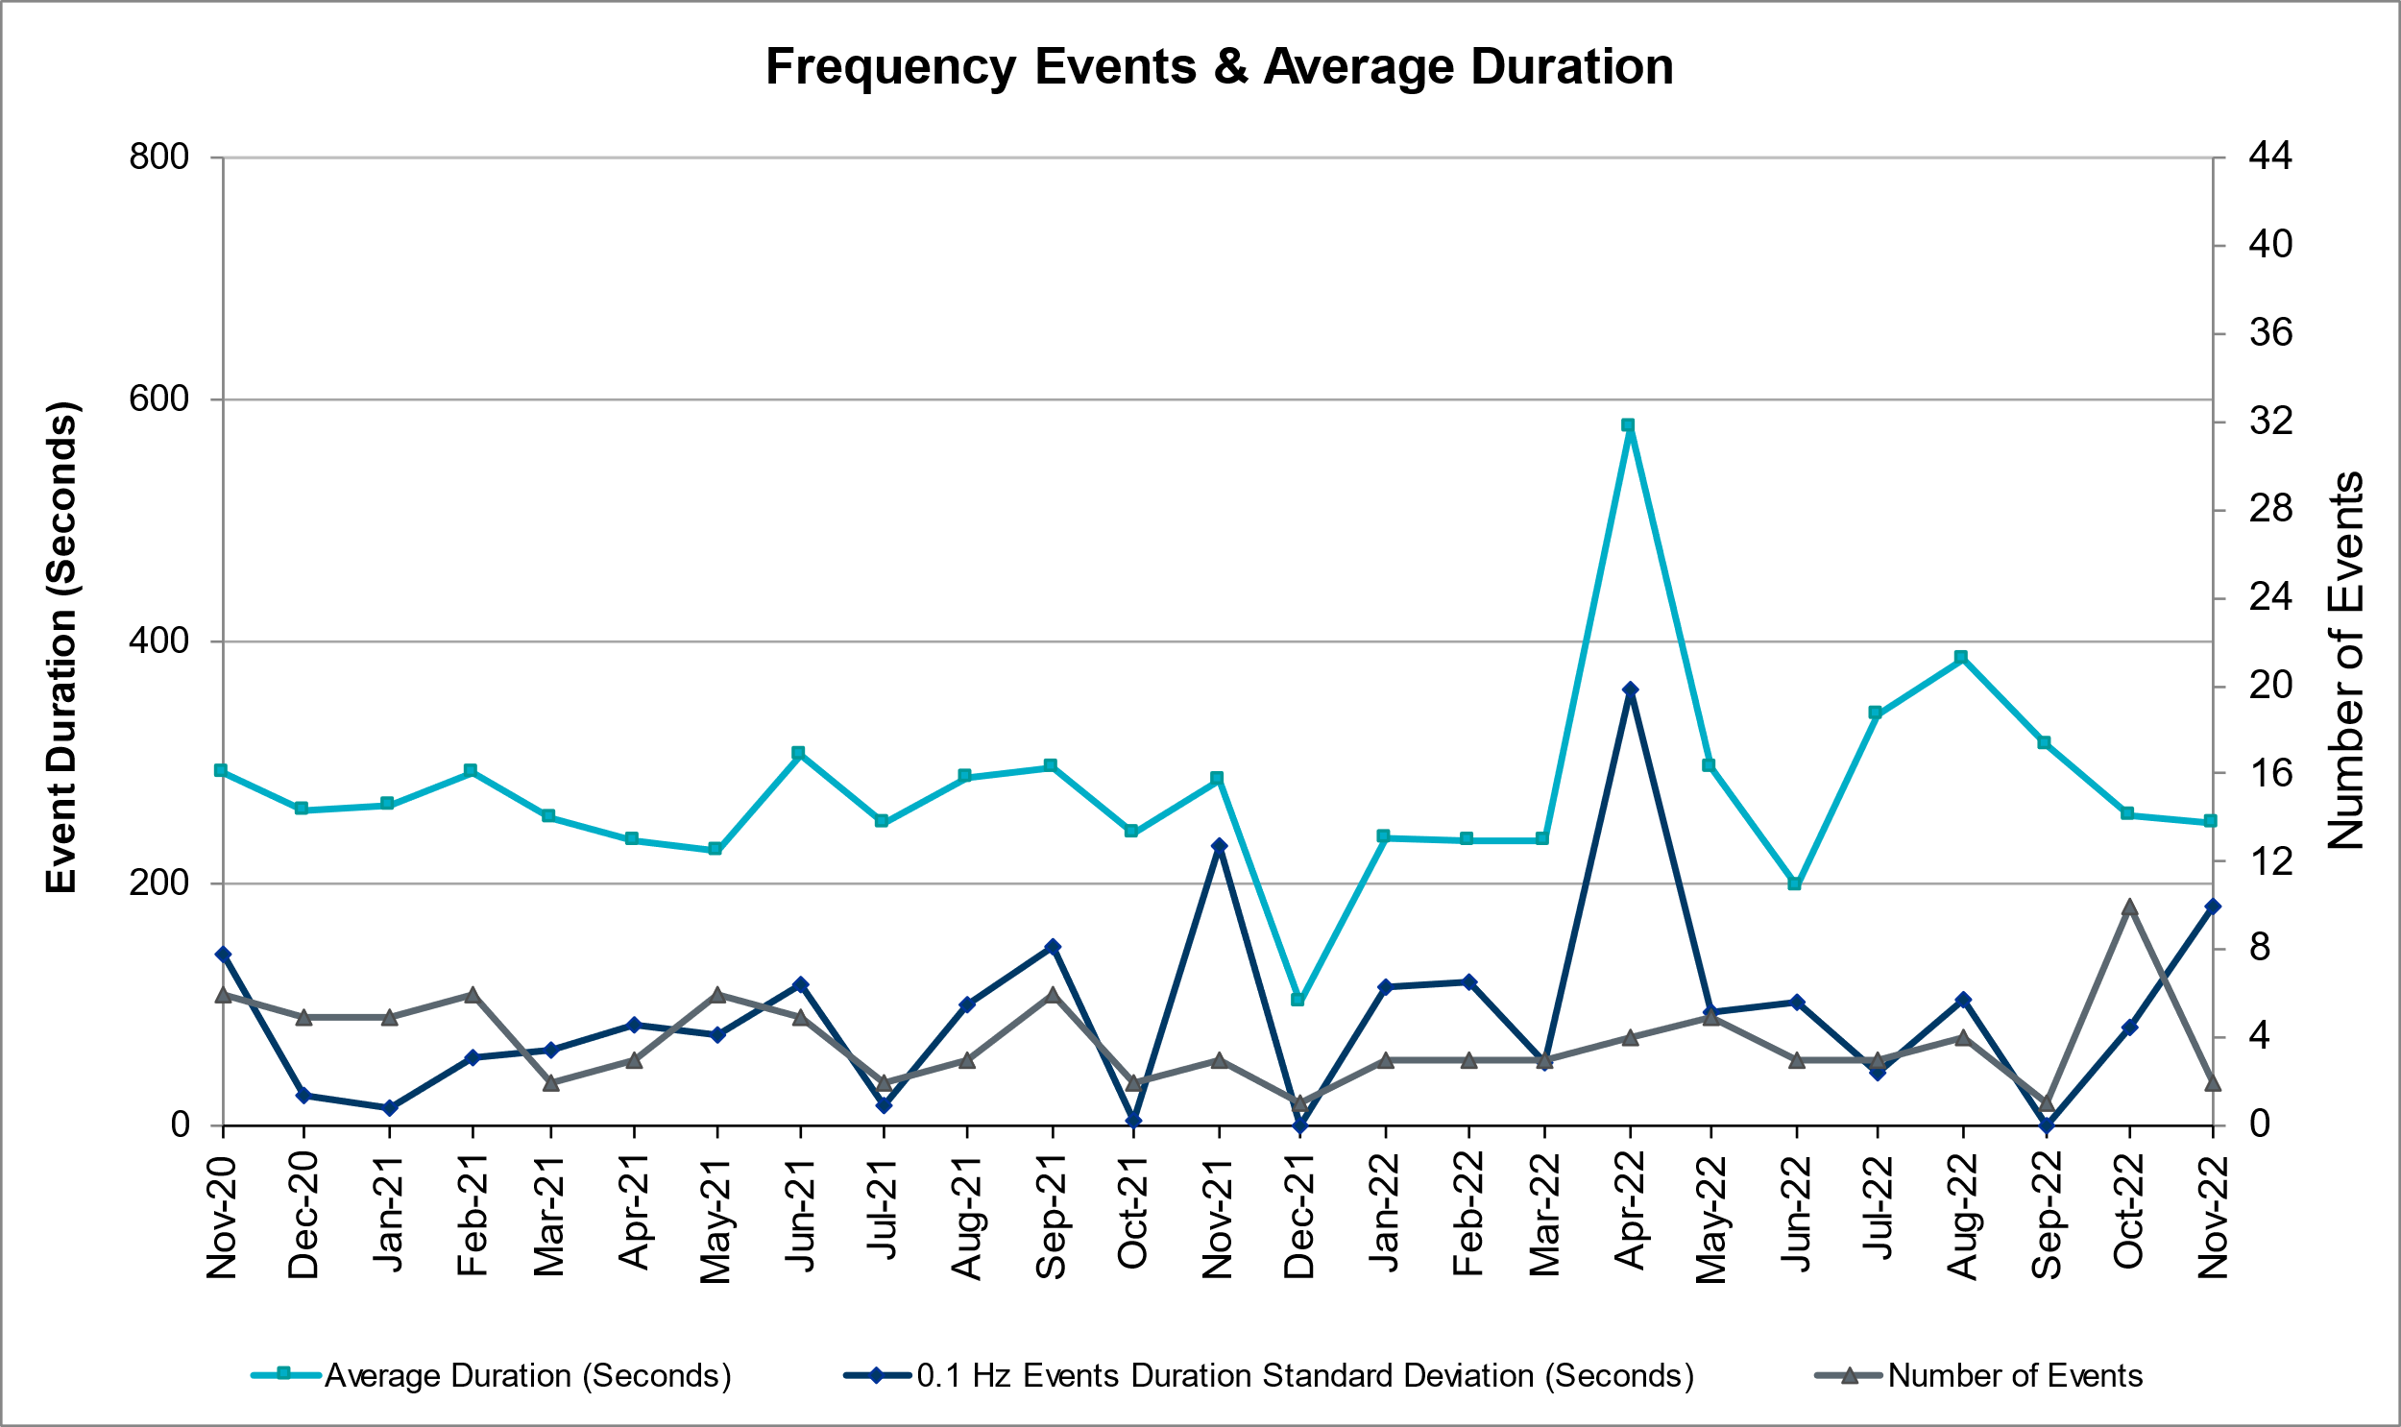

Responsive Reserve Events
There were 0 events where Responsive Reserve MWs were released to SCED. The events highlighted in blue were related to frequency events reported in Section 2.1 above, however since there were none this month this chart has been left blank.

Date and Time Released to SCED | Date and Time Recalled | Duration of Event | Maximum MWs Released | Comments
N/A | N/A | N/A | N/A | N/A

Load Resource Events
None.

Reliability Unit Commitment
ERCOT reports on Reliability Unit Commitments (RUC) monthly. Commitments are reported grouped by operating day and weather zone. The total number of hours committed is the sum of the hours for all the units in the specified region. Additional information on RUC commitments can be found on the MIS secure site at Grid Generation Reliability Unit Commitment.

There were no DRUC commitments.

There were 112 HRUC commitments

Resource Location | # of Resources | Operating Day | Total # of Hours Committed | Total MWhs | Reason for Commitment
COAST | 1 | 11/04/2022 | 2 | 988.0 | SBEAOR8
COAST | 2 | 11/05/2022 | 13 | 1,931.0 | SOR2RS8
EAST, NORTH, NORTH_CENTRAL, SOUTH_CENTRAL | 15 | 11/06/2022 | 68 | 18,448.0 | Capacity, Min Run Time
COAST, EAST, NORTH, NORTH_CENTRAL, SOUTH_CENTRAL | 16 | 11/07/2022 | 158 | 43,228.8 | Capacity, Min Run Time
COAST, EAST, SOUTH_CENTRAL | 5 | 11/08/2022 | 42 | 7,985.0 | Min Run Time, N to H
COAST | 4 | 11/09/2022 | 52 | 9,652.0 | Min Run Time, N to H
COAST, EAST, NORTH, NORTH_CENTRAL, SOUTH_CENTRAL | 6 | 11/10/2022 | 53 | 13,811.0 | Capacity, Min Run Time
EAST, NORTH_CENTRAL | 2 | 11/11/2022 | 11 | 5,528.0 | Capacity
COAST, EAST, NORTH_CENTRAL | 8 | 11/12/2022 | 39 | 11,847.0 | Capacity, DSTEXP12
COAST, EAST, NORTH_CENTRAL, SOUTH_CENTRAL | 9 | 11/15/2022 | 48 | 13,713.0 | Capacity
EAST, FAR_WEST, NORTH_CENTRAL, SOUTH_CENTRAL, SOUTHERN | 11 | 11/16/2022 | 95 | 22,788.0 | Capacity, Min Run Time, Valley Reliability
NORTH_CENTRAL, SOUTHERN | 2 | 11/17/2022 | 11 | 2,718.0 | Min Run Time, Valley Reliability
EAST, NORTH, NORTH_CENTRAL, SOUTH_CENTRAL | 10 | 11/19/2022 | 63 | 21,514.0 | Capacity
NORTH_CENTRAL, SOUTHERN | 2 | 11/20/2022 | 28 | 10,397.0 | Min Run Time, Valley Reliability
EAST | 1 | 11/21/2022 | 3 | 1,506.0 | Capacity
NORTH_CENTRAL, SOUTH_CENTRAL | 3 | 11/23/2022 | 14 | 3,793.0 | Capacity
NORTH_CENTRAL | 1 | 11/24/2022 | 4 | 2,367.0 | Capacity
EAST, NORTH_CENTRAL | 2 | 11/27/2022 | 6 | 3,015.0 | Capacity
COAST, FAR_WEST, NORTH_CENTRAL, SOUTHERN | 5 | 11/29/2022 | 31 | 12,624.0 | Capacity, SNATBEA8, SW_GODE5
EAST, NORTH_CENTRAL | 7 | 11/30/2022 | 25 | 9,845.0 | Capacity

IRR, Wind, and Solar Generation as a Percent of Load
The graph below shows the maximum, minimum and average aggregate solar, wind and IRR output as a percentage of total ERCOT load when evaluated as 10-minute averaged intervals, over the past 13 months. Current wind and solar generation and penetration records are listed in the footnote below. Maximum IRR penetration for the month was 63.3% on 11/29/2022 interval ending 02:50 and minimum IRR penetration for the month was 5.5% on 10/25/2022 interval ending18:30.

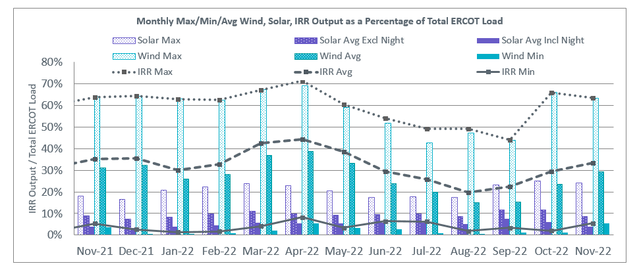

During the hour of peak load for the month, hourly integrated wind generation was 20,674 MW and solar generation was 1,331 MW. The graph below shows the wind and solar penetration percentage during the hour of the peak load in the last 13 months.

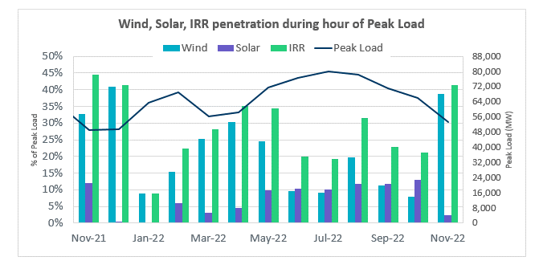

Lastly, the graph below shows the minimum wind, solar and IRR output during the peak load hour as a percentage of the daily peak load for every day in the month.

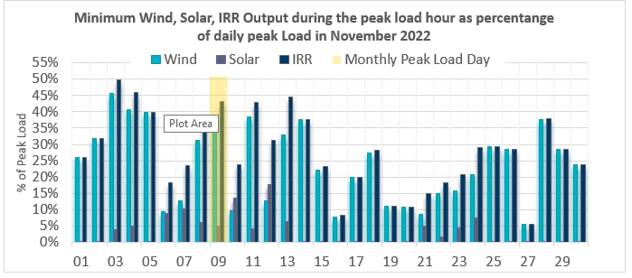

Largest Net-Load Ramps
The net-load ramp is defined as the change in net-load (load minus wind and PVGR generation) during the defined time horizon. Such a variation in net-load needs to be accommodated in grid operations to ensure that the reliability of the grid is satisfactorily maintained. The largest net-load ramp during 5-min, 10-min, 15-min, 30-min and 60-min in November 2022 was 1,107 MW, 1,907 MW, 2,764 MW, 5,166 MW, and 9,218 MW, respectively. The comparison with respect to the historical values is given in the table below.

Month and Year | 5 min | 10 min | 15 min | 30 min | 60 min
November 2014 | 991 MW | 1,689 MW | 2,112 MW | 3,289 MW | 5,392 MW
November 2015 | 915 MW | 1,637 MW | 1,995 MW | 3,241 MW | 5,516 MW
November 2016 | 821 MW | 1,404 MW | 1,827 MW | 3,166 MW | 5,866 MW
November 2017 | 877 MW | 1,581 MW | 2,078 MW | 3,393 MW | 5,708 MW
November 2018 | 814 MW | 1,553 MW | 2,148 MW | 4,109 MW | 7,218 MW
November 2019 | 940 MW | 1,606 MW | 2,269 MW | 3,934 MW | 6,317 MW
November 2020 | 971 MW | 1,264 MW | 1,655 MW | 3,061 MW | 5,751 MW
November 2021 | 1,311 MW | 1,639 MW | 2,281 MW | 3,781 MW | 6,587 MW
November 2022 | 1,107 MW | 1,907 MW | 2,764 MW | 5,166 MW | 9,218 MW
All months in 2014-2022 | 1,647 MW | 2,157 MW | 3,015 MW | 5,882 MW | 10,750 MW

COP Error Analysis
COP Error is calculated as the capacity difference between the COP HSL and real-time HSL of the unit. Mean Absolute Error (MAE) stayed over 10,000 MW until Day-Ahead at 09:00, then dropped significantly to 4,979 MW by Day-Ahead at 13:00 and to 1,328 MW by Day-Ahead at 15:00. In the following chart, Under-Scheduling Error indicates that COP had less generation capacity than real-time, and Over-Scheduling Error indicates that COP had more generation capacity than real-time.

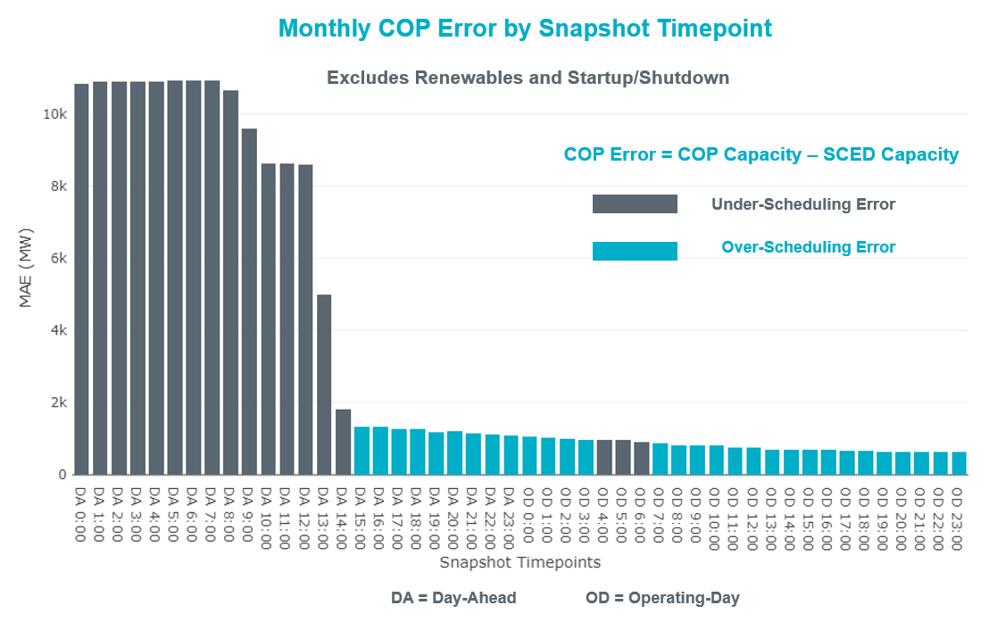

Monthly MAE for the Latest COP at the end of the Adjustment Period was 623 MW with medians ranging from -411 MW for Hour-Ending (HE) 19 to 453 MW for HE 22. HE 11 on 11/27/2022 had the largest Over-Scheduling Error (1,772 MW) and HE 23 on 11/16/2022 had the largest Under-Scheduling Error (-3,890 MW).

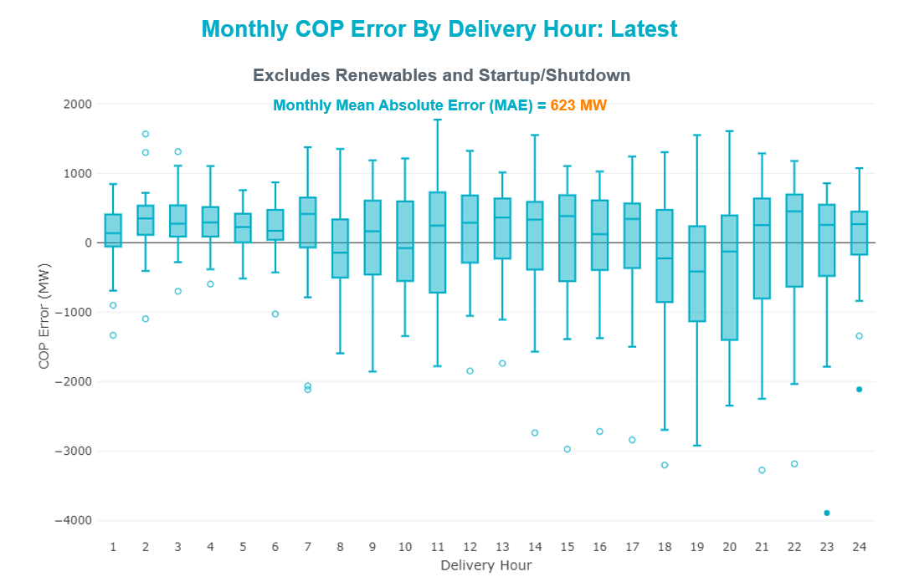

Monthly MAE for the Day-Ahead COP at 12:00 was 8,588 MW with median ranging from -11,256 MW for Hour-Ending (HE) 18 to -4,805 MW for HE 2. HE 2 on 11/29/2022 had the largest Over-Scheduling Error (694 MW) and HE 19 on 11/06/2022 had the largest Under-Scheduling Error (-21,197 MW).

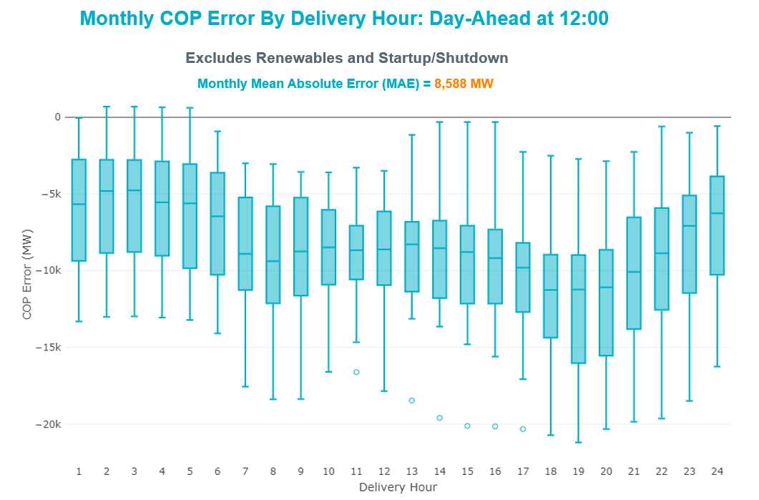

Congestion Analysis

Notable Constraints

Nodal protocol section 3.20 specifies that ERCOT shall identify transmission constraints that are binding in Real-Time three or more Operating Days within a calendar month. As part of this process, ERCOT reports congestion that meets this criterion to ROS. In addition, ERCOT also highlights notable constraints that have an estimated congestion rent exceeding $1,000 for a calendar month. These constraints are detailed in the table below, including approved transmission upgrades from TPIT that may provide some congestion relief based on ERCOT’s engineering judgement. Rows highlighted in blue indicate the congestion was affected by one or more outages. For a list of all constraints activated in SCED, please see Appendix A at the end of this report.

Contingency Name | Overloaded Element | Contingency Name | Overloaded Element | # of Days Constraint Binding | Congestion Rent | Transmission Project
BASE CASE | WESTEX | Basecase | WESTEX GTC | 14 | $41,607,307.60
BASE CASE | EASTEX | Basecase | EASTEX GTC | 9 | $9,428,594.70
BASE CASE | PNHNDL | Basecase | PNHNDL GTC | 14 | $9,205,540.18
SBWDDBM5 | LPLMK_LPLNE_1 | BLACKWATER DRAW SWITCH to DOUBLE MOUNTAIN SWITCH LIN 1 | Mackenzie Substation - Northeast Substation 115kV | 17 | $8,815,787.18
SW_GODE5 | 15060__B | wett_grelton to ODESSA EHV SWITCH LIN 1 | Koch Tap - Vealmoor 138kV | 8 | $5,967,621.53
MHARNED5 | BURNS_RIOHONDO_1 | Manual dbl ckt for NEDIN-BONILLA 345kV & RIOH-PRIM138kV | Burns Sub - Rio Hondo 138kV | 10 | $5,718,186.41
SLOBSA25 | CATARI_PILONC1_1 | Fowlerton to LOBO 345 LIN1 | Catarina - Piloncillo 138kV | 13 | $5,188,070.53
SALVTNN8 | G138_10B_1 | NORTH ALVIN TNP to ALVIN TNP LIN 1 | Magnolia Tnp - Seminole Tnp 138kV | 4 | $4,019,390.05
SNEDSTE5 | NEDIN_SERDEV1_1 | NORTH EDINBURG to STEWART ROAD LIN 1 | #N/A | 2 | $3,960,658.49
SNATBEA8 | 6144__A | NATURAL DAM to BEALS CREEK SUB LIN _A | Big Spring West - Stanton East 138kV | 18 | $3,384,156.92
DELMSAN5 | PAWNEE_SPRUCE_1 | Elmcreek-Sanmigl 345kV | Pawnee Switching Station - Calaveras 345kV | 10 | $3,254,968.28
DLYTZOR5 | 106T200_1 | Zorn-Austro&Lytton_S 345kV | Redwood - San Marcos 138kV | 8 | $3,160,788.19
DGBYCRN8 | BCVLY_03_A | GBY-DAV& TNK-CRN138KV | Bigvue - Lyondell 138kV | 3 | $2,923,894.99 | Bigvue - Lyondell 138 kV Line Upgrade (70665)
BASE CASE | N_TO_H | Basecase | N_TO_H GTC | 8 | $2,856,887.69
STVWCRT5 | 6200__D | TIMBERVIEW SWITCH to COURTLAND LIN _B | Park Row - Sherry Switch 138kV | 4 | $2,280,008.25
DBIGKEN5 | HAMILT_MAVERI1_1 | Bighil-Kendal 345kV | Hamilton Road - Maverick 138kV | 6 | $2,145,033.83
BASE CASE | NE_LOB | Basecase | NE_LOB GTC | 14 | $2,144,789.05 | The Lower Rio Grande Valley (LRGV) System Enhancement Project (21RPG017) will improve the NorthEd_LoboGTC to support up to 80% of total wind and solar generation capacity in the LRGV area.
SWDDMNS5 | PRSSW_MR1H | WOODARD SWITCH to MONTICELLO SES LIN _A | Paris Switch 345kV | 10 | $2,065,125.58
SWDDMNS5 | 871__A | WOODARD SWITCH to MONTICELLO SES LIN _A | Commerce Switch - Commerce 138kV | 9 | $2,048,079.26
SLPCPR25 | 392__A | LAMAR POWER PARTNERS to PARIS SWITCH LIN _A | Lamar Power Partners - Paris Switch 345kV | 1 | $1,993,290.75
MFLCMGS5 | MGSES_MR1H | MAN-DBL_FLCNS_MDLNE 345 -FLCNS_MGSES 345 DBLCKT | Morgan Creek Ses 345kV | 4 | $1,964,287.41
SMDSODE5 | MDSSW_MR1L | ODESSA EHV SWITCH to MIDESSA SOUTH SW LIN _A | Midessa South Sw 138kV | 2 | $1,820,932.21
DCS_CHS8 | BCVLY_03_A | TWR(138) CS-PSA08 & CHS-PSA94 | Bigvue - Lyondell 138kV | 4 | $1,818,982.37 | Bigvue - Lyondell 138 kV Line Upgrade (70665)
DRNS_TB5 | THWZEN71_A | Rns-Rtw & Sng-Tb 345kV | Th Wharton - Zenith 345kV | 6 | $1,582,384.43
DGS_CF_8 | BCVLY_03_A | GS-GBY21 & CF-GBY77 | Bigvue - Lyondell 138kV | 2 | $1,185,865.88 | Bigvue - Lyondell 138 kV Line Upgrade (70665)
DBIGKEN5 | HEXT_YELWJC1_1 | Bighil-Kendal 345kV | Yellow Jacket - Hext Lcra 69kV | 8 | $1,083,375.47
SBIGTWI5 | GANSO_MAVERI1_1 | Big HiLL to TWIN BUTTES LIN 1 | Ganso - Maverick 138kV | 2 | $1,014,793.51
DBIGKEN5 | BONDRO_SONR1_1 | Bighil-Kendal 345kV | Bondroad - Sonora 69kV | 4 | $870,669.64 | Rocksprings - Sonora 69 kV Line Rebuild (19RPG018, MOD 51001)
SBIGTWI5 | MASNPH_MASN1_1 | Big HiLL to TWIN BUTTES LIN 1 | Mason Aep - Mason Phillips Tap 69kV | 3 | $818,347.25
SFTLMES8 | CROSSO_NORTMC1_1 | MESA VIEW SWITCH to FORT LANCASTER LIN 1 | North Mccamey - Crossover 138kV | 7 | $787,740.84
DMGSMDS5 | MDSSW_MR1L | Mgses-Qalsw&Odehv-Mdssw 345kV | Midessa South Sw 138kV | 3 | $696,602.51
SBRAUVA8 | HAMILT_MAVERI1_1 | ODLAW SWITCHYARD to ASPHALT MINES LIN 1 | Hamilton Road - Maverick 138kV | 13 | $687,866.91
DBIGKEN5 | TREADW_YELWJC1_1 | Bighil-Kendal 345kV | Yellow Jacket - Treadwell 138kV | 8 | $610,404.98
SBLESTP5 | COLETO_VICTOR1_1 | SOUTH TEXAS PROJECT to BLESSING LIN 1 | Coleto Creek - Victoria 138kV | 5 | $585,178.07
DBIGKEN5 | HEXT_MASONS1_1 | Bighil-Kendal 345kV | Mason Switching Station - Hext Lcra 69kV | 7 | $578,034.29
SGBYSD25 | GBYLYD70_A | SHELDON to GREENS BAYOU LIN A | Lydell - Greens Bayou 138kV | 6 | $552,948.64
SCARFRI8 | ATSO_SONR1_1 | Carver to FRIEND RANCH LIN 1 | Atlantic Sonora - Sonora 69kV | 5 | $421,790.35
SCMNCPS5 | 651__B | COMANCHE SWITCH (Oncor) to COMANCHE PEAK SES LIN _A | Comanche Tap - Comanche Switch (Oncor) 138kV | 4 | $413,757.88
DSALKLN5 | 630__B | SALSW TO KLNSW 345 DBLCKT | Harker Heights South - Killeen Switch 138kV | 3 | $395,958.43
SCRMSAR8 | CONCHO_VRBS1_1 | SAN ANGELO RED CREEK to Weiss LIN 1 | San Angelo Concho - Veribest 69kV | 4 | $389,107.09
DCALBEC8 | J0_P0_1 | Calavers-Kirby&Beck_Rd 138kV | Harlanda - Southsan 138kV | 8 | $354,194.81
BASE CASE | MCCAMY | Basecase | MCCAMY GTC | 6 | $327,152.17
SBTPBNT8 | MYRA_VAL_1 | BENNETT ROAD SWITCH to WISE COUNTY LIN _B | Myra - Valley View Bepc 138kV | 4 | $283,558.18 | BEPC Myra to Spring 138-kV Line Rebuild (4645)
SSCJFS8 | BCVLY_03_A | JEFFERSON to SOUTH CHANNEL LIN A | Bigvue - Lyondell 138kV | 4 | $239,571.27 | Bigvue - Lyondell 138 kV Line Upgrade (70665)
DSTEXP12 | COLETO_VICTOR2_1 | South Texas # 1 & # 2 | Coleto Creek - Victoria 138kV | 9 | $222,474.84
SSCLWF18 | 6840__B | WINDTHORST SWITCH to RICE SWITCH LIN _C | Anarene - Navy Kickapoo Switch 69kV | 4 | $204,425.37
SBLESTP5 | COLETO_VICTOR2_1 | SOUTH TEXAS PROJECT to BLESSING LIN 1 | Coleto Creek - Victoria 138kV | 8 | $196,927.02
SCOLPAW5 | COLETO_VICTOR2_1 | COLETO CREEK to PAWNEE SWITCHING STATION LIN 1 | Coleto Creek - Victoria 138kV | 6 | $186,879.76
SHEAKAT9 | HEXT_MASONS1_1 | Heartland to KATEMCY LIN 1 | Mason Switching Station - Hext Lcra 69kV | 3 | $185,618.14
XBLE58 | COLETO_VICTOR2_1 | BLESSING TRX 1382 345/138 | Coleto Creek - Victoria 138kV | 3 | $169,277.12
BASE CASE | NELRIO | Basecase | NELRIO GTC | 9 | $165,047.34 | The Lower Rio Grande Valley (LRGV) System Enhancement Project (21RPG017) will cause there to be no stability constraint for NelsonSharpe_RioHondoGTC under normal conditions.
DWSHNAV5 | ESTES_PECAN_1_1 | Wshack-Samsw&Navarro 345kV | Estes - Pecan Bayou 138kV | 3 | $150,884.19
DCALBEC8 | D5_J0_1 | Calavers-Kirby&Beck_Rd 138kV | Leon Creek - Southsan 138kV | 4 | $145,946.94
BASE CASE | TRDWEL | Basecase | TRDWEL GTC | 14 | $136,311.94
BASE CASE | VALEXP | Basecase | VALEXP GTC | 7 | $116,235.06 | The Lower Rio Grande Valley (LRGV) System Enhancement Project (21RPG017) will improve but not eliminate the need for this GTC.
SN_SAJO5 | LASPUL_RAYMND1_1 | AJO to NELSON SHARPE LIN 1 | Las Pulgas - Raymondville 2 138kV | 6 | $110,145.13
SHLC6S8 | BCVLY_03_A | CROSBY to HIGHLANDS LIN A | Bigvue - Lyondell 138kV | 5 | $84,884.07 | Bigvue - Lyondell 138 kV Line Upgrade (70665)
DMTSCOS5 | 6437__F | DMTSW TO SCOSW 345 DBLCKT | Knapp - Scurry Chevron 138kV | 3 | $81,869.66
DBAKSOL5 | LYNX_TOMBST1_1 | Bakersfield - Solstice line 1 and 2 | Lynx - Tombstone 138kV | 3 | $49,528.00
DCAGCI58 | 255T279_1 | Cagnon-Kendal 345 &Cico-Mengcr 138 | Medina Lake - Pipe Creek 138kV | 3 | $33,704.89
SBRAUVA8 | ESCOND_GANSO1_1 | ODLAW SWITCHYARD to ASPHALT MINES LIN 1 | Escondido - Ganso 138kV | 5 | $29,974.27 | Escondido - Ganso 138 kV Line Rebuild (55624)
SMADSAP8 | MADDUX_SAPOWE2_1 | MADDUX to SAN ANGELO POWER STATION LIN 1 | Maddux - San Angelo Power Station 138kV | 4 | $26,397.99
SLYNRIO8 | LYNX_TOMBST1_1 | Lynx to RIO PECOS LIN 1 | Lynx - Tombstone 138kV | 3 | $24,536.56
SILLFTL8 | CARVER_TINSLE1_1 | FORT LANCASTER to ILLINOIS #4 LIN 1 | Carver - Tinsley Tap 138kV | 3 | $10,273.06
SLAQLOB8 | BRUNI_69_1 | LAQUINTA to LOBO LIN 1 | Bruni Sub 138kV | 3 | $2,212.81
SKLELOY8 | LOYOLA_69_1 | KLEBERG AEP to LOYOLA SUB LIN 1 | Loyola Sub 138kV | 3 | $878.02

Generic Transmission Constraint Congestion
There were 18 days of congestion on the North Edinburg to Lobo GTC, 17 days on the West Texas Export GTC, 17 days on the Panhandle GTC, 14 days on the Treadwell GTC, 13 days on the Nelson Sharpe to Rio Hondo GTC, 10 days on the North to Houston GTC, 10 days on the East Texas Export GTC, 10 days on the Valley Export GTC, 9 days on the McCamey GTC, and 1 day on the Wharton GTC. There was no activity on the remaining GTCs during the month.

Note: This is how many times a constraint has been activated to avoid exceeding a GTC limit, it does not imply an exceedance of the GTC occurred or that the GTC was binding.

Manual Overrides
None

Congestion Costs for Calendar Year 2022
The following table represents the top twenty active constraints for the calendar year based on the estimated congestion rent attributed to the congestion. ERCOT updates this list on a monthly basis.

Contingency | Overloaded Element | # of 5-min SCED | Estimated | Transmission Project
Basecase | WESTEX GTC | 22986 | $292,241,878.53
Toksw-Gibcrk & Jk_Ck 345kV | Jewett - Singleton 345kV | 9281 | $164,069,608.80
Basecase | NE_LOB GTC | 35264 | $113,802,262.55 | The Lower Rio Grande Valley (LRGV) System Enhancement Project (21RPG017) will improve the NorthEd_LoboGTC to support up to 80% of total wind and solar generation capacity in the LRGV area.
SALSW TO KLNSW 345 DBLCKT | Killeen Switch 345kV | 10779 | $92,294,055.67
Basecase | N_TO_H GTC | 10973 | $76,732,792.55
Elmcreek-Sanmigl 345kV | Pawnee Switching Station - Calaveras 345kV | 7656 | $74,876,966.63
Basecase | PNHNDL GTC | 17792 | $65,827,909.59
Manual dbl ckt for NEDIN-BONILLA 345kV & RIOH-PRIM138kV | Burns Sub - Rio Hondo 138kV | 18016 | $64,445,778.23
TWR(345) JCK-REF27 & JCK-STP18 | Hillje - South Texas Project 345kV | 6637 | $62,964,035.25
PH ROBINSON to MEADOW LIN A | Magnolia Tnp - Seminole Tnp 138kV | 16533 | $55,699,577.61
WA PARISH to OBRIEN LIN A | Wa Parish - Obrien 345kV | 1485 | $48,095,593.23
MAN_SGL_ MDL-FLC_345_kV_w_MDL_XMFR1_FLC_AMR2 | Midland County Northwest Switch - Mockingbird 138kV | 4260 | $39,903,573.59 | Oncor Midland East Area Project (21RPG003, MOD 57925) - NOTE: This project removes the overloaded element and reconfigures lines in the area, amongst other topology changes.
OASIS to MEADOW LIN A | Grant - Plaza 138kV | 3745 | $32,866,665.55 | Plaza to Grant: 138 kV Line Upgrade (70660)
Basecase | NELRIO GTC | 28007 | $32,659,617.05 | The Lower Rio Grande Valley (LRGV) System Enhancement Project (21RPG017) will cause there to be no stability constraint for NelsonSharpe_RioHondoGTC under normal conditions.
BLACKWATER DRAW SWITCH to DOUBLE MOUNTAIN SWITCH LIN 1 | Mackenzie Substation - Northeast Substation 115kV | 6173 | $30,668,219.22
WDGSW TO MARSW 138 DBLCKT | Mistletoe Heights - Hemphill 138kV | 2078 | $30,437,608.94
Fowlerton to LOBO 345 LIN1 | Laredo Vft North - Las Cruces 138kV | 9773 | $30,070,994.19 | Laredo VFT North to North Laredo Switch: Rebuild 138 kV Line (58008)
STP SWITCH to Esperanza LIN 1 | Blessing - Pavlov 138kV | 7457 | $28,859,506.14
Fowlerton to LOBO 345 LIN1 | Catarina - Piloncillo 138kV | 9971 | $27,380,238.02
COMANCHE SWITCH (Oncor) to COMANCHE PEAK SES LIN _A | Comanche Tap - Comanche Switch (Oncor) 138kV | 12028 | $25,195,322.97

System Events

ERCOT Peak Load
The unofficial ERCOT peak load for the month was 53,308 MW and occurred on 11/09/2022, during hour ending 16:00.

Load Shed Events
None.

Stability Events
None.

Notable PMU Events
ERCOT analyzes PMU data for any significant system disturbances that do not fall into the Frequency Events category reported in section 2.1. The results are summarized in this section once the analysis has been completed.

There were no PMU events outside of those reported in section 2.1.

DC Tie Curtailment
There was one DC tie curtailment

Date | DC Tie | Curtailing Period | # of Tags Curtailed | Initiating Event | Curtailment Reason
11/02/2022 | DC_R | HE 18 – HE 20 | 3 | Unplanned Outage | Planned or Unplanned Outage

TRE/DOE Reportable Events
- BPUB submitted an OE-417 for 11/02/2022. Reportable Event Type: Suspicious activity to its facility.
- BPUB submitted an OE-417 for 11/23/2022. Reportable Event Type: Suspicious activity to its facility.

New/Updated Constraint Management Plans
There were no new CMPs.

There was one modified CMP: MP_2013_27 Rev 14.

New/Modified/Removed RAS
BEARKAT RAS modification proposal was not approved in November and resulted in a retire on 12/01.

New Procedures/Forms/Operating Bulletins
Date | Subject | Bulletin No.
11/01/2022 | Communications Protocols V1 Rev 9 | 1061
11/01/2022 | Reliability Unit Commitment V1 Rev 71 | 1062
11/01/2022 | Resource Desk V1 Rev 73 | 1063

Emergency Conditions

OCNs
Date and Time | Message
Nov 1, 2022 14:05 CPT | ERCOT is issuing an OCN for the WESTEX IROL due to taking manual action for a topology change.
Nov 9, 2022 14:00 CPT | ERCOT issued an AAN due to a possible future emergency condition of reserve capacity deficiency beginning Thursday, November 10, 2022, HE 17 until Thursday, November 10, 2022, HE 20.

Advisories
Date and Time | Message
Nov 28, 2022 15:57 CPT | Advisory issued due to ERCOTs Voltage Security Assessment Tool is currently unavailable.

Watches
None.

Emergency Notices
None.

Application Performance

TSAT/VSAT Performance Issues
None.

Communication Issues
None.

Market System Issues
None.

Model Updates
The Downstream Production Change (DPC) process allows ERCOT to make changes in the on-line Network Operations Model without loading a completely new model. The purpose of this process is to allow for reliable grid operations as system conditions change between designated Network Operations Model database loads. The DPC process is limited in scope to just those items listed below, with equipment ratings updates being the most common. ERCOT has seen a rise in the use of the DPC process to make on-line updates to the Network Operations Model in recent years, instead of through the standard Network Operations Model Change Request process.

- Static Line ratings (Interim Update)
- Dynamic Line ratings (non-Interim Update)
- Autotransformer ratings (non-Interim Update)
- Breaker and Switch Normal status (Interim Update)
- Contingency Definitions (Interim Update)
- RAP and RAS changes or additions (Interim Update)
- Net Dependable and Reactive Capability (NDCRC) values (Interim Update)
- Impedance Updates (non-Interim)

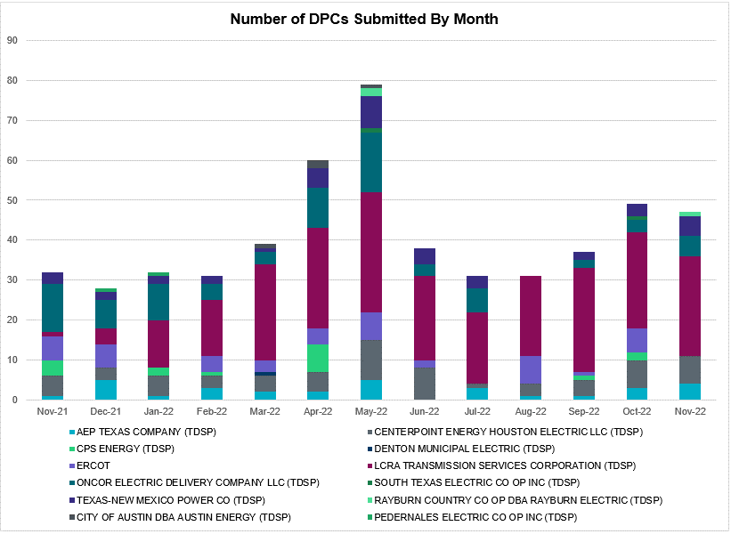

Transmission Operator | Number of DPCs
AEP TEXAS COMPANY (TDSP) | 4
BRAZOS ELECTRIC POWER CO OP INC (TDSP) | 0
BROWNSVILLE PUBLIC UTILITIES BOARD (TDSP) | 0
BRYAN TEXAS UTILITIES (TDSP) | 0
CENTERPOINT ENERGY HOUSTON ELECTRIC LLC (TDSP) | 7
CITY OF AUSTIN DBA AUSTIN ENERGY (TDSP) | 0
CITY OF COLLEGE STATION (TDSP) | 0
CITY OF GARLAND (TDSP) | 0
CPS ENERGY (TDSP) | 0
DENTON MUNICIPAL ELECTRIC (TDSP) | 0
ELECTRIC TRANSMISSION TEXAS LLC (TDSP) | 0
ERCOT | 0
LCRA TRANSMISSION SERVICES CORPORATION (TDSP) | 25
LONE STAR TRANSMISSION LLC (TSP) | 1
ONCOR ELECTRIC DELIVERY COMPANY LLC (TDSP) | 5
PEDERNALES ELECTRIC CO OP INC (TDSP) | 0
RAYBURN COUNTRY CO OP DBA RAYBURN ELECTRIC (TDSP) | 1
SHARYLAND UTILITIES LP (TDSP) | 0
SOUTH TEXAS ELECTRIC CO OP INC (TDSP) | 0
TEXAS MUNICIPAL POWER AGENCY (TDSP) | 0
TEXAS-NEW MEXICO POWER CO (TDSP) | 5

Appendix A: Real-Time Constraints
The following is a complete list of constraints activated in SCED. Full contingency descriptions can be found in the Standard Contingencies List located on the MIS secure site at Grid Generation Reliability Unit Commitment.
Year | Month of the Year | Contingency Name | Overloaded Element | From Station | To Station | Count of Days
2022 | 11 | SBWDDBM5 | LPLMK_LPLNE_1 | LPLMK | LPLNE | 23
2022 | 11 | SNATBEA8 | 6144__A | BSPRW | STASW | 20
2022 | 11 | SLOBSA25 | CATARI_PILONC1_1 | PILONCIL | CATARINA | 17
2022 | 11 | BASE CASE | NE_LOB | n/a | n/a | 17
2022 | 11 | SLOBSA25 | CATARI_PILONC1_1 | CATARINA | PILONCIL | 17
2022 | 11 | BASE CASE | WESTEX | n/a | n/a | 16
2022 | 11 | BASE CASE | PNHNDL | n/a | n/a | 16
2022 | 11 | BASE CASE | TRDWEL | n/a | n/a | 14
2022 | 11 | SBRAUVA8 | HAMILT_MAVERI1_1 | HAMILTON | MAVERICK | 13
2022 | 11 | SCOLPAW5 | COLETO_VICTOR2_1 | COLETO | VICTORIA | 12
2022 | 11 | BASE CASE | NELRIO | n/a | n/a | 12
2022 | 11 | SWDDMNS5 | PRSSW_MR1H | PRSSW | PRSSW | 12
2022 | 11 | SWDDMNS5 | 871__A | COMRC | COMSW | 12
2022 | 11 | SWDDMNS5 | 871__A | COMSW | COMRC | 12
2022 | 11 | DSTEXP12 | COLETO_VICTOR2_1 | COLETO | VICTORIA | 11
2022 | 11 | MHARNED5 | BURNS_RIOHONDO_1 | RIOHONDO | MV_BURNS | 11
2022 | 11 | DELMSAN5 | PAWNEE_SPRUCE_1 | PAWNEE | CALAVERS | 11
2022 | 11 | BASE CASE | N_TO_H | n/a | n/a | 10
2022 | 11 | SBLESTP5 | COLETO_VICTOR2_1 | COLETO | VICTORIA | 10
2022 | 11 | SW_GODE5 | 15060__B | VEALMOOR | KOCHTAP | 9
2022 | 11 | BASE CASE | VALEXP | n/a | n/a | 9
2022 | 11 | DLYTZOR5 | 106T200_1 | REDWOO | SANMAR | 9
2022 | 11 | DBIGKEN5 | TREADW_YELWJC1_1 | TREADWEL | YELWJCKT | 9
2022 | 11 | DCS_CHS8 | BCVLY_03_A | BCV | LY | 9
2022 | 11 | BASE CASE | EASTEX | n/a | n/a | 9
2022 | 11 | DCALBEC8 | J0_P0_1 | P0 | J0 | 9
2022 | 11 | BASE CASE | MCCAMY | n/a | n/a | 9
2022 | 11 | DBIGKEN5 | HEXT_MASONS1_1 | HEXT | MASONSW | 8
2022 | 11 | DBIGKEN5 | HEXT_YELWJC1_1 | YELWJCKT | HEXT | 8
2022 | 11 | SHLC6S8 | BCVLY_03_A | BCV | LY | 8
2022 | 11 | DRNS_TB5 | THWZEN71_A | ZEN | THW | 7
2022 | 11 | SBLESTP5 | COLETO_VICTOR1_1 | COLETO | VICTORIA | 7
2022 | 11 | SN_SAJO5 | LASPUL_RAYMND1_1 | LASPULGA | RAYMND2 | 7
2022 | 11 | DMGSMDS5 | MDSSW_MR1L | MDSSW | MDSSW | 7
2022 | 11 | SFTLMES8 | CROSSO_NORTMC1_1 | NORTMC | CROSSOVE | 7
2022 | 11 | DBAKSOL5 | LYNX_TOMBST1_1 | LYNX | TOMBSTNE | 7
2022 | 11 | DSALKLN5 | 630__B | KLNSW | HHSTH | 7
2022 | 11 | DBIGKEN5 | HAMILT_MAVERI1_1 | HAMILTON | MAVERICK | 6
2022 | 11 | SSCJFS8 | BCVLY_03_A | BCV | LY | 6
2022 | 11 | SMADSAP8 | MADDUX_SAPOWE2_1 | MADDUX | SAPOWER | 6
2022 | 11 | DWHILON5 | COLETO_VICTOR2_1 | COLETO | VICTORIA | 6
2022 | 11 | SGBYSD25 | GBYLYD70_A | LYD | GBY | 6
2022 | 11 | SSCLWF18 | 6840__B | NVKSW | ANARN | 6
2022 | 11 | SLAQLOB8 | BRUNI_69_1 | BRUNI | BRUNI | 5
2022 | 11 | SKLELOY8 | LOYOLA_69_1 | LOYOLA | LOYOLA | 5
2022 | 11 | BASE CASE | JFSSC_06_A | JFS | SC | 5
2022 | 11 | MFLCMGS5 | MGSES_MR1H | MGSES | MGSES | 5
2022 | 11 | DBAKSOL5 | NEVILL_NORTMC_1 | NEVILLSW | NORTMC | 5
2022 | 11 | SHEAKAT9 | HEXT_MASONS1_1 | MASONSW | HEXT | 5
2022 | 11 | XFL2C58 | MGSES_MR1H | MGSES | MGSES | 5
2022 | 11 | DCALBEC8 | D5_J0_1 | J0 | LEON_CRK | 5
2022 | 11 | DMTSCOS5 | 6437__F | SCRCV | KNAPP | 5
2022 | 11 | SBRAUVA8 | ESCOND_GANSO1_1 | GANSO | ESCONDID | 5
2022 | 11 | MRESMCM8 | RINCON_WHITE_2_1 | RINCON | WHITE_PT | 5
2022 | 11 | SMNSPRS5 | 871__A | COMRC | COMSW | 5
2022 | 11 | SLYNRIO8 | LYNX_TOMBST1_1 | LYNX | TOMBSTNE | 5
2022 | 11 | SCARFRI8 | ATSO_SONR1_1 | SONR | ATSO | 5
2022 | 11 | MRESMCM8 | RINCON_WHITE_2_1 | WHITE_PT | RINCON | 5
2022 | 11 | DMGSBTR5 | 6036__A | TKWSW | MGSES | 5
2022 | 11 | DBIGKEN5 | 56T379_1 | GILLES | FREDER | 4
2022 | 11 | SLOBSA25 | ASHERT_CATARI1_1 | ASHERTON | CATARINA | 4
2022 | 11 | SCRMSAR8 | CONCHO_VRBS1_1 | CONCHO | VRBS | 4
2022 | 11 | SBIGTWI5 | HEXT_MASONS1_1 | MASONSW | HEXT | 4
2022 | 11 | SBAKCED5 | 6095__D | LMESA | JPPOI | 4
2022 | 11 | SALVTNN8 | G138_10B_1 | SEMINOLE | MAGNO_TN | 4
2022 | 11 | MHARNED5 | HAINE__LA_PAL1_1 | LA_PALMA | HAINE_DR | 4
2022 | 11 | SBIGTWI5 | HEXT_MASONS1_1 | HEXT | MASONSW | 4
2022 | 11 | SBTPBNT8 | MYRA_VAL_1 | MYRA | VALYVIEW | 4
2022 | 11 | SKEYWLV8 | 15060__B | VEALMOOR | KOCHTAP | 4
2022 | 11 | STVWCRT5 | 6200__D | SHRSW | PRKRW | 4
2022 | 11 | SCMNCPS5 | 651__B | CMNSW | CMNTP | 4
2022 | 11 | DWHILON5 | COLETO_VICTOR1_1 | COLETO | VICTORIA | 4
2022 | 11 | DGBY_KG5 | JFSSC_06_A | JFS | SC | 4
2022 | 11 | SBAKCED5 | 15060__B | VEALMOOR | KOCHTAP | 4
2022 | 11 | SILLFTL8 | CARVER_TINSLE1_1 | CARVER | TINSLEY | 4
2022 | 11 | XBLE58 | COLETO_VICTOR2_1 | COLETO | VICTORIA | 4
2022 | 11 | SWDDMNS5 | 1561__B | PRSSW | DPREA | 4
2022 | 11 | XBLE58 | COLETO_VICTOR1_1 | COLETO | VICTORIA | 4
2022 | 11 | SZENTH35 | THWZEN71_A | ZEN | THW | 4
2022 | 11 | SWDDMNS5 | 1561__B | DPREA | PRSSW | 4
2022 | 11 | DBIGKEN5 | 8T352_1 | GARFIE | LYTTON_S | 4
2022 | 11 | DBIGKEN5 | BONDRO_SONR1_1 | SONR | BONDROAD | 4
2022 | 11 | DSNG_TB5 | THWZEN71_A | ZEN | THW | 4
2022 | 11 | SBIGTWI5 | TREADW_YELWJC1_1 | TREADWEL | YELWJCKT | 4
2022 | 11 | SLOBSA25 | ASHERT_CATARI1_1 | CATARINA | ASHERTON | 4
2022 | 11 | DWSHNAV5 | ESTES_PECAN_1_1 | PECAN_BY | ESTES | 3
2022 | 11 | DCENRI25 | RGCIT_ROMAS_1C_1 | ROMA_SW | ROMA | 3
2022 | 11 | SLYNRIO8 | FTST_TOMBST1_1 | TOMBSTNE | FTST | 3
2022 | 11 | DBCVPSA8 | JFSSC_06_A | JFS | SC | 3
2022 | 11 | DMOLLO58 | PAWNEE_TANGO1_1 | TANGO | PAWNEE | 3
2022 | 11 | DCAGCI58 | 255T279_1 | PIPECR | MEDILA | 3
2022 | 11 | SHLC6S8 | BCVPSA03_A | PSA | BCV | 3
2022 | 11 | SBIGTWI5 | MASNPH_MASN1_1 | MASN | MASNPHT | 3
2022 | 11 | SBIGTWI5 | GANSO_MAVERI1_1 | MAVERICK | GANSO | 3
2022 | 11 | SBCVPSA8 | JFSSC_06_A | JFS | SC | 3
2022 | 11 | SWHILON5 | NUECES_WHITE_2_1 | NUECES_B | WHITE_PT | 3
2022 | 11 | SMGIENW8 | TRU_UAT1 | TRU | TRU | 3
2022 | 11 | SMNSPRS5 | 1561__B | PRSSW | DPREA | 3
2022 | 11 | SBOMJC25 | 6626__F | BTTSW | HENWE | 3
2022 | 11 | SBIGTWI5 | GANSO_MAVERI1_1 | GANSO | MAVERICK | 3
2022 | 11 | SFORYEL8 | HEXT_MASONS1_1 | HEXT | MASONSW | 3
2022 | 11 | SFORYEL8 | HEXT_MASONS1_1 | MASONSW | HEXT | 3
2022 | 11 | DBIGKEN5 | MADDUX_TREADW1_1 | MADDUX | TREADWEL | 3
2022 | 11 | DTWIDIV5 | CROSSO_NORTMC1_1 | NORTMC | CROSSOVE | 3
2022 | 11 | SFORYEL8 | HEXT_YELWJC1_1 | YELWJCKT | HEXT | 3
2022 | 11 | SW_GODE5 | 15060__A | KOCHTAP | BUZSW | 3
2022 | 11 | XFL2C58 | 6095__D | LMESA | JPPOI | 3
2022 | 11 | DGS_CF_8 | BCVLY_03_A | BCV | LY | 3
2022 | 11 | SCBYNB5 | BCVLY_03_A | BCV | LY | 3
2022 | 11 | DNB_JOR5 | JFSSC_06_A | JFS | SC | 3
2022 | 11 | DCOTDMT5 | FARMLAND_LONGD_1 | FARMLAND | W_LD_345 | 3
2022 | 11 | DTHSLCS5 | 282__A | LHLSW | LCSES | 3
2022 | 11 | DMGSBIT5 | 6036__A | TKWSW | MGSES | 3
2022 | 11 | DGBYCRN8 | BCVLY_03_A | BCV | LY | 3
2022 | 11 | SMDOOAS5 | BCVLY_03_A | BCV | LY | 3
2022 | 11 | SBGLTWI8 | CONCHO_SANW0_1 | CONCHO | SANW | 3
2022 | 11 | SBLESTP5 | MAGRUD_THOMAS1_1 | THOMASTN | MAGRUDER | 3
2022 | 11 | SMNSPRS5 | PRSSW_MR1H | PRSSW | PRSSW | 3
2022 | 11 | DCALBEC8 | F1_O9_1 | F1 | SUTHRLND | 3
2022 | 11 | SCEDPEC8 | 138_CV1_PCM_1 | CEDRVALE | PECOS | 2
2022 | 11 | SW_GW_L5 | 15060__A | KOCHTAP | BUZSW | 2
2022 | 11 | DLEGOUT5 | 40__A | BBSES | JEWET | 2
2022 | 11 | SVEAW_L5 | 6217__A | WLVSW | GAILS | 2
2022 | 11 | SBAKCED5 | 6471__A | MGSES | MCDLD | 2
2022 | 11 | DCBYRN28 | BCVLY_03_A | BCV | LY | 2
2022 | 11 | SBRAHAM8 | HAMILT_MAVERI1_1 | HAMILTON | MAVERICK | 2
2022 | 11 | SWCSAN8 | LAN_CT_PAVLOV1_1 | LAN_CTY | PAVLOV | 2
2022 | 11 | DMNSALN5 | 1561__B | PRSSW | DPREA | 2
2022 | 11 | DMNSALN5 | 1650__E | MRTSP | SSETP | 2
2022 | 11 | DMNSALN5 | 1650__F | SSPSW | MRTSP | 2
2022 | 11 | DMNSALN5 | 1650__I | BRPOI | WCPOI | 2
2022 | 11 | DAUSLOS5 | 197T171_1 | GIDEON | AUSTRO | 2
2022 | 11 | DCAGCI58 | BERGHE_AT1H | BERGHE | BERGHE | 2
2022 | 11 | STHOCU28 | COLETO_VICTOR2_1 | COLETO | VICTORIA | 2
2022 | 11 | DBIGKEN5 | ESCOND_GANSO1_1 | GANSO | ESCONDID | 2
2022 | 11 | SBIGTWI5 | ESCOND_GANSO1_1 | GANSO | ESCONDID | 2
2022 | 11 | SBEAEB8 | FOSPT_25_A | PT | FOS | 2
2022 | 11 | DMGSMDS5 | MDSSW_MR1H | MDSSW | MDSSW | 2
2022 | 11 | SMDSODE5 | MDSSW_MR1L | MDSSW | MDSSW | 2
2022 | 11 | DJACALV8 | MYRA_VAL_1 | MYRA | VALYVIEW | 2
2022 | 11 | SBE2ASH8 | TURTLECK_WCRYS_1 | TURTLCRK | WCRYSTS | 2
2022 | 11 | SBE2ASH8 | TURTLECK_WCRYS_1 | WCRYSTS | TURTLCRK | 2
2022 | 11 | DCAGCO58 | BERGHE_AT1H | BERGHE | BERGHE | 2
2022 | 11 | DSNDBCE5 | CKT_1030_1 | GILLCRK | TRIDGE | 2
2022 | 11 | DBECKIR8 | D5_J0_1 | J0 | LEON_CRK | 2
2022 | 11 | DWLFWLF5 | DOWOAS18_A | DOW | OAS | 2
2022 | 11 | DWHICOT5 | FARMLAND_LONGD_1 | FARMLAND | W_LD_345 | 2
2022 | 11 | SCARFRI8 | FDR_OZNC_1 | FRIEND_R | OZNC | 2
2022 | 11 | SWHILON5 | KOCH_H_LON_HI1_1 | LON_HILL | KOCH_HF | 2
2022 | 11 | XWHI58 | KOCH_H_LON_HI1_1 | LON_HILL | KOCH_HF | 2
2022 | 11 | SMNSPRS5 | 1650__D | TALTP | MNTTP | 2
2022 | 11 | DMNSALN5 | 1650__E | SSETP | MRTSP | 2
2022 | 11 | XEIN58 | 6471__A | MGSES | MCDLD | 2
2022 | 11 | DCAGCI58 | BERGHE_AT1L | BERGHE | BERGHE | 2
2022 | 11 | DCAGCO58 | BERGHE_AT1L | BERGHE | BERGHE | 2
2022 | 11 | SCOLPAW5 | COLETO_VICTOR1_1 | COLETO | VICTORIA | 2
2022 | 11 | SVICCO28 | CUELCA_THOMAS1_1 | CUERO | THOMASTN | 2
2022 | 11 | DBIGKEN5 | MASNPH_MASN1_1 | MASN | MASNPHT | 2
2022 | 11 | SFORYEL8 | MASNPH_MASN1_1 | MASN | MASNPHT | 2
2022 | 11 | DWISALV8 | MYRA_VAL_1 | MYRA | VALYVIEW | 2
2022 | 11 | DMNSALN5 | 1561__B | DPREA | PRSSW | 2
2022 | 11 | DMNSALN5 | 1650__I | WCPOI | BRPOI | 2
2022 | 11 | SBCESND5 | 421__A | BCESW | SNDSW | 2
2022 | 11 | SBIGTWI5 | 56T379_1 | GILLES | FREDER | 2
2022 | 11 | SW_GW_L5 | 6095__D | LMESA | JPPOI | 2
2022 | 11 | DWPWFWP5 | DOWOAS18_A | DOW | OAS | 2
2022 | 11 | DBRNSTR8 | F1_O9_1 | F1 | SUTHRLND | 2
2022 | 11 | SCBYNB5 | JFSSC_06_A | JFS | SC | 2
2022 | 11 | SHEAKAT9 | MASNPH_MASN1_1 | MASN | MASNPHT | 2
2022 | 11 | DMNSALN5 | 1650__F | MRTSP | SSPSW | 2
2022 | 11 | SBOMJC25 | 6085__E | WFSSW | NSTAR | 2
2022 | 11 | SBIGTWI5 | 8T352_1 | GARFIE | LYTTON_S | 2
2022 | 11 | SCT2CAR8 | ESCOND_GANSO1_1 | GANSO | ESCONDID | 2
2022 | 11 | SBEAOR8 | FOSPT_25_A | PT | FOS | 2
2022 | 11 | DWAP_OB5 | G138_10B_1 | SEMINOLE | MAGNO_TN | 2
2022 | 11 | SODLBRA8 | HAMILT_MAVERI1_1 | HAMILTON | MAVERICK | 2
2022 | 11 | DMGSLNG5 | HARGRO_TWINBU1_1 | TWINBU | HARGROVE | 2
2022 | 11 | SOXYIN28 | I_DUPP_I_DUPS1_1 | I_DUPP1 | I_DUPSW | 2
2022 | 11 | DWISALV8 | SPR_VALY_1 | VALYVIEW | SPR | 2
2022 | 11 | DKENCA58 | 255T279_1 | PIPECR | MEDILA | 2
2022 | 11 | DCAGCO58 | 583T583_1 | BANDER | MASOCR | 2
2022 | 11 | SW_GODE5 | 6095__D | LMESA | JPPOI | 2
2022 | 11 | DSALKLN5 | 610__A | BLTON | TMSTH | 2
2022 | 11 | DBECKIR8 | F1_O9_1 | F1 | SUTHRLND | 2
2022 | 11 | SBIGTWI5 | HAMILT_MAVERI1_1 | HAMILTON | MAVERICK | 2
2022 | 11 | DBIGKEN5 | HAMILT_MAXWEL1_1 | MAXWELL | HAMILTON | 2
2022 | 11 | SCISPUT8 | LENSW_PUTN2_1 | LENSW | PUTN | 2
2022 | 11 | BASE CASE | THOMASTN_PS1 | THOMASTN | THOMASTN | 2
2022 | 11 | DSALHUT5 | 1710__C | BELCNTY | SALSW | 2
2022 | 11 | DCPSST58 | 651__B | CMNSW | CMNTP | 2
2022 | 11 | SCT2CAR8 | HAMILT_MAVERI1_1 | HAMILTON | MAVERICK | 2
2022 | 11 | SNEDSTE5 | NEDIN_SERDEV1_1 | NEDIN | NEDIN | 2
2022 | 11 | DBAKSOL5 | FTST_TOMBST1_1 | TOMBSTNE | FTST | 1
2022 | 11 | XWHI58 | GILA_MAYO1_1 | GILA | MAYO | 1
2022 | 11 | SSEGKMJ9 | HEXT_MASONS1_1 | MASONSW | HEXT | 1
2022 | 11 | DKG_NB_5 | JFSSC_06_A | JFS | SC | 1
2022 | 11 | SBIGTWI5 | MADDUX_TREADW1_1 | MADDUX | TREADWEL | 1
2022 | 11 | DCENFAL5 | PAWNEE_TANGO1_1 | TANGO | PAWNEE | 1
2022 | 11 | SL_4RAY8 | RAYBURN_69_2 | RAYBURN | RAYBURN | 1
2022 | 11 | DCE_RIO5 | RGCIT_ROMAS_1C_1 | ROMA_SW | ROMA | 1
2022 | 11 | DBWNAMO5 | SAPOWE_SAST1_1 | SAPOWER | SAST | 1
2022 | 11 | DRENPTE5 | 715__A | CRLNW | CRLJL | 1
2022 | 11 | SSANFOW5 | ASHERT_CATARI1_1 | ASHERTON | CATARINA | 1
2022 | 11 | STHOCU28 | COLETO_VICTOR1_1 | COLETO | VICTORIA | 1
2022 | 11 | DWSHNAV5 | HAMILT_MAVERI1_1 | HAMILTON | MAVERICK | 1
2022 | 11 | SHEAKAT9 | HEXT_YELWJC1_1 | HEXT | YELWJCKT | 1
2022 | 11 | SSANFOW5 | PAWNEE_TANGO1_1 | TANGO | PAWNEE | 1
2022 | 11 | DBCETMP5 | SNDSW_MR2H | SNDSW | SNDSW | 1
2022 | 11 | BASE CASE | WHARTN | n/a | n/a | 1
2022 | 11 | SCOBBOM5 | 6085__E | WFSSW | NSTAR | 1
2022 | 11 | DWSHNAV5 | 6380__D | PAINTCRE | MURRAY | 1
2022 | 11 | SMDSODE5 | 6512__B | ODEHV | TROTP | 1
2022 | 11 | SRICGRS8 | 6840__B | NVKSW | ANARN | 1
2022 | 11 | DMNSCHS5 | 690__C | LBRPD | SSPSW | 1
2022 | 11 | DMNSCHS5 | 690__C | SSPSW | LBRPD | 1
2022 | 11 | SFIRWY28 | APO_JUPI_1 | JUPITER | APOLLO | 1
2022 | 11 | SOWLBIG8 | BISON_STRS1_1 | BISON | STRS | 1
2022 | 11 | SBONNED5 | BURNS_RIOHONDO_1 | RIOHONDO | MV_BURNS | 1
2022 | 11 | SBRAHAM8 | ESCOND_GANSO1_1 | GANSO | ESCONDID | 1
2022 | 11 | XCAR89 | FDR_OZNC_1 | FRIEND_R | OZNC | 1
2022 | 11 | DMGSQAL5 | HARGRO_TWINBU1_1 | TWINBU | HARGROVE | 1
2022 | 11 | DTWIDIV5 | HARGRO_TWINBU1_1 | TWINBU | HARGROVE | 1
2022 | 11 | SLOBSA25 | LARDVN_LASCRU1_1 | LARDVNTH | LASCRUCE | 1
2022 | 11 | SRACNED8 | NEDIN_SERDEV1_1 | NEDIN | NEDIN | 1
2022 | 11 | DTWIDIV5 | NICOLE_TENNYS1_1 | NICOLE | TENNYSON | 1
2022 | 11 | MFLCMGS5 | 15060__B | VEALMOOR | KOCHTAP | 1
2022 | 11 | XFL2C58 | 15060__B | VEALMOOR | KOCHTAP | 1
2022 | 11 | DNAVOUT5 | 40__A | BBSES | JEWET | 1
2022 | 11 | MFLCMGS5 | 6095__D | LMESA | JPPOI | 1
2022 | 11 | BASE CASE | AM_AM_26_1 | AM | AM | 1
2022 | 11 | DNB_JOR5 | AM_AM_26_1 | AM | AM | 1
2022 | 11 | DSWELNC5 | BLUF_C_MULBER1_1 | BLUF_CRK | MULBERRY | 1
2022 | 11 | XBAL89 | CONCHO_VRBS1_1 | CONCHO | VRBS | 1
2022 | 11 | DBECKIR8 | J0_P0_1 | P0 | J0 | 1
2022 | 11 | SHEAKAT9 | MASNPH_MASONS1_1 | MASNPHT | MASONSW | 1
2022 | 11 | SCENLOB5 | PAWNEE_TANGO1_1 | TANGO | PAWNEE | 1
2022 | 11 | SGRICOL5 | PAWNEE_TANGO1_1 | TANGO | PAWNEE | 1
2022 | 11 | SLOBSA25 | PAWNEE_TANGO1_1 | TANGO | PAWNEE | 1
2022 | 11 | SSSPMNS5 | 1650__C | SLBLF | MNTTP | 1
2022 | 11 | DGRSLNC5 | 6380__D | PAINTCRE | MURRAY | 1
2022 | 11 | DBIGKEN5 | 72T120_1 | HOLLMI | KENDAL | 1
2022 | 11 | SLARLOB8 | ASHERT_CATARI1_1 | ASHERTON | CATARINA | 1
2022 | 11 | DNEWPLA8 | BCVLY_03_A | BCV | LY | 1
2022 | 11 | DLONOR58 | BESSEL_LON_HI1_1 | LON_HILL | BESSEL | 1
2022 | 11 | SWRDYN8 | BLESSI_PAVLOV1_1 | PAVLOV | BLESSING | 1
2022 | 11 | SCREBRU8 | BRUNI_69_1 | BRUNI | BRUNI | 1
2022 | 11 | SCOLPAW5 | COLETO_ROSATA1_1 | COLETO | ROSATA | 1
2022 | 11 | DSTPANS5 | COLETO_VICTOR1_1 | COLETO | VICTORIA | 1
2022 | 11 | MEABBOG8 | CO_PL_84_A | PL | CO | 1
2022 | 11 | XMAS89 | FORTMA_YELWJC1_1 | FORTMA | YELWJCKT | 1
2022 | 11 | SMDOPHR5 | G138_10B_1 | SEMINOLE | MAGNO_TN | 1
2022 | 11 | SLGEI_D8 | I_DUPS_LGE1_1 | LGE | I_DUPSW | 1
2022 | 11 | DBCVPSA8 | LHMLY_08_A | LHM | LY | 1
2022 | 11 | SMNSPRS5 | PRSSW_MR1L | PRSSW | PRSSW | 1
2022 | 11 | XOLS89 | WNTSP_FMR2 | WNTSP | WNTSP | 1
2022 | 11 | SSSPMNS5 | 1650__C | MNTTP | SLBLF | 1
2022 | 11 | STVWCRT5 | 3180__A | FCRSW | CDHSW | 1
2022 | 11 | SLPCPR25 | 392__A | LPCCS | PRSSW | 1
2022 | 11 | SBIGOR45 | 56T379_1 | GILLES | FREDER | 1
2022 | 11 | SCBYNB5 | AM_AM_26_1 | AM | AM | 1
2022 | 11 | SSANFOW5 | CATARI_PILONC1_1 | CATARINA | PILONCIL | 1
2022 | 11 | SCREBRU8 | FRE_BRUN_1 | BRUNI | FREERS | 1
2022 | 11 | DBIGKEN5 | HEARTL_KATEMC1_1 | HEARTLAN | KATEMCY | 1
2022 | 11 | DMGSLNG5 | JERRY_PUMPJA1_1 | PUMPJACK | JERRY | 1
2022 | 11 | SMDOOAS5 | JFSSC_06_A | JFS | SC | 1
2022 | 11 | DODEMOS5 | ODEHV_MR2H | ODEHV | ODEHV | 1
2022 | 11 | SBTPBNT8 | SPR_VALY_1 | VALYVIEW | SPR | 1
2022 | 11 | DMGSQAL5 | 6095__D | LMESA | JPPOI | 1
2022 | 11 | SMDSLNG5 | 6471__A | MGSES | MCDLD | 1
2022 | 11 | SBIGTWI5 | 72T120_1 | HOLLMI | KENDAL | 1
2022 | 11 | SWDDMNS5 | 870__A | COMSW | COMSO | 1
2022 | 11 | SW_2ASH8 | ASHERT_CATARI1_1 | ASHERTON | CATARINA | 1
2022 | 11 | SN_SLON5 | CELANE_KLEBER1_1 | CELANEBI | KLEBERG | 1
2022 | 11 | SN_SLON5 | CELANE_N_SHAR1_1 | N_SHARPE | CELANEBI | 1
2022 | 11 | SGRILON5 | COLETO_VICTOR2_1 | COLETO | VICTORIA | 1
2022 | 11 | SCARLVO8 | CONCHO_SANW0_1 | CONCHO | SANW | 1
2022 | 11 | XBLE58 | CUELCA_THOMAS1_1 | CUERO | THOMASTN | 1
2022 | 11 | SMENLYT8 | DEERCR_AT1 | DEERCR | DEERCR | 1
2022 | 11 | DWPWFCK5 | DOWOAS18_A | DOW | OAS | 1
2022 | 11 | SWLFWAP5 | DOWOAS18_A | DOW | OAS | 1
2022 | 11 | DGRSPKR5 | ESTES_PECAN_1_1 | PECAN_BY | ESTES | 1
2022 | 11 | BASE CASE | HEXT_MASONS1_1 | HEXT | MASONSW | 1
2022 | 11 | DCENREV5 | PAWNEE_TANGO1_1 | TANGO | PAWNEE | 1
2022 | 11 | DWHILON5 | PAWNEE_TANGO1_1 | TANGO | PAWNEE | 1
2022 | 11 | DMGSQAL5 | 6471__A | MGSES | MCDLD | 1
2022 | 11 | XCAR89 | ATSO_OZNC1_1 | OZNC | ATSO | 1
2022 | 11 | DKG_NB_5 | BCVLY_03_A | BCV | LY | 1
2022 | 11 | DMGSLNG5 | CONCHO_SANW0_1 | CONCHO | SANW | 1
2022 | 11 | MBOGTID8 | CO_PL_84_A | PL | CO | 1
2022 | 11 | DBRNSTR8 | D3_G3_1 | D3 | G3 | 1
2022 | 11 | DCALBEC8 | D3_G3_1 | D3 | G3 | 1
2022 | 11 | SDI2DIL9 | DILLEYSW_69A1 | DILLEYSW | DILLEYSW | 1
2022 | 11 | SWCSAN8 | EL_CAM_LANCTY1_1 | LANCTYPM | EL_CAMPO | 1
2022 | 11 | SVICCO28 | GRETA_REFUGI1_1 | REFUGIO | GRETA | 1
2022 | 11 | SBEVASH8 | HAMILT_MAVERI1_1 | HAMILTON | MAVERICK | 1
2022 | 11 | SJUNYEL9 | HEXT_YELWJC1_1 | YELWJCKT | HEXT | 1
2022 | 11 | MHARNED5 | LASPUL_RAYMND1_1 | LASPULGA | RAYMND2 | 1
2022 | 11 | DWSHNAV5 | SOUTHA_VINSON1_1 | SOUTHABI | VINSON | 1
2022 | 11 | DAUSSND5 | 1730__C | TMPSW | TINPD | 1
2022 | 11 | SWCSAN8 | BLESSI_PAVLOV1_1 | PAVLOV | BLESSING | 1
2022 | 11 | DELMSAN5 | COLETO_VICTOR1_1 | COLETO | VICTORIA | 1
2022 | 11 | SODLBRA8 | ESCOND_GANSO1_1 | GANSO | ESCONDID | 1

Current Wind Generation Record: 27,044 MW on 05/29/2022 at 22:36 | Current Wind Penetration Record: 69.15% on 04/10/2022 at 01:43 Current Solar Generation Record: 10,100 MW on 10/01/2022 at 11:03 | Current Solar Penetration Record: 24.99% on 10/01/2022 at 10:06
This is the hourly integrated peak demand as published in the ERCOT D&E report.
All DC Tie Curtailments are posted publicly on the ERCOT Market Information System. See that posting for additional details for the event(s) in question.
See DC Tie Operating Procedure (http://www.ercot.com/mktrules/guides/procedures) for more details.

