Rough Outline of ADER Pilot

Resource Registration and Operation Steps/Milestones

DRAFT Version 1.0

December 16, 2022

Revision History
Date | Version | Description | Author
12/16/2022 | 1.0 | First Draft | ERCOT Staff

Table of Contents
1. Overview 4
2. List of Steps and Milestones 4
3. Dependencies, Prerequisites and Estimated Duration for Each Step 8
4. Appendix 9
4.1. Links to Various Forms and Information 9
4.2. What it required to submit registration information in RIOO before the DOTA is approved? 9

Overview
The purpose of this document is to describe the steps and milestones in the process of registering and qualifying an ADER to participate in the ADER pilot. Some steps can be executed simultaneously and in other cases there is a sequential order that must be followed respecting the required prerequisites.

List of Steps and Milestones
ID | Short Description | Estimated Duration (days) | Market Participant with Action Item | ERCOT Contacts or Receiving Entity | Additional Information
1 | Identify legal wholesale entity and Resource Entity. Submit the Supplement to the Standard Market Participate Agreement Form. | 7 | QSE | ERCOT Client Services | It may take several days for ERCOT to review and approve.
2 | Submit the Decision Making Entity (DME) Form | 7 | Resource Entity | ERCOT Client Services | See Protocol Section 23, Form C, Managed Capacity Declaration  Submission through the MIS link requires a valid Authorized Representative’s Digital Certificate. An alternative to MIS  is to submit the signed Declaration form in pdf format to both ercotregistration@ercot.com and  MPRegistration@ercot.com.
3 | Submit PUC ADER Registration Materials to PUC | 7 | QSE | PUC | Must be submitted to the PUC prior to the Resource Participating in the Pilot. (Could be done as late as week 12.)
4 | DSP receives initial Details of the Aggregation (DOTA) | 1 | QSE | DSP
5 | DSP reviews and works with QSE on DOTA | 12 | QSE and DSP | QSE and DSP | Target is 10 business days, but could be up to 45 days
6 | QSE submits final DSP approved DOTA and the DSP Acknowledgement Form to ERCOT | N/A | QSE | ERCOT (DSP should get copy of filed DOTA)
7 | ERCOT "approves" DOTA | 5 | ERCOT | QSE and DSP
8 | Register CLR (ADER) through RIOO**** | 7 | Resource Entity | Donald House, Steve Krein | May need to first complete the process to set up a RIOO Services User Account. The parameters of the CLR should be based on the expected size and location of the DER as presented in the DOTA. A reasonable "cushion" can be included in the MW size. Note that changes to the submittal are not allowed after "x" date. The model Load Date will be no sooner than 45 days after this submittal through RIOO.
9 | Model Load Date in Production | 45 days or more from RIOO submittal | ERCOT | N/A | The "Model Load Date" is at least 45 days after the RIOO submittal. See the Model Load date schedule.
10 | Telemetry is set up and initial check completed | 7 | QSE and ERCOT | ERCOT ADER Team  pilotprojects@ercot.com | This can only begin after the Model Load Date (once the Resource is in the model) This check confirms all required telemetry points active and reasonable.
11 | Telemetry validation performed by ERCOT and QSE | 7 | ERCOT and QSE | ERCOT ADER Team  pilotprojects@ercot.com
12 | "Energization Date" | N/A | N/A | N/A | Resource can begin Operation and Testing
13 | QSE requests CLR/ADER qualification testing for SCED and AS (Non-Spin only) and it is scheduled | 14 | QSE | ERCOT | Note that the ERCOT Control Room may need to cancel or delay testing if certain conditions exist or are expected.
14 | SCED testing is executed | 10 | QSE and ERCOT | N/A | Once the ADER is SCED qualified it can participate in the Real-Time Energy Market. This test is a prerequisite for Non-Spin qualification.
15 | AS testing is executed | 10 | QSE and ERCOT | N/A | Once the ADER is AS qualified it can offer and take on AS responsibility as appropriate. There may be overlap for the SCED and AS testing duration windows. For example, it may be possible to execute this test during the same day that SCED testing is executed.

Dependencies, Prerequisites and Estimated Duration for Each Step
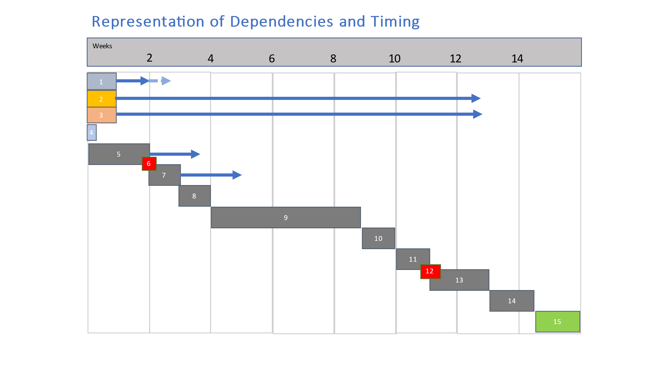

Appendix

Links to Various Forms and Information
A: Link to Supplement Standard Form: https://www.ercot.com/files/docs/2022/11/18/Supplement%20to%20Standard%20Form%20-%20Appendix%20B%2011-18-22%200952.docx
B: Link to DSP Acknowledgement Form: https://www.ercot.com/files/docs/2022/11/18/DSP%20Acknowledgment%20-%20Appendix%20A%2011-18-22%200950.docx
C: Link to RE Sign-Up Guide for RIOO: https://www.ercot.com/files/docs/2022/01/14/RE-SignUp-Guide-for-RIOO-Services.pdf
D: Link to Model Load Schedule: https://www.ercot.com/gridinfo/transmission/opsys-change-schedule/
E: Link to ICCP Handbook: https://www.ercot.com/files/docs/2022/02/10/ERCOT_Nodal_ICCP_Communications_Handbook.docx

What it required to submit registration information in RIOO before the DOTA is approved?
A Resource Entity may submit RIOO information prior to having an approved DOTA, however the TSP, DSP and ERCOT will need to determine the CIM Load for the ADER based on the preliminary information available at the time the RIOO information is collected.

