IE/RE Submits INR Application for Screening Study Only
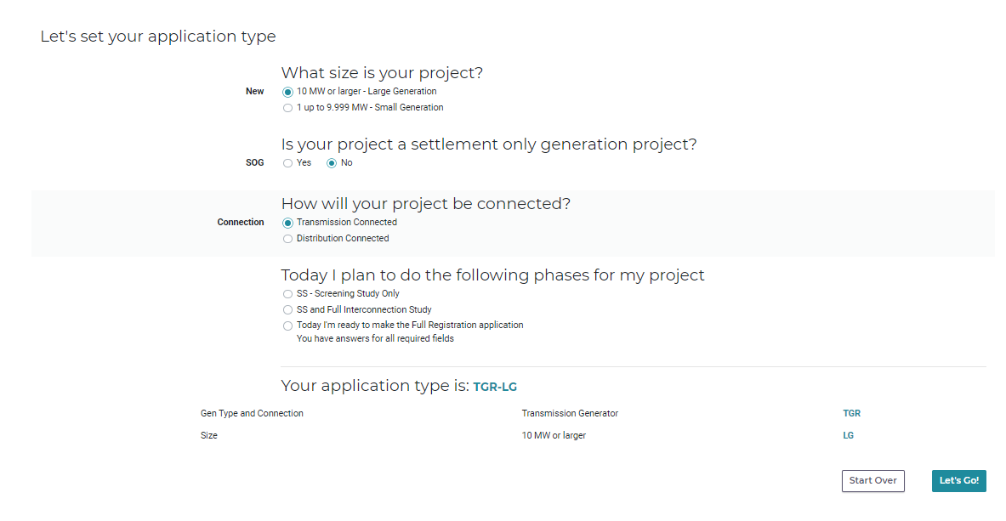
Figure 1 This is for Large Gen. This is the first different screen. Select an option under NEW, SOG, CONNECTION. Then pick the appropriate option under "Today I plan...". For a standard timeline, the IE will pick “SS – Screening Study Only”. Click “Let’s Go”
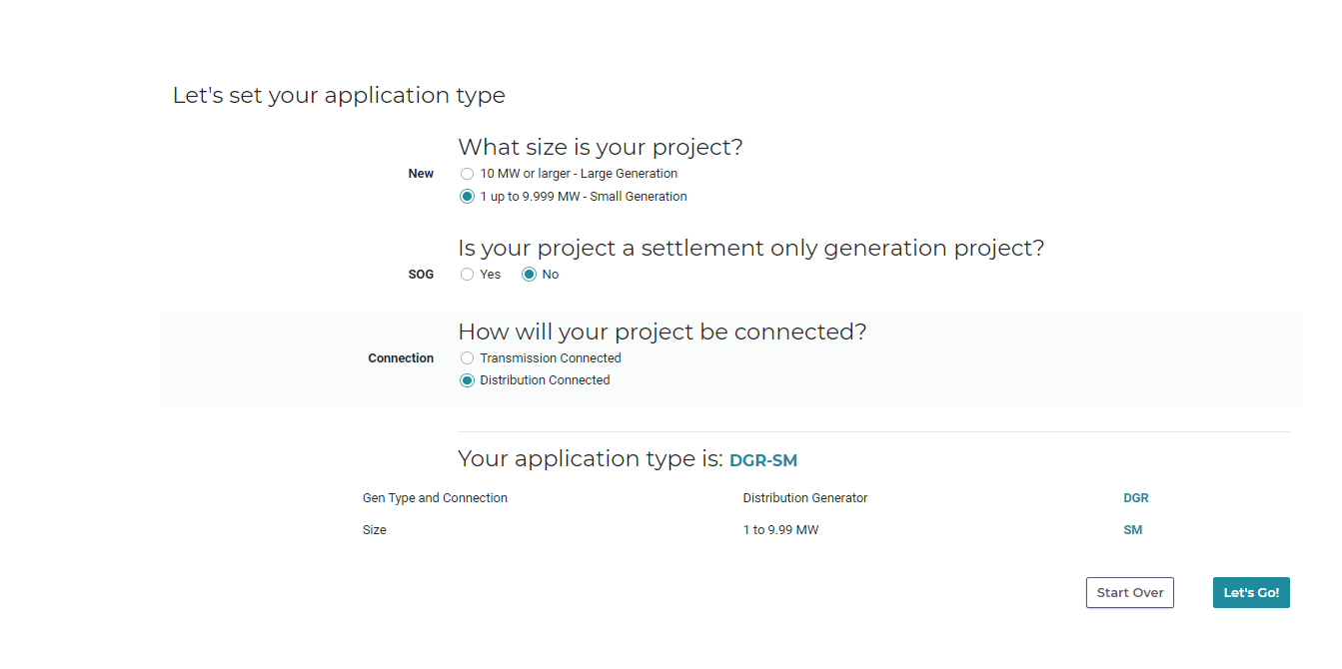
Figure 2 This is for Small Gen
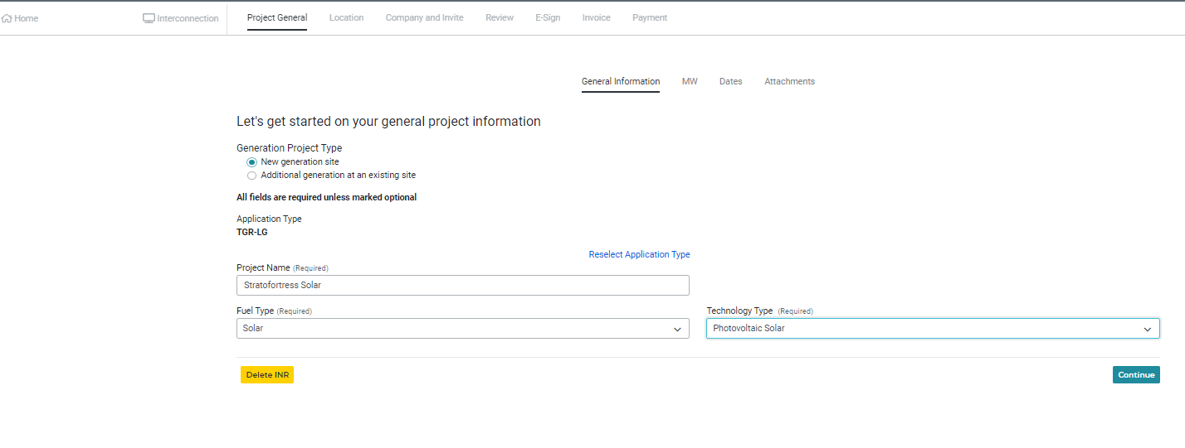
Figure 3Mostly the same as current, Note the Application Type is TGR-LG which means Transmission-connected Generation Resource - Large Generation. Also note the “Reselect Application Type” in blue. This will take you back to the previous screen. Click “Continue”
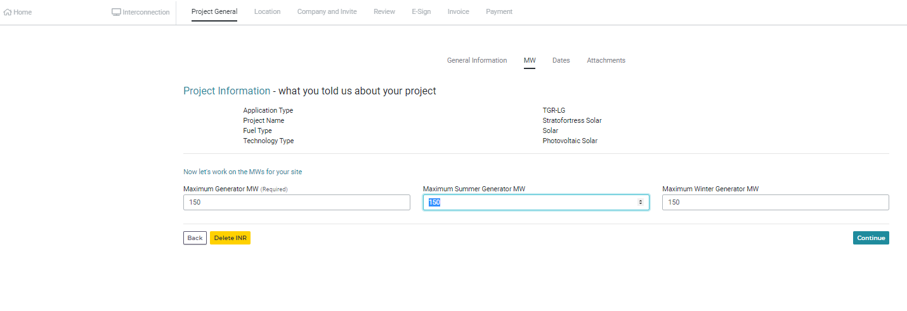
Figure 4This screen is relatively the same as current. Click "Continue"
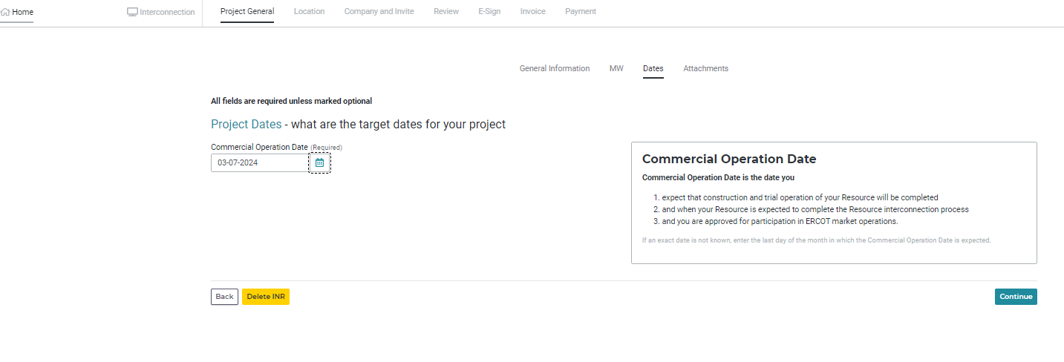
Figure 5 No changes to this screen. The COD has to be 15 months into the future. Click "Continue"
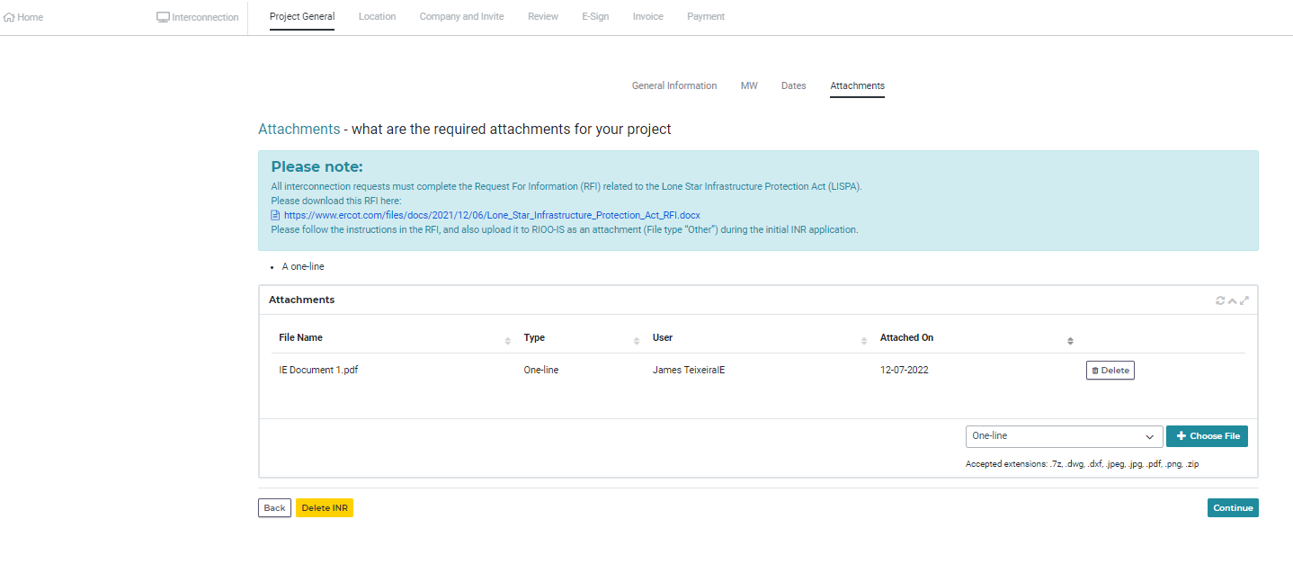
Figure 6 Since we are doing only the screening study, only the One-Line attachment is needed. Attach the one-line and click "Continue"
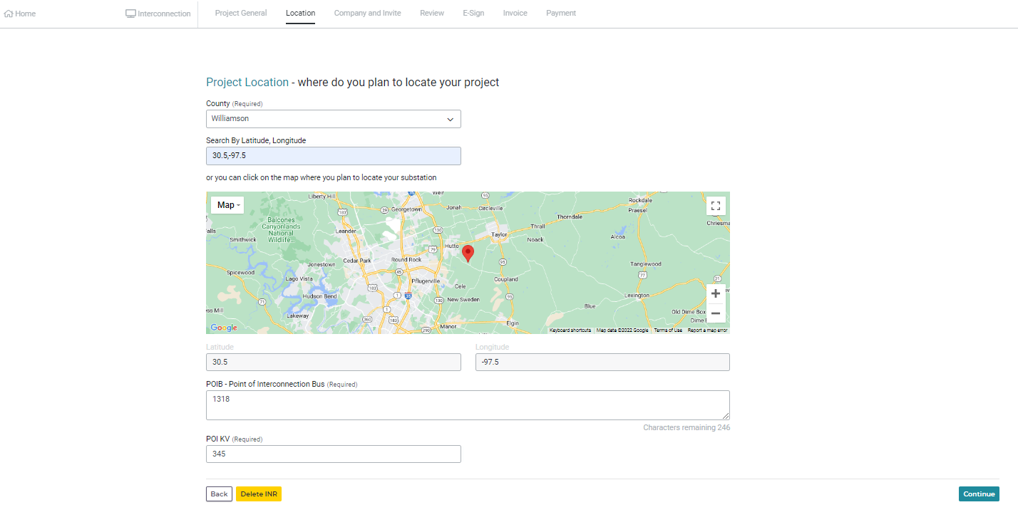
Figure 7 No changes here. Enter the info and click "Continue"
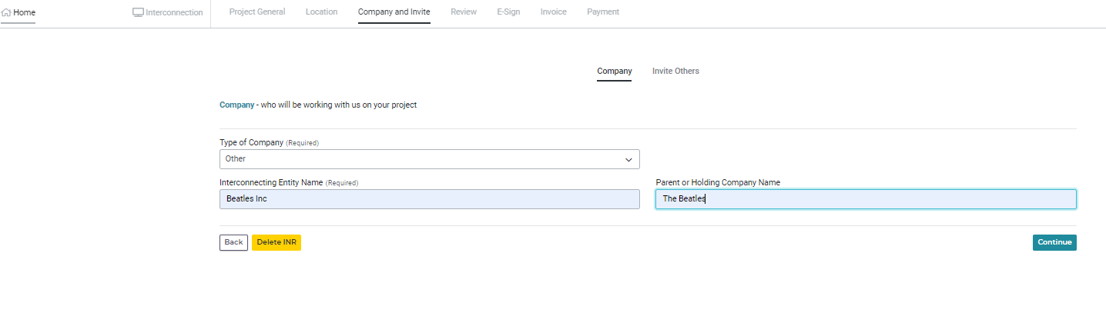
Figure 8 No changes here. Enter the info and click "Continue"
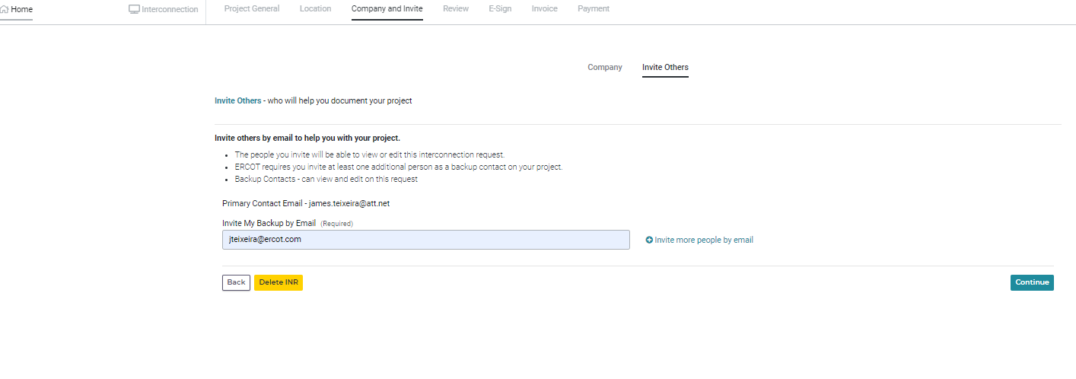
Figure 9 No changes here. Enter the info and click "Continue"

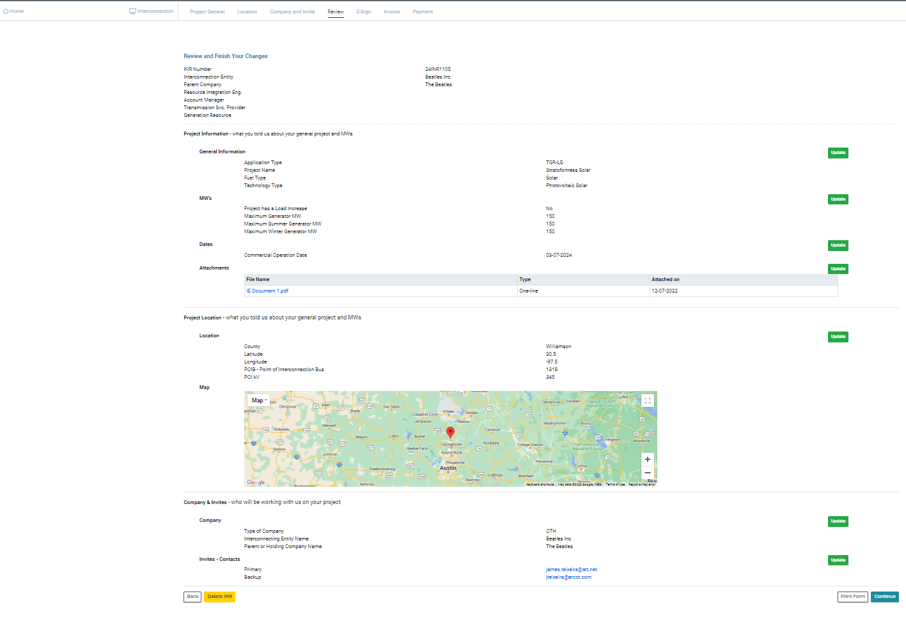
Figure 10 No changes here. Review for all green buttons on the right, click "Continue"
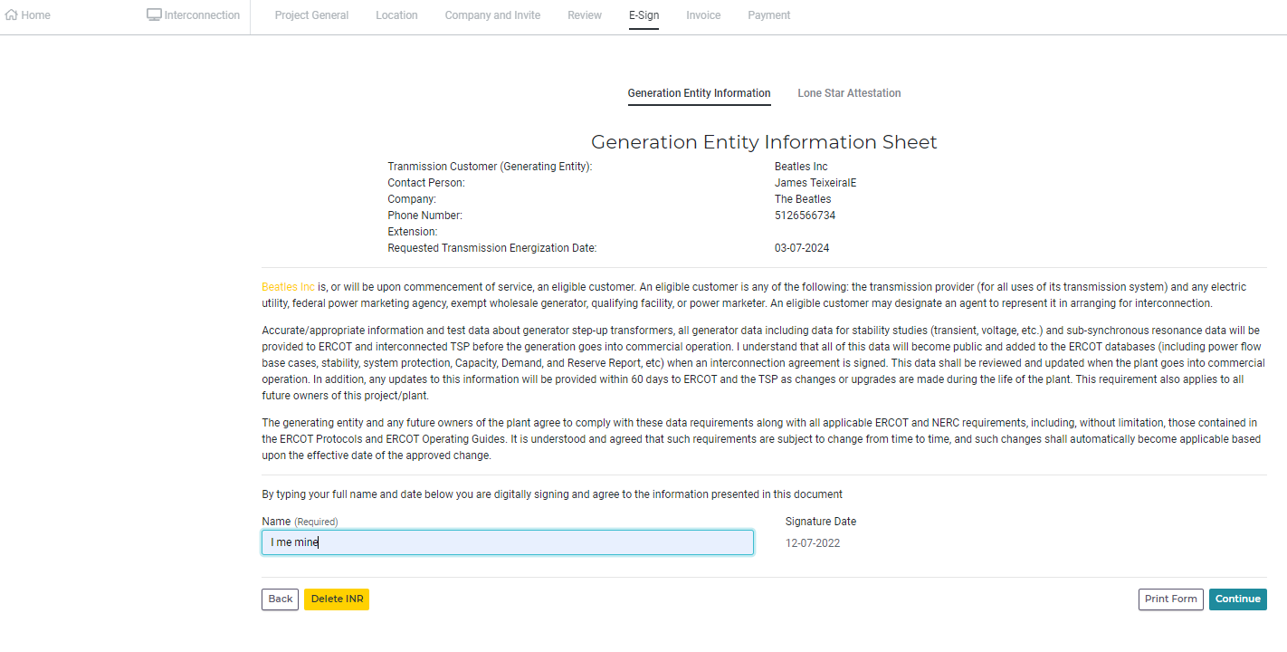
Figure 11 No changes, electronically sign in and click "Continue"

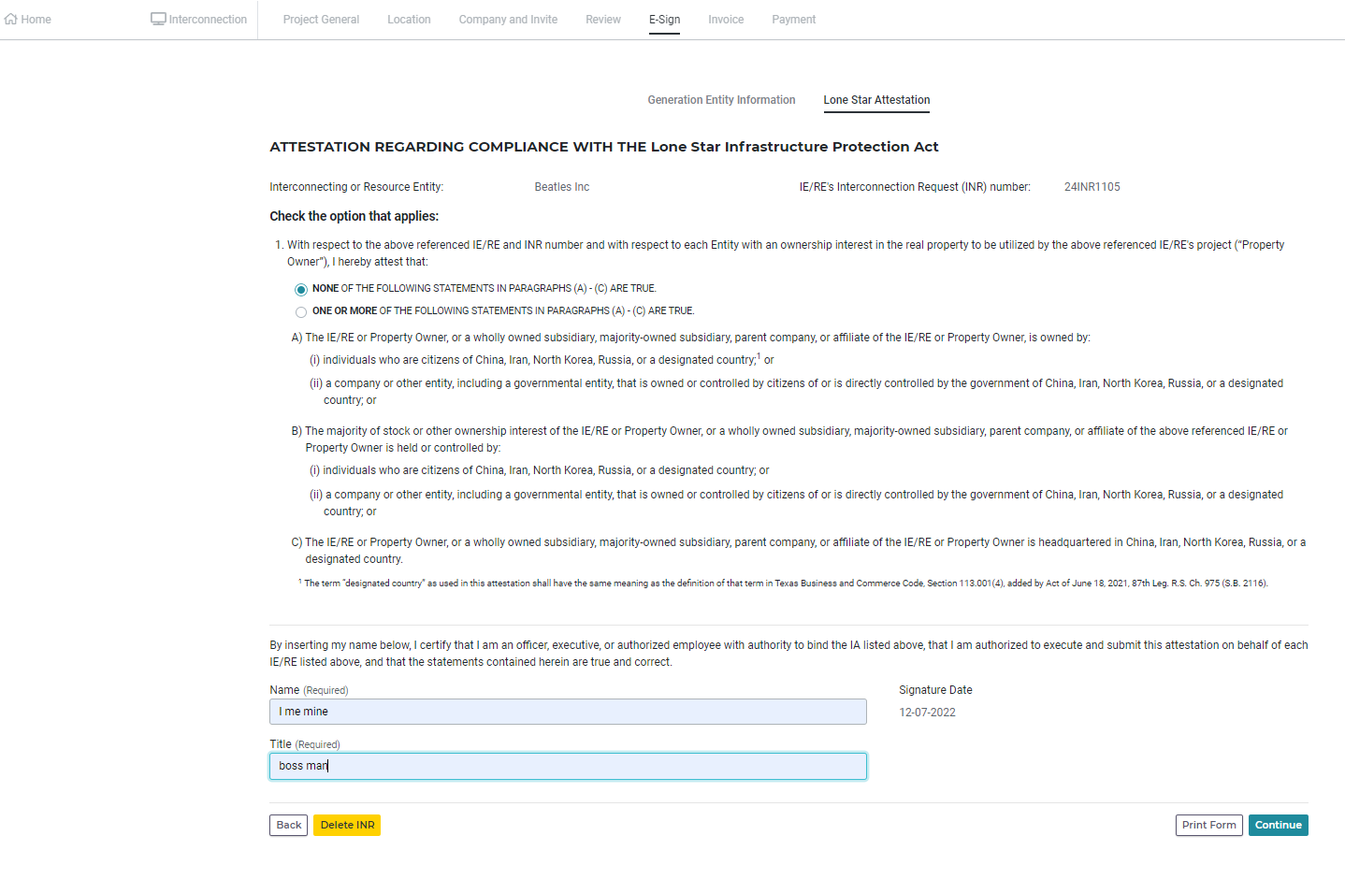
Figure 12 One of the options in paragraph 1 must be selected. Then electronically sign, with title and click "Continue"
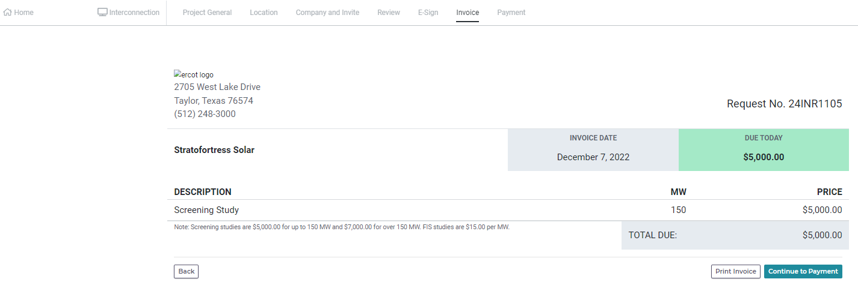
Figure 13 Review. Since we are doing Screening Study for 150 MW gen, the fee should be $5,000. This is in line with the ERCOT fee schedule –
Application to interconnect generation to the ERCOT System.
$5,000 (less than or equal to 150MW)
$7,000 (greater than 150MW)
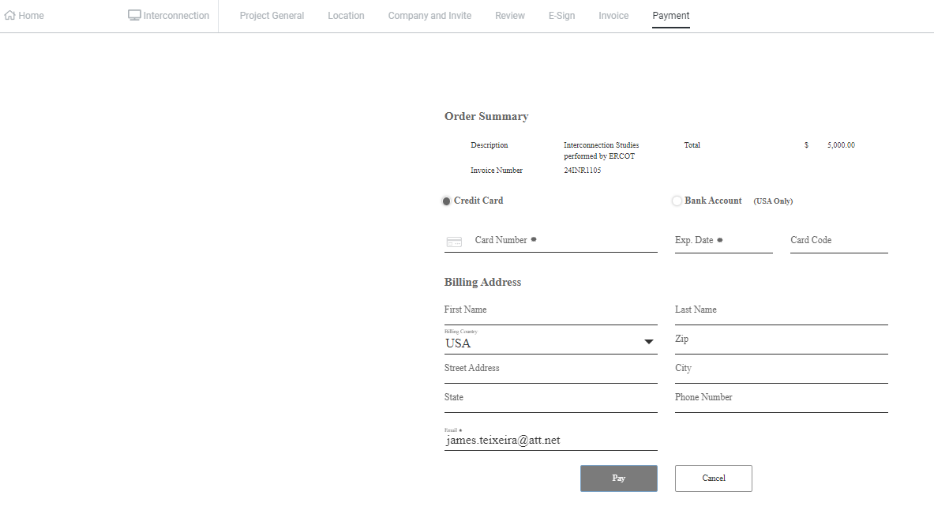
Figure 14 You must pay using this screen. Fill in the fields and click "Pay"
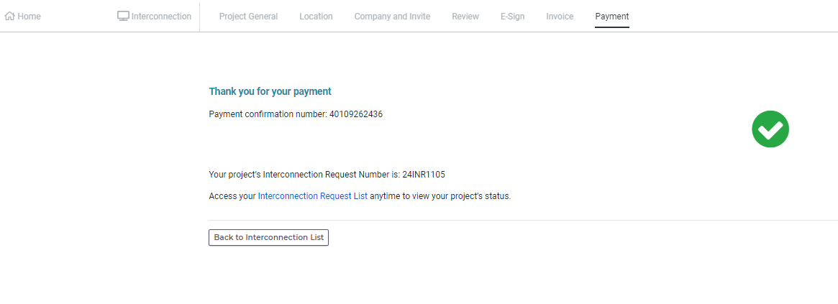
Figure 15 You should get confirmation screen.
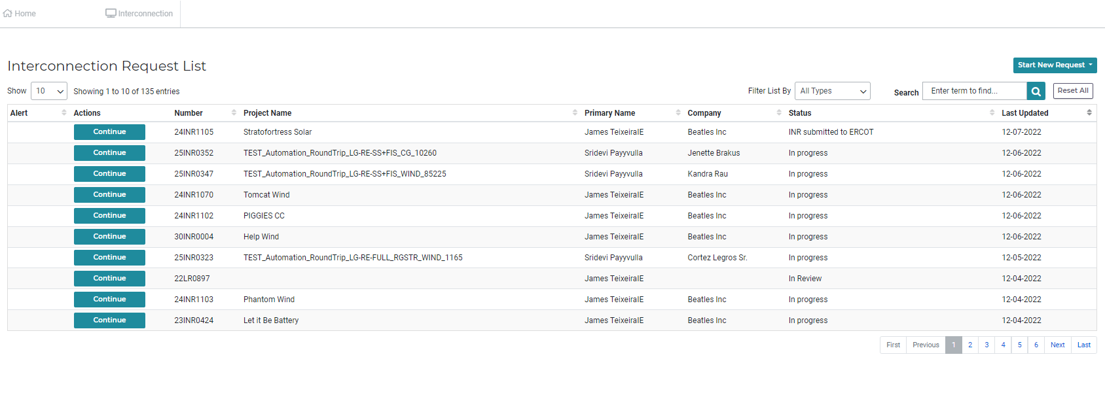
Figure 16 The status of the project in the dashboard should read "INR submitted to ERCOT"

ERCOT View of Screening Study Application
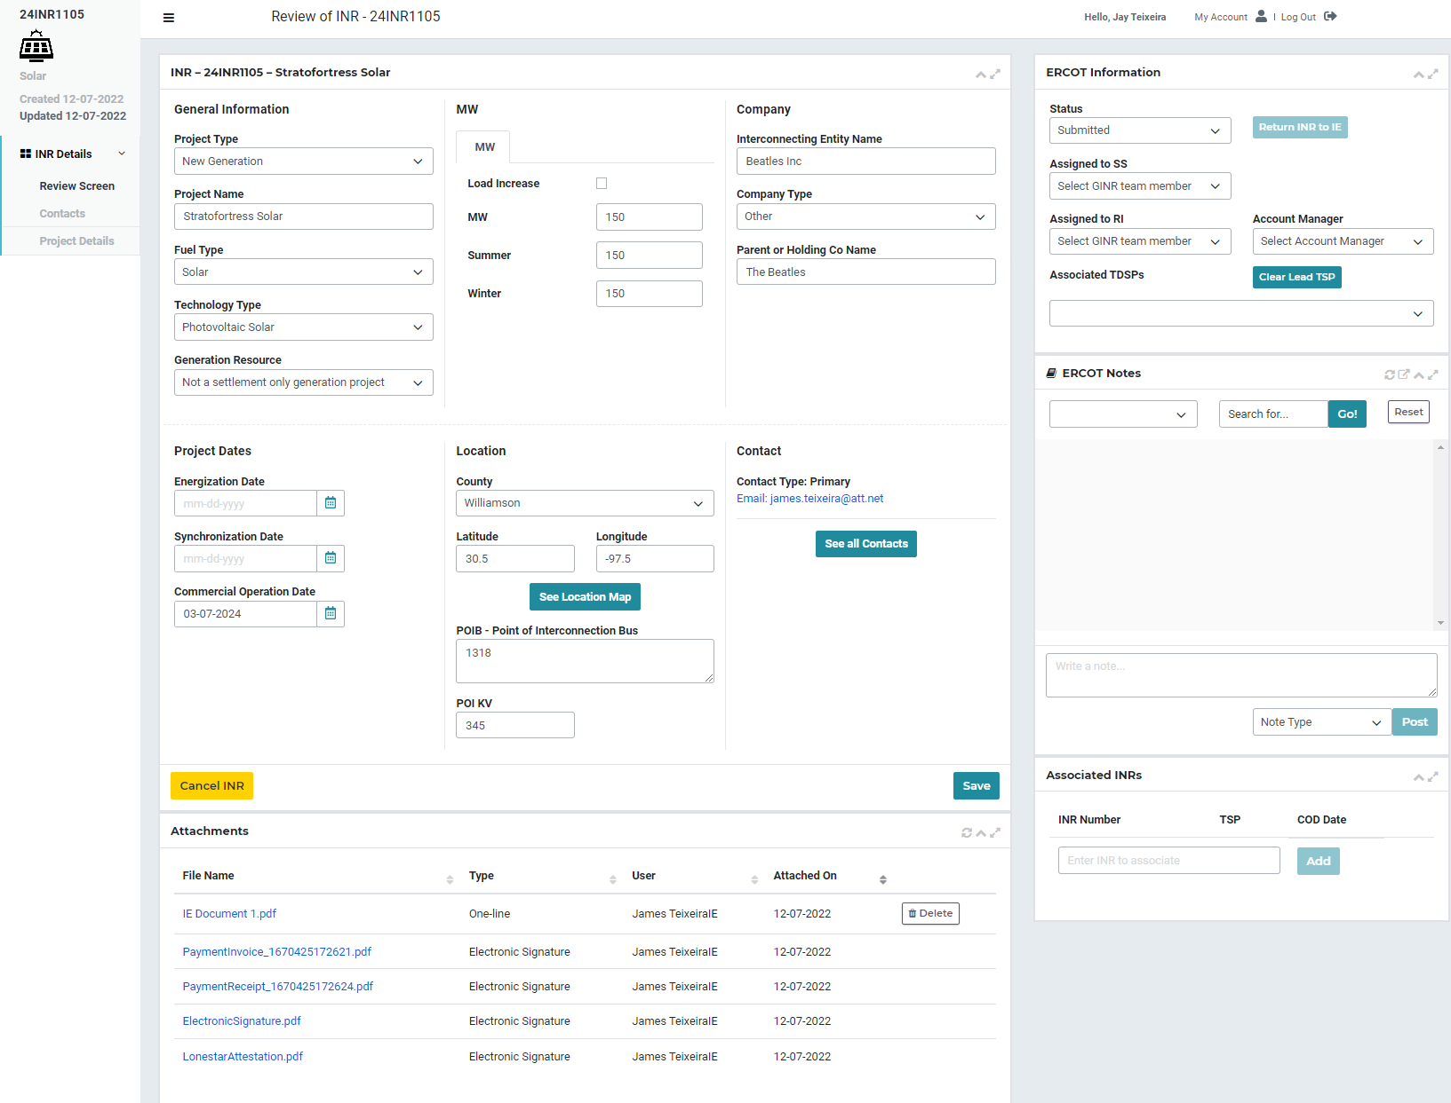
Figure 17 No difference at this point. Review application and attachments and set Status to Planned, assign SS Engineer, etc.
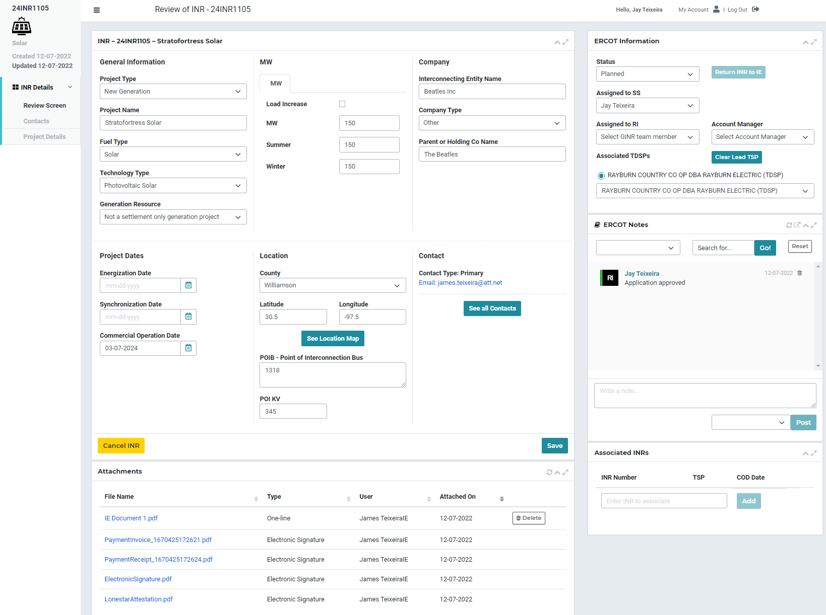
Figure 18 Application Approved

IE Submits FIS Request
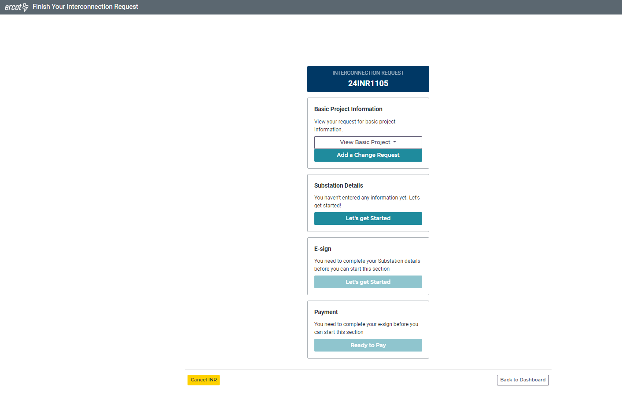
Figure 19 This is a new screen. After ERCOT approves application. IE/RE finds INR on their Dashboard and clicks on "Continue". To request the FIS, the IE/RE needs to "Add a Change Request" to add energization and sync dates and attach proof of site control.
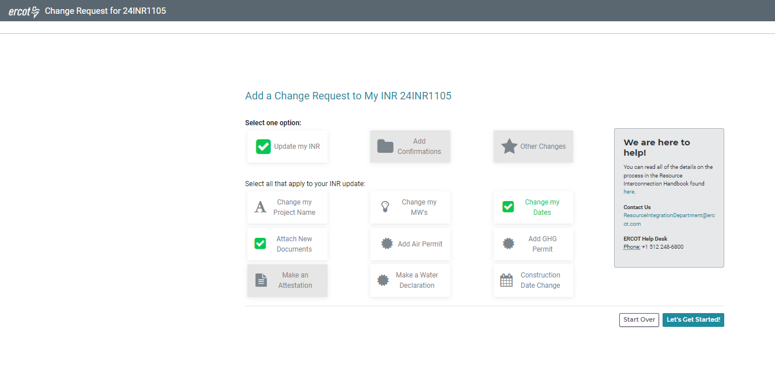
Figure 20 Click "Add a Change Request" on previous screen to get here. Choose "Update myh INR" and then "Attach New Documents" and "Change my Dates". Click "Let's Get Started"
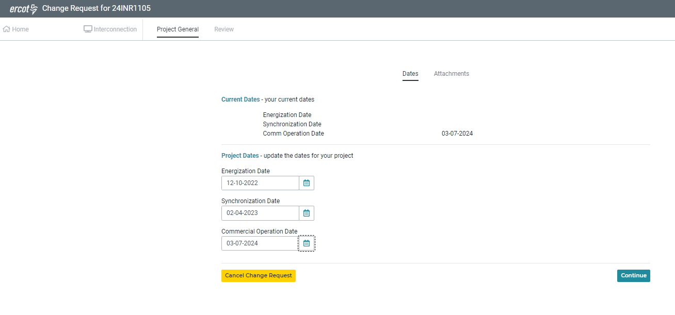
Figure 21 Add all 3 dates even though COD was previously populated. Click "Continue"
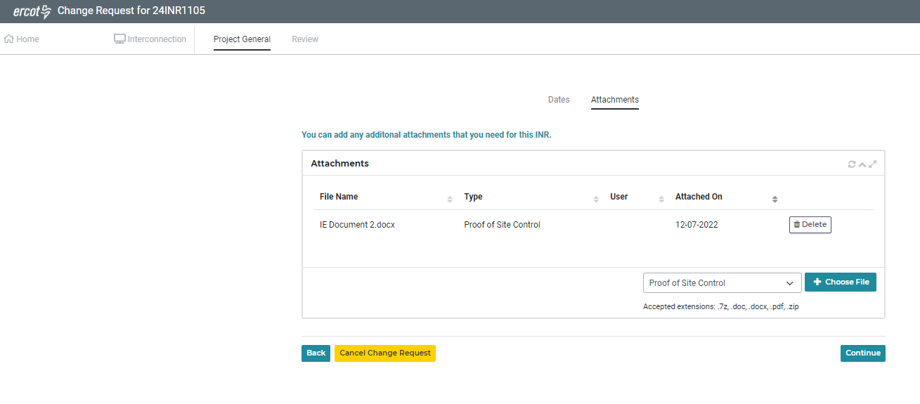
Figure 22 Attach Proof of Site Control document. Click “Continue”
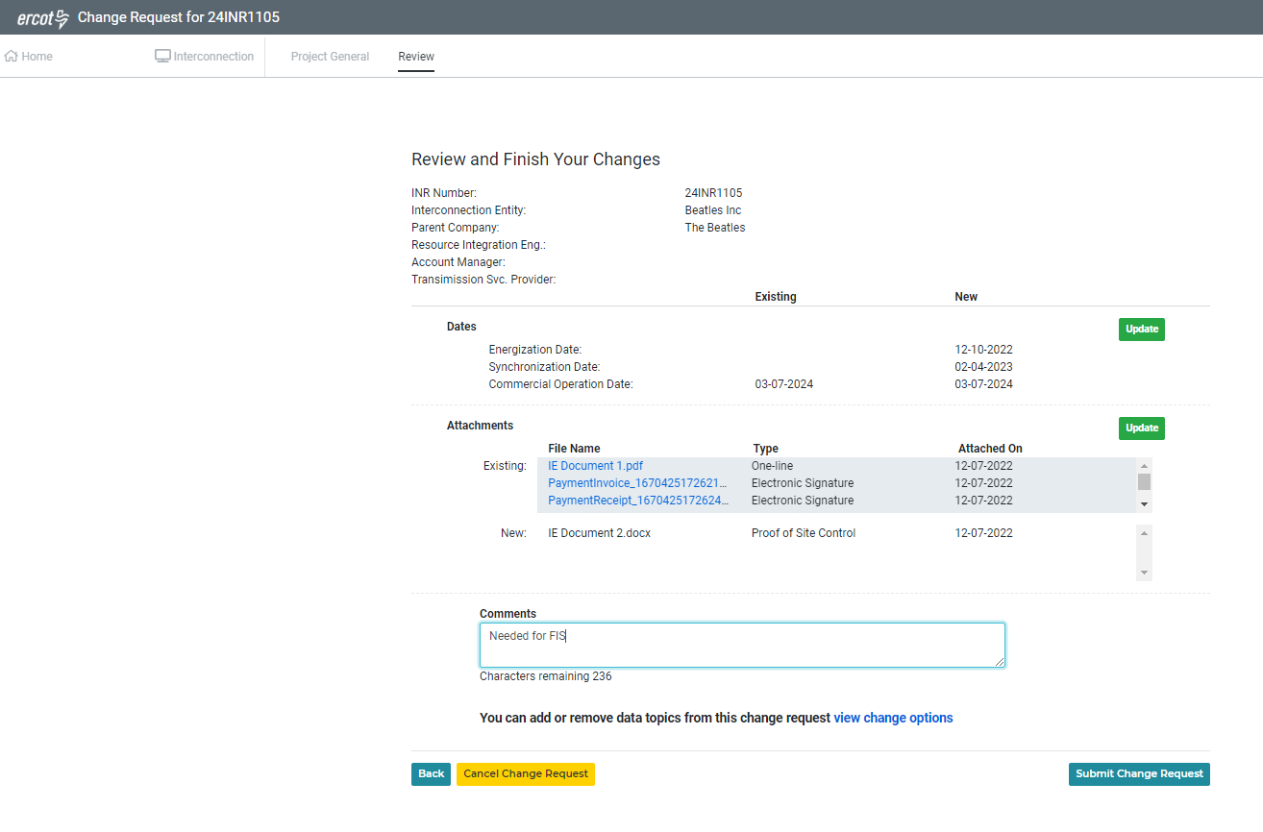
Figure 23 Review and click "Submit Change Request"
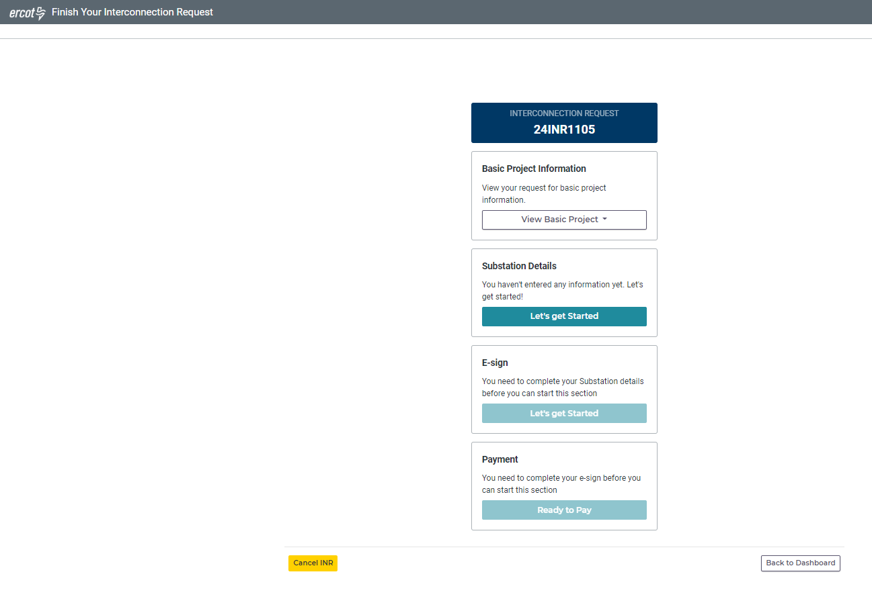
Figure 24 After successful submittal of Change Request, this screen comes up again. Note that "Basic Project Information" block does not allow a CR. ERCOT has not approved the CR just submitted.

ERCOT Approves Change Request
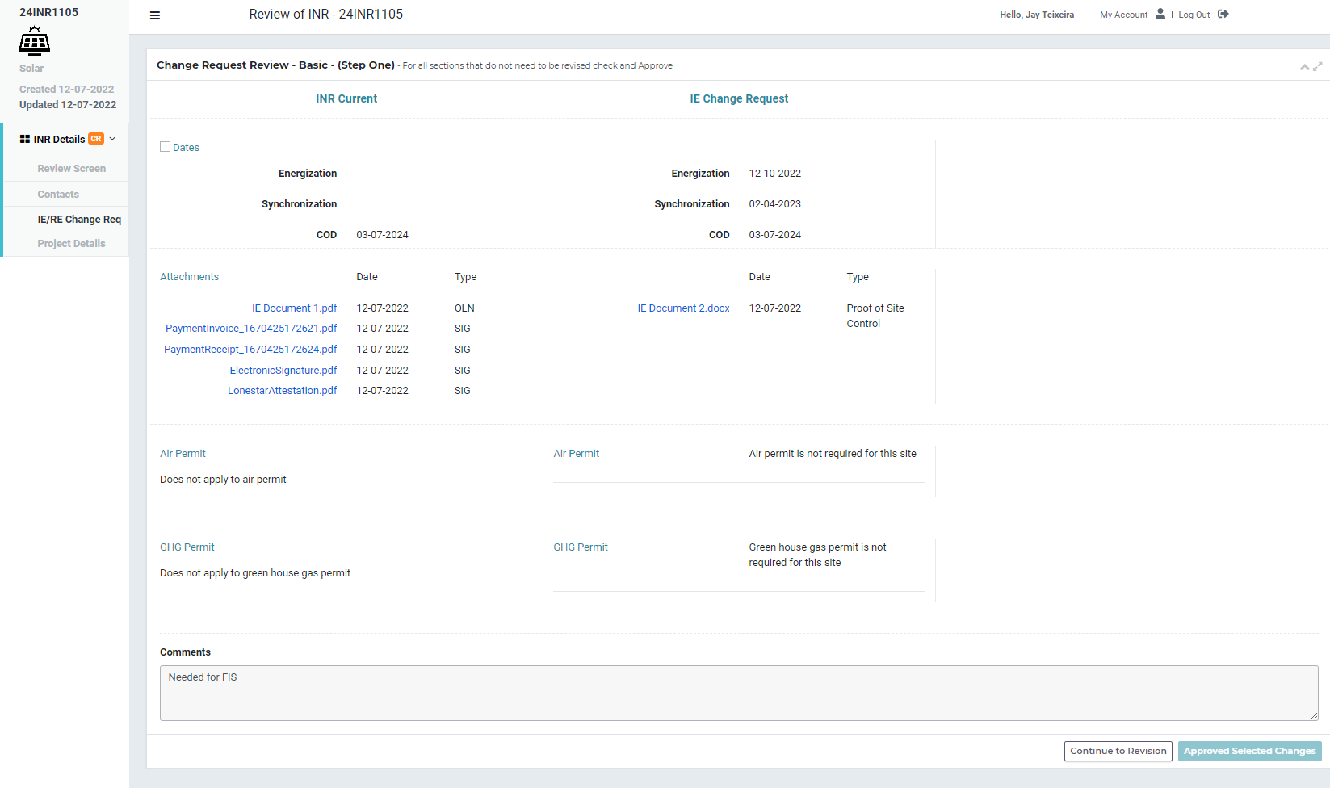
Figure 25 ERCOT gets the CR just as it does now. Click the "Dates" check box and then clicks "Approved Selected Changes"

IE Continues with FIS Request to submit FIS Resource Data (new)
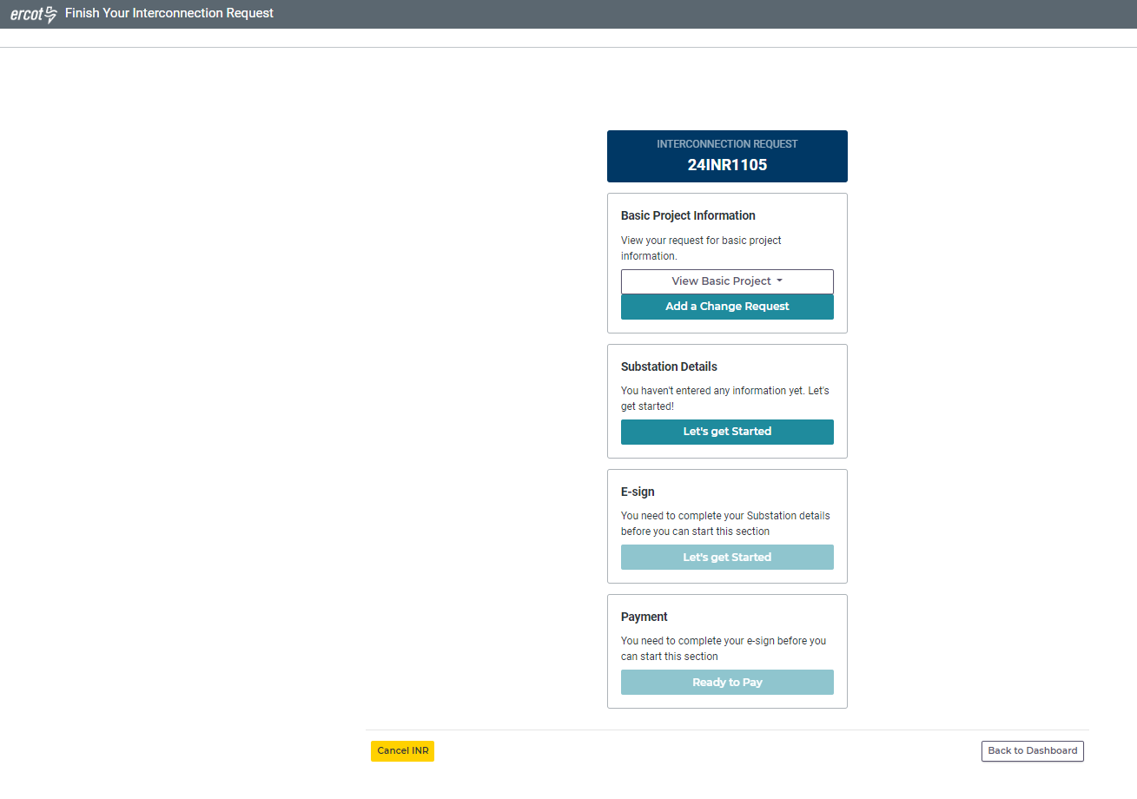
Figure 26 After ERCOT approves the CR, the IE/RE will see this screen. Note that now they can submit a new CR. Click “Let’s get Started” on the “Substation Details” block to start entering resource data needed for FIS.
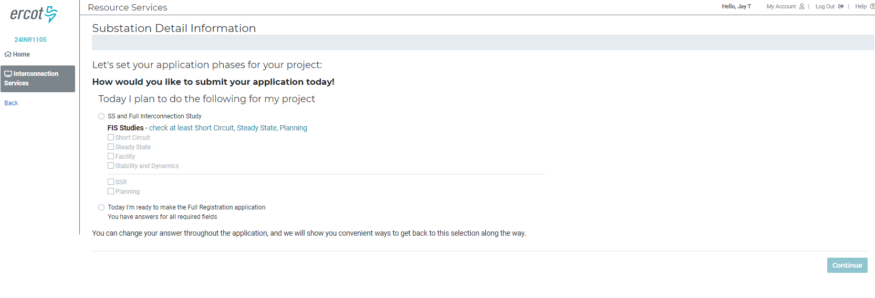
Figure 27 This is a new screen. To start the FIS, click the "SS and Full Interconnection Study" radial button, then select either "Short Circuit", "Steady State", "Stability and Dynamics" or any combination.
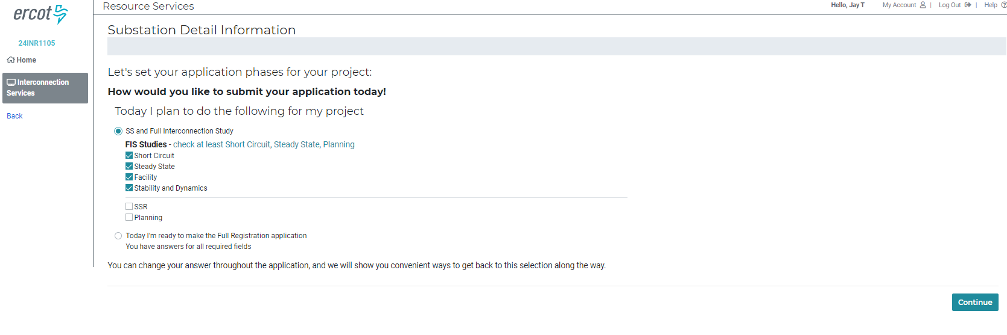
Figure 28 Clicking just the "Facility" study alone will not start the FIS, but it should be clicked when the data for all three studies has been entered. Click “Continue”
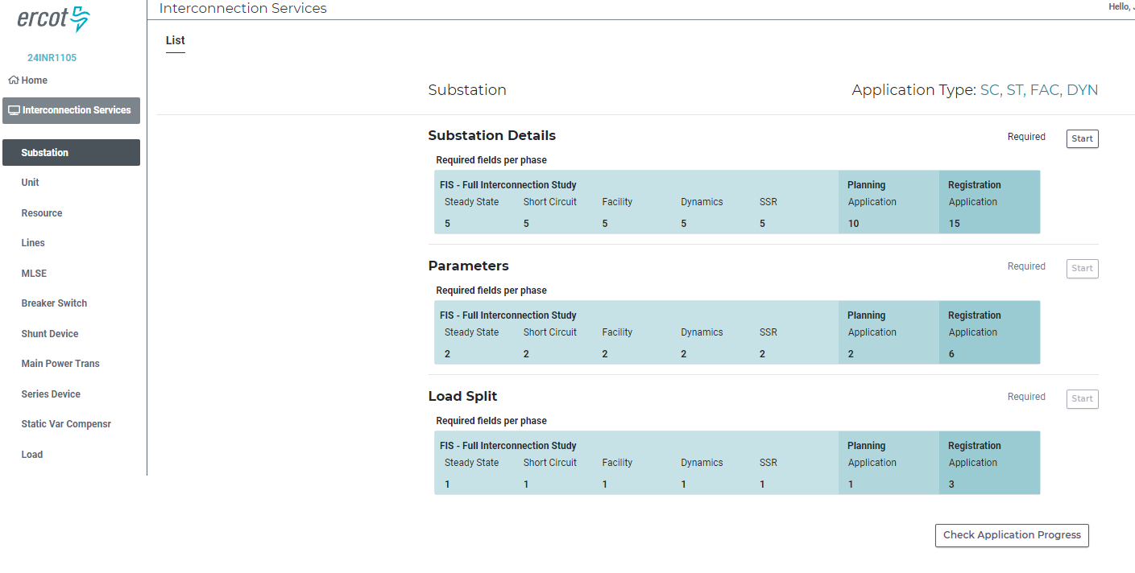
Figure 29 This is a new screen. The left side of the screen is the "Left Navigation" part of the screen. You can move among devices by clicking one of these tabs. The right side of the screen shows the sections for "Substation" which is selected in the Left Nav. The numbers inside the shaded blue sections indicate the number of required fields for each study and phase of the interconnection. Click on the “Start” button to the right of the “Substation Details” section.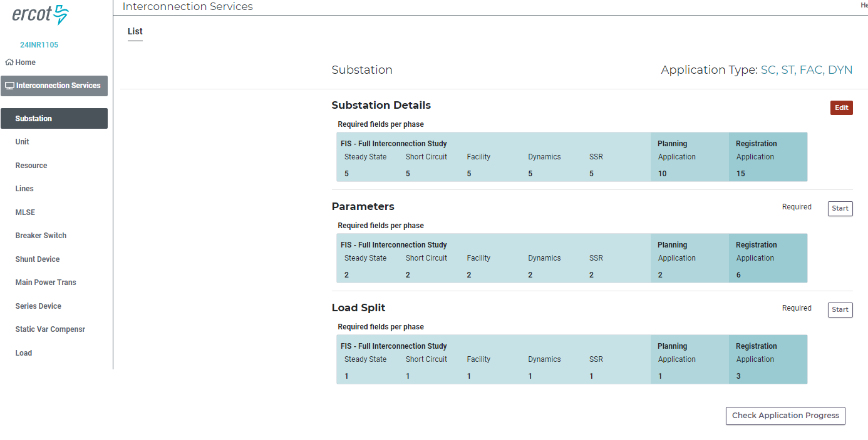
Figure 30 After clicking the start button, the button turns red indicating that data should be entered or corrected in that section. Click the red "Edit" button.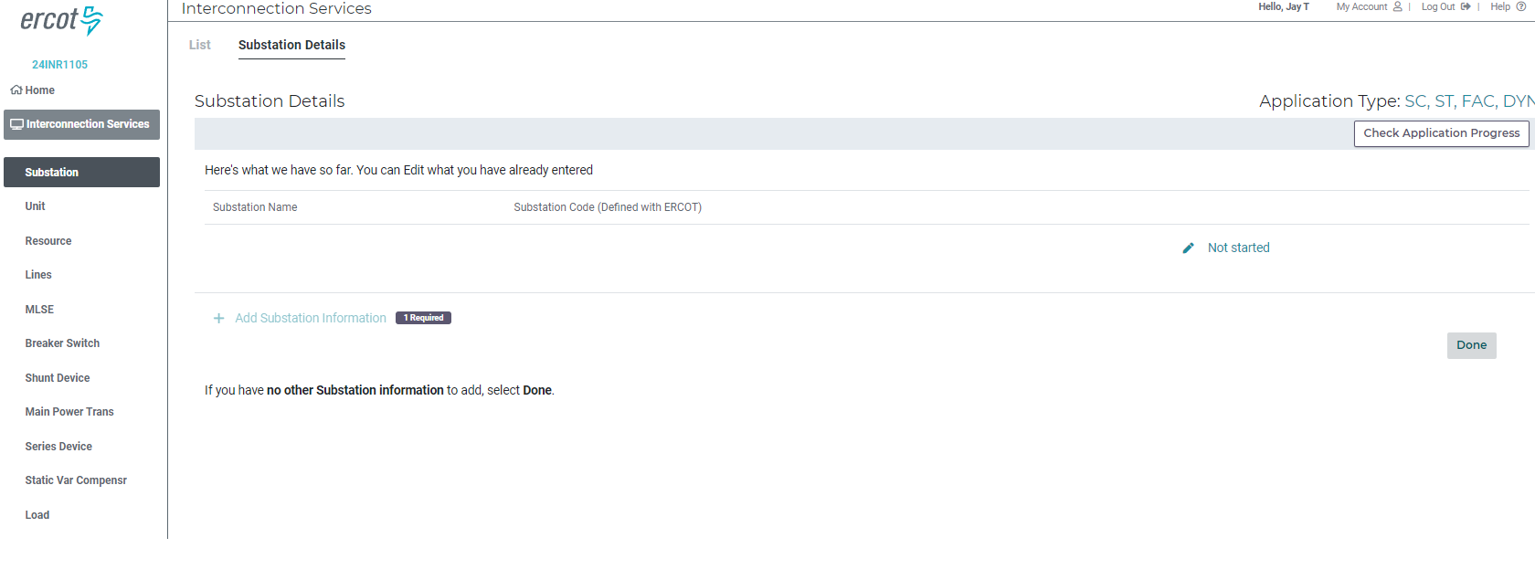
Figure 31 After clicking the Edit button, this screen is shown and is known as the "Pre-Rec" page. If no data has been entered, the IE/RE will see "Not Started". If data has been entered the IE/RE will see a red or green "Edit". Red means some data needs to be entered or corrected. Green means no data needs to be entered or all data entered meets validation rules. Click on “Not Started”
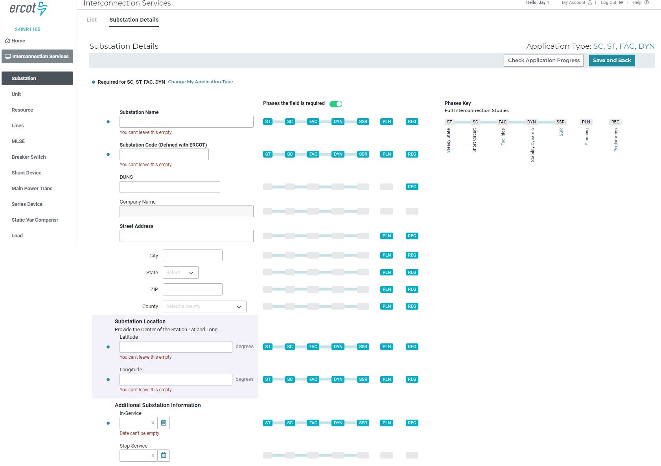
Figure 32 This is the blank entry screen for Substation Details. In the middle at the top click the “phases the field is required” slider to show data that is required for the current application type, which can be seen in the top right and reads “SC, ST, FAC, DYR”. This is from Figure 27 where the IE/RE selected the FIS studies they would be entering data. All data that has “SC”, “ST”, “FAC” or “DYN” shown in white letters on blue background, must be entered. This is also indicated by the blue dots to the left of each entry field.
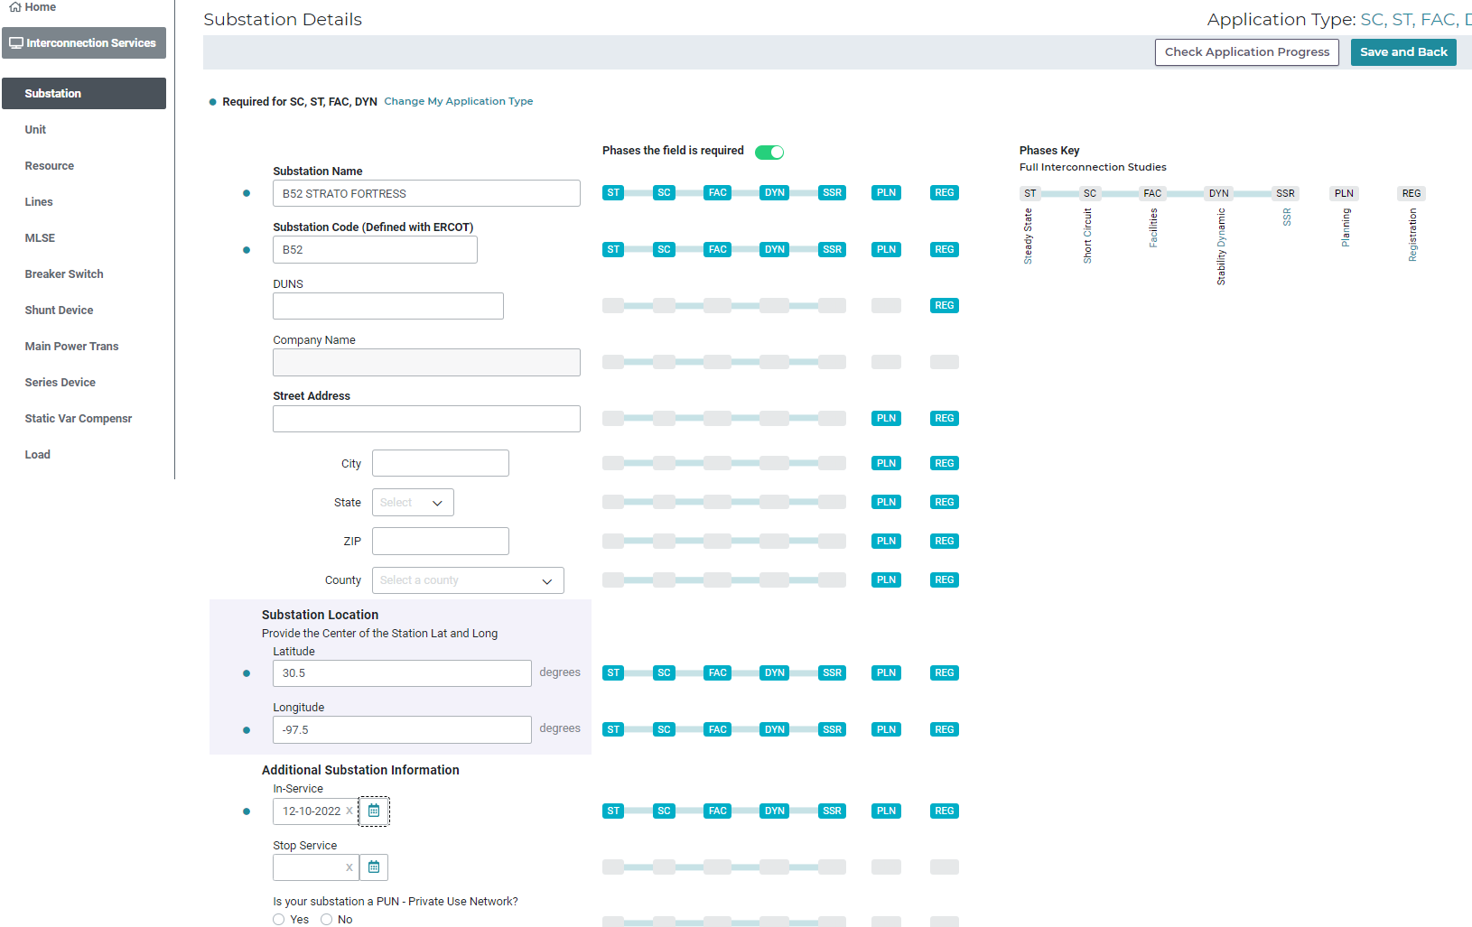
Figure 33 As the required data is being entered, it is being validated and the IE/RE may get red or orange text below the entry field. Red text indicates a validation error and must be fixed. Orange text indicates a validation warning and does not have to be fixed but the IE/RE should review the data for accuracy.
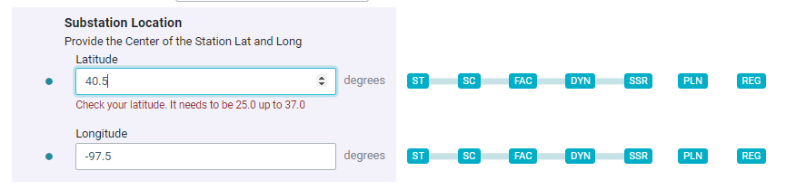
Figure 34 This shows red text indicating a validation error. The latitude entered is outside the accepted latitude for the state of Texas. This must be corrected, or the page will have an error and the resource data will not be able to be submitted.
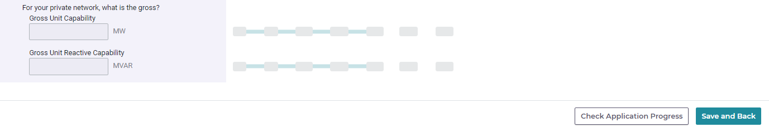
Figure 35 Once all the data has been entered and no red text error messages are displayed, click the “Save and Back” buttons at either the top or bottom right of the page.
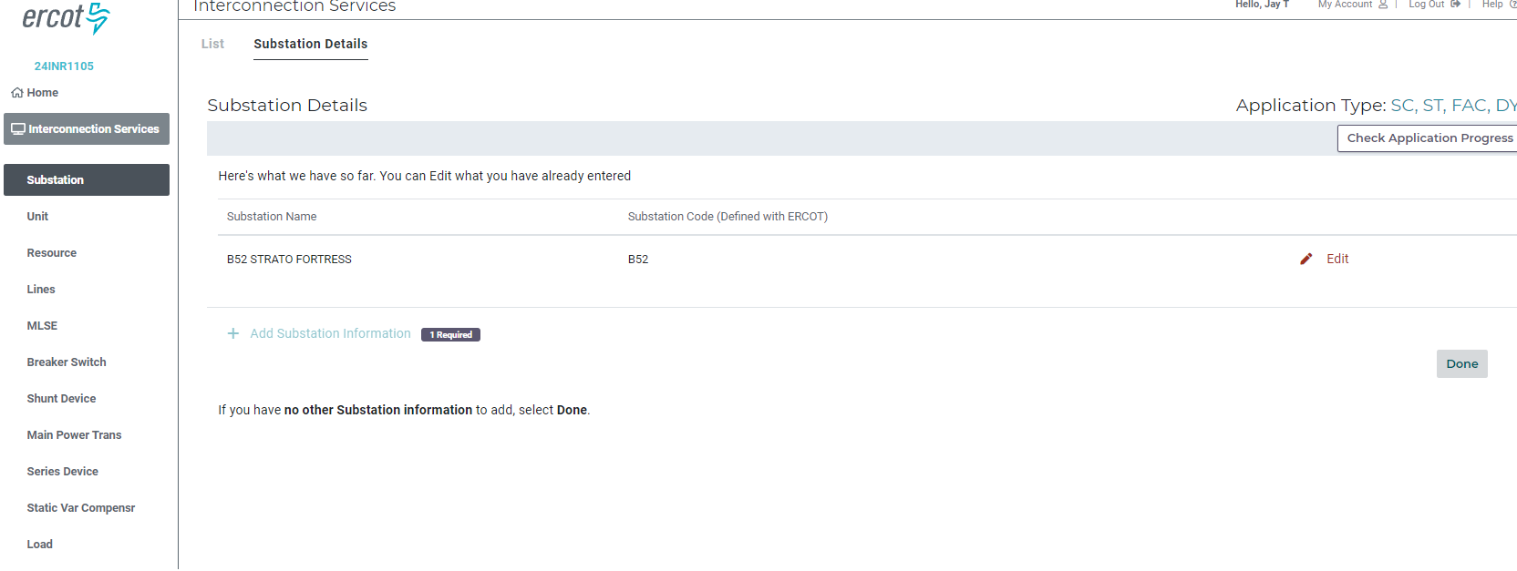
Figure 36 The error shown above was not fixed so after clicking the “Save and Back” button, the IE/RE goes back to the pre-rec page and sees a red “Edit” button. This means there is an error that must be fixed or a required field was not entered. Click the red “Edit” button to go back to the Substation Details page and fix the error.
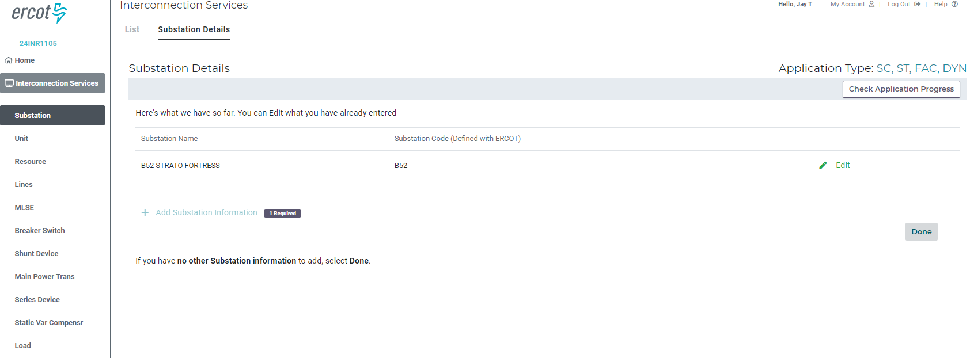
Figure 37 After changing the 40.5 to 30.5, the error was fixed, the “Save and Back” button was clicked, and now at the pre-rec page the “Edit” is green.
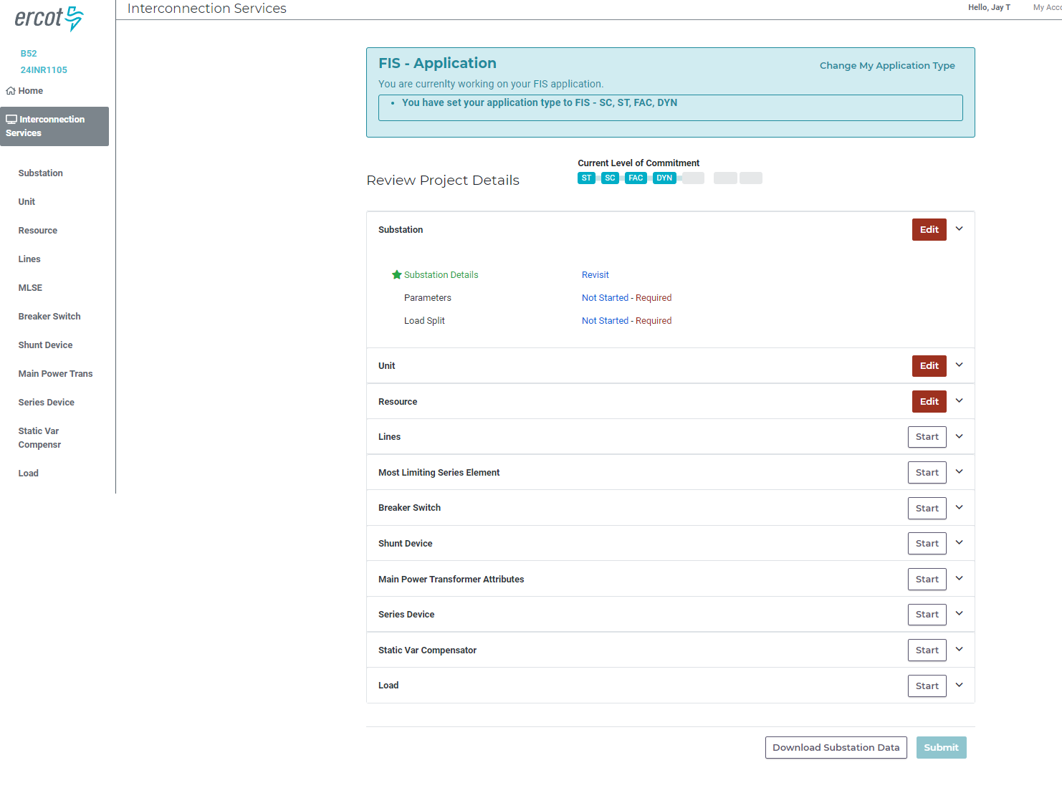
Figure 38 The “Check Application Progress” button can be clicked to show where the next required data to enter exists. The Substation “Edit” button is still red so there is more there to enter. Clicking the down arrow to the right of the “Edit” button expands to show all the data pages under Substation. The “Substation Details” is green and has a link to “Revisit” the data if desired. The next place to enter data is the “Parameters” page in the Substation section. It shows “Not Started – Required” to show that there is required data on that page that has not been entered. Click on “Not Started – Required”.
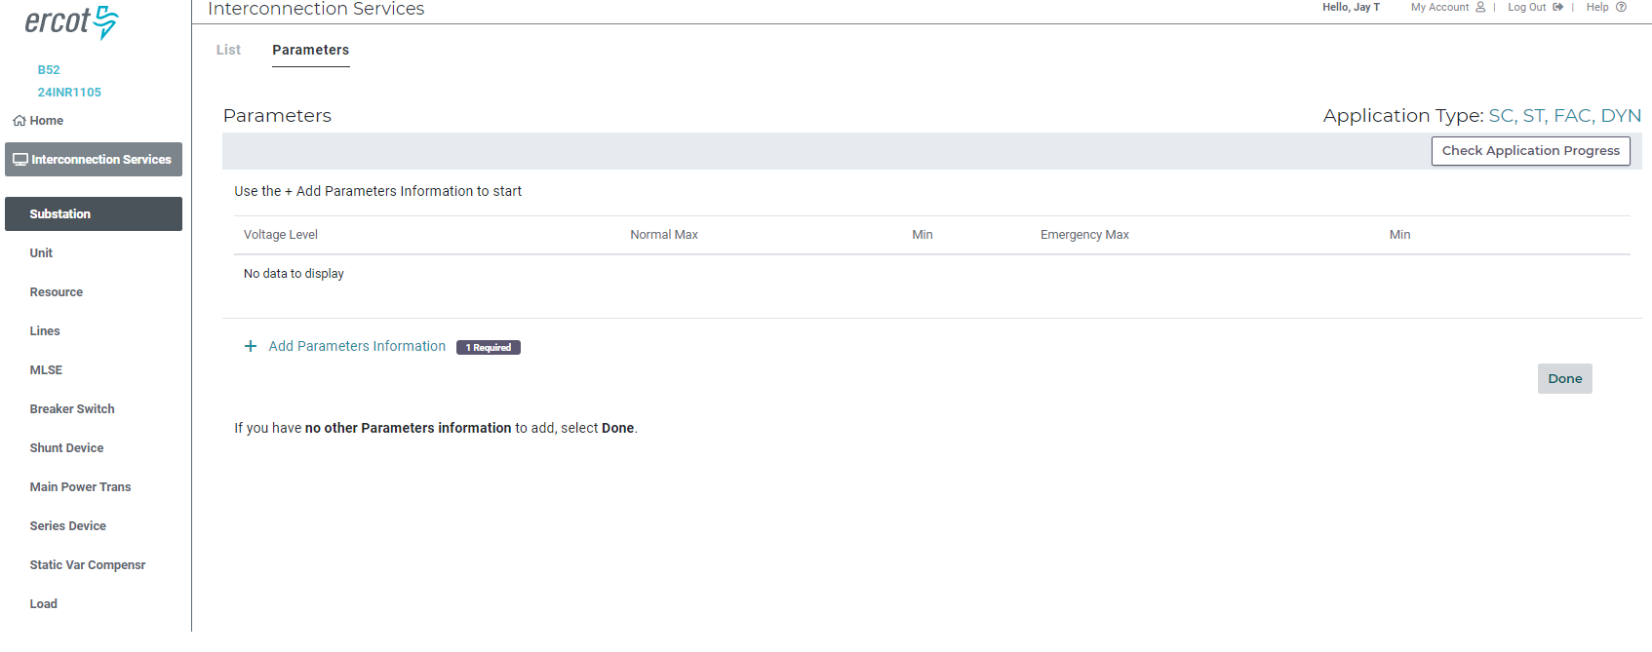
Figure 39 This page is like the Substation Details page but instead of a “Not Started” or “Edit” button, it has a “+ Add Parameters Information” link below the pre-rec data. Click on this link to enter Substation Parameters.
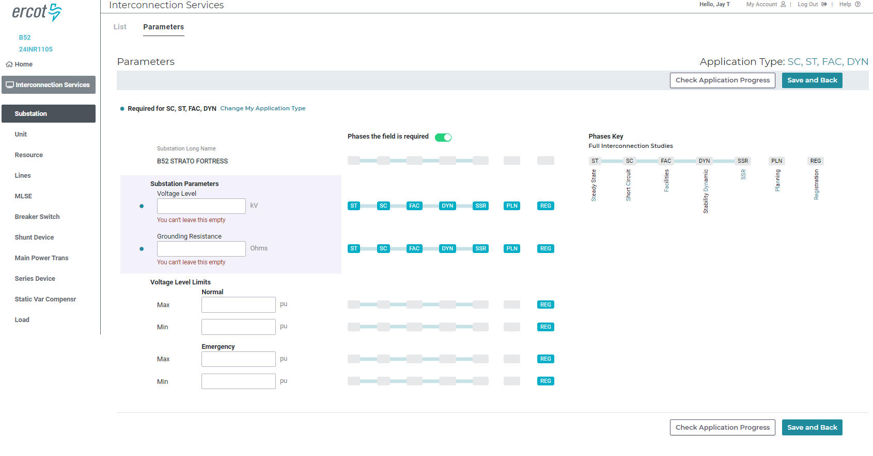
Figure 40 Click the slider for “Phases the field is required” to show the required fields. The blue dots also show required data. The substation parameters required are “Voltage Level” and “Grounding Resistance”. Enter this data and click “Save and Back”.
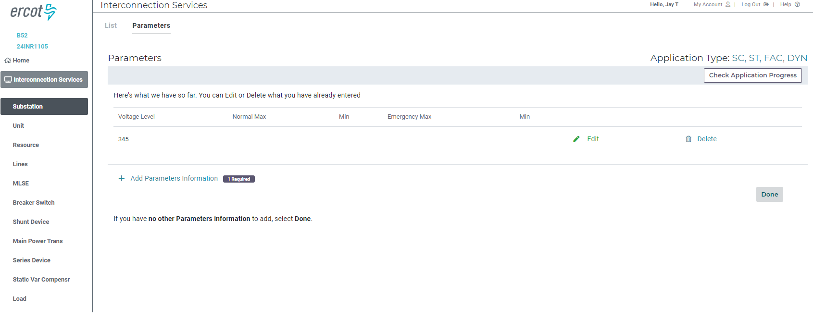
Figure 41 Now this page has a green "Edit" link. It can also be deleted by clicking the “Delete” link.

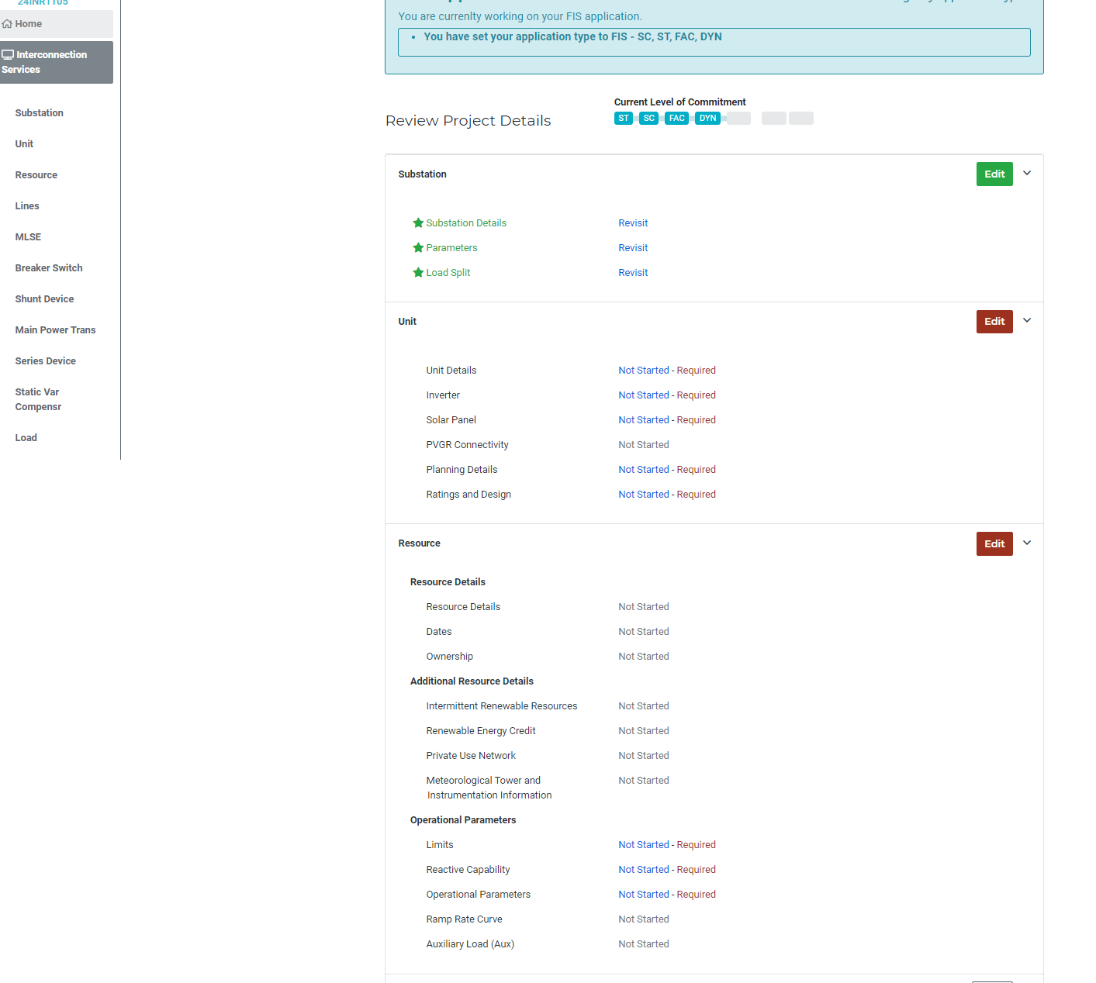
Figure 42 After entering the data for Substation “Load Split”, the required data for the Substation section has been entered and the section has a green “Edit” button. The next data that needs to be entered is the Unit data, starting with the “Unit Details” page. Then move to the next page and when complete, the next section. The Substation, Unit, and Resource sections are the minimum data sections that must be completed. Other sections are completed if the IE/RE has that type of equipment, such as breakers, shunt devices, lines, transformers, etc. The MLSE section should be complete if the IE/RE has data to enter in that section.

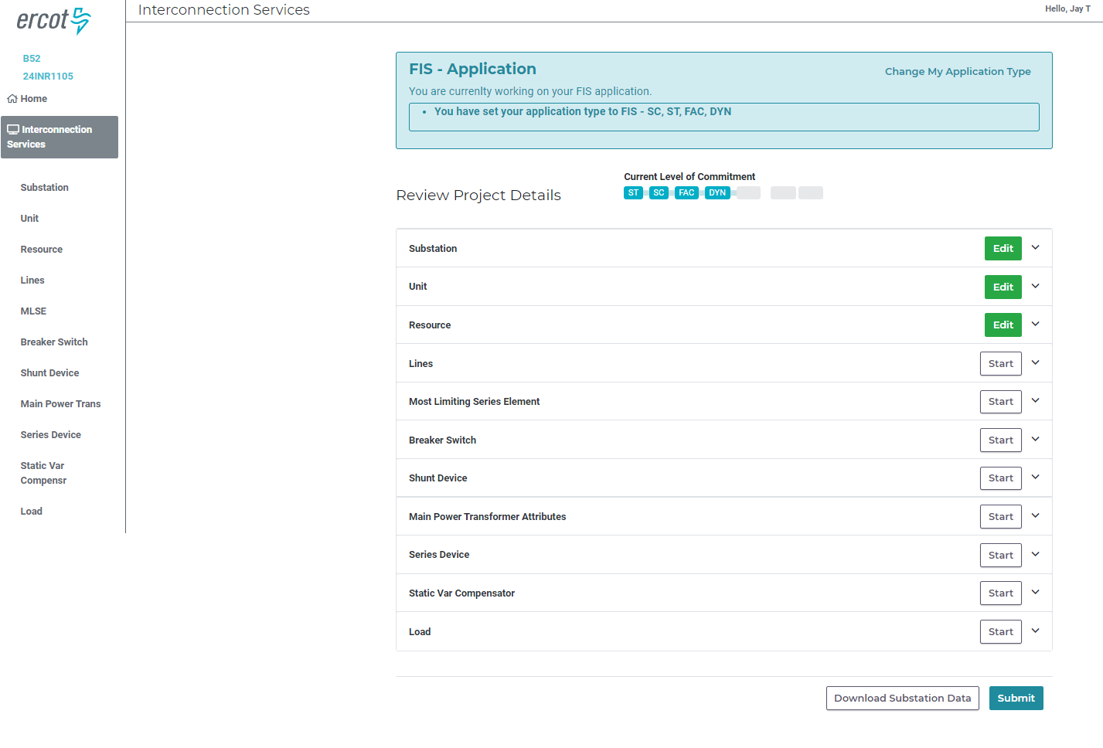
Figure 43 After entering all the required data and getting a green “Edit” button for the Substation, Unit, and Resource sections, the “Submit” button is now enabled. Click the “Submit” button will end the resource data screen and move to the next block to submit the FIS Request to ERCOT.
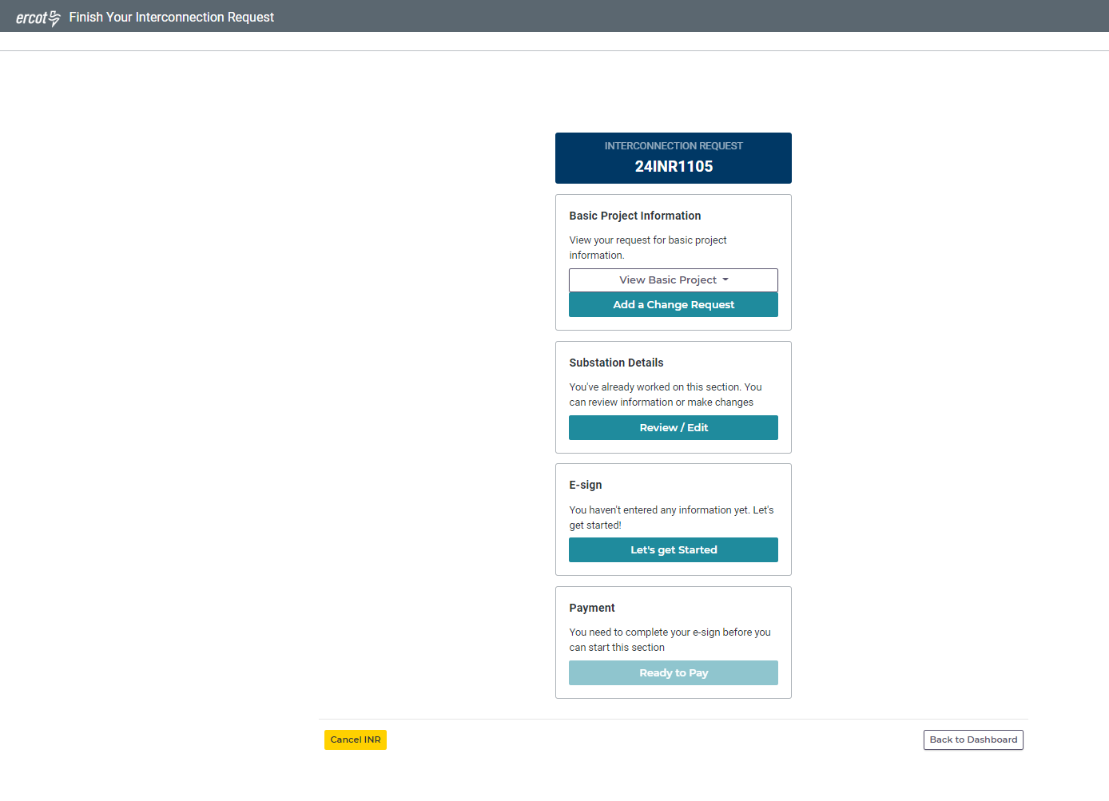
Figure 44 After clicking the “Submit” button, the IE/RE is returned to the “Finish Your Interconnection Request” screen. Read the text for each of the blocks. The E-Sign block says that no information has been entered yet. Click on the “Let’s get Started” button in the E-sign section.
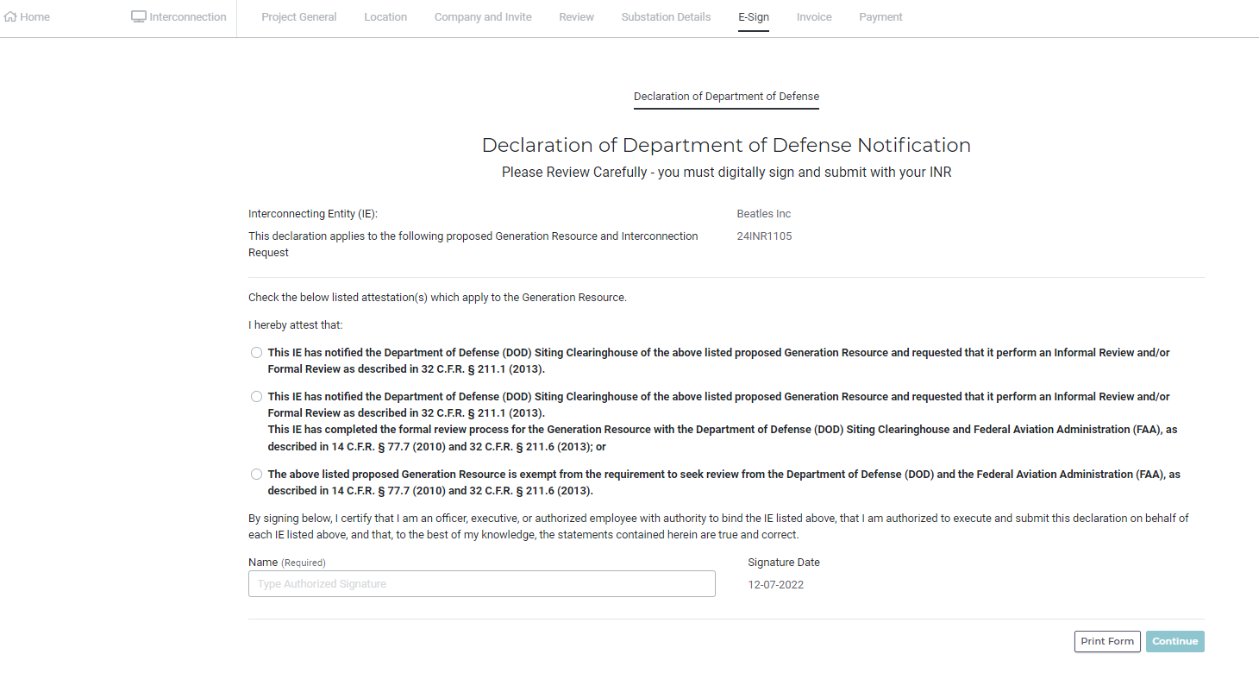
Figure 45 After clicking the E-sign button, the IE/RE is brought to the DoD declaration. Choose the appropriate radial button, electronically sign, and click the “Continue” button.
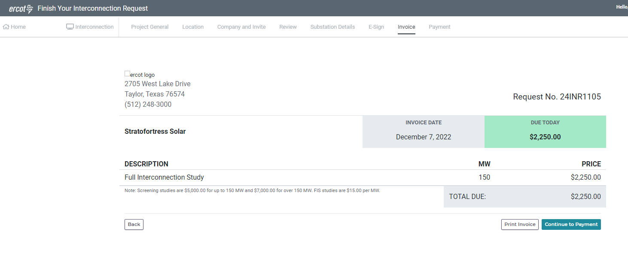
Figure 46 Now the payment for the FIS must be paid. Click the “Continue to Payment” button and make the payment as was done for the Interconnection fee in Figure 13. The FIS request has now been submitted to ERCOT.
At this time, ERCOT does not receive any indication that the FIS request has been made. The IE/RE should email ERCOT and make it known.

IE/RE Submits Planning data to meet PG 6.9

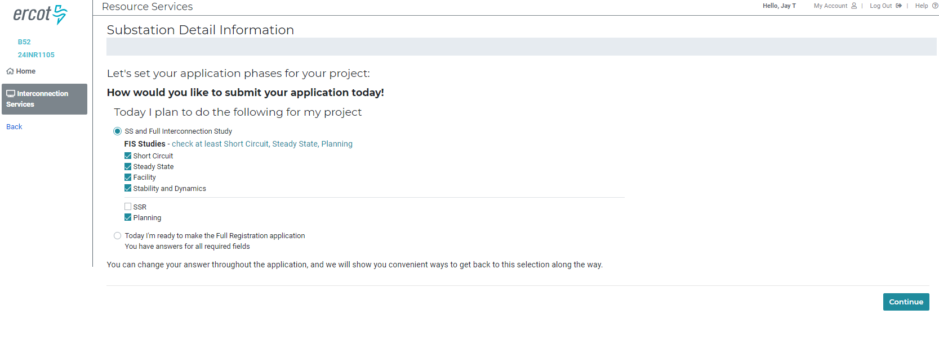
Figure 47 The IE/RE can then open the INR in their dashboard, click “Review/Edit” on the Substation Details block and get this screen where they can click to enter Planning data to meet Planning Guide 6.9. Then click on the “Continue” button.
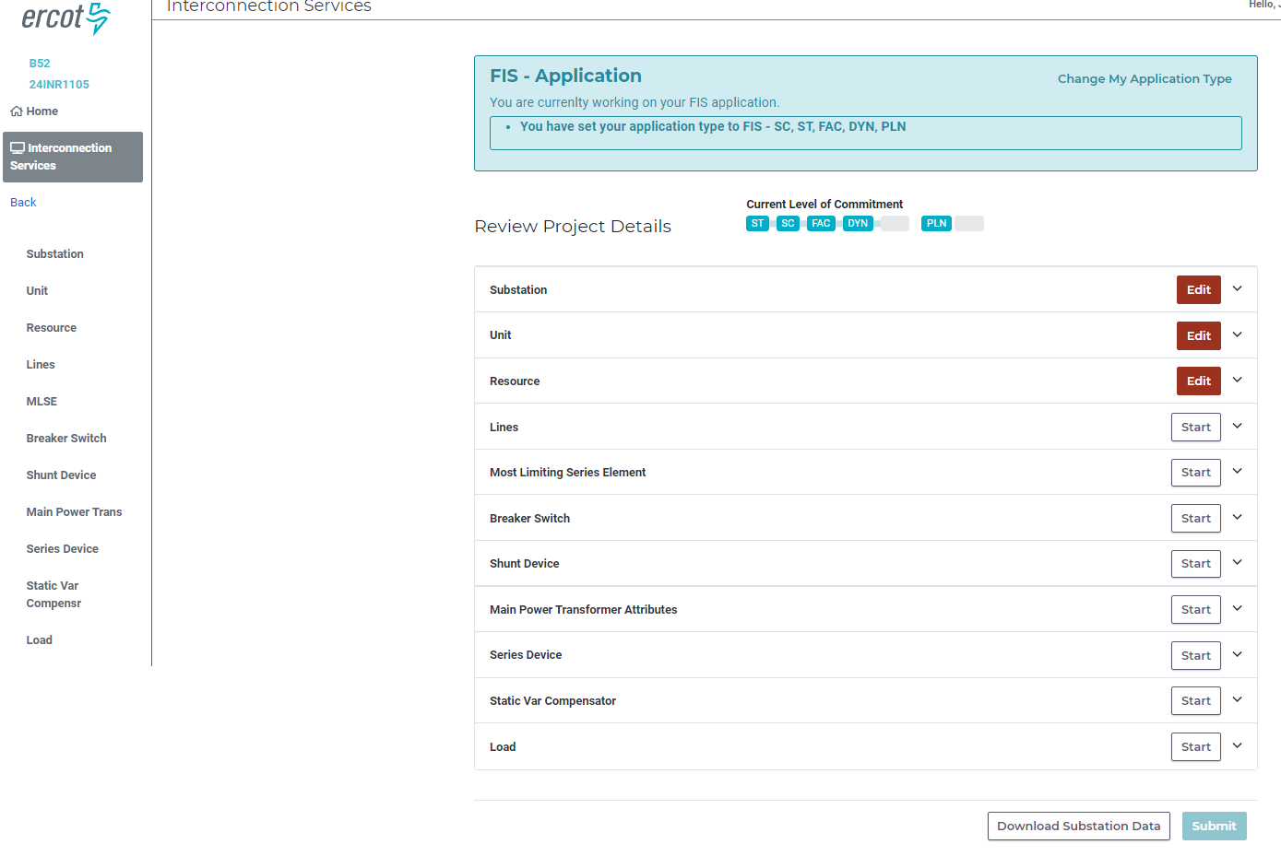
Figure 48 Click on the "Check Application Progress” button to get this view. There are three red “Edit” buttons meaning there is additional data in those sections that need to be added to meet Planning Guide 6.9. Click the down arrow to the right of the “Edit” button to see which pages need additional data. When completed and the “Submit” button is enabled, click the “Submit” button.
At this time, ERCOT does not receive any indication that the Planning model has been submitted. The IE/RE should email ERCOT and make it known.

IE/RE Submits Full Registration Data
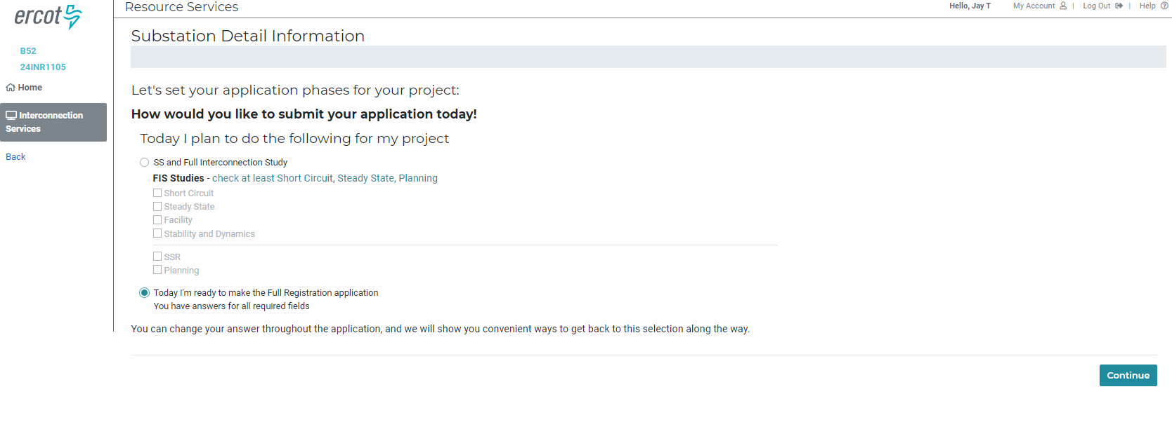
Figure 49 The IE/RE can then open the INR in their dashboard, click “Review/Edit” on the Substation Details block and get this screen where they can click to enter Full Registration data by clicking on the radial button for “Today I’m ready to make the Full Registration application”. Then click on the “Continue” button.
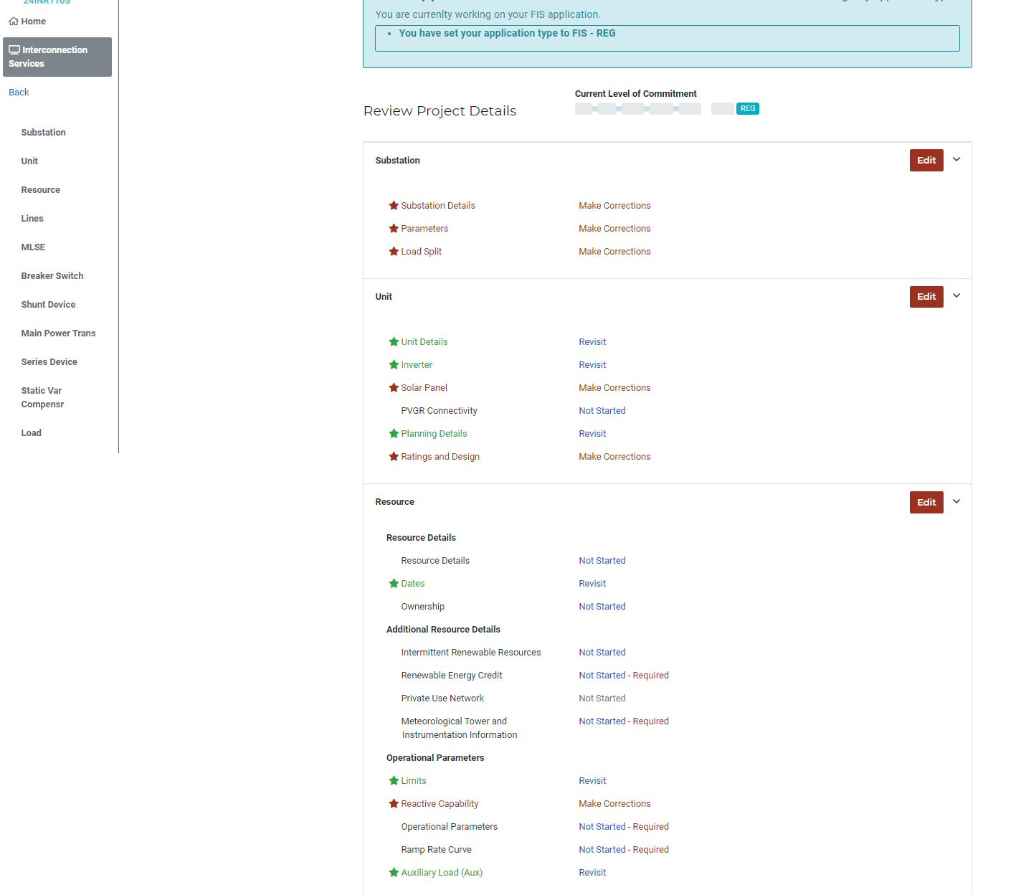
Figure 50 Just as for the Planning data, additional data will be required for Full Registration. Click on the “Check Application Progress” button to see the sections and pages that need additional data. Anything that reads “Make Corrections” or “Not Started – Required” has additional data required or validation errors to fix. When all sections have the green “Edit” button and the “Submit” button is enabled, click the “Submit” button.

At this time, ERCOT does not receive any indication that the Full Registration data has been submitted. The IE/RE should email ERCOT and make it known.

ERCOT Processes Full Registration Data Submittal
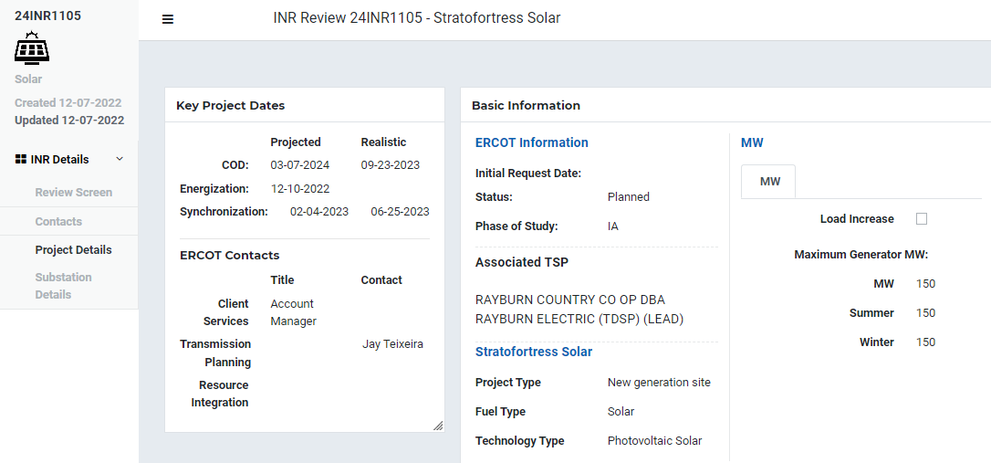
Figure 51 When the IE/RE notifies ERCOT that it has submitted Full Registration Data, ERCOT will click on “Substation Details” on the left nav below “Project Details “.
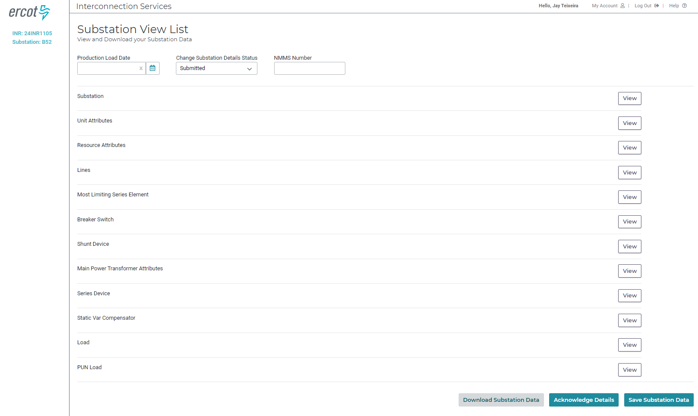
Figure 52 Clicking the “Substation Details” brings up this screen. ERCOT should set the Production Load Data to the project PLD. ERCOT should set the “Change Substation Details Status” to “Ready for Modeling”. Then, in the bottom right, click the “Acknowledge Details” and then the “Save Substation Data” buttons. The Full Registration data should appear in RIOO-RS on the PLD.

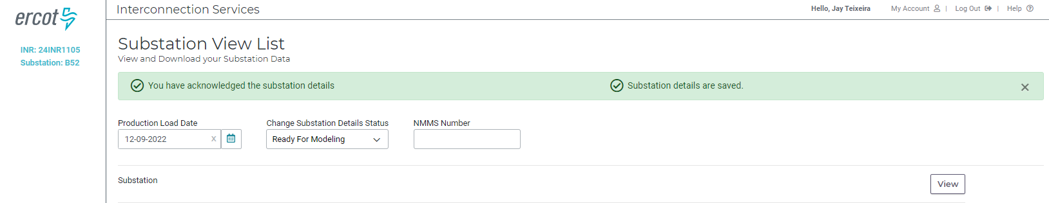
Figure 53 Here the Full Registration data should appear in RIOO-RS on 12/9/2022. When it is in RIOO-RS, the “Change Substation Details Status” should have changed to “Modeled” or “Processed”.
The day after the Full Registration Data has been set to “Ready For Modeling”, the follow query can be run to run a separate set of validation rules in PL/SQL.
select * from RARFSTG.PRE_GRADUATE_VALIDATE_EXCEPTIONS_VIEW t where t.inr_id in ('24INR1105')
If any errors are detected when this query is run then the INR can be put into “Incomplete“ in the “Change Substation Details Status” control. Then click “Save Substation Data” and the IE/RE should be able to correct the errors. They would then change the ““Change Substation Details Status” back to “Ready for Modeling” after correcting the errors and click the “Save Substation Data” button again.

IE/RE Submits INR Application for Simultaneous Screening Study and Full Interconnection Study
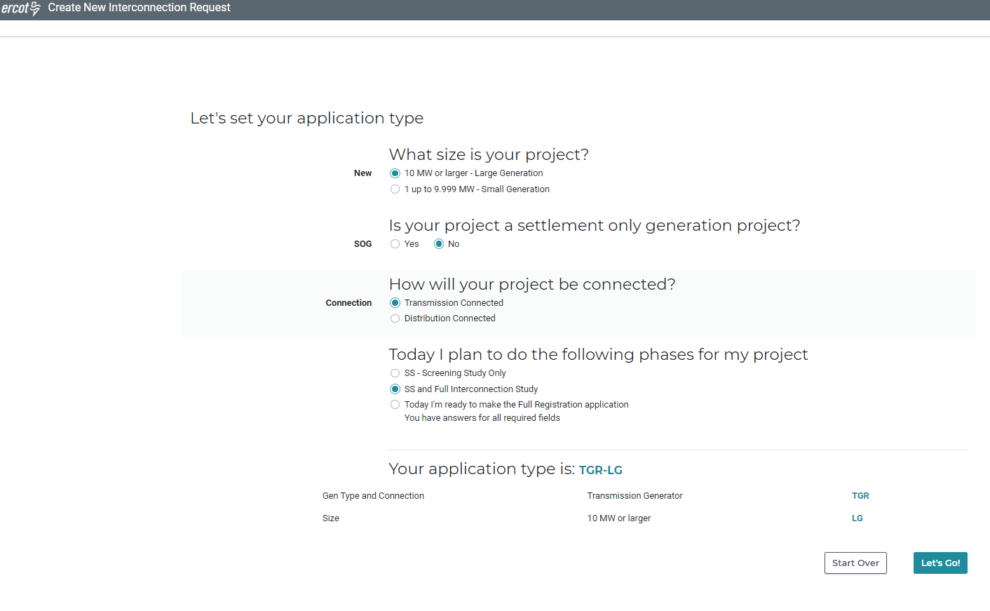
Figure 54 In this example, the IE/RE has requested the simultaneous SS and FIS. Click “Let’s Go”
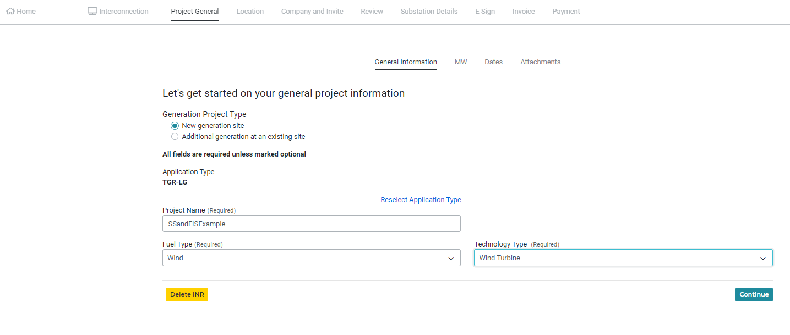
Figure 55 This screen is the same as for the SS only. Click "Continue"
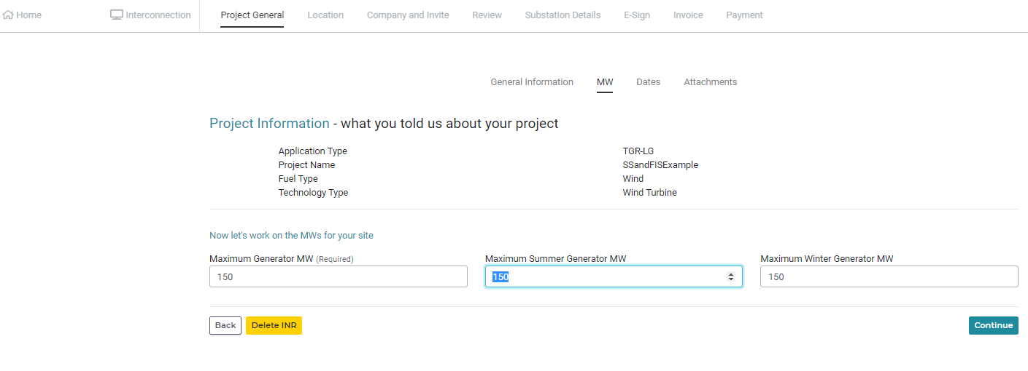
Figure 56 This screen is the same as for SS. Click "Continue"
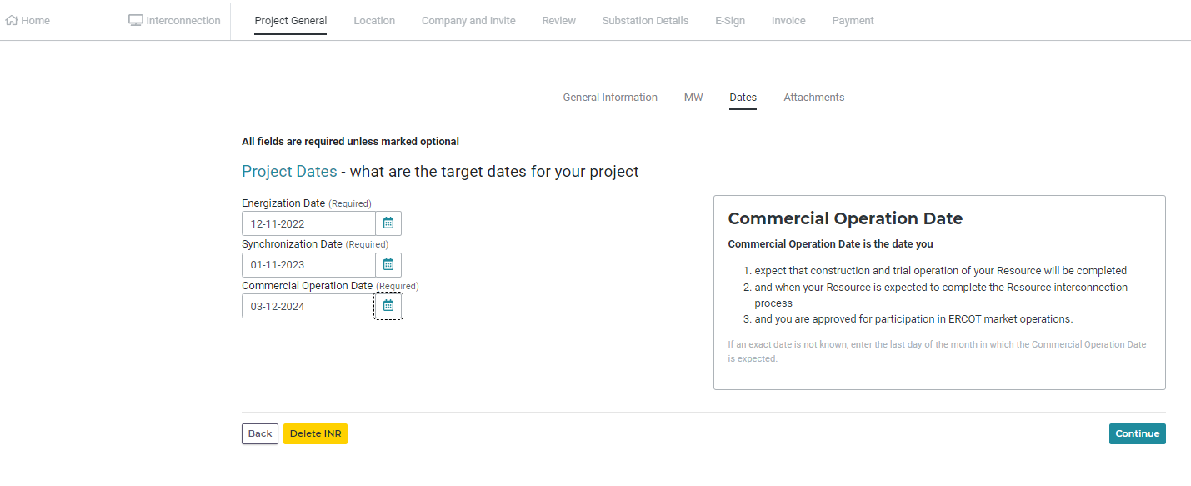
Figure 57 All three dates for Energization, Synchronization, and Commercial Operations must be entered for the FIS. Click "Continue"
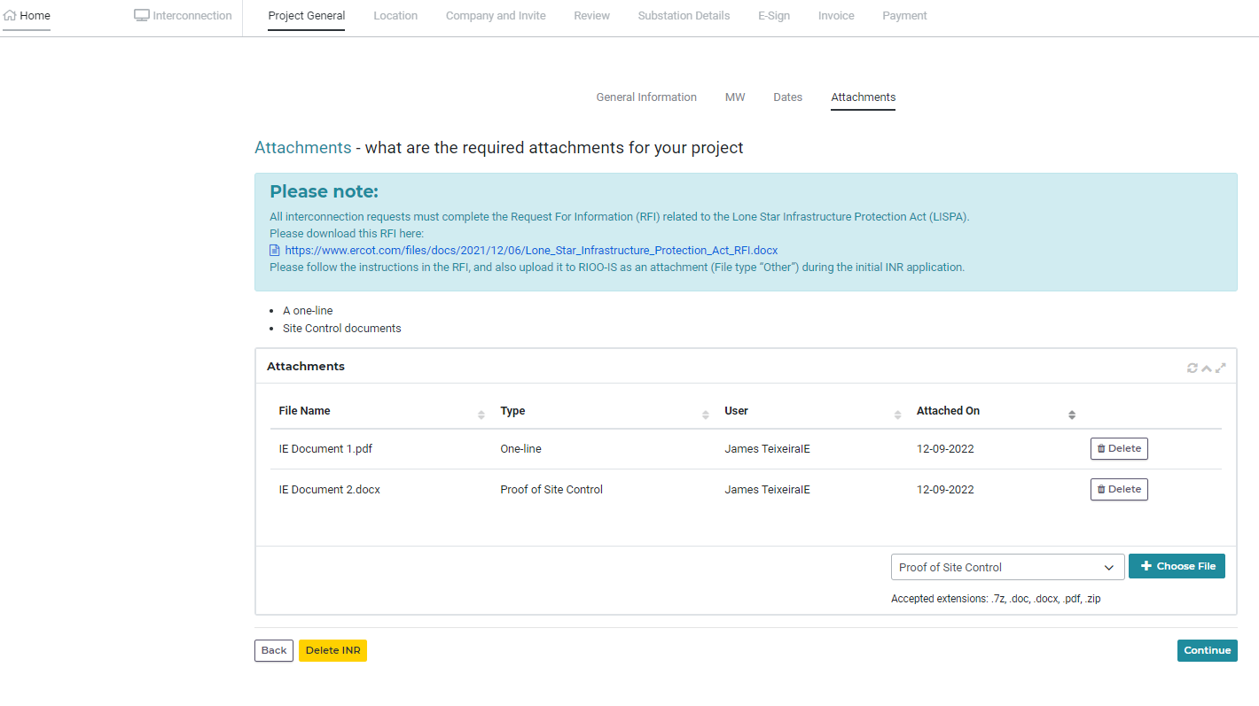
Figure 58 For the FIS, both the One-line and Proof of Site Control need to be attached. Click continue
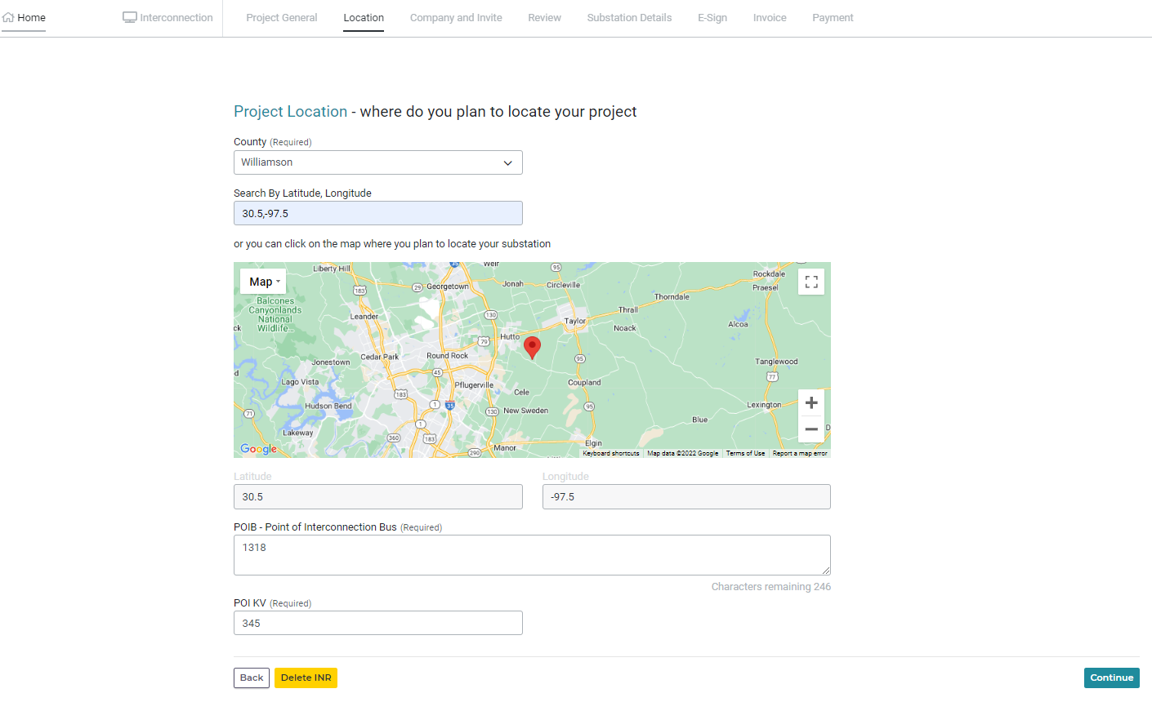
Figure 59 No change to this screen, click “Continue”
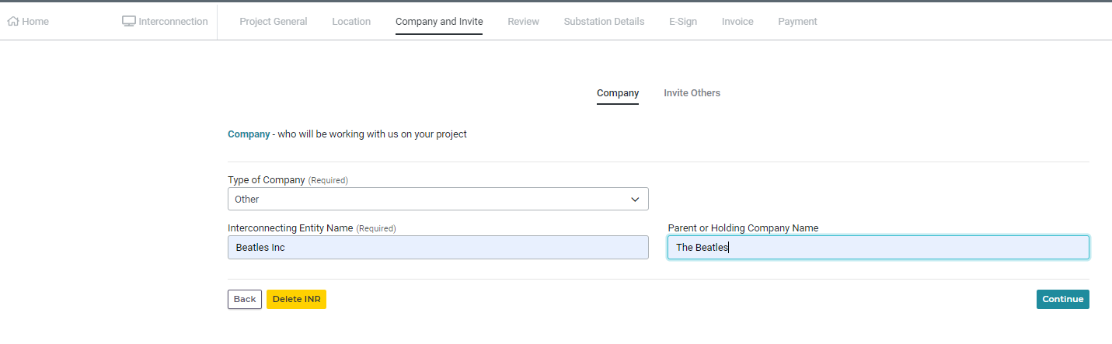
Figure 60 No change to this screen. Click "Continue"
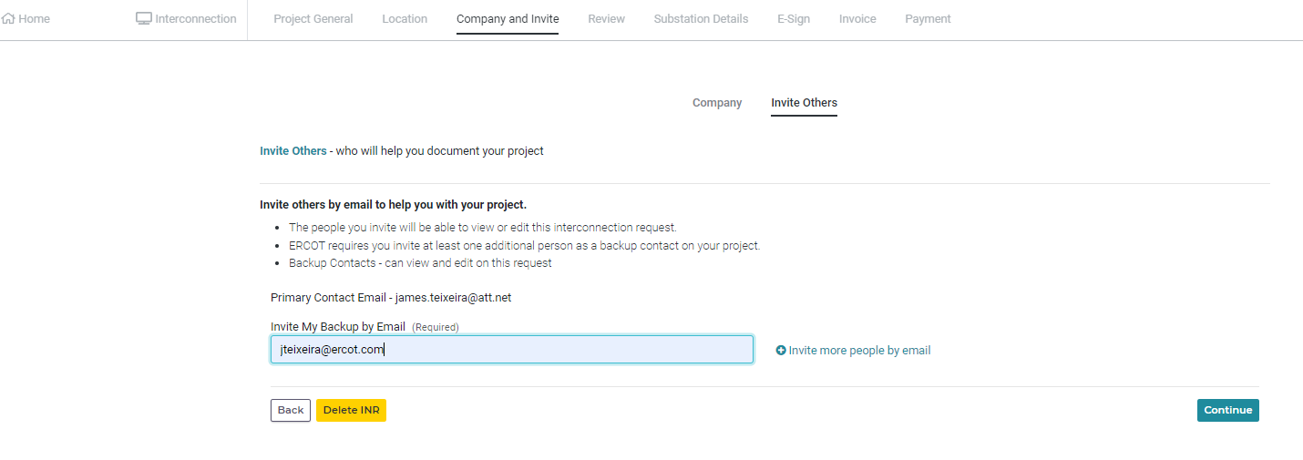
Figure 61 No change to this screen. Click "Continue"
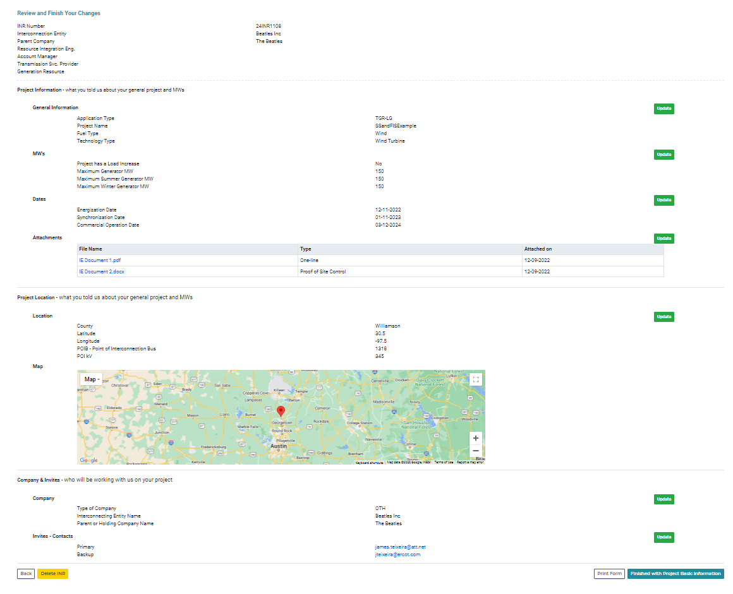
Figure 62 No change to this screen. Make sure all three dates have been entered and both the one-line and proof of site-control are attached. Click "Finished with Project Basic Information"
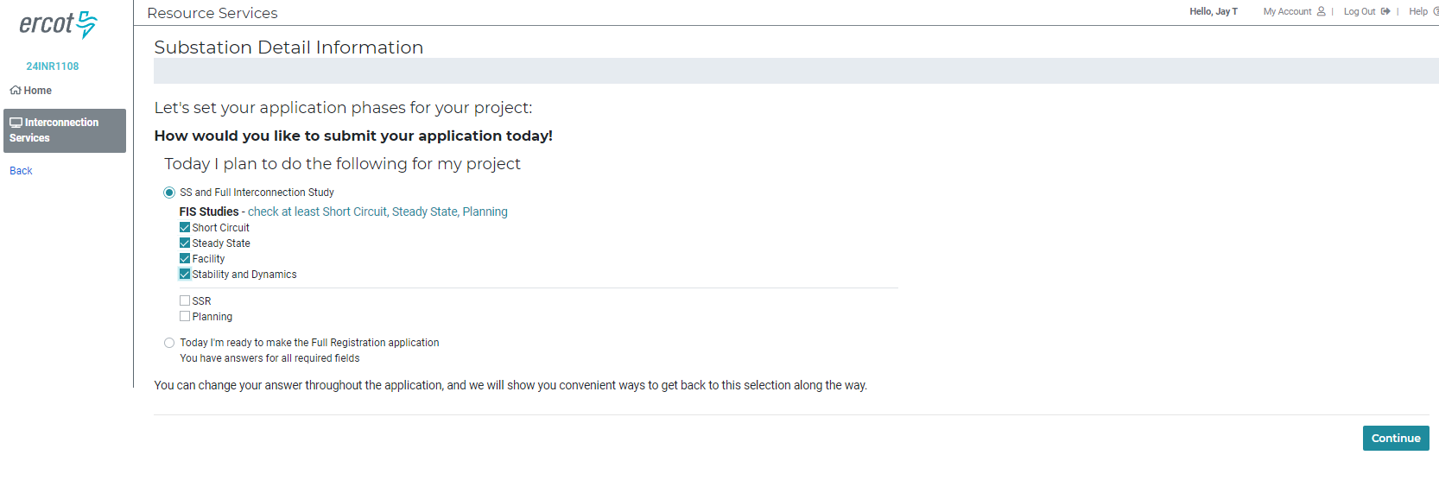
Figure 63 This is new. Now the IE/RE must select which FIS studies they will be submitting data. Click either "Short Circuit", "Steady State", or "Stability and Dynamics" or any combination to begin the FIS process. Once data for the three studies have been selected, select the “Facility” study as well. Click “Continue”
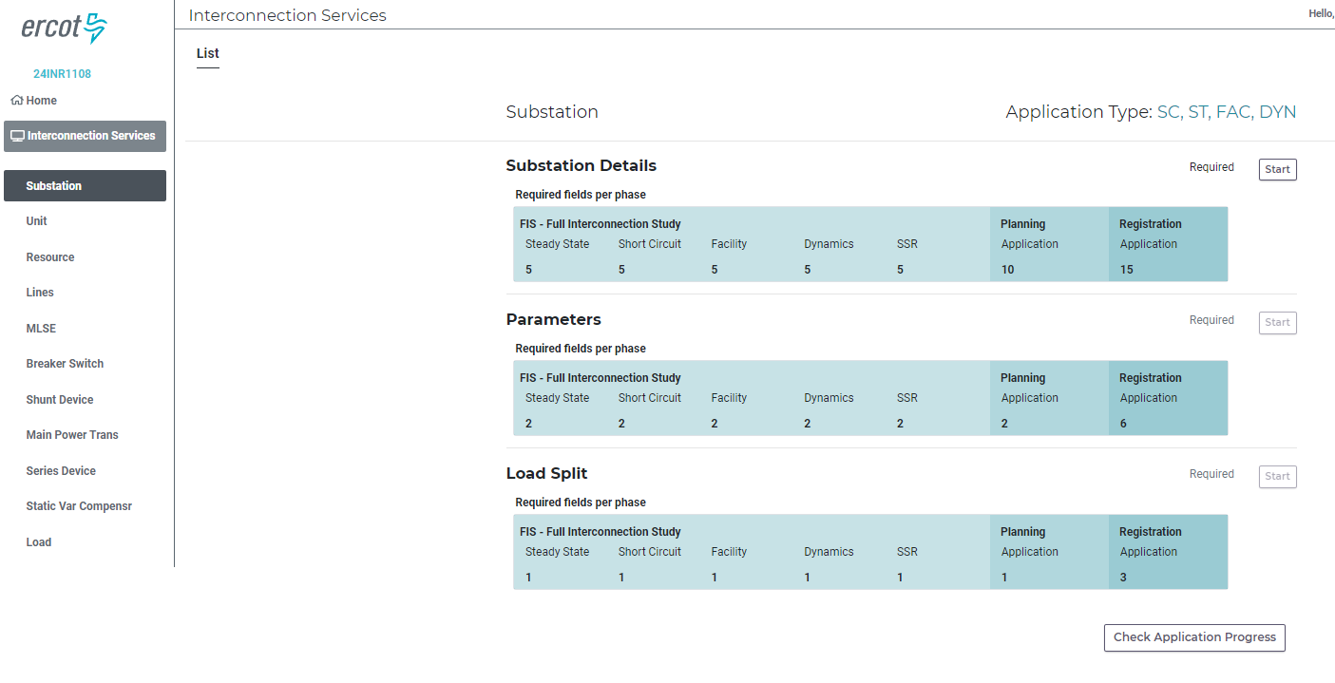
Figure 64 Now the data entry has begun. This is the same as shown for the SS beginning with Fig 29.

IE/RE Submits INR Application for Small Generation
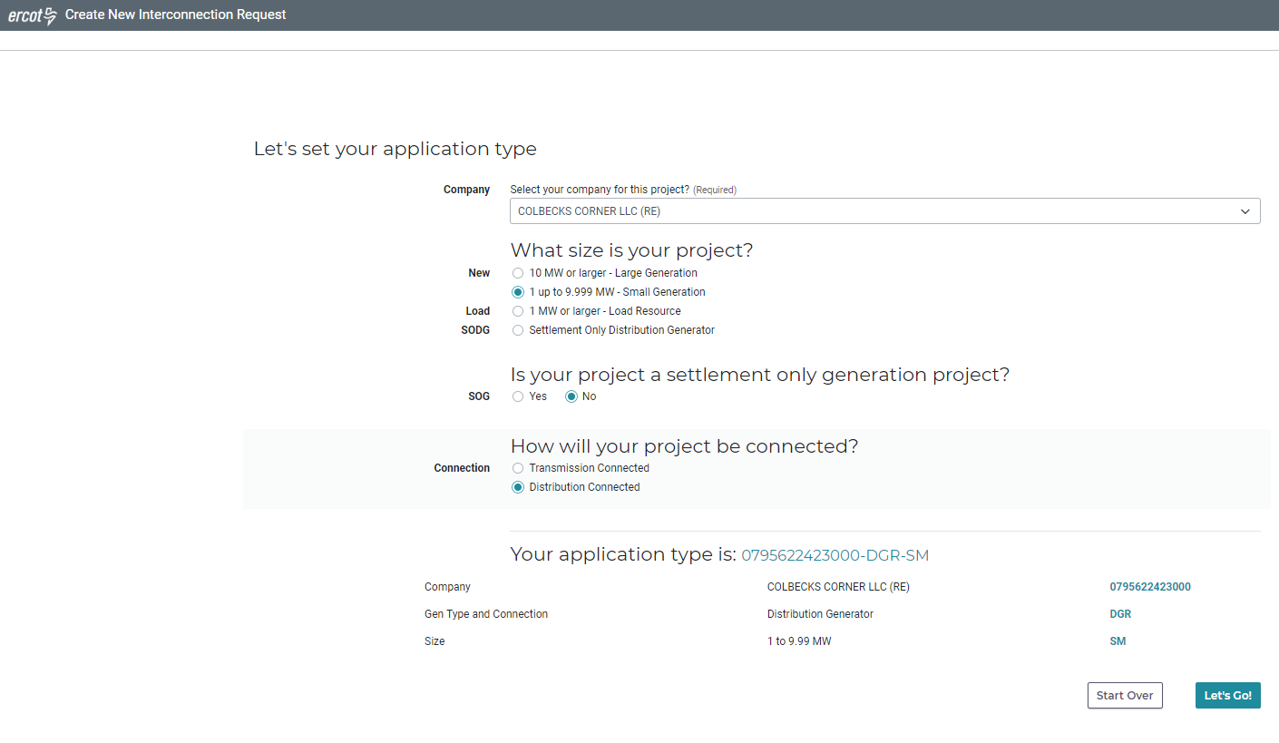
Figure 65 Small Gen application connected to distribution. Click “Let’s Go”
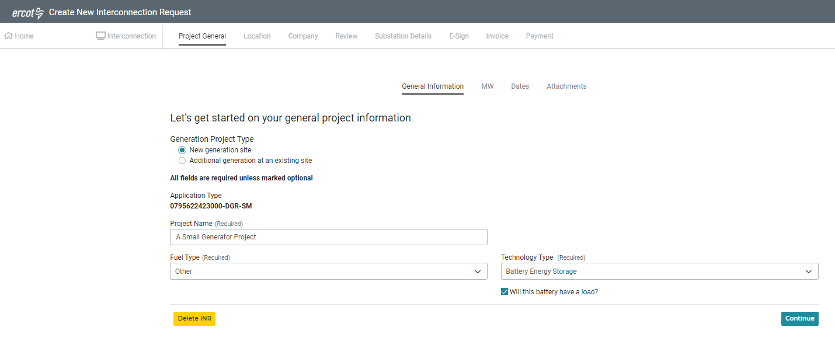
Figure 66 For battery, click the checkbox for “Will this battery have a load”. Click “Continue”
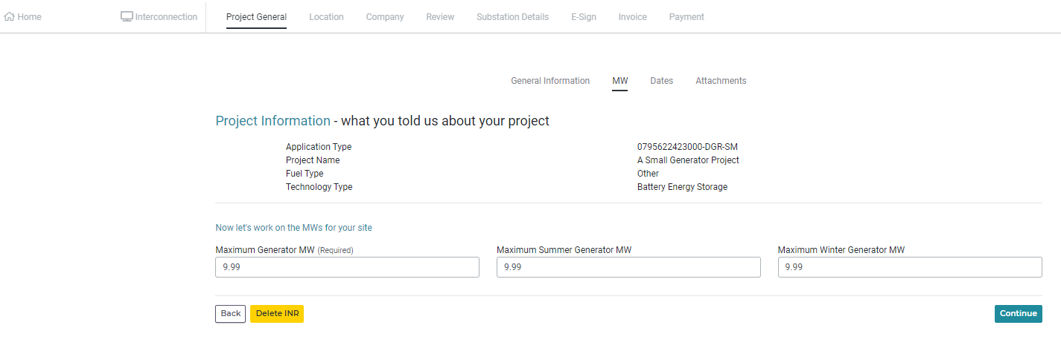
Figure 67 No change for this screen. Click "Continue"
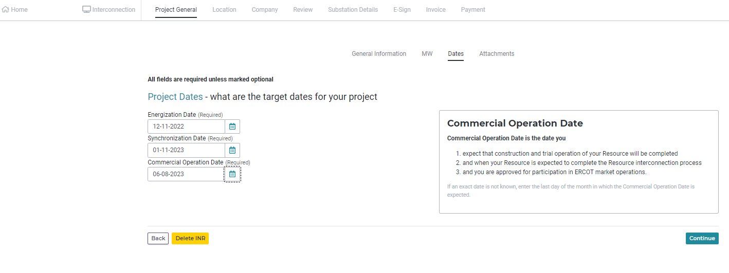
Figure 68 Enter all three dates. Click "Continue"
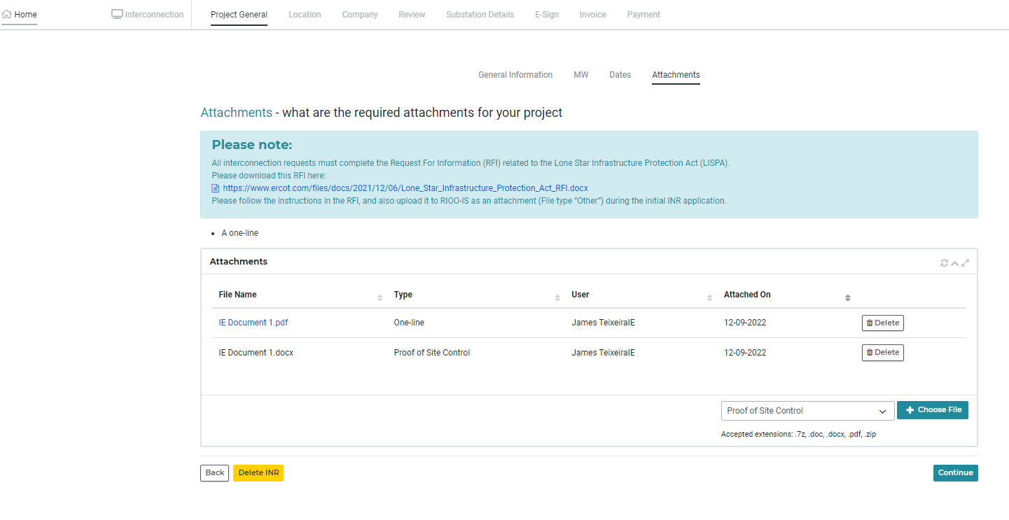
Figure 69 Attach both the one-line and proof of site control. Click "Continue"
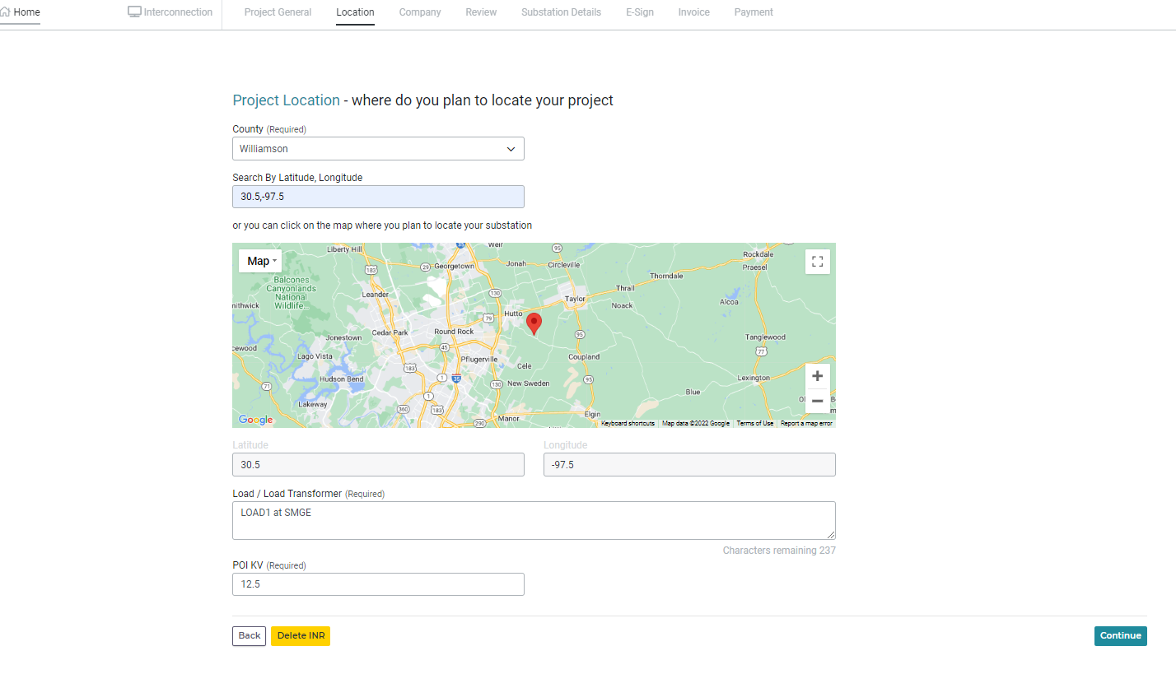
Figure 70 Since this is a small gen, the Load or Load Transformer and Station name need to be identified. POI kV is at distribution level.
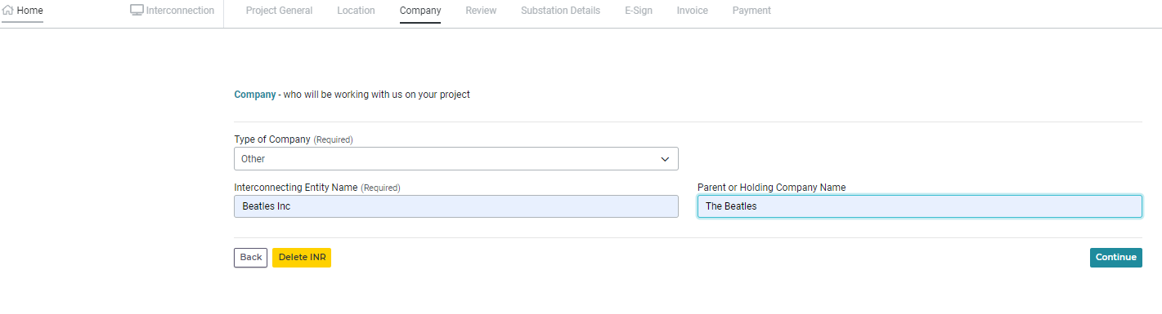
Figure 71 No Change to this page. Click "Continue"
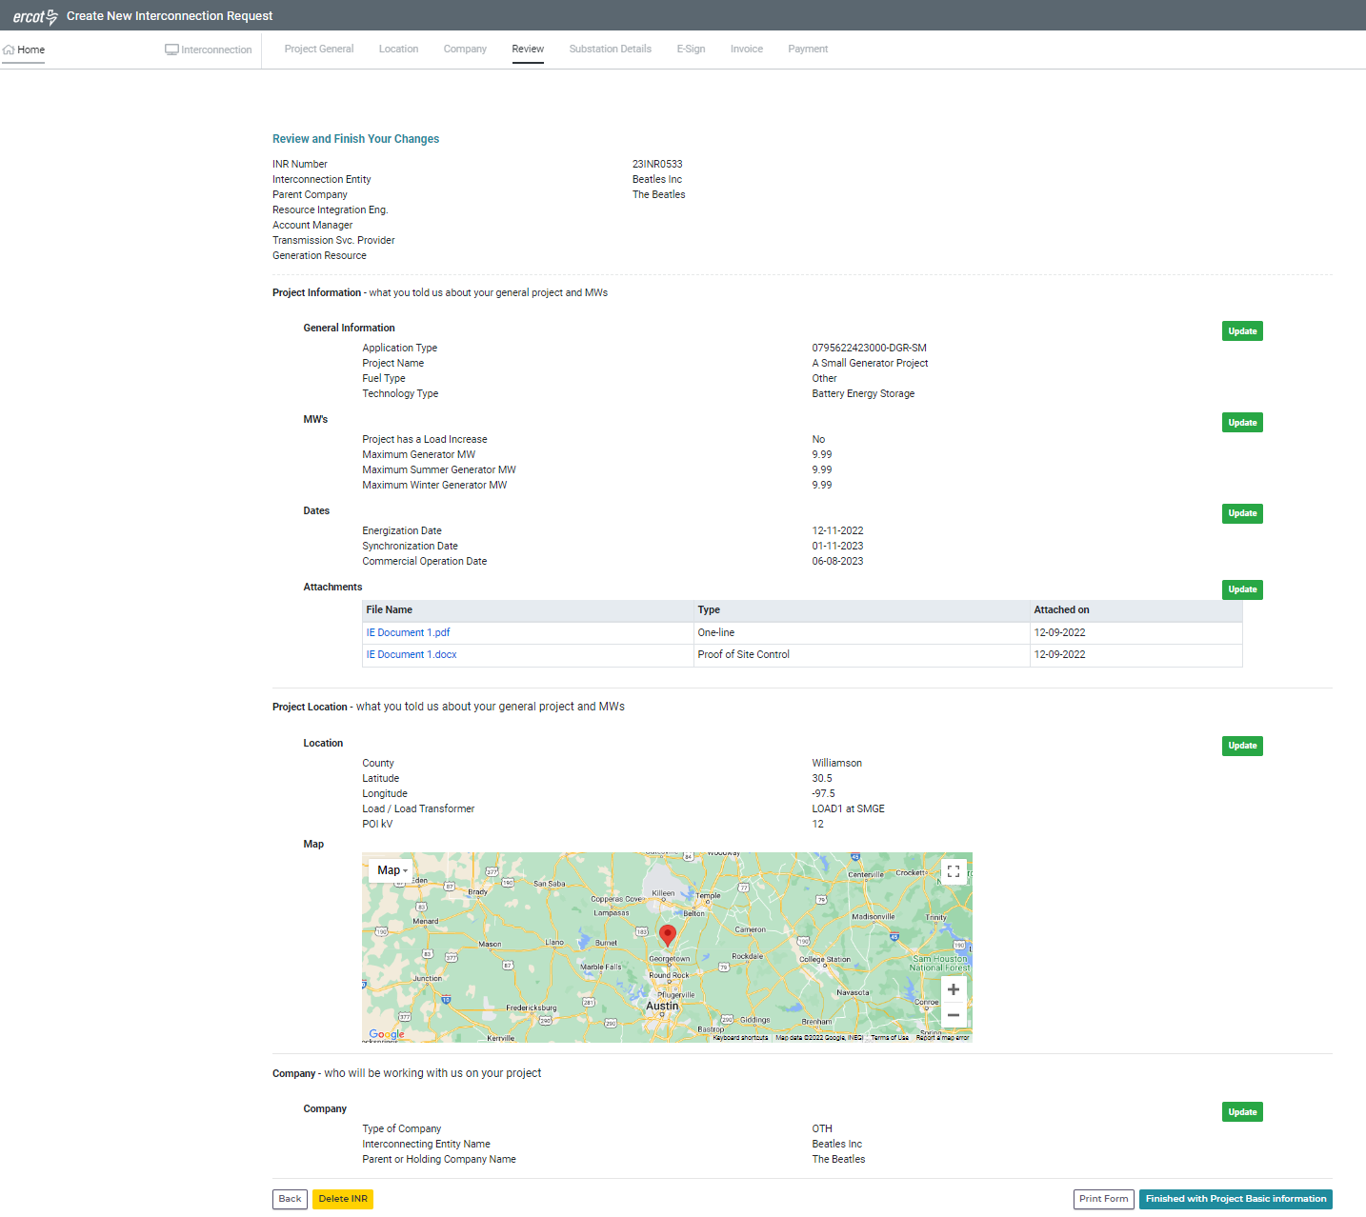
Figure 72 Review dates and attachments. Click "Finished with Project Basic Information"
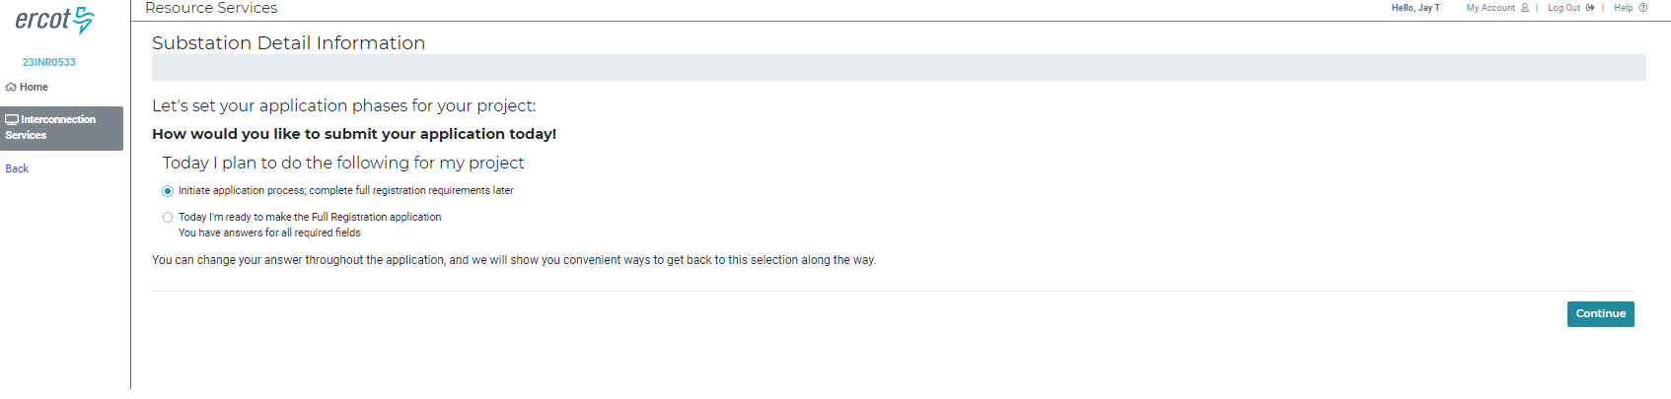
Figure 73 Click “Initiate application process; full registration requirements later” radial button. Click “Continue”
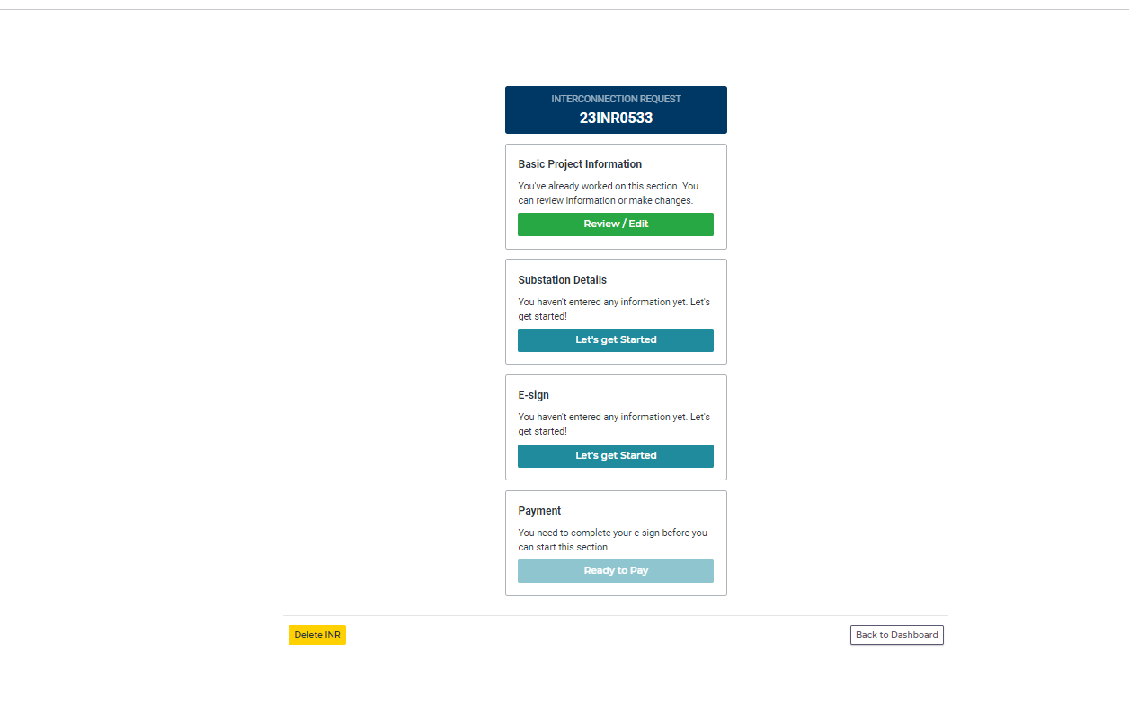
Figure 74 The IE/RE Finished the basic information, the Substation Details will be done later. Click the “E-sign” button
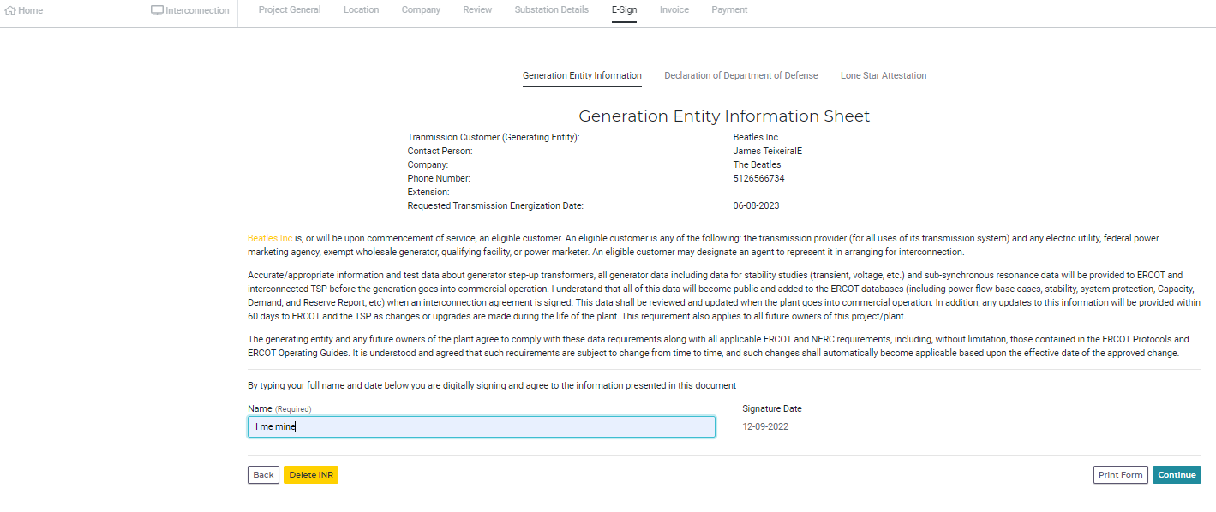
Figure 75 Electrically sign the document and click “Continue”
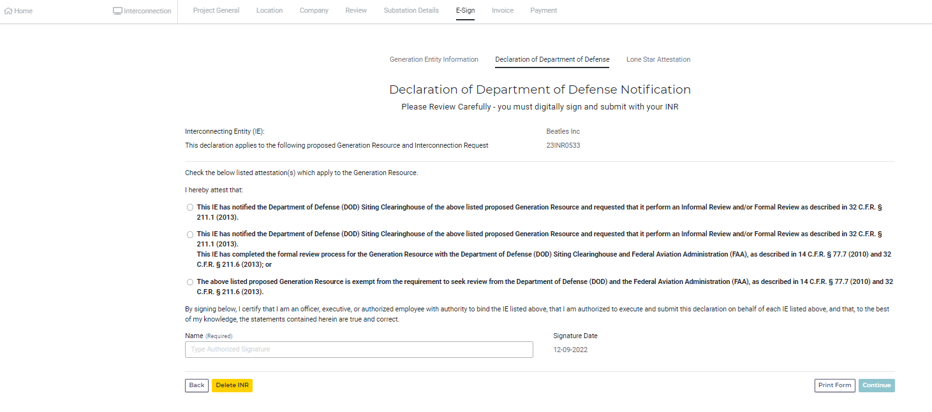
Figure 76 Click the radial button for the appropriate DoD bullet, electrically sign the document and click "Continue"
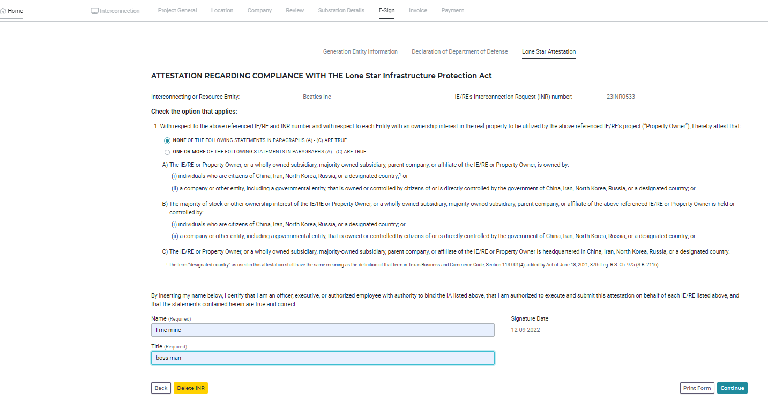
Figure 77 Click the appropriate Lone Star Infrastructure Protection Act bullet, electrically sign the document, and enter Title, click "Continue"
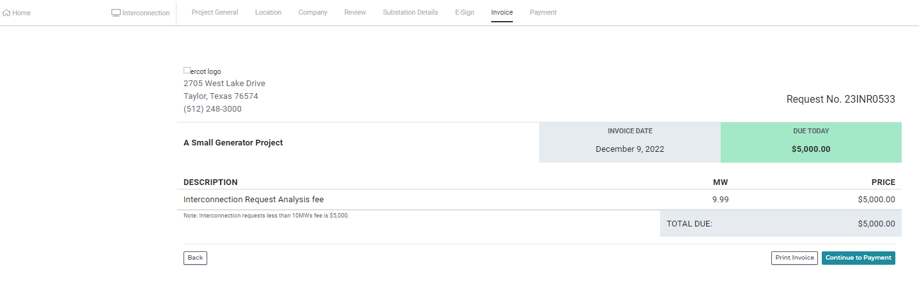
Figure 78 This is the payment screen, check the description, MW, and Price, click "Continue to Payment"
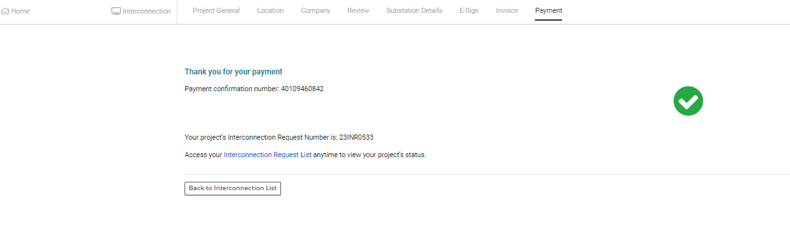
Figure 79 Enter the payment information and make sure the address entered matches the address on the account. Click Continue and then get this confirmation screen. Payment should have been submitted and the application should have been submitted to ERCOT. Click “Back to Interconnection List” to go back to the dashboard.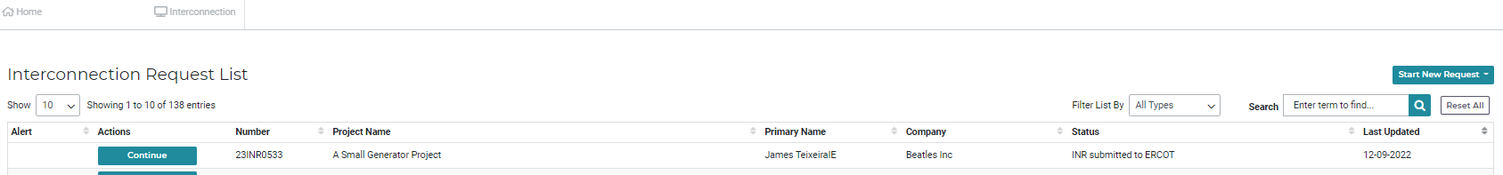
Figure 80 The application has been submitted to ERCOT and has a status "INR submitted to ERCOT". If the IE/RE is ready to enter the resource data and ERCOT has approved the IE/RE to enter resource data, click the “Continue” button. Otherwise, continue work on other INR’s or assignments.
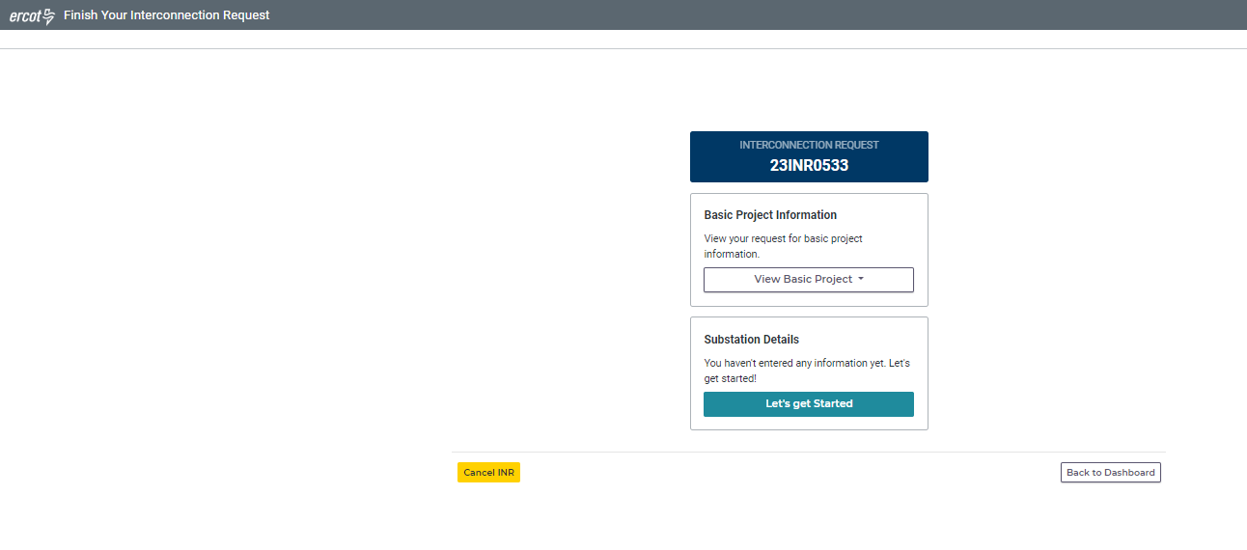
Figure 81 Now to enter the resource data or Substation Details as known in RIOO. Click "Let's get Started" in the Substation Details block
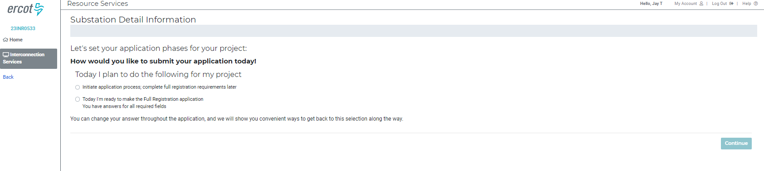
Figure 82 The IE/RE is now back at this screen. This time, click the radial button for "Today I’m ready to make the Full Registration application”. Click “Continue”
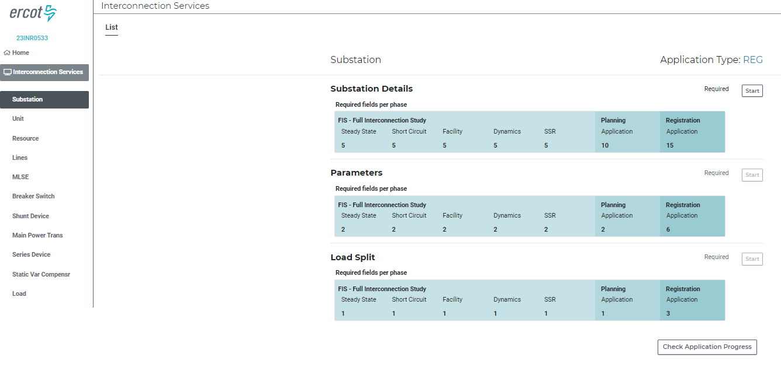
Figure 83 Now the data entry has begun. This is the same as shown for the SS beginning with Fig 29.

