TDTMS
November 16th, 2022
WebEx only
Attendee | Company | Attendee | Company | Attendee | Company
Diana Rehfeldt | TNMP | Dave Michelson | ERCOT | Kyle Patrick | NRG
Sam Pak | Oncor | Tammy Stewart | ERCOT | Monica Jones | CNP
Jordan Troublefield | ERCOT | Mick Hanna | ERCOT | Eric Lotter | GridMonitor
Sheri Wiegand | Vistra | Paula Shadle | NEC | Kathy Scott | CNP
Carolyn Reed | CNP | Elizabeth Alvarado | PUC | Bill Snyder | AEP
 |  |  |  | Angela ?

Antitrust/Minutes
- Antitrust Admonition was read by Sheri Wiegand
  - Minutes from 10/20/22 were reviewed and approved.

ERCOT System Instances & MarkeTrak Monthly Performance Review
- Mick presented October performance reports – all monthly and annual SLA targets have been met
    - Maintenance/data patching occurred 10/9
- MarkeTrak response times remains flat which is positive
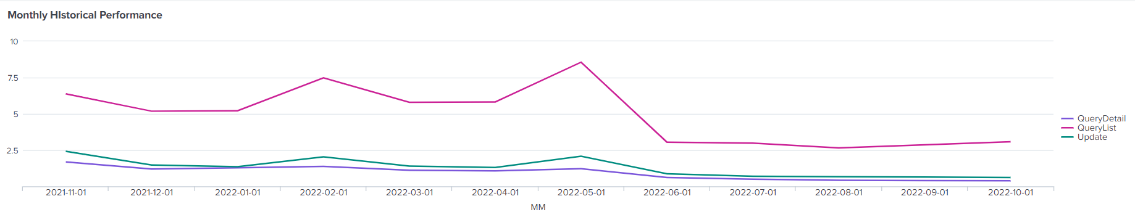

- Listserv activity – Mick mentioned the issue brought up at the last TDTMS meeting where some market notices were held in queue due to size constraints. This has been corrected and no other incidents to report. Only 2 users were unsubscribed from Weather Moratorium listserve due to thresholds being exceeded.
- SLAs for 2023 – Mick indicated ERCOT was finalizing the SLA targets and release schedule for 2023 for TDTMS review next meeting. First release for 2023 is scheduled for 1/31 – 2/2 (midweek) and extended release window is to align with LP&L market open (October timeframe). All other language remains the same.

MarkeTrak Upgrade and Stabilization
- Update on last remaining issue:
  - New Users and Search functionality – testing a solution prior to putting in production

SCR 815 – MarkeTrak Administrative Changes (December 2022)
- GO LIVE is still planned for 12/12
- TRAINING DATES –
    - 11/30, Wednesday @ 1:00 – 2:00 PM
    - 12/7, Wednesday @ 9:30 AM (during TDTMS)
- Tammy to set up WebEx information for training on 11/30 and will develop a powerpoint presentation for posting to the training page

SCR 817 MarkeTrak Validations –
Tammy reported the approved business requirements are now with the developers and they are writing test scripts. Sheri announced she posted a summary of the business requirements to the meeting page for anyone’s reference.

MarkeTrak Subtype Volume Analysis – Mid Year 2022
Sam presented the ranking of subtypes by volume year over year and will post to the main TDTMS page for reference.
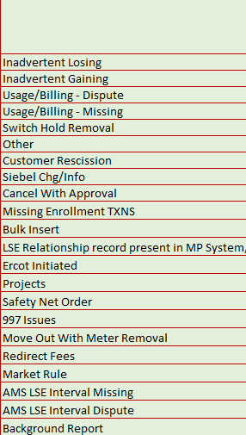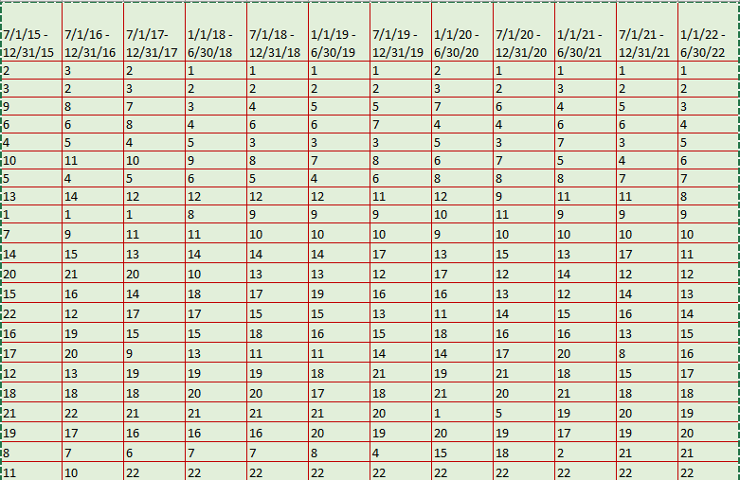

Part II of the analysis will focus on the total time of various subtypes. Sam will review and sample the data and smaller group (Kyle, Monica, Sheri, Sam) will review prior to presenting at next TDTMS meeting.

RMGRR170 - Inadvertent Gain Process Update
Governance process for approval of RMGRR170 will be at the PUCT on 12/15 for final approval. If approved, the effective date will be 1/1/23.
Tammy will ensure updates are included in the MarkeTrak User’s Guide. Other updates will be on-line MarkeTrak modules and MarkeTrak training. This will be communicated to RMTTF.

NEXT MEETING scheduled – December 7th @ 9:30 AM WebEx only
- SCR815 Training
- ERCOT Updates
  - System Instances & MT Performance
  - Listserv
  - MarkeTrak Upgrade Stabilization
- SCR817 Business Requirements discussion, if needed
- MarkeTrak Volume Subtype Analysis Discussion –
  - Time Spent on Issues of Various Subtypes
- PUCT Project 52796 – Shortening of timeline for complaints in 25.495 from 21 day down to 15 day – impacts on IGL process

