October 2022 ERCOT Monthly Operations Report
Reliability and Operations Subcommittee Meeting
December 1, 2022

Table of Contents
1. Report Highlights 2
2. Frequency Control 3
2.1. Frequency Events 3
2.2. Responsive Reserve Events 4
2.3. Load Resource Events 4
3. Reliability Unit Commitment 4
4. IRR, Wind, and Solar Generation as a Percent of Load 7
5. Largest Net-Load Ramps 8
6. COP Error Analysis 9
7. Congestion Analysis 11
7.1. Notable Constraints 11
7.2. Generic Transmission Constraint Congestion 21
7.3. Manual Overrides 21
7.4. Congestion Costs for Calendar Year 2022 21
8. System Events 22
8.1. ERCOT Peak Load 22
8.2. Load Shed Events 22
8.3. Stability Events 22
8.4. Notable PMU Events 23
8.5. DC Tie Curtailment 23
8.6. TRE/DOE Reportable Events 23
8.7. New/Updated Constraint Management Plans 23
8.8. New/Modified/Removed RAS 23
8.9. New Procedures/Forms/Operating Bulletins 23
9. Emergency Conditions 24
9.1. OCNs 24
9.2. Advisories 24
9.3. Watches 24
9.4. Emergency Notices 24
10. Application Performance 24
10.1. TSAT/VSAT Performance Issues 24
10.2. Communication Issues 24
10.3. Market System Issues 24
11. Model Updates 25
Appendix A: Real-Time Constraints 27

Report Highlights
- The unofficial ERCOT peak load for the month was 66,110 MW and occurred on 10/12/2022, during hour ending 17:00. Prior to this year, the peak usage for the month of October was 65,304 MW set on 10/02/2019.
- There were 10 frequency events.
- There were 8 instances where Responsive Reserves was deployed.
- There were 81 HRUC commitments.
- There were 17 days of congestion on the North Edinburg to Lobo GTC, 12 days on the Nelson Sharpe to Rio Hondo GTC, 11 days on the North to Houston GTC, 10 days on the West Texas Export GTC, 9 days on the Bearkat GTC, 7 days on the Panhandle GTC, 4 days on the Valley Export GTC, 4 days on the Wharton GTC, 2 days on the East Texas Export GTC, and 2 days on the Treadwell GTC. There was no activity on the remaining GTCs during the month.
- There was 1 DC Tie Curtailment.
- A PVGR Generation Record of 10,100 MW was set on 10/01/2022 at 11:03.
- A PVGR Penetration Record of 24.99% was set on 10/01/2022 at 10:06.

Frequency Control

Frequency Events
The ERCOT Interconnection experienced 10 frequency events, which resulted from units’ trip. The event average event duration was 00:04:17.

A summary of the frequency events is provided below. The reported frequency events meet one of the following criteria: Delta Frequency is 60 mHz or greater; the MW loss is 350 MW or greater; resource trip event triggered RRS deployment. Frequency events that have been identified as Frequency Measurable Events (FME) for purposes of BAL-001-TRE-2 analysis are highlighted in blue. When analyzing frequency events, ERCOT evaluates PMU data according to industry standards. Events with an oscillating frequency of less than 1 Hz are inter-area, while higher frequencies indicate local events. Industry standards specify that damping ratio for inter-area oscillations should be 3.0% or greater. For the frequency events listed below, the ERCOT system met these standards and transitioned well after each disturbance. In the case of negative delta frequency, the MW Loss column could refer to load loss.

Date and Time | Delta Frequency | Max/Min Frequency | Duration of Event | PMU Data |  | MW Loss | Load | IRR | Inertia
 | (Hz) | (Hz) |  | Oscillation Mode (Hz) | Damping Ratio |  | (MW) | % | (GW-s)
10/3/2022 16:46:58 | 0.079 | 59.928 | 00:04:19 | 0.64 | 13% | 413 | 56,216 | 20% | 298,992
10/6/2022 2:24:28 | 0.117 | 59.863 | 00:06:15 | 0.76 | 12% | 656 | 36,217 | 13% | 240,438
10/6/2022 11:54:34 | 0.110 | 59.877 | 00:03:14 | 0.62 | 15% | 782 | 49,366 | 17% | 297,112
10/8/2022 6:47:42 | 0.116 | 59.897 | 00:04:22 | 1.17 | 16% | 685 | 35,990 | 23% | 222,114
10/16/2022 18:41:48 | 0.079 | 59.898 | 00:03:18 | 0.67 | 7% | 501 | 53,385 | 29% | 252,089
10/20/2022 5:04:54 | 0.121 | 59.858 | 00:06:38 | 0.77 | 15% | 796 | 34,646 | 50% | 184,973
10/21/2022 16:45:49 | 0.077 | 59.880 | 00:02:24 | 0.65 | 13% | 505 | 52,521 | 49% | 214,399
10/26/2022 0:21:03 | 0.101 | 59.893 | 00:04:25 | 0.68 | 16% | 496 | 34,610 | 15% | 216,713
10/27/2022 23:15:32 | 0.089 | 59.888 | 00:04:47 | 0.72 | 15% | 430 | 39,190 | 45% | 170,934
10/31/2022 23:12:25 | -0.161 | 60.140 | 00:03:07 | 0.76 | 12% | -500 | 37,970 | 32% | 197,386

(Note: All data on this graph encompasses frequency event analysis based on BAL-001-TRE-2.)

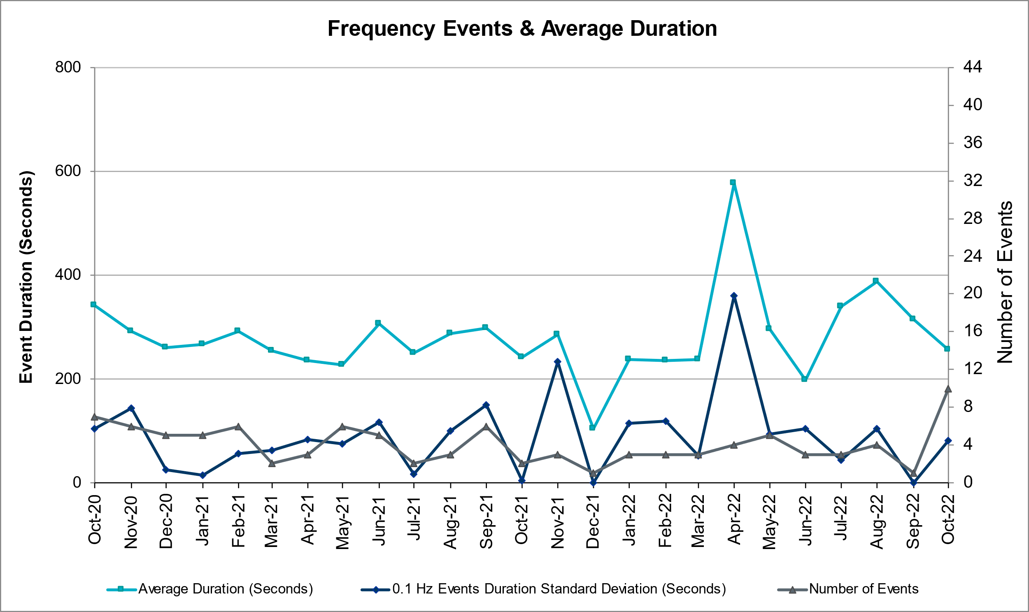

Responsive Reserve Events
There were 8 events where Responsive Reserve MWs were released to SCED. The events highlighted in blue were related to frequency events reported in Section 2.1 above.

Date and Time Released to SCED | Date and Time Recalled | Duration of Event | Maximum MWs Released | Comments
10/06/2022 2:24:38 | 10/06/2022 2:30:50 | 00:06:12 | 941
10/06/2022 11:54:46 | 10/06/2022 11:57:10 | 00:02:24 | 558
10/08/2022 6:47:50 | 10/08/2022 6:51:58 | 00:04:08 | 252
10/16/2022 18:41:56 | 10/16/2022 18:45:32 | 00:03:36 | 576
10/20/2022 5:05:02 | 10/20/2022 5:11:38 | 00:06:36 | 849
10/21/2022 16:45:58 | 10/21/2022 16:49:02 | 00:03:04 | 769
10/26/2022 0:21:12 | 10/26/2022 0:25:16 | 00:04:04 | 540
10/27/2022 23:15:40 | 10/27/2022 23:20:28 | 00:04:48 | 704

Load Resource Events
None.

Reliability Unit Commitment
ERCOT reports on Reliability Unit Commitments (RUC) monthly. Commitments are reported grouped by operating day and weather zone. The total number of hours committed is the sum of the hours for all the units in the specified region. Additional information on RUC commitments can be found on the MIS secure site at Grid Generation Reliability Unit Commitment.

There were no DRUC commitments.

There were 81 HRUC commitments

Resource Location | # of Resources | Operating Day | Total # of Hours Committed | Total MWhs | Reason for Commitment
NORTH_CENTRAL | 1 | 10/04/2022 | 4 | 1,240.0 | System Capacity
EAST, NORTH_CENTRAL | 4 | 10/05/2022 | 14 | 5,043.0 | System Capacity
EAST, NORTH_CENTRAL, SOUTH_CENTRAL | 9 | 10/06/2022 | 54 | 12,170.0 | System Capacity
COAST, EAST, NORTH_CENTRAL, SOUTH_CENTRAL | 11 | 10/07/2022 | 53 | 14,275.0 | Minimum Run Time, System Capacity
COAST, NORTH_CENTRAL, SOUTH_CENTRAL | 4 | 10/08/2022 | 25 | 6,678.0 | DWPWEWP5, DWPWFWP5, Minimum Run Time, System Capacity
COAST, NORTH_CENTRAL | 2 | 10/10/2022 | 12 | 4,936.0 | System Capacity
EAST, NORTH_CENTRAL | 5 | 10/12/2022 | 31 | 9,757.0 | System Capacity
COAST, EAST, NORTH_CENTRAL | 11 | 10/13/2022 | 61 | 17,957.0 | N_TO_H, System Capacity
COAST | 3 | 10/14/2022 | 26 | 7,998.0 | N_TO_H
EAST, NORTH_CENTRAL | 2 | 10/15/2022 | 7 | 2,288.0 | System Capacity
COAST | 3 | 10/16/2022 | 18 | 5,640.0 | N_TO_H
NORTH_CENTRAL | 2 | 10/18/2022 | 4 | 1,901.0 | System Capacity
COAST, EAST, NORTH_CENTRAL | 7 | 10/19/2022 | 20 | 6,385.0 | System Capacity
COAST, NORTH_CENTRAL, SOUTH_CENTRAL | 4 | 10/20/2022 | 24 | 10,648.0 | System Capacity
COAST | 1 | 10/24/2022 | 1 | 244.0 | N_TO_H
EAST, NORTH_CENTRAL, SOUTH_CENTRAL | 4 | 10/25/2022 | 15 | 4,584.0 | System Capacity
COAST, EAST, NORTH_CENTRAL | 5 | 10/29/2022 | 23 | 8,765.0 | System Capacity
SOUTH_CENTRAL, SOUTHERN | 2 | 10/30/2022 | 12 | 4,120.0 | System Capacity
SOUTHERN | 1 | 10/31/2022 | 7 | 1,750.0 | Minimum Run Time

IRR, Wind, and Solar Generation as a Percent of Load
The graph below shows the maximum, minimum and average aggregate solar, wind and IRR output as a percentage of total ERCOT load when evaluated as 10-minute averaged intervals, over the past 13 months. Current wind and solar generation and penetration records are listed in the footnote below. Maximum IRR penetration for the month was 66% on 10/22/2022 interval ending 04:30 and minimum IRR penetration for the month was 2.0% on 10/25/2022 interval ending 19:00.

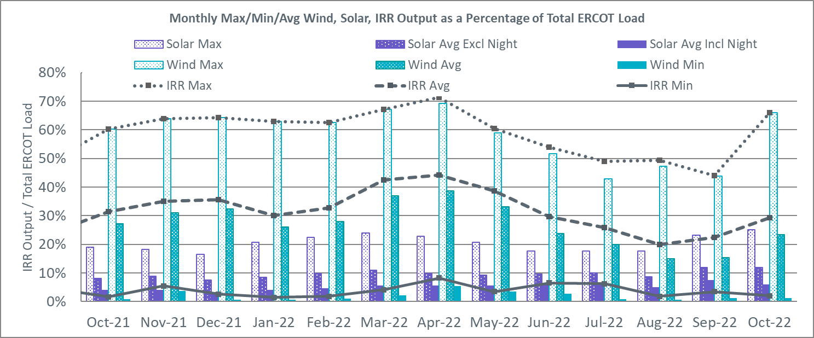

During the hour of peak load for the month, hourly integrated wind generation was 5,306 MW and solar generation was 8,602 MW. The graph below shows the wind and solar penetration percentage during the hour of the peak load in the last 13 months.

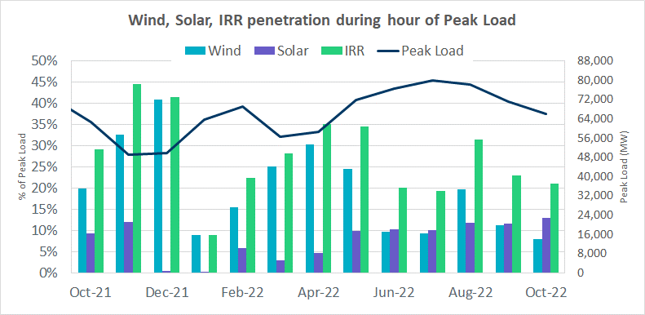

Lastly, the graph below shows the minimum wind, solar and IRR output during the peak load hour as a percentage of the daily peak load for every day in the month.

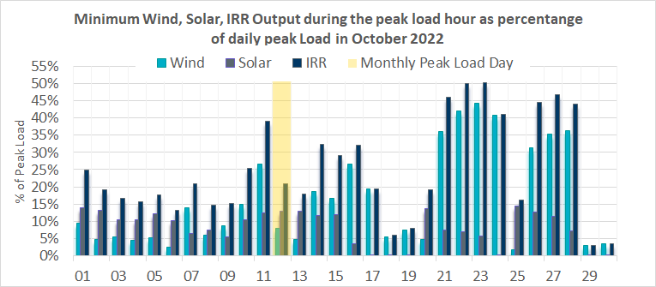

Largest Net-Load Ramps
The net-load ramp is defined as the change in net-load (load minus wind and PVGR generation) during the defined time horizon. Such a variation in net-load needs to be accommodated in grid operations to ensure that the reliability of the grid is satisfactorily maintained. The largest net-load ramp during 5-min, 10-min, 15-min, 30-min and 60-min in October 2022 was 925 MW, 1,645 MW, 2,292 MW, 4,366 MW, and 7,413 MW, respectively. The comparison with respect to the historical values is given in the table below.

Month and Year | 5 min | 10 min | 15 min | 30 min | 60 min
October 2014 | 780 MW | 1,796 MW | 2,152 MW | 2,780 MW | 4,579 MW
October 2015 | 1,141 MW | 1,553 MW | 1,839 MW | 2,779 MW | 4,606 MW
October 2016 | 863 MW | 1,543 MW | 2,035 MW | 3,213 MW | 5,335 MW
October 2017 | 812 MW | 1,338 MW | 1,820 MW | 3,029 MW | 5,347 MW
October 2018 | 860 MW | 1,386 MW | 1,907 MW | 2,824 MW | 5,346 MW
October 2019 | 1,192 MW | 1,728 MW | 2,465 MW | 3,537 MW | 6,408 MW
October 2020 | 1,048 MW | 1,600 MW | 2,488 MW | 3,578 MW | 6,269 MW
October 2021 | 1,371 MW | 1,949 MW | 2,709 MW | 5,037 MW | 9,438 MW
October 2022 | 925 MW | 1,645 MW | 2,292 MW | 4,366 MW | 7,413 MW
All months in 2014-2022 | 1,647 MW | 2,157 MW | 3,015 MW | 5,882 MW | 10,750 MW

COP Error Analysis
COP Error is calculated as the capacity difference between the COP HSL and real-time HSL of the unit. Mean Absolute Error (MAE) stayed over 10,000 MW until Day-Ahead at 12:00, then dropped significantly to 4,671 MW by Day-Ahead at 13:00 and to 1,205 MW by Day-Ahead at 14:00. In the following chart, Under-Scheduling Error indicates that COP had less generation capacity than real-time, and Over-Scheduling Error indicates that COP had more generation capacity than real-time.

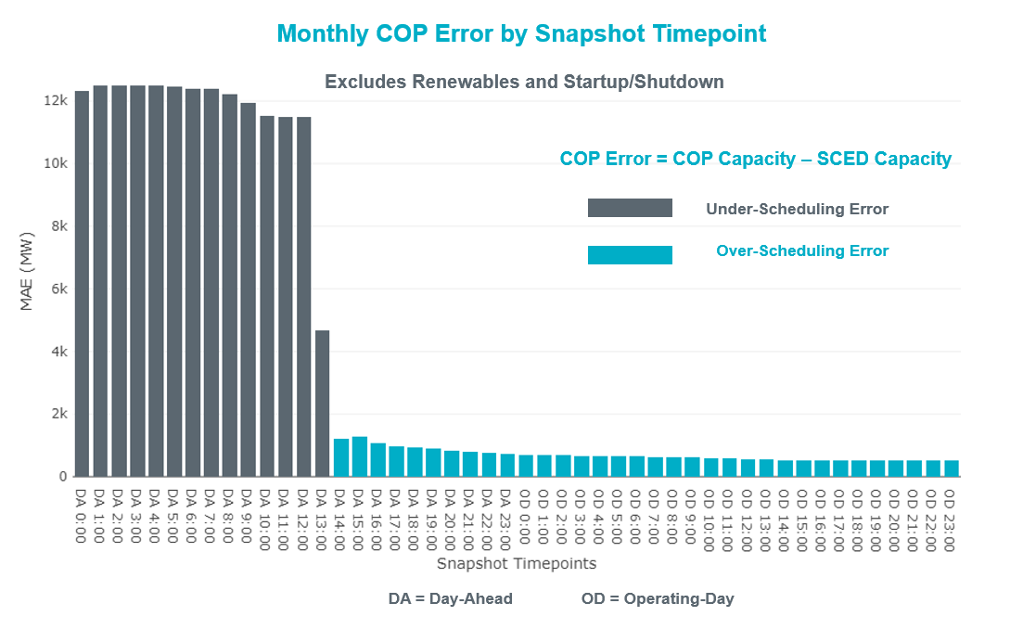

Monthly MAE for the Latest COP at the end of the Adjustment Period was 506 MW with medians ranging from -322 MW for Hour-Ending (HE) 20 to 526 MW for HE 13. HE 24 on 10/14/2022 had the largest Over-Scheduling Error (1,719 MW) and HE 20 on 10/2/2022 had the largest Under-Scheduling Error (-2,705 MW).

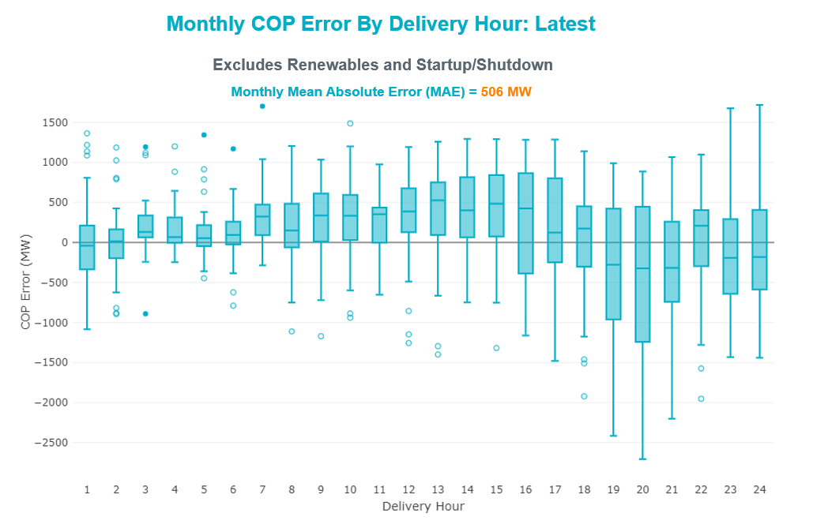

Monthly MAE for the Day-Ahead COP at 12:00 was 11,474 MW with median ranging from -18,185 MW for Hour-Ending (HE) 19 to -7,550 MW for HE 5. HE 20 on 10/12/2022 had the largest Under-Scheduling Error (-25,086 MW) and HE 6 on 10/22/2022 had the smallest Under-Scheduling Error (-698 MW).

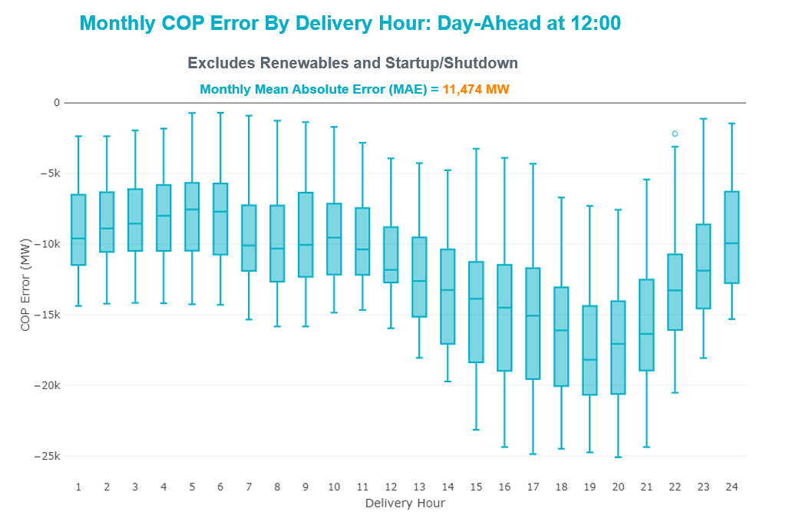

Congestion Analysis

Notable Constraints
Nodal protocol section 3.20 specifies that ERCOT shall identify transmission constraints that are binding in Real-Time three or more Operating Days within a calendar month. As part of this process, ERCOT reports congestion that meets this criterion to ROS. In addition, ERCOT also highlights notable constraints that have an estimated congestion rent exceeding $1,000 for a calendar month. These constraints are detailed in the table below, including approved transmission upgrades from TPIT that may provide some congestion relief based on ERCOT’s engineering judgement. Rows highlighted in blue indicate the congestion was affected by one or more outages. For a list of all constraints activated in SCED, please see Appendix A at the end of this report.

Contingency Name | Overloaded Element | Contingency Name | Overloaded Element | # of Days Constraint Binding | Congestion Rent | Transmission Project
BASE CASE | WESTEX | Basecase | WESTEX GTC | 10 | $28,046,104.05
SBWDDBM5 | LPLMK_LPLNE_1 | BLACKWATER DRAW SWITCH to DOUBLE MOUNTAIN SWITCH LIN 1 | Mackenzie Substation - Northeast Substation 115kV | 18 | $9,219,729.75
DWHILON5 | COLETO_VICTOR1_1 | White Point to Angstrom & Lon Hill 345KV DOUBLE | Coleto Creek - Victoria 138kV | 10 | $5,141,808.99
DSALHUT5 | 1710__C | SALSW - HUTTO 345KV | Bell County - Salado Switch 138kV | 3 | $4,951,683.35
MHARNED5 | BURNS_RIOHONDO_1 | Manual dbl ckt for NEDIN-BONILLA 345kV & RIOH-PRIM138kV | Burns Sub - Rio Hondo 138kV | 10 | $4,287,695.78
SLOBSA25 | CATARI_PILONC1_1 | Fowlerton to LOBO 345 LIN1 | Catarina - Piloncillo 138kV | 15 | $4,272,788.91
BASE CASE | PNHNDL | Basecase | PNHNDL GTC | 7 | $3,993,652.74
DMCOPHA8 | AZTECA_HEC1_1 | McColl Rd to N Edinburg & N Edinburg to N McAllen | Hidalgo Energy Center - Azteca Sub 138kV | 2 | $3,714,778.97
BASE CASE | NE_LOB | Basecase | NE_LOB GTC | 15 | $3,663,709.39 | The Lower Rio Grande Valley (LRGV) System Enhancement Project (21RPG017).
SKENKEN8 | 72T120_1 | KENDALL to KENDALL CTEC LIN 1 | Hollmig - Kendall 138kV | 2 | $2,858,014.10
BASE CASE | EASTEX | Basecase | EASTEX GTC | 2 | $2,793,134.63
SSCJFS8 | BCVLY_03_A | JEFFERSON to SOUTH CHANNEL LIN A | Bigvue - Lyondell 138kV | 3 | $2,268,608.15
DBT_SRB8 | JFSSC_06_A | TWR (138) BT-EXN66 & SRB-TX87 | Jefferson - South Channel 138kV | 2 | $1,870,892.91
MMDLFLC5 | 6471__A | MAN-SGL_MDLNE 345KV-FLCNS 345KV | Morgan Creek Ses - Forest Creek And Sand Bluff Wind Farms 138kV | 4 | $1,815,626.66
MFLCMGS5 | MGSES_MR1H | MAN-DBL_FLCNS_MDLNE 345 -FLCNS_MGSES 345 DBLCKT | Morgan Creek Ses 345kV | 6 | $1,433,934.81
BASE CASE | HHGTOM_1 | Basecase | Omega - Horse Hollow Generation Tie 345kV | 5 | $1,398,178.48
DQABSRB8 | JFSSC_06_A | TWR (138) QAB-SRB06 & DOL-SRB84 | Jefferson - South Channel 138kV | 4 | $1,397,503.81
DMTSCOS5 | 6437__F | DMTSW TO SCOSW 345 DBLCKT | Knapp - Scurry Chevron 138kV | 9 | $1,397,302.76
DAUSDUN8 | CKT_962_1 | Austro-Daffin&Dunlap-Decker 138kV | Garfield Aen - Stoney Ridge 138kV | 1 | $1,235,848.68
DSALHUT5 | 1710__E | SALSW - HUTTO 345KV | Salado Switch - Salado South 138kV | 1 | $1,020,171.64
SMDOPHR5 | G138_10B_1 | PH ROBINSON to MEADOW LIN A | Magnolia Tnp - Seminole Tnp 138kV | 5 | $998,538.72 | Magnolia to Seminole: Rebuild 138 kV Line (4010)
MFLCMGS5 | 6471__A | MAN-DBL_FLCNS_MDLNE 345 -FLCNS_MGSES 345 DBLCKT | Morgan Creek Ses - Forest Creek And Sand Bluff Wind Farms 138kV | 8 | $996,685.12
DBIGKEN5 | TREADW_YELWJC1_1 | Bighil-Kendal 345kV | Yellow Jacket - Treadwell 138kV | 7 | $953,466.34
BASE CASE | BEARKT | Basecase | BEARKT GTC | 9 | $799,636.46
DWPWFWP5 | AE_WML26_A | TWR(345) WAP-WLF64 & WAP-WLY72 | Angleton - Winmil 138kV | 5 | $778,509.36
SVEAW_L5 | 6137__C | wett_long_draw to VEALMOOR - Sharyland Utilities LIN 1 | Gunsight Switch - Howden Pod 138kV | 7 | $701,116.09
DELMSAN5 | PAWNEE_SPRUCE_1 | Elmcreek-Sanmigl 345kV | Pawnee Switching Station - Calaveras 345kV | 8 | $683,408.04
SN_SLON5 | CELANE_KLEBER1_1 | LON HILL to NELSON SHARPE LIN 1 | Celanese Bishop - Kleberg Aep 138kV | 3 | $663,527.30
SMDSLNG5 | 6471__A | Longshore Switch to MIDESSA SOUTH SW LIN _A | Morgan Creek Ses - Forest Creek And Sand Bluff Wind Farms 138kV | 6 | $651,896.37
SBAKCED5 | HARGRO_TWINBU1_1 | BAKERSFIELD SWITCHYARD to CEDAR CANYON LIN 1 | Hargrove - Twin Buttes 138kV | 3 | $598,204.75
SBRAUVA8 | HAMILT_MAVERI1_1 | ODLAW SWITCHYARD to ASPHALT MINES LIN 1 | Hamilton Road - Maverick 138kV | 12 | $509,123.79
SW_GODE5 | 15060__B | wett_grelton to ODESSA EHV SWITCH LIN 1 | Koch Tap - Vealmoor 138kV | 4 | $435,558.61
SMDSODE5 | MDSSW_MR1L | ODESSA EHV SWITCH to MIDESSA SOUTH SW LIN _A | Midessa South Sw 138kV | 5 | $386,861.84
DSALHUT5 | 270__A | SALSW - HUTTO 345KV | Temple Switch - Knob Creek Switch 345kV | 4 | $382,366.92
SHLC6S8 | LHMLY_08_A | CROSBY to HIGHLANDS LIN A | Lyondell - Lychem 138kV | 3 | $324,012.36
SLOBSA25 | LARDVN_LASCRU1_1 | Fowlerton to LOBO 345 LIN1 | Laredo Vft North - Las Cruces 138kV | 3 | $194,044.90 | Laredo VFT North to North Laredo Switch: Rebuild 138 kV Line (58008)
BASE CASE | VALEXP | Basecase | VALEXP GTC | 3 | $187,849.37 | The Lower Rio Grande Valley (LRGV) System Enhancement Project (21RPG017).
SWRDYN8 | LAN_CT_PAVLOV1_1 | DYANN to CANEY LIN A | Lane City - Pavlov 138kV | 9 | $185,539.54
SMADSAP8 | MADDUX_SAPOWE2_1 | MADDUX to SAN ANGELO POWER STATION LIN 1 | Maddux - San Angelo Power Station 138kV | 8 | $184,919.23
DCALBEC8 | J0_P0_1 | Calavers-Kirby&Beck_Rd 138kV | Harlanda - Southsan 138kV | 4 | $174,576.82
SILLFTL8 | CARVER_TINSLE1_1 | FORT LANCASTER to ILLINOIS #4 LIN 1 | Carver - Tinsley Tap 138kV | 3 | $163,312.85
BASE CASE | N_TO_H | Basecase | N_TO_H GTC | 6 | $151,306.24
SBGLTWI8 | CONCHO_SANW0_1 | TWIN BUTTES to HARGROVE LIN 1 | San Angelo Concho - San Angelo Lake Nasworthy 69kV | 5 | $144,925.20
SSPJFS8 | JFSSC_06_A | JEFFERSON to COLLEGE LIN A | Jefferson - South Channel 138kV | 7 | $138,290.59
SKINFAL8 | FALFUR_PREMON1_1 | KING RANCH GAS PLANT to FALFURRIAS LIN 1 | Falfurrias - Premont 69kV | 4 | $122,135.49
SBAKCED5 | 6471__A | BAKERSFIELD SWITCHYARD to CEDAR CANYON LIN 1 | Morgan Creek Ses - Forest Creek And Sand Bluff Wind Farms 138kV | 3 | $121,726.18
SNATBEA8 | 6144__A | NATURAL DAM to BEALS CREEK SUB LIN _A | Big Spring West - Stanton East 138kV | 8 | $115,299.91
SCRMSAR8 | CONCHO_VRBS1_1 | SAN ANGELO RED CREEK to Weiss LIN 1 | San Angelo Concho - Veribest 69kV | 3 | $103,643.03 | Ballinger to Concho: Rebuild 69 kV Line (55421)
SBTPBNT8 | MYRA_VAL_1 | BENNETT ROAD SWITCH to WISE COUNTY LIN _B | Myra - Valley View Bepc 138kV | 3 | $73,189.15 | BEPC Myra to Spring 138-kV Line Rebuild (4645)
SBRAUVA8 | ESCOND_GANSO1_1 | ODLAW SWITCHYARD to ASPHALT MINES LIN 1 | Escondido - Ganso 138kV | 5 | $66,163.86
MHARNED5 | HAINE__LA_PAL1_1 | Manual dbl ckt for NEDIN-BONILLA 345kV & RIOH-PRIM138kV | Haine Drive - La Palma 138kV | 4 | $62,046.28
SWRDYN8 | BLESSI_PAVLOV1_1 | DYANN to CANEY LIN A | Blessing - Pavlov 138kV | 6 | $54,837.03
DBIGKEN5 | HAMILT_MAXWEL1_1 | Bighil-Kendal 345kV | Hamilton Road - Maxwell 138kV | 3 | $46,644.18
DCENRI25 | BATES_LISTON1_1 | Cenizo-Reloj(345) & Rio_brav-S_Ygnaci(138) triple circuit | Bates - Liston 138kV | 4 | $38,046.37
SLOBSA25 | ASHERT_CATARI1_1 | Fowlerton to LOBO 345 LIN1 | Asherton - Catarina 138kV | 4 | $37,908.32
SREAUVA8 | DOWNIES_AX1H | Reading to UVALDE AEP LIN 1 | Downie Switching Station 138kV | 4 | $35,337.03
BASE CASE | NELRIO | Basecase | NELRIO GTC | 8 | $31,340.99 | The Lower Rio Grande Valley (LRGV) System Enhancement Project (21RPG017).
SN_SAJO5 | LASPUL_RAYMND1_1 | AJO to NELSON SHARPE LIN 1 | Las Pulgas - Raymondville 2 138kV | 6 | $24,823.07
SKLELOY8 | LOYOLA_69_1 | KLEBERG AEP to LOYOLA SUB LIN 1 | Loyola Sub 138kV | 3 | $10,710.07
SMV_PAR8 | RIOHND_ERIOHND_1 | PAREDES SWITCHING STATION to CENTRAL AVENUE SUB LIN 1 | Rio Hondo - East Rio Hondo Sub 138kV | 3 | $2,767.58 | Rio Hondo to East Rio Hondo: Rebuild 138 kV line (6687)
BASE CASE | BEEVIL_CHARTE1_1 | Basecase | Beeville - Charter 69kV | 3 | $365.85

Generic Transmission Constraint Congestion
There were 17 days of congestion on the North Edinburg to Lobo GTC, 12 days on the Nelson Sharpe to Rio Hondo GTC, 11 days on the North to Houston GTC, 10 days on the West Texas Export GTC, 9 days on the Bearkat GTC, 7 days on the Panhandle GTC, 4 days on the Valley Export GTC, 4 days on the Wharton GTC, 2 days on the East Texas Export GTC, and 2 days on the Treadwell GTC. There was no activity on the remaining GTCs during the month.

Note: This is how many times a constraint has been activated to avoid exceeding a GTC limit, it does not imply an exceedance of the GTC occurred or that the GTC was binding.

Manual Overrides
None

Congestion Costs for Calendar Year 2022
The following table represents the top twenty active constraints for the calendar year based on the estimated congestion rent attributed to the congestion. ERCOT updates this list on a monthly basis.

Contingency | Overloaded Element | # of 5-min SCED | Estimated | Transmission Project
Basecase | WESTEX GTC | 20,135 | $250,634,570.93
Toksw-Gibcrk & Jk_Ck 345kV | Jewett - Singleton 345kV | 9,281 | $164,069,608.80
Basecase | NE_LOB GTC | 33,822 | $111,657,473.50 | The Lower Rio Grande Valley (LRGV) System Enhancement Project (21RPG017).
SALSW TO KLNSW 345 DBLCKT | Killeen Switch 345kV | 10,779 | $92,294,055.67
Basecase | N_TO_H GTC | 9,276 | $73,875,904.86
Elmcreek-Sanmigl 345kV | Pawnee Switching Station - Calaveras 345kV | 6,440 | $71,621,998.34
TWR(345) JCK-REF27 & JCK-STP18 | Hillje - South Texas Project 345kV | 6,637 | $62,964,035.25
Manual dbl ckt for NEDIN-BONILLA 345kV & RIOH-PRIM138kV | Burns Sub - Rio Hondo 138kV | 16,696 | $58,727,591.81
Basecase | PNHNDL GTC | 15,683 | $56,622,369.41
PH ROBINSON to MEADOW LIN A | Magnolia Tnp - Seminole Tnp 138kV | 16,438 | $55,699,577.61 | Magnolia to Seminole: Rebuild 138 kV Line (4010)
WA PARISH to OBRIEN LIN A | Wa Parish - Obrien 345kV | 1,485 | $48,095,593.23
MAN_SGL_ MDL-FLC_345_kV_w_MDL_XMFR1_FLC_AMR2 | Midland County Northwest Switch - Mockingbird 138kV | 4,260 | $39,903,573.59 | Oncor Midland East Area Project (21RPG003, MOD 57925) - NOTE: This project removes the overloaded element and reconfigures lines in the area, amongst other topology changes.
OASIS to MEADOW LIN A | Grant - Plaza 138kV | 3,745 | $32,866,665.55 | Plaza to Grant: 138 kV Line Upgrade (70660)
Basecase | NELRIO GTC | 26,927 | $32,401,052.63 | The Lower Rio Grande Valley (LRGV) System Enhancement Project (21RPG017).
WDGSW TO MARSW 138 DBLCKT | Mistletoe Heights - Hemphill 138kV | 2,078 | $30,437,608.94
Fowlerton to LOBO 345 LIN1 | Laredo Vft North - Las Cruces 138kV | 9,742 | $30,052,340.21 | Laredo VFT North to North Laredo Switch: Rebuild 138 kV Line (58008)
STP SWITCH to Esperanza LIN 1 | Blessing - Pavlov 138kV | 7,457 | $28,859,506.14
South Texas # 1 & # 2 | Blessing - Lolita 138kV | 3,850 | $24,884,091.62
COMANCHE SWITCH (Oncor) to COMANCHE PEAK SES LIN _A | Comanche Tap - Comanche Switch (Oncor) 138kV | 11,607 | $24,781,565.08
Lytton - Slaughtr & Turner 138 kV | Lytton Springs - Pilot Knob 138kV | 1,198 | $24,738,582.05 | Lytton Springs to Pilot Knob: Rebuild 138 kV line (71408)

System Events

ERCOT Peak Load
The unofficial ERCOT peak load for the month was 66,110 MW and occurred on 10/12/2022, during hour ending 17:00.

Load Shed Events
None.

Stability Events
None.

Notable PMU Events
ERCOT analyzes PMU data for any significant system disturbances that do not fall into the Frequency Events category reported in section 2.1. The results are summarized in this section once the analysis has been completed.

There were no PMU events outside of those reported in section 2.1.

DC Tie Curtailment
There was one DC tie curtailment

Date | DC Tie | Curtailing Period | # of Tags Curtailed | Initiating Event | Curtailment Reason
10/29/2022 | DC-L | HE 5 -7 | 2 | Unplanned Outage | Planned or Unplanned Outage

TRE/DOE Reportable Events
- CenterPoint submitted an OE-417 for 10/25/2022. Reportable Event Type: Loss of electric service.
- Oncor submitted an OE-417 for 10/26/2022. Reportable Event Type: Loss of control capability.

New/Updated Constraint Management Plans
There were no new CMPs.

There was one modified CMP: MP_2011_08.

New/Modified/Removed RAS
None.

New Procedures/Forms/Operating Bulletins
Date | Subject | Bulletin No.
10/06/2022 | Real Time Desk V1 Rev 83 | 1056
10/06/2022 | Resource Desk V1 Rev 72 | 1057
10/06/2022 | Shift Supervisor Desk V1 Rev 81 | 1058
10/06/2022 | Transmission and Security Desk V1 Rev 97 | 1059
10/13/2022 | Real Time Desk V1 Rev 84 | 1060

Emergency Conditions

OCNs
Date and Time | Message
10/3/2022 08:27 CPT | ERCOT is taking manual action on the WESTEX IROL due to a topology change.
10/12/2022 09:07 CPT | ERCOT is taking manual action on the WESTEX IROL due to a topology change.
10/17/2022 08:29 CPT | ERCOT is taking manual action on the PANHANDL IROL due to a topology change.
10/22/2022 07:10 CPT | ERCOT is taking manual action on the PANHANDL IROL due to a topology change

Advisories
Date and Time | Message
10/14/2022 09:53 CPT | ERCOT has extended the deadline for DAM submissions for OD 10/15/2022 until 10:30 due to potential submissions issues.
10/26/2022 13:30 CPT | ERCOT has postponed the deadline for the posting of the DAM solution for Operating Day 10/27/2022 due to long running solution.

Watches
None.

Emergency Notices
None.

Application Performance

TSAT/VSAT Performance Issues
None.

Communication Issues
None.

Market System Issues
None.

Model Updates
The Downstream Production Change (DPC) process allows ERCOT to make changes in the on-line Network Operations Model without loading a completely new model. The purpose of this process is to allow for reliable grid operations as system conditions change between designated Network Operations Model database loads. The DPC process is limited in scope to just those items listed below, with equipment ratings updates being the most common. ERCOT has seen a rise in the use of the DPC process to make on-line updates to the Network Operations Model in recent years, instead of through the standard Network Operations Model Change Request process.

- Static Line ratings (Interim Update)
- Dynamic Line ratings (non-Interim Update)
- Autotransformer ratings (non-Interim Update)
- Breaker and Switch Normal status (Interim Update)
- Contingency Definitions (Interim Update)
- RAP and RAS changes or additions (Interim Update)
- Net Dependable and Reactive Capability (NDCRC) values (Interim Update)
- Impedance Updates (non-Interim)

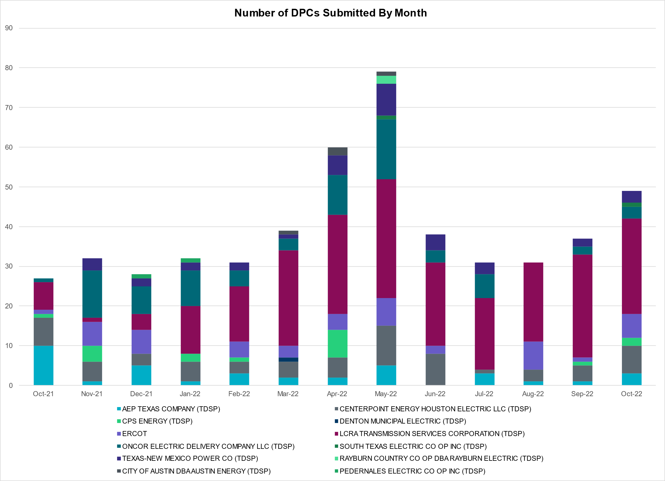

Transmission Operator | Number of DPCs
AEP TEXAS COMPANY (TDSP) | 3
BRAZOS ELECTRIC POWER CO OP INC (TDSP) | 0
BROWNSVILLE PUBLIC UTILITIES BOARD (TDSP) | 0
BRYAN TEXAS UTILITIES (TDSP) | 0
CENTERPOINT ENERGY HOUSTON ELECTRIC LLC (TDSP) | 7
CITY OF AUSTIN DBA AUSTIN ENERGY (TDSP) | 0
CITY OF COLLEGE STATION (TDSP) | 0
CITY OF GARLAND (TDSP) | 0
CPS ENERGY (TDSP) | 2
DENTON MUNICIPAL ELECTRIC (TDSP) | 0
ELECTRIC TRANSMISSION TEXAS LLC (TDSP) | 0
ERCOT | 6
LCRA TRANSMISSION SERVICES CORPORATION (TDSP) | 24
LONE STAR TRANSMISSION LLC (TSP) | 0
ONCOR ELECTRIC DELIVERY COMPANY LLC (TDSP) | 3
PEDERNALES ELECTRIC CO OP INC (TDSP) | 0
RAYBURN COUNTRY CO OP DBA RAYBURN ELECTRIC (TDSP) | 0
SHARYLAND UTILITIES LP (TDSP) | 0
SOUTH TEXAS ELECTRIC CO OP INC (TDSP) | 1
TEXAS MUNICIPAL POWER AGENCY (TDSP) | 0
TEXAS-NEW MEXICO POWER CO (TDSP) | 3

Appendix A: Real-Time Constraints
The following is a complete list of constraints activated in SCED. Full contingency descriptions can be found in the Standard Contingencies List located on the MIS secure site at Grid Generation Reliability Unit Commitment.

Year | Month of the Year | Contingency Name | Overloaded Element | From Station | To Station | Count of Days
2022 | 10 | SBWDDBM5 | LPLMK_LPLNE_1 | LPLMK | LPLNE | 19
2022 | 10 | XFL2C58 | 6471__A | MGSES | MCDLD | 18
2022 | 10 | SLOBSA25 | CATARI_PILONC1_1 | PILONCIL | CATARINA | 17
2022 | 10 | BASE CASE | NE_LOB | n/a | n/a | 17
2022 | 10 | MFLCMGS5 | 6471__A | MGSES | MCDLD | 14
2022 | 10 | SNATBEA8 | 6144__A | BSPRW | STASW | 12
2022 | 10 | SBRAUVA8 | HAMILT_MAVERI1_1 | HAMILTON | MAVERICK | 12
2022 | 10 | SSPJFS8 | JFSSC_06_A | JFS | SC | 12
2022 | 10 | BASE CASE | N_TO_H | n/a | n/a | 11
2022 | 10 | BASE CASE | NELRIO | n/a | n/a | 11
2022 | 10 | MHARNED5 | BURNS_RIOHONDO_1 | RIOHONDO | MV_BURNS | 11
2022 | 10 | DMTSCOS5 | 6437__F | SCRCV | KNAPP | 10
2022 | 10 | SWRDYN8 | LAN_CT_PAVLOV1_1 | LAN_CTY | PAVLOV | 10
2022 | 10 | DWHILON5 | COLETO_VICTOR1_1 | COLETO | VICTORIA | 10
2022 | 10 | SWRDYN8 | LAN_CT_PAVLOV1_1 | PAVLOV | LAN_CTY | 10
2022 | 10 | MFLCMGS5 | MGSES_MR1H | MGSES | MGSES | 10
2022 | 10 | BASE CASE | WESTEX | n/a | n/a | 10
2022 | 10 | DBIGKEN5 | TREADW_YELWJC1_1 | TREADWEL | YELWJCKT | 10
2022 | 10 | SMADSAP8 | MADDUX_SAPOWE2_1 | MADDUX | SAPOWER | 9
2022 | 10 | BASE CASE | BEARKT | n/a | n/a | 9
2022 | 10 | XFL2C58 | MGSES_MR1H | MGSES | MGSES | 9
2022 | 10 | SLOBSA25 | ASHERT_CATARI1_1 | CATARINA | ASHERTON | 9
2022 | 10 | SMDSLNG5 | 6471__A | MGSES | MCDLD | 9
2022 | 10 | SLOBSA25 | ASHERT_CATARI1_1 | ASHERTON | CATARINA | 9
2022 | 10 | DELMSAN5 | PAWNEE_SPRUCE_1 | PAWNEE | CALAVERS | 9
2022 | 10 | MMDLFLC5 | 6471__A | MGSES | MCDLD | 8
2022 | 10 | SN_SAJO5 | LASPUL_RAYMND1_1 | LASPULGA | RAYMND2 | 8
2022 | 10 | SBAKCED5 | HARGRO_TWINBU1_1 | TWINBU | HARGROVE | 8
2022 | 10 | SKOCBUZ8 | 6137__C | GUNSW | HWPOD | 7
2022 | 10 | SWRDYN8 | BLESSI_PAVLOV1_1 | PAVLOV | BLESSING | 7
2022 | 10 | SBRAUVA8 | ESCOND_GANSO1_1 | GANSO | ESCONDID | 7
2022 | 10 | SVEAW_L5 | 6137__C | GUNSW | HWPOD | 7
2022 | 10 | SBRAUVA8 | ESCOND_GANSO1_1 | ESCONDID | GANSO | 7
2022 | 10 | BASE CASE | PNHNDL | n/a | n/a | 7
2022 | 10 | SW_GODE5 | 15060__B | VEALMOOR | KOCHTAP | 6
2022 | 10 | SBGLTWI8 | CONCHO_SANW0_1 | CONCHO | SANW | 6
2022 | 10 | SMDSODE5 | MDSSW_MR1L | MDSSW | MDSSW | 6
2022 | 10 | SBCVPSA8 | JFSSC_06_A | JFS | SC | 6
2022 | 10 | SMDOPHR5 | G138_10B_1 | SEMINOLE | MAGNO_TN | 6
2022 | 10 | SKINFAL8 | FALFUR_PREMON1_1 | FALFUR | PREMONT | 6
2022 | 10 | SPAWCAL5 | COLETO_VICTOR1_1 | COLETO | VICTORIA | 5
2022 | 10 | DBCVPSA8 | JFSSC_06_A | JFS | SC | 5
2022 | 10 | SKLELOY8 | LOYOLA_69_1 | LOYOLA | LOYOLA | 5
2022 | 10 | SGARBAT8 | 15010__B | BLISS | ESTILES | 5
2022 | 10 | DWPWFCK5 | AE_WML26_A | AE | WML | 5
2022 | 10 | DWPWFWP5 | AE_WML26_A | AE | WML | 5
2022 | 10 | BASE CASE | HHGTOM_1 | HHGT | OMEGA | 5
2022 | 10 | DPHRAL58 | G138_10B_1 | SEMINOLE | MAGNO_TN | 5
2022 | 10 | DSALKLN5 | 630__B | KLNSW | HHSTH | 5
2022 | 10 | SBAKCED5 | 6471__A | MGSES | MCDLD | 5
2022 | 10 | SCRMSAR8 | CONCHO_VRBS1_1 | CONCHO | VRBS | 5
2022 | 10 | DCENRI25 | BATES_LISTON1_1 | LISTON | BATES | 4
2022 | 10 | SLOBSA25 | LARDVN_LASCRU1_1 | LARDVNTH | LASCRUCE | 4
2022 | 10 | DQABSRB8 | JFSSC_06_A | JFS | SC | 4
2022 | 10 | DJACALV8 | MYRA_VAL_1 | MYRA | VALYVIEW | 4
2022 | 10 | DSALHUT5 | 1710__C | BELCNTY | SALSW | 4
2022 | 10 | BASE CASE | BEEVIL_CHARTE1_1 | CHARTER | BEEVILLE | 4
2022 | 10 | MHARNED5 | HAINE__LA_PAL1_1 | LA_PALMA | HAINE_DR | 4
2022 | 10 | SFORYEL8 | HEXT_MASONS1_1 | HEXT | MASONSW | 4
2022 | 10 | SFORYEL8 | HEXT_MASONS1_1 | MASONSW | HEXT | 4
2022 | 10 | SVEAW_L5 | 6217__A | WLVSW | GAILS | 4
2022 | 10 | SMV_PAR8 | RIOHND_ERIOHND_1 | MV_RIOHO | RIOHONDO | 4
2022 | 10 | BASE CASE | VALEXP | n/a | n/a | 4
2022 | 10 | DSALHUT5 | 270__A | KNBSW | TMPSW | 4
2022 | 10 | DCALBEC8 | J0_P0_1 | P0 | J0 | 4
2022 | 10 | SREAUVA8 | DOWNIES_AX1H | DOWNIES | DOWNIES | 4
2022 | 10 | SNOECED5 | HARGRO_TWINBU1_1 | TWINBU | HARGROVE | 4
2022 | 10 | BASE CASE | JFSSC_06_A | JFS | SC | 4
2022 | 10 | DBIGKEN5 | HAMILT_MAXWEL1_1 | MAXWELL | HAMILTON | 4
2022 | 10 | XEIN58 | 6471__A | MGSES | MCDLD | 3
2022 | 10 | SBRAUVA8 | GANSO_MAVERI1_1 | MAVERICK | GANSO | 3
2022 | 10 | DNEWPLA8 | JFSSC_06_A | JFS | SC | 3
2022 | 10 | BASE CASE | WHARTN | n/a | n/a | 3
2022 | 10 | SCE2PEC8 | 138_CV2_PCM_1 | CEDRVALE | PECOS | 3
2022 | 10 | SBRAUVA8 | GANSO_MAVERI1_1 | GANSO | MAVERICK | 3
2022 | 10 | SSANEL25 | PAWNEE_SPRUCE_1 | PAWNEE | CALAVERS | 3
2022 | 10 | DBT_SRB8 | BCVLY_03_A | BCV | LY | 3
2022 | 10 | SDI2DIL9 | DILLEYSW_69A1 | DILLEYSW | DILLEYSW | 3
2022 | 10 | SODLBRA8 | HAMILT_MAVERI1_1 | HAMILTON | MAVERICK | 3
2022 | 10 | DMGSQAL5 | 6471__A | MGSES | MCDLD | 3
2022 | 10 | SILLFTL8 | CARVER_TINSLE1_1 | CARVER | TINSLEY | 3
2022 | 10 | SBLESTP5 | COLETO_VICTOR1_1 | COLETO | VICTORIA | 3
2022 | 10 | DCALBEC8 | D5_J0_1 | J0 | LEON_CRK | 3
2022 | 10 | SBIGSCH5 | HARGRO_TWINBU1_1 | TWINBU | HARGROVE | 3
2022 | 10 | DCC1_VIC | COLETO_VICTOR1_1 | COLETO | VICTORIA | 3
2022 | 10 | DKG_NB_5 | JFSSC_06_A | JFS | SC | 3
2022 | 10 | SEBHUG8 | LAN_CT_PAVLOV1_1 | LAN_CTY | PAVLOV | 3
2022 | 10 | SBTPBNT8 | MYRA_VAL_1 | MYRA | VALYVIEW | 3
2022 | 10 | SNOERAN5 | 6471__A | MGSES | MCDLD | 3
2022 | 10 | SCARFRI8 | ATSO_SONR1_1 | SONR | ATSO | 3
2022 | 10 | SHLC6S8 | LHMLY_08_A | LHM | LY | 3
2022 | 10 | DLYTZOR5 | 725T725_1 | MCCALA | RATTLE | 3
2022 | 10 | DMCOPHA8 | AZTECA_HEC1_1 | HEC | AZTECA | 3
2022 | 10 | SSCJFS8 | BCVLY_03_A | BCV | LY | 3
2022 | 10 | DBIGKEN5 | BONDRO_SONR1_1 | SONR | BONDROAD | 3
2022 | 10 | SN_SLON5 | CELANE_KLEBER1_1 | CELANEBI | KLEBERG | 3
2022 | 10 | SNEDLON5 | FALFUR_PREMON1_1 | FALFUR | PREMONT | 3
2022 | 10 | DDR_JFS8 | JFSSC_06_A | JFS | SC | 3
2022 | 10 | DJFSFT_8 | JFSSC_06_A | JFS | SC | 3
2022 | 10 | MMYKPA_8 | JFSSC_06_A | JFS | SC | 3
2022 | 10 | UCBYCBY1 | JFSSC_06_A | JFS | SC | 3
2022 | 10 | XWHI58 | KOCH_H_LON_HI1_1 | LON_HILL | KOCH_HF | 3
2022 | 10 | DELMSAN5 | COLETO_VICTOR1_1 | COLETO | VICTORIA | 3
2022 | 10 | DSCOTKW5 | 15060__B | VEALMOOR | KOCHTAP | 2
2022 | 10 | DWHICOT5 | FARMLAND_LONGD_1 | FARMLAND | W_LD_345 | 2
2022 | 10 | DRILKRW5 | 6085__E | WFSSW | NSTAR | 2
2022 | 10 | DCAGCO58 | 656T656_1 | KENDAL | BERGHE | 2
2022 | 10 | DSALHUT5 | GABRIE_AT1 | GABRIE | GABRIE | 2
2022 | 10 | SMDOOAS5 | JFSSC_06_A | JFS | SC | 2
2022 | 10 | MWHI58 | KOCH_H_LON_HI1_1 | LON_HILL | KOCH_HF | 2
2022 | 10 | XNED358 | NEDIN_SERDEV1_1 | NEDIN | NEDIN | 2
2022 | 10 | DLWSRNK5 | 587__A | ARGYL | LWSVH | 2
2022 | 10 | DELMSAN5 | BEEVIL_NORMAN1_1 | BEEVILLE | NORMANNA | 2
2022 | 10 | DGS_CF_8 | GBYGP_17_A | GBY | GP | 2
2022 | 10 | SFORYEL8 | HEXT_YELWJC1_1 | YELWJCKT | HEXT | 2
2022 | 10 | DRNS_TB5 | THWZEN71_A | ZEN | THW | 2
2022 | 10 | SMGIENW8 | TRU_UAT1 | TRU | TRU | 2
2022 | 10 | SBCESND5 | 421__A | BCESW | SNDSW | 2
2022 | 10 | SBIGSCH5 | 6471__A | MGSES | MCDLD | 2
2022 | 10 | SSCJFS8 | BCVPSA03_A | PSA | BCV | 2
2022 | 10 | DLONOR58 | CALALS_LON_HI1_1 | LON_HILL | CALALS | 2
2022 | 10 | SHNYCS8 | JFSSC_06_A | JFS | SC | 2
2022 | 10 | DBIGKEN5 | MADDUX_TREADW1_1 | MADDUX | TREADWEL | 2
2022 | 10 | DAUSLOS5 | 190T152_1 | WINCHES | GIDEON | 2
2022 | 10 | SBAKCED5 | 6095__D | LMESA | JPPOI | 2
2022 | 10 | SSCHNOE5 | 6471__A | MGSES | MCDLD | 2
2022 | 10 | DCAGCI58 | 656T656_1 | KENDAL | BERGHE | 2
2022 | 10 | SCOLPAW5 | COLETO_VICTOR1_1 | COLETO | VICTORIA | 2
2022 | 10 | DCALBEC8 | E1_R2_1 | R2 | E1 | 2
2022 | 10 | BASE CASE | EASTEX | n/a | n/a | 2
2022 | 10 | DLONOR58 | FALFUR_PREMON1_1 | FALFUR | PREMONT | 2
2022 | 10 | DLYTZOR5 | 106T200_1 | REDWOO | SANMAR | 2
2022 | 10 | DCAGCI58 | 255T279_1 | PIPECR | MEDILA | 2
2022 | 10 | SKENKEN8 | 72T120_1 | KENDAL | HOLLMI | 2
2022 | 10 | SMOUJOH8 | 72T120_1 | KENDAL | HOLLMI | 2
2022 | 10 | SEBHUG8 | BLESSI_PAVLOV1_1 | PAVLOV | BLESSING | 2
2022 | 10 | SCEDHI_5 | HARGRO_TWINBU1_1 | TWINBU | HARGROVE | 2
2022 | 10 | SWHILON5 | NUECES_WHITE_2_1 | NUECES_B | WHITE_PT | 2
2022 | 10 | SCRTEIL8 | RKYROAD_ESTILE_1 | ESTILES | RCKYROAD | 2
2022 | 10 | DBERAN58 | 85T329_1 | BERGHE | DEVIHI | 2
2022 | 10 | SN_SLON5 | CELANE_N_SHAR1_1 | N_SHARPE | CELANEBI | 2
2022 | 10 | SNOERAN5 | HARGRO_TWINBU1_1 | TWINBU | HARGROVE | 2
2022 | 10 | DBT_SRB8 | JFSSC_06_A | JFS | SC | 2
2022 | 10 | MHARNED5 | LASPUL_RAYMND1_1 | LASPULGA | RAYMND2 | 2
2022 | 10 | SBIGOR55 | TREADW_YELWJC1_1 | TREADWEL | YELWJCKT | 2
2022 | 10 | DMBDRKC5 | 6005__A | PKRSW | BNBSW | 2
2022 | 10 | SW_GODE5 | 6095__D | LMESA | JPPOI | 2
2022 | 10 | SBERSC8 | BCVLY_03_A | BCV | LY | 2
2022 | 10 | DBIGKEN5 | CARVER_TINSLE1_1 | CARVER | TINSLEY | 2
2022 | 10 | DCALBEC8 | F1_O9_1 | F1 | SUTHRLND | 2
2022 | 10 | SBREHIG8 | 276T350_1 | GAYHIL | SANDHI | 2
2022 | 10 | DCPSMBD5 | 6005__A | PKRSW | BNBSW | 2
2022 | 10 | XFL2C58 | 6095__D | LMESA | JPPOI | 2
2022 | 10 | SKOCBUZ8 | 6217__A | WLVSW | GAILS | 2
2022 | 10 | SVEAW_L5 | 6471__A | MGSES | MCDLD | 2
2022 | 10 | DCALBEC8 | D3_G3_1 | D3 | G3 | 2
2022 | 10 | SWRDYN8 | DA_WC_89_A | WC | DA | 2
2022 | 10 | DCAGCO58 | 583T583_1 | BANDER | MASOCR | 2
2022 | 10 | DSALHUT5 | 1710__E | SALSW | SALDS | 1
2022 | 10 | DNAVOUT5 | 50__A | BBSES | JEWET | 1
2022 | 10 | SMCDBSP8 | 6471__A | MGSES | MCDLD | 1
2022 | 10 | DZORHAY5 | BERGHE_AT1H | BERGHE | BERGHE | 1
2022 | 10 | DCAGCO58 | BERGHE_AT1L | BERGHE | BERGHE | 1
2022 | 10 | DWHILON5 | BLESSI_LOLITA1_1 | LOLITA | BLESSING | 1
2022 | 10 | SCBYCBY8 | BT_CBY88_A | CBY | BT | 1
2022 | 10 | DKENNO89 | COLETO_ROSATA1_1 | COLETO | ROSATA | 1
2022 | 10 | DSTPANS5 | COLETO_VICTOR1_1 | COLETO | VICTORIA | 1
2022 | 10 | SBRACAL8 | D3_G3_1 | D3 | G3 | 1
2022 | 10 | SWCAE8 | DA_WC_89_A | WC | DA | 1
2022 | 10 | SN_SLON5 | HOLLY4_SOUTH_1_1 | HOLLY4 | SOUTH_SI | 1
2022 | 10 | DI_DRIN8 | INGLES_I_DUPS1_1 | I_DUPSW | INGLESID | 1
2022 | 10 | XKEN458 | KENDAL_AT4H | KENDAL | KENDAL | 1
2022 | 10 | SFORYEL8 | MASNPH_MASN1_1 | MASN | MASNPHT | 1
2022 | 10 | DWHIGIB8 | NAVALB_N_PADR1_1 | NAVALBAS | N_PADRE | 1
2022 | 10 | MRESMCM8 | RINCON_WHITE_2_1 | WHITE_PT | RINCON | 1
2022 | 10 | SSPUSLT8 | ROBY_ROTN1_1 | ROTN | ROBY | 1
2022 | 10 | DSALHUT5 | 1710__A | SALDS | SONTERRA | 1
2022 | 10 | DGRSPKR5 | 6377__A | BRTSW | ORANS | 1
2022 | 10 | XKEN458 | BERGHE_AT1L | BERGHE | BERGHE | 1
2022 | 10 | DELMSAN5 | CHOATE_CHARCO_1 | CHOATE | CHARCOS | 1
2022 | 10 | SPAWCAL5 | COLETO_ROSATA1_1 | COLETO | ROSATA | 1
2022 | 10 | XCO2L58 | COLETO_VICTOR1_1 | COLETO | VICTORIA | 1
2022 | 10 | SLAQLOB8 | FALFUR_PREMON1_1 | FALFUR | PREMONT | 1
2022 | 10 | DBIGKEN5 | FORTMA_YELWJC1_1 | FORTMA | YELWJCKT | 1
2022 | 10 | SBRAHAM8 | GANSO_MAVERI1_1 | GANSO | MAVERICK | 1
2022 | 10 | DHUGWR_8 | LAN_CT_PAVLOV1_1 | LAN_CTY | PAVLOV | 1
2022 | 10 | SMAYWHI8 | NUECES_WHITE_2_1 | NUECES_B | WHITE_PT | 1
2022 | 10 | SAIRNCA8 | REFUG_VICTO_1C_1 | VICTORIA | OCONNOR | 1
2022 | 10 | SREAUVA8 | UVLD_DOWI_1 | DOWNIES | UVLDES | 1
2022 | 10 | SCEDHI_5 | 6471__A | MGSES | MCDLD | 1
2022 | 10 | SBONNED5 | BURNS_RIOHONDO_1 | RIOHONDO | MV_BURNS | 1
2022 | 10 | DAUSDUN8 | CKT_962_1 | GARFIELD | STONEY_R | 1
2022 | 10 | SBLESTP5 | CUELCA_THOMAS1_1 | CUERO | THOMASTN | 1
2022 | 10 | XBLE58 | CUELCA_THOMAS1_1 | CUERO | THOMASTN | 1
2022 | 10 | DBECKIR8 | D3_G3_1 | D3 | G3 | 1
2022 | 10 | DBRNSTR8 | F1_O9_1 | F1 | SUTHRLND | 1
2022 | 10 | DDELGA58 | FREER_LOBO1_1 | LOBO | FREER | 1
2022 | 10 | SILLFTL8 | HAMILT_MAXWEL1_1 | MAXWELL | HAMILTON | 1
2022 | 10 | SCRMSAR8 | HARI_VRBS1_1 | VRBS | HARI | 1
2022 | 10 | SLGEI_D8 | I_DUPS_LGE1_1 | LGE | I_DUPSW | 1
2022 | 10 | DGRMGRS8 | OLN_FMR2 | OLN | OLN | 1
2022 | 10 | DSARIND8 | 3070__C | MDLTM | ENTOH | 1
2022 | 10 | DCDHMCS8 | 3160__A | CDCSW | OKCLS | 1
2022 | 10 | DWYLBEN8 | APO_JUPI_1 | JUPITER | APOLLO | 1
2022 | 10 | SCO2EUL8 | COLETO_ROSATA1_1 | COLETO | ROSATA | 1
2022 | 10 | SREAUVA8 | FER_DOWNI_1 | DOWNIES | FERRISW | 1
2022 | 10 | DGBY_KG5 | JFSSC_06_A | JFS | SC | 1
2022 | 10 | XVI2C89 | MAGRUD_VICTOR2_1 | VICTORIA | MAGRUDER | 1
2022 | 10 | SOXYING8 | RINCON_WHITE_2_1 | RINCON | WHITE_PT | 1
2022 | 10 | SBGLTWI8 | SAMATH_SANW1_1 | SANW | SAMATHIS | 1
2022 | 10 | XBLE58 | SAR_FRAN_1 | FRANKC | SARGNTS | 1
2022 | 10 | DTVWJON5 | 151__A | CPSES | WOFHO | 1
2022 | 10 | SNOECED5 | 6471__A | MGSES | MCDLD | 1
2022 | 10 | DCAGTA58 | BERGHE_AT1H | BERGHE | BERGHE | 1
2022 | 10 | SPORWH38 | RINCON_WHITE_2_1 | RINCON | WHITE_PT | 1
2022 | 10 | DKENCA58 | 255T279_1 | PIPECR | MEDILA | 1
2022 | 10 | SSPUSLT8 | ASPM_69T2 | ASPM | ASPM | 1
2022 | 10 | DCE_RIO5 | BATES_LISTON1_1 | LISTON | BATES | 1
2022 | 10 | DGBYCRN8 | BCVLY_03_A | BCV | LY | 1
2022 | 10 | STANPAW5 | BEEVIL_NORMAN1_1 | BEEVILLE | NORMANNA | 1
2022 | 10 | DCAGCO58 | BERGHE_AT1H | BERGHE | BERGHE | 1
2022 | 10 | XKEN458 | BERGHE_AT1H | BERGHE | BERGHE | 1
2022 | 10 | DSWECBF5 | BLUF_C_MULBER1_1 | MULBERRY | BLUF_CRK | 1
2022 | 10 | SLAQLOB8 | BRUNI_69_1 | BRUNI | BRUNI | 1
2022 | 10 | SGRILON5 | COLETO_VICTOR1_1 | COLETO | VICTORIA | 1
2022 | 10 | SODLBRA8 | ESCOND_GANSO1_1 | ESCONDID | GANSO | 1
2022 | 10 | DCOTDMT5 | FARMLAND_LONGD_1 | FARMLAND | W_LD_345 | 1
2022 | 10 | SPOMNED5 | FREER_LOBO1_1 | LOBO | FREER | 1
2022 | 10 | SODLBRA8 | GANSO_MAVERI1_1 | GANSO | MAVERICK | 1
2022 | 10 | SBRAHAM8 | HAMILT_MAVERI1_1 | HAMILTON | MAVERICK | 1
2022 | 10 | XWHI58 | NUECES_WHITE_2_1 | NUECES_B | WHITE_PT | 1
2022 | 10 | DCE_RIO5 | RGCIT_ROMAS_1C_1 | ROMA_SW | ROMA | 1
2022 | 10 | SRINWHI8 | RINCON_69A1 | RINCON | RINCON | 1
2022 | 10 | DFERWIR8 | SANDCR_AT1 | SANDCR | SANDCR | 1
2022 | 10 | SCISPUT8 | SOUTHA_VINSON1_1 | SOUTHABI | VINSON | 1
2022 | 10 | BASE CASE | TRDWEL | n/a | n/a | 1
2022 | 10 | MWIRJO28 | 72T120_1 | KENDAL | HOLLMI | 1
2022 | 10 | SWCSAN8 | BEAEB_60_A | EB | BEA | 1
2022 | 10 | DCAGCI58 | BERGHE_AT1H | BERGHE | BERGHE | 1
2022 | 10 | DBWN_AM5 | CONCHO_VRBS1_1 | CONCHO | VRBS | 1
2022 | 10 | DBECKIR8 | D5_J0_1 | J0 | LEON_CRK | 1
2022 | 10 | BASE CASE | HAMILT_MAXWEL1_1 | MAXWELL | HAMILTON | 1
2022 | 10 | SMDOOAS5 | MSNPET04_A | PET | MSN | 1
2022 | 10 | SCEDPEC8 | 138_CV1_PCM_1 | CEDRVALE | PECOS | 1
2022 | 10 | DWLDSCO5 | 15060__B | VEALMOOR | KOCHTAP | 1
2022 | 10 | DAUSLOS5 | 197T171_1 | GIDEON | AUSTRO | 1
2022 | 10 | DLEGOUT5 | 50__A | BBSES | JEWET | 1
2022 | 10 | SW_BW_25 | 6471__A | MGSES | MCDLD | 1
2022 | 10 | SZORAUS5 | 8T352_1 | GARFIE | LYTTON_S | 1
2022 | 10 | SRAYRAY8 | COLETO_VICTOR1_1 | COLETO | VICTORIA | 1
2022 | 10 | SBAKCED5 | CONCHO_SANW0_1 | CONCHO | SANW | 1
2022 | 10 | XKEN458 | KENDAL_AT4L | KENDAL | KENDAL | 1
2022 | 10 | DDOWOAS5 | MSNPET04_A | PET | MSN | 1
2022 | 10 | DBWNAMO5 | SAPOWE_SAST1_1 | SAPOWER | SAST | 1
2022 | 10 | DENWSTE8 | TRU_UAT1 | TRU | TRU | 1
2022 | 10 | SFRAPAR8 | WEIDER_RAND_1 | WEIDER | W2 | 1

Current Wind Generation Record: 27,044 MW on 05/29/2022 at 22:36 | Current Wind Penetration Record: 69.15% on 04/10/2022 at 01:43 Current Solar Generation Record: 10,100 MW on 10/01/2022 at 11:03 | Current Solar Penetration Record: 24.99% on 10/01/2022 at 10:06
This is the hourly integrated peak demand as published in the ERCOT D&E report.
All DC Tie Curtailments are posted publicly on the ERCOT Market Information System. See that posting for additional details for the event(s) in question.
See DC Tie Operating Procedure (http://www.ercot.com/mktrules/guides/procedures) for more details.

