TDTMS
October 20th, 2022
WebEx only
Attendee | Company | Attendee | Company | Attendee | Company
Diana Rehfeldt | TNMP | Dave Michelson | ERCOT | Kyle Patrick | NRG
Sam Pak | Oncor | Tammy Stewart | ERCOT | Monica Jones | CNP
Jordan Troublefield | ERCOT | Mick Hanna | ERCOT | Eric Lotter | GridMonitor
Sheri Wiegand | Vistra | Stephen Wilson | Vistra | Kathy Scott | CNP
Carolyn Reed | CNP | Mark Hensley | Oncor | Bill Snyder | AEP

Antitrust/Minutes
- Antitrust Admonition was read by Sheri Wiegand
  - Minutes from 9/22/22 were reviewed and approved.

ERCOT System Instances & MarkeTrak Monthly Performance Review
- Mick presented September performance reports - ERCOT has met monthly SLA targets and now has met annual target
    - A few incidents noted on report: 9/11 reducing risk activity, 9/18 site failover
    - MarkeTrak was intermittent some mornings where users were unable to log in – working with vendor, yet issue should be resolved
- MarkeTrak response times remains flat

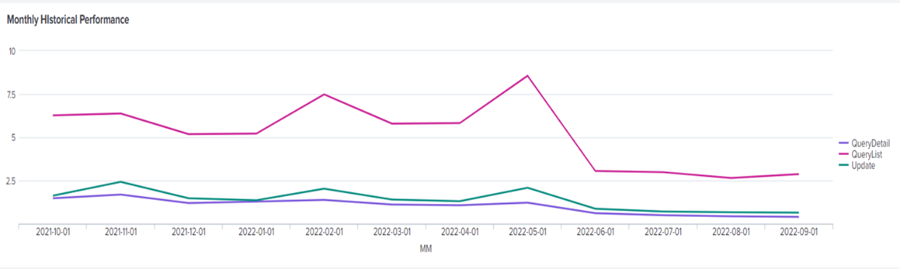

- Listserv activity – experienced issue with listserv not sending market notices to recipients due to a size threshold issue. Configuration was identified and Proofpoint and other thresholds were modified (size of mailbox = size of message)
- TDSP Extract – a couple market participants missed the market notice regarding the change in URL for the daily TSDP extract posting. The ask was for ERCOT IT to provide some an advance notification at TDTMS meeting for awareness.

MarkeTrak Upgrade and Stabilization
- Update on last remaining issue:
  - New Users and Search functionality – still researching w/ vendor

SCR 815 – MarkeTrak Administrative Changes (December 2022)
- GO LIVE is actually on 12/12 which is the Monday following the final retail release of 2022.
- Market notice was sent out 10/20 regarding WSDLs availability in RMTE only
- API users will need to upload WSDLs from the MarkeTrak Information Page
- TRAINING DATES – NEW INFORMATION: training has been moved to the following dates:
    - 11/30, Wednesday @ 1:00 – 2:00 PM
    - 12/7, Wednesday @ 9:30 AM (during TDTMS)
- Sheri has forwarded information to Stakeholder Services for WebEx information. NOTE: Tammy Stewart to set up WebEx for 11/30 Training.

SCR 817 MarkeTrak Validations –
IAG
- Sheri expressed Vistra had concerns with the proposed workflow for IAGs when the Losing REP proposes a ‘regain date’ that the Gaining CR does not approve (even if it falls in the existing guardrails) and creates a circular loop where the MT will not advance/close
- After discussion at TDMTS, Sheri was going to take back that the Losing REP does control the regain date
- NEW INFORMATION: Following TDTMS, Sheri continued discussion with Vistra and NRG and proposed new workflow. Tammy reviewed with developers and offered a solution that was reviewed at the following MCT meeting on 10/27.
Reject Codes
- Concerns were expressed over the need to list all 36 new codes under a drop-down list when submitting this subtype. (For API users, this adds a significant amount of code, when this is a low volume subtype).
- The decision was reached to make the ‘Reject Code’ a freeform, optional field. ESI, OTRAN, and TRAN TYPE would still remain required fields. Comments are also optional excluding if the code is A13.
- Business requirements would be modified.
Tammy reviewed and clarified any questions or final decisions regarding each of the business requirements. Next week’s final MCT meeting on 10/27 will be the last opportunity to make any revisions.

MarkeTrak Subtype Volume Analysis – Mid Year 2022
Sheri respectfully requested Sam Pak perform the following additional analysis on the data provided by Dave Michelson:
- Review time spent (submit to close) on each of the following subtypes:
  - Switch Hold
  - Usage & Billing – Missing
  - Usage & Billing – Dispute
  - Other
  - Cancel w/ Approval
  - Missing Enrollment Transactions
  - Siebel Changes
  - Projects
- Plot out ‘ranking volumes’ for each subtype over time – i.e. IAGs #1 in YE2021, #2 in MY2021, etc.
ACTION: Sheri will provide data to Sam for analysis and set up smaller group (Kyle, Monica, Sam, Sheri) to review data format.

NEXT MEETING scheduled – November 16th @ 1:00PM WebEx only
- ERCOT Updates
  - System Instances & MT Performance
  - Listserv
  - MarkeTrak Upgrade Stabilization
- SCR815 Updates – training & notices
- SCR817 Business Requirements discussion, if needed
- MarkeTrak Volume Subtype Analysis Discussion –
  - Time Spent on Issues of Various Subtypes
  - Ranking Volumes over time

