PLWG October 19th

# Background

California has a high penetration of solar throughout its system. It has started to experience an ever increasing load ramp; also known as a “Duck Curve”

Duck Curve

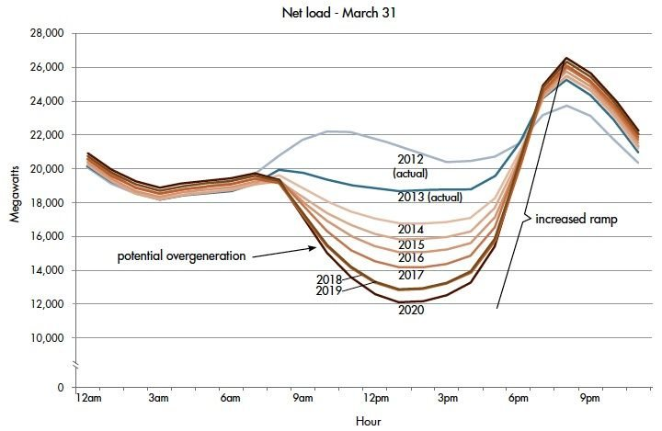

ERCOT currently operates just under 10,000 MW of solar generation participating in the market. The SSWG planning cases being built now shows ~29,200 MW of Solar Generation. There is currently ~118,400 MW of Solar Generation requests in the ERCOT queue.

# Concerns:

ERCOT has traditionally planned on utilizing the steady state planning cases to represent the peak load, which has usually been around 5 pm. With the increasing penetration of solar, there may be times throughout the day which cause strain on the transmission which are not observed. For example, around 8 pm there is virtually no solar generation; yet the load on a summer day doesn’t necessarily drop as much as the solar.

Using Brazos as an example: ERCOT’s summer peak day was recorded August 13th at 16:45. Brazos’ load for the day looked as follows:

When running the numbers, the load connected to Brazos at 8:00 pm was 95.2% of the peak value. The load doesn’t drop off when the sun sets.

Similar results can be see from ERCOT’s 5 minute data from this summer:

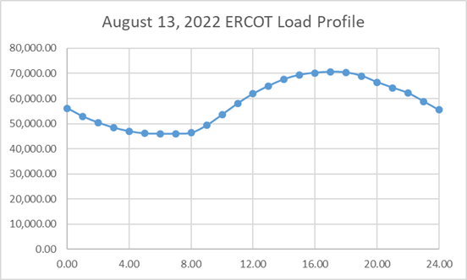

It is recommended to create a load flow case which studies this type of 8:00 pm hour, when solar has gone offline to determine if there are additional constraints on the transmission system.

# How would a SSWG Case be built?

No topology changes would be necessary for this type of case build. It would only require new load profiles and new generation profiles.

Each TSP would be required to determine approximately what they expect the load difference is from a peak load to 8 pm on their system. The load profile would be a simple scaling amount from the summer peak case load profiles. As a default, TSPs could use 95% as a starting place.

The concept of this case would be to have 0 solar generation online. The sun doesn’t shine at night. Perhaps the batteries which are traditionally shown to be 0 MW in SSWG cases would be enough generation to offset the difference, or maybe extraordinary dispatch will be necessary. The idea is to see if the change of generation patterns at this time causes any additional strain on the transmission system so planners can determine how to address it before it occurs.

Currently it is recommended to consider this based on a summer peak 2 years in the future. It may be useful to consider one for a winter peak scenario as well.

# Why is a new SSWG case necessary?

The change of ERCOT’s generation dispatch throughout the day is not represented in load flow planning studies. Changing the dispatch may reveal constraints on the transmission system that are otherwise unseen. It is likely that as traditional generation continues to be mothballed, this study case will show potential thermal constraints such that planners can begin to prepare action plans and construction projects accordingly. Currently none of the SSWG planning cases show battery generation to be online. This particular study case would consider batteries to be used as generators.

# Are there other study cases that need to be considered?

Most likely, yes. Traditional study cases have only considered seasonal peaks and minimums. Due to the dynamic nature of the available generation, there may be many scenarios which occur and are not being studied. For the purposes of this request, the low hanging fruit would be a summer peak, just after the sun goes down and the load hasn’t fallen to a minimum.

# Request and Recommendation:

It is requested that PLWG decide to initiate the process of having SSWG prepare additional study cases such that planners can more accurately perform planning studies.

If required, with PLWG’s recommendation this discussion can be taken to ROS.