NOGRR Number | 230 | NOGRR Title | WAN Participant Security

Date | November 4, 2022

Submitter’s Information
Name | Roy True
E-mail Address | royt@acespower.com
Company | ACES
Phone Number | 317-344-7203
Cell Number | 317-695-4146
Market Segment | Cooperative

Comments
ACES submits these comments to include alternative means to ensure the integrity of the Wide Area Network (WAN) Data transmission from Denial of Service (DoS) and Distributed Denial Of Service (DDoS) attacks. While ACES agrees with the need to ensure integrity of the WAN and to require network designs which prevent DoS and DDoS attacks, we have evaluated many different options for secure and reliable transfer of data between the WAN Participant and a physical Resource location. While we agree that using a Secure Private Network (SPN) is an effective means of preventing a DoS or DDoS attack, it is susceptible to reliability issues presented with using a single Internet Service Provider (ISP). While the ISP may enter into an agreement to provide 99.9% uptime or better, that does not account for scheduled downtime due to maintenance on older infrastructure for which the SPN definition requires.

The proposal allows for Secure Dual Homed Internet (SDHI) as an option for communications between a WAN Participant and a physical Resource location will provide comparable protections from a DoS or DDoS attack, while adding in redundancy to increase reliability in the communication that is lacking from an SPN. With the use of multiple ISPs, providing Internet circuits layered with a solution such as Software-Defined WAN (SD-WAN) which automatically evaluates each circuit in real time, deciding which of the available circuits is the best route to its destination, provides defense against DoS or DDoS attacks with a higher reliability of the communications. In the event of an attempt to interrupt communications utilizing a DoS or DDoS style attack, the networking equipment will cease use of that circuit and send communications using the un-effected circuit.

To further protect from a DoS or DDoS style attack, ISPs offer a service which can either alert to unknown traffic or block and alert on traffic that has not been previously identified as acceptable, effectively stopping an attack from having any impact on communications.
Revised Cover Page Language

Business Case | When transmission of data over the WAN is negatively impacted by shared Internet connected hardware/software outages or a DDoS attack from the Internet, this creates an undesirable risk to the operation of the ERCOT Bulk Electric System. The market should take measures to prevent such risks against dependency on a single “Internet Service Provider” (ISP) connectivity to the WAN.

Revised Proposed Guide Language

1.4 Definitions

7.1.2 WAN Participant Responsibilities
(1) WAN Participant responsibilities include the following:
(a) A prospective WAN Participant is required to complete a WAN application, signed by the WAN Participant’s Authorized Representative, and sign the ERCOT Private WAN Agreement, which governs installation, operation, and maintenance of the WAN hardware. Appropriate WAN documents can be obtained by contacting ERCOT. The WAN application shall include the following information at a minimum:
(i) WAN circuit termination location and requested functionality specifications;
(ii) WAN Participant’s primary and backup contacts for WAN facilities management and services;
(iii) WAN Participant’s primary and backup contacts for WAN emergency restoration;
(iv) WAN Invoicing contact information;
(v) WAN Participant’s 24x7 operations desk long distance number; and
(vi) WAN Participant’s 24x7 analog line for maintenance.
(b) Each WAN Participant must timely update information provided to ERCOT in the application process, and must promptly respond to any reasonable request by ERCOT for updated information regarding the WAN Participant or the information provided to ERCOT in item (a) above. Changes to any of the information listed in item (a) above shall be submitted to ERCOT using a Notice of Change of Information (NCI) form.
(c) A WAN Participant shall provide physical security systems compliant with the applicable Critical Infrastructure Protection (CIP) requirement of the North American Electric Reliability Corporation (NERC) Reliability Standards.
(d) WAN Participant equipment provided by ERCOT that exchanges ICCP Data, Resource-Specific XML Data, or operational voice communications with ERCOT shall connect directly to the ERCOT WAN. ERCOT will work with each WAN Participant to determine the most appropriate WAN demarcation point. Criteria for determining demarcation points include:
(i) Reliability;
(ii) Location of data centers;
(iii) Location of control centers and/or communication centers;
(iv) Location of disaster recovery facilities;
(v) Location of Energy and Market Management System (EMMS) equipment;
(vi) Location of ICCP equipment;
(vii) Location of Resource-Specific XML equipment; and
(viii) Location of private branch exchange (PBX) or call management equipment installation.
(e) ERCOT is responsible for designating necessary WAN equipment for the reliable transport of communications over the ERCOT WAN and will make the ultimate determination of the demarcation point location.
(f) A WAN Participant that serves both Transmission Service Provider (TSP) and QSE functions at one location may have a single ERCOT WAN connection as defined in Section 7.1, ERCOT Wide Area Network, at that location.
(g) If a TSP and QSE share a centralized PBX or call management, separate OPX circuits will be terminated for each participant.
(h) Each WAN Participant is required to extend the ERCOT OPX and Hotline voice circuits into its 24x7 operations desk. The OPX and Hotline voice circuits are transported across the ERCOT WAN. If a WAN Participant is designated to represent another Market Participant through an agency agreement approved by ERCOT, the WAN Participant must have dedicated OPX circuits for each Market Participant represented, in addition to a dedicated OPX for the WAN Participant if it is also representing Resources. In these cases, a single Hotline button will be used for the WAN Participant and all of the represented Market Participants. The Market Participant and its agent, if applicable, are both responsible for delivering the Hotline and the OPX to the Market Participant’s 24x7 operations desk in a manner that reasonably assures continuous communication with ERCOT and is not affected by calling features such as automatic transfer or roll to voice mail. Also, a touchtone keypad is required for the Hotline to be able to provide an acknowledged receipt. The demarcation point for all voice circuits is the WAN Participant’s router.
(i) Each WAN Participant must provide internal facilities and communications to collect and furnish data and voice signals to the ERCOT WAN as required by the Protocols. For TSPs and TOs such data includes, but is not limited to, voice communications, ICCP Data, and Supervisory Control and Data Acquisition (SCADA) for substations and other Transmission Facilities. For QSEs such data includes, but is not limited to, operational voice communications, ICCP Data, Resource-Specific XML Data, and SCADA for Resources.
(j) A WAN Participant shall provide adequate physical facilities to support the ERCOT WAN communications equipment. The physical facilities and communications equipment requirements include the following:
(i) Provide an analog business phone line or PBX analog extension for troubleshooting and maintenance of equipment;
(ii) Provide a height of 24” of rack space in a 19” wide rack;
(iii) Provide two separate uninterruptible power supply single-phase 115 VAC 20 amp circuits, each with four receptacles in the 19” rack listed above;
(iv) Provide building wiring from circuit termination to equipment rack;
(v) Within 24-hours notice, provide ERCOT employees or contractors access to the communication facility;
(vi) Within one-hour notice, provide ERCOT employees or contractors emergency access to the communication facility;
(vii) Provide onsite personnel to escort ERCOT employees or contractors;
(viii) Provide a firewall or router, located at the WAN Participant site, for the network address translation of internal WAN Participant addresses to external addresses on the ERCOT LAN;
(ix) Provide connectivity from WAN Participant firewall or router to ERCOT LAN located at WAN Participant site. WAN Participants are responsible for their own security through this connection;
(x) Dual cable entrances to WAN Participant, connecting to different Telco Central Offices are highly recommended; and
(xi) Provide ERCOT with internal IP addressing scheme as needed for network design. This will be kept confidential.
(k) A WAN Participant shall supply, implement, and maintain all data and voice communication facilities required to fulfill the obligations set forth in these Operating Guides.
(l) A WAN Participant’s installation of data and voice communication facilities described in paragraph (k) above must complete qualification testing as specified by ERCOT before ERCOT will grant approval to commence operational use of the WAN connection. A WAN Participant shall request prior approval from ERCOT of any changes in data and voice communication facilities that impact connectivity through the WAN and shall coordinate with ERCOT before commencing operational use.
(m) If a WAN Participant extends its network or otherwise transmits WAN Data or operational voice communications to another of its control and/or data center or another WAN Participant’s control and/or data center, then such communications shall be transmitted or received using an approved mode of communication.
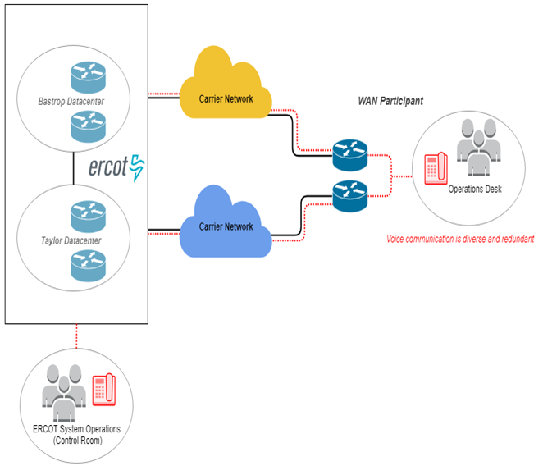
Figure 1 ERCOT Wide Area Network Overview
(n) If a WAN Participant is a QSE that represents a Resource Entity, ERS Resource, or another QSE and receives or transmits WAN Data, the WAN Participant shall utilize an approved mode of communication for the transmission or receipt of WAN Data between it and the Resource Entity, ERS Resource, or QSE it represents.
[NOGRR177: Replace Section 7.1.2 above with the following upon system implementation of NPRR857:]

7.1.2 WAN Participant Responsibilities
(1) WAN Participant responsibilities include the following:
(a) A prospective WAN Participant is required to complete a WAN application, signed by the WAN Participant’s Authorized Representative, and sign the ERCOT Private WAN Agreement, which governs installation, operation, and maintenance of the WAN hardware. Appropriate WAN documents can be obtained by contacting ERCOT. The WAN application shall include the following information at a minimum:
(i) WAN circuit termination location and requested functionality specifications;
(ii) WAN Participant’s primary and backup contacts for WAN facilities management and services;
(iii) WAN Participant’s primary and backup contacts for WAN emergency restoration;
(iv) WAN Invoicing contact information;
(v) WAN Participant’s 24x7 operations desk long distance number; and
(vi) WAN Participant’s 24x7 analog line for maintenance.
(b) Each WAN Participant must timely update information provided to ERCOT in the application process, and must promptly respond to any reasonable request by ERCOT for updated information regarding the WAN Participant or the information provided to ERCOT in item (a) above. Changes to any of the information listed in item (a) above shall be submitted to ERCOT using a Notice of Change of Information (NCI) form.
(c) A WAN Participant shall provide physical security systems compliant with the applicable Critical Infrastructure Protection (CIP) requirement of the North American Electric Reliability Corporation (NERC) Reliability Standards.
(d) WAN Participant equipment provided by ERCOT that exchanges ICCP Data, Resource-Specific XML Data, or operational voice communications with ERCOT shall connect directly to the ERCOT WAN. ERCOT will work with each WAN Participant to determine the most appropriate WAN demarcation point. Criteria for determining demarcation points include:
(i) Reliability;
(ii) Location of data centers;
(iii) Location of control centers and/or communication centers;
(iv) Location of disaster recovery facilities;
(v) Location of Energy and Market Management System (EMMS) equipment;
(vi) Location of ICCP equipment;
(vii) Location of Resource-Specific XML equipment; and
(viii) Location of private branch exchange (PBX) or call management equipment installation.
(e) ERCOT is responsible for the reliable transport of communications over the ERCOT WAN and will make the ultimate determination of the demarcation point location.
(f) A WAN Participant that serves both TO and QSE functions at one location may have a single ERCOT WAN connection as defined in Section 7.1, ERCOT Wide Area Network, at that location.
(g) If a TO and QSE share a centralized PBX or call management with a QSE, the QSE’s OPX circuits will be terminated separately from the OPX circuits of the TO.
(h) Each WAN Participant is required to extend the ERCOT OPX and Hotline voice circuits into its 24x7 operations desk. The OPX and Hotline voice circuits are transported across the ERCOT WAN. If a WAN Participant is designated to represent another Market Participant through an agency agreement approved by ERCOT, the WAN Participant must have dedicated OPX circuits for each Market Participant represented, in addition to a dedicated OPX for the WAN Participant if it is also representing Resources. In these cases, a single Hotline button will be used for the WAN Participant and all of the represented Market Participants. The Market Participant and its agent, if applicable, are both responsible for delivering the Hotline and the OPX to the Market Participant’s 24x7 operations desk in a manner that reasonably assures continuous communication with ERCOT and is not affected by calling features such as automatic transfer or roll to voice mail. Also, a touchtone keypad is required for the Hotline to be able to provide an acknowledged receipt. The demarcation point for all voice circuits is the WAN Participant’s router.
(i) Each WAN Participant must provide internal facilities and communications to collect and furnish data and voice signals to the ERCOT WAN as required by the Protocols. For TOs such data includes, but is not limited to, operational voice communications, ICCP Data, and Supervisory Control and Data Acquisition (SCADA) for substations and other Transmission Facilities. For QSEs, such data includes, but is not limited to, operational voice communications, ICCP Data, Resource-Specific XML Data, and SCADA for Resources.
(j) A WAN Participant shall provide adequate physical facilities to support the ERCOT WAN communications equipment. The physical facilities and communications equipment requirements include the following:
(i) Provide an analog business phone line or PBX analog extension for troubleshooting and maintenance of equipment;
(ii) Provide a height of 24” of rack space in a 19” wide rack;
(iii) Provide two separate uninterruptible power supply single-phase 115 VAC 20 amp circuits, each with four receptacles in the 19” rack listed above;
(iv) Provide building wiring from circuit termination to equipment rack;
(v) Within 24-hours notice, provide ERCOT employees or contractors access to the communication facility;
(vi) Within one-hour notice, provide ERCOT employees or contractors emergency access to the communication facility;
(vii) Provide onsite personnel to escort ERCOT employees or contractors;
(viii) Provide a firewall or router, located at the WAN Participant site, for the network address translation of internal WAN Participant addresses to external addresses on the ERCOT LAN;
(ix) Provide connectivity from WAN Participant firewall or router to ERCOT LAN located at WAN Participant site. WAN Participants are responsible for their own security through this connection;
(x) Dual cable entrances to WAN Participant, connecting to different Telco Central Offices are highly recommended; and
(xi) Provide ERCOT with internal IP addressing scheme as needed for network design. This will be kept confidential.
(k) A WAN Participant shall supply, implement, and maintain all data and voice communication facilities required to fulfill the obligations set forth in these Operating Guides.
(l) A WAN Participant’s installation of data and voice communication facilities described in paragraph (k) above must complete qualification testing as specified by ERCOT before ERCOT will grant approval to commence operational use of the WAN connection. A WAN Participant shall request prior approval from ERCOT of any changes in data and voice communication facilities that impact connectivity through the WAN and shall coordinate with ERCOT before commencing operational use.
(m) If a WAN Participant extends its network or otherwise transmits WAN Data or operational voice communications to another of its control and/or data center or another WAN Participant’s control and/or data center, then such communications shall be transmitted or received using an approved mode of communication.

INCLUDEPICTURE "cid:image001.png@01D4C84F.EABE7930" \* MERGEFORMATINET INCLUDEPICTURE "cid:image001.png@01D4C84F.EABE7930" \* MERGEFORMATINET INCLUDEPICTURE "cid:image001.png@01D4C84F.EABE7930" \* MERGEFORMATINET INCLUDEPICTURE "cid:image001.png@01D4C84F.EABE7930" \* MERGEFORMATINET INCLUDEPICTURE "cid:image001.png@01D4C84F.EABE7930" \* MERGEFORMATINET INCLUDEPICTURE "cid:image001.png@01D4C84F.EABE7930" \* MERGEFORMATINET INCLUDEPICTURE "cid:image001.png@01D4C84F.EABE7930" \* MERGEFORMATINET INCLUDEPICTURE "cid:image001.png@01D4C84F.EABE7930" \* MERGEFORMATINET 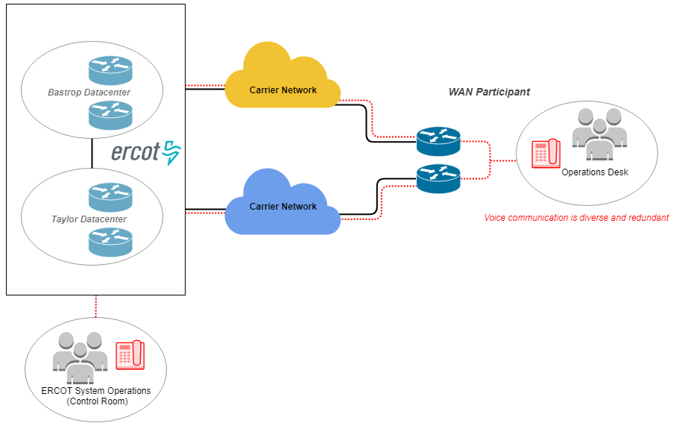
Figure 1 ERCOT Wide Area Network Overview
(n) If a WAN Participant is a QSE that represents a Resource Entity, ERS Resource, or another QSE and receives or transmits WAN Data, the WAN Participant shall utilize an approved mode of communication for the transmission or receipt of WAN Data between it and the Resource Entity, ERS Resource, or QSE it represents.

