September 2022 ERCOT Monthly Operations Report
Reliability and Operations Subcommittee Meeting
November 7, 2022

Table of Contents
1. Report Highlights 2
2. Frequency Control 3
2.1. Frequency Events 3
2.2. Responsive Reserve Events 4
2.3. Load Resource Events 4
3. Reliability Unit Commitment 4
4. IRR, Wind, and Solar Generation as a Percent of Load 7
5. Largest Net-Load Ramps 8
6. COP Error Analysis 9
7. Congestion Analysis 11
7.1. Notable Constraints 11
7.2. Generic Transmission Constraint Congestion 21
7.3. Manual Overrides 21
7.4. Congestion Costs for Calendar Year 2022 21
8. System Events 22
8.1. ERCOT Peak Load 22
8.2. Load Shed Events 22
8.3. Stability Events 22
8.4. Notable PMU Events 23
8.5. DC Tie Curtailment 23
8.6. TRE/DOE Reportable Events 23
8.7. New/Updated Constraint Management Plans 23
8.8. New/Modified/Removed RAS 23
8.9. New Procedures/Forms/Operating Bulletins 23
9. Emergency Conditions 24
9.1. OCNs 24
9.2. Advisories 24
9.3. Watches 24
9.4. Emergency Notices 24
10. Application Performance 24
10.1. TSAT/VSAT Performance Issues 24
10.2. Communication Issues 24
10.3. Market System Issues 24
11. Model Updates 25
Appendix A: Real-Time Constraints 27

Report Highlights
- The unofficial ERCOT peak load for the month was 71,037 MW and occurred on 09/20/2022, during hour ending 17:00. Prior to this year, the peak usage for the month of September was 72,370 MW set on 9/01/2021.
- There was 1 frequency event.
- There was 1 instance where Responsive Reserves was deployed.
- There were 177 HRUC commitments.
- There were 9 days of congestion on the Panhandle GTC, 5 days of congestion on the North Edinburg to Lobo GTC, 4 days on the West Texas Export GTC, 1 day on the Valley Export GTC, 1 day on the North to Houston GTC, and 1 day on the Culberson GTC. There was no activity on the remaining GTCs during the month.
- There were no DC Tie Curtailments.
- A PVGR Generation Record of 10,013 MW was set on 09/29/2022 at 11:28.

Frequency Control

Frequency Events
The ERCOT Interconnection experienced 1 frequency event, which resulted a from unit’s trip. The event duration was 00:05:14.

A summary of the frequency events is provided below. The reported frequency events meet one of the following criteria: Delta Frequency is 60 mHz or greater; the MW loss is 350 MW or greater; resource trip event triggered RRS deployment. Frequency events that have been identified as Frequency Measurable Events (FME) for purposes of BAL-001-TRE-2 analysis are highlighted in blue. When analyzing frequency events, ERCOT evaluates PMU data according to industry standards. Events with an oscillating frequency of less than 1 Hz are inter-area, while higher frequencies indicate local events. Industry standards specify that damping ratio for inter-area oscillations should be 3.0% or greater. For the frequency events listed below, the ERCOT system met these standards and transitioned well after each disturbance. In the case of negative delta frequency, the MW Loss column could refer to load loss.

Date and Time | Delta Frequency | Max/Min Frequency | Duration of Event | PMU Data |  | MW Loss | Load | IRR | Inertia
 | (Hz) | (Hz) |  | Oscillation Mode (Hz) | Damping Ratio |  | (MW) | % | (MW-s)
09/05/2022 23:48:10 | 0.186 | 59.810 | 00:05:14 | 0.68 | 13% | 1208 | 46,201 | 18% | 281,556

(Note: All data on this graph encompasses frequency event analysis based on BAL-001-TRE-2.)

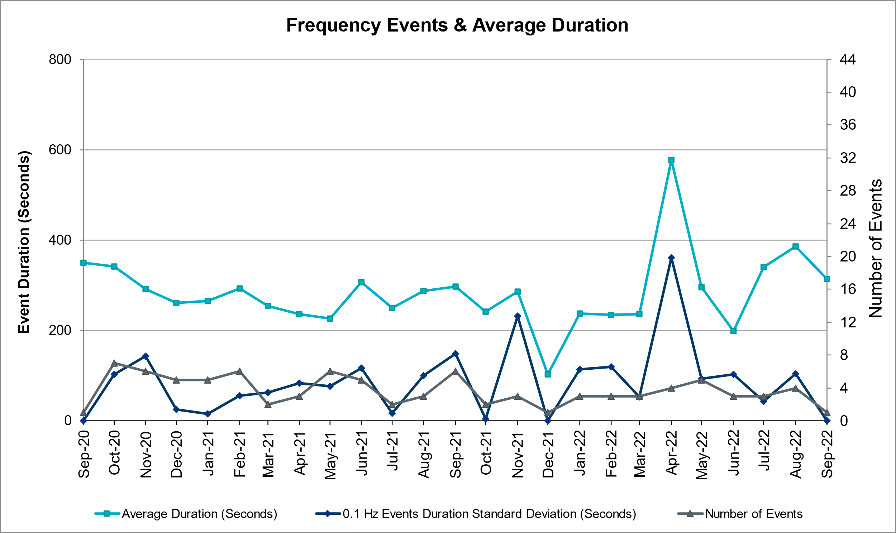

Responsive Reserve Events
There was 1 event where Responsive Reserve MWs were released to SCED. The events highlighted in blue were related to frequency events reported in Section 2.1 above.

Date and Time Released to SCED | Date and Time Recalled | Duration of Event | Maximum MWs Released | Comments
09/05/2022 23:48:16 | 09/05/2022 23:52:44 | 00:04:28 | 1219

Load Resource Events
None.

Reliability Unit Commitment
ERCOT reports on Reliability Unit Commitments (RUC) monthly. Commitments are reported grouped by operating day and weather zone. The total number of hours committed is the sum of the hours for all the units in the specified region. Additional information on RUC commitments can be found on the MIS secure site at Grid Generation Reliability Unit Commitment.

There were no DRUC commitments.

There were 177 HRUC commitments

Resource Location | # of Resources | Operating Day | Total # of Hours Committed | Total MWhs | Reason for Commitment
EAST, NORTH_CENTRAL, SOUTH_CENTRAL | 15 | 09/01/2022 | 113 | 32,521.0 | System Capacity
EAST, NORTH_CENTRAL, SOUTH_CENTRAL | 14 | 09/02/2022 | 127 | 36,730.0 | System Capacity
COAST | 2 | 09/03/2022 | 6 | 1,923.0 | System Capacity
EAST, NORTH_CENTRAL | 5 | 09/04/2022 | 24 | 9,518.0 | System Capacity
COAST, EAST, NORTH_CENTRAL, SOUTH_CENTRAL | 8 | 09/05/2022 | 41 | 10,470.0 | System Capacity,
EAST, NORTH_CENTRAL, SOUTH_CENTRAL | 18 | 09/06/2022 | 180 | 45,848.0 | System Capacity
EAST, NORTH_CENTRAL | 10 | 09/07/2022 | 115 | 26,762.0 | Minimum Run Time,  System Capacity
EAST, NORTH_CENTRAL, SOUTH_CENTRAL | 8 | 09/08/2022 | 56 | 21,302.0 | System Capacity
EAST, NORTH_CENTRAL | 7 | 09/09/2022 | 51 | 15,026.0 | System Capacity
COAST, EAST, SOUTH_CENTRAL | 3 | 09/10/2022 | 22 | 8,820.0 | System Capacity
COAST, EAST, NORTH_CENTRAL | 4 | 09/11/2022 | 26 | 11,142.0 | System Capacity
COAST, EAST, NORTH_CENTRAL, SOUTH_CENTRAL | 15 | 09/12/2022 | 106 | 28,179.0 | Minimum Run Time,  System Capacity
NORTH_CENTRAL | 3 | 09/13/2022 | 67 | 14,997.0 | Minimum Run Time,  System Capacity
NORTH_CENTRAL | 2 | 09/14/2022 | 27 | 3,327.0 | Minimum Run Time
NORTH_CENTRAL | 1 | 09/15/2022 | 3 | 360.0 | Minimum Run Time
EAST | 1 | 09/16/2022 | 7 | 3,514.0 | System Capacity
EAST, NORTH_CENTRAL, SOUTH_CENTRAL | 8 | 09/18/2022 | 73 | 13,513.0 | System Capacity
EAST, NORTH_CENTRAL | 6 | 09/19/2022 | 21 | 6,008.0 | Minimum Run Time,  System Capacity
EAST, NORTH_CENTRAL | 5 | 09/20/2022 | 47 | 9,804.0 | Minimum Run Time,  System Capacity
COAST, EAST, NORTH_CENTRAL | 7 | 09/21/2022 | 36 | 11,296.0 | Minimum Run Time,  System Capacity
COAST, EAST, NORTH_CENTRAL | 6 | 09/22/2022 | 74 | 16,950.0 | Minimum Run Time,  System Capacity
COAST | 1 | 09/23/2022 | 24 | 1,560.0 | Minimum Run Time,  System Capacity
COAST, EAST, NORTH_CENTRAL, SOUTH_CENTRAL | 11 | 09/24/2022 | 75 | 18,112.0 | Minimum Run Time,  System Capacity
NORTH_CENTRAL | 1 | 09/25/2022 | 15 | 5,625.0 | Minimum Run Time
EAST, NORTH_CENTRAL | 7 | 09/26/2022 | 30 | 11,438.0 | DEVRHLS8, System Capacity
EAST, NORTH_CENTRAL | 6 | 09/27/2022 | 20 | 6,236.0 | System Capacity
EAST, NORTH_CENTRAL | 2 | 09/28/2022 | 4 | 950.0 | System Capacity

IRR, Wind, and Solar Generation as a Percent of Load
The graph below shows the maximum, minimum and average aggregate solar, wind and IRR output as a percentage of total ERCOT load when evaluated as 10-minute averaged intervals, over the past 13 months. Current wind and solar generation and penetration records are listed in the footnote below. Maximum IRR penetration for the month was 44% on 09/17/2022 interval ending 09:40 and minimum IRR penetration for the month was 1.1% on 09/01/2022 interval ending 05:30.

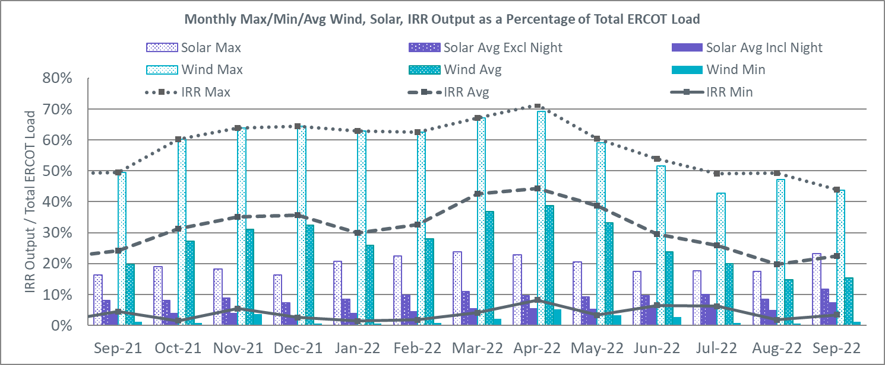

During the hour of peak load for the month, hourly integrated wind generation was 7,942 MW and solar generation was 8,315 MW. The graph below shows the wind and solar penetration percentage during the hour of the peak load in the last 13 months.

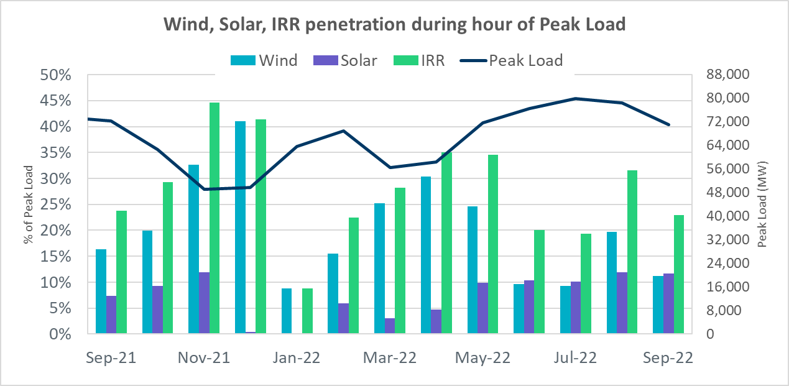

Lastly, the graph below shows the minimum wind, solar and IRR output during the peak load hour as a percentage of the daily peak load for every day in the month.

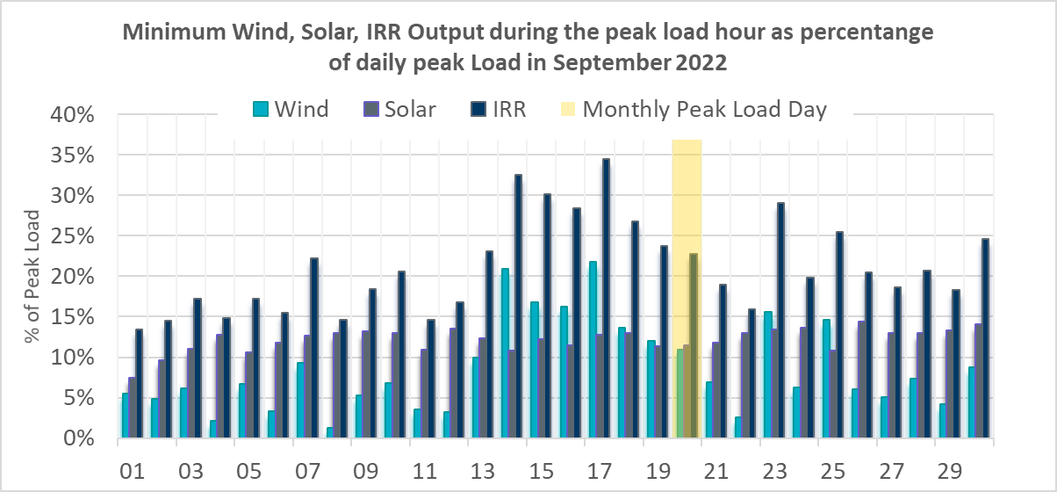

Largest Net-Load Ramps
The net-load ramp is defined as the change in net-load (load minus wind and PVGR generation) during the defined time horizon. Such a variation in net-load needs to be accommodated in grid operations to ensure that the reliability of the grid is satisfactorily maintained. The largest net-load ramp during 5-min, 10-min, 15-min, 30-min and 60-min in September 2022 was 887 MW, 1,391 MW, 1,818 MW, 3,099 MW, and 5,351 MW, respectively. The comparison with respect to the historical values is given in the table below.

Month and Year | 5 min | 10 min | 15 min | 30 min | 60 min
September 2014 | 1,054 MW | 1,531 MW | 1,695 MW | 2,628 MW | 4,898 MW
September 2015 | 993 MW | 1,457 MW | 1,779 MW | 2,952 MW | 5,659 MW
September 2016 | 827 MW | 1,260 MW | 1,688 MW | 2,880 MW | 5,464 MW
September 2017 | 730 MW | 1,251 MW | 1,758 MW | 3,298 MW | 5,716 MW
September 2018 | 1,129 MW | 1,991 MW | 2,372 MW | 3,391 MW | 6,015 MW
September 2019 | 867 MW | 1,207 MW | 1,643 MW | 3,134 MW | 5,716 MW
September 2020 | 776 MW | 1,285 MW | 1,763 MW | 2,728 MW | 5,087 MW
September 2021 | 1,251 MW | 1,655 MW | 1,972 MW | 3,519 MW | 6,629 MW
September 2022 | 887 MW | 1,391 MW | 1,818 MW | 3,099 MW | 5,351 MW
All months in 2014-2022 | 1,647 MW | 2,157 MW | 3,015 MW | 5,882 MW | 10,750 MW

COP Error Analysis
COP Error is calculated as the capacity difference between the COP HSL and real-time HSL of the unit. Mean Absolute Error (MAE) stayed over 15,000 MW until Day-Ahead at 12:00, then dropped significantly to 6,281 MW by Day-Ahead at 13:00 and to 1,716 MW by Day-Ahead at 14:00. In the following chart, Under-Scheduling Error indicates that COP had less generation capacity than real-time, and Over-Scheduling Error indicates that COP had more generation capacity than real-time.

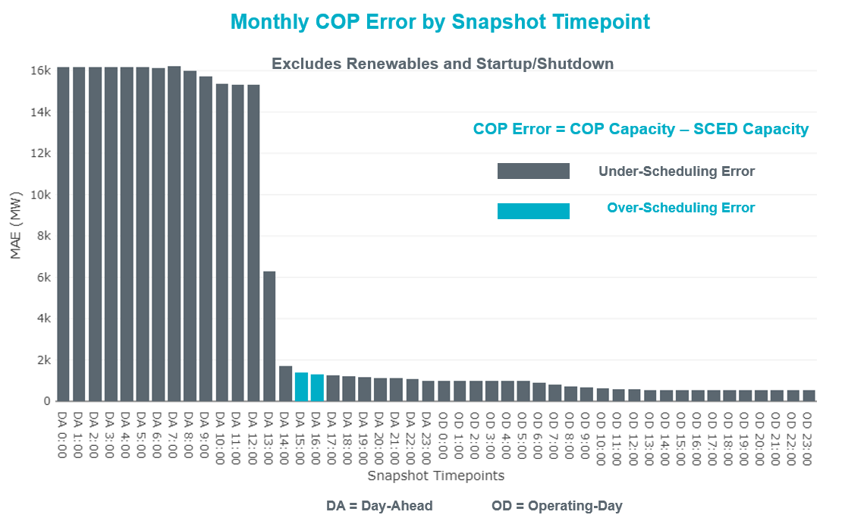

Monthly MAE for the Latest COP at the end of the Adjustment Period was 535 MW with medians ranging from -1,126 MW for Hour-Ending (HE) 20 to 438 MW for HE 12. HE 12 on 09/27/2022 had the largest Over-Scheduling Error (1,661 MW) and HE 20 on 09/28/2022 had the largest Under-Scheduling Error (-2,813 MW).

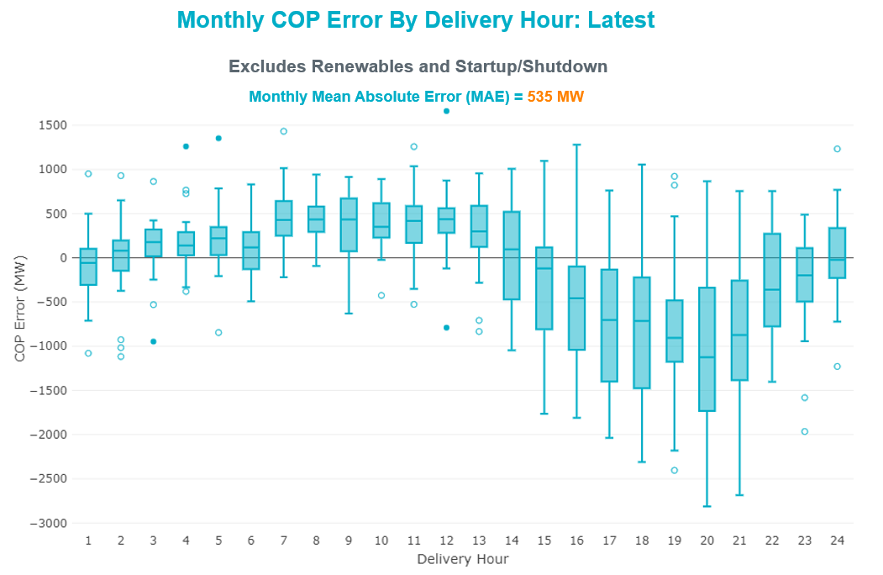

Monthly MAE for the Day-Ahead COP at 12:00 was 15,314MW with median ranging from -21,525 MW for Hour-Ending (HE) 19 to -9,482 MW for HE 5. HE 20 on 09/08/2022 had the largest Under-Scheduling Error (-26,930 MW) and HE 4 on 09/16/2022 had the smallest Under-Scheduling Error (-4,839 MW).

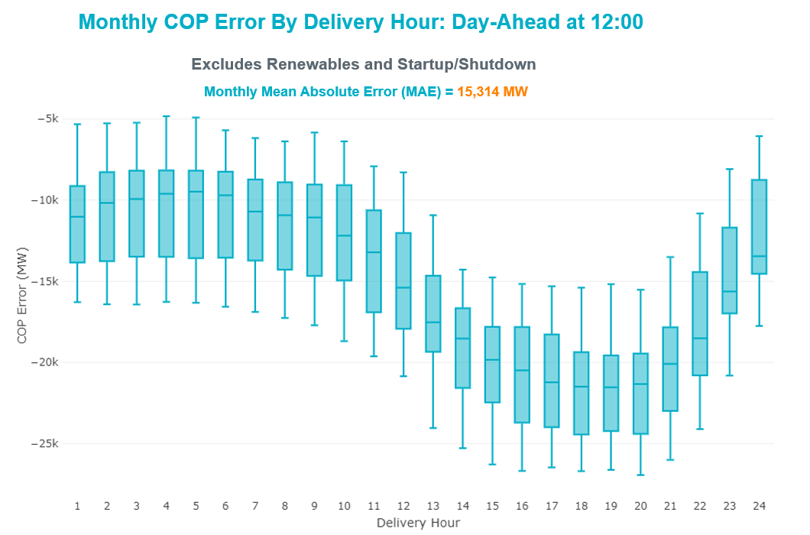

Congestion Analysis

Notable Constraints
Nodal protocol section 3.20 specifies that ERCOT shall identify transmission constraints that are binding in Real-Time three or more Operating Days within a calendar month. As part of this process, ERCOT reports congestion that meets this criterion to ROS. In addition, ERCOT also highlights notable constraints that have an estimated congestion rent exceeding $1,000 for a calendar month. These constraints are detailed in the table below, including approved transmission upgrades from TPIT that may provide some congestion relief based on ERCOT’s engineering judgement. Rows highlighted in blue indicate the congestion was affected by one or more outages. For a list of all constraints activated in SCED, please see Appendix A at the end of this report.

Contingency Name | Overloaded Element | # of Days Constraint Binding | Congestion Rent | Transmission Project
Basecase | PNHNDL GTC | 7 | $7,155,412.65
BLACKWATER DRAW SWITCH to DOUBLE MOUNTAIN SWITCH LIN 1 | Mackenzie Substation - Northeast Substation 115kV | 14 | $6,292,013.84
MANUAL WHITEPOINT TRX 345A 345-138 | Nueces Bay - Whitepoint 138kV | 13 | $6,103,246.65
YELLOW JACKET TRX PS_1 138/138 | Hollmig - Kendall 138kV | 3 | $3,690,003.03
Bighil-Kendal 345kV | Yellow Jacket - Treadwell 138kV | 7 | $2,993,093.76
Cagnon-Kendal 345 & Cico-Comfor 138 | Hollmig - Kendall 138kV | 3 | $2,662,275.32
NATURAL DAM to BEALS CREEK SUB LIN _A | Big Spring West - Stanton East 138kV | 7 | $2,517,165.75
TWR(345) WAP-WLF64 & WAP-WLY72 | Oasis - Dow Chemical 345kV | 11 | $2,345,694.58
Cagnon-Kendal 345 & Cico-Comfor 138 | Bergheim - Kendall 345kV | 4 | $2,084,033.20
TWR(345) WAP-WLF64 & WAP-WLY72 | South Texas Project - Wa Parish 345kV | 8 | $1,871,929.40
EVRSW TO HLSES 138 DBLCKT | Mistletoe Heights - Hemphill 138kV | 2 | $1,589,467.88
Basecase | WESTEX GTC | 3 | $1,473,649.84
TWR(345) WAP-WLF64 & WAP-WLY72 | Angleton - Winmil 138kV | 3 | $1,372,828.74
SKYWEST to SPRABERRY SWITCH LIN 1 | South Midland - Cottonfield Sub 138kV | 1 | $1,241,335.58
MGSES TO CCRSW 345 AND BTRCK TO MGSES 345 DBLCKT | Tonkawa Switch - Morgan Creek Ses 345kV | 3 | $1,209,633.20
COMANCHE SWITCH (Oncor) to COMANCHE PEAK SES LIN _A | Comanche Tap - Comanche Switch (Oncor) 138kV | 2 | $1,136,538.91
GARDENDALE SWITCH to TELEPHONE ROAD - Sharyland Utilities LIN _A | Andrews County South 345kV | 7 | $993,050.29
ZORN - HAYSEN 345KV | Bergheim 138kV | 3 | $742,020.73
Bighil-Kendal 345kV | Maddux - Treadwell 138kV | 6 | $612,590.13
ENNIS SWITCH to ENNIS WEST SWITCH LIN _C | Ennis West Switch - Waxahachie 138kV | 3 | $439,562.01
Fowlerton to LOBO 345 LIN1 | Asherton - Catarina 138kV | 7 | $340,635.14
Basecase | NE_LOB GTC | 5 | $315,564.57 | The Lower Rio Grande Valley (LRGV) System Enhancement Project (21RPG017) will improve the NorthEd_LoboGTC to support up to 80% of total wind and solar generation capacity in the LRGV area.
BAKERSFIELD SWITCHYARD to Big HiLL LIN 1 | North Mccamey - Crossover 138kV | 3 | $297,241.35
ODLAW SWITCHYARD to ASPHALT MINES LIN 1 | Hamilton Road - Maverick 138kV | 6 | $268,255.58
DMTSW TO SCOSW 345 DBLCKT | Knapp - Scurry Chevron 138kV | 3 | $229,562.43
Fowlerton to LOBO 345 LIN1 | Catarina - Piloncillo 138kV | 3 | $122,841.86
BALLINGER TRX FMR1 138/69 | San Angelo Concho - Veribest 69kV | 3 | $64,231.17 | Ballinger to Concho: 69 kV Line Rebuild (55421)
WEST COLUMBIA to San Bernard LIN A | El Campo - Lane City Pump 138kV | 3 | $51,113.12
TWR(345) WAP-WLF64 & CCK-WLY72 | Oasis - Dow Chemical 345kV | 4 | $46,034.80
Bighil-Kendal 345kV | Hamilton Road - Maxwell 138kV | 3 | $11,997.62 | Hamilton Road to Maxwell: Line Rebuild (61396)

Generic Transmission Constraint Congestion
There were 9 days of congestion on the Panhandle GTC, 5 days of congestion on the North Edinburg to Lobo GTC, 4 days on the West Texas Export GTC, 1 day on the Valley Export GTC, 1 day on the North to Houston GTC, and 1 day on the Culberson GTC. There was no activity on the remaining GTCs during the month.

Note: This is how many times a constraint has been activated to avoid exceeding a GTC limit, it does not imply an exceedance of the GTC occurred or that the GTC was binding.

Manual Overrides
None

Congestion Costs for Calendar Year 2022
The following table represents the top twenty active constraints for the calendar year based on the estimated congestion rent attributed to the congestion. ERCOT updates this list on a monthly basis.

Contingency | Overloaded Element | # of 5-min SCED | Estimated | Transmission Project
Basecase | WESTEX GTC | 18,556 | $222,588,466.88
Toksw-Gibcrk & Jk_Ck 345kV | Jewett - Singleton 345kV | 9,281 | $164,069,608.80
Basecase | NE_LOB GTC | 32,035 | $107,993,764.12 | The Lower Rio Grande Valley (LRGV) System Enhancement Project (21RPG017) will improve the NorthEd_LoboGTC to support up to 80% of total wind and solar generation capacity in the LRGV area.
SALSW TO KLNSW 345 DBLCKT | Killeen Switch 345kV | 10,779 | $92,294,055.67
Basecase | N_TO_H GTC | 8,320 | $73,724,598.62
Elmcreek-Sanmigl 345kV | Pawnee Switching Station - Calaveras 345kV | 5,535 | $70,938,590.30
TWR(345) JCK-REF27 & JCK-STP18 | Hillje - South Texas Project 345kV | 6,637 | $62,964,035.25
PH ROBINSON to MEADOW LIN A | Magnolia Tnp - Seminole Tnp 138kV | 15,548 | $54,701,038.89 | Rebuild Magnolia - Seminole 138 kV Line (4010)
Manual dbl ckt for NEDIN-BONILLA 345kV & RIOH-PRIM138kV | Burns Sub - Rio Hondo 138kV | 15,514 | $54,439,896.03
Basecase | PNHNDL GTC | 14,572 | $52,628,716.67
WA PARISH to OBRIEN LIN A | Wa Parish - Obrien 345kV | 1,485 | $48,095,593.23
MAN_SGL_ MDL-FLC_345_kV_w_MDL_XMFR1_FLC_AMR2 | Midland County Northwest Switch - Mockingbird 138kV | 4,260 | $39,903,573.59 | Oncor Midland East Area Project (21RPG003, MOD 57925) - NOTE: This project removes the overloaded element and reconfigures lines in the area, amongst other topology changes.
OASIS to MEADOW LIN A | Grant - Plaza 138kV | 3,745 | $32,866,665.55
Basecase | NELRIO GTC | 26,098 | $32,369,711.64 | The Lower Rio Grande Valley (LRGV) System Enhancement Project (21RPG017) will cause there to be no stability constraint for NelsonSharpe_ RioHondoGTC under normal conditions.
WDGSW TO MARSW 138 DBLCKT | Mistletoe Heights - Hemphill 138kV | 2,078 | $30,437,608.94
Fowlerton to LOBO 345 LIN1 | Laredo Vft North - Las Cruces 138kV | 9,328 | $29,858,295.31 | Laredo VFT North to North Laredo Switch: Rebuild 138 kV Line (58008)
STP SWITCH to Esperanza LIN 1 | Blessing - Pavlov 138kV | 7,457 | $28,859,506.14
South Texas # 1 & # 2 | Blessing - Lolita 138kV | 3,850 | $24,884,091.62
COMANCHE SWITCH (Oncor) to COMANCHE PEAK SES LIN _A | Comanche Tap - Comanche Switch (Oncor) 138kV | 11,607 | $24,781,565.08
Lytton - Slaughtr & Turner 138 kV | Lytton Springs - Pilot Knob 138kV | 1,198 | 24,738,582.05 | Lytton Springs to Pilot Knob: Rebuild 138 kV line (71408)

System Events

ERCOT Peak Load
The unofficial ERCOT peak load for the month was 71,036 MW and occurred on 09/20/2022, during hour ending 17:00.

Load Shed Events
None.

Stability Events
None.

Notable PMU Events
ERCOT analyzes PMU data for any significant system disturbances that do not fall into the Frequency Events category reported in section 2.1. The results are summarized in this section once the analysis has been completed.

There were no PMU events outside of those reported in section 2.1.

DC Tie Curtailment
None.

TRE/DOE Reportable Events
- BPUB submitted an OE-417 for 09/06/2022. Reportable Event Type: Suspicious activity to its facility.
- LCRA submitted an OE-417 for 09/11/2022. Reportable Event Type: Transmission loss.

New/Updated Constraint Management Plans
There were no new or modified CMPs.

New/Modified/Removed RAS
None.

New Procedures/Forms/Operating Bulletins
Date | Subject | Bulletin No.
09/29/2022 | Communications Protocols V1 Rev 8 | 1055

Emergency Conditions

OCNs
Date and Time | Message
9/17/2022 21:00 CPT | ERCOT is taking manual action on the WESTEX IROL due to a topology change.
9/24/2022 01:50 CPT | ERCOT is taking manual action on the WESTEX IROL due to a topology change.
9/28/2022 15:37 CPT | ERCOT is taking manual action on the BEARKT GTC due to a topology change.

Advisories
Date and Time | Message
9/27/2022 12:28 CPT | ERCOT issued an Advisory due to ERCOTs Voltage Security Assessment Tool has not solved in the last 30 minutes.

Watches
Date and Time | Message
9/1/2022 13:45 CPT | ERCOT Issued a Watch due to the failure of the SCED process.
9/1/2022 14:45 CPT | ERCOT Issued a Watch for HRUC failure due to timeline deviation.

Emergency Notices
None.

Application Performance

TSAT/VSAT Performance Issues
None.

Communication Issues
None.

Market System Issues
None.

Model Updates
The Downstream Production Change (DPC) process allows ERCOT to make changes in the on-line Network Operations Model without loading a completely new model. The purpose of this process is to allow for reliable grid operations as system conditions change between designated Network Operations Model database loads. The DPC process is limited in scope to just those items listed below, with equipment ratings updates being the most common. ERCOT has seen a rise in the use of the DPC process to make on-line updates to the Network Operations Model in recent years, instead of through the standard Network Operations Model Change Request process.

- Static Line ratings (Interim Update)
- Dynamic Line ratings (non-Interim Update)
- Autotransformer ratings (non-Interim Update)
- Breaker and Switch Normal status (Interim Update)
- Contingency Definitions (Interim Update)
- RAP and RAS changes or additions (Interim Update)
- Net Dependable and Reactive Capability (NDCRC) values (Interim Update)
- Impedance Updates (non-Interim)

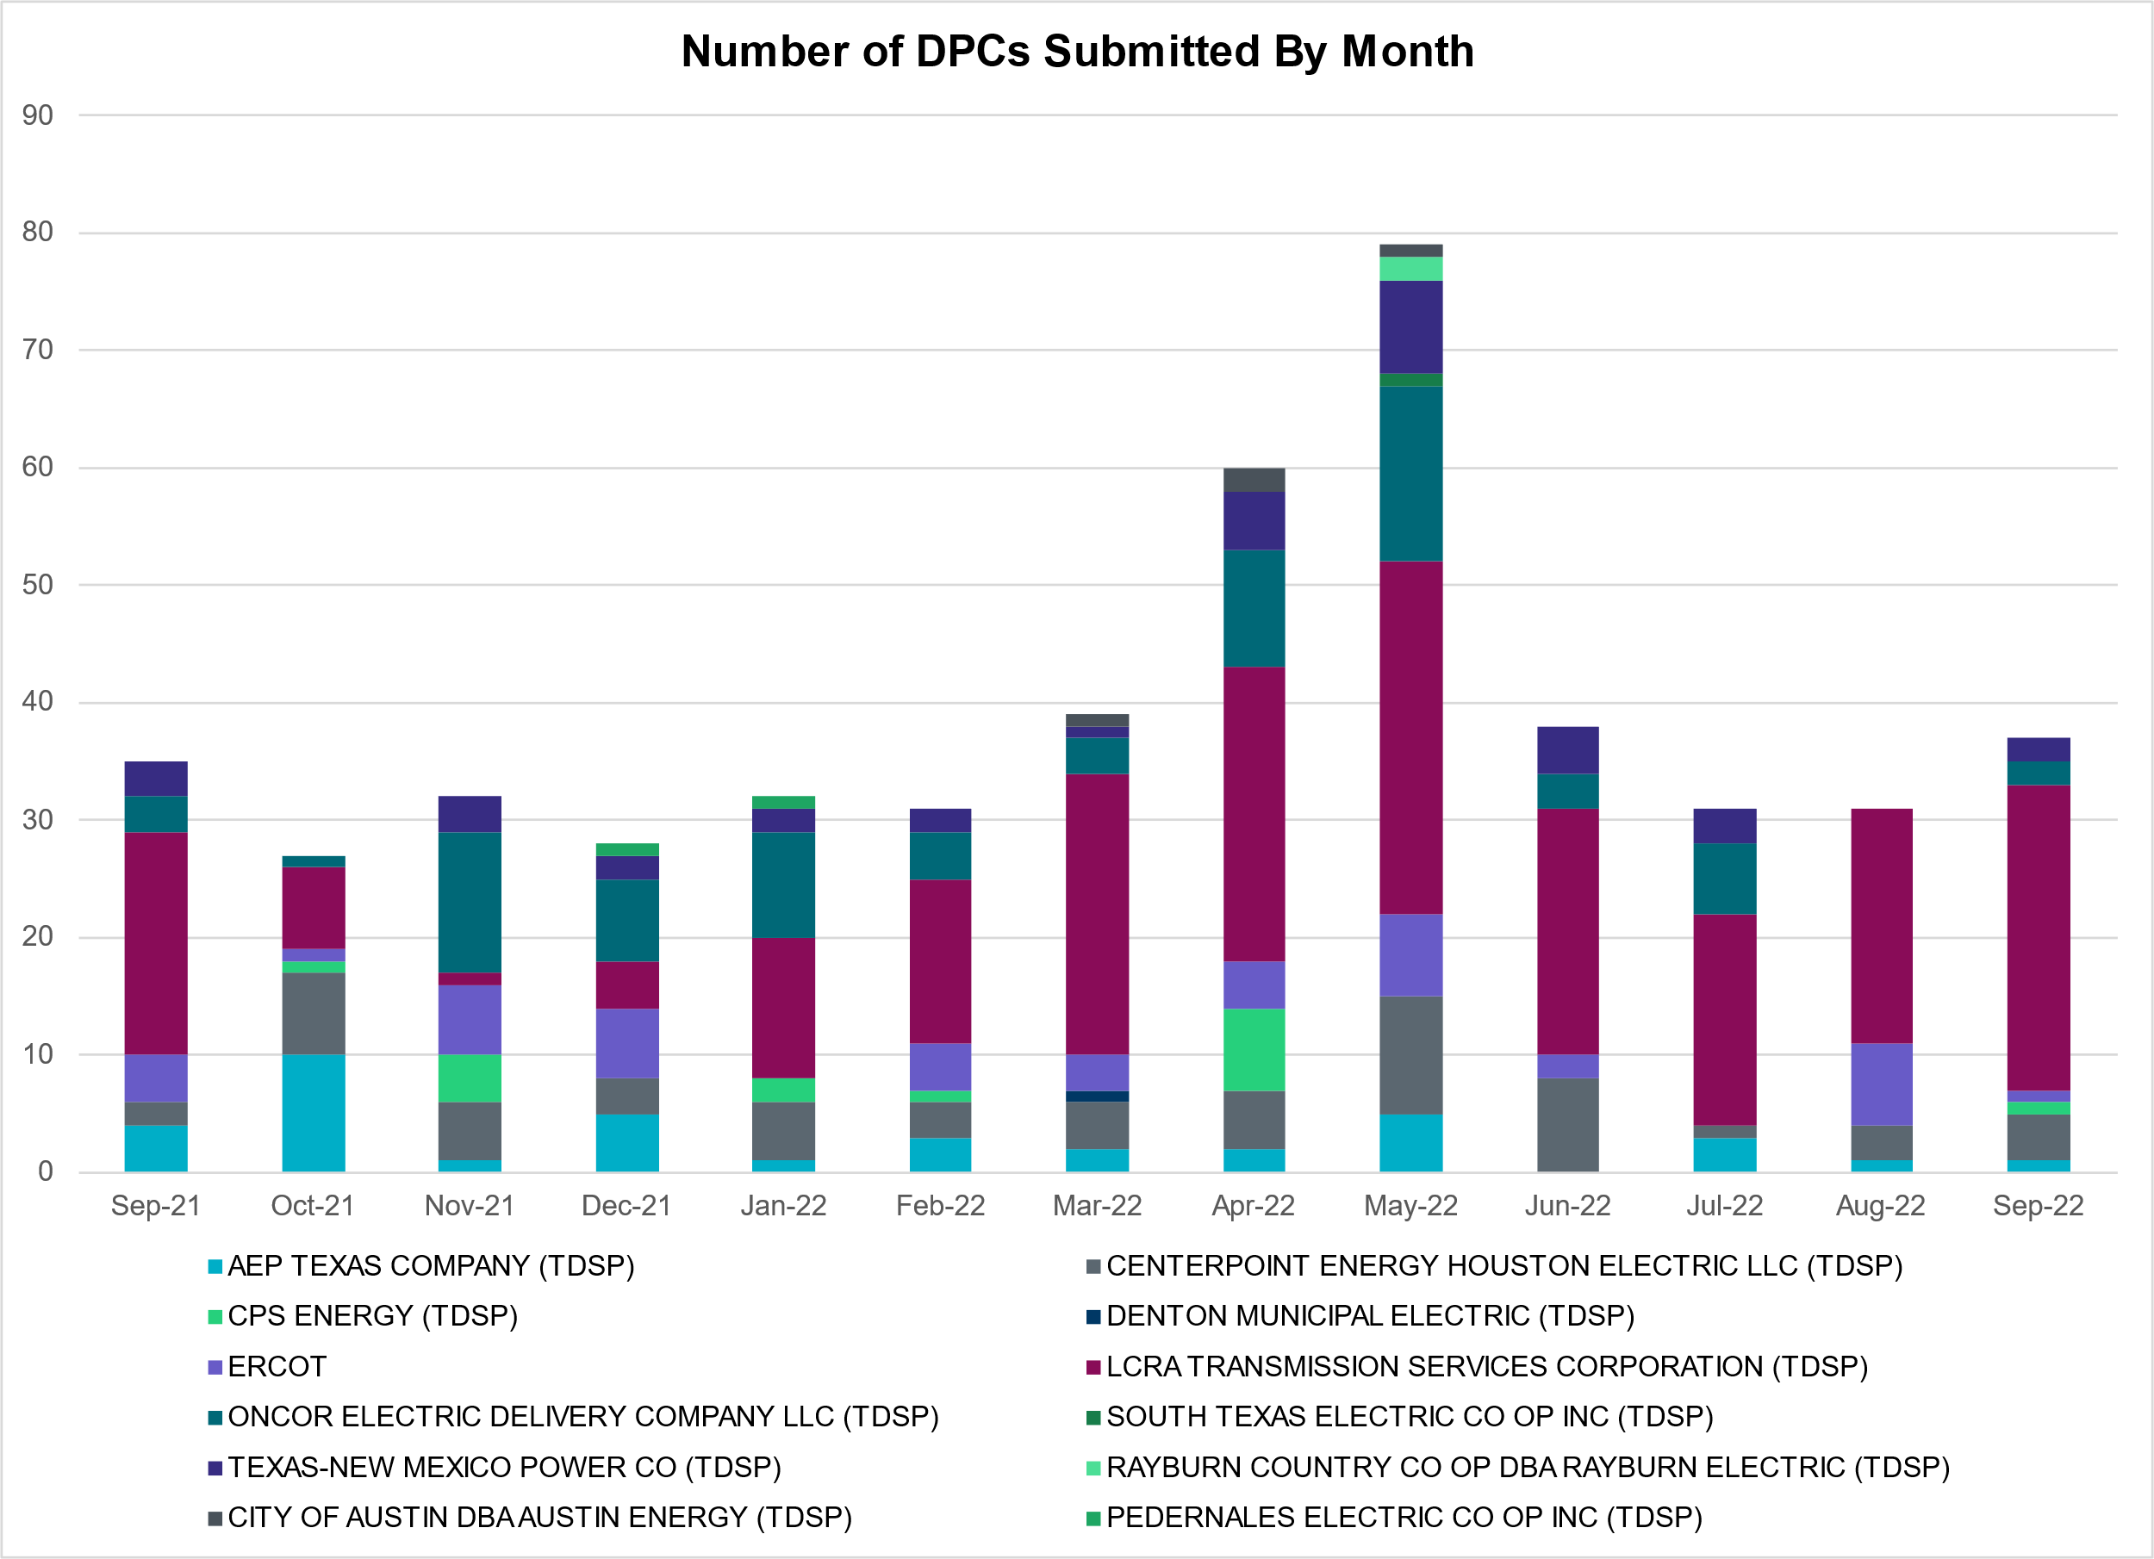

Transmission Operator | Number of DPCs
AEP TEXAS COMPANY (TDSP) | 1
BRAZOS ELECTRIC POWER CO OP INC (TDSP) | 0
BROWNSVILLE PUBLIC UTILITIES BOARD (TDSP) | 0
BRYAN TEXAS UTILITIES (TDSP) | 0
CENTERPOINT ENERGY HOUSTON ELECTRIC LLC (TDSP) | 4
CITY OF AUSTIN DBA AUSTIN ENERGY (TDSP) | 0
CITY OF COLLEGE STATION (TDSP) | 0
CITY OF GARLAND (TDSP) | 0
CPS ENERGY (TDSP) | 1
DENTON MUNICIPAL ELECTRIC (TDSP) | 0
ELECTRIC TRANSMISSION TEXAS LLC (TDSP) | 0
ERCOT | 1
LCRA TRANSMISSION SERVICES CORPORATION (TDSP) | 26
LONE STAR TRANSMISSION LLC (TSP) | 0
ONCOR ELECTRIC DELIVERY COMPANY LLC (TDSP) | 2
PEDERNALES ELECTRIC CO OP INC (TDSP) | 0
RAYBURN COUNTRY CO OP DBA RAYBURN ELECTRIC (TDSP) | 0
SHARYLAND UTILITIES LP (TDSP) | 0
SOUTH TEXAS ELECTRIC CO OP INC (TDSP) | 0
TEXAS MUNICIPAL POWER AGENCY (TDSP) | 0
TEXAS-NEW MEXICO POWER CO (TDSP) | 2

Appendix A: Real-Time Constraints
The following is a complete list of constraints activated in SCED. Full contingency descriptions can be found in the Standard Contingencies List located on the MIS secure site at Grid Generation Reliability Unit Commitment.

Year | Month of the Year | Contingency Name | Overloaded Element | From Station | To Station | Count of Days
2022 | 9 | SBWDDBM5 | LPLMK_LPLNE_1 | LPLMK | LPLNE | 16
2022 | 9 | SNATBEA8 | 6144__A | BSPRW | STASW | 14
2022 | 9 | MWHI58 | NUECES_WHITE_2_1 | NUECES_B | WHITE_PT | 13
2022 | 9 | DWPWFWP5 | DOWOAS27_A | DOW | OAS | 11
2022 | 9 | SLOBSA25 | ASHERT_CATARI1_1 | ASHERTON | CATARINA | 10
2022 | 9 | DWPWFCK5 | DOWOAS27_A | DOW | OAS | 9
2022 | 9 | DWPWFWP5 | STPWAP39_1 | STP | WAP | 9
2022 | 9 | DWPWFCK5 | STPWAP39_1 | STP | WAP | 9
2022 | 9 | BASE CASE | PNHNDL | n/a | n/a | 9
2022 | 9 | SLOBSA25 | CATARI_PILONC1_1 | PILONCIL | CATARINA | 8
2022 | 9 | SLOBSA25 | CATARI_PILONC1_1 | CATARINA | PILONCIL | 8
2022 | 9 | SBRAUVA8 | HAMILT_MAVERI1_1 | HAMILTON | MAVERICK | 8
2022 | 9 | DBIGKEN5 | MADDUX_TREADW1_1 | MADDUX | TREADWEL | 7
2022 | 9 | DBIGKEN5 | TREADW_YELWJC1_1 | TREADWEL | YELWJCKT | 7
2022 | 9 | SGDNTEL5 | ACSSW_AX2H | ACSSW | ACSSW | 7
2022 | 9 | SFTLMES8 | CROSSO_NORTMC1_1 | NORTMC | CROSSOVE | 5
2022 | 9 | BASE CASE | NE_LOB | n/a | n/a | 5
2022 | 9 | DCAGCO58 | 656T656_1 | KENDAL | BERGHE | 4
2022 | 9 | SBRAHAM8 | HAMILT_MAVERI1_1 | HAMILTON | MAVERICK | 4
2022 | 9 | SBIGSCH5 | CROSSO_NORTMC1_1 | NORTMC | CROSSOVE | 4
2022 | 9 | SHCKRNK5 | 106__A | HCKSW | ALLNC | 4
2022 | 9 | DWPWFWP5 | DA_WC_89_A | WC | DA | 4
2022 | 9 | DWPWFWP5 | AE_WML26_A | AE | WML | 4
2022 | 9 | BASE CASE | WESTEX | n/a | n/a | 4
2022 | 9 | BASE CASE | BEEVIL_CHARTE1_1 | CHARTER | BEEVILLE | 4
2022 | 9 | DCAGCI58 | 656T656_1 | KENDAL | BERGHE | 3
2022 | 9 | SBRAUVA8 | ESCOND_GANSO1_1 | GANSO | ESCONDID | 3
2022 | 9 | SSANFOW5 | CATARI_PILONC1_1 | CATARINA | PILONCIL | 3
2022 | 9 | XBAL89 | CONCHO_VRBS1_1 | CONCHO | VRBS | 3
2022 | 9 | SPGSAN8 | EL_CAM_LANCTY1_1 | LANCTYPM | EL_CAMPO | 3
2022 | 9 | DSWECCR5 | 6036__A | TKWSW | MGSES | 3
2022 | 9 | DMTSCOS5 | 6437__F | SCRCV | KNAPP | 3
2022 | 9 | DCAGCO58 | 72T120_1 | KENDAL | HOLLMI | 3
2022 | 9 | SGDNTEL5 | ACSSW_AX2L | ACSSW | ACSSW | 3
2022 | 9 | BASE CASE | ARAGORN_TIE_1 | ARAGORN | PINNAC | 3
2022 | 9 | SWCSAN8 | EL_CAM_LANCTY1_1 | LANCTYPM | EL_CAMPO | 3
2022 | 9 | SBTPBNT8 | MYRA_VAL_1 | MYRA | VALYVIEW | 3
2022 | 9 | DMGSBIT5 | 6036__A | TKWSW | MGSES | 3
2022 | 9 | SKENKEN8 | 72T120_1 | KENDAL | HOLLMI | 3
2022 | 9 | SBREHIG8 | 276T350_1 | GAYHIL | SANDHI | 3
2022 | 9 | DEVRHLS8 | 6125__C | MSTLT | HMPHL | 3
2022 | 9 | XYEL88 | 72T120_1 | KENDAL | HOLLMI | 3
2022 | 9 | SENSENW8 | 940__C | ENWSW | WXHCH | 3
2022 | 9 | DBIGKEN5 | HAMILT_MAXWEL1_1 | MAXWELL | HAMILTON | 3
2022 | 9 | DMGSBTR5 | 6036__A | TKWSW | MGSES | 3
2022 | 9 | DZORHAY5 | BERGHE_AT1L | BERGHE | BERGHE | 3
2022 | 9 | DWPWFCK5 | AE_WML26_A | AE | WML | 3
2022 | 9 | SCMNCPS5 | 651__B | CMNSW | CMNTP | 2
2022 | 9 | SWRDYN8 | DA_WC_89_A | WC | DA | 2
2022 | 9 | DTOKJK_5 | 260_A_1 | JEWET | SNG | 2
2022 | 9 | DCMNCMN8 | 660__B | MGPSW | ZEPHYR | 2
2022 | 9 | SLGEI_D8 | I_DUPS_LGE1_1 | LGE | I_DUPSW | 2
2022 | 9 | DTVWSHR5 | 495__B | TVWSW | VENSW | 2
2022 | 9 | STREMAD8 | 72T120_1 | KENDAL | HOLLMI | 2
2022 | 9 | SENSENW8 | 943__B | ENWSW | SHKSW | 2
2022 | 9 | SWCOWC8 | G138_17_1 | BRAZORIA | RT | 2
2022 | 9 | DELMSAN5 | PAWNEE_SPRUCE_1 | PAWNEE | CALAVERS | 2
2022 | 9 | DVENLIG5 | 6020__B | TVWSW | CRTLD | 2
2022 | 9 | DLYTTUR8 | CKT_943_1 | LYTTON_S | PILOT | 2
2022 | 9 | DFERWIR8 | SANDCR_AT1 | SANDCR | SANDCR | 2
2022 | 9 | DHJWFCK5 | STPWAP39_1 | STP | WAP | 2
2022 | 9 | SRDOPEB8 | TRU_UAT1 | TRU | TRU | 2
2022 | 9 | DKENCA58 | 656T656_1 | KENDAL | BERGHE | 2
2022 | 9 | SENSENW8 | 943__B | SHKSW | ENWSW | 2
2022 | 9 | SWCOWC8 | G138_17_1 | RT | BRAZORIA | 2
2022 | 9 | DCHBJO25 | CBYCD_84_A | CBY | CD | 2
2022 | 9 | SKINFAL8 | FALFUR_PREMON1_1 | FALFUR | PREMONT | 2
2022 | 9 | SMADSAP8 | MADDUX_SAPOWE2_1 | MADDUX | SAPOWER | 2
2022 | 9 | DWISALV8 | MYRA_VAL_1 | MYRA | VALYVIEW | 2
2022 | 9 | DCAGTA58 | 656T656_1 | KENDAL | BERGHE | 2
2022 | 9 | SSANFOW5 | ASHERT_CATARI1_1 | ASHERTON | CATARINA | 2
2022 | 9 | DCPSST58 | 651__B | CMNSW | CMNTP | 2
2022 | 9 | SHAYZO25 | 6T227_1 | HAYSEN | ZORN | 2
2022 | 9 | SBKENSH8 | DA_WC_89_A | WC | DA | 2
2022 | 9 | SODLBRA8 | HAMILT_MAVERI1_1 | HAMILTON | MAVERICK | 2
2022 | 9 | SSKYSB28 | 15080__A | SMIDLAND | CTFLD | 1
2022 | 9 | DSALHUT5 | 421__A | BCESW | SNDSW | 1
2022 | 9 | DRILKRW5 | 6085__E | WFSSW | NSTAR | 1
2022 | 9 | DCRLNOR5 | 740__A | CRLNW | NLSES | 1
2022 | 9 | DSTEXP12 | BLESSI_LOLITA1_1 | LOLITA | BLESSING | 1
2022 | 9 | SDOWMOO8 | DOWNIES_AX1H | DOWNIES | DOWNIES | 1
2022 | 9 | DABPAB98 | LENSW_PUTN2_1 | PUTN | LENSW | 1
2022 | 9 | STRECFL8 | MADDUX_SAPOWE1_1 | MADDUX | SAPOWER | 1
2022 | 9 | DSALHUT5 | 270__A | KNBSW | TMPSW | 1
2022 | 9 | XCDH58 | 3160__A | CDCSW | OKCLS | 1
2022 | 9 | DWCSHCK5 | 35100__A | PKRSW | HCKSW | 1
2022 | 9 | SLIGVEN5 | 6020__B | TVWSW | CRTLD | 1
2022 | 9 | SW_GODE5 | 6095__D | LMESA | JPPOI | 1
2022 | 9 | DCRLNOR5 | 710__A | CRLNW | NLSES | 1
2022 | 9 | SNLSCRL8 | 710__A | CRLNW | NLSES | 1
2022 | 9 | SENWSHK8 | 941__C | ENWSW | ENSSO | 1
2022 | 9 | SWRDYN8 | EL_CAM_LANCTY1_1 | LANCTYPM | EL_CAMPO | 1
2022 | 9 | SODLBRA8 | ESCOND_GANSO1_1 | GANSO | ESCONDID | 1
2022 | 9 | DELMSAN5 | MAGRUD_VICTOR2_1 | VICTORIA | MAGRUDER | 1
2022 | 9 | XHOL89 | OLN_FMR2 | OLN | OLN | 1
2022 | 9 | DSTNCPS8 | OLS_CLIF_1 | OLSEN | CLIFTON1 | 1
2022 | 9 | BASE CASE | VALEXP | n/a | n/a | 1
2022 | 9 | DEVRHLS8 | 6405__D | HMPHL | RDLML | 1
2022 | 9 | DHUGWR_8 | DA_WC_89_A | WC | DA | 1
2022 | 9 | SBOMJC25 | 35020__B | GRVSW | GRSES | 1
2022 | 9 | STV2EVR5 | 6020__B | TVWSW | CRTLD | 1
2022 | 9 | SBOMJC25 | 6085__E | WFSSW | NSTAR | 1
2022 | 9 | SPEBTRU8 | 940__C | ENWSW | WXHCH | 1
2022 | 9 | XBGL88 | BISON_STRS1_1 | BISON | STRS | 1
2022 | 9 | DFERWIR8 | CORONA_AT4 | CORONA | CORONA | 1
2022 | 9 | SBRAHAM8 | ESCOND_GANSO1_1 | GANSO | ESCONDID | 1
2022 | 9 | SFORGIL8 | FRPHIL_GILLES1_1 | GILLES | FRPHILLT | 1
2022 | 9 | DFL_MAR8 | HK_TB_66_A | TB | HK | 1
2022 | 9 | SHCKRNK5 | 106__B | ALLNC | RNKSW | 1
2022 | 9 | DGABGEA8 | 353T353_1 | LEANDE | SEWAJU | 1
2022 | 9 | SHAYZOR5 | 388T388_1 | HAYSEN | ZORN | 1
2022 | 9 | DCAGCO58 | 398T389_1 | BERGHE | HAYSEN | 1
2022 | 9 | DHCKRNK5 | 6020__B | TVWSW | CRTLD | 1
2022 | 9 | DLWSRNK5 | 6020__B | TVWSW | CRTLD | 1
2022 | 9 | DNAVVEN5 | 6020__B | TVWSW | CRTLD | 1
2022 | 9 | SVEAW_L5 | 6217__A | WLVSW | GAILS | 1
2022 | 9 | DTVWSHR5 | 6415__C | HLSES | ARLNG | 1
2022 | 9 | DBIGKEN5 | CTHR_TINSLE1_1 | TINSLEY | CTHR | 1
2022 | 9 | BASE CASE | CULBSN | n/a | n/a | 1
2022 | 9 | SPHRHDN8 | G138_10B_1 | SEMINOLE | MAGNO_TN | 1
2022 | 9 | SFORYEL8 | HEXT_MASONS1_1 | HEXT | MASONSW | 1
2022 | 9 | SPAWCAL5 | MAGRUD_VICTOR2_1 | VICTORIA | MAGRUDER | 1
2022 | 9 | SWHILON5 | NUECES_WHITE_2_1 | NUECES_B | WHITE_PT | 1
2022 | 9 | SGDNTEL5 | 6094__B | ANDNR | MSTNG | 1
2022 | 9 | DCMNCMN8 | 663__A | CMNSW | MGPSW | 1
2022 | 9 | XCAG158 | CAGNON_MR4H | CAGNON | CAGNON | 1
2022 | 9 | SLOBSA25 | LARDVN_LASCRU1_1 | LARDVNTH | LASCRUCE | 1
2022 | 9 | SSKYSB28 | PECNGRV_SMIDLA_1 | PECN_GRV | SMIDLAND | 1
2022 | 9 | DTMPBE58 | 1680__A | RRWES | GEORSO | 1
2022 | 9 | SCOBBOM5 | 35020__B | GRVSW | GRSES | 1
2022 | 9 | DSCOTKW5 | 6095__D | LMESA | JPPOI | 1
2022 | 9 | SSHKCRI8 | 940__C | ENWSW | WXHCH | 1
2022 | 9 | SCRMSAR8 | CONCHO_VRBS1_1 | CONCHO | VRBS | 1
2022 | 9 | DABPAB98 | ESTES_PECAN_1_1 | PECAN_BY | ESTES | 1
2022 | 9 | SBRAUVA8 | GANSO_MAVERI1_1 | MAVERICK | GANSO | 1
2022 | 9 | BASE CASE | N_TO_H | n/a | n/a | 1
2022 | 9 | DGRMGRS8 | OLN_FMR2 | OLN | OLN | 1
2022 | 9 | DSALHUT5 | 1710__C | BELCNTY | SALSW | 1
2022 | 9 | DMGSQAL5 | 6095__D | LMESA | JPPOI | 1
2022 | 9 | DMTFCRS8 | 951__A | SARDIS | STERT | 1
2022 | 9 | SFORGIL8 | FRPHIL_MASN1_1 | MASN | FRPHILLT | 1
2022 | 9 | DBIGKEN5 | HAMILT_MAVERI1_1 | HAMILTON | MAVERICK | 1
2022 | 9 | XBLE58 | SAR_FRAN_1 | FRANKC | SARGNTS | 1
2022 | 9 | DABPAB98 | SOUTHA_VINSON1_1 | SOUTHABI | VINSON | 1

Current Wind Generation Record: 27,044 MW on 05/29/2022 at 22:36 | Current Wind Penetration Record: 69.15% on 04/10/2022 at 01:43 Current Solar Generation Record: 10,013 MW on 09/29/2022 at 11:28 | Current Solar Penetration Record: 23.85% on 03/19/2022 at 13:41
This is the hourly integrated peak demand as published in the ERCOT D&E report.

