

System Planning

**Monthly Status Report**

Report Highlights

* ERCOT is currently reviewing proposed transmission improvements with a total estimated cost of $202.12 million as of September 30, 2022.
* Transmission Projects endorsed in 2022 total $2.505 billion as of September 30, 2022.
* All projects (in engineering, routing, licensing, and construction) total approximately $9.275 billion[1] as of June 1, 2022.
* Transmission Projects energized in 2022 total approximately $1.523 billion[2] (as of June 1, 2022).

Regional Planning Group Reviews

RPG Projects under Review:

* REC has submitted the Tawakoni Area Transmission Project (RPG Project ID: 22RPG021). This is a Tier 2 project that is estimated to cost $27.5 million. This project is currently under ERCOT’s independent review.
* STEC has submitted the Hondo Creek to Pearson 69 kV Transmission Line Rebuild Project (RPG Project ID: 22RPG022). This is a Tier 2 project that is estimated to cost $37.5 million. This project is currently under ERCOT’s independent review.
* PEC has submitted the Wimberley Loop Project (RPG Project ID: 22RPG026). This is a Tier 2 project that is estimated to cost $77.32 million. This project is currently under ERCOT’s independent review.
* LCRA TSC has submitted the Fairland – Lago Vista Transmission Line Rehabilitation Project (RPG Project ID: 22RPG029). This is a Tier 3 project that is estimated to cost $26.9 million. This project is currently in the RPG comment period.
* LCRA TSC has submitted the Buchanan CTEC – Pitsburg Transmission Line Overhaul Project (RPG Project ID: 22RPG030). This is a Tier 3 project that is estimated to cost $32.9 million. This project is currently in the RPG comment period.
* Oncor has submitted the Wolf-General Tire-Odessa EHV 138 kV Line Rebuild Project (RPG Project ID: 22RPG024). This is a Tier 3 project that is estimated to cost $60.77 million. The RPG review of this project was completed on September 14. Pursuant to the Protocol Section 3.11.4.3.1 (d), this project has been reclassified as a Tier 4 neutral project.
* Oncor has submitted the Yucca Drive - Courtney Creek 69 kV Line Conversion to 138 kV Project (RPG Project ID: 22RPG025). This is a Tier 3 project that is estimated to cost $65 million. The RPG review of this project was completed on September 16, and ERCOT has issued the acceptance letter.
* Oncor and LCRA TSC have jointly submitted the East Hutto Area 345/138 kV Project (RPG Project ID: 22RPG027). This is a Tier 3 project that is estimated to cost $61.6 million. The RPG review of this project was completed on September 21, and ERCOT has issued the acceptance letter.
* AEPSC has submitted the Ballinger to Santa Anna 69 kV Transmission Line Rebuild Project (RPG Project ID: 22RPG028). This is a Tier 3 project that is estimated to cost $64.8 million. The RPG review of this project was completed on September 21. Pursuant to the Protocol Section 3.11.4.3.1 (d), this project has been reclassified as a Tier 4 neutral project.

RPG Project Reviews Completed in 2022:

|  |  |  |  |  |  |
| --- | --- | --- | --- | --- | --- |
| RPG Project ID | RPG Project Name | Submitted Entity | Tier | Estimated Cost  ($ Millions) | Review Completion Month |
| 21RPG021 | Mulberry Creek 345 kV Station Improvements Project | AEPSC/Oncor | Reclassified from Tier 3 to Tier 4 per Protocol | 49.2 | January |
| 21RPG022 | Marshall Ford-Ruther Ford 138 kV Line Rebuild Project | PEC | Reclassified from Tier 3 to Tier 4 per Protocol | 28.8 | January |
| 21RPG023 | Barrilla Junction 69 kV loop Rebuild and Conversion Project | AEPSC | Tier 3 | 44 | January |
| 21RPG024 | Tungsten 138/69 kV Station Transmission Project | AEPSC | Reclassified from Tier 3 to Tier 4 per Protocol | 34.9 | January |
| 22RPG001 | Greens Bayou to Clinton 138 kV Conversion Project | CNP | Reclassified from Tier 3 to Tier 4 per Protocol | 88.5 | February |
| 22RPG002 | Abilene South to Putnam 138 kV Transmission Line Rebuild Project | AEPSC | Reclassified from Tier 3 to Tier 4 per Protocol | 31.5 | March |
| 22RPG004 | Pulsar to Victoria 138 kV Line Rebuild project | AEPSC | Reclassified from Tier 3 to Tier 4 per Protocol | 75.7 | March |
| 22RPG006 | Consavvy 345/138 kV Switch Project | Oncor | Tier 3 | 90.2 | April |
| 22RPG007 | Lenorah Area 345/138 kV Project | Oncor/WETT | Tier 3 | 45.2 | April |
| 20RPG019 | Nacogdoches Southeast Switch – Redland Switch – Lufkin Switch 345 kV Loop | Oncor | Tier 2 | 71.26 | April |
| 22RPG008 | Bowman Switch 345/138 kV Autotransformers Project | Oncor | Tier 3 | 13 | April |
| 22RPG009 | Eden to North Brady 69 kV Line Rebuild Project | AEPSC | Reclassified from Tier 3 to Tier 4 per Protocol | 34 | April |
| 22RPG011 | Fayetteville – Salem Transmission Line Rehabilitation Project | LCRA TSC | Reclassified from Tier 3 to Tier 4 per Protocol | 77.8 | May |
| 22RPG012 | Partial Rebuild 69 kV Deepwater to Clinton Ckt 33 Project | CNP | Reclassified from Tier 3 to Tier 4 per Protocol | 55.91 | May |
| 22RPG013 | Wolf Switch - Moss Switch 138 kV Line Rebuild Project | Oncor | Tier 3 to Tier 4 Pursuant to the Protocol Section 3.11.4.3.1 (d) | 56.2 | June |
| 22RPG014 | Red Oak Area Upgrades project | Oncor | Tier 3 | 63 | June |
| 22RPG016 | Hutto East - Brushy Creek 138kV Line Project | Oncor | Tier 3 | 29.7 | June |
| 22RPG017 | McGregor Phillips – Waco West 69 kV Line Conversion Project | Oncor | Tier 3 to Tier 4 Pursuant to the Protocol Section 3.11.4.3.1 (d) | 38.8 | June |
| 22RPG018 | Marshall Ford – McNeil Transmission Line Storm Hardening Project | LCRA TSC | Tier 3 to Tier 4 Pursuant to the Protocol Section 3.11.4.3.1 (d) | 34.1 | July |
| 22RPG019 | Partial Rebuild of 69 kV HOC to Dunlavy Ckt 40 Project | CNP | Tier 3 to Tier 4 Pursuant to the Protocol Section 3.11.4.3.1 (d) | 31.39 | July |
| 22RPG015 | Tyler Switch – Forest Grove Switch 138 kV Line Project | Oncor | Tier 3 to Tier 4 Pursuant to the Protocol Section 3.11.4.3.1 (d) | 62.7 | July |
| 22RPG005 | Hays Energy – Kendall Corridor Transmission Line Rehabilitation Projects | LCRA TSC | Tier 1 to Tier 4 Pursuant to the Protocol Section 3.11.4.3.1 (d) | 399.9 | July |
| 22RPG020 | Belknap to Fort Griffin 69 kV Line Rebuild Project | AEPSC | Tier 3 to Tier 4 Pursuant to the Protocol Section 3.11.4.3.1 (d) | 27.6 | July |
| 22RPG003 | Roanoke Area Upgrades Project | Oncor | Tier 1 | 285.9 | August |
| 22RPG010 | Bearkat – North McCamey – Sand Lake 345-kV Transmission Line Addition Project | LCRA TSC, Oncor, WETT | Tier 1 | 477.6 | August |
| 22RPG023 | Hill Country 345/138 kV Autotransformer Replacement Project | CPS | Tier 3 | 6.9 | August |
| 22RPG024 | Wolf-General Tire-Odessa EHV 138 kV Line Rebuild Project | Oncor | Tier 3 to Tier 4 Pursuant to the Protocol Section 3.11.4.3.1 (d) | 60.77 | September |
| 22RPG025 | Yucca Drive - Courtney Creek 69 kV Line Conversion to 138 kV Project | Oncor | Tier 3 | 65 | September |
| 22RPG027 | East Hutto Area 345/138 kV Project | Oncor, LCRA TSC | Tier 3 | 61.6 | September |
| 22RPG028 | Ballinger to Santa Anna 69 kV Transmission Line Rebuild Project | AEPSC | Tier 3 to Tier 4 Pursuant to the Protocol Section 3.11.4.3.1 (d) | 64.8 | September |

More information on current and past RPG projects can be found on the ERCOT MIS Secure (digital certificate required): https://mis.ercot.com/secure/data-products/grid/regional-planning

Past email communication on RPG projects can be found on the ERCOT listserv by signing up for the REGPLANGROUP list: <http://lists.ercot.com/scripts/wa-ERCOT.exe?A0=REGPLANGROUP>

Planning Model Activities

The short-term calendar of major planning model events is as follows:

* By October 15, 2022 22SSWG Update 1 cases, in PSS/E 35, and TPIT will be posted
* By November 1, 2022 22SSWG Update 1 Contingency definitions & Planning Data Dictionary will be posted

The following table shows interconnection projects that met Planning Guide section 6.9(1) and 6.9(2) and were modeled in the SSWG cases as a full model or as a simple model in accordance with Planning Guide section 6.9.



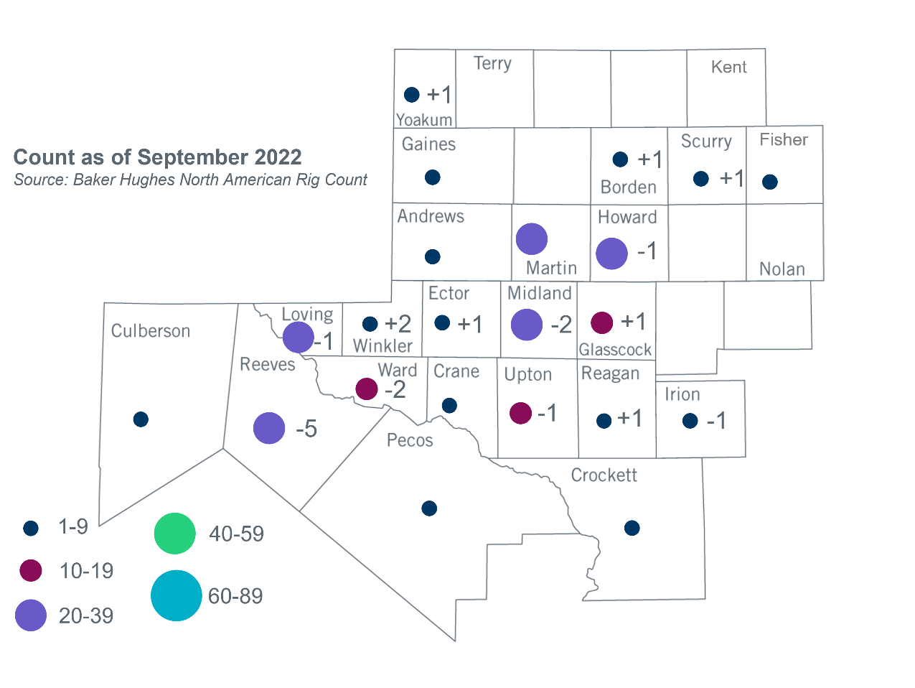Permian Basin Oil Rig Count[3]

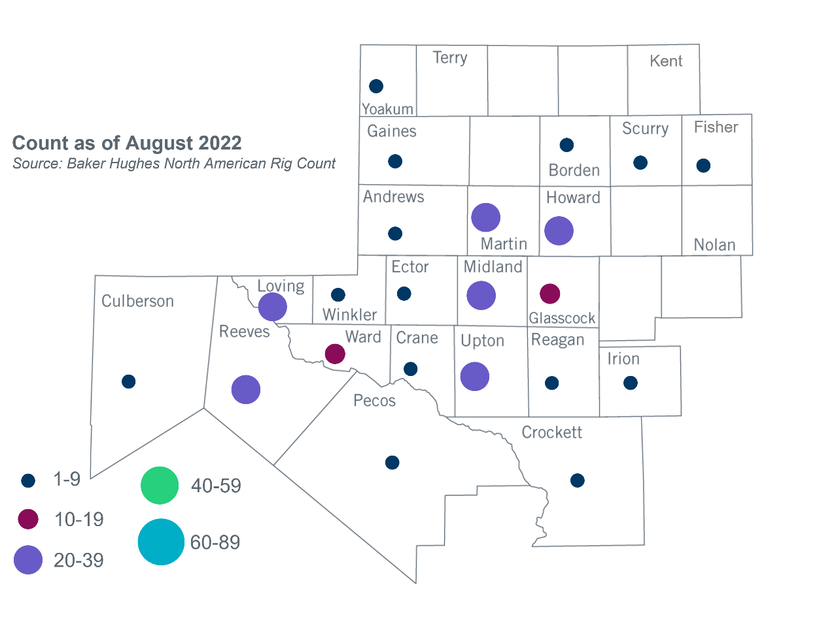

Other Notable Activities

1. Based on the Total Project Estimated Cost for all future projects listed in the Transmission Project Information and Tracking (TPIT) report. TPIT is updated three times each year based on information TSPs provide in Model on Demand (MOD) as specified in the ERCOT Steady State Working Group Procedure Manual. The latest TPIT is available at https://www.ercot.com/gridinfo/planning.
2. Based on the Total Project Estimated Cost for all completed projects with Projected In-Service Dates in 2022 listed in the TPIT.
3. +/- symbol indicates the increase or decrease from the previous month in oil rigs present in each county. There are 230 rigs, including a decrease of 5 oil rigs, in the Permian Basin from August to September 2022.