**TDTMS**

**September 22nd, 2022**

**WebEx only**

|  |  |  |  |  |  |
| --- | --- | --- | --- | --- | --- |
| Attendee | Company | Attendee | Company | Attendee | Company |
| Diana Rehfeldt | TNMP | Erin Waskik-Guitierrez | ERCOT | Kyle Patrick | NRG |
| Sam Pak | Oncor | Tammy Stewart | ERCOT | Monica Jones | CNP |
| Lori Lee Barfield | Just | Mick Hanna | ERCOT | Eric Lotter | GridMonitor |
| Sheri Wiegand | Vistra | Neal Roper | Constellation | Kathy Scott | CNP |
| Carolyn Reed | CNP | Jesse Macias | AEP | Bill Snyder | AEP |
|  |  | Dailey Smith | LP&L | Sarais Cortez | Trailstone |
|  |  |  |  |  |  |
|  |  |  |  |  |  |

**Antitrust/Minutes**

* Antitrust Admonition was read by Sheri Wiegand
  + Minutes from 8/25/22 were reviewed and approved.

**ERCOT System Instances & MarkeTrak Monthly Performance Review**

* Mick presented **August performance reports** - ERCOT has met SLA targets yet remains below the annual target. Need 8 days without issue and should be back on target for annual SLA
* MarkeTrak response times remain well below 12 month average with upgrade
* MarkeTrak did have some issues with performance, particularly early morning log is would receive an error. This was a “bug on a bug” and a workaround is still being researched but should not continue to be an issue.

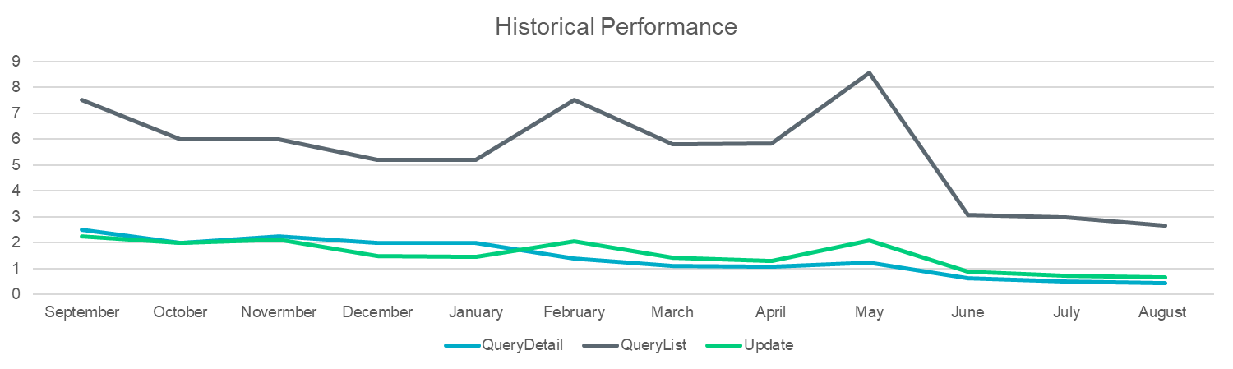

* **Listserv activity** – Mick continues to monitor email auto-deletes and deletes from the Weather Moratorium listserv. Does not appear to be any issues.

**MarkeTrak Upgrade and Stabilization**

* Update on two remaining issues:
  + New Users and Search functionality – still researching
  + Bulk Insert Template for Usage & Billing – should be resolved – migrated to production a few weeks ago

**SCR 815 – MarkeTrak Administrative Changes (December 2022)**

* Remain on target for GO LIVE of 12/5.
* Mid to late October for availability in RMTE, as well as WSDL changes available
* TRAINING DATES: initial training workshops are slated for 11/16 (during TDTMS meeting) and 11/30 in the afternoon
* Tammy explained archiving the unused subtypes where the DEV “In both systems with date issue” NIDR (last used in 2016) and the IDR (last used in 2013) will both be archived.
* ACTION: Tammy to send the final list of archived subtypes to Sheri for posting.

**SCR 817 MarkeTrak Validations –**

IAG

* Reviewed proposed workflows for IAG ‘Happy Path’ and ‘Unhappy Path’.
* For Recission workflow, will add current error message
* Changing transition to read “Agree to Proposed Regain Date”
* REPs to review reasons for pushing back on proposed regain date.

Cancel W/ Approval

* will leave language as currently stated for same day cancel attempts

867 vs Sum of LSE Intervals – Dispute

* modified start time to eliminate hh:mm:ss
* noted central time is the standard yet dependent upon settings of user
* Hard format Start: 00:00:00 and End 23:59:59
* Bulk Insert template will need to align as well

Switch Hold Workflow

* revised requirement for warning message instead of hard stop when ‘switch hold does not exist’ to allow for out of sync conditions
* confirmed warning message when ROR is submitting SH removal
* discussion on pre-population of Assignee by ERCOT for SH removal MTs when ESI is de-energized in ERCOT registration and no current ROR - ERCOT plans to transition to TDSP with a null value in Assignee field – this could be the result of an out of sync condition.

Reject Codes

* Tammy will add the new reject codes created (a result of the A13 work)to the dropdown for the reject codes

Business Requirements will be reviewed again on the 28th of October at the MCT meeting.

**MarkeTrak Subtype Volume Analysis – Mid Year 2022**

Below are the results of the mid year 2022 MT (raw) volume subtype analysis:



Observations:

* While IALs are down, IAGs are up (likely due to the Bulk Insert submissions in June)
* Rescissions are up, may be due to higher prices in the market
* Switch Holds are down, however, could be seasonal with first half of the year being lighter than latter half – also, DPP action is not impacted by ERP, Uri and weather moratoriums
* Usage & Billing Dispute and Usage & Billing Missing – spike likely due to TNMP 3G remediation
* AMS LSE – way down – contributing factor is the improvement of AMS data quality – saw spike with Uri impacts, now volumes have dropped and hopefully levelled off
* Other – down as Oncor concluded their transition from BUSIDRRQ to BUSLO and now BUSLRG is an active choice for these size (>700 kW) customers
* Cancel w/ Approval – slightly higher, but does not appear not appear out of line
* Siebel Changes – bit of a spike and like due to CNP FME incident earlier in the year where Siebel changes were needed to re-sync the market
* Bulk Inserts submissions up – contributing factor – TNMP 3G remediation and IAG submissions in June
* ERCOT Initiated – dropped - good story possibly meaning fewer invalid character issues and POLR Drops
* DEV issues have fallen off over the years as rules and behavior have shifted activity where leap frog scenarios have been minimized

Suggestion for further discussion is to provide rank trends by volume and how much time is spent on each subtype.

**NEXT MEETING scheduled – October 20th @ 9:30AM WebEx only**

* ERCOT Updates
  + System Instances & MT Performance
  + Listserv
  + MarkeTrak Upgrade Stabilization
* SCR815 Updates
* SCR817 Business Requirements discussion, *if needed*
* MarkeTrak Volume Subtype Analysis Discussion –
  + Time Spent on Issues of Various Subtypes
  + Ranking Volumes over time