

Detailed Business Requirements:
SCR817-MarkeTrak Revisions Aligning with TX Set V5.0
Version 4.0

Document Revisions

Date | Version | Description | Author(s)
08/31/2022 | 1.0 | Initial draft | Tammy Stewart
09/01/2022 | 2.0 | Initial review with the Market. Reviewed up to Requirement #7. | Tammy Stewart
09/14/2022 | 3.0 | Second review with the Market. | Tammy Stewart
09/22/2022 | 4.0 | TDTMS review. | Tammy Stewart

Table of Contents

1. Project Overview 1
1.1. Background 1
1.2. Requirements Overview 2
2. Business Requirements 3
2.1. Revise Inadvertent Gain/Loss/Rescission workflows to remove Ready to Receive transition 3
2.2. Develop a unique set of Unexecutable Reasons for applicable subtypes 4
2.3. 150 day validation on the Proposed Regain Date for Inadvertent Gain, Inadvertent Loss workflows 5
2.4. Reduce 25 day validation on Customer Rescission subtype to 15 days 6
2.5. Creation of a new Meter Cycle Change Request subtype 6
2.6. Creation of a new 867 vs. Sum of LSE Intervals-Dispute subtype 7
2.7. Redesign AMS LSE-Dispute subtype 8
2.8. Add radio button to Usage & Billing-Dispute subtype to clarify expected results 8
2.9. Expand Siebel validations on the Submit transition for Missing Enrollment TXNs subtype 9
2.10. Modify Switch Hold Removal subtype to allow TDSP to execute Time Limit Exceeded transition 9
2.11. Create additional validations on the Submit transition for Switch Hold Removal subtype 10
2.12. Modify Switch Hold Removal subtype for ERCOT to auto populate the holding CR 10
2.13. Change the name of the Complete transition to Agree/Complete on Siebel Chg/Info subtype 10
2.14. Add a warning message on the Submit transition for Inadvertent Gain, Inadvertent Loss, Customer Rescission subtypes for third party transactions that are “Scheduled” or “In Review” 11
2.15. Add new reject codes to the Reject TXNs subtype – ERCOT requirement to support TX SET 5.0 11
APPENDIX A Inadvertent Workflow diagrams 13

Project Overview

Background
The MarkeTrak tool, launched in November of 2006, is a web based database application used to track, manage and store data utilized by ERCOT and the Market Participants. This tool is the supported method for issue management resolution within the retail market. The Texas Data Transport and MarkeTrak Systems Working Group (TDTMS) submitted SCR817 which was approved by the Board. The SCR outlined enhancements that will further increase the application efficiency, create new workflows for specific tracking and resolution of issues that are currently submitted under generic Other or Projects subtypes, and support TX SET 5.0 process changes.

Requirements Overview

High Level Requirement # | Description of Requirement
1 | Revise Inadvertent Gain/Loss/Rescission workflows to remove Ready to Receive transition
2 | Develop a unique set of Unexecutable Reasons for each applicable Subtype
3 | Add a 150 day validation on the Proposed Regain Date for Inadvertent Gain, Inadvertent Loss workflows
4 | Reduce 25 day validation on the Customer Rescission workflow to 15 days
5 | Creation of a new Meter Cycle Change Request subtype
6 | Creation of a new 867 vs. Sum of LSE Intervals-Dispute subtype
7 | Redesign AMS LSE-Dispute subtype
8 | Add radio button to Usage & Billing-Dispute subtype to clarify expected results
9 | Expand Siebel validations on the Submit transition for Missing Enrollment TXNs subtype
10 | Modify Switch Hold Removal subtype to all TDSPs to execute Time Limit Exceeded transition
11 | Create additional validations on the Submit transition for Switch Hold Removal subtype
12 | Modify Switch Hold Removal subtype for ERCOT to auto populate the holding CR
13 | Change the name of the Complete transition to Agree/Complete on Siebel Chg/Info subtype
14 | Add a warning message on the Submit transition for Inadvertent Gain, Inadvertent Loss, Customer Rescission subtypes for third party transactions that are “Scheduled” or “In Review”
15 | Add new reject codes to the Reject TXNs subtype – ERCOT requirement to support TX Set 5.0

Business Requirements

Revise Inadvertent Gain/Loss/Rescission workflows to remove Ready to Receive transition

Description:
Revise the Inadvertent Gain/Loss/Rescission workflows to remove the Ready to Receive transition which allowed TDSPs to prepare their systems for a BDMVI. Upon agreement of the two REPs, the TDSPs would gain visibility of the MarkeTrak and the Losing Competitive Retailer (CR) will submit the BDMVI TX SET transaction with the proposed “IA” or “CR” code.
This resolution once implemented will support the TX SET transactional solution as stated in TX SET Change Control 2021-829, Add a New Indicator to Indicate Regain Due to Inadvertent Gain/Loss and Right of Rescission, that was approved by RMS on May 4, 2021.
- GUI:
  - Revisions to Inadvertent Gaining subtype (see Appendix A for workflow diagram):
    - State of ‘In Progress (Losing CR)’
      - Remove ‘Send To TDSP’ transition
      - Add ‘Provide Proposed Regain Date’ transition. Required information on this transition includes:
        - Proposed Regain Date
    - State of ‘In Progress (Gaining CR)’
      - Add ‘Agree To Proposed Regain Date’ transition
      - Add transition ‘Request Updated Proposed Regain Date’
        - Dropdown ‘Request Updated Regain Date Reason’ field with the following values:
          - Regain Date < Date of Loss + 1 day
          - Regain Date > MarkeTrak submit date + 10 days
          - Regain Date on a non-AMS operational day
          - Regain Date should not be greater than first MarkeTrak submit date + 10 days
          - Regain Date > 150 days in the past
    - State of ‘In Progress (Submit Regaining)’
      - Remove ‘Send To TDSP’ transition
    - Remove the following states/transitions:
      - ‘New (TDSP)’
        - ‘Begin Working’
      - ‘In Progress (TDSP)’
        - ‘Ready To Receive’
        - ‘Send To Submitting CR’
        - ‘Request Updated Proposed Regain Date’

  - Customer Rescission subtype (see Appendix A for workflow diagram):
    - State of ‘In Progress (Losing CR)’
      - Remove ‘Send To TDSP’ transition
      - Add ‘Provide Regaining BGN02’ transition.
        - Regaining BGN02 Required
      - Upon execution of ‘Provide Regaining BGN02’ transition from the ‘In Progress (Losing CR)’ state, issue transitions to ‘Regaining TXN Submitted (PC)’ with the Submitting CR as the Responsible MP. TDSP has full visibility to Marketrak issue.
    - Remove the following states/transitions from the Customer Rescission workflow:
        - ‘New (TDSP)’
          - ‘Begin Working’
        - ‘In Progress (TDSP)’
          - ‘Ready To Receive’
          - ‘Send To Submitting CR’
          - ‘Request Updated Proposed Regain Date’
        - ‘New (Losing CR Submit)’
          - ‘Begin Working’
          - ‘Close’
        - ‘In Progress (Submit Regaining)’
          - ‘Provide Regaining BGN02’ (moved to state of ‘In Progress (Losing CR)’)
          - ‘Send To TDSP’
          - ‘Close’

  - Revisions to Inadvertent Losing subtype (see Appendix A for workflow diagram):
    - State of ‘Create’
      - Add Proposed Regain Date field to the GUI form. This is required information on the ‘Submit’ transition.
    - State of ‘In Progress (Gaining CR)’
      - Add transition ‘Request Updated Proposed Regain Date’
        - Dropdown ‘Request Updated Regain Date Reason’ field with the following values:
          - Regain Date < Date of Loss + 1 day
          - Regain Date > MarkeTrak submit date + 10 days
          - Regain Date on a non-AMS operational day
          - Regain Date should not be greater than first MarkeTrak submit date + 10 days
          - Regain Date > 150 days in the past
      - Change transition name ‘Agree’ to ‘Agree To Proposed Regain Date’
    - State of ‘In Progress (Losing CR)’
      - Remove ‘Send To TDSP’ transition
      - Add new transition ‘Provide Proposed Regain Date’
    - State of ‘In Progress (Submit Regaining)’
      - Remove ‘Send To TDSP’ transition
    - Remove the following states/transitions:
      - ‘New (TDSP)’
        - ‘Begin Working’
      - ‘In Progress (TDSP)’
        - ‘Ready To Receive’
        - ‘Send To Submitting CR’
        - ‘Request Updated Proposed Regain Date’

- API: XSD/WSDL updates
- Bulk Insert: Update Bulk Insert Template for Inadvertent Losing subtype

Develop a unique set of Unexecutable Reasons for applicable subtypes

Description:
Develop a unique set of relevant Unexecutable Reasons for each applicable subtype in addition to free form comments if necessary. Common Unexecutable Reasons can be tracked for reporting and continuing process improvements.

- GUI
  - Add Unable To Cancel Reason drop down field on the ‘Unable To Cancel’ transition for Cancel With Approval subtype.
    - Unable To Cancel Reason field values:
      - Transaction is already Complete in the TDSP system
      - Per ERCOT Protocols, the CR must send an 814_08 Cancel Request unless there is a system outage and the CR is unable to send/receive TXSET EDI transactions
      - Incorrect ESI ID Provided
      - Transaction does not exist in TDSP system
      - Incorrect Original Tran ID provided

    - New Unable To Cancel Reason field displays on the GUI form

  - Modify Unexecutable Reason field for Switch Hold Removal subtype.
    - When Documentation Invalid/Incomplete is selected from the Unexecutable Reason dropdown field on the Unexecutable transition, a secondary dropdown field ‘Documentation Invalid Reason’ displays with the following values:
      - Incorrect or missing documents
      - Illegible supporting documents
      - Address not listed on documents
      - Missing phone number on New Occupant Statement
      - Signatures missing on the lease agreement
      - Address on the lease does not match the service address
      - The name on the lease does not match New Occupant Statement
      - ESI ID invalid or not found
      - ESI ID not listed on New Occupant Statement
      - New customer is same as current tenant
      - Other
        - Comments Required
    - Comments optional/required
    - New Documentation Invalid Reason field displays on the GUI form
- API: XSD/WSDL update
- Bulk Insert: N/A
- Reporting: Users should have the ability to return new field values in all reports

150 day validation on the Proposed Regain Date for Inadvertent Gain, Inadvertent Loss workflows

Description:
Add a pop-up validation message, “Regain dates > 150 days in the past will be rejected by the TDSP”.
This resolution once implemented will be a precautionary warning that will prevent transactional delays caused by TDSP rejects as stated in TX SET Change Control 2021- 832, To Support Change Control 2021-829 for Inadvertent Gain/Loss or Customer Rescission This Change Control Adds 3 New Rejection Reasons, that was approved by RMS on August 3, 2021.
- GUI:
    - Inadvertent Gaining subtype:
      - From the state of ‘In Progress (Losing CR)’, on the ‘Provide Proposed Regain Date’ transition, add a validation on the date entered in the required Proposed Regain Date field to validate that the date entered is not greater than 150 days in the past.

      - Warning message to display if validation = True: “Regain dates greater than 150 days in the past will be rejected by the TDSP”.

      - User has the ability to select OK to move the issue forward or select Cancel and change the Proposed Regain Date.

    - Inadvertent Losing subtype:
      - On the ‘Submit’ transition, add a validation on the date entered in the Proposed Regain Date field to validate that the date entered is not greater than 150 days in the past.

      - From the state of ‘In Progress (Losing CR), on the transition ‘Update Proposed Regain Date’, add a validation on the date entered in the required Proposed Regain Date field to validate that the date entered is not greater than 150 days in the past.

      - Warning message to display if validation = True: “Regain dates greater than 150 days in the past will be rejected by the TDSP”.

      - User has the ability to select OK to move the issue forward or select Cancel and change the Proposed Regain Date.

- API: N/A
- Bulk Insert: N/A

Reduce 25 day validation on Customer Rescission subtype to 15 days

Description:
Reduce the current hard stop validation of 25 days to 15 days based on the 2020 review of 4600 Rescission MarkeTraks, 94% of which were submitted within 15 days of originating switch transaction.
- GUI:
  - On the ‘Submit’ transition, modify the 25 day validation logic to 15 days. Update the error message to display as follows: “Error: This issue is unable to proceed because the effective date of the originating transaction at this premise was more than 15 calendar days in the past. Please enter a different ESIID or consult the Retail Market Guide to determine the proper course of action.”
- API: N/A
- Bulk Insert: N/A

Creation of a new Meter Cycle Change Request subtype

Description:
Creation of a new Meter Cycle Change Request subtype to be submitted by REP of record only. Requires field entries such as current cycle and proposed meter cycle. Addition of a YES/NO radio button indicating TDSP approval of request.

- GUI: New subtype Meter Cycle Change Request added to D2D Project list. Workflow should follow ‘Other’ subtype in design keeping the following existing fields on the Submit form:
      - Assignee: (Required)
      - Assign To Pending
      - ESI ID (Required)
      - Comments (Optional)

- New fields on the Submit form:
    - New Field “Current Meter Read Cycle”
      - Field length - Required two digits:
        - Add help hover text “Requires two digits. Example: Cycle 1 should be entered as 01”
      - Type – numeric
      - Default value – blank
      - Screen location – Issue section
      - Updateable – No
      - Automatically populated – No
      - Proprietary – All MPs Involved
      - Field Screen Title – “Current Meter Read Cycle”
      - Transitions Enabled – Upon Submit
      - Workflows Involved – Meter Cycle Change Request

    - New Field “Proposed Meter Read Cycle”
      - Field length - Required two digits
        - Add help hover text “Requires two digits. Example: Cycle 1 should be entered as 01”
      - Type – numeric
      - Default value – blank
      - Screen location – Issue section
      - Updateable – No
      - Automatically populated – No
      - Proprietary – All MPs Involved
      - Field Screen Title – “Proposed Meter Read Cycle”
      - Transitions Enabled – Upon Submit
      - Workflows Involved – Meter Cycle Change Request

    - New Transition: ‘Approved’
      - Transition Enabled – ‘In Progress (Assignee)’ state
    - Revise Unexecutable Transition:
      - Add dropdown ‘Unexecutable Reason’ field to the Unexecutable transition with the following values:
          - Only one meter cycle change per ESIID per Rep of Record for this Customer
          - Causes cycle imbalance
          - Unable to Accommodate
            - Comments required if this value selected
          - Surpasses TDSP cycle threshold
      - Comments field optional/required

- API: XSD/WSDL update
- Bulk Insert: Create new Bulk Insert template
- Reporting: New subtype captured in all reporting
- Validations:
  - Submitting MP Type must be a CR
  - Submitting CR must be current Rep of Record in ERCOT Registration System
  - Assignee must be MP Type TDSP
- Notifications: When in states of ‘Pending Complete’ or ‘Unexecutable (PC)’ issue Auto Closes after 14 days

Creation of a new 867 vs. Sum of LSE Intervals-Dispute subtype

Description:
Creation of a new subtype 867 vs Sum of LSE Intervals – Dispute requiring the 867_03 Tran ID to be entered for reference, Start date/time and end date/time stamps to match the 867_03 transaction dates for validation, and comments required.

- GUI: New subtype 867 vs. Sum of LSE Intervals-Dispute added to D2D Project list. Workflow should follow ‘Usage & Billing – Dispute workflow’ subtype in design keeping the following existing fields on the Submit form:
      - Assignee: (Required)
      - Assign To Pending
      - ESI ID (Required)
      - Comments (Required)
        - Tran ID (Required)
          - Help text “Tran ID of the 867_03 in dispute”
        - STARTTIME (Required)
          - Format: mm/dd/yyyy
          - Help text “Start Time of the 867_03 transaction in dispute”
        - STOPTIME (Required)
          - Format: mm/dd/yyyy
          - Help text “Stop Time of the 867_03 transaction in dispute”

- API: XSD/WSDL update
  - Bulk Insert: Create new Bulk Insert template
  - Reporting: New subtype captured in all reporting
  - Validations:
    - Submitting CR must be Rep of Record for the start and stop time being disputed
    - Submitter must be MP Type CR
    - Assignee must be MP Type TDSP
  - Notifications: When in state of ‘Pending Complete’ or ‘Unexecutable (PC)’ issue Auto Closes after 14 days

Redesign AMS LSE-Dispute subtype

Description:
Redesign of the AMS LSE – Dispute subtype to support the various reasons for submittal.
- GUI:
  - Transition: ‘Submit’
    - New field Reason for Dispute (Required)
      - Field format – dropdown field with the following values:
        - Disputing Peak Interval
        - Requesting Estimation Methodology Utilized
        - Disputing interval allocation of estimated consumption
        - 4CP Verification
        - Other
          - Comments required if ‘Other’ selected
      - Min/Max length – 1/60
      - Type – alphanumeric
      - Default value – blank
      - Screen location – Issue section
      - Automatically populated – No
      - Proprietary – All MPs Involved
      - Field Screen Title – “Reason for Dispute”
      - Transitions Enabled – Upon Submit
      - Workflows Involved – Usage/Billing AMS LSE Interval - Dispute
- API: XSD/WSDL update
- Bulk Insert: Update Bulk Insert Template
- Reporting: Users should have the ability to return new field values in all reports

Add radio button to Usage & Billing-Dispute subtype to clarify expected results

Description:
Addition of a radio button (YES/NO) if corrections are to be expected as a result of the dispute.
- GUI:
  - State – ‘In Progress (Assignee):
    - New Field Corrections Expected (required)
      - Field format – radio button
      - Field values – YES/NO
      - Default value – blank
      - Screen location – Issue section
      - Automatically populated – No
      - Proprietary – All MPs Involved
      - Field Screen Title – “Corrections Expected”
      - Workflows Involved – Usage & Billing - Dispute
- API: XSD/WSDL update
- Bulk Insert: N/A
- Reporting: Users should have the ability to return new field values in all reports

Expand Siebel validations on the Submit transition for Missing Enrollment TXNs subtype

Description:
If possible, expand Siebel interaction to perform the following validations:
- Check status – hard stop for CANCEL
- Check 867_04 transaction – hard stop if already submitted
Check for date parameter on 814_04 and 814_05, CR Enrollment Notification Response, transactions; consider date changes/cancels; and if > 5 days, allow MarkeTrak to proceed

- GUI:
  - Transition: Submit
    - When 867_04 is selected from the Tran Type field, perform the following validations on the ‘Submit’ transition:
      - Verify service order for Global ID provided is not in status of ‘Cancelled’ in Siebel. If the service order is Cancelled, the following error message will display: “The service order for the Global ID provided has been cancelled in ERCOT Registration System. Please update the ESIID/Original Tran ID provided and click OK or click Cancel to exit”.
      - Verify the 867_04 has been received in ERCOT system for the Global ID provided. Error message to display if 867_04 is in the system: “The 867_04 transaction has already been sent””
      - For the Global ID provided, perform a check in Siebel to determine if the 814_04 and 814_05 transactions have been received. If TRUE, verify the Scheduled Meter Read Date is greater than 5 days of the submit date of the MarkeTrak issue. If TRUE, no action. If FALSE, warning message displays: “Please allow at least 5 days for the 867_04 to be sent by the TDSP”.

- API: N/A
- Bulk Insert: N/A

Modify Switch Hold Removal subtype to allow TDSP to execute Time Limit Exceeded transition

Description:
Modify workflow for Switch Hold Removal subtypes to allow the TDSP to also transition a Switch Hold Removal request releasing the switch hold and completing the MarkeTrak.
- GUI:
  - Transition: ‘Time Limit Exceeded’
    - Add ‘Time Limit Exceeded’ transition button to the TDSP’s view when a Switch Hold Removal issue is in the states of ‘New (Assignee)’ and ‘In Progress (Assignee)’.
    - Add optional comments on the ‘Time Limit Exceeded’ transition in all states.
    - No workflow changes upon execution of ‘Time Limit Exceeded’ transition.
- API: XSD/WSDL update
- Bulk Insert: N/A

Create additional validations on the Submit transition for Switch Hold Removal subtype

Description:
Create validations within the MarkeTrak tool to provide a hard stop with a pop-up message if no Switch Hold is pending on the ESI ID, and to provide a warning message if the issue is being submitted by the current Rep of Record.

- GUI:
  - New Validation:
    - Transition enabled – ‘Submit’
    - Check is performed to verify if a Switch Hold currently exists on the ESIID in the ERCOT Registration System. Warning message to display if no Switch Hold currently exists:
      - “ERCOT system indicates there is no Switch Hold currently in place on the ESIID provided. ”
  - New Validation:
    - Transition enabled – ‘Submit’
    - Check is performed to verify if the Submitting MP is the current Rep of Record in ERCOT’s Registration System. Warning message to display if TRUE:
      - “Switch Hold Removal issues should not be submitted by the current Rep of Record. Click OK to continue with the submit process or Cancel to exit.”
- API: N/A
- Bulk Insert: N/A

Modify Switch Hold Removal subtype for ERCOT to auto populate the holding CR

Description:
Reducing handling time by allowing ERCOT to automatically pre-populate the holding CR prior to transitioning the MarkeTrak to the TDSP for initial review.
- GUI:
  - Add field Assignee to Switch Hold Removal issue upon the ‘Submit’ transition. This is currently a field that is manually populated by the TDSP upon the ‘Send To Rep of Record’ transition when the issue is in the state of ‘In Progress (TDSP)’. New functionality will auto populate the Assignee and this field will be visible when the issue transitions to state of ‘New (TDSP)’.
    - Assignee to be auto populated from the ERCOT Registration System with the current Rep of Record DUNS as of the Submit date of the MarkeTrak issue. Value will be populated during the ‘Submit’ transition.
    - If the ESIID provided is de-energized in the ERCOT Registration system and there is no current Rep of Record, ERCOT will transition the issue to the TDSP with a null value in the Assignee field.
  - Modify ‘Send To Rep of Record’ transition when issue is in the state of ‘In Progress (TDSP)’
    - Assignee field will prompt with pre-populated DUNS. This value can be changed by the TDSP if needed.

- API: XSD/ WSDL update
- Bulk Insert: N/A

Change the name of the Complete transition to Agree/Complete on Siebel Chg/Info subtype

Description:
Providing clarity to the “Complete” button by adding “Agree/Complete” to transition the issue back to the submitter.

- GUI:
  - Siebel Chg/Info subtype:
    - State of ‘In Progress (Assignee)’
      - Update label on ‘Complete’ transition to ‘Agree/Complete’
- API: XSD/WSDL update
- Bulk Insert: N/A

Add a warning message on the Submit transition for Inadvertent Gain, Inadvertent Loss, Customer Rescission subtypes for third party transactions that are “Scheduled” or “In Review”

Description:
Create a validation during the submittal of an Inadvertent subtype providing a pop-up warning for any third party or Move-Out transaction that is “Scheduled” or “In Review” that would potentially result in an unexecuted MarkeTrak response. Consider adding a warning flag or escalation instructing REPs to take action on a pending order.
This resolution once implemented will prevent transactional delays caused by TDSP rejects as stated in TX SET Change Control 2021- 832, To Support Change Control 2021-829 for Inadvertent Gain/Loss or Customer Rescission This Change Control Adds 3 New Rejection Reasons, that was approved by RMS on August 3, 2021.
This process change has been documented as part of the implementation of RMGRR169.

- GUI: New Validation:
    - Transition enabled – ‘Submit’
    - Check is performed to verify if a third party transaction for the ESIID provided is in the ERCOT Registration System with a service order status of “Scheduled” or “ In Review”. Warning message to display if a third party transaction exists with either status:
      - “There is a third party or Move Out transaction in a status of “Scheduled” or “In Review” in the ERCOT Registration System for the ESIID provided. Please review prior to proceeding with Submit to avoid a potential Unexecutable situation.”
- API: N/A
- Bulk Insert: N/A

Add new reject codes to the Reject TXNs subtype – ERCOT requirement to support TX SET 5.0

Description:
Modify the Reject Code field on the Reject TXNs subtype to include new Reject Codes added with TX SET 5.0.

Reject Code | Transactions
090 | 814_02  814_04  814_05  814_11  814_13  814_17  814_19  814_25
150 | 814_04  814_05
270 | 814_02  814_04  814_05  814_11  814_13  814_17  814_19  814_25
A78 | 814_04  814_05  814_11  814_25
A84 | 814_27
BED | 814_19
CCL | 814_04  814_05  814_11  814_25
CEF | 814_19
CSA | 814_25
DCI | 814_13
DIP | 814_04  814_05  814_25
DIV | 814_19
DNR | 814_19
DNS | 814_13
EDR | 814_19
ERS | 814_21
12M | 814_04  814_25
IIC | 814_21
LFG | 814_04  814_05
MVO | 814_04  814_05
NAC | 814_19
NCC | 814_19
NFI | 814_04
NVS | 814_04  814_05  814_11  814_25
PCI | 814_04  814_05  814_11
RDF | 814_21
RSD | 814_13
SCD | 814_19
SDR | 814_19
SHF | 814_11
SND | 814_21
SNP | 814_11
SNR | 814_19
SOP | 814_09
TMI | 814_04  814_05
TNR | 814_29

- GUI: Add new codes to the Reject Code dropdown field
- API: XSD/WSDL update
- Bulk Insert: Update template

APPENDIX A – Proposed Revisions to Inadvertent Workflows:
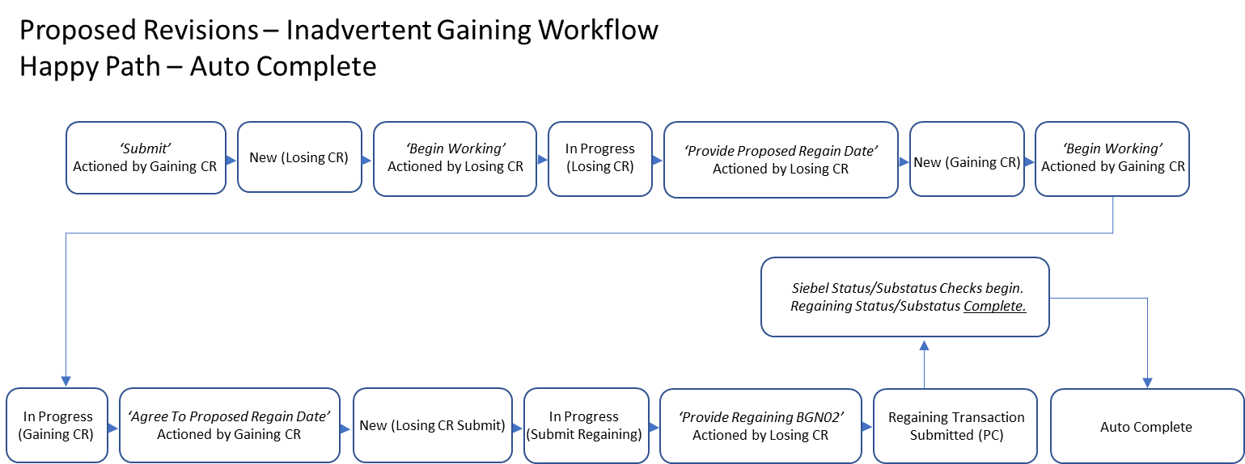

Notes:
Change transition name ‘Agree’ when in ‘In Progress (Gaining CR)’ to ‘Agree to Proposed Regain Date’

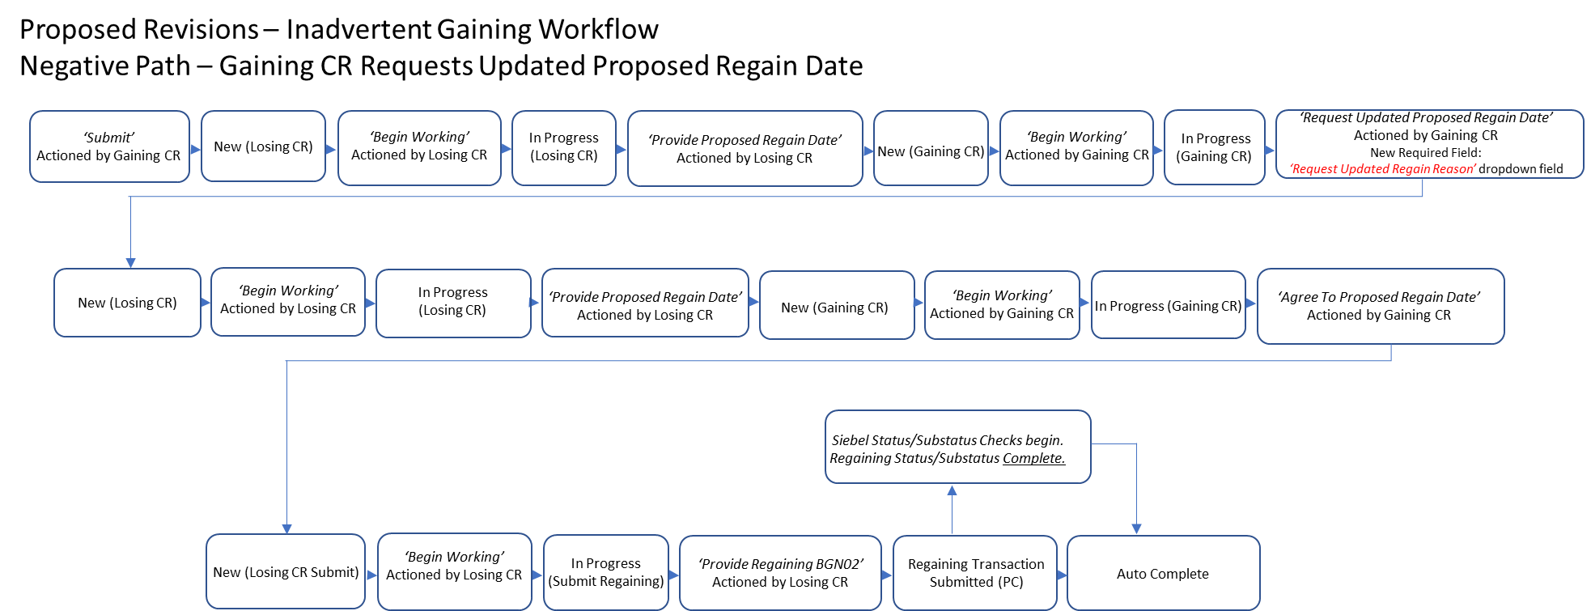

Notes: Add ‘Request Updated Regain Date Reason’ dropdown field on ‘Request Updated Proposed Regain Date’ transition.

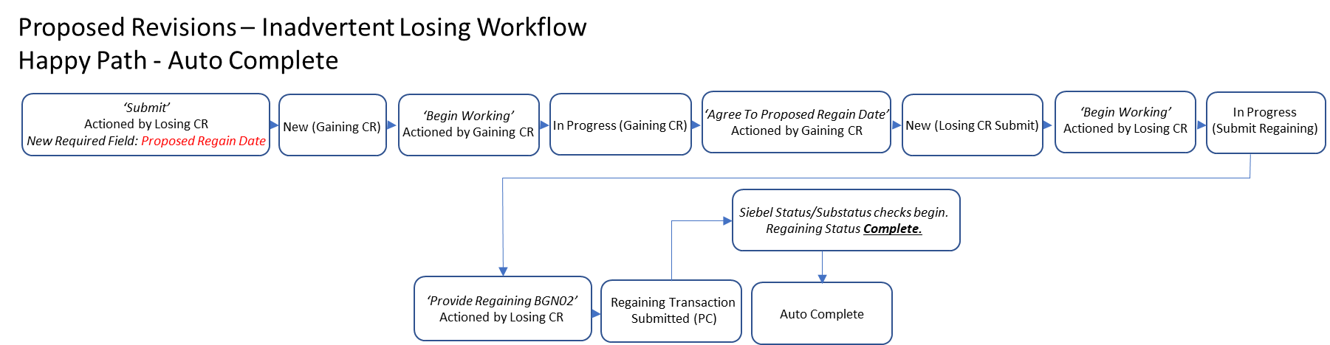

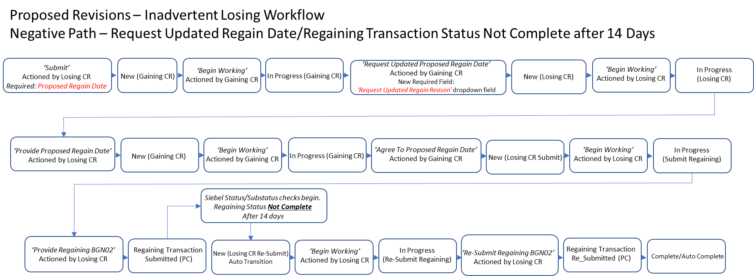
Notes: Add ‘Request Updated Regain Date Reason’ dropdown field on ‘Request Updated Proposed Regain Date’ transition.

