**PWG Meeting Notes** – August 17th, 2022

Via WebEx 9:30 AM

Attendees:

|  |  |  |  |
| --- | --- | --- | --- |
| Sam Pak - Oncor | Jordan Troublefield – ERCOT | Eric Lotter – Grid Monitor | Diana Rehfeldt - TNMP |
| Sheri Wiegand - TXUE | Billy Lee – Garland P&L | Amir Khalifeh - ERCOT | Randy Roberts - ERCOT |
| Kathy Scott - CNP | Jamie Wood – LP&L | Calvin Opheim - ERCOT | Norm Levine - NRG |
| Jesse Macias - AEP | Bill Snyder - AEP | Pam Shaw – LP&L | Steven Pliler - Vistra |
| Angela Ghormley - Calpine | Holly Bohart - Constellation | John Schatz - Vistra | Richard Beasley - CNP |
|  |  |  |  |

* Meeting notes for June 14th were reviewed and approved
* **2021 Weather Sensitivity Progress**
  + Same results as last month (shown below) – TNMP ESI has been active since June last year, yet no data found, TNMP still working on issue
  + Conversation around if WS review would still be required when BUSIDRRQ ESIs move to BUSLRG/DG. Randy indicated previously 25-30% of load on BUSIDRRQ and today only 15% of load on BUSIDRRQ. WS review is performed for ERCOT settlement purposes and should not significantly impact REPs’ procurement and pricing practices.
  + It was suggested that once CNP and TNMP complete their transitions to BUSLRG, the necessity of the WS activity will be reviewed.



* **Business Annual Validation**

Amir provided a presentation listing the summary of changes for this year’s BAV (see below). In reviewing the numbers, questions were raised as to why the total populations YOY were declining. Also, the same total population was listed for 2021 and 2022. ACTION: Amir is going to review and send an updated presentation of which Sam will distribute to the listserv.

CNP, AEP and Oncor are reporting their profile changes have completed. The remaining parties have until 9/30/22 to complete changes.

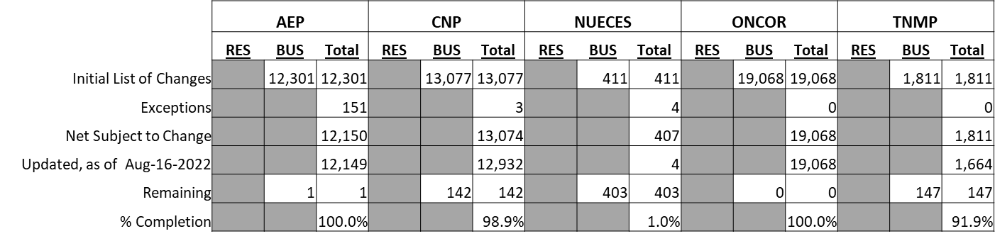

ERCOT provided the following **update.**.



* **IDR/AMS BUSLRG(DG) Update from TDSPs**
  + **Transition Plans/Data Accessibility for BUSLRG profiles:**
    - **Oncor** - 412 ESIs are remaining on BUSIDRRQ with conversions continuing. These are the more complex metering configurations or access issues.  Late Q3 is still the timeline for interval data availability in CRIP.  However, Oncor will be adding full 24 months of historical data upon Go Live.
    - **AEP** was showing ~60 BUSLRGDG which will be confirmed as that was thought to be high.  AEP will have ~150-175 ESIs that will remain on the BUSIDRRQ.
    - **CNP** is currently in the development stage to make the transition, targeting early Q2 of 2023 (1st wk of April 2023) for a Go Live.  Will transition to BUSLRG on cycle basis.  Interval data will also be available at that time.
    - **TNMP** status quo due to 3G remediation and likely will not make the conversions until 2023. Below are the profile counts as of 6/7/22, noting the new BUSLRG and BUSLRGDG

* **Adding Lubbock Power & Light Zip Codes to Load Profiling Guide** 
  + Calvin and Jordan indicated the LPGRR is close to being published and will be posted in time for September RMS review.
  + The LPGRR path forward would be IA @ October RMS and Language @ October TAC, followed by Dec PUCT with an effective date of 1/1/2023. With an early 2023 effective date, that should be about 5-6 months ahead of schedule for LP&L’s use.
  + Calvin indicated the source for the LP&L zip codes was LP&L
* **LPGRR proposal converting Profile Decision Tree from Excel to Word format** – Jordan stated this is likely an early 2023 project/revision request
* **DRAFT agenda for next meeting – October 14th, Friday @ 9:30 AM**

It was decided the September 14th meeting would be cancelled.

* + Weather Sensitivity status
  + Business Annual Validation update
  + IDR/AMS BUSLRG Updates from TDSPs