August 2022 ERCOT Monthly Operations Report
Reliability and Operations Subcommittee Meeting
September 29, 2022

Table of Contents
1. Report Highlights 2
2. Frequency Control 3
2.1. Frequency Events 3
2.2. Responsive Reserve Events 4
2.3. Load Resource Events 4
3. Reliability Unit Commitment 4
4. IRR, Wind, and Solar Generation as a Percent of Load 7
5. Largest Net-Load Ramps 8
6. COP Error Analysis 9
7. Congestion Analysis 11
7.1. Notable Constraints 11
7.2. Generic Transmission Constraint Congestion 21
7.3. Manual Overrides 21
7.4. Congestion Costs for Calendar Year 2022 21
8. System Events 22
8.1. ERCOT Peak Load 22
8.2. Load Shed Events 22
8.3. Stability Events 22
8.4. Notable PMU Events 23
8.5. DC Tie Curtailment 23
8.6. TRE/DOE Reportable Events 23
8.7. New/Updated Constraint Management Plans 23
8.8. New/Modified/Removed RAS 23
8.9. New Procedures/Forms/Operating Bulletins 23
9. Emergency Conditions 24
9.1. OCNs 24
9.2. Advisories 24
9.3. Watches 24
9.4. Emergency Notices 24
10. Application Performance 24
10.1. TSAT/VSAT Performance Issues 24
10.2. Communication Issues 24
10.3. Market System Issues 24
11. Model Updates 25
Appendix A: Real-Time Constraints 27

Report Highlights
- The unofficial ERCOT peak load for the month was 78,465 MW and occurred on 08/02/2022, during hour ending 17:00. Prior to this year, the peak usage for the month of August was 74,820 MW set on 8/12/2019.
- There were 4 frequency events.
- There was 1 instance where Responsive Reserves was deployed.
- There were 151 HRUC commitments.
- There were 26 days of congestion on the North Edinburg to Lobo GTC, 17 days on the Nelson Sharpe to Rio Hondo GTC, 2 days on the West Texas Export GTC, 4 days on the Treadwell GTC, 5 days on the Valley Export GTC, 1 day on the Bearkat GTC, 1 day on the North to Houston GTC, and 1 day on the Culberson GTC. There was no activity on the remaining GTCs during the month. There were no DC Tie Curtailments.
- A PVGR Generation Record of 9,928 MW was set on 08/08/2022 at 10:56.

Frequency Control

Frequency Events
The ERCOT Interconnection experienced 4 frequency events, which resulted from units’ trips. The average event duration was 00:06:27.

A summary of the frequency events is provided below. The reported frequency events meet one of the following criteria: Delta Frequency is 60 mHz or greater; the MW loss is 350 MW or greater; resource trip event triggered RRS deployment. Frequency events that have been identified as Frequency Measurable Events (FME) for purposes of BAL-001-TRE-2 analysis are highlighted in blue. When analyzing frequency events, ERCOT evaluates PMU data according to industry standards. Events with an oscillating frequency of less than 1 Hz are inter-area, while higher frequencies indicate local events. Industry standards specify that damping ratio for inter-area oscillations should be 3.0% or greater. For the frequency events listed below, the ERCOT system met these standards and transitioned well after each disturbance. In the case of negative delta frequency, the MW Loss column could refer to load loss.

Date and Time | Delta Frequency | Max/Min Frequency | Duration of Event | PMU Data |  | MW Loss | Load | IRR | Inertia
 | (Hz) | (Hz) |  | Oscillation Mode (Hz) | Damping Ratio |  | (MW) | % | (MW-s)
08/13/2022 7:22:11 | 0.074 | 59.913 | 00:05:46 | 0.66 | 10% | 507.69 | 46,123 | 10% | 312,197
08/17/2022 22:02:15 | 0.071 | 59.937 | 00:06:14 | 0.64 | 7% | 469.94 | 64,518 | 19% | 354,119
08/17/2022 23:10:31 | 0.071 | 59.921 | 00:08:55 | 0.66 | 11% | 645.73 | 58,622 | 20% | 335,506
08/21/2022 19:27:02 | 0.104 | 59.875 | 00:04:51 | 0.64 | 14% | 713.66 | 60,530 | 17% | 324,104

(Note: All data on this graph encompasses frequency event analysis based on BAL-001-TRE-2.)

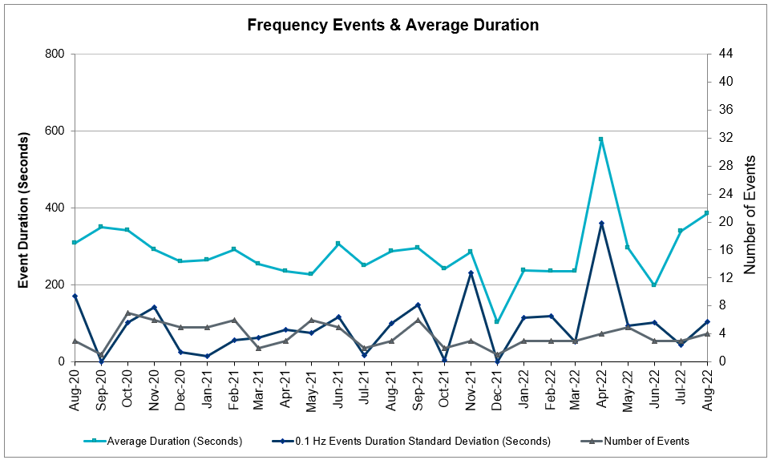

Responsive Reserve Events
There was 1 event where Responsive Reserve MWs were released to SCED. The events highlighted in blue were related to frequency events reported in Section 2.1 above.

Date and Time Released to SCED | Date and Time Recalled | Duration of Event | Maximum MWs Released | Comments
08/21/2022 19:27:12 | 08/21/2022 19:31:56 | 00:04:44 | 763

Load Resource Events
None.

Reliability Unit Commitment
ERCOT reports on Reliability Unit Commitments (RUC) monthly. Commitments are reported grouped by operating day and weather zone. The total number of hours committed is the sum of the hours for all the units in the specified region. Additional information on RUC commitments can be found on the MIS secure site at Grid Generation Reliability Unit Commitment.

There were no DRUC commitments.

There were 151 HRUC commitments

Resource Location | # of Resources | Operating Day | Total # of Hours Committed | Total MWhs | Reason for Commitment
EAST, NORTH_CENTRAL, SOUTH_CENTRAL | 6 | 08/01/2022 | 25 | 7,915.0 | System Capacity
NORTH_CENTRAL | 2 | 08/02/2022 | 10 | 4,350.0 | DMBDBNB8, XBN158
EAST, NORTH_CENTRAL, SOUTH_CENTRAL | 8 | 08/03/2022 | 66 | 17,291.0 | MIN RUN TIME, System Capacity
EAST, NORTH_CENTRAL | 3 | 08/04/2022 | 7 | 1,922.0 | System Capacity, XTRS258
EAST, NORTH_CENTRAL, SOUTH_CENTRAL | 6 | 08/05/2022 | 31 | 10,608.0 | System Capacity
EAST | 1 | 08/06/2022 | 5 | 2,510.0 | System Capacity
EAST | 1 | 08/07/2022 | 4 | 2,008.0 | System Capacity
EAST, NORTH_CENTRAL | 5 | 08/08/2022 | 45 | 18,421.0 | System Capacity,
EAST, NORTH_CENTRAL | 4 | 08/09/2022 | 34 | 14,009.0 | System Capacity
EAST, NORTH_CENTRAL | 7 | 08/11/2022 | 55 | 19,294.0 | System Capacity
EAST, NORTH_CENTRAL | 8 | 08/12/2022 | 57 | 17,061.5 | System Capacity
EAST, NORTH_CENTRAL | 6 | 08/13/2022 | 42 | 15,006.0 | System Capacity
EAST, NORTH_CENTRAL | 5 | 08/16/2022 | 45 | 16,875.0 | System Capacity
EAST, NORTH_CENTRAL | 3 | 08/17/2022 | 16 | 6,716.0 | System Capacity
EAST, NORTH_CENTRAL, SOUTH_CENTRAL | 11 | 08/18/2022 | 106 | 18,862.0 | System Capacity
EAST, NORTH_CENTRAL, SOUTH_CENTRAL | 3 | 08/19/2022 | 15 | 5,902.0 | MIN RUN TIME, System Capacity
NORTH_CENTRAL | 2 | 08/20/2022 | 7 | 2,925.0 | System Capacity
EAST, NORTH_CENTRAL, SOUTH_CENTRAL | 10 | 08/22/2022 | 86 | 24,679.0 | System Capacity
EAST, NORTH_CENTRAL, SOUTH_CENTRAL | 5 | 08/23/2022 | 25 | 10,230.0 | System Capacity
EAST, NORTH_CENTRAL, SOUTH_CENTRAL | 12 | 08/24/2022 | 94 | 27,642.0 | System Capacity
EAST, NORTH_CENTRAL | 5 | 08/25/2022 | 48 | 17,744.0 | System Capacity
EAST, FAR_WEST, NORTH_CENTRAL, SOUTHERN | 8 | 08/26/2022 | 71 | 24,063.0 | System Capacity
COAST, EAST, FAR_WEST, NORTH_CENTRAL | 4 | 08/27/2022 | 31 | 8,856.0 | MIN RUN TIME, System Capacity
COAST, EAST, FAR_WEST, NORTH_CENTRAL, SOUTHERN | 6 | 08/28/2022 | 28 | 7,738.0 | System Capacity
EAST, NORTH_CENTRAL | 5 | 08/29/2022 | 33 | 14,041.0 | System Capacity
NORTH_CENTRAL | 1 | 08/30/2022 | 8 | 3,136.0 | System Capacity
EAST, NORTH_CENTRAL, SOUTH_CENTRAL | 11 | 08/31/2022 | 92 | 30,169.0 | System Capacity

IRR, Wind, and Solar Generation as a Percent of Load
The graph below shows the maximum, minimum and average aggregate solar, wind and IRR output as a percentage of total ERCOT load when evaluated as 10-minute averaged intervals, over the past 13 months. Current wind and solar generation and penetration records are listed in the footnote below. Maximum IRR penetration for the month was 49% on 08/03/2022 interval ending 08:50 and minimum IRR penetration for the month was 1.8% on 08/11/2022 interval ending 07:00.

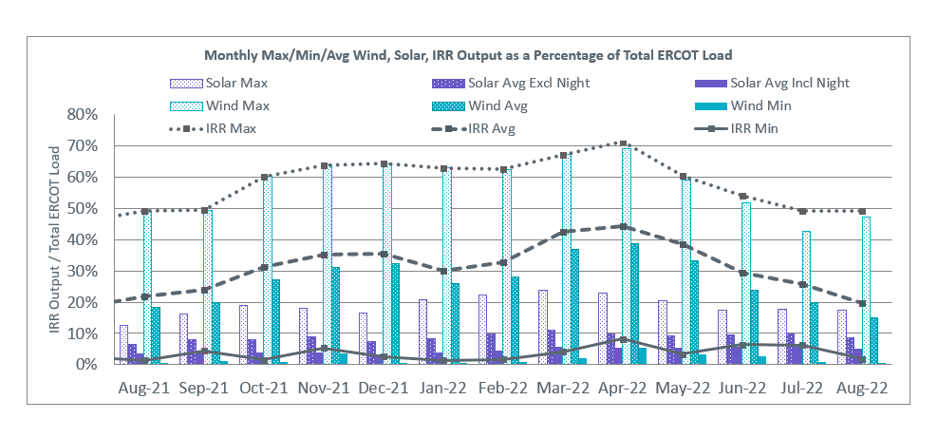

During the hour of peak load for the month, hourly integrated wind generation was 15,420 MW and solar generation was 9,303 MW. The graph below shows the wind and solar penetration percentage during the hour of the peak load in the last 13 months.

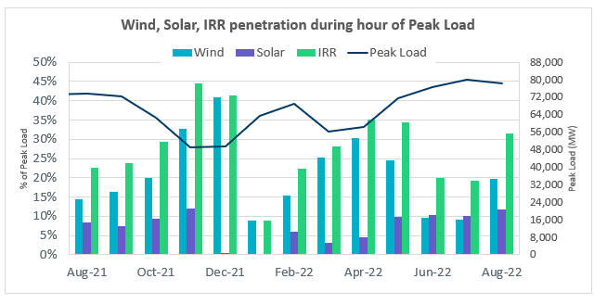

Lastly, the graph below shows the minimum wind, solar and IRR output during the peak load hour as a percentage of the daily peak load for every day in the month.

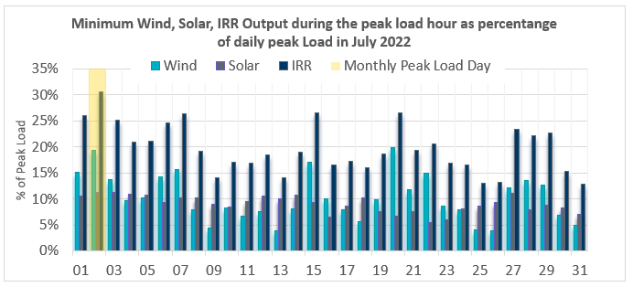

Largest Net-Load Ramps
The net-load ramp is defined as the change in net-load (load minus wind and PVGR generation) during the defined time horizon. Such a variation in net-load needs to be accommodated in grid operations to ensure that the reliability of the grid is satisfactorily maintained. The largest net-load ramp during 5-min, 10-min, 15-min, 30-min and 60-min in August 2022 was 977 MW, 1,837 MW, 2,664 MW, 4,529 MW, and 7,716 MW, respectively. The comparison with respect to the historical values is given in the table below.

Month and Year | 5 min | 10 min | 15 min | 30 min | 60 min
August 2014 | 674 MW | 1,169 MW | 1,589 MW | 2,854 MW | 5,201 MW
August 2015 | 776 MW | 1,231 MW | 1,754 MW | 3,303 MW | 6,260 MW
August 2016 | 834 MW | 1,350 MW | 1,881 MW | 3,230 MW | 6,319 MW
August 2017 | 797 MW | 1,421 MW | 1,953 MW | 3,167 MW | 5,798 MW
August 2018 | 1,333 MW | 1,854 MW | 2,780 MW | 3,205 MW | 6,604 MW
August 2019 | 830 MW | 1,460 MW | 2,084 MW | 3,795 MW | 7,375 MW
August 2020 | 954 MW | 1,536 MW | 2,221 MW | 4,101 MW | 7,690 MW
August 2021 | 1,323 MW | 1,596 MW | 2,081 MW | 3,614 MW | 6,761 MW
August 2022 | 977 MW | 1,837 MW | 2,664 MW | 4,529 MW | 7,716 MW
All months in 2014-2022 | 1,647 MW | 2,157 MW | 3,015 MW | 5,882 MW | 10,750 MW

COP Error Analysis
COP Error is calculated as the capacity difference between the COP HSL and real-time HSL of the unit. Mean Absolute Error (MAE) stayed over 16,000 MW until Day-Ahead at 12:00, then dropped significantly to 8,640 MW by Day-Ahead at 13:00 and to 2,159 MW by Day-Ahead at 14:00. In the following chart, Under-Scheduling Error indicates that COP had less generation capacity than real-time and Over-Scheduling Error indicates that COP had more generation capacity than real-time.
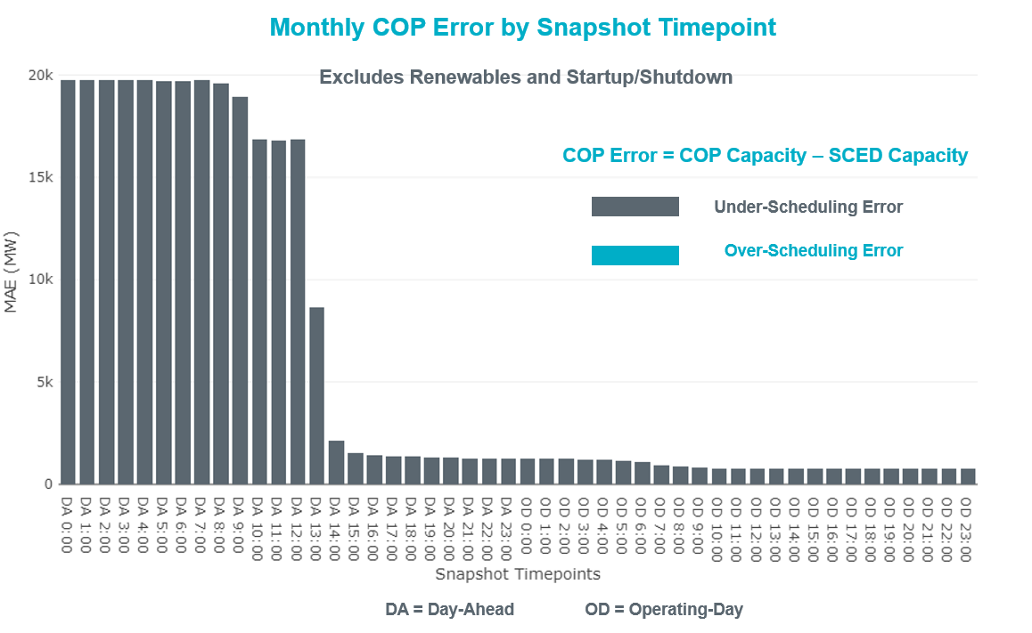

Monthly MAE for the Latest COP at the end of the Adjustment Period was 776 MW with medians ranging from -1,650 MW for Hour-Ending (HE) 16 to 364 MW for HE 8. HE 10 on 08/13//2022 had the largest Over-Scheduling Error (1,507 MW) and HE 15 on 08/09/2022 had the largest Under-Scheduling Error (-3,621 MW).

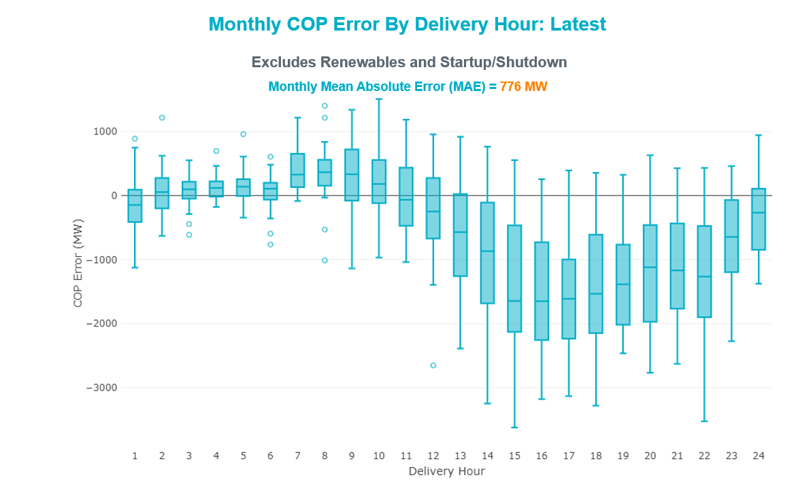

Monthly MAE for the Day-Ahead COP at 12:00 was 16,828 MW with median ranging from -22,662 MW for Hour-Ending (HE) 16 to -13,252 MW for HE 6. HE 17 on 08/16/2022 had the largest Under-Scheduling Error (-27,280 MW) and HE 7 on 08/03/2022 had the smallest Under-Scheduling Error (-5,647 MW).

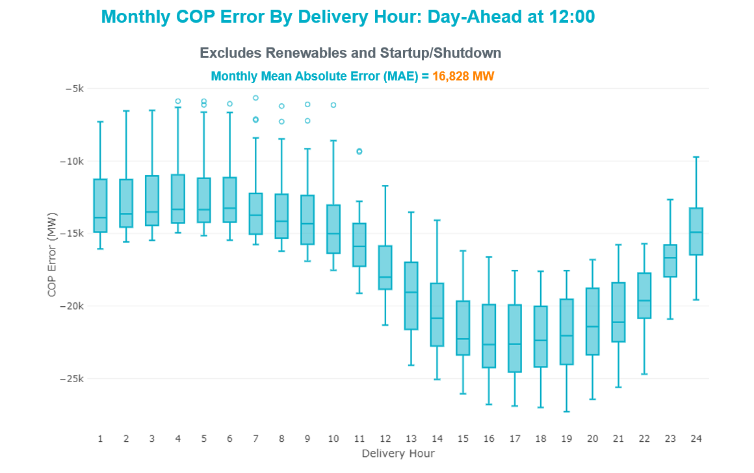

Congestion Analysis

Notable Constraints
Nodal protocol section 3.20 specifies that ERCOT shall identify transmission constraints that are binding in Real-Time three or more Operating Days within a calendar month. As part of this process, ERCOT reports congestion that meets this criterion to ROS. In addition, ERCOT also highlights notable constraints that have an estimated congestion rent exceeding $1,000 for a calendar month. These constraints are detailed in the table below, including approved transmission upgrades from TPIT that may provide some congestion relief based on ERCOT’s engineering judgement. Rows highlighted in blue indicate the congestion was affected by one or more outages. For a list of all constraints activated in SCED, please see Appendix A at the end of this report.

Contingency Name | Overloaded Element | # of Days Constraint Binding | Congestion Rent | Transmission Project
Elmcreek-Sanmigl 345kV | Pawnee Switching Station - Calaveras 345kV | 22 | $16,753,171.99
Basecase | NE_LOB GTC | 22 | $10,077,970.46 | The Lower Rio Grande Valley (LRGV) System Enhancement Project (21RPG017) will improve the NorthEd_LoboGTC to support up to 80% of total wind and solar generation capacity in the LRGV area.
MAN-TRX_MDLNE_AXFMR1_345/138 | Midland County Northwest Switch - Mockingbird 138kV | 11 | $8,650,276.69 | Oncor Midland East Area Project (21RPG003, MOD 57925) - NOTE: This project removes the overloaded element and reconfigures lines in the area, amongst other topology changes.
MCSES TO CDHSW 138 DBLCKT | Cedar Crest Switch - Oak Cliff South 138kV | 2 | $5,327,104.25
TWR(345) WAP-WLF64 & WAP-WLY72 | South Texas Project - Wa Parish 345kV | 6 | $5,235,049.44
Basecase | WESTEX GTC | 2 | $4,033,498.41
Basecase | NELRIO GTC | 16 | $3,009,360.97 | The Lower Rio Grande Valley (LRGV) System Enhancement Project (21RPG017) will cause there to be no stability constraint for NelsonSharpe_RioHondoGTC under normal conditions.
Fowlerton to LOBO 345 LIN1 | Laredo Vft North - Las Cruces 138kV | 16 | $2,851,101.01 | Laredo VFT North to North Laredo Switch: Rebuild 138 kV Line (58008) - NOTE: The original ISD in MOD was 5/31/2022, but per Grid Geo ratings the line has not been upgraded yet.
TWR (345) JN-WAP64 & JN-WAP72 | Wa Parish - Obrien 345kV | 6 | $2,676,269.99
Manual dbl ckt for NEDIN-BONILLA 345kV & RIOH-PRIM138kV | Burns Sub - Rio Hondo 138kV | 11 | $2,497,867.85
TWR (345) JN-WAP64 & JN-WAP72 | Wa Parish - Obrien 345kV | 5 | $2,072,441.04
WA PARISH to OBRIEN LIN A | Wa Parish - Obrien 345kV | 3 | $1,585,725.10
COMANCHE SWITCH (Oncor) to COMANCHE PEAK SES LIN _A | Comanche Tap - Comanche Switch (Oncor) 138kV | 3 | $1,429,796.10
INGLESIDE COGEN SWITCH to OXYCHEM INGLESIDE LIN 1 | Dupont Pp1 - Ingleside - Dupont Switch - Ingleside 138kV | 5 | $1,384,940.35
Cagnon-Kendal 345 & Cico-Comfor 138 | Bergheim 345kV | 2 | $1,287,560.37
Lytton - Slaughtr & Turner 138 kV | Lytton Springs - Pilot Knob 138kV | 2 | $1,076,477.18
NATURAL DAM to BEALS CREEK SUB LIN _A | Big Spring West - Stanton East 138kV | 10 | $1,045,683.33
LAQUINTA to LOBO LIN 1 | Bruni Sub 138kV | 16 | $942,897.11
Basecase | Aragorn Solar - Pinnacle 138kV | 17 | $695,594.66
Fowlerton to LOBO 345 LIN1 | Catarina - Piloncillo 138kV | 3 | $471,083.82
AJO to NELSON SHARPE LIN 1 | Las Pulgas - Raymondville 2 138kV | 11 | $439,110.52
DIMMIT to BEVO LIN 1 | Hamilton Road - Maverick 138kV | 5 | $375,360.66
MAN-SGL_MDLNE 345KV-MCNSW 345KV | Midland County Northwest Switch - Mockingbird 138kV | 4 | $309,252.88 | Oncor Midland East Area Project (21RPG003, MOD 57925) - NOTE: This project removes the overloaded element and reconfigures lines in the area, amongst other topology changes.
DUPONT SWITCH - INGLESIDE to GREGORY POWER LIN 1 | Dupont Switch - Ingleside - Lge 138kV | 12 | $252,010.46
LAQUINTA to LOBO LIN 1 | Falfurrias - Premont 69kV | 9 | $237,010.97
KLEBERG AEP to LOYOLA SUB LIN 1 | Loyola Sub 138kV | 5 | $230,806.66
MOLINA - LOBO 138 & LOBO - CENIZO 345 | Pawnee Switching Station - Tango 345kV | 4 | $190,590.68
I_DUPSW-MCCAMPBE #1 & HECKER | Dupont Switch - Ingleside - Mccampbell 138kV | 4 | $173,673.80
Toksw-Gibcrk & Jk_Ck 345kV | Jewett - Singleton 345kV | 3 | $150,183.98
Basecase | Beeville - Charter 69kV | 13 | $150,011.43 | Poesta to Three Rivers (5166) - NOTE: This project removes the overloaded element and reconfigures lines in the area, amongst other topology changes.
Basecase | VALEXP GTC | 5 | $147,084.88 | The Lower Rio Grande Valley (LRGV) System Enhancement Project (21RPG017) will improve but not eliminate the need for this GTC.
ODLAW SWITCHYARD to ASPHALT MINES LIN 1 | Hamilton Road - Maverick 138kV | 3 | $102,985.94
MESA VIEW SWITCH to FORT LANCASTER LIN 1 | Crossover - Santa Rita 138kV | 4 | $62,126.94
Basecase | TRDWEL GTC | 4 | $51,100.27
MADDUX to SAN ANGELO POWER STATION LIN 1 | Maddux - San Angelo Power Station 138kV | 3 | $39,290.14
TANGO to PAWNEE SWITCHING STATION LIN 1 | Beeville - Normanna 69kV | 5 | $13,048.51 | Poesta to Tuleta (5167) - NOTE: This project removes the overloaded element and reconfigures lines in the area, amongst other topology changes.
FORT LANCASTER to ILLINOIS #4 LIN 1 | Hamilton Road - Maxwell 138kV | 3 | $6,891.04 | Hamilton Road to Maxwell: Line Rebuild (61396)

Generic Transmission Constraint Congestion
There were 26 days of congestion on the North Edinburg to Lobo GTC, 17 days on the Nelson Sharpe to Rio Hondo GTC, 2 days on the West Texas Export GTC, 4 days on the Treadwell GTC, 5 days on the Valley Export GTC, 1 day on the Bearkat GTC, 1 day on the North to Houston GTC, and 1 day on the Culberson GTC. There was no activity on the remaining GTCs during the month.

Note: This is how many times a constraint has been activated to avoid exceeding a GTC limit, it does not imply an exceedance of the GTC occurred or that the GTC was binding.

Manual Overrides
None

Congestion Costs for Calendar Year 2022
The following table represents the top twenty active constraints for the calendar year based on the estimated congestion rent attributed to the congestion. ERCOT updates this list on a monthly basis.

Contingency | Overloaded Element | # of 5-min SCED | Estimated | Transmission Project
Basecase | WESTEX GTC | 18017 | $221,114,817.05
Toksw-Gibcrk & Jk_Ck 345kV | Jewett - Singleton 345kV | 9125 | $164,040,728.54
Basecase | NE_LOB GTC | 31849 | $107,678,199.55 | The Lower Rio Grande Valley (LRGV) System Enhancement Project (21RPG017) will improve the NorthEd_LoboGTC to support up to 80% of total wind and solar generation capacity in the LRGV area.
SALSW TO KLNSW 345 DBLCKT | Killeen Switch 345kV | 10779 | $92,294,055.67
Basecase | N_TO_H GTC | 8294 | $73,724,598.62
Elmcreek-Sanmigl 345kV | Pawnee Switching Station - Calaveras 345kV | 5428 | $70,813,509.71
TWR(345) JCK-REF27 & JCK-STP18 | Hillje - South Texas Project 345kV | 6637 | $62,964,035.25
PH ROBINSON to MEADOW LIN A | Magnolia Tnp - Seminole Tnp 138kV | 15548 | $54,701,038.89 | Rebuild Magnolia - Seminole 138 kV Line (4010)
Manual dbl ckt for NEDIN-BONILLA 345kV & RIOH-PRIM138kV | Burns Sub - Rio Hondo 138kV | 15514 | $54,439,896.03
WA PARISH to OBRIEN LIN A | Wa Parish - Obrien 345kV | 1485 | $48,095,593.23
Basecase | PNHNDL GTC | 13338 | $45,473,304.02
MAN_SGL_ MDL-FLC_345_kV_w_MDL_XMFR1_FLC_AMR2 | Midland County Northwest Switch - Mockingbird 138kV | 4260 | $39,903,573.59 | Oncor Midland East Area Project (21RPG003, MOD 57925) - NOTE: This project removes the overloaded element and reconfigures lines in the area, amongst other topology changes.
OASIS to MEADOW LIN A | Grant - Plaza 138kV | 3745 | $32,866,665.55
Basecase | NELRIO GTC | 26098 | $32,369,711.64 | The Lower Rio Grande Valley (LRGV) System Enhancement Project (21RPG017) will cause there to be no stability constraint for NelsonSharpe_RioHondoGTC under normal conditions.
WDGSW TO MARSW 138 DBLCKT | Mistletoe Heights - Hemphill 138kV | 2078 | $30,437,608.94
Fowlerton to LOBO 345 LIN1 | Laredo Vft North - Las Cruces 138kV | 9299 | $29,822,815.55 | Laredo VFT North to North Laredo Switch: Rebuild 138 kV Line (58008) - NOTE: The original ISD in MOD was 5/31/2022, but per Grid Geo ratings the line has not been upgraded yet.
STP SWITCH to Esperanza LIN 1 | Blessing - Pavlov 138kV | 7457 | $28,859,506.14
South Texas # 1 & # 2 | Blessing - Lolita 138kV | 3825 | $24,868,713.07
Lytton - Slaughtr & Turner 138 kV | Lytton Springs - Pilot Knob 138kV | 1066 | $24,476,550.76
COMANCHE SWITCH (Oncor) to COMANCHE PEAK SES LIN _A | Comanche Tap - Comanche Switch (Oncor) 138kV | 11388 | $23,645,026.17

System Events

ERCOT Peak Load
The unofficial ERCOT peak load for the month was 78,465 MW and occurred on 08/02/2022, during hour ending 17:00.

Load Shed Events
None.

Stability Events
None.

Notable PMU Events
ERCOT analyzes PMU data for any significant system disturbances that do not fall into the Frequency Events category reported in section 2.1. The results are summarized in this section once the analysis has been completed.

There were no PMU events outside of those reported in section 2.1.

DC Tie Curtailment
None.

TRE/DOE Reportable Events
- BPUB submitted an OE-417 for 08/04/2022. Reportable Event Type: Suspicious activity to its facility.
- CenterPoint submitted an OE-417 for 08/10/2022 Reportable Event Type: Loss of electric service.
- LCRA submitted an OE-417 for 08/22/2022 Reportable Event Type: Loss of transmission.

New/Updated Constraint Management Plans
There were no new CMPs.

There was one modified CMP: MP_2022_06.

There were no new PCAPs.

New/Modified/Removed RAS
None.

New Procedures/Forms/Operating Bulletins
Date | Subject | Bulletin No.
08/31/2022 | Reliability Risk Desk Operating Procedure V1 Rev 29 | 1054

Emergency Conditions

OCNs
Date and Time | Message
8/9/2022 10:25 CPT | ERCOT is taking manual action on the WESTEX IROL due to a topology change.

Advisories
None.

Watches
None.

Emergency Notices
None.

Application Performance

TSAT/VSAT Performance Issues
None.

Communication Issues
None.

Market System Issues
None.

Model Updates
The Downstream Production Change (DPC) process allows ERCOT to make changes in the on-line Network Operations Model without loading a completely new model. The purpose of this process is to allow for reliable grid operations as system conditions change between designated Network Operations Model database loads. The DPC process is limited in scope to just those items listed below, with equipment ratings updates being the most common. ERCOT has seen a rise in the use of the DPC process to make on-line updates to the Network Operations Model in recent years, instead of through the standard Network Operations Model Change Request process.

- Static Line ratings (Interim Update)
- Dynamic Line ratings (non-Interim Update)
- Autotransformer ratings (non-Interim Update)
- Breaker and Switch Normal status (Interim Update)
- Contingency Definitions (Interim Update)
- RAP and RAS changes or additions (Interim Update)
- Net Dependable and Reactive Capability (NDCRC) values (Interim Update)
- Impedance Updates (non-Interim)

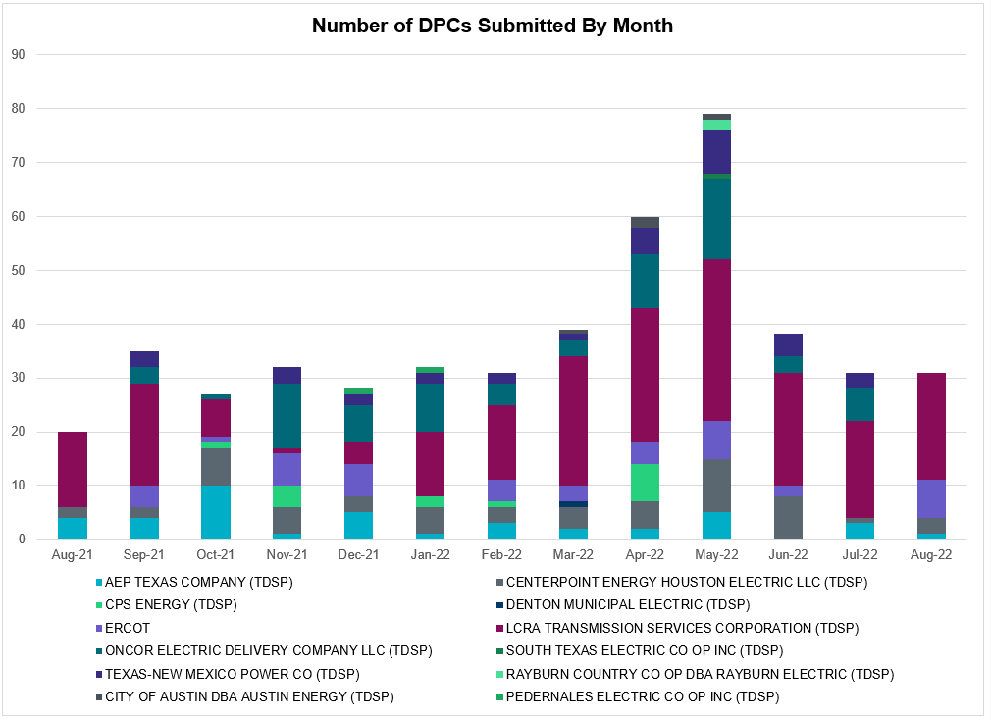

Transmission Operator | Number of DPCs
AEP TEXAS COMPANY (TDSP) | 1
BRAZOS ELECTRIC POWER CO OP INC (TDSP) | 0
BROWNSVILLE PUBLIC UTILITIES BOARD (TDSP) | 0
BRYAN TEXAS UTILITIES (TDSP) | 0
CENTERPOINT ENERGY HOUSTON ELECTRIC LLC (TDSP) | 3
CITY OF AUSTIN DBA AUSTIN ENERGY (TDSP) | 0
CITY OF COLLEGE STATION (TDSP) | 0
CITY OF GARLAND (TDSP) | 0
CPS ENERGY (TDSP) | 0
DENTON MUNICIPAL ELECTRIC (TDSP) | 0
ELECTRIC TRANSMISSION TEXAS LLC (TDSP) | 0
ERCOT | 7
LCRA TRANSMISSION SERVICES CORPORATION (TDSP) | 20
LONE STAR TRANSMISSION LLC (TSP) | 0
ONCOR ELECTRIC DELIVERY COMPANY LLC (TDSP) | 0
PEDERNALES ELECTRIC CO OP INC (TDSP) | 0
RAYBURN COUNTRY CO OP DBA RAYBURN ELECTRIC (TDSP) | 0
SHARYLAND UTILITIES LP (TDSP) | 0
SOUTH TEXAS ELECTRIC CO OP INC (TDSP) | 0
TEXAS MUNICIPAL POWER AGENCY (TDSP) | 0
TEXAS-NEW MEXICO POWER CO (TDSP) | 0

Appendix A: Real-Time Constraints
The following is a complete list of constraints activated in SCED. Full contingency descriptions can be found in the Standard Contingencies List located on the MIS secure site at Grid Generation Reliability Unit Commitment.

Year | Month of the Year | Contingency Name | Overloaded Element | From Station | To Station | Count of Days
2022 | 8 | BASE CASE | NE_LOB | n/a | n/a | 25
2022 | 8 | DELMSAN5 | PAWNEE_SPRUCE_1 | PAWNEE | CALAVERS | 24
2022 | 8 | DELMSAN5 | PAWNEE_SPRUCE_1 | CALAVERS | PAWNEE | 24
2022 | 8 | BASE CASE | ARAGORN_TIE_1 | ARAGORN | PINNAC | 22
2022 | 8 | SLAQLOB8 | BRUNI_69_1 | BRUNI | BRUNI | 20
2022 | 8 | SLOBSA25 | LARDVN_LASCRU1_1 | LARDVNTH | LASCRUCE | 18
2022 | 8 | SLGEI_D8 | I_DUPS_LGE1_1 | I_DUPSW | LGE | 17
2022 | 8 | SLGEI_D8 | I_DUPS_LGE1_1 | LGE | I_DUPSW | 17
2022 | 8 | BASE CASE | NELRIO | n/a | n/a | 17
2022 | 8 | BASE CASE | BEEVIL_CHARTE1_1 | CHARTER | BEEVILLE | 17
2022 | 8 | SLAQLOB8 | FALFUR_PREMON1_1 | FALFUR | PREMONT | 16
2022 | 8 | SNATBEA8 | 6144__A | BSPRW | STASW | 14
2022 | 8 | MXFL1C58 | 6462__C | MCNSW | MKNGB | 13
2022 | 8 | MHARNED5 | BURNS_RIOHONDO_1 | RIOHONDO | MV_BURNS | 11
2022 | 8 | SN_SAJO5 | LASPUL_RAYMND1_1 | LASPULGA | RAYMND2 | 11
2022 | 8 | STANPAW5 | BEEVIL_NORMAN1_1 | BEEVILLE | NORMANNA | 8
2022 | 8 | DMOLLO58 | PAWNEE_TANGO1_1 | TANGO | PAWNEE | 8
2022 | 8 | BASE CASE | BRIGHT_CHARTE1_1 | BRIGHTSD | CHARTER | 8
2022 | 8 | DWPWFCK5 | STPWAP39_1 | STP | WAP | 6
2022 | 8 | SGRICOL5 | PAWNEE_TANGO1_1 | TANGO | PAWNEE | 6
2022 | 8 | DWAP_JN5 | OB_WAP99_A | WAP | OB | 6
2022 | 8 | MMDLMOS5 | 6462__C | MCNSW | MKNGB | 6
2022 | 8 | DWPWFWP5 | STPWAP39_1 | STP | WAP | 6
2022 | 8 | SFTLMES8 | CROSSO_SANTAR1_1 | CROSSOVE | SANTARIT | 5
2022 | 8 | SOXYIN28 | I_DUPP_I_DUPS1_1 | I_DUPP1 | I_DUPSW | 5
2022 | 8 | SLOBSA25 | CATARI_PILONC1_1 | CATARINA | PILONCIL | 5
2022 | 8 | DWAP_JN5 | OB_WAP98_A | WAP | OB | 5
2022 | 8 | SJNWA1P5 | OB_WAP98_A | WAP | OB | 5
2022 | 8 | SLOBSA25 | BRUNI_69_1 | BRUNI | BRUNI | 5
2022 | 8 | SOBWAP5 | OB_WAP98_A | WAP | OB | 5
2022 | 8 | SDIMBEV8 | HAMILT_MAVERI1_1 | HAMILTON | MAVERICK | 5
2022 | 8 | SKLELOY8 | LOYOLA_69_1 | LOYOLA | LOYOLA | 5
2022 | 8 | BASE CASE | VALEXP | n/a | n/a | 5
2022 | 8 | DWHILON5 | BEEVIL_NORMAN1_1 | BEEVILLE | NORMANNA | 5
2022 | 8 | DDUPHE18 | I_DUPS_MCCAMP2_1 | I_DUPSW | MCCAMPBE | 5
2022 | 8 | SLOBSA25 | CATARI_PILONC1_1 | PILONCIL | CATARINA | 5
2022 | 8 | SBTPBNT8 | MYRA_VAL_1 | MYRA | VALYVIEW | 4
2022 | 8 | SMADSAP8 | MADDUX_SAPOWE2_1 | MADDUX | SAPOWER | 4
2022 | 8 | BASE CASE | TRDWEL | n/a | n/a | 4
2022 | 8 | DWISALV8 | MYRA_VAL_1 | MYRA | VALYVIEW | 4
2022 | 8 | SBRAUVA8 | HAMILT_MAVERI1_1 | HAMILTON | MAVERICK | 4
2022 | 8 | DWHILON5 | PAWNEE_TANGO1_1 | TANGO | PAWNEE | 4
2022 | 8 | SALIKIN8 | FALFUR_PREMON1_1 | FALFUR | PREMONT | 4
2022 | 8 | DCPSST58 | 651__B | CMNSW | CMNTP | 3
2022 | 8 | SILLFTL8 | HAMILT_MAXWEL1_1 | MAXWELL | HAMILTON | 3
2022 | 8 | DCAGCI58 | BERGHE_AT1L | BERGHE | BERGHE | 3
2022 | 8 | DHWIND89 | MORRIS_NUECES1_1 | NUECES_B | MORRIS | 3
2022 | 8 | DTOKJK_5 | 260_A_1 | JEWET | SNG | 3
2022 | 8 | DKENNO89 | COLETO_ROSATA1_1 | COLETO | ROSATA | 3
2022 | 8 | SBIGSCH5 | CROSSO_SANTAR1_1 | CROSSOVE | SANTARIT | 3
2022 | 8 | SLOBSA25 | FALFUR_PREMON1_1 | FALFUR | PREMONT | 3
2022 | 8 | DCAGCI58 | BERGHE_AT1H | BERGHE | BERGHE | 3
2022 | 8 | DCAGCO58 | BERGHE_AT1L | BERGHE | BERGHE | 3
2022 | 8 | SKINFAL8 | FALFUR_PREMON1_1 | FALFUR | PREMONT | 3
2022 | 8 | SCOLBAL8 | BALLIN_HUMBLT1_1 | BALLINGE | HUMBLTAP | 3
2022 | 8 | DSTNCPS8 | OLS_CLIF_1 | OLSEN | CLIFTON1 | 3
2022 | 8 | DCAGCO58 | 583T583_1 | BANDER | MASOCR | 3
2022 | 8 | DCAGCO58 | BERGHE_AT1H | BERGHE | BERGHE | 3
2022 | 8 | DLYTTUR8 | CKT_943_1 | LYTTON_S | PILOT | 3
2022 | 8 | SCMNCPS5 | 651__B | CMNSW | CMNTP | 3
2022 | 8 | DVENLIG5 | 530__C | VENSW | BRTRD | 2
2022 | 8 | XRN2K58 | RNKSW_MR2H | RNKSW | RNKSW | 2
2022 | 8 | SN_SAJO5 | FALFUR_PREMON1_1 | FALFUR | PREMONT | 2
2022 | 8 | XTRS258 | 1920__B | ATHNS | TRNDD | 2
2022 | 8 | DBUCKLN5 | 651__B | CMNSW | CMNTP | 2
2022 | 8 | DELMSAN5 | BEEVIL_NORMAN1_1 | BEEVILLE | NORMANNA | 2
2022 | 8 | MHARNED5 | HAINE__LA_PAL1_1 | LA_PALMA | HAINE_DR | 2
2022 | 8 | DWHILON5 | NCARBI_SEADRF1_1 | SEADRFTC | NCARBIDE | 2
2022 | 8 | SLOBSA25 | ASHERT_CATARI1_1 | ASHERTON | CATARINA | 2
2022 | 8 | DHJWFCK5 | STPWAP39_1 | STP | WAP | 2
2022 | 8 | DBIGKEN5 | TREADW_YELWJC1_1 | TREADWEL | YELWJCKT | 2
2022 | 8 | DKENCA58 | 255T279_1 | PIPECR | MEDILA | 2
2022 | 8 | DMGSBTR5 | 6036__A | TKWSW | MGSES | 2
2022 | 8 | SODLBRA8 | HAMILT_MAVERI1_1 | HAMILTON | MAVERICK | 2
2022 | 8 | XRNK58 | RNKSW_MR1L | RNKSW | RNKSW | 2
2022 | 8 | DHILMAR5 | 361T361_1 | SCHERT | PARKWA | 2
2022 | 8 | DBIGKEN5 | HAMILT_MAXWEL1_1 | MAXWELL | HAMILTON | 2
2022 | 8 | SFORYEL8 | HEXT_MASONS1_1 | HEXT | MASONSW | 2
2022 | 8 | SJNWA1P5 | OB_WAP99_A | WAP | OB | 2
2022 | 8 | SBE2ASH8 | TURTLECK_WCRYS_1 | TURTLCRK | WCRYSTS | 2
2022 | 8 | BASE CASE | WESTEX | n/a | n/a | 2
2022 | 8 | DCDHMCS8 | 3160__A | CDCSW | OKCLS | 2
2022 | 8 | SDI2DIL9 | DILLEYSW_69A1 | DILLEYSW | DILLEYSW | 2
2022 | 8 | SBRAUVA8 | ESCOND_GANSO1_1 | GANSO | ESCONDID | 2
2022 | 8 | SCENLOB5 | PAWNEE_TANGO1_1 | TANGO | PAWNEE | 2
2022 | 8 | DFERWIR8 | SANDCR_AT1 | SANDCR | SANDCR | 2
2022 | 8 | DBWNAMO5 | SAPOWE_SAST1_1 | SAPOWER | SAST | 2
2022 | 8 | DCAGCI58 | 255T279_1 | PIPECR | MEDILA | 2
2022 | 8 | DFERWIR8 | CORONA_AT4 | CORONA | CORONA | 2
2022 | 8 | DWHILON5 | MELONC_RINCON1_1 | RINCON | MELONCRE | 2
2022 | 8 | DCENRI35 | PAWNEE_TANGO1_1 | TANGO | PAWNEE | 2
2022 | 8 | SLOBSA25 | ASHERT_CATARI1_1 | CATARINA | ASHERTON | 2
2022 | 8 | DTRIASH8 | 211T147_1 | GILLCR | MCNEIL_ | 1
2022 | 8 | DGRMGRS8 | 6830__B | CRDSW | OLNEY | 1
2022 | 8 | SPEBTRU8 | 940__C | ENWSW | WXHCH | 1
2022 | 8 | DMCOPHA8 | AZTECA_HEC1_1 | HEC | AZTECA | 1
2022 | 8 | DKENCA58 | BERGHE_AT1H | BERGHE | BERGHE | 1
2022 | 8 | DWHILON5 | CALLIC_LON_HI1_1 | LON_HILL | CALLICOA | 1
2022 | 8 | SMCEABS8 | CAPELL_MERK1_1 | CAPELLA | MERK | 1
2022 | 8 | SWRDYN8 | DA_WC_89_A | WC | DA | 1
2022 | 8 | SODLBRA8 | ESCOND_GANSO1_1 | GANSO | ESCONDID | 1
2022 | 8 | SBE2ASH8 | HAMILT_MAVERI1_1 | HAMILTON | MAVERICK | 1
2022 | 8 | SBRAHAM8 | HAMILT_MAVERI1_1 | HAMILTON | MAVERICK | 1
2022 | 8 | SI_DWH38 | HECKER_I_DUPS2_1 | I_DUPSW | HECKER | 1
2022 | 8 | SHOLWES8 | HOLLY4_SOUTH_1_1 | HOLLY4 | SOUTH_SI | 1
2022 | 8 | DELMSAN5 | MAGRUD_VICTOR2_1 | VICTORIA | MAGRUDER | 1
2022 | 8 | SSANFOW5 | ASHERT_CATARI1_1 | CATARINA | ASHERTON | 1
2022 | 8 | DKENNO89 | MAGRUD_VICTOR2_1 | VICTORIA | MAGRUDER | 1
2022 | 8 | DODESLT8 | PECNGRV_TALLCY_1 | TALLCITY | PECN_GRV | 1
2022 | 8 | SHCKRNK5 | 106__A | HCKSW | ALLNC | 1
2022 | 8 | DMBDRKC5 | 651__B | CMNSW | CMNTP | 1
2022 | 8 | DCAGTA58 | BERGHE_AT1L | BERGHE | BERGHE | 1
2022 | 8 | DSTEXP12 | BLESSI_LOLITA1_1 | LOLITA | BLESSING | 1
2022 | 8 | DCOLFA59 | CALLIC_LON_HI1_1 | LON_HILL | CALLICOA | 1
2022 | 8 | STANPAW5 | CALLIC_LON_HI1_1 | LON_HILL | CALLICOA | 1
2022 | 8 | BASE CASE | CULBSN | n/a | n/a | 1
2022 | 8 | DVICEDN8 | LOOP_VICTORIA_1 | VICTORIA | L_463S | 1
2022 | 8 | SBRAUVA8 | MAXWEL_WHITIN1_1 | MAXWELL | WHITING | 1
2022 | 8 | DWHILON5 | MELONC_SEADRF1_1 | MELONCRE | SEADRFTC | 1
2022 | 8 | STANPAW5 | NCARBI_SEADRF1_1 | SEADRFTC | NCARBIDE | 1
2022 | 8 | SMVRLA_8 | STEWAR_VERTRE1_1 | STEWART | VERTREES | 1
2022 | 8 | DCAGCI58 | 388T388_1 | HAYSEN | ZORN | 1
2022 | 8 | BASE CASE | BEEVIL_NORMAN1_1 | BEEVILLE | NORMANNA | 1
2022 | 8 | DCOLFA59 | BEEVIL_NORMAN1_1 | BEEVILLE | NORMANNA | 1
2022 | 8 | SCO2EUL8 | BEEVIL_NORMAN1_1 | BEEVILLE | NORMANNA | 1
2022 | 8 | DKENCA58 | BERGHE_AT1L | BERGHE | BERGHE | 1
2022 | 8 | SHONMOO8 | BIG_FO_MOORE1_1 | MOORE | BIG_FOOT | 1
2022 | 8 | SBONNED5 | BURNS_RIOHONDO_1 | RIOHONDO | MV_BURNS | 1
2022 | 8 | XCAG158 | CAGNON_MR4H | CAGNON | CAGNON | 1
2022 | 8 | BASE CASE | N_TO_H | n/a | n/a | 1
2022 | 8 | DCENREV5 | PAWNEE_TANGO1_1 | TANGO | PAWNEE | 1
2022 | 8 | DLWSRNK5 | W_DENT_T2H | W_DENT | W_DENT | 1
2022 | 8 | SCMNCPS5 | 651__C | CMNTP | SHILO | 1
2022 | 8 | DHENZOR8 | 85T329_1 | BERGHE | DEVIHI | 1
2022 | 8 | SHILMCC8 | 85T329_1 | BERGHE | DEVIHI | 1
2022 | 8 | BASE CASE | BEARKT | n/a | n/a | 1
2022 | 8 | DSTPANS5 | BEEVIL_NORMAN1_1 | BEEVILLE | NORMANNA | 1
2022 | 8 | SMCEABS8 | CAPELL_MERK1_1 | MERK | CAPELLA | 1
2022 | 8 | DABPAB98 | CONAN_SANA1_1 | SANA_TAP | CONAN | 1
2022 | 8 | SAIRNCA8 | GRETA_REFUGI1_1 | REFUGIO | GRETA | 1
2022 | 8 | SI_DWHI8 | I_DUPS_MCCAMP2_1 | I_DUPSW | MCCAMPBE | 1
2022 | 8 | DDUPHE28 | RINCON_WHITE_2_1 | RINCON | WHITE_PT | 1
2022 | 8 | DCAGCO58 | 388T388_1 | HAYSEN | ZORN | 1
2022 | 8 | SMCCRAT8 | 445T445_1 | HILLTO | STRAHAT1 | 1
2022 | 8 | SCO2EUL8 | COLETO_ROSATA1_1 | COLETO | ROSATA | 1
2022 | 8 | SBRAHAM8 | ESCOND_GANSO1_1 | GANSO | ESCONDID | 1
2022 | 8 | DODESLT8 | PECNGRV_SMIDLA_1 | PECN_GRV | SMIDLAND | 1
2022 | 8 | DWLFHLJ5 | STPWAP39_1 | STP | WAP | 1
2022 | 8 | STENCR28 | TEN_KEN_1 | TEN | KEN | 1
2022 | 8 | DHARSOM8 | V2_Z5_1 | Z5 | V2 | 1
2022 | 8 | DCAGTA58 | 388T388_1 | HAYSEN | ZORN | 1
2022 | 8 | DKENCA58 | 388T388_1 | HAYSEN | ZORN | 1
2022 | 8 | SBCESND5 | 421__A | BCESW | SNDSW | 1
2022 | 8 | DBUCBWN5 | 651__B | CMNSW | CMNTP | 1
2022 | 8 | SCM2DCS8 | 805__A | DCSES | CMBSW | 1
2022 | 8 | SDUKNE28 | ADERHO_HEC1_1 | HEC | ADERHOLD | 1
2022 | 8 | SBGLTWI8 | CONCHO_SANW0_1 | CONCHO | SANW | 1
2022 | 8 | DSHEIN89 | CORONA_AT4 | CORONA | CORONA | 1
2022 | 8 | SBE2ASH8 | ESCOND_GANSO1_1 | GANSO | ESCONDID | 1
2022 | 8 | MHARNED5 | LASPUL_RAYMND1_1 | LASPULGA | RAYMND2 | 1
2022 | 8 | SMCEABS8 | MKLT_TRNT1_1 | TRNT | MKLT | 1
2022 | 8 | DWISALV8 | SPR_VALY_1 | VALYVIEW | SPR | 1
2022 | 8 | STENCR28 | TEN_CRD1_1 | TEN | CRD | 1
2022 | 8 | DSALHUT5 | 1710__C | BELCNTY | SALSW | 1
2022 | 8 | SGDNTEL5 | 6094__B | ANDNR | MSTNG | 1
2022 | 8 | DMGSMDS5 | 6512__B | ODEHV | TROTP | 1
2022 | 8 | SILLFTL8 | CARVER_TINSLE1_1 | CARVER | TINSLEY | 1
2022 | 8 | SSANFOW5 | CATARI_PILONC1_1 | PILONCIL | CATARINA | 1
2022 | 8 | SDESMEV8 | CROSSO_SANTAR1_1 | CROSSOVE | SANTARIT | 1
2022 | 8 | SBIGOR55 | TREADW_YELWJC1_1 | TREADWEL | YELWJCKT | 1

Current Wind Generation Record: 27,044 MW on 05/29/2022 at 22:36 | Current Wind Penetration Record: 69.15% on 04/10/2022 at 01:43 Current Solar Generation Record: 9,928 MW on 08/08/2022 at 10:56 | Current Solar Penetration Record: 23.85% on 03/19/2022 at 13:41
This is the hourly integrated peak demand as published in the ERCOT D&E report.

