**TDTMS**

**August 25th, 2022**

**WebEx only**

|  |  |  |  |  |  |
| --- | --- | --- | --- | --- | --- |
| Attendee | Company | Attendee | Company | Attendee | Company |
| Diana Rehfeldt | TNMP | Dave Michelson | ERCOT | Kyle Patrick | NRG |
| Sam Pak | Oncor | Tammy Stewart | ERCOT | Monica Jones | CNP |
| Crystal Diaz | Constellation | Mick Hanna | ERCOT | Eric Lotter | GridMonitor |
| Sheri Wiegand* | Vistra | Mark Ruane | ERCOT | Kathy Scott | CNP |
| Holly Bohart | Constellation | Brittney Albracht | ERCOT | Carolyn Reed | CNP |
| Dee Lowere | NRG | Kathryn Thurman | ERCOT | Bill Snyder | AEP |
| John Schatz | Vistra | Erin Waskik-Guitierrez | ERCOT | Jesse Macias | AEP |
| Jim Lee | CNP | Chuck Costello | Siemens | Tomas Fernandez | NRG |

**Antitrust/Minutes**

* Antitrust Admonition was read by Sheri Wiegand
  + Updated minutes from 7/21/22 were reviewed and approved. ACTION: Sheri will submit for posting.

**ERCOT System Instances & MarkeTrak Monthly Performance Review**

* Mick presented **June and July performance reports** - ERCOT has met SLA targets yet remains below the annual target. Hoping to get back on track in September with no extended outages in Q3
* MarkeTrak response times remain solid, particularly since the recent upgrade

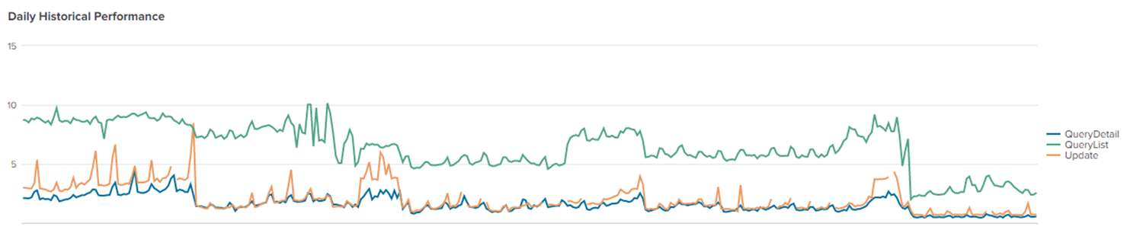

* **Listserv activity** – Mick has been tracking email auto-deletes and deletes from the Weather Moratorium listserv and will continue to monitor. Auto-deletes occur when email address receives 20 bounce-backs within 10 days. Also to note, it was thought “full mailboxes” will not receive the market notices of un-subscription warnings. ACTION: Mick will confirm. Market participants with previous issues have not received reports of internal deletions.

**MarkeTrak Upgrade and Stabilization**

* Tammy Stewart reminded WG four issues surfaced post MT upgrade – 2 have been resolved and the 2 remaining are wrapping up testing and will be put into production soon.
  + New Users and Search functionality
  + Bulk Insert Template for Usage & Billing – Dispute properly loading

**SCR 815 – MarkeTrak Administrative Changes (December 2022)**

* Tammy explained User’s Guide and on-line modules are being updated and will be available when functionality is placed in RMTE around mid to late October 2022.
* GO LIVE remains planned for 12/5.
* WSDL changes for API users will be available mid-October as well.
* TRAINING DATES: initial training workshops are slated for 11/16 (possibly during or after TDTMS meeting) and 11/30, allowing ~ one week prior to implementation.
* Tammy explained one correction was needed with the condensing of the rolodex escalation contacts. Five categories were originally discussed; however, it is recommended the Load Profile Assignment category remain as well. There were no objections from the group. Also, the default names for all contacts will be the MT Admin names with a call to action for all REPs to “clean up” rolodex with appropriate contacts.

**RMGRR – TXSET/MCT for Use of Market Rule Subtype to Cancel a Pending CSA Add**

During an earlier Market Coordination Team (MCT) meeting, it was suggested to use the MarkeTrak subtype Market Rule to cancel a pending CSA Add transaction. In doing so, the group decided the code to be used would be **CSACAN.**

The RMGRR documenting the change will be included in the overall RMGRR for TXSET 5.0 changes needed post development with “pens down” 11/1.

**Review of DRAFT RMGRR Inadvertent Gain Process Update**

Sheri presented a DRAFT RMGRR with proposed changes to the Inadvertent Gain Process. Sheri explained four REPs had collaborated on the language. A few edits were made and noted on the attached DRAFT version.



Sheri will again present to RMS after documenting the description and business case of the RR. One clarification made during the meeting was around the market communication should a CR experience a system processing issue impacting 100+ ESIs. The REPs explained the proposed process for TXSET v5.0 would not change, and the notification is simply a courtesy to other market participants explaining the issue to allow for better transparency and swift resolution of the issues.

**SCR 817 MarkeTrak Validations –**

**Unexecutable Reasons**

It was decided to move the Unexecutable Reasons (Switch Hold & Cancel w/Approval) change from SCR815 to SCR817 due to additional discussion needed for the drop-down reasons. A group of TSDP representatives met to review the appropriate reasons.

Cancel W/ Approval

It was confirmed the Unexecutable function does not exist for Cancel w/Approval subtype and the following reasons will be used for ‘Unable to Cancel’ functionality:

* Per ERCOT Protocols Section 15.1.8, the CR must send an 814_08 Cancel Request unless there is a system outage and the CR is unable to send/receive TXSET EDI transactions
* Incorrect ESI ID Provided
* ESI ID Not Provided
* Transaction does not exist in TDU’s system
* Incorrect Orig Tran ID provided

Switch Hold

After discussion, the decision was made to keep the existing reasons as shown below, however, if *Documentation Invalid/Incomplete* was selected, a supplementary drop down would be required with the following options:

* + Incorrect or missing documents
  + Illegible supporting documents
  + Address not listed on documents
  + Missing phone number on NOS
  + Signatures missing on the lease agreement
  + Address on the lease does not match the service address
  + The name on the lease does not match NOS
  + ESI ID listed does not match TDU CIS system
  + ESI ID not listed on NOS
  + New customer is same as current tenant

The group prefers the supplementary drop down, however, if not feasible, *Comments* would be required with the choice of *Documentation Invalid/Incomplete.*

**IA &CR codes**

Tammy was questioning the workflow on the MT when the “ready to receive” functionality is removed for TDSPs to retain visibility of the MT, yet no action is required. ACTION: Sheri indicated a workflow was developed earlier and would forward to Tammy for review. FOLLOW UP: the workflow diagram did not detail the MT flow once Gaining and Losing CRs agree on regain date.

The discussion will be taken up at the next MCT or TDTMS meeting.

**NEXT MEETING scheduled – September 22nd @ 9:30AM WebEx only**

1. ERCOT Updates
   1. System Instances & MT Performance
   2. Listserv
   3. Marketrak Upgrade Stabilization
2. SCR 817 – MarkeTrak Validations follow up
3. RMGRR Draft Inadvertent Gain Process Update