July 2022 ERCOT Monthly Operations Report
Reliability and Operations Subcommittee Meeting
September 1, 2022

Table of Contents
1. Report Highlights 2
2. Frequency Control 3
2.1. Frequency Events 3
2.2. Responsive Reserve Events 4
2.3. Load Resource Events 4
3. Reliability Unit Commitment 4
4. IRR, Wind, and Solar Generation as a Percent of Load 8
5. Largest Net-Load Ramps 10
6. COP Error Analysis 10
7. Congestion Analysis 13
7.1. Notable Constraints 13
7.2. Generic Transmission Constraint Congestion 18
7.3. Manual Overrides 18
7.4. Congestion Costs for Calendar Year 2022 19
8. System Events 20
8.1. ERCOT Peak Load 20
8.2. Load Shed Events 20
8.3. Stability Events 20
8.4. Notable PMU Events 21
8.5. DC Tie Curtailment 21
8.6. TRE/DOE Reportable Events 21
8.7. New/Updated Constraint Management Plans 21
8.8. New/Modified/Removed RAS 21
8.9. New Procedures/Forms/Operating Bulletins 21
9. Emergency Conditions 22
9.1. OCNs 22
9.2. Advisories 22
9.3. Watches 22
9.4. Emergency Notices 22
10. Application Performance 23
10.1. TSAT/VSAT Performance Issues 23
10.2. Communication Issues 23
10.3. Market System Issues 23
11. Model Updates 23
Appendix A: Real-Time Constraints 26

Report Highlights
- The unofficial ERCOT peak load for the month was 80,038 MW and occurred on 07/20/2022, during hour ending 17:00. Prior to this year, the peak usage for the month of July was 73,098 MW set on 7/26/2021.
- There were 3 frequency events.
- There was 1 instance where Responsive Reserves was deployed.
- There were public Conservation Appeals on 7/11/2022 and 7/13/2022.
- On 07/13, ERS Deployment and Distribution Voltage Reduction implemented.
- There were 130 HRUC commitments.
- There were 31 days of congestion on the North Edinburg to Lobo GTC, 30 days on the Nelson Sharpe to Rio Hondo GTC, 9 days on the West Texas Export GTC, 4 days on the Treadwell GTC, and 3 days on the Valley Export GTC. There was no activity on the remaining GTCs during the month. There were no DC Tie Curtailments.
- A PVGR Generation Record of 9,828 MW was set on 07/26/2022 at 11:32.

Frequency Control

Frequency Events
The ERCOT Interconnection experienced 3 frequency events, which resulted from units’ trips. The average event duration was 00:05:40.

A summary of the frequency events is provided below. The reported frequency events meet one of the following criteria: Delta Frequency is 60 mHz or greater; the MW loss is 350 MW or greater; resource trip event triggered RRS deployment. Frequency events that have been identified as Frequency Measurable Events (FME) for purposes of BAL-001-TRE-2 analysis are highlighted in blue. When analyzing frequency events, ERCOT evaluates PMU data according to industry standards. Events with an oscillating frequency of less than 1 Hz are inter-area, while higher frequencies indicate local events. Industry standards specify that damping ratio for inter-area oscillations should be 3.0% or greater. For the frequency events listed below, the ERCOT system met these standards and transitioned well after each disturbance. In the case of negative delta frequency, the MW Loss column could refer to load loss.

Date and Time | Delta Frequency | Max/Min Frequency | Duration of Event | PMU Data |  | MW Loss | Load | IRR | Inertia
 | (Hz) | (Hz) |  | Oscillation Mode (Hz) | Damping Ratio |  | (MW) | % | (MW-s)
07/11/2022 6:27:53 | 0.066 | 59.939 | 00:05:56 | 0.62 | 10% | 435.16 | 51,241 | 10% | 353,888
07/25/2022 7:36:33 | 0.091 | 59.928 | 00:04:51 | 0.62 | 12% | 549.19 | 51,285 | 30% | 286,659
07/27/2022 1:17:48 | 0.106 | 59.909 | 00:06:13 | 0.75 | 11% | 517 | 55,404 | 36% | 274,756

(Note: All data on this graph encompasses frequency event analysis based on BAL-001-TRE-1.)

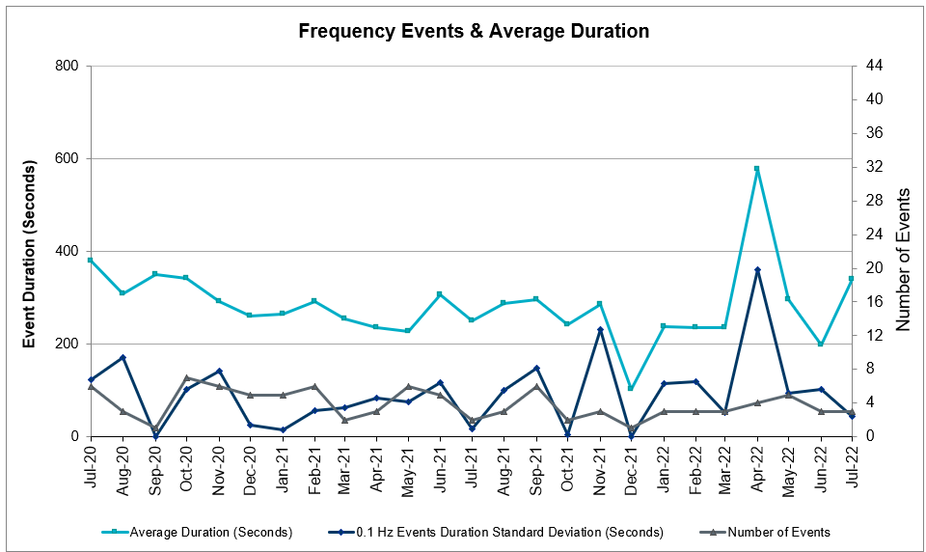

Responsive Reserve Events
There was 1 event where Responsive Reserve MWs were released to SCED. The events highlighted in blue were related to frequency events reported in Section 2.1 above.

Date and Time Released to SCED | Date and Time Recalled | Duration of Event | Maximum MWs Released | Comments
07/13/2022 15:16:04 | 07/13/2022 16:42:04 | 01:26:00 | 500 | Operator manually released

Load Resource Events
None.

Reliability Unit Commitment
ERCOT reports on Reliability Unit Commitments (RUC) monthly. Commitments are grouped by operating day and weather zone. The total number of hours committed is the sum of the hours for all the units in the specified region. Additional information on RUC commitments can be found on the MIS secure site at Grid Generation Reliability Unit Commitment.

There were no DRUC commitments.

There were 130 HRUC commitments

Resource Location | # of Resources | Operating Day | Total # of Hours Committed | Total MWhs | Reason for Commitment
COAST, EAST, NORTH, NORTH_CENTRAL, SOUTH_CENTRAL, SOUTHERN | 10 | 07/01/2022 | 111 | 26,983.5 | MIN RUN TIME, System Capacity
NORTH_CENTRAL, SOUTH_CENTRAL, SOUTHERN | 10 | 07/02/2022 | 90 | 22,564.0 | MIN RUN TIME, System Capacity
NORTH_CENTRAL | 1 | 07/03/2022 | 24 | 4,992.0 | MIN RUN TIME
EAST, NORTH_CENTRAL, SOUTH_CENTRAL, SOUTHERN | 12 | 07/06/2022 | 91 | 20,403.0 | MIN RUN TIME, System Capacity
EAST, NORTH_CENTRAL | 8 | 07/07/2022 | 86 | 21,752.0 | MIN RUN TIME, System Capacity
EAST, FAR_WEST, NORTH_CENTRAL | 5 | 07/08/2022 | 11 | 2,464.0 | System Capacity
EAST, FAR_WEST, NORTH_CENTRAL | 5 | 07/09/2022 | 23 | 5,085.0 | System Capacity
FAR_WEST, NORTH_CENTRAL | 3 | 07/10/2022 | 9 | 1,586.0 | System Capacity
FAR_WEST | 1 | 07/11/2022 | 8 | 1,068.0 | System Capacity
EAST, NORTH_CENTRAL | 5 | 07/12/2022 | 47 | 14,560.0 | System Capacity
EAST, NORTH_CENTRAL | 4 | 07/13/2022 | 22 | 8,024.0 | System Capacity
EAST, NORTH_CENTRAL | 4 | 07/15/2022 | 20 | 6,310.0 | System Capacity
NORTH_CENTRAL | 3 | 07/16/2022 | 15 | 5,289.0 | System Capacity
FAR_WEST, NORTH, NORTH_CENTRAL, SOUTH_CENTRAL | 6 | 07/17/2022 | 38 | 9,270.7 | System Capacity
EAST | 1 | 07/18/2022 | 8 | 1,888.0 | System Capacity
EAST | 1 | 07/19/2022 | 7 | 3,514.0 | System Capacity
EAST, NORTH_CENTRAL | 4 | 07/20/2022 | 19 | 5,577.0 | System Capacity
EAST, NORTH_CENTRAL, SOUTH_CENTRAL | 6 | 07/21/2022 | 38 | 12,703.0 | System Capacity
EAST, NORTH_CENTRAL | 4 | 07/22/2022 | 15 | 5,249.0 | System Capacity
EAST, NORTH_CENTRAL, SOUTH_CENTRAL | 4 | 07/24/2022 | 15 | 3,741.0 | System Capacity
EAST, NORTH_CENTRAL, SOUTHERN | 5 | 07/25/2022 | 19 | 6,814.0 | System Capacity
EAST, NORTH_CENTRAL, SOUTH_CENTRAL | 7 | 07/26/2022 | 41 | 13,045.0 | System Capacity
EAST, NORTH_CENTRAL | 5 | 07/27/2022 | 40 | 10,854.5 | System Capacity
EAST, NORTH_CENTRAL | 6 | 07/28/2022 | 51 | 16,327.5 | System Capacity
EAST, NORTH_CENTRAL, SOUTH_CENTRAL | 7 | 07/29/2022 | 49 | 14,766.5 | System Capacity
EAST, NORTH_CENTRAL, SOUTH_CENTRAL | 5 | 07/30/2022 | 30 | 10,750.0 | System Capacity
NORTH_CENTRAL | 1 | 07/31/2022 | 2 | 784.0 | System Capacity

IRR, Wind, and Solar Generation as a Percent of Load
The graph below shows the maximum, minimum and average aggregate solar, wind and IRR output as a percentage of total ERCOT load when evaluated as 10-minute averaged intervals, over the past 13 months. Current wind and solar generation and penetration records are listed in the footnote below. Maximum IRR penetration for the month was 49% on 07/04/2022 interval ending 09:30 and minimum IRR penetration for the month was 6.2% on 07/13/2022 interval ending 06:50.

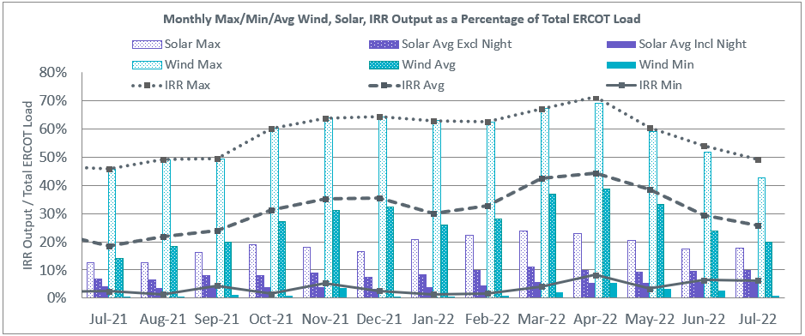

During the hour of peak load for the month, hourly integrated wind generation was 7,370 MW and solar generation was 8,079 MW. The graph below shows the wind, solar, and combined IRR penetration percentage during the hour of the peak load in the last 13 months.

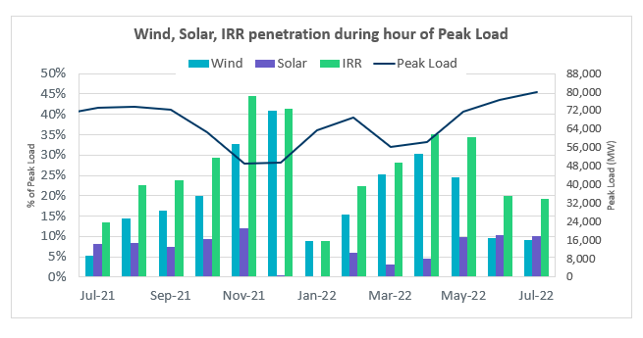

Lastly, the graph below shows the minimum wind, solar and IRR output during the peak load hour as a percentage of the daily peak load for every day in the month.

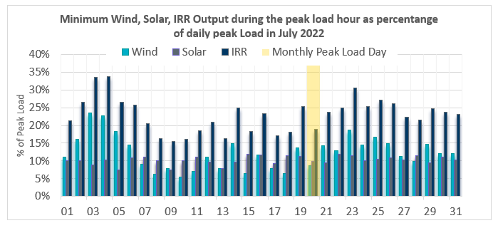

Largest Net-Load Ramps
The net-load ramp is defined as the change in net-load (load minus wind and PVGR generation) during the defined time horizon. Such a variation in net-load needs to be accommodated in grid operations to ensure that the reliability of the grid is satisfactorily maintained. The largest net-load ramp during 5-min, 10-min, 15-min, 30-min and 60-min in July 2022 was 1,284 MW, 1,822 MW, 2,413 MW, 4,376 MW, and 7,867 MW, respectively. The comparison with respect to the historical values is given in the table below.

Month and Year | 5 min | 10 min | 15 min | 30 min | 60 min
July 2014 | 1,074 MW | 1,424 MW | 1,713 MW | 2,809 MW | 5,392 MW
July 2015 | 905 MW | 1,257 MW | 1,688 MW | 3,075 MW | 5,843 MW
July 2016 | 863 MW | 1,660 MW | 1,885 MW | 3,390 MW | 5,900 MW
July 2017 | 880 MW | 1,243 MW | 1,756 MW | 3,048 MW | 5,738 MW
July 2018 | 1,399 MW | 1,779 MW | 2,202 MW | 3,572 MW | 6,698 MW
July 2019 | 1,120 MW | 1,699 MW | 2,291 MW | 3,561 MW | 6,546 MW
July 2020 | 1,399 MW | 1,779 MW | 2,291 MW | 3,572 MW | 6,698 MW
July 2021 | 859 MW | 1,464 MW | 1,804 MW | 3,352 MW | 6,132 MW
July 2022 | 1,284 MW | 1,822 MW | 2,413 MW | 4,376 MW | 7,867 MW
All months in 2014-2022 | 1,647 MW | 2,157 MW | 3,015 MW | 5,882 MW | 10,750 MW

COP Error Analysis
COP Error is calculated as the capacity difference between the COP HSL and real-time HSL of the unit. Mean Absolute Error (MAE) stayed over 16,000 MW until Day-Ahead at 12:00, then dropped significantly to 8,974 MW by Day-Ahead at 13:00 and to 2,486 MW by Day-Ahead at 14:00. In the following chart, Under-Scheduling Error indicates that COP had less generation capacity than real-time and Over-Scheduling Error indicates that COP had more generation capacity than real-time.
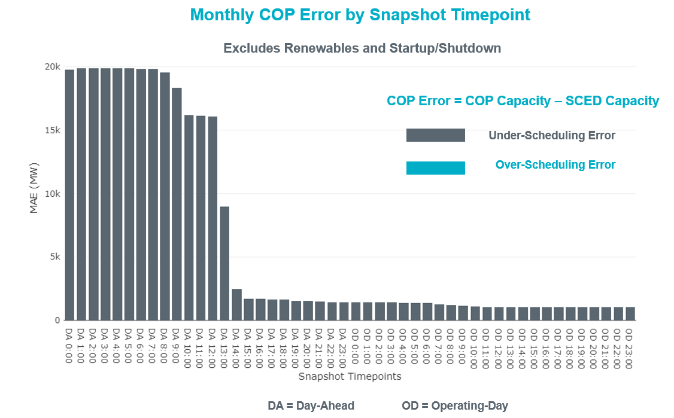

Monthly MAE for the latest COP at the end of the Adjustment Period was 1,052 MW with median ranging from -2,176 MW for Hour-Ending (HE) 17 to 456 MW for HE 8. HE 8 on 07/11//2022 had the largest Over-Scheduling Error (1,609 MW) and HE 21 on 07/18/2022 had the largest Under-Scheduling Error (-4,681 MW).

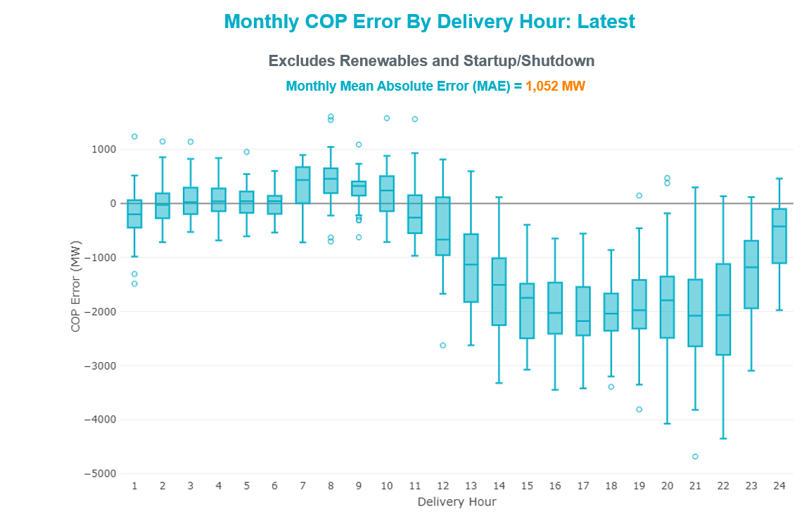

Monthly MAE for the Day-Ahead COP at 12:00 was 16,104 MW with median ranging from -22,593 MW for Hour-Ending (HE) 16 to -10,186 MW for HE 4. HE 17 on 07/01/2022 had the largest Under-Scheduling Error (-26,204 MW) and HE 7 on 07/23/2022 had the smallest Under-Scheduling Error (-4,515 MW).

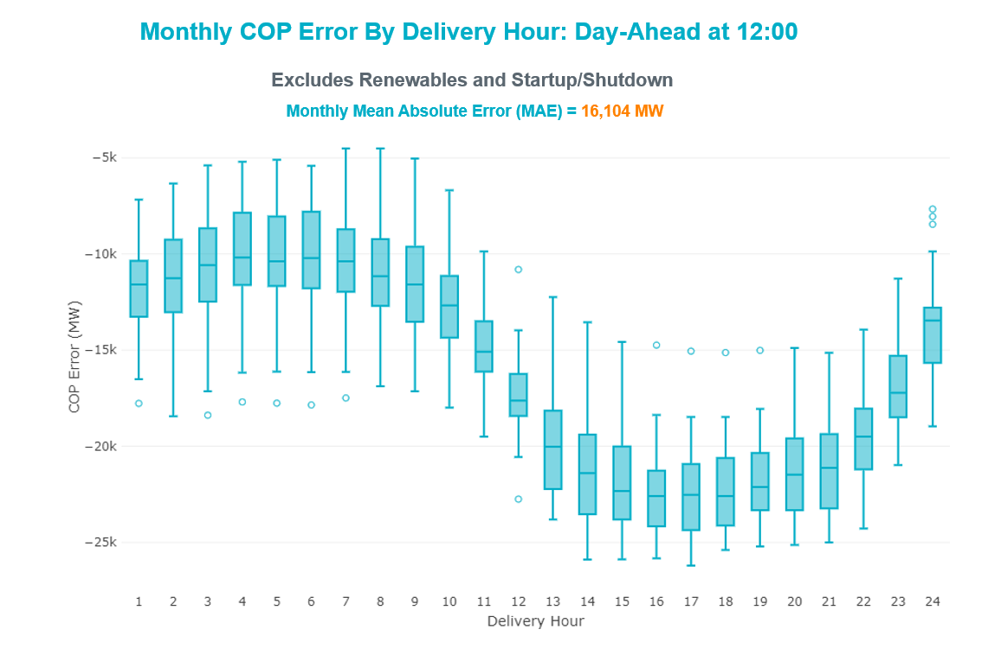

Congestion Analysis

Notable Constraints
Nodal protocol section 3.20 specifies that ERCOT shall identify transmission constraints that are binding in Real-Time three or more Operating Days within a calendar month. As part of this process, ERCOT reports congestion that meets this criterion to ROS. In addition, ERCOT also highlights notable constraints that have an estimated congestion rent exceeding $1,000 for a calendar month. These constraints are detailed in the table below, including approved transmission upgrades from TPIT that may provide some congestion relief based on ERCOT’s engineering judgement. Rows highlighted in blue indicate the congestion was affected by one or more outages. For a list of all constraints activated in SCED, please see Appendix A at the end of this report.

Contingency Name |  | Overloaded Element | # of Days Constraint Binding | Congestion Rent | Transmission Project
Elmcreek-Sanmigl Dbl Ckt 345kV |  | Pawnee Switching Station - Calaveras 345kV | 24 | $51,183,064.84
WA PARISH to OBRIEN LIN A |  | Wa Parish - Obrien 345kV | 8 | $45,249,132.22
Lytton - Slaughtr & Turner 138 kV |  | Lytton Springs - Pilot Knob 138kV | 8 | $23,400,073.58
Basecase |  | NE_LOB GTC | 30 | $17,463,234.37 | The Lower Rio Grande Valley (LRGV) System Enhancement Project (21RPG017) will improve the NorthEd_LoboGTC to support up to 80% of total wind and solar generation capacity in the LRGV area.
Manual dbl ckt for NEDIN-BONILLA 345kV & RIOH-PRIM138kV |  | Burns Sub - Rio Hondo 138kV | 25 | $12,833,717.11
Fowlerton to LOBO 345 LIN1 |  | Laredo Vft North - Las Cruces 138kV | 25 | $12,558,333.55 | Laredo VFT North to North Laredo Switch: Rebuild 138 kV Line (58008) - NOTE: The original ISD in MOD was 5/31/2022, but per Grid Geo the line has not been upgraded yet.
COLETO CREEK to PAWNEE SWITCHING STATION LIN 1 |  | Pawnee Switching Station - Tango 345kV | 1 | $11,348,148.45
Mgses-Qalsw&Odehv-Mdssw 345kV |  | Trigas Odessa Tap - Odessa Ehv Switch 138kV | 4 | $11,097,449.56
MAN_SGL_ MDL-FLC_345_kV_w_MDL_XMFR1_FLC_AMR2 |  | Midland County Northwest Switch - Mockingbird 138kV | 18 | $10,417,586.05 | Oncor Midland East Area Project (21RPG003, MOD 57925) - NOTE: This project removes the overloaded element and reconfigures lines in the area, amongst other topology changes.
Basecase |  | NELRIO GTC | 29 | $10,130,907.82 | The Lower Rio Grande Valley (LRGV) System Enhancement Project (21RPG017) will cause there to be no stability constraint for NelsonSharpe_RioHondoGTC under normal conditions.
McCala-Hunter &Hillto 138kV |  | Rattler - Mccarty Lane 138kV | 6 | $8,870,371.07
South Texas # 1 & # 2 |  | Blessing - Lolita 138kV | 8 | $4,801,244.02
Basecase |  | Aragorn Solar - Pinnacle 138kV | 28 | $4,181,115.79
Fowlerton to LOBO 345 LIN1 |  | Catarina - Piloncillo 138kV | 16 | $4,159,178.13
MAN-TRX_MDLNE_AXFMR1_345/138 |  | Midland County Northwest Switch - Mockingbird 138kV | 7 | $3,656,943.92 | Oncor Midland East Area Project (21RPG003, MOD 57925) - NOTE: This project removes the overloaded element and reconfigures lines in the area, amongst other topology changes.
TWR(345) WAP-WLF64 & WAP-WLY72 |  | South Texas Project - Wa Parish 345kV | 11 | $3,176,259.88
COLETO CREEK to PAWNEE SWITCHING STATION LIN 1 |  | Magruder - Victoria 138kV | 2 | $3,051,868.11
DIMMIT to BEVO LIN 1 |  | Hamilton Road - Maverick 138kV | 9 | $2,837,893.86
Austro-Daffin&Dunlap-Decker 138kV |  | Sim Gideon - Bastrop City 138kV | 6 | $2,820,993.10
CALAVERAS to PAWNEE SWITCHING STATION LIN 1 |  | Magruder - Victoria 138kV | 1 | $2,185,951.25
KENEDSW - TULETA (138) & PETTUS - NORMANNA (69) |  | Magruder - Victoria 138kV | 1 | $2,169,730.09
Elmcreek-Sanmigl 345kV |  | Magruder - Victoria 138kV | 2 | $2,149,190.90
Cagnon-Kendal 345 &Cico-Mengcr 138 |  | Medina Lake - Pipe Creek 138kV | 3 | $1,984,281.40
MOLINA - LOBO 138 & LOBO - CENIZO 345 |  | Pawnee Switching Station - Tango 345kV | 12 | $1,950,213.50
LAQUINTA to LOBO LIN 1 |  | Bruni Sub 138kV | 29 | $1,730,061.45
SAN MIGUEL 345_138 KV SWITCHYARDS to PAWNEE SWITCHING STATION LIN 1 |  | Pawnee Switching Station - Calaveras 345kV | 1 | $1,659,395.38
TVWSW TO CDHSW 345 AND CDHSW TO VENSW 345 DBLCKT |  | Park Row - Sherry Switch 138kV | 3 | $1,628,890.19 | Park Row to Sherry Switch 138-kV Terminal Equipment Upgrade (66006)
White Point to Angstrom & Lon Hill 345KV DOUBLE |  | Blessing - Lolita 138kV | 2 | $1,568,186.62
LCRANE TO KINGMO AND CASTIL 138 KV |  | Rio Pecos - Crane Lcra 138kV | 2 | $1,481,915.12
MCSES TO CDHSW 138 DBLCKT |  | Cedar Crest Switch - Oak Cliff South 138kV | 2 | $1,464,437.95
McCala-Hunter &Hillto 138kV |  | Turnersville - Buda 138kV | 1 | $1,353,140.06
MCCARTY LANE to RATTLER LIN 1 |  | Hilltop - Strahan 138kV | 5 | $1,299,283.44 | LCRATSC Hilltop to Strahan 138-kV Transmission Line Upgrade (54103)
NATURAL DAM to BEALS CREEK SUB LIN _A |  | Big Spring West - Stanton East 138kV | 11 | $1,260,721.30
PEBBLE CREEK SWITCH to TRUMBULL LIN _G |  | Ennis West Switch - Waxahachie 138kV | 5 | $1,040,489.77
TANGO to PAWNEE SWITCHING STATION LIN 1 |  | Orange Grove Switching Station - Lon Hill 138kV | 1 | $1,037,100.26
Elmcreek-Sanmigl 345kV |  | Beeville - Normanna 69kV | 16 | $968,008.25 | Poesta to Tuleta (5167) - NOTE: This project removes the overloaded element and reconfigures lines in the area, amongst other topology changes.
Basecase |  | Brightside Solar - Charter 69kV | 30 | $849,319.60 | Poesta to Three Rivers (5166) - NOTE: This project removes the overloaded element and reconfigures lines in the area, amongst other topology changes.
COLETO CREEK to Euler LIN 1 |  | Beeville - Normanna 69kV | 11 | $848,029.02 | Poesta to Tuleta (5167) - NOTE: This project removes the overloaded element and reconfigures lines in the area, amongst other topology changes.
AJO to NELSON SHARPE LIN 1 |  | Las Pulgas - Raymondville 2 138kV | 19 | $783,711.52
HAYS ENERGY to ZORN LIN 1 |  | Zorn - Hays Energy 345kV | 8 | $763,653.64
Basecase |  | WESTEX GTC | 4 | $725,701.55
COMANCHE SWITCH (Oncor) to COMANCHE PEAK SES LIN _A |  | Comanche Tap - Comanche Switch (Oncor) 138kV | 8 | $722,282.21
MAN-SGL_MDLNE 345KV-MCNSW 345KV |  | Midland County Northwest Switch - Mockingbird 138kV | 3 | $690,390.14 | Oncor Midland East Area Project (21RPG003, MOD 57925) - NOTE: This project removes the overloaded element and reconfigures lines in the area, amongst other topology changes.
ROANOKE SWITCH to HICKS SWITCH LIN _A |  | Hicks Switch - Alliance 345kV | 3 | $515,373.22
NORTH CARBIDE to SEADRIFT SUB LIN 1 |  | North Carbide - Port Lavaca Tap 69kV | 4 | $507,845.33
Cenizo-Delsol ckt 1(345)&Revill-Zapata(138) |  | Pawnee Switching Station - Tango 345kV | 5 | $415,276.41
Cenizo-Delsol ckt 1(345)&Rio_Brav-Zapata(138) |  | Pawnee Switching Station - Tango 345kV | 3 | $414,934.33
DUPONT SWITCH - INGLESIDE to GREGORY POWER LIN 1 |  | Dupont Switch - Ingleside - Lge 138kV | 14 | $370,249.46
LAQUINTA to LOBO LIN 1 |  | Falfurrias - Premont 69kV | 15 | $312,464.94
ODLAW SWITCHYARD to ASPHALT MINES LIN 1 |  | Hamilton Road - Maverick 138kV | 6 | $292,451.30
KINGSVILLE to ALICE LIN 1 |  | Falfurrias - Premont 69kV | 4 | $276,984.56
CARMICHAEL BEND SWITCH to DECORDOVA SES LIN _A |  | Decordova Ses - Carmichael Bend Switch 138kV | 5 | $264,577.91
MOORE SWITCHING STATION to HONDO CREEK SWITCHING STATION LIN 1 |  | Moore Switching Station - Big Foot 138kV | 4 | $227,228.90
Bighil-Kendal 345kV |  | Yellow Jacket - Treadwell 138kV | 6 | $126,281.37
BENNETT ROAD SWITCH to WISE COUNTY LIN _B |  | Myra - Valley View Bepc 138kV | 6 | $116,990.01 | BEPC Myra to Spring 138-kV Line Rebuild (4645)
BLACKWATER DRAW SWITCH to DOUBLE MOUNTAIN SWITCH LIN 1 |  | Mackenzie Substation - Northeast Substation 115kV | 3 | $111,901.06
PH ROBINSON to MEADOW LIN A |  | Magnolia Tnp - Seminole Tnp 138kV | 5 | $98,882.98 | Rebuild Magnolia - Seminole 138 kV Line (4010)
STNVL TO CPSES 138 AND STNVL TO WHTNY 138 DBLCKT |  | Olsen Tnp - Clifton 1 Tnp 69kV | 5 | $89,963.53
Bighil-Kendal 345kV |  | Hamilton Road - Maxwell 138kV | 4 | $74,023.98 | Hamilton Road to Maxwell: Line Rebuild (61396)
FORT LANCASTER to ILLINOIS #4 LIN 1 |  | Hamilton Road - Maxwell 138kV | 4 | $51,732.17 | Hamilton Road to Maxwell: Line Rebuild (61396)
KLEBERG AEP to LOYOLA SUB LIN 1 |  | Loyola Sub 138kV | 3 | $46,497.07
TVWSW TO CDHSW 345 AND CDHSW TO VENSW 345 DBLCKT |  | Liggett Switch - Norwood Switch 345kV | 3 | $44,574.76
Basecase |  | TRDWEL GTC | 4 | $30,913.70
PAREDES SWITCHING STATION to CENTRAL AVENUE SUB LIN 1 |  | Rio Hondo - East Rio Hondo Sub 138kV | 4 | $5,846.56 | Rebuild Rio Hondo to East Rio Hondo (6687)

Generic Transmission Constraint Congestion
There were 31 days of congestion on the North Edinburg to Lobo GTC, 30 days on the Nelson Sharpe to Rio Hondo GTC, 9 days on the West Texas Export GTC, 4 days on the Treadwell GTC, and 3 days on the Valley Export GTC. There was no activity on the remaining GTCs during the month.

Note: This is how many times a constraint has been activated to avoid exceeding a GTC limit, it does not imply an exceedance of the GTC occurred or that the GTC was binding.

Manual Overrides
None

Congestion Costs for Calendar Year 2022
The following table represents the top twenty active constraints for the calendar year based on the estimated congestion rent attributed to the congestion. ERCOT updates this list on a monthly basis.

Contingency | Overloaded Element | # of 5-min SCED | Estimated | Transmission Project
Basecase | WESTEX GTC | 17735 | $217,081,318.64
Toksw-Gibcrk & Jk_Ck 345kV | Jewett - Singleton 345kV | 8976 | $163,890,544.56
Basecase | NE_LOB GTC | 28677 | $97,303,806.09 | The Lower Rio Grande Valley (LRGV) System Enhancement Project (21RPG017) will improve the NorthEd_LoboGTC to support up to 80% of total wind and solar generation capacity in the LRGV area.
SALSW TO KLNSW 345 DBLCKT | Killeen Switch 345kV | 10779 | $92,294,055.67
Basecase | N_TO_H GTC | 8268 | $73,724,598.62
TWR(345) JCK-REF27 & JCK-STP18 | Hillje - South Texas Project 345kV | 6637 | $62,964,035.25
PH ROBINSON to MEADOW LIN A | Magnolia Tnp - Seminole Tnp 138kV | 15548 | $54,701,038.89 | Rebuild Magnolia - Seminole 138 kV Line (4010)
Elmcreek-Sanmigl 345kV | Pawnee Switching Station - Calaveras 345kV | 3071 | $53,901,869.80
Manual dbl ckt for NEDIN-BONILLA 345kV & RIOH-PRIM138kV | Burns Sub - Rio Hondo 138kV | 14713 | $51,942,028.18
WA PARISH to OBRIEN LIN A | Wa Parish - Obrien 345kV | 1211 | $46,509,868.13
Basecase | PNHNDL GTC | 13338 | $45,473,304.02
MAN_SGL_ MDL-FLC_345_kV_w_MDL_XMFR1_FLC_AMR2 | Midland County Northwest Switch - Mockingbird 138kV | 4260 | $39,903,573.59 | Oncor Midland East Area Project (21RPG003, MOD 57925) - NOTE: This project removes the overloaded element and reconfigures lines in the area, amongst other topology changes.
OASIS to MEADOW LIN A | Grant - Plaza 138kV | 3745 | $32,866,665.55
WDGSW TO MARSW 138 DBLCKT | Mistletoe Heights - Hemphill 138kV | 2078 | $30,437,608.94
Basecase | NELRIO GTC | 24236 | $29,360,350.66 | The Lower Rio Grande Valley (LRGV) System Enhancement Project (21RPG017) will cause there to be no stability constraint for NelsonSharpe_RioHondoGTC under normal conditions.
STP SWITCH to Esperanza LIN 1 | Blessing - Pavlov 138kV | 7457 | $28,859,506.14
Fowlerton to LOBO 345 LIN1 | Laredo Vft North - Las Cruces 138kV | 7676 | $26,971,714.54 | Laredo VFT North to North Laredo Switch: Rebuild 138 kV Line (58008) - NOTE: The original ISD in MOD was 5/31/2022, but per Grid Geo the line has not been upgraded yet.
South Texas # 1 & # 2 | Blessing - Lolita 138kV | 3766 | $24,868,713.07
Lytton - Slaughtr & Turner 138 kV | Lytton Springs - Pilot Knob 138kV | 845 | $23,400,073.58
COMANCHE SWITCH (Oncor) to COMANCHE PEAK SES LIN _A | Comanche Tap - Comanche Switch (Oncor) 138kV | 10738 | $21,953,140.03

System Events

ERCOT Peak Load
The unofficial ERCOT peak load for the month was 80,038 MW and occurred on 07/20/2022, during hour ending 17:00.

Load Shed Events
None.

Stability Events
None.

Notable PMU Events
ERCOT analyzes PMU data for any significant system disturbances that do not fall into the Frequency Events category reported in section 2.1. The results are summarized in this section once the analysis has been completed.

There were no PMU events outside of those reported in section 2.1.

DC Tie Curtailment
None.

TRE/DOE Reportable Events
- ERCOT ISO submitted an OE-417 for 07/11/2022. Reportable Event Type: Media Appeal.
- ERCOT ISO submitted an OE-417 for 07/13/2022. Reportable Event Type: Media Appeal.

New/Updated Constraint Management Plans
There were no new CMPs.

There were two modified CMPs: MP_2022_05 and MP_2022_06.

There were no new PCAPs.

New/Modified/Removed RAS
None.

New Procedures/Forms/Operating Bulletins
Date | Subject | Bulletin No.
7/28/2022 | DC Tie V1 Rev 71 | 1047
7/28/2022 | Real Time Desk V1 Rev 82 | 1048
7/28/2022 | Reliability Unit Commitment V1 Rev 70 | 1049
7/28/2022 | Resource Desk V1 Rev 71 | 1050
7/28/2022 | Scripts V1 Rev 43 | 1051
7/28/2022 | Shift Supervisor Desk V1 Rev 80 | 1052
7/28/2022 | Transmission and Security Desk V1 Rev 96 | 1053

Emergency Conditions

OCNs
Date and Time | Message
7/5/2022 09:30 CPT | ERCOT is issuing an OCN for the extreme hot weather with forecasted temperatures to be above 103°F in the North Central and South-Central weather zones, from Thursday, July 7, 2022, until Tuesday, July 12, 2022.
7/11/2022 18:30 CPT | ERCOT is issuing an OCN for the extreme hot weather with forecasted temperatures to be above 103°F in the North Central and South-Central weather zones, from Wednesday, July 13, 2022, until Sunday, July 17, 2022.
7/16/2022 14:30 CPT | ERCOT is issuing an OCN for the extreme hot weather with forecasted temperatures to be above 103°F in the North Central and South-Central weather zones, from Monday, July 18, 2022, until Sunday, July 24, 2022.
7/24/2022 13:30 CPT | ERCOT is issuing an OCN for the extreme hot weather with forecasted temperatures to be above 103°F in the North Central and South-Central weather zones, from Monday, July 25, 2022, until Wednesday, July 27, 2022.
7/26/2022 18:30 CPT | ERCOT is issuing an OCN for the extreme hot weather with forecasted temperatures to be above 103°F in the North Central and South-Central weather zones, from Thursday, July 28, 2022, until Friday, July 29, 2022.
7/31/2022 14:00 CPT | ERCOT is issuing an OCN for the extreme hot weather with forecasted temperatures to be above 103°F in the North Central and South-Central weather zones, from Tuesday, August 2, 2022, until Thursday, August 4, 2022.

Advisories
Date and Time | Message
7/13/2022 14:55 CPT | ERCOT issued an Advisory for Physical Responsive Capability below 3,000 MW.

Watches
Date and Time | Message
7/10/2022 21:00 CPT | ERCOT issued a Watch for a projected reserve capacity shortage with no market solution for Monday, July 11, 2022 HE 14:00 through 20:00.
7/13/2022 11:30 CPT | ERCOT issued a Watch for a projected reserve capacity shortage with no market solution for Wednesday, July 13, 2022 HE 14:00 through 21:00.

Emergency Notices
None.

Application Performance

TSAT/VSAT Performance Issues
None.

Communication Issues
None.

Market System Issues
None.

Model Updates
The Downstream Production Change (DPC) process allows ERCOT to make changes in the on-line Network Operations Model without loading a completely new model. The purpose of this process is to allow for reliable grid operations as system conditions change between designated Network Operations Model database loads. The DPC process is limited in scope to just those items listed below, with equipment ratings updates being the most common. ERCOT has seen a rise in the use of the DPC process to make on-line updates to the Network Operations Model in recent years, instead of through the standard Network Operations Model Change Request process.

- Static Line ratings (Interim Update)
- Dynamic Line ratings (non-Interim Update)
- Autotransformer ratings (non-Interim Update)
- Breaker and Switch Normal status (Interim Update)
- Contingency Definitions (Interim Update)
- RAP and RAS changes or additions (Interim Update)
- Net Dependable and Reactive Capability (NDCRC) values (Interim Update)
- Impedance Updates (non-Interim)

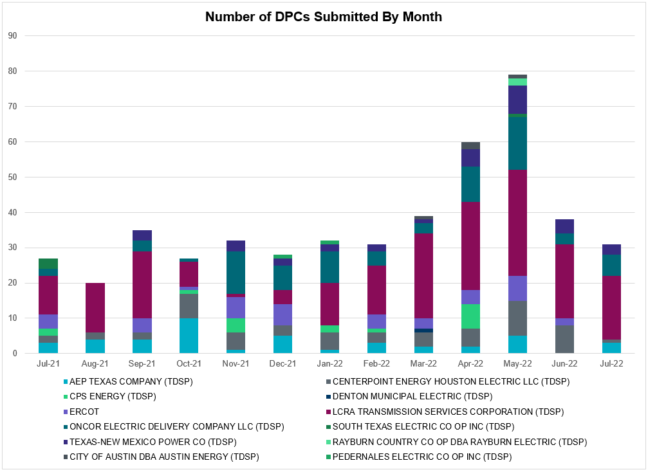

Transmission Operator | Number of DPCs
AEP TEXAS COMPANY (TDSP) | 3
BRAZOS ELECTRIC POWER CO OP INC (TDSP) | 0
BROWNSVILLE PUBLIC UTILITIES BOARD (TDSP) | 0
BRYAN TEXAS UTILITIES (TDSP) | 0
CENTERPOINT ENERGY HOUSTON ELECTRIC LLC (TDSP) | 1
CITY OF AUSTIN DBA AUSTIN ENERGY (TDSP) | 0
CITY OF COLLEGE STATION (TDSP) | 0
CITY OF GARLAND (TDSP) | 0
CPS ENERGY (TDSP) | 0
DENTON MUNICIPAL ELECTRIC (TDSP) | 0
ELECTRIC TRANSMISSION TEXAS LLC (TDSP) | 0
ERCOT | 0
LCRA TRANSMISSION SERVICES CORPORATION (TDSP) | 18
LONE STAR TRANSMISSION LLC (TSP) | 0
ONCOR ELECTRIC DELIVERY COMPANY LLC (TDSP) | 6
PEDERNALES ELECTRIC CO OP INC (TDSP) | 0
RAYBURN COUNTRY CO OP DBA RAYBURN ELECTRIC (TDSP) | 0
SHARYLAND UTILITIES LP (TDSP) | 0
SOUTH TEXAS ELECTRIC CO OP INC (TDSP) | 0
TEXAS MUNICIPAL POWER AGENCY (TDSP) | 0
TEXAS-NEW MEXICO POWER CO (TDSP) | 3

Appendix A: Real-Time Constraints
The following is a complete list of constraints activated in SCED. Full contingency descriptions can be found in the Standard Contingencies List located on the MIS secure site at Grid Generation Reliability Unit Commitment.

Year | Month of the Year | Contingency Name | Overloaded Element | From Station | To Station | Count of Days
2022 | 7 | BASE CASE | ARAGORN_TIE_1 | ARAGORN | PINNAC | 31
2022 | 7 | BASE CASE | NE_LOB | n/a | n/a | 31
2022 | 7 | SLAQLOB8 | BRUNI_69_1 | BRUNI | BRUNI | 31
2022 | 7 | BASE CASE | BRIGHT_CHARTE1_1 | BRIGHTSD | CHARTER | 30
2022 | 7 | BASE CASE | NELRIO | n/a | n/a | 30
2022 | 7 | SLOBSA25 | LARDVN_LASCRU1_1 | LARDVNTH | LASCRUCE | 28
2022 | 7 | MHARNED5 | BURNS_RIOHONDO_1 | RIOHONDO | MV_BURNS | 25
2022 | 7 | DELMSAN5 | PAWNEE_SPRUCE_1 | PAWNEE | CALAVERS | 24
2022 | 7 | SLAQLOB8 | FALFUR_PREMON1_1 | FALFUR | PREMONT | 23
2022 | 7 | SN_SAJO5 | LASPUL_RAYMND1_1 | LASPULGA | RAYMND2 | 21
2022 | 7 | SLGEI_D8 | I_DUPS_LGE1_1 | LGE | I_DUPSW | 20
2022 | 7 | MFLCMDL5 | 6462__C | MCNSW | MKNGB | 19
2022 | 7 | SNATBEA8 | 6144__A | BSPRW | STASW | 19
2022 | 7 | DMOLLO58 | PAWNEE_TANGO1_1 | TANGO | PAWNEE | 18
2022 | 7 | DELMSAN5 | BEEVIL_NORMAN1_1 | BEEVILLE | NORMANNA | 17
2022 | 7 | SLOBSA25 | CATARI_PILONC1_1 | PILONCIL | CATARINA | 16
2022 | 7 | SLOBSA25 | CATARI_PILONC1_1 | CATARINA | PILONCIL | 16
2022 | 7 | DWPWFWP5 | STPWAP39_1 | STP | WAP | 13
2022 | 7 | SCO2EUL8 | BEEVIL_NORMAN1_1 | BEEVILLE | NORMANNA | 13
2022 | 7 | DWPWFCK5 | STPWAP39_1 | STP | WAP | 12
2022 | 7 | SDIMBEV8 | HAMILT_MAVERI1_1 | HAMILTON | MAVERICK | 11
2022 | 7 | DCENRI35 | PAWNEE_TANGO1_1 | TANGO | PAWNEE | 11
2022 | 7 | SOBWAP5 | OB_WAP98_A | WAP | OB | 11
2022 | 7 | DLYTTUR8 | CKT_943_1 | LYTTON_S | PILOT | 11
2022 | 7 | DCENREV5 | PAWNEE_TANGO1_1 | TANGO | PAWNEE | 10
2022 | 7 | SHAYZO25 | 6T227_1 | HAYSEN | ZORN | 10
2022 | 7 | SBRAUVA8 | HAMILT_MAVERI1_1 | HAMILTON | MAVERICK | 9
2022 | 7 | BASE CASE | WESTEX | n/a | n/a | 9
2022 | 7 | SCMNCPS5 | 651__B | CMNSW | CMNTP | 9
2022 | 7 | DSTEXP12 | BLESSI_LOLITA1_1 | LOLITA | BLESSING | 9
2022 | 7 | DAUSDUN8 | 608T608_1 | GIDEON | BASTCI | 9
2022 | 7 | XMDL58 | 6462__C | MCNSW | MKNGB | 8
2022 | 7 | MXFL1C58 | 6462__C | MCNSW | MKNGB | 8
2022 | 7 | SGRICOL5 | PAWNEE_TANGO1_1 | TANGO | PAWNEE | 8
2022 | 7 | SALIKIN8 | FALFUR_PREMON1_1 | FALFUR | PREMONT | 7
2022 | 7 | SBTPBNT8 | MYRA_VAL_1 | MYRA | VALYVIEW | 7
2022 | 7 | SCM2DCS8 | 805__A | DCSES | CMBSW | 7
2022 | 7 | SPEBTRU8 | 940__C | ENWSW | WXHCH | 7
2022 | 7 | DMCCHIL8 | 725T725_1 | MCCALA | RATTLE | 6
2022 | 7 | SMCCRAT8 | 445T445_1 | HILLTO | STRAHAT1 | 6
2022 | 7 | DWISALV8 | MYRA_VAL_1 | MYRA | VALYVIEW | 6
2022 | 7 | DBIGKEN5 | TREADW_YELWJC1_1 | TREADWEL | YELWJCKT | 6
2022 | 7 | DCDHTVW5 | 310__A | LIGSW | NORSW | 6
2022 | 7 | DMCCHIL8 | 725T725_1 | RATTLE | MCCALA | 6
2022 | 7 | SMV_PAR8 | RIOHND_ERIOHND_1 | MV_RIOHO | RIOHONDO | 5
2022 | 7 | SILLFTL8 | HAMILT_MAXWEL1_1 | MAXWELL | HAMILTON | 5
2022 | 7 | DELMSAN5 | MAGRUD_VICTOR2_1 | VICTORIA | MAGRUDER | 5
2022 | 7 | DSTNCPS8 | OLS_CLIF_1 | OLSEN | CLIFTON1 | 5
2022 | 7 | SLOBSA25 | PAWNEE_TANGO1_1 | TANGO | PAWNEE | 5
2022 | 7 | SMDOPHR5 | G138_10B_1 | SEMINOLE | MAGNO_TN | 5
2022 | 7 | DWHILON5 | PAWNEE_TANGO1_1 | TANGO | PAWNEE | 5
2022 | 7 | DMGSMDS5 | 6512__B | ODEHV | TROTP | 5
2022 | 7 | SHONMOO8 | BIG_FO_MOORE1_1 | MOORE | BIG_FOOT | 5
2022 | 7 | DCENFAL5 | PAWNEE_TANGO1_1 | TANGO | PAWNEE | 5
2022 | 7 | SBWDDBM5 | LPLMK_LPLNE_1 | LPLMK | LPLNE | 4
2022 | 7 | BASE CASE | TRDWEL | n/a | n/a | 4
2022 | 7 | DCDHTVW5 | 6200__D | SHRSW | PRKRW | 4
2022 | 7 | MMDLMOS5 | 6462__C | MCNSW | MKNGB | 4
2022 | 7 | DBIGKEN5 | HAMILT_MAXWEL1_1 | MAXWELL | HAMILTON | 4
2022 | 7 | SPORNCA9 | NCARBI_PV_TAP1_1 | NCARBIDE | PV_TAP | 4
2022 | 7 | SKLELOY8 | LOYOLA_69_1 | LOYOLA | LOYOLA | 4
2022 | 7 | SCENLOB5 | PAWNEE_TANGO1_1 | TANGO | PAWNEE | 4
2022 | 7 | SLOBSA25 | LASCRU_MILO1_1 | LASCRUCE | MILO | 4
2022 | 7 | SHCKRNK5 | 106__A | HCKSW | ALLNC | 4
2022 | 7 | XCAG158 | CAGNON_MR4H | CAGNON | CAGNON | 4
2022 | 7 | MHARNED5 | LASPUL_RAYMND1_1 | LASPULGA | RAYMND2 | 4
2022 | 7 | MKMPSOP8 | 1810__D | MDTXI | MDTHS | 3
2022 | 7 | DCAGCI58 | 255T279_1 | PIPECR | MEDILA | 3
2022 | 7 | SLOBSA25 | ASHERT_CATARI1_1 | CATARINA | ASHERTON | 3
2022 | 7 | MBLUTUR8 | CKT_943_1 | LYTTON_S | PILOT | 3
2022 | 7 | SLOBSA25 | FALFUR_PREMON1_1 | FALFUR | PREMONT | 3
2022 | 7 | SCOLPAW5 | MAGRUD_VICTOR2_1 | VICTORIA | MAGRUDER | 3
2022 | 7 | MHARNED5 | BURNS_HEIDLBRG_1 | MV_BURNS | MV_HBRG4 | 3
2022 | 7 | MHARNED5 | HAINE__LA_PAL1_1 | LA_PALMA | HAINE_DR | 3
2022 | 7 | DCOLFA59 | PAWNEE_TANGO1_1 | TANGO | PAWNEE | 3
2022 | 7 | DCDHMCS8 | 3160__A | CDCSW | OKCLS | 3
2022 | 7 | BASE CASE | VALEXP | n/a | n/a | 3
2022 | 7 | SKYLSAN8 | 108T273_1 | SANMAR | CANYON | 3
2022 | 7 | DVENLIG5 | 530__C | VENSW | BRTRD | 3
2022 | 7 | SGDNTEL5 | 6094__B | ANDNR | MSTNG | 3
2022 | 7 | DBNBMBD5 | 161__A | CMBSW | TVWSW | 2
2022 | 7 | SMDLMOS5 | 6462__C | MCNSW | MKNGB | 2
2022 | 7 | DCPSST58 | 651__B | CMNSW | CMNTP | 2
2022 | 7 | DWHILON5 | BLESSI_LOLITA1_1 | LOLITA | BLESSING | 2
2022 | 7 | SKINFAL8 | FALFUR_PREMON1_1 | FALFUR | PREMONT | 2
2022 | 7 | SODLBRA8 | HAMILT_MAVERI1_1 | HAMILTON | MAVERICK | 2
2022 | 7 | BASE CASE | RANDAD_ZAPATA1_1 | RANDADO | ZAPATA | 2
2022 | 7 | SOLNELB9 | 6855_D_1 | SMR | SMRTP | 2
2022 | 7 | DKENNO89 | CHARTE_THREER1_1 | CHARTER | THREER69 | 2
2022 | 7 | DCAGCO58 | 584T584_1 | KENDAL | WELFAR | 2
2022 | 7 | DMGSBTR5 | 6036__A | TKWSW | MGSES | 2
2022 | 7 | DWHIPEL8 | LON_HI_WWKS_T1_1 | LON_HILL | WWKS_TAP | 2
2022 | 7 | STENCR28 | TEN_KEN_1 | TEN | KEN | 2
2022 | 7 | DGRMGRS8 | 6830__B | CRDSW | OLNEY | 2
2022 | 7 | XTHR89 | CHARTE_THREER1_1 | CHARTER | THREER69 | 2
2022 | 7 | DTOKJK_5 | 260_A_1 | JEWET | SNG | 2
2022 | 7 | SBONNED5 | BURNS_RIOHONDO_1 | RIOHONDO | MV_BURNS | 2
2022 | 7 | SFORYEL8 | HEXT_MASONS1_1 | HEXT | MASONSW | 2
2022 | 7 | SWHILON5 | NUECES_WHITE_2_1 | NUECES_B | WHITE_PT | 2
2022 | 7 | DMCCHIL8 | 103T262_1 | RATTLE | REDWOO | 2
2022 | 7 | STALTEL8 | 6462__C | MCNSW | MKNGB | 2
2022 | 7 | DODEMOS5 | 6512__B | ODEHV | TROTP | 2
2022 | 7 | SSANFOW5 | COTULL_REVEIL1_1 | REVEILLE | COTULLA | 2
2022 | 7 | SRUSCON9 | SANORTH_69T1 | SANORTH | SANORTH | 2
2022 | 7 | SHUNMCC8 | 108T273_1 | SANMAR | CANYON | 2
2022 | 7 | SSKISIN9 | BEEVIL_CHARTE1_1 | CHARTER | BEEVILLE | 2
2022 | 7 | DELMSAN5 | BIG_FO_MOORE1_1 | MOORE | BIG_FOOT | 2
2022 | 7 | SLOLBLE8 | BROOKH_P_LAVA1_1 | P_LAVACA | BROOKHOL | 2
2022 | 7 | SGEOSIG8 | CHARTE_THREER1_1 | CHARTER | THREER69 | 2
2022 | 7 | SFTLMES8 | CROSSO_NORTMC1_1 | NORTMC | CROSSOVE | 2
2022 | 7 | SOXYIN28 | I_DUPP_I_DUPS1_1 | I_DUPP1 | I_DUPSW | 2
2022 | 7 | STANPAW5 | LON_HI_ORNGRO1_1 | LON_HILL | ORNGROV | 2
2022 | 7 | SCOLPAW5 | PAWNEE_TANGO1_1 | TANGO | PAWNEE | 2
2022 | 7 | DHJWFCK5 | STPWAP39_1 | STP | WAP | 2
2022 | 7 | SWRDYN8 | DA_WC_89_A | WC | DA | 2
2022 | 7 | DLCRKIN8 | LCRANE_RIOPEC1_1 | RIOPECOS | LCRANE | 2
2022 | 7 | DMOLLO58 | LON_HI_ORNGRO1_1 | LON_HILL | ORNGROV | 1
2022 | 7 | SHAYZOR5 | 388T388_1 | HAYSEN | ZORN | 1
2022 | 7 | DTALGLS8 | 6462__C | MCNSW | MKNGB | 1
2022 | 7 | XMDS58 | 6462__C | MCNSW | MKNGB | 1
2022 | 7 | BASE CASE | BURNS_RIOHONDO_1 | RIOHONDO | MV_BURNS | 1
2022 | 7 | SBRAUVA8 | ESCOND_GANSO1_1 | GANSO | ESCONDID | 1
2022 | 7 | XALI89 | FALFUR_PREMON1_1 | FALFUR | PREMONT | 1
2022 | 7 | SN_SLON5 | HOLLY4_SOUTH_1_1 | HOLLY4 | SOUTH_SI | 1
2022 | 7 | BASE CASE | MAGRUD_VICTOR2_1 | VICTORIA | MAGRUDER | 1
2022 | 7 | DKENNO89 | MAGRUD_VICTOR2_1 | VICTORIA | MAGRUDER | 1
2022 | 7 | SPAWCAL5 | MAGRUD_VICTOR2_1 | VICTORIA | MAGRUDER | 1
2022 | 7 | DVICDUP8 | NCARBI_PV_TAP1_1 | NCARBIDE | PV_TAP | 1
2022 | 7 | DWAP_JN5 | OB_WAP98_A | WAP | OB | 1
2022 | 7 | SJNWA1P5 | OB_WAP98_A | WAP | OB | 1
2022 | 7 | DSTNCPS8 | OLS_JNES_1 | OLSEN | JNESBORO | 1
2022 | 7 | DSKYCAL5 | R5_U3_1 | BRAUNIG | CAGNON | 1
2022 | 7 | DGIBLIM5 | 260_A_1 | JEWET | SNG | 1
2022 | 7 | DCAGCO58 | 656T656_1 | KENDAL | BERGHE | 1
2022 | 7 | STHRSUN9 | BEEVIL_CHARTE1_1 | BEEVILLE | CHARTER | 1
2022 | 7 | BASE CASE | BEEVIL_NORMAN1_1 | BEEVILLE | NORMANNA | 1
2022 | 7 | SLOBSA25 | BRUNI_69_1 | BRUNI | BRUNI | 1
2022 | 7 | STANPAW5 | CALLIC_LON_HI1_1 | LON_HILL | CALLICOA | 1
2022 | 7 | SHOLNLA8 | CATARI_PILONC1_1 | PILONCIL | CATARINA | 1
2022 | 7 | SVICCO28 | COLETO_VICTOR2_1 | COLETO | VICTORIA | 1
2022 | 7 | SBIGSCH5 | CROSSO_NORTMC1_1 | NORTMC | CROSSOVE | 1
2022 | 7 | SBRAUVA8 | GANSO_MAVERI1_1 | MAVERICK | GANSO | 1
2022 | 7 | DCENREV5 | LON_HI_ORNGRO1_1 | LON_HILL | ORNGROV | 1
2022 | 7 | SMDOOAS5 | OB_WAP98_A | WAP | OB | 1
2022 | 7 | SGRILON5 | PAWNEE_TANGO1_1 | TANGO | PAWNEE | 1
2022 | 7 | DKENCA58 | 255T279_1 | PIPECR | MEDILA | 1
2022 | 7 | DAUSDUN8 | 286T608_1 | BASTCI | SWIFTE | 1
2022 | 7 | DSWECCR5 | 6036__A | MGSES | TKWSW | 1
2022 | 7 | SHENCO28 | 97T205_1 | ZORN | MCCALA | 1
2022 | 7 | STANPAW5 | BEEVIL_NORMAN1_1 | BEEVILLE | NORMANNA | 1
2022 | 7 | SREVDIL8 | BRUNI_69_1 | BRUNI | BRUNI | 1
2022 | 7 | STANPAW5 | CATARI_PILONC1_1 | PILONCIL | CATARINA | 1
2022 | 7 | XDES258 | 1810__D | MDTXI | MDTHS | 1
2022 | 7 | DHUTGEA8 | 211T147_1 | GILLCR | MCNEIL_ | 1
2022 | 7 | DMGSBIT5 | 6036__A | TKWSW | MGSES | 1
2022 | 7 | DSALKLN5 | 630__B | KLNSW | HHSTH | 1
2022 | 7 | DMGSMDS5 | 6462__C | MCNSW | MKNGB | 1
2022 | 7 | DDMTBCK8 | 6474__A | MGSES | SUNSW | 1
2022 | 7 | DCAGCO58 | BERGHE_AT1H | BERGHE | BERGHE | 1
2022 | 7 | SDILDIL9 | BIG_FOOT_69A1 | BIG_FOOT | BIG_FOOT | 1
2022 | 7 | SHONMOO8 | BIG_FOOT_69A1 | BIG_FOOT | BIG_FOOT | 1
2022 | 7 | DGOBCOM8 | BNMSW_FMR1 | BNMSW | BNMSW | 1
2022 | 7 | SKENKEN9 | CHARTE_THREER1_1 | CHARTER | THREER69 | 1
2022 | 7 | SDOWMOO8 | DOWNIES_AX1H | DOWNIES | DOWNIES | 1
2022 | 7 | SBRAHAM8 | HAMILT_MAVERI1_1 | HAMILTON | MAVERICK | 1
2022 | 7 | DCENRI35 | LON_HI_ORNGRO1_1 | LON_HILL | ORNGROV | 1
2022 | 7 | MWHI58 | LON_HI_WWKS_T1_1 | LON_HILL | WWKS_TAP | 1
2022 | 7 | DELMSAN5 | NORMAN_PETTUS1_1 | NORMANNA | PETTUS | 1
2022 | 7 | SPAWSAN5 | PAWNEE_SPRUCE_1 | PAWNEE | CALAVERS | 1
2022 | 7 | DCENRO58 | PAWNEE_TANGO1_1 | TANGO | PAWNEE | 1
2022 | 7 | BASE CASE | X5_ALAMO1_1 | OCI_ALM1 | X5 | 1
2022 | 7 | DCAGCO58 | 392T392_1 | MASOCR | PIPECR | 1
2022 | 7 | DCAGCO58 | 583T583_1 | BANDER | MASOCR | 1
2022 | 7 | DSCOFAR5 | 6216__B | WLVSW | SHRNE | 1
2022 | 7 | STHRSUN9 | BEEVIL_CHARTE1_1 | CHARTER | BEEVILLE | 1
2022 | 7 | DKOCNUE8 | CHAMPL_WEIL_T1_1 | WEIL_TRC | CHAMPLIN | 1
2022 | 7 | BASE CASE | LARDVN_LASCRU1_1 | LARDVNTH | LASCRUCE | 1
2022 | 7 | SMCEABS8 | MKLT_TRNT1_1 | TRNT | MKLT | 1
2022 | 7 | DCAGBRA5 | N5_P4_2_1 | CALAVERS | SKYLINE | 1
2022 | 7 | DRNS_TB5 | THW_AT1L | THW | THW | 1
2022 | 7 | DLWSRNK5 | W_DENT_T2H | W_DENT | W_DENT | 1
2022 | 7 | SALLHCK5 | 107__A | HCKSW | RNKSW | 1
2022 | 7 | SBONWF28 | 1940__D | BNMSW | ECTOR | 1
2022 | 7 | DFERWIR8 | 33T218_1 | WIRTZ | BURNET | 1
2022 | 7 | DAUSDES8 | 608T608_1 | GIDEON | BASTCI | 1
2022 | 7 | BASE CASE | BEEVIL_ERALIO1_1 | ERALIO | BEEVILLE | 1
2022 | 7 | SILLFTL8 | CARVER_TINSLE1_1 | CARVER | TINSLEY | 1
2022 | 7 | SHOLNLA8 | CATARI_PILONC1_1 | CATARINA | PILONCIL | 1
2022 | 7 | SFORYEL8 | HEXT_YELWJC1_1 | YELWJCKT | HEXT | 1
2022 | 7 | SCENLOB5 | LON_HI_ORNGRO1_1 | LON_HILL | ORNGROV | 1
2022 | 7 | XBLE58 | SAR_FRAN_1 | FRANKC | SARGNTS | 1
2022 | 7 | DSALHUT5 | 1710__C | BELCNTY | SALSW | 1
2022 | 7 | DKENCA58 | 460T460_1 | MEDILA | W1 | 1
2022 | 7 | DKENCA58 | 584T584_1 | KENDAL | WELFAR | 1
2022 | 7 | XYEL88 | BALLIN_PAINTR1_1 | BALLINGE | PAINTROC | 1
2022 | 7 | XKEN289 | BEEVIL_CHARTE1_1 | BEEVILLE | CHARTER | 1
2022 | 7 | DCAGCI58 | BERGHE_AT1H | BERGHE | BERGHE | 1
2022 | 7 | DCAGCO58 | BERGHE_AT1L | BERGHE | BERGHE | 1
2022 | 7 | STANPAW5 | CATARI_PILONC1_1 | CATARINA | PILONCIL | 1
2022 | 7 | BASE CASE | CHARTE_THREER1_1 | CHARTER | THREER69 | 1
2022 | 7 | SCRDJON5 | HOOD_DECRDVA_1 | DCDAM | HOD | 1
2022 | 7 | SDELLAR8 | LARDVN_LASCRU1_1 | LARDVNTH | LASCRUCE | 1
2022 | 7 | SPOMDEL5 | LON_HI_ORNGRO1_1 | LON_HILL | ORNGROV | 1
2022 | 7 | DMCCHIL8 | 258T380_1 | TURNER | BUDA | 1
2022 | 7 | DGRSPKR5 | 6377__A | BRTSW | ORANS | 1
2022 | 7 | DMBDRKC5 | 651__B | CMNSW | CMNTP | 1
2022 | 7 | XKEN289 | BEEVIL_CHARTE1_1 | CHARTER | BEEVILLE | 1
2022 | 7 | MASHBEV8 | BIG_COTU_1 | COTULAS | BIGWELS | 1
2022 | 7 | DCENFAL5 | LON_HI_ORNGRO1_1 | LON_HILL | ORNGROV | 1

Current Wind Generation Record: 27,044 MW on 05/29/2022 at 22:36 | Current Wind Penetration Record: 69.15% on 04/10/2022 at 01:43 Current Solar Generation Record: 9,828 MW on 07/26/2022 at 11:32 | Current Solar Penetration Record: 23.85% on 03/19/2022 at 13:41
This is the hourly integrated peak demand as published in the ERCOT D&E report.

