TDTMS
July 21st, 2022
WebEx only
Attendee | Company | Attendee | Company | Attendee | Company
Diana Rehfeldt | TNMP | Dave Michelson | ERCOT | Kyle Patrick | NRG
Sam Pak | Oncor | Tammy Stewart | ERCOT | Monica Jones | CNP
Crystal Diaz | Constellation | Mick Hanna | ERCOT | Eric Lotter | GridMonitor
Sheri Wiegand* | Vistra | Mark Ruane | ERCOT | Kathy Scott | CNP
Holly Bohart | Constellation | Mike Dameron | ERCOT | Carolyn Reed | CNP
Jamie Wood | LP&L | Trish Matus | ERCOT | Bill Snyder | AEP
Melinda Earnest | AEP | Lori Lee Barfield | Just

Antitrust/Minutes
- Antitrust Admonition was read by Sheri Wiegand
  - Minutes from 5/19/22 were reviewed and approved

TDTMS Structural Review
The following was drafted by Sheri and will be presented to RMS without edit:
- Review of Scope – Is the Scope still valid and is the subcommittee/working group/task force still performing these functions; Does the scope need to be revised?
  - NO, the scope of TDTMS does not need to be revised. The working group is still performing the functions as outlined.
- Review Open Action Items list – Is the subcommittee/working group/task force discussing open issues, ongoing issues, etc.
  - YES, TDTMS has facilitated the upgraded version of MarkeTrak with market participants as well as developed two System Change Requests for improvements to the system along with the revisions associated with TXSET v5.0.
  - The working group continues to monitor system performance issues
- How often does the subcommittee/working group/task force meet and how long are their meetings? Are meetings well attended?
  - Typically, the working group meets monthly for approximately 3 hours. The attendance at the meetings is usually around 15 – 20 market participants with the exception of the demo of the new MarkeTrak platform that hosted over 40 market participants
- Does the subcommittee/working group/task force have a similar scope with another subcommittee/working group/task force – if so, can the groups be consolidated?
  - TDTMS works collaboratively with TXSET, however, the emphasis for TDTMS is on any issues related to the MarkeTrak platform and system performance.
- If applicable, review subcommittee/working group/task force procedures. (voting, process, etc.)
  - Not applicable
- Is the subcommittee/working group/task force still necessary?
  - Yes, the presence of TDTMS allows a forum for any system related and MarkeTrak issues to be discussed

ERCOT System Instances & MarkeTrak Monthly Performance Review
- Mick presented June performance reports - ERCOT did meet the June SLA target, yet remains below the annual target. Hoping to get back on track with no extended outages in Q3
- This morning, 7/21, MarkeTrak experienced an outage – failover this past weekend and upgraded tasks were performed
- MT Upgrade was successful the weekend of 6/4 & 6/5 – since upgrade have seen improvements on API performance (see graph below)
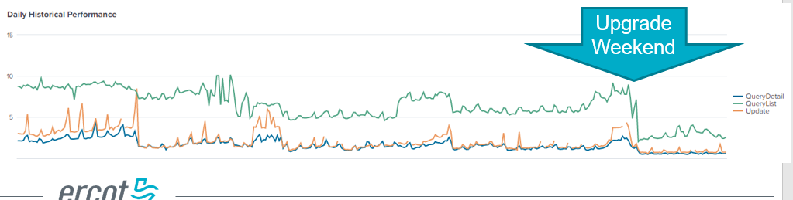

- Listserv activity – some issues with communication to some market participants – when no “sender” on emails, some may not receive due to cybersecurity measures or quarantine measures on the receivers’ side , also suggestion is to not subscribe a distribution list where the risk of any members to unsubscribe is great -- ACTION: ERCOT will continue to work with impacted market participants and monitor subscriber levels, particularly the Weather Moratorium listserve as these notices are time-sensitive
- 7/31 Planned maintenance with IP address changes

ERCOT Help Desk Service Ticket Update
- To address the question of “peeling retail activity” away from Help Desk ticket process – Mick stated this would be difficult with no easy solution; also, keeping the Help Desk on premise is “not on the table” at the moment
- There has been more communication internally w/ ERCOT regarding process and knowledge articles for proper distribution have been updated
- The IT Service Management System with a portal for direct access by the public, primarily media, is scheduled for later this year – portal access for market participants to enter Help tickets is scheduled for early next year where an IT Service catalog with an index would be available where the process can be mapped to solution
- ACTION: Mick is interested in a smaller group to provide input on help desk ticket design - Kyle and Kathy have volunteered – ACTION: Sheri will set up a smaller group to review the week of 8/15

MarkeTrak Upgrade and Stabilization
- Dave Michelson commented ERCOT has received few questions, comments, or confusion post go live
- Tammy Stewart presented four issues that have been discussed post go live for awareness and resolution:
- For new users, the basic search bar at the top of the tool bar did not produce results. Workaround is to use the Advanced Search functionality. Modification will be put into production at a later date.
- Settings on refreshing dashboard reports @ various intervals, resulted in an error message. Solution has been resolved in production
- Market participant was not receiving the nightly escalation emails. Issue has been resolved.
- Bulk Insert template for Usage & Billing – Dispute was failing to load when Dispute Category = Other. Typically, if Other is selected, comments are required. Even when comments were entered, error still resulted. WORKAROUND: select another category besides Other. Fix has been identified and will be put into production at a later date.
- User’s Guide and On line modules have all been updated with new applicable screen shots

SCR 815 – MarkeTrak Administrative Changes (December 2022)
Tammy explained SCR is in the development stage and needed some additional clarity on the items included:
- Already clarified
- TDTMS off line team provided applicable Unexecutable reasons for IAG family, however, Tammy needed reasons for Switch Hold Removal and Cancel w/ Approval ACTION: Sheri will assemble a smaller team off line again to provide those unexecutable reasons
- Escalation contacts - proposed are 5 subtypes with each having a primary/secondary and primary escalation/secondary escalation. The ask is when this is transitioned if ERCOT can default set each of these contacts to the MT Admin. By doing so, each MP will need to “clean up” their rolodex and ensure proper contacts are added. Tammy indicated this is what occurs when a new market participant is set up.
- Escalation email – had clarified the escalation email will be sent every 7 days until issue is closed
- Same escalation pattern for Rescissions, except email sent every 2 days until issue BDMVI is sent and issue is closed
- Background Reports – report on “closed” not “auto-closed” and use the closed date for ‘average days open’. ACTION: Sheri will assemble smaller group to review the 15 background reports and what date is desired for reporting. Participants are Monica, Kyle, Sheri – need information by 7/29
- Unused Subtypes: understanding that these will not be “archived” but removed from the submit tree. If an issue arises for these removed, an Other subtype would need to be submitted. Background reports however will still be able to report on these subtypes
Timing of SCR 815 is still planned for December release. User’s Guide will be updated to reflect changes. These changes will have API implications.

Review of Retail Market Guide – IAG Valid/Invalid Unexecutable Reasons / Fraud / Current Occupant Process
Sheri provided a level set on the current valid/invalid unexecutable reasons for IAGs. Questions were brought up in the last MarkeTrak training session regarding fraudulent enrollments when a REP requests It is suggested in the training to utilize the ‘Current Occupant’ process, however, this is not codified in the Retail Market Guide currently. TDTMS offered to discuss this issue.

Holly (Constellation) explained they would like to take a three-pronged approach to address fraudulent enrollments. The first, falling within the scope of TDTMS as discussed by Sheri, documenting the Current Occupant process, and possibly review proposed changes to the RMG for the use of the IAG process for non-pay fraudulent enrollments. The second, engaging PUCT Enforcement and bringing awareness to Commissioners. And thirdly, reaching out to law enforcement, with possible interest at the Attorney General’s office.

ACTION: Sheri will assemble a smaller group of REPs to review the RMG and propose changes to codify the use of the IAG process for fraud as well as the Current Occupant process.

NEXT MEETING scheduled – August 25th @ 1:30PM WebEx only
Based on the agenda item topics, the working group agreed to meet the afternoon after TXSET and MCT meets in the morning. The below are DRAFT agenda items:
- ERCOT Updates
  - System Instances & MT Performance
  - Listserv
  - Marketrak Upgrade Stabilization
- SCR815 Updates/Questions
  - Training
- Retail Market Guide – IAG Valid/Invalid Unexecutable Reasons
  - Current Occupant Process

