**Common Unexecutable Reasons**

Cancel With Approval & Switch Hold Removal Subtypes

Switch Hold Removal

* Inadequate documentation
  + Wrong or missing documents
  + Address not listed on the document CSA
  + Missing phone number on NOS
  + Signatures missing on the lease agreement
  + Address on the lease does not match the service address
  + The name on the lease does not match NOS
  + ESI ID listed does not match our cis system

**I checked with our developer and he indicated it would be very difficult to create a hierarchy of ‘sub-reasons’ like this in a single dropdown field.  Would you be agreeable to adding the list of examples of Inadequate documentation to the User’s Guide as a reference for the market participants to follow when selecting the Unexecutable Reason of ‘Inadequate documentation’?

***M Allen 08/16/2022 – The sub-reasons were listed to ensure everyone’s input was considered. I think the question you are asking is better answered by the group responsible for the requirements. I was asked to provide input for Oncor and consolidate the answers from all other contributors. However, I am agreeable with your proposition to include them in the User’s Guide.***

* Missing supporting documentation
* Rep of Record submitted the switch hold removal MarkeTrak
* Problems with documentation – unreadable or illegible
* The customer listed on the new occupancy statement is not listed on any of the supporting documentation
* ESI ID not listed on the New Occupancy Statement
* The new customer is the same as the current tenant
  + Based on matching name or phone number

**Same note/question here about the ‘sub-reason’.

***M Allen 08/16/2022 – same answer as above.***

* Switch Hold does not exist on the ESI ID

Last question on SHR.  Below is a screenshot of the current Unexecutable Reasons for SHR – I just want to be sure that the intent is to replace the existing with the new values.  It seems that all of the new values map at a high level to the current reasons but I don’t want to assume.

***M Allen 08/16/2022 – I believe the intent is to expand the list of Unexecutable reasons in the drop-down field of the MarkeTrak. However, I was not part of this discussion, so I would have to defer to Sam Pak or Sheri Wiegand. As mentioned above, I volunteered to combine the responses from the other contributors.***

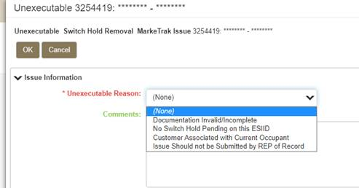

Cancel with Approval

* Incorrect ESI ID Provided
* ESI ID Not Provided
* Transaction does not exist in TDU’s system
* Incorrect Orig Tran ID provided
* Per ERCOT Protocols Section 15.1.8, the CR must send an 814_08 Cancel Request unless there is a system outage and the CR is unable to send/receive TXSET EDI transactions

On the Cancel With Approval subtype, there is currently no ‘Unexecutable’ transition.  Please confirm we are going to add the values below as a dropdown to the ‘Unable To Cancel’ transition. We can create a new ‘Unable To Cancel Reason’ dropdown field for this.

***M Allen 08/16/2022 – Sorry, but I do not know what the intent was for this request. I was not part of this discussion, so I would have to defer to Sam Pak or Sheri Wiegand. As mentioned above, I volunteered to combine the responses from the other contributors.***

Lastly, we are coding the Unexecutable Reason field for the other subtypes (Missing Enrollment, Usage/Billing subtypes, etc.) per the following guideline:

1. Select an Unexecutable reason from the drop down choices   ---OR---
2. Comments would be required

Are we applying the same logic to CWA and SHR?

***M Allen 08/16/2022 – I believe that is the intent. But, I would have to defer to Sam Pak or Sheri Wiegand.***