**PWG Meeting Notes** – June 14th, 2022

Via WebEx 2:00 PM

Attendees:

|  |  |  |  |
| --- | --- | --- | --- |
| Sam Pak - Oncor | Jordan Troublefield – ERCOT | Eric Lotter – Grid Monitor | Diana Rehfeldt - TNMP |
| Sheri Wiegand - TXUE | Clint Gardner – LP&L | Amir Khalifeh - ERCOT | Randy Roberts - ERCOT |
| Kathy Scott - CNP | Jamie Wood – LP&L | Cody Phillips – Enel N America | Norm Levine - NRG |
| Jesse Macias - AEP | Bill Snyder - AEP | Scott Smith - Tenaska |  |
| Angela Ghormley - Calpine | Carl Raish - ERCOT | William – LP&L | Richard Beasley - CNP |
| Calvin Opheim - ERCOT | Jim Lee - TEC | Mallory Vrana - ERCOT |  |

* Meeting notes for May 12th were reviewed and approved
* **Analysis of Residential Rooftop PV in Competitive ERCOT Area**
  + Carl presented follow-up data from his last residential PV analysis where he provided aggregated interval data for 2021 by:
    - Profile type (RESLO/RESHI)
    - Weather Zone – COAST, EAST, etc
  + The excel spreadsheet will have five tabs:
    - Actual, Export, PV Output, Baseline, and Summary
  + The spreadsheet will be posted to the main PWG meeting page (for now).
  + Carl had offered the following changes to consider:
    - Post profiles for years prior to 2021 – WG indicated 2021 is a good start for now and perhaps analysis can be performed on a go-forward annual basis for comparison
    - Format of file, file type, and contents – excel is good
    - Fields to include/exclude – no elimination of fields
    - Vintage breakdowns (2009- present) – not necessary at this time
    - More tabs: baseline, load offset values – suggested to add baseline tab
    - Update frequently – annually, yet will not codify at this time – do not want to impose deadlines

* **2021 Weather Sensitivity Progress**
  + Same results as last month (shown below)
  + TNMP is still working on the outstanding issue



* **Business Annual Validation**

Below is the updated status and task list :

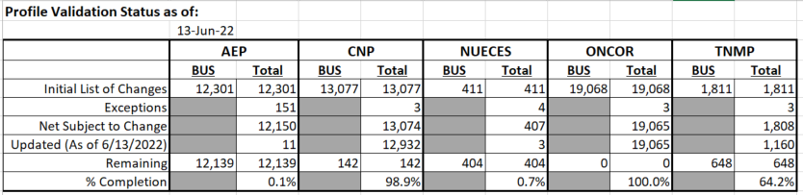



Sheri had asked ERCOT if they were going to provide an overall summary of the changes as we have reviewed in years past – the presentation that showed how many changes each TDSP was responsible for and what profiles the ESIs were changing from and to. PWG has typically reviewed to analyze any trends. ERCOT indicated they would provide that presentation at the next PWG meeting.

* **IDR/AMS BUSLRG(DG) Update from TDSPs**
  + **Transition Plans/Data Accessibility for BUSLRG profiles:**
    - Oncor has completed apprx 6555 conversions to BUSLRG as of 6/7/22 per ERCOT counts.  Approx 200 ESIs have been transitioned since last month.  462 are remaining on BUSIDRRQ with conversions continuing.  Q3 is still timeline for interval data availability in CRIP.
    - AEP has completed apprx 837 conversions to BUSLRG as of 6/7/22 per ERCOT counts.  259 remaining on BUSIRRQ with conversions to continue.
    - CNP is targeting  Q1 of 2023 (1st wk of April 2023) for a Go Live.  Will transition to BUSLRG on cycle basis.  Interval data will also be available at that time.
    - TNMP status quo due to 3G remediation
  + Below are the profile counts as of 6/7/22, noting the new BUSLRG and BUSLRGDG



* **O&G Flat Profiles to BUSLRG**
  + Oncor was seeking clarity on the Profile Decision Tree for those existing BUSOGFLT load profiles who reach 700 kW or above. Oncor explained they have ~13,000 O&G profiles of which ~60 ESIs fall into this category.
  + It was agreed the Decision Tree would remain the same and any ESIs would transition from OGFLT profile to BUSLRG if the threshold of 700 kW was reached.
  + Given the concern about the availability of interval data, Oncor has agreed to hold off making the conversion to BUSLRG until data could be available via CRIP portal (Q3 2022).

* **Adding Lubbock Power & Light Zip Codes to Load Profiling Guide** 
  + Calvin has agreed to sponsor an ERCOT LPGRR to add rows to the Profiling Guide listing all applicable Lubbock zip codes. Calvin indicated Lubbock has already been assigned to the North Weather Zone.
  + The LPGRR would be submitted to RMS and would not have to be remanded to PWG
* **LPGRR proposal converting Profile Decision Tree from Excel to Word format** – no updates
* **DRAFT agenda for next meeting – August 17th, Tuesday**

It was decided the July 13th meeting would be cancelled.

* + Weather Sensitivity wrap up
  + Business Annual Validation update
  + IDR/AMS BUSLRG Updates from TDSPs
  + Lubbock Power & Light Zip Codes to LPG