OBDRR Number | 042 | OBDRR Title | Related to NPRR1142, ERS Changes to Reflect Updated PUCT Rule Changes re SUBST. R. 25.507
Date Posted |  | July 14, 2022
Requested Resolution |  | Urgent – In order to implement changes prior to the Request For Proposal (RFP) posting date (September 30, 2022) for the December-March 2023 Emergency Response Service (ERS) Standard Contract Term
Other Binding Document Requiring Revision |  | Emergency Response Service Procurement Methodology
Supporting Protocol or Guide Section(s) / Related Documents |  | 3.14.3.1, Emergency Response Service Procurement  Nodal Protocol Revision Request (NPRR) 1142, ERS Changes to Reflect Updated PUCT Rule Changes re SUBST. R. 25.507  Emergency Response Service Technical Requirements & Scope of Work
Revision Description |  | This Other Binding Document Revision Request (OBDRR) increases the annual budget for the Emergency Response Service (ERS) and makes other administrative changes to the ERS program.
Reason for Revision |  | Addresses current operational issues.  Meets Strategic goals (tied to the ERCOT Strategic Plan or directed by the ERCOT Board).  Market efficiencies or enhancements  Administrative  Regulatory requirements  Other: To align with PUCT Project No. 53493 to amend P.U.C. SUBST. R, 25.507, Electric Reliability Council of Texas (ERCOT) Emergency Response Service (ERS)  (please select all that apply)
Business Case |  | In PUCT Project No. 53493, Emergency Response Service, Public Utility Commission of Texas (PUCT) Staff filed a Proposal for Publication to amend P.U.C. SUBST. R, 25.507, Electric Reliability Council of Texas (ERCOT) Emergency Response Service (ERS), which “increases the annual budget for ERS, allows ERCOT the flexibility to contract ERS for up to 24 hours in a contract term to better address seasonal needs, and makes other administrative changes to the program.” The PUCT approved this proposal by a vote of its Commissioners at its July 14, 2022 Open Meeting.  To effectuate the PUCT’s direction, ERCOT is revising ERCOT Protocols and the Emergency Response Service Procurement Methodology to make clear the increase to the annual budget for ERS, the 24 hour maximum deployment obligation time for each ERS Contract Period, and other administrative changes to the program. These changes will be applicable for all activities related to administering ERS beginning with the December 2022 to March 2023 ERS Standard Contract Term and all subsequent ERS Standard Contract Terms.

Sponsor
Name | Mark Patterson
E-mail Address | Mark.Patterson@ercot.com
Company | ERCOT
Phone Number | 512-248-3912
Cell Number
Market Segment | Not Applicable

Market Rules Staff Contact
Name | Brittney Albracht
E-Mail Address | Brittney.Albracht@ercot.com
Phone Number | 512-225-7027

Proposed Other Binding Document Language Revision



EMERGENCY RESPONSE SERVICE

Procurement Methodology

ERCOT Board approved TBD
Effective Date of TBD

Date Approved | Version | Description | Author(s) | Approved By | Effective Date
11/19/13 | 0.1 | ERCOT Board approved NPRR564, Thirty-Minute Emergency Response Service (ERS) and Other ERS Revisions, and associated OBD, Emergency Response Service Procurement Methodology | ERCOT | ERCOT Board | 11/20/13
4/8/14 | 0.2 | Revised Section G, Clearing Price. Language grey boxed until effective date of 5/1/14.  History:  - 3/11/14 – Notification of proposed revisions  - 3/27/14 – TAC recommended approval  - 4/8/14 – ERCOT Board of Directors approved  - 5/1/14 – Removed grey box from Section G | ERCOT | ERCOT Board | 5/1/14
10/14/14 | 0.3 | Revised Section G, Clearing Price. (Associated NPRR637, Clarification of ERS Language and ERCOT Process for Co-located Resources.) Language grey boxed until effective date of 11/1/14.  History:  - 8/21/14 – Notification of proposed revisions  - 8/28/14 – TAC recommended approval  - 10/14/14 – ERCOT Board of Directors approved  - 11/1/14 – Removed grey box from Section G | ERCOT | ERCOT Board | 11/1/14
6/12/18 | 0.4 | Revisions proposed by OBDRR004, Updates to Emergency Response Service Procurement Methodology | ERCOT | ERCOT Board | 7/1/18
10/13/20 | 0.5 | Revisions proposed by OBDRR023, Related to NPRR984, Change ERS Standard Contract Terms. Language grey boxed until effective date of 2/1/21 and upon system implementation of NPRR984  History:  - 8/5/20 – Notification of proposed revisions  - 8/26/20 – TAC recommended approval  - 10/13/20 – ERCOT Board of Directors approved  - 2/1/21 – Unboxed footnote in Section E;  - 10/1/21 – Unboxed remaining language due to system implementation of NPRR984;  - 12/1/21 – Removed footnote in Section E | ERCOT | ERCOT Board | 2/1/21
4/13/21 | 0.6 | Revisions proposed by OBDRR027, Clarify Implementation Timeline for OBDRR023 (changed effective date of OBDRR023)  History:  - 2/2/21 – Notification of proposed revisions  - 3/24/21 – TAC recommended approval  - 4/13/21 – ERCOT Board of Directors approved | ERCOT | ERCOT Board | 4/16/21
12/10/21 | 0.7 | Revisions proposed by OBDRR036, Related to NPRR1106, Deployment of ERS Prior to Declaration of EEA  History:  - 11/19/21 – Notification of proposed revisions  - 11/29/21 – TAC recommended approval  - 12/10/21 – ERCOT Board of Directors approved | ERCOT | ERCOT Board | 12/17/21
MM/DD/YY | 0.8 | Revisions proposed by OBDRR042, Related to NPRR1142, ERS Changes to Reflect Updated PUCT Rule Changes re SUBST. R. 25.507  History:  - 7/14/22 – Notification of proposed revisions | ERCOT | ERCOT Board | MM/DD/YY

Table of Contents

A. Document Description 6
B. Change Control Process 6
C. ERS Capacity Demand Curve 6
D. ERS Offer Cap 7
E. ERS Expenditure Limit 7
F. Capacity Inflection Point 8
G. Clearing Price 10
H. ERS Capacity provided through ERS Self Provision 11

Electric Reliability Council of Texas, Inc. (ERCOT) administers Emergency Response Service (ERS) in accordance with Public Utility Commission of Texas (PUCT) Substantive Rule §25.507, Electric Reliability Council of Texas (ERCOT) Emergency Response Service (ERS) and the ERCOT Nodal Protocols. This document is intended to be consistent with these standards, but to the extent any conflict exists, the PUC Rule or Protocols control.

A. Document Description
This document describes the mechanism for procuring ERS and is considered an “Other Binding Document,” as that term is defined in the ERCOT Protocols.

B. Change Control Process
ERCOT Staff will provide a period for stakeholder review and comment for proposed revisions to this document as follows:
(1) ERCOT shall post proposed revisions to the Emergency Response Service Procurement Methodology to the ERCOT website.
(2) ERCOT shall also electronically notify stakeholders of the proposed revisions via the TAC and Others distribution list and define the comment period which shall be at least 14 days after initial posting.
(3) To receive consideration, comments should be submitted via email to ERS@ercot.com by the deadline set forth in the notification.
(4) Upon Market Participant written request, ERCOT will conduct a conference call and online review of the submitted comments.
(5) ERCOT will review proposed document revisions with the Technical Advisory Committee (TAC).
(6) ERCOT will submit proposed document revisions for ERCOT Board approval.
(7) Within three Business Days of ERCOT Board approval, ERCOT shall post the revised document to the ERCOT website.

C. ERS Capacity Demand Curve
ERCOT will develop a capacity demand curve for each ERS Time Period, and all ERS products will be procured together within the limits of that curve. ERCOT shall maximize the MW procured subject to the expenditure limit for the relevant Time Period. Each demand curve is derived from the three following parameters, which ERCOT will specify in the Request for Proposal (RFP) for ERS procurement:
(1) ERS Offer Cap
(2) ERS Time Period Capacity Inflection Point
(3) ERS Time Period Expenditure Limit

MW
$/MW/Hr
Offer Cap
Expenditure Limit
Capacity
Demand
Curve
Capacity
Inflection
Point

D. ERS Offer Cap
The ERS offer cap establishes a maximum possible procurement price of $80/MW/hr for every ERS Time Period during the ERS program year. ERCOT will automatically reject any offers above the offer cap.

E. ERS Expenditure Limit
P.U.C. Substantive Rule 25.507 restricts ERCOT’s ERS expenditures to a maximum of $75 million in a 12-month period, unless otherwise determined by the PUCT. ERCOT will allocate the $75 million available expenditure within its ERS program year, which starts with the December through March ERS Standard Contract Term and ends with the October through November ERS Standard Contract Term. During that 12-month period, ERCOT may exceed the $75 million maximum by up to an additional $25 million for ERS contract renewals.
No later than 60 days before each new ERS program year, ERCOT will make an initial allocation of the annual expenditure limit to each ERS Time Period in each ERS Standard Contract Term based on the expected risk of deploying ERS in that ERS Time Period, in accordance with the formula detailed below. ERCOT will assign a high (H), moderate (M), or low (L) risk designation to each ERS Time Period and will assign a risk-weighting factor (a value from 1 to 100 with 1 being the lowest risk value and 100 being the highest risk value) for each risk designation. ERCOT’s risk assessment will consider a number of factors, including, but not limited to, forecasted operating reserves, forecasted Load, Resource outage information, and the obligated cumulative deployment time for an ERS Contract Period as specified for the ERS Standard Contract Term in paragraph (18)(b) of ERCOT Protocol Section 3.14.3.1, Emergency Response Service Procurement.
Prior to issuing an RFP for an upcoming ERS Standard Contract Term, ERCOT will update the ERS Time Period Expenditure Limits for each remaining ERS Time Period in the ERS program year to reflect updated forecasts and any expected remaining funds from ERS Standard Contract Terms within the same ERS program year. Unless the offer submission deadline for the upcoming ERS Standard Contract Term has passed, ERCOT may update the ERS Time Period Expenditure Limits and issue a revised RFP if funds originally allocated to the upcoming ERS Standard Contract Term must be reallocated to fund an ERS renewal Contract Period in the current ERS Standard Contract Term. ERCOT may revise and reissue the RFP for other reasons if the offer submission date has not yet passed. Any funds remaining at the end of an ERS program year will not be carried forward into a new ERS program year.
For each ERS Time Period, the expenditure limit is calculated as follows:
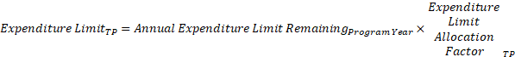
Where
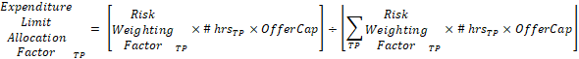

F. Capacity Inflection Point
The capacity inflection point establishes the point on the capacity demand curve where capacity can only be procured at an offer price less than the ERS Time Period offer cap while respecting the expenditure limit for that ERS Time Period. The capacity inflection point for each time period is calculated as follows:

Table A below provides hypothetical calculations of the expenditure limits and capacity inflection point for each ERS Time Period in each ERS program year.
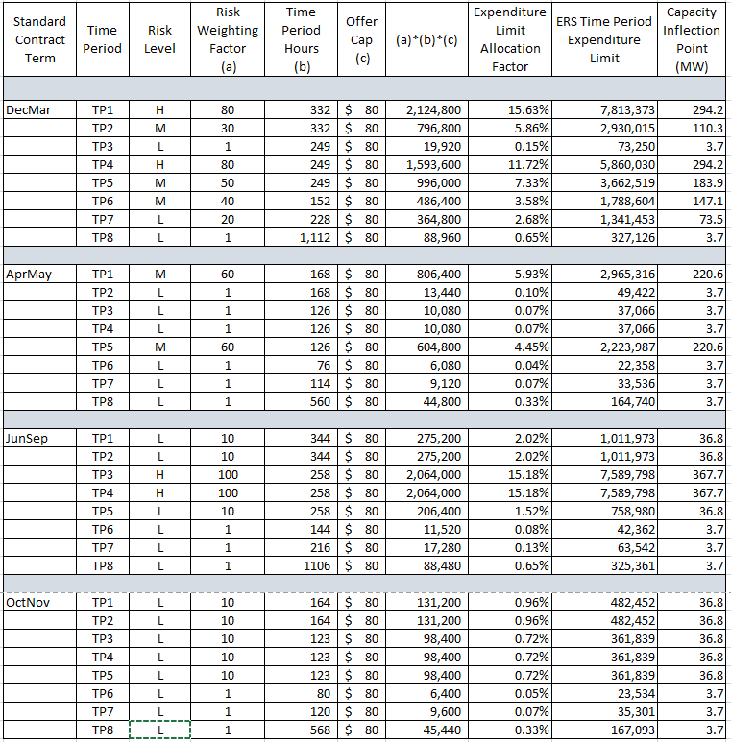
Table A. ERS Time Period Expenditure Limit Allocation and Capacity Inflection Point Calculations

G. Clearing Price
The highest offer accepted for an ERS Time Period from will set the clearing price for all ERS Resources cleared in that ERS Time Period. All ERS service types specified in the Protocols will be procured using a common ERS capacity demand curve for each ERS Time Period and the highest offer accepted for an ERS Time Period will set the clearing price for all ERS service types.
If the procurement of all offers at the same price for an ERS Time Period would exceed the ERS Expenditure Limit for that ERS Time Period, ERCOT shall consider each such offer in an order established at random.
If awarding an offer would not exceed the ERS Expenditure Limit that offer will be awarded for the full capacity offered.
If awarding an offer for the full amount of the offered capacity would exceed the ERS Expenditure Limit, the following steps will be taken:
(1) If awarding an offer for the full amount of the offered capacity would exceed the ERS Expenditure Limit, the following steps will be taken: If the QSE has indicated on its offer that capacity proration is not allowed for that ERS Resource, the offer will be rejected.
(2) If the QSE has indicated on its offer that capacity proration is allowed for that ERS Resource, and if the capacity following proration is greater than or equal to the Proration Lower Limit specified on the offer, the offer will be accepted and the prorated capacity will be awarded.
(3) If the QSE has indicated on its offer that capacity proration is allowed by the QSE for that ERS Resource, and if the prorated capacity is less than the Proration Lower Limit specified on the offer, the offer will be rejected.

H. ERS Capacity provided through ERS Self Provision
For any ERS self-provision, ERCOT will reduce the Time Period expenditure limit for any offers to self-provide part or all of a QSE’s ERS Obligation by the clearing price for ERS.

http://www.puc.state.tx.us/agency/rulesnlaws/subrules/electric/25.507/25.507ei.aspx

