June 2022 ERCOT Monthly Operations Report
Reliability and Operations Subcommittee Meeting
August 10, 2022

Table of Contents
1. Report Highlights 2
2. Frequency Control 3
2.1. Frequency Events 3
2.2. Responsive Reserve Events 4
2.3. Load Resource Events 4
3. Reliability Unit Commitment 4
4. IRR, Wind, and Solar Generation as a Percent of Load 7
5. Largest Net-Load Ramps 9
6. COP Error Analysis 9
7. Congestion Analysis 12
7.1. Notable Constraints 12
7.2. Generic Transmission Constraint Congestion 18
7.3. Manual Overrides 18
7.4. Congestion Costs for Calendar Year 2022 18
8. System Events 20
8.1. ERCOT Peak Load 20
8.2. Load Shed Events 20
8.3. Stability Events 20
8.4. Notable PMU Events 20
8.5. DC Tie Curtailment 20
8.6. TRE/DOE Reportable Events 21
8.7. New/Updated Constraint Management Plans 21
8.8. New/Modified/Removed RAS 21
8.9. New Procedures/Forms/Operating Bulletins 21
9. Emergency Conditions 21
9.1. OCNs 21
9.2. Advisories 21
9.3. Watches 22
9.4. Emergency Notices 22
10. Application Performance 22
10.1. TSAT/VSAT Performance Issues 22
10.2. Communication Issues 22
10.3. Market System Issues 22
11. Model Updates 22
Appendix A: Real-Time Constraints 25

Report Highlights
- The unofficial ERCOT peak load for the month was 76,681 MW which occurred on 06/23/2022, during hour ending 17:00. Prior to this year, the previous peak usage for the month of June was 70,257 MW set on 06/23/2021. This was also an all-time peak record, exceeding the previous record of 74,820 set on 08/12/2019.
- There were 3 frequency events.
- There were 3 instances where Responsive Reserves were deployed.
- There were 100 HRUC commitments.
- There were 14 days of congestion on the North to Houston GTC, 15 days on the West Texas Export GTC, 28 days on the North Edinburg to Lobo GTC, 21 days on the Panhandle GTC, 16 days on the Nelson Sharpe to Rio Hondo GTC, 2 days on the Bearkat GTC, 1 day on the McCamey GTC, and 1 day on the Valley Export GTC. There was no activity on the remaining GTCs during the month.
- There was 1 DC Tie Curtailments.

Frequency Control

Frequency Events

The ERCOT Interconnection experienced 3 frequency events, which resulted from units’ trips. The average event duration was 00:03:18.

A summary of the frequency events is provided below. The reported frequency events meet one of the following criteria: Delta Frequency is 60 mHz or greater; the MW loss is 350 MW or greater; resource trip event triggered RRS deployment. Frequency events that have been identified as Frequency Measurable Events (FME) for purposes of BAL-001-TRE-2 analysis are highlighted in blue. When analyzing frequency events, ERCOT evaluates PMU data according to industry standards. Events with an oscillating frequency of less than 1 Hz are inter-area, while higher frequencies indicate local events. Industry standards specify that damping ratio for inter-area oscillations should be 3.0% or greater. For the frequency events listed below, the ERCOT system met these standards and transitioned well after each disturbance. In the case of negative delta frequency, the MW Loss column could refer to load loss.

Date and Time | Delta Frequency | Max/Min Frequency | Duration of Event | PMU Data |  | MW Loss | Load | IRR | Inertia
 | (Hz) | (Hz) |  | Oscillation Mode (Hz) | Damping Ratio |  | (MW) | % | (GW-s)
06/03/2022 19:33:41 | 0.088 | 59.924 | 00:04:16 | 0.63 | 12% | 375.36 | 57,258 | 18% | 327,158
06/04/2022 12:59:26 | 0.305 | 59.700 | 00:01:19 | 0.73 | 11% | 2519 | 55,412 | 26% | 310,669
06/28/2022 16:18:37 | 0.071 | 59.902 | 00:04:19 | 0.6 | 8% | 624.23 | 66,485 | 22% | 341,862

(Note: All data on this graph encompasses frequency event analysis based on BAL-001-TRE-1.)

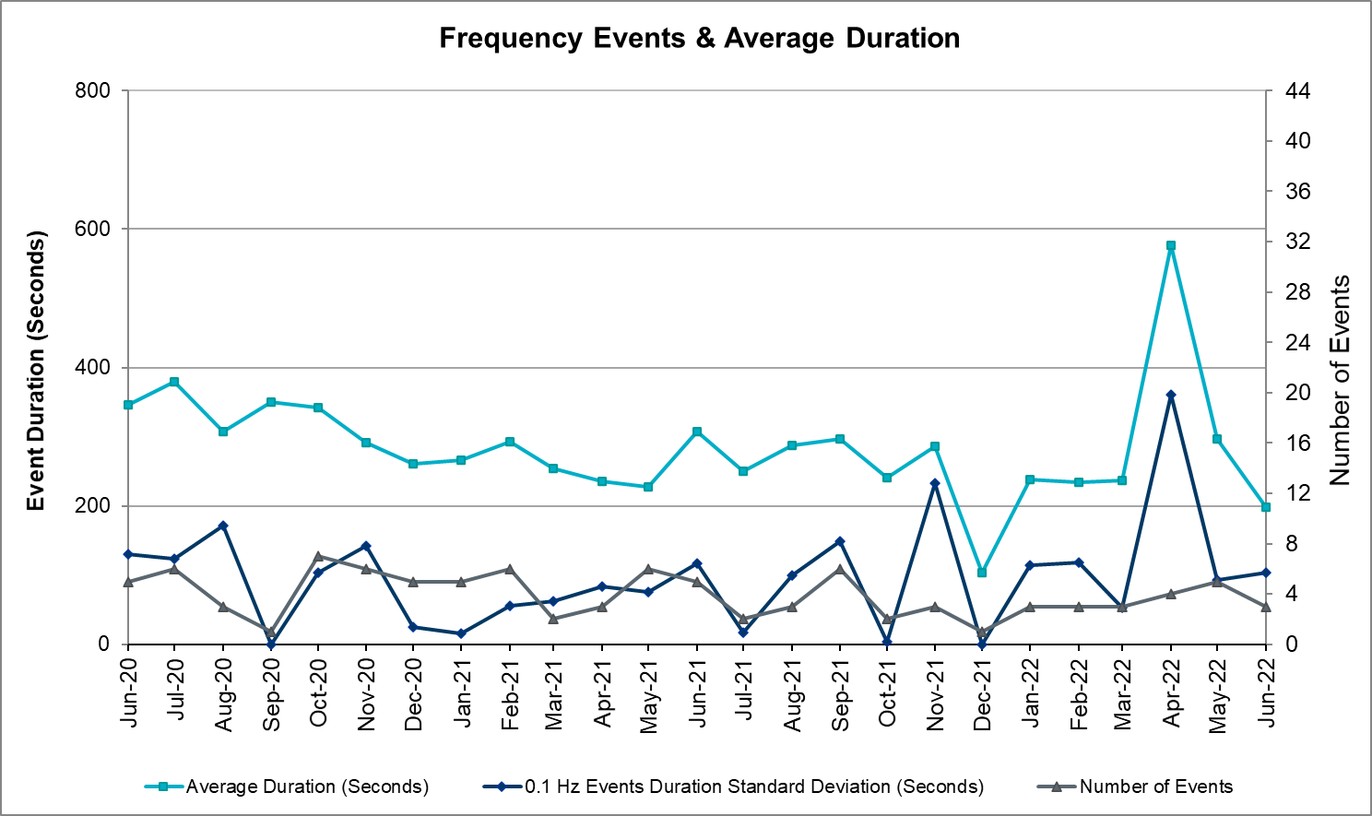

Responsive Reserve Events
There were 3 events where Responsive Reserve MWs were released to SCED. The events highlighted in blue were related to frequency events reported in Section 2.1 above.

Date and Time Released to SCED | Date and Time Recalled | Duration of Event | Maximum MWs Released | Comments
06/04/2022 12:59:36 | 06/04/2022 13:00:55 | 00:01:19 | 1227
06/20/2022 19:26:00 | 06/20/2022 19:30:28 | 00:04:28 | 671
06/28/2022 16:18:52 | 06/28/2022 16:23:12 | 00:04:20 | 680

Load Resource Events
On June 4th at 12:59:36, 1,116 MW of Load Resources tripped due to Under-Frequency Relay (UFR) action and were recalled at 13:13.

Reliability Unit Commitment
ERCOT reports on Reliability Unit Commitments (RUC) monthly. Commitments are reported grouped by operating day and weather zone. The total number of hours committed is the sum of the hours for all the units in the specified region. Additional information on RUC commitments can be found on the MIS secure site at Grid Generation Reliability Unit Commitment.

There were no DRUC commitments.

There were 100 HRUC commitments

Resource Location | # of Resources | Operating Day | Total # of Hours Committed | Total MWhs | Reason for Commitment
NORTH_CENTRAL | 1 | 06/01/2022 | 4 | 1,580.0 | Capacity
EAST, NORTH, NORTH_CENTRAL, SOUTH_CENTRAL | 6 | 06/02/2022 | 26 | 7,870.0 | Capacity, DTOKJK_5
EAST | 1 | 06/03/2022 | 4 | 2,008.0 | Capacity
EAST, NORTH_CENTRAL | 2 | 06/08/2022 | 11 | 3,481.0 | Capacity
EAST, NORTH_CENTRAL | 2 | 06/10/2022 | 12 | 2,400.0 | Capacity
SOUTH_CENTRAL, SOUTHERN | 5 | 06/13/2022 | 24 | 5,042.0 | WESTEX
COAST, NORTH_CENTRAL, SOUTH_CENTRAL, SOUTHERN, | 6 | 06/14/2022 | 30 | 6,388.0 | DTOKJK_5, SVICCO28, WESTEX
COAST, SOUTH_CENTRAL, SOUTHERN | 4 | 06/15/2022 | 25 | 6,000.5 | SVICCO28, WESTEX
EAST, NORTH_CENTRAL, SOUTHERN | 4 | 06/17/2022 | 19 | 6,251.0 | Capacity
NORTH_CENTRAL, SOUTHERN | 4 | 06/20/2022 | 12 | 4,917.0 | Capacity
EAST, NORTH_CENTRAL, SOUTH_CENTRAL | 7 | 06/21/2022 | 47 | 15,712.0 | Capacity
EAST, NORTH_CENTRAL | 7 | 06/22/2022 | 55 | 19,819.0 | Capacity
EAST, NORTH_CENTRAL | 3 | 06/23/2022 | 13 | 6,315.0 | Capacity
EAST, NORTH_CENTRAL, SOUTH_CENTRAL | 6 | 06/25/2022 | 35 | 9,561.5 | Capacity
COAST, EAST, NORTH_CENTRAL, SOUTH_CENTRAL, SOUTHERN | 15 | 06/27/2022 | 98 | 25,524.5 | Capacity
EAST, NORTH_CENTRAL, SOUTH_CENTRAL | 6 | 06/28/2022 | 42 | 13,360.0 | Capacity
EAST, NORTH_CENTRAL | 10 | 06/29/2022 | 67 | 13,216.5 | Capacity, Minimum Run Time
EAST, NORTH_CENTRAL, SOUTH_CENTRAL | 11 | 06/30/2022 | 114 | 22,697.0 | Capacity, Minimum Run Time

IRR, Wind, and Solar Generation as a Percent of Load
The graph below shows the maximum, minimum and average aggregate solar, wind and IRR output as a percentage of total ERCOT load when evaluated as 10-minute averaged intervals, over the past 13 months. Current wind and solar generation and penetration records are listed in the footnote below. Maximum IRR penetration for the month was 54% on 06/05/2022 interval ending 09:10 and minimum IRR penetration for the month was 6.5% on 06/29/2022 interval ending 06:30.

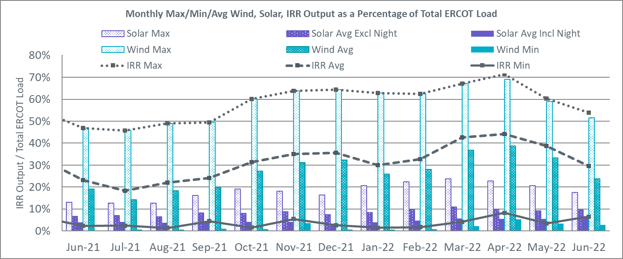

During the hour of peak load for the month, hourly integrated wind generation was 7,384 MW and solar generation was 7,944 MW. The graph below shows the wind and solar penetration percentage during the hour of the peak load in the last 13 months.

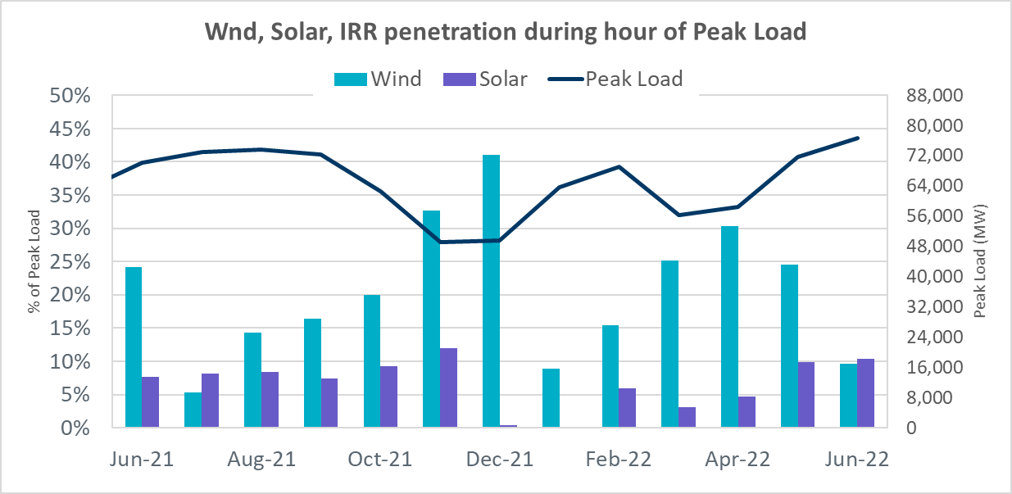

Lastly, the graph below shows the minimum wind, solar and IRR output during the peak load hour as a percentage of the daily peak load for every day in the month.

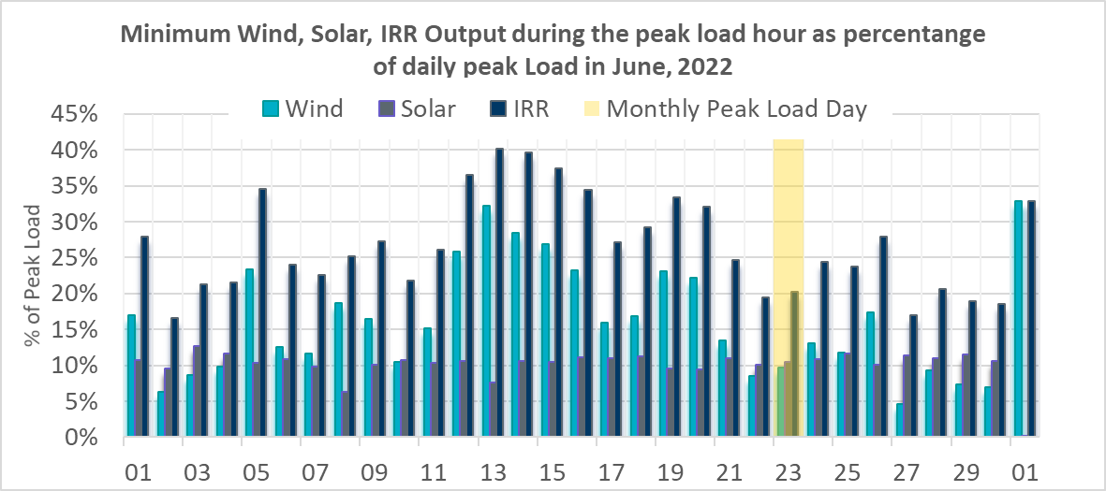

Largest Net-Load Ramps
The net-load ramp is defined as the change in net-load (load minus wind and PVGR generation) during the defined time horizon. Such a variation in net-load needs to be accommodated in grid operations to ensure that the reliability of the grid is satisfactorily maintained. The largest net-load ramp during 5-min, 10-min, 15-min, 30-min and 60-min in June 2022 was 1,064 MW, 1,588 MW, 2,166 MW, 4,035 MW, and 7,866 MW, respectively. The comparison with respect to the historical values is given in the table below.

Month and Year | 5 min | 10 min | 15 min | 30 min | 60 min
June 2014 | 919 MW | 1,329 MW | 1,873 MW | 3,516 MW | 5,724 MW
June 2015 | 1,038 MW | 1,771 MW | 2,489 MW | 3,119 MW | 5,360 MW
June 2016 | 1,183 MW | 1,716 MW | 2,148 MW | 3,131 MW | 5,975 MW
June 2017 | 751 MW | 1,287 MW | 1,772 MW | 3,106 MW | 5,573 MW
June 2018 | 1,029 MW | 1,413 MW | 2,035 MW | 3,590 MW | 6,320 MW
June 2019 | 824 MW | 1,284 MW | 1,706 MW | 2,985 MW | 5,684 MW
June 2020 | 902 MW | 1,615 MW | 2,340 MW | 3,726 MW | 7,015 MW
June 2021 | 1,442 MW | 2,157 MW | 2,646 MW | 3,468 MW | 5,963 MW
June 2022 | 1,064 MW | 1,588 MW | 2,166 MW | 4,035 MW | 7,866 MW
All months in 2014-2022 | 1,647 MW | 2,157 MW | 3,015 MW | 5,882 MW | 10,750 MW

COP Error Analysis
COP Error is calculated as the capacity difference between the COP HSL and real-time HSL of the unit. Mean Absolute Error (MAE) stayed over 16,000 MW until Day-Ahead at 12:00, then dropped significantly to 8,308 MW by Day-Ahead at 13:00. In the following chart, Under-Scheduling Error indicates that COP had less generation capacity than real-time and Over-Scheduling Error indicates that COP had more generation capacity than real-time.

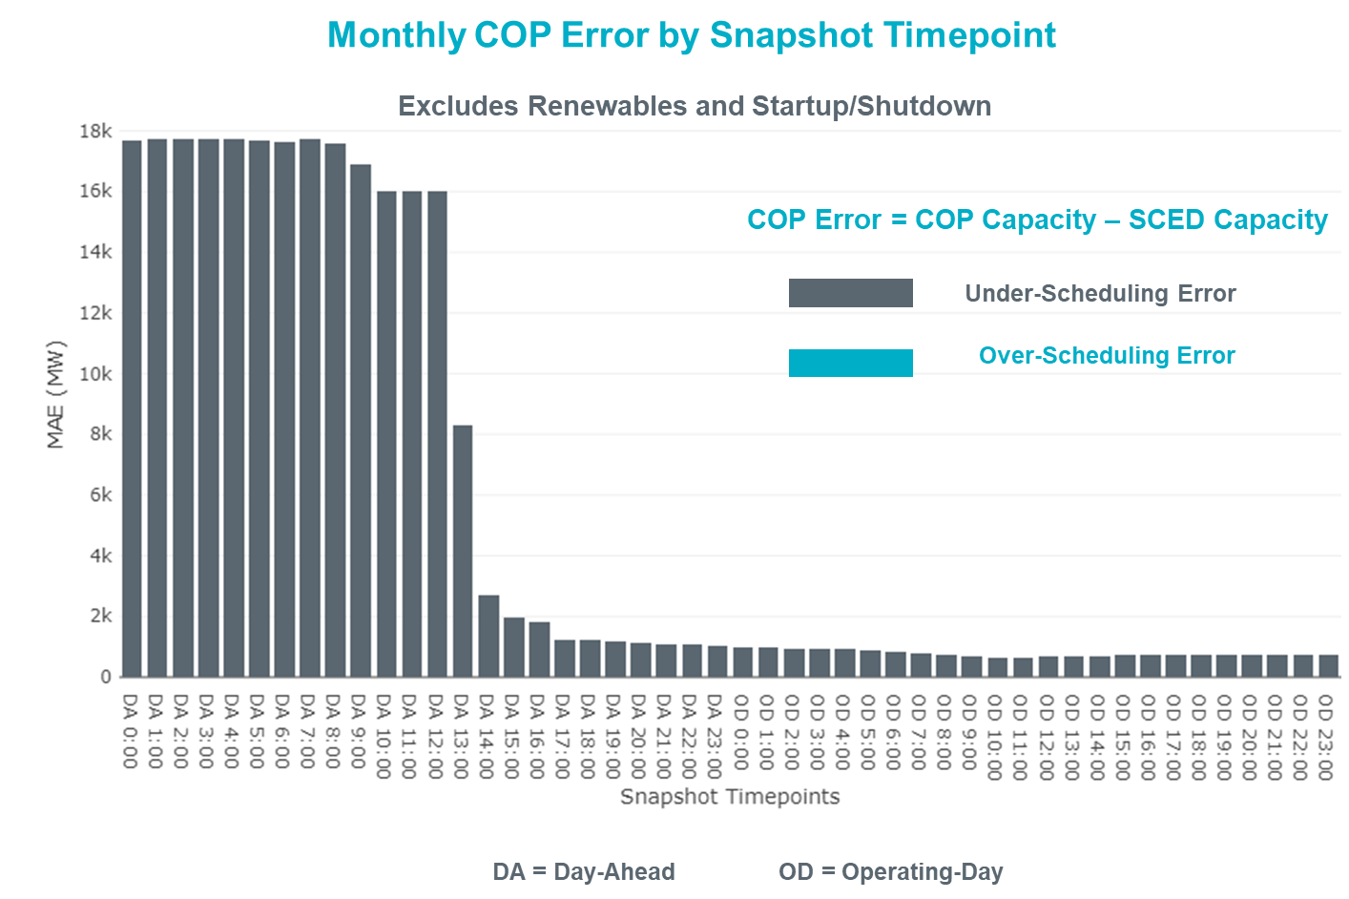

Monthly MAE for the Latest COP at the end of the Adjustment Period was 747 MW with median ranging from -1,454.4 MW for Hour-Ending (HE) 22 to 489.4 MW for HE 7. HE 1 on 06/05/2022 had the largest Over-Scheduling Error (1,418 MW) and HE 17 on 6/30/2022 had the largest Under-Scheduling Error (-3,306 MW).

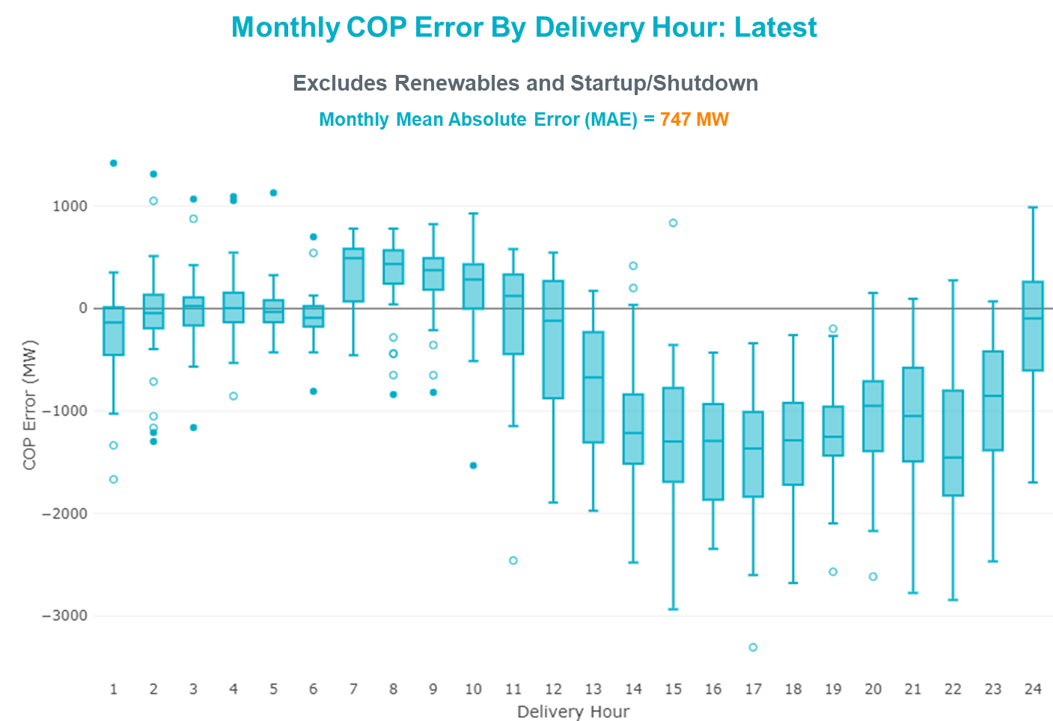

Monthly MAE for the Day-Ahead COP at 12:00 was 16,016 MW with median ranging from -23,046 MW for Hour-Ending (HE) 17 to -9,604.5 MW for HE 5. HE 16 on 06/22/2022 had the largest Under-Scheduling Error (-27,562 MW) and HE 4 on 06/13/2022 had the largest Over-Scheduling Error (-1,970 MW).

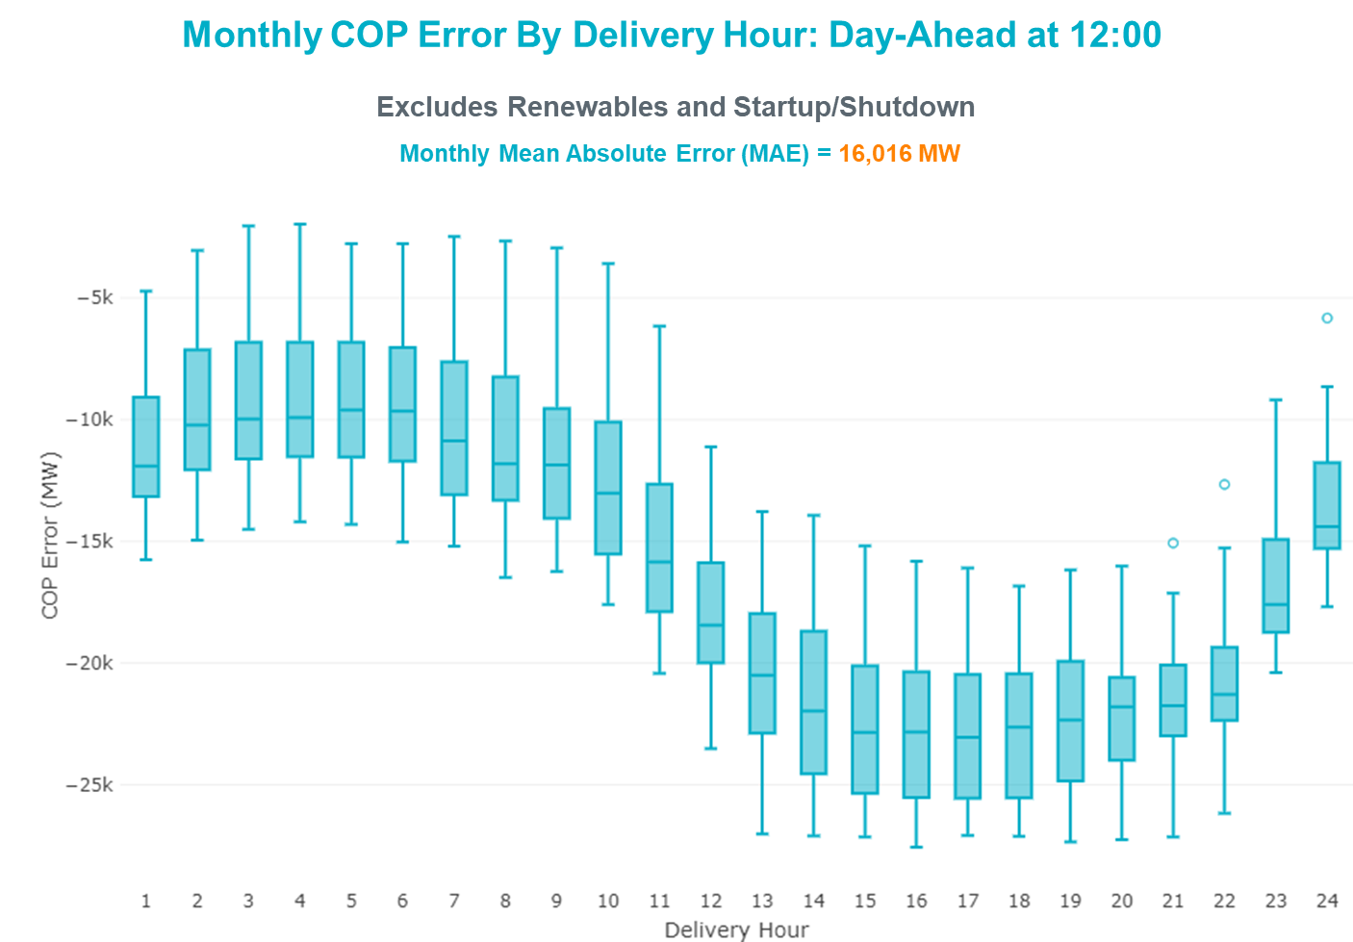

Congestion Analysis

Notable Constraints
Nodal protocol section 3.20 specifies that ERCOT shall identify transmission constraints that are binding in Real-Time three or more Operating Days within a calendar month. As part of this process, ERCOT reports congestion that meets this criterion to ROS. In addition, ERCOT also highlights notable constraints that have an estimated congestion rent exceeding $1,000 for a calendar month. These constraints are detailed in the table below, including approved transmission upgrades from TPIT that may provide some congestion relief based on ERCOT’s engineering judgement. Rows highlighted in blue indicate the congestion was affected by one or more outages. For a list of all constraints activated in SCED, please see Appendix A at the end of this report.

Contingency Name | Overloaded Element | # of Days Constraint Binding | Congestion Rent | Transmission Project
Basecase | WESTEX GTC | 11 | $37,911,335.71
Toksw-Gibcrk & Jk_Ck 345kV | Jewett - Singleton 345kV | 23 | $33,699,333.90
OASIS to MEADOW LIN A | Grant - Plaza 138kV | 11 | $30,738,846.39
PH ROBINSON to MEADOW LIN A | Magnolia Tnp - Seminole Tnp 138kV | 15 | $18,058,315.75 | Rebuild Magnolia - Seminole 138 kV Line (4010)
Basecase | NE_LOB GTC | 27 | $15,573,550.96 | The Lower Rio Grande Valley (LRGV) System Enhancement Project (21RPG017) will improve but not eliminate the need for this GTC.
TWR(345) WAP-WLF64 & CCK-WLY72 | South Texas Project - Wa Parish 345kV | 9 | $10,968,399.92
MAN_SGL_ MDL-FLC_345_kV_w_MDL_XMFR1_FLC_AMR2 | Midland County Northwest Switch - Mockingbird 138kV | 16 | $10,191,065.99 | Oncor Midland East Area Project (21RPG003, MOD 57925) - NOTE: This project removes the overloaded element and reconfigures lines in the area, amongst other topology changes.
Basecase | PNHNDL GTC | 17 | $7,875,508.42
Fowlerton to LOBO 345 LIN1 | Laredo Vft North - Las Cruces 138kV | 22 | $6,940,531.51 | Laredo VFT North to North Laredo Switch: Rebuild 138 kV Line (58008) - NOTE: The original ISD in MOD was 5/31/2022, but per Grid Geo the line has not been upgraded yet.
Fowlerton to LOBO 345 LIN1 | Catarina - Piloncillo 138kV | 20 | $6,852,319.12
Manual dbl ckt for NEDIN-BONILLA 345kV & RIOH-PRIM138kV | Burns Sub - Rio Hondo 138kV | 16 | $6,417,659.44
TWR(345) WAP-WLF64 & WAP-WLY72 | South Texas Project - Wa Parish 345kV | 4 | $6,164,278.26
ROANOKE SWITCH to HICKS SWITCH LIN _A | Hicks Switch - Alliance 345kV | 9 | $4,489,879.60
COMANCHE SWITCH (Oncor) to COMANCHE PEAK SES LIN _A | Comanche Tap - Comanche Switch (Oncor) 138kV | 10 | $3,900,998.07
OASIS to MEADOW LIN A | Monsan Cogen - Petson 138kV | 3 | $3,776,223.08
Basecase | NELRIO GTC | 16 | $3,316,941.25 | The Lower Rio Grande Valley (LRGV) System Enhancement Project (21RPG017) will improve but not eliminate the need for this GTC.
OASIS to MEADOW LIN A | Bigvue - Power Systems Arco Cogen 138kV | 2 | $2,936,144.89
Bighil-Kendal 345kV | Yellow Jacket - Treadwell 138kV | 13 | $2,712,516.32
OASIS to MEADOW LIN A | Bigvue - Lyondell 138kV | 4 | $1,857,492.82
KENDALL to COMFORT LIN 1 | Kerrville Stadium - Kendall 138kV | 4 | $1,850,339.19
HAYS ENERGY to ZORN LIN 1 | Zorn - Hays Energy 345kV | 19 | $1,849,579.17
HUTTO TO RNDRK 138 AND HUTTO TO GEORSO 138 DBLCKT | Wells Branch - Howard Lane 138kV | 1 | $1,723,706.07
VENSW TO LIGSW 345 TRPLCKT 1 OF 3 | Britton Road - Venus Switch 345kV | 5 | $1,555,676.37 | Venus - Webb/Cedar Hill Sw. Sta. (5492)
CALF CREEK POI to NATURAL DAM LIN _A | Big Spring West - Stanton East 138kV | 6 | $1,380,176.57
STILLMAN to LOMA ALTA SUBSTATION LIN 1 | Titan Substation - South Carbide 138kV | 1 | $1,177,747.57
CAGNON TRX CAGNON_3_3 345/138 | Cagnon 345kV | 9 | $1,150,304.66
WATERPORT SUBSTATION to LOMA ALTA SUBSTATION LIN 1 | Palo Alto Substation - Titan Substation 138kV | 1 | $1,119,205.89
MANUAL TWR(345) WAP-WLF64 & CCK-WLY72 NEW | South Texas Project - Wa Parish 345kV | 3 | $896,954.82
BLACKWATER DRAW SWITCH to DOUBLE MOUNTAIN SWITCH LIN 1 | Mackenzie Substation - Northeast Substation 115kV | 4 | $872,065.41
BENNETT ROAD SWITCH to WISE COUNTY LIN _B | Myra - Valley View Bepc 138kV | 5 | $693,336.61
Cagnon-Kendal 345 &Cico-Mengcr 138 | Bergheim - Kendall 345kV | 3 | $685,865.55
NATURAL DAM to BEALS CREEK SUB LIN _A | Big Spring West - Stanton East 138kV | 3 | $641,716.77
LAQUINTA to LOBO LIN 1 | Falfurrias - Premont 69kV | 20 | $630,950.38
LAQUINTA to LOBO LIN 1 | Bruni Sub 138kV | 18 | $627,404.77
Mgses-Qalsw&Odehv-Mdssw 345kV | Trigas Odessa Tap - Odessa Ehv Switch 138kV | 6 | $616,638.98
MANUAL TWR(138) CS-PSA08 & PSA-RVR94 | Bigvue - Lyondell 138kV | 3 | $585,375.78
South Texas # 1 & # 2 | Blessing - Lolita 138kV | 13 | $521,131.22
MESA VIEW SWITCH to FORT LANCASTER LIN 1 | North Mccamey - Crossover 138kV | 4 | $514,481.57
MOLINA - LOBO 138 & LOBO - CENIZO 345 | Pawnee Switching Station - Tango 345kV | 10 | $490,746.78
WISECNTY TO JACKCNTY AND ALVRD TO CHITP 138 DBLCKT | Myra - Valley View Bepc 138kV | 4 | $453,401.69
AJO to NELSON SHARPE LIN 1 | Las Pulgas - Raymondville 2 138kV | 7 | $450,548.62
TVWSW TO CDHSW 345 AND CDHSW TO VENSW 345 DBLCKT | Liggett Switch - Norwood Switch 345kV | 3 | $418,005.35
ODLAW SWITCHYARD to ASPHALT MINES LIN 1 | Hamilton Road - Maverick 138kV | 5 | $385,089.17
FIREROCK TO BRNWD 138 AND FIREROCK TO BANGS 69 DBLCKT | Cottonwood Road Switch - Olney Pod 69kV | 5 | $350,827.21
Basecase | Brightside Solar - Charter 69kV | 26 | $338,868.91 | Poesta to Three Rivers (5166) - NOTE: This project removes the overloaded element and reconfigures lines in the area, amongst other topology changes.
DIMMIT to BEVO LIN 1 | Hamilton Road - Maverick 138kV | 3 | $330,591.45
GRSES TO PKRSW 345 DBLCKT | Barton Chapel Wind Farm - Oran Sub 138kV | 5 | $327,541.13
DUPONT SWITCH - INGLESIDE to GREGORY POWER LIN 1 | Dupont Switch - Ingleside - Lge 138kV | 8 | $290,033.80
Cagnon-Kendal 345 &Cico-Mengcr 138 | Medina Lake - Pipe Creek 138kV | 3 | $289,249.17
Elmcreek-Sanmigl 345kV | Beeville - Normanna 69kV | 7 | $280,243.81 | Poesta to Tuleta (5167) - NOTE: This project removes the overloaded element and reconfigures lines in the area, amongst other topology changes.
Manual MADDUX to SAPOWER2 138kV | Maddux - San Angelo Power Station 138kV | 3 | $45,059.93
TANGO to PAWNEE SWITCHING STATION LIN 1 | Lon Hill - Callicoatte 138kV | 3 | $228,361.14 | Lon Hill - STEC Warburton Line Rebuild (50882)
SANDOW SWITCH to BELL COUNTY EAST SWITCH LIN _A | Sandow Switch - Bell County East Switch 345kV | 7 | $190,395.06
Elmcreek-Sanmigl 345kV | Pawnee Switching Station - Calaveras 345kV | 7 | $102,324.16
COLETO CREEK to Euler LIN 1 | Beeville - Normanna 69kV | 5 | $94,760.57 | Poesta to Tuleta (5167) - NOTE: This project removes the overloaded element and reconfigures lines in the area, amongst other topology changes.
KLEBERG AEP to LOYOLA SUB LIN 1 | Loyola Sub 138kV | 3 | $90,218.71
MOORE SWITCHING STATION to HONDO CREEK SWITCHING STATION LIN 1 | Moore Switching Station - Big Foot 138kV | 7 | $76,598.78
FORT LANCASTER to ILLINOIS #4 LIN 1 | Hamilton Road - Maxwell 138kV | 3 | $74,588.06 | Hamilton Road to Maxwell: Line Rebuild (61396)
ODLAW SWITCHYARD to ASPHALT MINES LIN 1 | Maddux - Santiago 138kV | 4 | $50,274.91
Bighil-Kendal 345kV | Maddux - Treadwell 138kV | 4 | $263,420.14
MGSES TO CCRSW 345 AND BTRCK TO MGSES 345 DBLCKT | Tonkawa Switch - Morgan Creek Ses 345kV | 3 | $42,964.56
MIDLAND EAST to MIDLAND COUNTY NORTHWEST SWITCH LIN _A | Midland County Northwest Switch - Mockingbird 138kV | 3 | $40,203.14 | Oncor Midland East Area Project (21RPG003, MOD 57925) - NOTE: This project removes the overloaded element and reconfigures lines in the area, amongst other topology changes.
COLETO CREEK to VICTORIA LIN 1 | Coleto Creek - Victoria 138kV | 3 | $37,824.84
BRACKETTVILLE to HAMILTON ROAD LIN 1 | Hamilton Road - Maverick 138kV | 3 | $17,050.75
KENEDY SWITCH TRX 69A1 138/69 | Beeville - Charter 69kV | 3 | $4,851.75 | Poesta to Three Rivers (5166) - NOTE: This project removes the overloaded element and reconfigures lines in the area, amongst other topology changes.

Generic Transmission Constraint Congestion
There were 14 days of congestion on the North to Houston GTC, 15 days on the West Texas Export GTC, 28 days on the North Edinburg to Lobo GTC, 21 days on the Panhandle GTC, 16 days on the Nelson Sharpe to Rio Hondo GTC, 2 days on the Bearkat GTC, 1 day on the McCamey GTC, and 1 day on the Valley Export GTC. There was no activity on the remaining GTCs during the month.

Note: This is how many times a constraint has been activated to avoid exceeding a GTC limit, it does not imply an exceedance of the GTC occurred or that the GTC was binding.

Manual Overrides
None

Congestion Costs for Calendar Year 2022
The following table represents the top twenty active constraints for the calendar year based on the estimated congestion rent attributed to the congestion. ERCOT updates this list on a monthly basis.

Contingency | Overloaded Element | # of 5-min SCED | Estimated
Basecase | WESTEX GTC | 17407 | $216,355,617.09
Toksw-Gibcrk & Jk_Ck 345kV | Jewett - Singleton 345kV | 8949 | $163,888,785.16
SALSW TO KLNSW 345 DBLCKT | Killeen Switch 345kV | 10779 | $92,294,055.67
Basecase | NE_LOB GTC | 24297 | $80,104,902.01
Basecase | N_TO_H GTC | 8268 | $73,724,598.62
TWR(345) JCK-REF27 & JCK-STP18 | Hillje - South Texas Project 345kV | 6637 | $62,964,035.25
PH ROBINSON to MEADOW LIN A | Magnolia Tnp - Seminole Tnp 138kV | 15232 | $54,602,155.91
Basecase | PNHNDL GTC | 13261 | $45,473,304.02
Manual dbl ckt for NEDIN-BONILLA 345kV & RIOH-PRIM138kV | Burns Sub - Rio Hondo 138kV | 12508 | $39,108,311.07
OASIS to MEADOW LIN A | Grant - Plaza 138kV | 3745 | $32,866,665.55
WDGSW TO MARSW 138 DBLCKT | Mistletoe Heights - Hemphill 138kV | 2078 | $30,437,608.94
MAN_SGL_ MDL-FLC_345_kV_w_MDL_XMFR1_FLC_AMR2 | Midland County Northwest Switch - Mockingbird 138kV | 2754 | $29,248,454.77
STP SWITCH to Esperanza LIN 1 | Blessing - Pavlov 138kV | 7457 | $28,859,506.14
COMANCHE SWITCH (Oncor) to COMANCHE PEAK SES LIN _A | Comanche Tap - Comanche Switch (Oncor) 138kV | 10180 | $21,492,947.86
Cagnon-Calavers&Braunig 345kV | Pawnee Switching Station - Calaveras 345kV | 4181 | $20,273,972.23
South Texas # 1 & # 2 | Blessing - Lolita 138kV | 3234 | $20,067,469.04
Basecase | NELRIO GTC | 20613 | $19,229,442.84
CALF CREEK POI to NATURAL DAM LIN _A | Big Spring West - Stanton East 138kV | 8406 | $19,217,930.00
LWSSW TO RNKSW AND LWSSW TO KRWSW 345 DBLCKT | Argyle - Highlands Tnp 138kV | 3626 | $19,084,728.31
TWR(345) JCK-STP18 & REF-STP27 | Hillje - South Texas Project 345kV | 4569 | $14,808,051.93

System Events

ERCOT Peak Load
The unofficial ERCOT peak load for the month was 76,681 MW which occurred on 06/23/2022, during hour ending 17:00.

Load Shed Events
None.

Stability Events
None.

Notable PMU Events
ERCOT analyzes PMU data for any significant system disturbances that do not fall into the Frequency Events category reported in section 2.1. The results are summarized in this section once the analysis has been completed.

There were no PMU events outside of those reported in section 2.1.

DC Tie Curtailment
There was one DC tie curtailment.

Date | DC Tie | Curtailing Period | # of Tags Curtailed | Initiating Event | Curtailment Reason
06/17/2022 | DC-R | HE 13-14 | 0 | Unplanned Outage | Planned or Unplanned Outage

TRE/DOE Reportable Events
- ERCOT ISO submitted an OE-417 for 06/04/2022. Reportable Event Type: Generation Loss.
- Oncor submitted an EOP-004 for 06/09/2022. Reportable Event Type: Damage or Destruction of a Facility.
- AEP submitted an OE-417 for 06/27/2022. Reportable Event Type: Loss of Control Capability.
- AEP submitted an OE-417 for 06/27/2022. Reportable Event Type: Loss of Transmission.
- AEN submitted an OE-417 for 06/28/2022. Reportable Event Type: Loss of Control Capability.

New/Updated Constraint Management Plans
There were 4 new CMPs, MP_2022_05, MP_2022_06, MP_2022_17, MP_2022_20.

There were 11 modified CMPs, MP_2011_08, MP_2012_07, MP_2022_08, MP_2013_27, MP_2016_12, MP_2020_01, MP_2021_02, MP_2021_09, MP_2022_01, MP_2022_02, MP_2022_05 (MP is both new and modified).

There was one new PCAP, PCAP_2022_01.

New/Modified/Removed RAS
None.

New Procedures/Forms/Operating Bulletins
Date | Subject | Bulletin No.
6/30/2022 | Reliability Unit Commitment V1 Rev 69 | 1045
6/30/2022 | Resource Desk V1 Rev 70 | 1046

Emergency Conditions

OCNs
Date and Time | Message
6/8/2022 9:00 CPT | ERCOT is issuing an OCN for the extreme hot weather with forecasted temperatures to be above 103°F in the North Central and South Central weather zones, from Friday, June 10, 2022 until Monday, June 13, 2022.
6/20/2022 9:30 CPT | ERCOT is issuing an OCN for the extreme hot weather with forecasted temperatures to be above 103°F in the North Central and South Central weather zones, from Thursday, June 23, 2022 until Sunday, June 26, 2022.

Advisories
Date and Time | Message
6/1/2022 13:30 CPT | ERCOT has postponed the deadline for the posting of the DAM solution for Operating Day 06/02/2022 due to long running solution.

Watches
None.

Emergency Notices
None.

Application Performance

TSAT/VSAT Performance Issues
None.

Communication Issues
None.

Market System Issues
None.

Model Updates
The Downstream Production Change (DPC) process allows ERCOT to make changes in the on-line Network Operations Model without loading a completely new model. The purpose of this process is to allow for reliable grid operations as system conditions change between designated Network Operations Model database loads. The DPC process is limited in scope to just those items listed below, with equipment ratings updates being the most common. ERCOT has seen a rise in the use of the DPC process to make on-line updates to the Network Operations Model in recent years, instead of through the standard Network Operations Model Change Request process.

- Static Line ratings (Interim Update)
- Dynamic Line ratings (non-Interim Update)
- Autotransformer ratings (non-Interim Update)
- Breaker and Switch Normal status (Interim Update)
- Contingency Definitions (Interim Update)
- RAP and RAS changes or additions (Interim Update)
- Net Dependable and Reactive Capability (NDCRC) values (Interim Update)
- Impedance Updates (non-Interim)

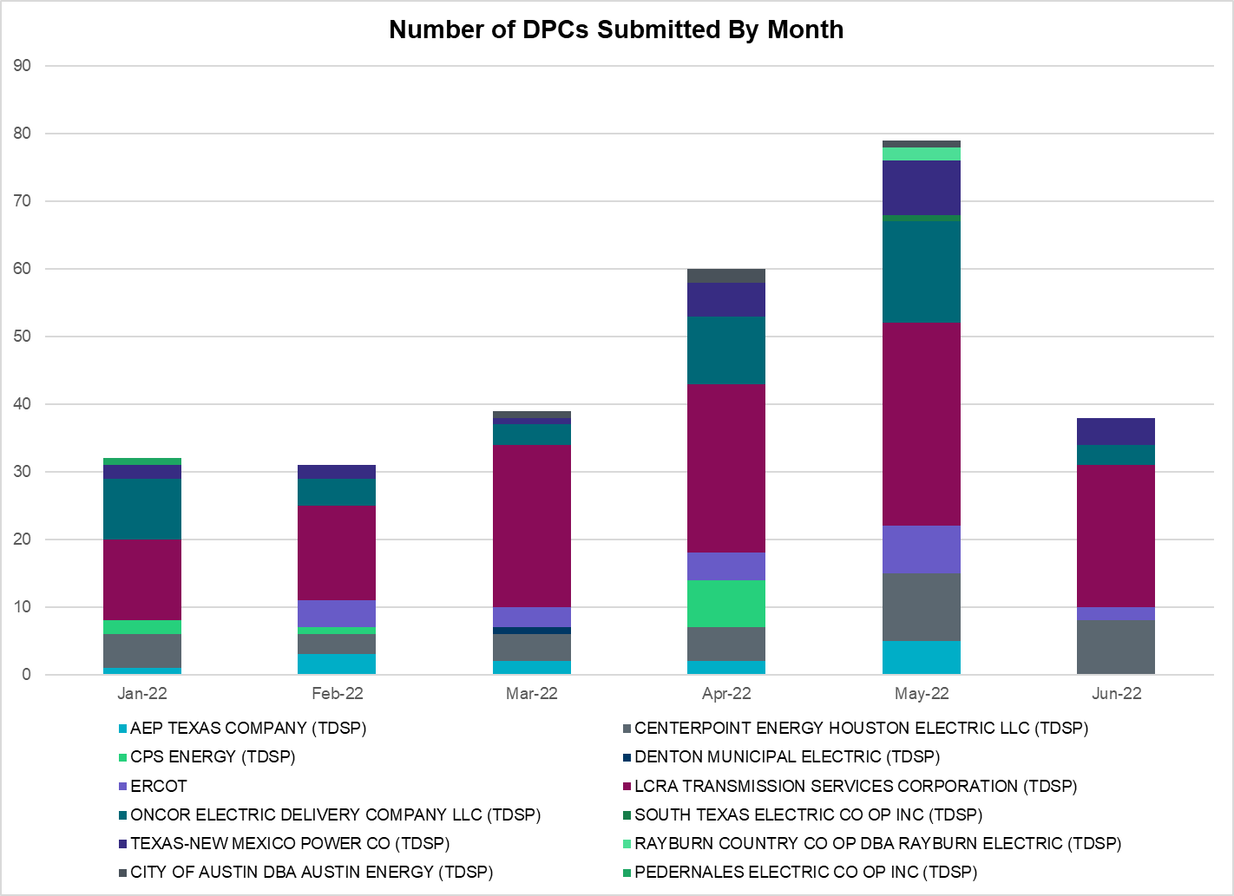

Transmission Operator | Number of DPCs
AEP TEXAS COMPANY (TDSP) | 0
BRAZOS ELECTRIC POWER CO OP INC (TDSP) | 0
BROWNSVILLE PUBLIC UTILITIES BOARD (TDSP) | 0
BRYAN TEXAS UTILITIES (TDSP) | 0
CENTERPOINT ENERGY HOUSTON ELECTRIC LLC (TDSP) | 8
CITY OF AUSTIN DBA AUSTIN ENERGY (TDSP) | 0
CITY OF COLLEGE STATION (TDSP) | 0
CITY OF GARLAND (TDSP) | 0
CPS ENERGY (TDSP) | 0
DENTON MUNICIPAL ELECTRIC (TDSP) | 0
ELECTRIC TRANSMISSION TEXAS LLC (TDSP) | 1
ERCOT | 2
LCRA TRANSMISSION SERVICES CORPORATION (TDSP) | 21
LONE STAR TRANSMISSION LLC (TSP) | 0
ONCOR ELECTRIC DELIVERY COMPANY LLC (TDSP) | 3
PEDERNALES ELECTRIC CO OP INC (TDSP) | 0
RAYBURN COUNTRY CO OP DBA RAYBURN ELECTRIC (TDSP) | 0
SHARYLAND UTILITIES LP (TDSP) | 0
SOUTH TEXAS ELECTRIC CO OP INC (TDSP) | 0
TEXAS MUNICIPAL POWER AGENCY (TDSP) | 0
TEXAS-NEW MEXICO POWER CO (TDSP) | 4

Appendix A: Real-Time Constraints
The following is a complete list of constraints activated in SCED. Full contingency descriptions can be found in the Standard Contingencies List located on the MIS secure site at Grid Generation Reliability Unit Commitment.

Contingency Name | Overloaded Element | From Station | To Station | Count of Days
BASE CASE | BRIGHT_CHARTE1_1 | BRIGHTSD | CHARTER | 27
BASE CASE | NE_LOB | n/a | n/a | 27
SLAQLOB8 | FALFUR_PREMON1_1 | FALFUR | PREMONT | 26
SLOBSA25 | LARDVN_LASCRU1_1 | LARDVNTH | LASCRUCE | 24
DTOKJK_5 | 260_A_1 | JEWET | SNG | 23
SLAQLOB8 | BRUNI_69_1 | BRUNI | BRUNI | 23
SLOBSA25 | CATARI_PILONC1_1 | PILONCIL | CATARINA | 22
BASE CASE | PNHNDL | n/a | n/a | 20
SHAYZO25 | 6T227_1 | HAYSEN | ZORN | 19
MFLCMDL5 | 6462__C | MCNSW | MKNGB | 19
SMDOPHR5 | G138_10B_1 | SEMINOLE | MAGNO_TN | 18
BASE CASE | NELRIO | n/a | n/a | 16
MHARNED5 | BURNS_RIOHONDO_1 | RIOHONDO | MV_BURNS | 16
BASE CASE | WESTEX | n/a | n/a | 15
DBIGKEN5 | TREADW_YELWJC1_1 | TREADWEL | YELWJCKT | 15
DSTEXP12 | BLESSI_LOLITA1_1 | LOLITA | BLESSING | 14
BASE CASE | N_TO_H | n/a | n/a | 14
DWPWFCK5 | STPWAP39_1 | STP | WAP | 13
SCMNCPS5 | 651__B | CMNSW | CMNTP | 12
XCAG158 | CAGNON_MR4H | CAGNON | CAGNON | 12
SMDOOAS5 | GN_PZ_08_A | GN | PZ | 12
DWPWFWP5 | STPWAP39_1 | STP | WAP | 12
DELMSAN5 | PAWNEE_SPRUCE_1 | PAWNEE | CALAVERS | 11
DELMSAN5 | PAWNEE_SPRUCE_1 | CALAVERS | PAWNEE | 11
DELMSAN5 | BEEVIL_NORMAN1_1 | BEEVILLE | NORMANNA | 10
SHCKRNK5 | 106__A | HCKSW | ALLNC | 10
DMOLLO58 | PAWNEE_TANGO1_1 | TANGO | PAWNEE | 10
SHONMOO8 | BIG_FO_MOORE1_1 | MOORE | BIG_FOOT | 9
SN_SAJO5 | LASPUL_RAYMND1_1 | LASPULGA | RAYMND2 | 9
SBCESND5 | 421__A | BCESW | SNDSW | 9
XMDL58 | 6462__C | MCNSW | MKNGB | 8
SLGEI_D8 | I_DUPS_LGE1_1 | LGE | I_DUPSW | 8
SBTPBNT8 | MYRA_VAL_1 | MYRA | VALYVIEW | 8
DWISALV8 | MYRA_VAL_1 | MYRA | VALYVIEW | 7
SMDLMOS5 | 6462__C | MCNSW | MKNGB | 7
SBRAUVA8 | HAMILT_MAVERI1_1 | HAMILTON | MAVERICK | 7
DGRMGRS8 | 6830__B | CRDSW | OLNEY | 7
DMGSMDS5 | 6512__B | ODEHV | TROTP | 6
DWHILON5 | PAWNEE_TANGO1_1 | TANGO | PAWNEE | 6
DHJWFCK5 | STPWAP39_1 | STP | WAP | 6
SLOBSA25 | ASHERT_CATARI1_1 | CATARINA | ASHERTON | 6
SSPJFS8 | JFSSC_06_A | JFS | SC | 6
DGRSPKR5 | 6377__A | BRTSW | ORANS | 6
SSTABS18 | 6144__A | BSPRW | STASW | 6
DCAGCO58 | 398T389_1 | BERGHE | HAYSEN | 5
DVENLIG5 | 530__C | VENSW | BRTRD | 5
SDIMBEV8 | HAMILT_MAVERI1_1 | HAMILTON | MAVERICK | 5
DRNS_TB5 | THWZEN71_A | ZEN | THW | 5
SMDOOAS5 | MSNPET04_A | PET | MSN | 5
SGRICOL5 | PAWNEE_TANGO1_1 | TANGO | PAWNEE | 5
SVICCO28 | COLETO_VICTOR2_1 | COLETO | VICTORIA | 5
DCMNCMN8 | 660__B | MGPSW | ZEPHYR | 5
SCO2EUL8 | BEEVIL_NORMAN1_1 | BEEVILLE | NORMANNA | 5
SILLFTL8 | HAMILT_MAXWEL1_1 | MAXWELL | HAMILTON | 5
SCOMKEN8 | 115T123_1 | KENDAL | KERRST | 5
DMGSBTR5 | 6036__A | TKWSW | MGSES | 4
DCDHTVW5 | 6200__D | SHRSW | PRKRW | 4
DPHRAL58 | G138_10B_1 | SEMINOLE | MAGNO_TN | 4
SSTPESP8 | BLESSI_PAVLOV1_1 | BLESSING | PAVLOV | 4
DBUCKLN5 | 651__B | CMNSW | CMNTP | 4
SBRAUVA8 | MADDUX_SANTIA1_1 | SANTIAGO | MADDUX | 4
MHARNED5 | LASPUL_RAYMND1_1 | LASPULGA | RAYMND2 | 4
SMDOOAS5 | BCVLY_03_A | BCV | LY | 4
SFTLMES8 | CROSSO_NORTMC1_1 | NORTMC | CROSSOVE | 4
SKLELOY8 | LOYOLA_69_1 | LOYOLA | LOYOLA | 4
DBIGKEN5 | MADDUX_TREADW1_1 | MADDUX | TREADWEL | 4
SALLHCK5 | 107__A | HCKSW | RNKSW | 4
XKEN289 | BEEVIL_CHARTE1_1 | CHARTER | BEEVILLE | 4
DJFSCGR8 | JFSSC_06_A | JFS | SC | 4
SBWDDBM5 | LPLMK_LPLNE_1 | LPLMK | LPLNE | 4
XKEN289 | BEEVIL_CHARTE1_1 | BEEVILLE | CHARTER | 4
DCENRI35 | PAWNEE_TANGO1_1 | TANGO | PAWNEE | 3
MWAPCK25 | STPWAP39_1 | STP | WAP | 3
BASE CASE | ARAGORN_TIE_1 | ARAGORN | PINNAC | 3
SMDOOAS5 | BCVPSA03_A | PSA | BCV | 3
DCAGCO58 | 583T583_1 | BANDER | MASOCR | 3
MMADSP28 | MADDUX_SAPOWE1_1 | MADDUX | SAPOWER | 3
DCAGCI58 | 255T279_1 | PIPECR | MEDILA | 3
DCDHTVW5 | 310__A | LIGSW | NORSW | 3
DSWECCR5 | 6036__A | MGSES | TKWSW | 3
SNATBEA8 | 6144__A | BSPRW | STASW | 3
DCAGCI58 | 656T656_1 | KENDAL | BERGHE | 3
DELMSAN5 | BIG_FO_MOORE1_1 | MOORE | BIG_FOOT | 3
SODLBRA8 | HAMILT_MAVERI1_1 | HAMILTON | MAVERICK | 3
DJFSFT_8 | JFSSC_06_A | JFS | SC | 3
SPTHK8 | FOSPT_25_A | PT | FOS | 3
DCENREV5 | PAWNEE_TANGO1_1 | TANGO | PAWNEE | 3
STANPAW5 | CALLIC_LON_HI1_1 | LON_HILL | CALLICOA | 3
DCAGCO58 | 656T656_1 | KENDAL | BERGHE | 3
MCS_CHS8 | BCVLY_03_A | BCV | LY | 3
MWAPWL25 | STPWAP39_1 | STP | WAP | 3
DWSHNAV5 | 6377__A | BRTSW | ORANS | 3
XCA2G58 | CAGNON_MR3H | CAGNON | CAGNON | 3
SBIGSCH5 | CROSSO_NORTMC1_1 | NORTMC | CROSSOVE | 3
SBRAHAM8 | HAMILT_MAVERI1_1 | HAMILTON | MAVERICK | 3
SMV_PAR8 | RIOHND_ERIOHND_1 | MV_RIOHO | RIOHONDO | 3
DSCOFAR5 | 6216__B | WLVSW | SHRNE | 3
SENWSHK8 | 941__C | ENWSW | ENSSO | 2
DKG_NB_5 | JFSSC_06_A | JFS | SC | 2
DHK_WL_8 | FOSPT_25_A | PT | FOS | 2
DSALHUT5 | 1710__C | BELCNTY | SALSW | 2
MHARNED5 | BURNS_HEIDLBRG_1 | MV_BURNS | MV_HBRG4 | 2
DWPWFWP5 | FOSPT_25_A | PT | FOS | 2
DWAP_JN5 | OB_WAP99_A | WAP | OB | 2
DODEMOS5 | ODEHV_MR1H | ODEHV | ODEHV | 2
SPRAWAL8 | 155T217_1 | BELLSO | PT | 2
DCPSST58 | 651__B | CMNSW | CMNTP | 2
DRINMID9 | BEEVIL_CHARTE1_1 | CHARTER | BEEVILLE | 2
DWPWFCK5 | FOSPT_25_A | PT | FOS | 2
DHECWHI8 | RINCON_WHITE_2_1 | WHITE_PT | RINCON | 2
SCISPUT8 | SOUTHA_VINSON1_1 | SOUTHABI | VINSON | 2
DTVWSHR5 | 530__C | VENSW | BRTRD | 2
DTVWJON5 | 6017__B | MBDSW | CMBSW | 2
SFARFID5 | 6216__B | WLVSW | SHRNE | 2
SBLSJAC8 | MYRA_VAL_1 | MYRA | VALYVIEW | 2
DWAP_JN5 | OB_WAP98_A | WAP | OB | 2
SHCKRNK5 | 106__B | ALLNC | RNKSW | 2
BASE CASE | BEARKT | n/a | n/a | 2
DSWELNC5 | BLUF_C_MULBER1_1 | BLUF_CRK | MULBERRY | 2
DMTSCOS5 | 6437__F | SCRCV | KNAPP | 2
DWHILON5 | BLESSI_LOLITA1_1 | LOLITA | BLESSING | 2
BASE CASE | CHARTE_THREER1_1 | CHARTER | THREER69 | 2
SSTPESP8 | LAN_CT_PAVLOV1_1 | PAVLOV | LAN_CTY | 2
SPORWH38 | RINCON_WHITE_2_1 | WHITE_PT | RINCON | 2
SMOOPEA8 | UVALDE_W_BATE1_1 | W_BATESV | UVALDE | 2
SSKISIN9 | BEEVIL_CHARTE1_1 | CHARTER | BEEVILLE | 2
SKINFAL8 | FALFUR_PREMON1_1 | FALFUR | PREMONT | 2
DCAGCI58 | 398T389_1 | BERGHE | HAYSEN | 1
DMGSBIT5 | 6036__A | TKWSW | MGSES | 1
DSWETKW5 | 6036__A | TKWSW | MGSES | 1
DTWIDIV5 | 6128__A | BITTCR | SWESW | 1
DMCCHIL8 | 725T725_1 | MCCALA | RATTLE | 1
MCS_CHS8 | BCVPSA03_A | PSA | BCV | 1
STHOCU28 | BLESSI_PALACI1_1 | BLESSING | PALACIOS | 1
XTHR89 | CHARTE_THREER1_1 | CHARTER | THREER69 | 1
SN_SAJO5 | FALFUR_PREMON1_1 | FALFUR | PREMONT | 1
XFRE89 | GILLES_AT1 | GILLES | GILLES | 1
SFTLMES8 | RIOPEC_SCROSS1_1 | RIOPECOS | SCROSSTP | 1
SRDOPEB8 | TRU_UAT1 | TRU | TRU | 1
XTHO88 | VICTORIA_69A2 | VICTORIA | VICTORIA | 1
DMGSLNG5 | 6216__B | WLVSW | SHRNE | 1
DSALKLN5 | 630__B | KLNSW | HHSTH | 1
SCOLBAL8 | BALLIN_HUMBLT1_1 | BALLINGE | HUMBLTAP | 1
BASE CASE | BCVPSA03_A | PSA | BCV | 1
SBLESTP5 | BROOKH_P_LAVA1_1 | P_LAVACA | BROOKHOL | 1
DWHILON5 | CALLIC_LON_HI1_1 | LON_HILL | CALLICOA | 1
SPAWCAL5 | MAGRUD_VICTOR2_1 | VICTORIA | MAGRUDER | 1
SJNWA1P5 | OB_WAP98_A | WAP | OB | 1
SOBWAP5 | OB_WAP98_A | WAP | OB | 1
SSTILOM8 | PALOAL_TITAN_1_1 | TITAN_SU | PALOALTO | 1
DBWNAMO5 | SAPOWE_SAST1_1 | SAPOWER | SAST | 1
BASE CASE | VALEXP | n/a | n/a | 1
STHOCU28 | VICTORIA_69A2 | VICTORIA | VICTORIA | 1
DKG_NB_5 | BCVLY_03_A | BCV | LY | 1
DVICVI89 | COLETO_VICTOR2_1 | COLETO | VICTORIA | 1
SCOMHA38 | HAMILT_MAXWEL1_1 | MAXWELL | HAMILTON | 1
SFORYEL8 | HEXT_MASONS1_1 | HEXT | MASONSW | 1
BASE CASE | HHGTOM_1 | HHGT | OMEGA | 1
SMDOOAS5 | HUDMSN04_A | MSN | HUD | 1
SDBMFID5 | LPLHY_LPLDB_1 | LPLDB | LPLHY | 1
DCOLFA59 | PAWNEE_TANGO1_1 | TANGO | PAWNEE | 1
SSTILOM8 | SCARBI_TITAN_1_1 | SCARBIDE | TITAN_SU | 1
DWLDSCO5 | 15060__B | VEALMOOR | KOCHTAP | 1
DFERWIR8 | 497T497_1 | MARBFA | LAKEWY | 1
SGRMGRS8 | 6830__B | CRDSW | OLNEY | 1
DCREALN5 | 715__A | CRLNW | CRLJL | 1
DNLSCRL8 | 715__A | CRLNW | CRLJL | 1
XVE2N58 | 945__A | DESSW | GLNHT | 1
SHLC6S8 | BCVLY_03_A | BCV | LY | 1
STANPAW5 | CALLIC_HAISLE1_1 | CALLICOA | HAISLEY | 1
DKENNO89 | CHARTE_THREER1_1 | CHARTER | THREER69 | 1
MBLUTUR8 | CKT_943_1 | LYTTON_S | PILOT | 1
SCOLBAL8 | CONAN_SANA1_1 | SANA_TAP | CONAN | 1
SALIKIN8 | FALFUR_PREMON1_1 | FALFUR | PREMONT | 1
DELMSAN5 | MAGRUD_VICTOR2_1 | VICTORIA | MAGRUDER | 1
DDUPHE18 | RINCON_WHITE_2_1 | WHITE_PT | RINCON | 1
XBLE58 | SAR_FRAN_1 | FRANKC | SARGNTS | 1
DWPWFCK5 | 155T217_1 | BELLSO | PT | 1
DCDHMCS8 | 3160__A | CDCSW | OKCLS | 1
DMCCHIL8 | 584T584_1 | KENDAL | WELFAR | 1
STALTEL8 | 6462__C | MCNSW | MKNGB | 1
DBUCBWN5 | 651__B | CMNSW | CMNTP | 1
SCLCMGS9 | 6785__D | USGYP | USGTP | 1
DRENCRL5 | 715__A | CRLNW | CRLJL | 1
SENSENW8 | 943__B | ENWSW | SHKSW | 1
DSTPANS5 | BLESSI_PALACI1_1 | BLESSING | PALACIOS | 1
DWHILON5 | BLESSI_PALACI1_1 | BLESSING | PALACIOS | 1
XBAL89 | CONCHO_VRBS1_1 | CONCHO | VRBS | 1
SILLFTL8 | CTHR_TINSLE1_1 | TINSLEY | CTHR | 1
MWBAUVA8 | DOWNIE_READIN1_1 | DOWNIES | READING | 1
DRILTES5 | FARMLAND_LONGD_1 | FARMLAND | W_LD_345 | 1
DWHICOT5 | FARMLAND_LONGD_1 | FARMLAND | W_LD_345 | 1
SBIGSCH5 | MADDUX_SANTIA1_1 | SANTIAGO | MADDUX | 1
SMDOOAS5 | OB_WAP99_A | WAP | OB | 1
SCOLBAL8 | SANA_FMR1 | SANA | SANA | 1
DABPAB98 | SOUTHA_VINSON1_1 | SOUTHABI | VINSON | 1
DSTPANS5 | BLESSI_LOLITA1_1 | BLESSING | LOLITA | 1
DSKYCAL5 | CAGNON_MR4H | CAGNON | CAGNON | 1
DBWN_AM5 | CONCHO_VRBS1_1 | CONCHO | VRBS | 1
XVIC89 | GREENL_NCARBI1_1 | GREENLK | NCARBIDE | 1
DELMSAN5 | NORMAN_PETTUS1_1 | NORMANNA | PETTUS | 1
SWHILON5 | NUECES_WHITE_2_1 | NUECES_B | WHITE_PT | 1
SVANRAY8 | NUR_FORT_1 | NURSRYS | FORTRSW | 1
SSGVTRC5 | 175__A | TRCNR | FORSW | 1
DHUTGEA8 | 378T387_1 | HWRDTP | WELLBR | 1
DHCKDEN8 | 6265__B | RHTP2 | RSNHT | 1
XTHO88 | GREENL_WEAVER1_1 | GREENLK | WEAVERRD | 1
SCABWES8 | HOLLY4_SOUTH_1_1 | HOLLY4 | SOUTH_SI | 1
SN_SLON5 | HOLLY4_SOUTH_1_1 | HOLLY4 | SOUTH_SI | 1
BASE CASE | MCCAMY | n/a | n/a | 1
SWATLO28 | PALOAL_TITAN_1_1 | TITAN_SU | PALOALTO | 1
DTRIASH8 | 211T147_1 | GILLCR | MCNEIL_ | 1
DFERWIR8 | 51T376_1 | FERGUS | GRANMO | 1
DMBDRKC5 | 651__B | CMNSW | CMNTP | 1
SGRICOL5 | CALLIC_LON_HI1_1 | LON_HILL | CALLICOA | 1
XVIC89 | GREENL_NCARBI1_1 | NCARBIDE | GREENLK | 1
SPLUFLA8 | MAGRUD_VICTOR2_1 | VICTORIA | MAGRUDER | 1
DMCEBUT8 | MKLT_TRNT1_1 | TRNT | MKLT | 1
SJNWA1P5 | OB_WAP99_A | WAP | OB | 1
SCENLOB5 | PAWNEE_TANGO1_1 | TANGO | PAWNEE | 1
DGIBZEN5 | SNGXGC75_1 | GIBCRK | SNG | 1
XRIN89 | WHITE_PT_69A1 | WHITE_PT | WHITE_PT | 1

Current Wind Generation Record: 27,044 MW on 05/29/2022 at 22:36 | Current Wind Penetration Record: 69.15% on 04/10/2022 at 01:43 Current Solar Generation Record: 9,812 MW on 07/16/2022 at 10:39 | Current Solar Penetration Record: 23.85% on 03/19/2022 at 13:41
This is the hourly integrated peak demand as published in the ERCOT D&E report.
All DC Tie Curtailments are posted publicly on the ERCOT Market Information System. See that posting for additional details for the event(s) in question.
See DC Tie Operating Procedure (http://www.ercot.com/mktrules/guides/procedures) for more details.

