May 2022 ERCOT Monthly Operations Report
Reliability and Operations Subcommittee Meeting
July 7, 2022

Table of Contents
1. Report Highlights 2
2. Frequency Control 3
2.1. Frequency Events 3
2.2. Responsive Reserve Events 4
2.3. Load Resource Events 4
3. Reliability Unit Commitment 4
4. IRR, Wind, and Solar Generation as a Percent of Load 7
5. Largest Net-Load Ramps 8
6. COP Error Analysis 9
7. Congestion Analysis 11
7.1. Notable Constraints 11
7.2. Generic Transmission Constraint Congestion 21
7.3. Manual Overrides 21
7.4. Congestion Costs for Calendar Year 2022 21
8. System Events 22
8.1. ERCOT Peak Load 22
8.2. Load Shed Events 22
8.3. Stability Events 22
8.4. Notable PMU Events 23
8.5. DC Tie Curtailment 23
8.6. TRE/DOE Reportable Events 23
8.7. New/Updated Constraint Management Plans 23
8.8. New/Modified/Removed RAS 23
8.9. New Procedures/Forms/Operating Bulletins 23
9. Emergency Conditions 24
9.1. OCNs 24
9.2. Advisories 24
9.3. Watches 24
9.4. Emergency Notices 24
10. Application Performance 24
10.1. TSAT/VSAT Performance Issues 24
10.2. Communication Issues 24
10.3. Market System Issues 24
11. Model Updates 25
Appendix A: Real-Time Constraints 27

Report Highlights
- The unofficial ERCOT peak load for the month was 71,632 MW and occurred on 05/31/2022, during hour ending 17:00. Prior to this year, the previous peak usage for the month of May was 67,265 MW set on 05/29/2018
- There were 5 frequency events.
- There were 3 instances where Responsive Reserves were deployed.
- There were 118 HRUC commitments.
- There were 26 days of congestion on the West Texas Export GTC, 27 days on the North Edinburg to Lobo GTC, 16 days on the Panhandle GTC, 28 days on the Nelson Sharpe to Rio Hondo GTC, 18 days on the Bearkat GTC, 9 days on the North to Houston GTC, 11 days on the Culberson GTC, 4 days on the McCamey GTC, 5 days on the Valley Export GTC, 8 days on the Treadwell GTC, and 1 day on the Valley Import GTC. There was no activity on the remaining GTCs during the month.
- There were no DC Tie Curtailments.
- A Wind Generation Record of 27,044 MW was set on 05/29/2022 at 22:36.
- A PVGR Generation Record of 9,370 MW was set on 05/19/2022 at 13:15.

Frequency Control

Frequency Events
The ERCOT Interconnection experienced 5 frequency events, which resulted from units’ trips. The average event duration was 00:04:19.

A summary of the frequency events is provided below. The reported frequency events meet one of the following criteria: Delta Frequency is 60 mHz or greater; the MW loss is 350 MW or greater; resource trip event triggered RRS deployment. Frequency events that have been identified as Frequency Measurable Events (FME) for purposes of BAL-001-TRE-2 analysis are highlighted in blue. When analyzing frequency events, ERCOT evaluates PMU data according to industry standards. Events with an oscillating frequency of less than 1 Hz are inter-area, while higher frequencies indicate local events. Industry standards specify that damping ratio for inter-area oscillations should be 3.0% or greater. For the frequency events listed below, the ERCOT system met these standards and transitioned well after each disturbance. In the case of negative delta frequency, the MW Loss column could refer to load loss.

Date and Time | Delta Frequency | Max/Min Frequency | Duration of Event | PMU Data |  | MW Loss | Load | IRR | Inertia
 | (Hz) | (Hz) |  | Oscillation Mode (Hz) | Damping Ratio |  | (MW) | % | (GW-s)
05/08/2022 23:37:46 | 0.109 | 59.905 | 00:04:39 | 0.56 | 8% | 520.24 | 52,241 | 45% | 221,543
05/13/2022 12:32:24 | 0.099 | 59.901 | 00:05:02 | 0.4 | 14% | 563.49 | 57,810 | 25% | 304,563
05/19/2022 18:52:55 | 0.065 | 59.934 | 00:04:31 | 0.65 | 13% | 493 | 67,848 | 39% | 305,144
05/22/2022 1:26:37 | -0.103 | 60.107 | 00:07:24 | 0.75 | 8% | -573 | 43,634 | 51% | 189,128
05/26/2022 18:17:24 | 0.086 | 59.922 | 00:03:06 | 0.63 | 11% | 401.32 | 61,103 | 20% | 322,219

(Note: All data on this graph encompasses frequency event analysis based on BAL-001-TRE-1.)

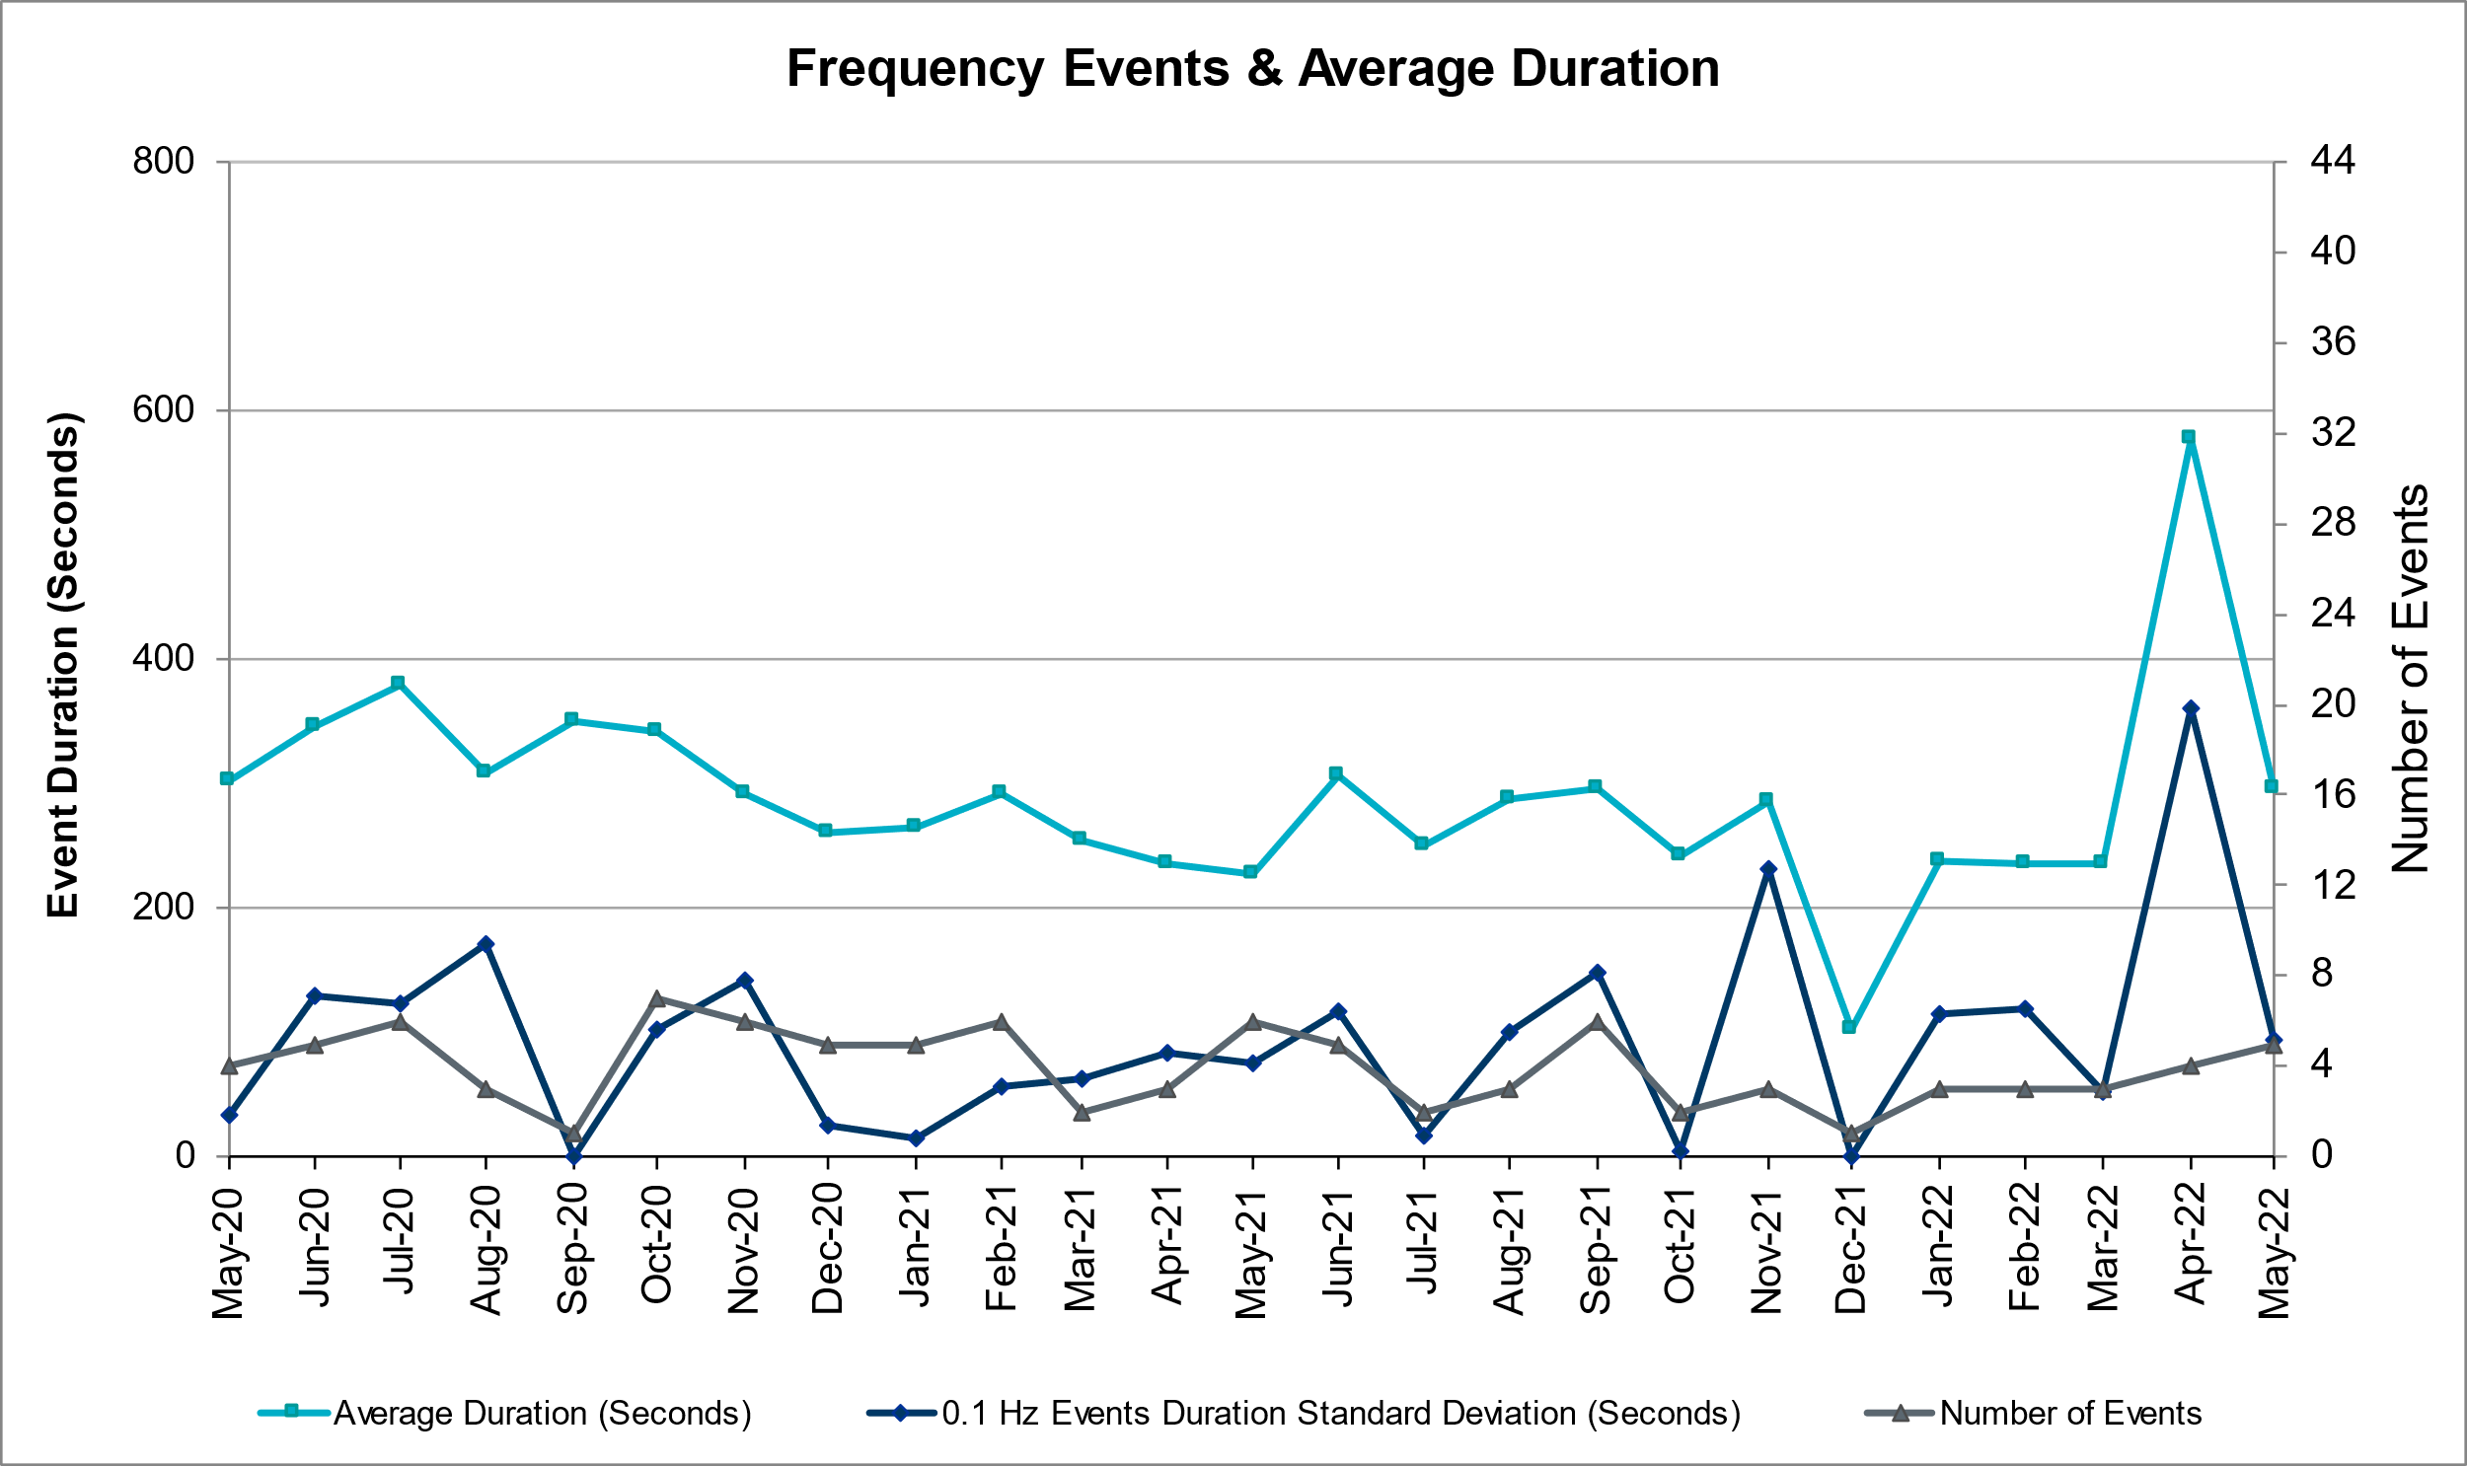

Responsive Reserve Events
There were 3 events where Responsive Reserve MWs were released to SCED. The events highlighted in blue were related to frequency events reported in Section 2.1 above.

Date and Time Released to SCED | Date and Time Recalled | Duration of Event | Maximum MWs Released | Comments
05/08/2022 23:37:54 | 05/08/2022 23:42:14 | 00:04:20 | 555
05/13/2022 12:32:34 | 05/13/2022 12:36:50 | 00:04:16 | 553
05/24/2022 7:05:08 | 05/24/2022 7:07:56 | 00:02:48 | 662

Load Resource Events
NONE.

Reliability Unit Commitment
ERCOT reports on Reliability Unit Commitments (RUC) monthly. Commitments are reported grouped by operating day and weather zone. The total number of hours committed is the sum of the hours for all the units in the specified region. Additional information on RUC commitments can be found on the MIS secure site at Grid Generation Reliability Unit Commitment.

There were no DRUC commitments.

There were 118 HRUC commitments

Resource Location | # Of Resources | Operating Day | Total # of Hours Committed | Total MWhs | Reason for Commitment
COAST | 2 | 05/01/2022 | 12 | 2,676.0 | DTOKJK_5
NORTH, NORTH_CENTRAL, SOUTH_CENTRAL | 10 | 05/02/2022 | 60 | 21,511.3 | WESTEX
COAST, NORTH_CENTRAL | 3 | 05/03/2022 | 19 | 6,883.0 | System Capacity, DTOKJK_5
NORTH_CENTRAL, SOUTH_CENTRAL, SOUTHERN | 10 | 05/05/2022 | 40 | 5,165.0 | System Capacity
COAST, NORTH_CENTRAL | 3 | 05/06/2022 | 38 | 6,510.0 | System Capacity, N_H,
NORTH_CENTRAL | 1 | 05/07/2022 | 6 | 720.0 | System Capacity
SOUTHERN | 1 | 05/08/2022 | 8 | 4,633.0 | N_H
EAST, NORTH, NORTH_CENTRAL, SOUTH_CENTRAL, SOUTHERN | 11 | 05/09/2022 | 36 | 12,400.2 | WESTEX
EAST, NORTH_CENTRAL, SOUTH_CENTRAL | 7 | 05/10/2022 | 36 | 9,818.0 | System Capacity, DSALHUT5, WESTEX
COAST, NORTH_CENTRAL | 6 | 05/11/2022 | 40 | 5,402.0 | N_TO_H, WESTEX
NORTH_CENTRAL | 2 | 05/12/2022 | 12 | 2,220.0 | WESTEX
EAST, FAR_WEST, NORTH_CENTRAL, SOUTH_CENTRAL | 7 | 05/13/2022 | 34 | 10,855.0 | System Capacity
EAST, NORTH_CENTRAL, SOUTH_CENTRAL | 5 | 05/14/2022 | 52 | 21,244.0 | System Capacity
SOUTH_CENTRAL | 1 | 05/15/2022 | 24 | 12,198.0 | System Capacity
NORTH_CENTRAL, SOUTH_CENTRAL | 3 | 05/16/2022 | 30 | 13,853.0 | System Capacity
SOUTH_CENTRAL | 2 | 05/17/2022 | 10 | 1,045.0 | WESTEX
EAST, NORTH_CENTRAL, SOUTH_CENTRAL | 12 | 05/20/2022 | 52 | 9,825.0 | System Capacity WESTEX
EAST, SOUTH_CENTRAL | 3 | 05/21/2022 | 14 | 3,230.0 | WESTEX
EAST | 1 | 05/22/2022 | 2 | 472.0 | System Capacity
COAST, FAR_WEST, NORTH_CENTRAL | 7 | 05/24/2022 | 47 | 13,024.0 | System Capacity, N_TO_H
EAST, NORTH_CENTRAL | 3 | 05/25/2022 | 6 | 2,749.0 | System Capacity
COAST, EAST, NORTH_CENTRAL, SOUTH_CENTRAL | 14 | 05/26/2022 | 72 | 15,275.0 | System Capacity
SOUTHERN | 1 | 05/27/2022 | 8 | 2,400.0 | WESTEX
EAST, NORTH | 3 | 05/28/2022 | 17 | 10,028.1 | WESTEX

IRR, Wind, and Solar Generation as a Percent of Load
The graph below shows the maximum, minimum and average aggregate solar, wind and IRR output as a percentage of total ERCOT load when evaluated as 10-minute averaged intervals, over the past 13 months. Current wind and solar generation and penetration records are listed in the footnote below. Maximum IRR penetration for the month was 60.4% on 05/29/2022 interval ending 09:10 and minimum IRR penetration for the month was 3.4% on 05/25/2022 interval ending 10:00.

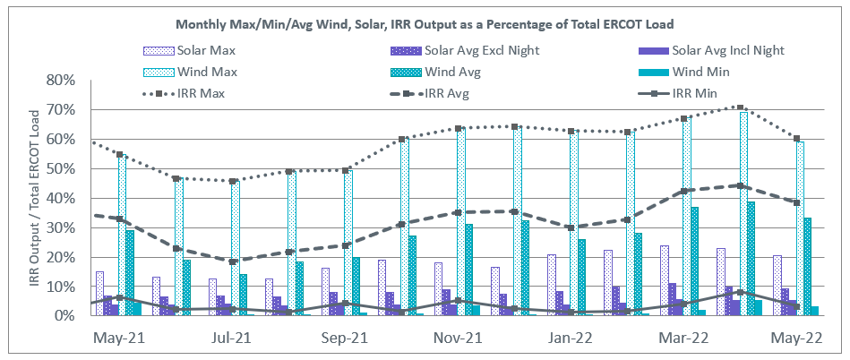

During the hour of peak load for the month, hourly integrated wind generation was 17,627 MW and solar generation was 7,118 MW. The graph below shows the wind and solar penetration percentage during the hour of the peak load in the last 13 months.

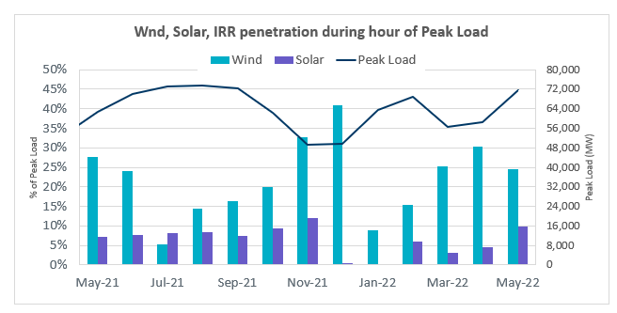

Lastly, the graph below shows the minimum wind, solar and IRR output during the peak load hour as a percentage of the daily peak load for every day in the month.

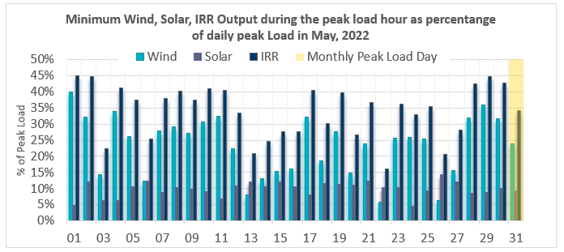

Largest Net-Load Ramps
The net-load ramp is defined as the change in net-load (load minus wind and PVGR generation) during the defined time horizon. Such a variation in net-load needs to be accommodated in grid operations to ensure that the reliability of the grid is satisfactorily maintained. The largest net-load ramp during 5-min, 10-min, 15-min, 30-min and 60-min in May 2022 was 1,647 MW, 1,663 MW, 2,154 MW, 4,140 MW, and 7,012 MW, respectively. The comparison with respect to the historical values is given in the table below.

Month and Year | 5 min | 10 min | 15 min | 30 min | 60 min
May 2014 | 914 MW | 1468 MW | 2264 MW | 3123 MW | 4331 MW
May 2015 | 1156 MW | 1770 MW | 2088 MW | 3242 MW | 5318 MW
May 2016 | 871 MW | 1324 MW | 1804 MW | 2945 MW | 4897 MW
May 2017 | 1109 MW | 1422 MW | 1883 MW | 3149 MW | 5348 MW
May 2018 | 1173 MW | 1330 MW | 1845 MW | 3382 MW | 6508 MW
May 2019 | 1066 MW | 1767 MW | 2483 MW | 4227 MW | 5146 MW
May 2020 | 988 MW | 1529 MW | 1852 MW | 3104 MW | 5757 MW
May 2021 | 1414 MW | 1664 MW | 1967 MW | 2874 MW | 4860 MW
May 2022 | 1,647 MW | 1,663 MW | 2,154 MW | 4,140 MW | 7,012 MW
All Months in 2014-2022 | 1,647 MW | 2,155 MW | 3,015 MW | 5,882 MW | 10,750 MW

COP Error Analysis
COP Error is calculated as the capacity difference between the COP HSL and real-time HSL of the unit. Mean Absolute Error (MAE) stayed over 7,000 MW until Day-Ahead at 12:00, then dropped significantly to 6,653 MW by Day-Ahead at 13:00. In the following chart, Under-Scheduling Error indicates that COP had less generation capacity than real-time and Over-Scheduling Error indicates that COP had more generation capacity than real-time.

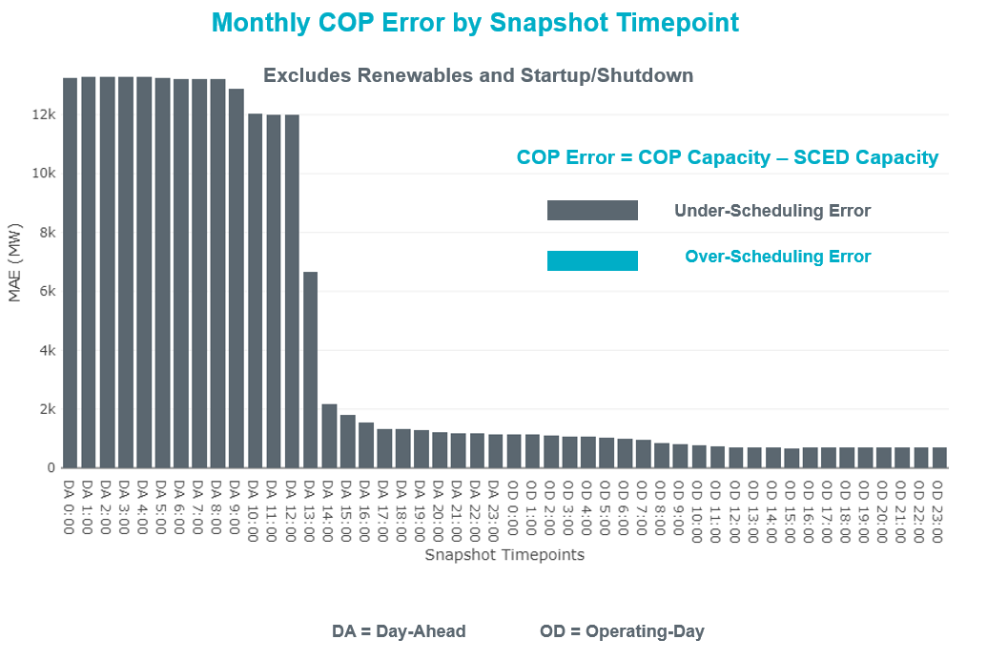

Monthly MAE for the Latest COP at the end of the Adjustment Period was 677 MW with median ranging from -1067.4 MW for Hour-Ending (HE) 18 to 453.5 MW for HE 9. HE 7 on 05/27/2022 had the largest Over-Scheduling Error (2049 MW) and HE 23 on 05/20/2022 had the largest Under-Scheduling Error (-3809 MW).

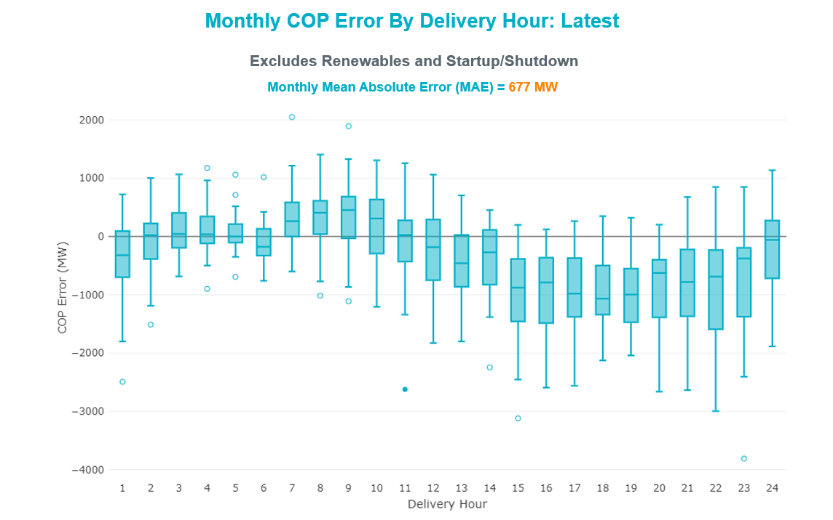

Monthly MAE for the Day-Ahead COP at 12:00 was 12,000 MW with median ranging from -18,762 MW for Hour-Ending (HE) 17 to -5,359 MW for HE 4. HE 18 on 05/14/2022 had the largest Under-Scheduling Error (-24,954 MW) and HE 24 on 05/21/2022 had the largest Over-Scheduling Error (7,567 MW).

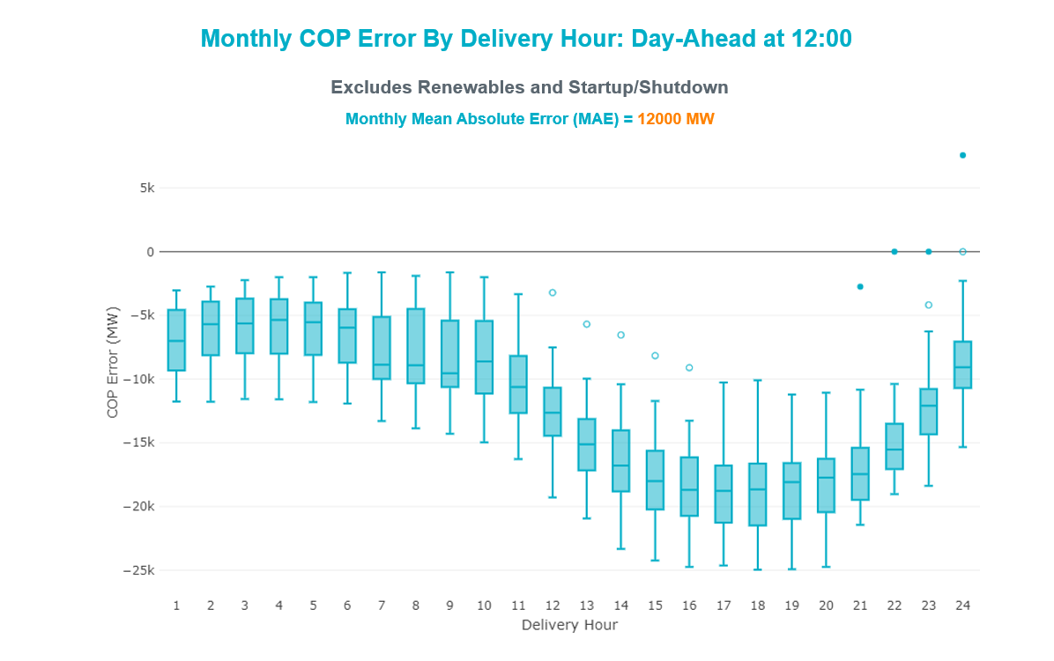

Congestion Analysis

Notable Constraints
Nodal protocol section 3.20 specifies that ERCOT shall identify transmission constraints that are binding in Real-Time three or more Operating Days within a calendar month. As part of this process, ERCOT reports congestion that meets this criterion to ROS. In addition, ERCOT also highlights notable constraints that have an estimated congestion rent exceeding $1,000 for a calendar month. These constraints are detailed in the table below, including approved transmission upgrades from TPIT that may provide some congestion relief based on ERCOT’s engineering judgement. Rows highlighted in blue indicate the congestion was affected by one or more outages. For a list of all constraints activated in SCED, please see Appendix A at the end of this report.

Contingency Name | Overloaded Element | # of Days Constraint Binding | Congestion Rent | Transmission Project
DTOKJK_5 | 260_A_1 | 29 | $130,150,841.93
BASE CASE | N_TO_H | 20 | $73,042,522.17
BASE CASE | WESTEX | 20 | $57,179,210.13
DSTPRED5 | CKT_3124_1 | 10 | $32,631,329.71
DSALKLN5 | KLNSW_MR2H | 7 | $28,981,110.96
BASE CASE | NE_LOB | 30 | $27,315,898.92 | The Lower Rio Grande Valley (LRGV) System Enhancement Project (21RPG017) will improve but not eliminate the need for this GTC.
BASE CASE | PNHNDL | 24 | $23,312,938.90
DSTEXP12 | BLESSI_LOLITA1_1 | 16 | $19,543,701.05
MFLCMDL5 | 6462__C | 15 | $19,057,388.78 | Oncor Midland East Area Project (21RPG003, MOD 57925) - NOTE: This project removes the overloaded element and reconfigures lines in the area, amongst other topology changes.
SSTPESP8 | BLESSI_PAVLOV1_1 | 13 | $16,327,604.76
DCAGBRA5 | PAWNEE_SPRUCE_1 | 16 | $13,638,469.60
DBLYWLF5 | JCKREF27_A | 1 | $13,174,948.43
DREFSTP5 | CKT_3124_1 | 3 | $12,254,542.65
SMDOPHR5 | G138_10B_1 | 15 | $12,211,974.69 | Rebuild Magnolia - Seminole 138 kV Line (4010)
XMDL58 | 6462__C | 3 | $11,693,319.82 | Oncor Midland East Area Project (21RPG003, MOD 57925) - NOTE: This project removes the overloaded element and reconfigures lines in the area, amongst other topology changes.
MHARNED5 | BURNS_RIOHONDO_1 | 19 | $10,275,567.61
BASE CASE | NELRIO | 28 | $9,458,140.75 | The Lower Rio Grande Valley (LRGV) System Enhancement Project (21RPG017) will improve but not eliminate the need for this GTC.
SCAGHIL5 | CAGNON_MR4L | 2 | $7,331,769.20
DHECWHI8 | RINCON_WHITE_2_1 | 6 | $6,461,639.21 | AEPTCC Whitepoint Area Improvements (50950)
DGIBTOK5 | 260_A_1 | 1 | $6,077,262.23
SHAYZO25 | 6T227_1 | 9 | $6,047,032.45
DWHILON5 | BLESSI_LOLITA1_1 | 8 | $6,015,983.91
SLOBSA25 | CATARI_PILONC1_1 | 18 | $5,939,845.70
SBRACAG5 | N5_R5_1 | 6 | $5,925,491.39
SLOBSA25 | LARDVN_LASCRU1_1 | 14 | $5,465,966.75 | Laredo VFT North to North Laredo Switch: Rebuild 138 kV Line (58008)
SSTABS18 | 6144__A | 22 | $4,679,598.96
SCABWES8 | ARCADI_SOUTH_1_1 | 3 | $4,665,020.66
SCOMKEN8 | 115T123_1 | 4 | $4,543,014.88
DCAGBRA5 | PAWNEE_XF1 | 4 | $4,367,264.52
DSALKLN5 | KLNSW_MR2L | 3 | $3,896,332.16
SHASTNN8 | G138_8B_1 | 3 | $3,711,849.78
SW_GODE5 | LUTHER_VEALMOR_1 | 2 | $3,705,066.93
DCALCAG5 | PAWNEE_XF1 | 7 | $3,453,959.76
SCMNCPS5 | 651__B | 9 | $3,392,675.41
BASE CASE | HHGTOM_1 | 15 | $3,280,692.70
DLWSRNK5 | RNKSW_MR2L | 2 | $3,269,735.59
SDBMFID5 | LPLHY_LPLDB_1 | 4 | $3,118,167.48
SBRAUVA8 | HAMILT_MAVERI1_1 | 20 | $3,061,732.08
SN_SAJO5 | LASPUL_RAYMND1_1 | 17 | $2,966,775.54
SFTLMES8 | CROSSO_NORTMC1_1 | 10 | $2,737,087.54
DELMSAN5 | PAWNEE_SPRUCE_1 | 2 | $2,709,816.27
SLAQLOB8 | FALFUR_PREMON1_1 | 24 | $2,560,054.47
DCALCAG5 | PAWNEE_SPRUCE_1 | 5 | $2,381,928.74
MJOSFOR8 | LOLITA_VICTOR1_1 | 3 | $2,293,186.95
SLGEI_D8 | HECKER_I_DUPS2_1 | 1 | $2,261,550.38
DCAGCO58 | 656T656_1 | 10 | $2,249,584.26
SLOBSA25 | GATEWT_WORMSE1_1 | 4 | $2,193,579.31
DCAGCI58 | 255T279_1 | 6 | $2,182,251.06
SBTPBNT8 | MYRA_VAL_1 | 12 | $2,155,966.61
SLCRCAS8 | LCRANE_RIOPEC1_1 | 2 | $2,061,411.16
DSTPANS5 | BLESSI_LOLITA1_1 | 2 | $2,045,199.87
SHLJSTP5 | CKT_3124_1 | 1 | $1,916,190.40
SMDLMOS5 | 6462__C | 3 | $1,905,904.03 | Oncor Midland East Area Project (21RPG003, MOD 57925) - NOTE: This project removes the overloaded element and reconfigures lines in the area, amongst other topology changes.
SKINFAL8 | FALFUR_PREMON1_1 | 20 | $1,836,646.52
DKG_NB_5 | BCVLY_03_A | 4 | $1,791,524.28
DODEMOS5 | ODEHV_MR1H | 4 | $1,739,484.30
XCAG158 | CAGNON_MR4H | 6 | $1,674,798.17
DELMSAN5 | BLESSI_LOLITA1_1 | 2 | $1,609,641.62
SN_SLON5 | CELANE_KLEBER1_1 | 5 | $1,523,482.72
DCAGBRA5 | COLETO_ROSATA1_1 | 5 | $1,509,935.13
DSALHUT5 | 270__A | 4 | $1,459,457.82
SSTPESP8 | LAN_CT_PAVLOV1_1 | 2 | $1,349,086.33
BASE CASE | WILBRN | 4 | $1,318,447.94
SBCESND5 | 421__A | 3 | $1,263,330.52
BASE CASE | BEARKT | 8 | $1,168,527.77
DMTSCOS5 | 6437__F | 6 | $1,093,000.34
SBRAHAM8 | HAMILT_MAVERI1_1 | 3 | $1,056,638.02
MHARNED5 | LASPUL_RAYMND1_1 | 10 | $1,054,835.55
DGRMGRS8 | 6830__B | 6 | $1,005,600.89
DTHSLCS5 | 282__A | 3 | $959,587.86
SLOBSA25 | FALFUR_PREMON1_1 | 3 | $892,825.79
SBIGSCH5 | CROSSO_NORTMC1_1 | 3 | $857,619.91
DWISALV8 | MYRA_VAL_1 | 6 | $826,465.69
DMGSMDS5 | MDSSW_MR1H | 4 | $788,709.54
SVICCO28 | COLETO_VICTOR2_1 | 7 | $785,461.32
XVIC89 | GREENL_NCARBI1_1 | 4 | $752,213.75
DLWSRNK5 | 587__A | 3 | $706,540.46
SKLELOY8 | LOYOLA_69_1 | 11 | $646,191.34
SMDOOAS5 | GN_PZ_08_A | 3 | $616,215.44
DFER_WI8 | 39T188_1 | 3 | $604,462.21
DLONOR58 | FALFUR_PREMON1_1 | 4 | $597,630.77
SBWDDBM5 | LPLMK_LPLNE_1 | 4 | $581,077.00
XKEN289 | BEEVIL_CHARTE1_1 | 3 | $567,822.95 | Poesta to Three Rivers (5166) - NOTE: This project removes the overloaded element and reconfigures lines in the area, amongst other topology changes.
DBIGKEN5 | TREADW_YELWJC1_1 | 10 | $553,244.80
XCAG158 | CAGNON_MR4L | 3 | $527,741.57
BASE CASE | BRIGHT_CHARTE1_1 | 29 | $500,212.58
SHCKRNK5 | 106__A | 3 | $465,046.25
DBIGKEN5 | HAMILT_MAXWEL1_1 | 12 | $459,882.64 | Hamilton Road to Maxwell: Line Rebuild (61396)
SWHILON5 | PELICA_WHITE_1_1 | 6 | $456,844.18
SENSENW8 | 943__B | 5 | $409,804.79
DFERSTA8 | 33T218_1 | 3 | $400,826.19
DGRSPKR5 | 6377__A | 7 | $389,747.77
DBEEPAL8 | 33T218_1 | 5 | $343,925.15
SN_SLON5 | HOLLY4_SOUTH_1_1 | 5 | $322,052.15
SMCCCNR5 | 1390__F | 3 | $293,568.99
SOXYIN28 | I_DUPP_I_DUPS1_1 | 4 | $272,567.46
SHONMOO8 | BIG_FO_MOORE1_1 | 5 | $247,686.52
BASE CASE | CULBSN | 4 | $246,757.36
DCAGCO58 | 583T583_1 | 3 | $225,314.90
DRNS_TB5 | THWZEN71_A | 3 | $223,810.34
DKG_NB_5 | JFSSC_06_A | 3 | $220,117.89
SBRAUVA8 | ESCOND_GANSO1_1 | 6 | $196,580.13 | Escondido - Ganso 138 kV Line Rebuild (55624)
SNEDLON5 | FALFUR_PREMON1_1 | 3 | $170,495.61
SLOBSA25 | BRUNI_69_1 | 4 | $151,780.02
SVANRAY8 | NUR_FORT_1 | 3 | $151,138.57
DJFSCGR8 | JFSSC_06_A | 4 | $140,348.29
SLAQLOB8 | BRUNI_69_1 | 6 | $107,689.22
SMADSAP8 | LVOK_PAW21_1 | 7 | $96,567.01
DWHILON5 | PAWNEE_TANGO1_1 | 3 | $89,455.94
DELMSAN5 | BEEVIL_NORMAN1_1 | 3 | $88,232.77 | Poesta to Tuleta (5167) - NOTE: This project removes the overloaded element and reconfigures lines in the area, amongst other topology changes.
SBRACAL5 | N5_R5_1 | 3 | $63,906.94
BASE CASE | MCCAMY | 3 | $55,966.55
SILLFTL8 | HAMILT_MAXWEL1_1 | 6 | $45,225.11 | Hamilton Road to Maxwell: Line Rebuild (61396)
SVANRAY8 | RAYBURN_69_2 | 4 | $43,588.14
SRICGRS8 | 6840__B | 3 | $43,450.94
SSANMAD8 | LVOK_PAW21_1 | 3 | $17,736.03
SGARBAT8 | 15010__B | 3 | $15,314.47

Generic Transmission Constraint Congestion
There were 30 days of congestion on the North to Houston GTC, 25 days on the West Texas Export GTC, 31 days on the North Edinburg to Lobo GTC, 26 days on the Panhandle GTC, 28 days on the Nelson Sharpe to Rio Hondo GTC, 5 days on the Wilbrn GTC, 9 days on the Bearkat GTC, 4 days on the Culberson GTC, 3 days on the McCamey GTC, 1 day on the Valley Export GTC, 1 day on the RV to RH GTC, and 1 day on the Valley Import GTC. There was no activity on the remaining GTCs during the month.

Note: This is how many times a constraint has been activated to avoid exceeding a GTC limit, it does not imply an exceedance of the GTC occurred or that the GTC was binding.

Manual Overrides
None

Congestion Costs for Calendar Year 2022
The following table represents the top twenty active constraints for the calendar year based on the estimated congestion rent attributed to the congestion. ERCOT updates this list on a monthly basis.

Contingency | Overloaded Element | # of 5-min SCED | Estimated | Transmission Project
Basecase | WESTEX GTC | 15517 | $178,444,281.37
Toksw-Gibcrk & Jk_Ck 345kV | Jewett - Singleton 345kV | 5461 | $130,189,451.26
SALSW TO KLNSW 345 DBLCKT | Killeen Switch 345kV | 10779 | $92,294,055.67
Basecase | N_TO_H GTC | 6509 | $73,657,158.27
Basecase | NE_LOB GTC | 20315 | $64,531,351.04 | The Lower Rio Grande Valley (LRGV) System Enhancement Project (21RPG017) will improve but not eliminate the need for this GTC.
TWR(345) JCK-REF27 & JCK-STP18 | Hillje - South Texas Project 345kV | 6637 | $62,964,035.25
Basecase | PNHNDL GTC | 10573 | $37,597,795.60
PH ROBINSON to MEADOW LIN A | Magnolia Tnp - Seminole Tnp 138kV | 11556 | $36,543,840.17 | Rebuild Magnolia - Seminole 138 kV Line (4010)
Manual dbl ckt for NEDIN-BONILLA 345kV & RIOH-PRIM138kV | Burns Sub - Rio Hondo 138kV | 11140 | $32,690,651.63
WDGSW TO MARSW 138 DBLCKT | Mistletoe Heights - Hemphill 138kV | 2078 | $30,437,608.94
STP SWITCH to Esperanza LIN 1 | Blessing - Pavlov 138kV | 6848 | $28,034,158.76
Cagnon-Calavers&Braunig 345kV | Pawnee Switching Station - Calaveras 345kV | 4181 | $20,273,972.23
South Texas # 1 & # 2 | Blessing - Lolita 138kV | 2221 | $19,546,337.82
LWSSW TO RNKSW AND LWSSW TO KRWSW 345 DBLCKT | Argyle - Highlands Tnp 138kV | 3626 | $19,084,728.31
MAN_SGL_ MDL-FLC_345_kV_w_MDL_XMFR1_FLC_AMR2 | Midland County Northwest Switch - Mockingbird 138kV | 1307 | $19,057,388.78 | Oncor Midland East Area Project (21RPG003, MOD 57925) - NOTE: This project removes the overloaded element and reconfigures lines in the area, amongst other topology changes.
CALF CREEK POI to NATURAL DAM LIN _A | Big Spring West - Stanton East 138kV | 7694 | $17,837,753.44
COMANCHE SWITCH (Oncor) to COMANCHE PEAK SES LIN _A | Comanche Tap - Comanche Switch (Oncor) 138kV | 8554 | $17,591,949.79
Basecase | NELRIO GTC | 18025 | $15,912,501.59 | The Lower Rio Grande Valley (LRGV) System Enhancement Project (21RPG017) will improve but not eliminate the need for this GTC.
TWR(345) JCK-STP18 & REF-STP27 | Hillje - South Texas Project 345kV | 4569 | $14,808,051.93
TWR(345) JOR-KG97 & JOR-NB99 | Bigvue - Lyondell 138kV | 3446 | $13,929,714.69

System Events

ERCOT Peak Load
The unofficial ERCOT peak load for the month was 71,632 MW and occurred on 05/31/2022, during hour ending 17:00.

Load Shed Events
None.

Stability Events
None.

Notable PMU Events
ERCOT analyzes PMU data for any significant system disturbances that do not fall into the Frequency Events category reported in section 2.1. The results are summarized in this section once the analysis has been completed.

There were no PMU events outside of those reported in section 2.1.

DC Tie Curtailment
There were no DC tie curtailments.

TRE/DOE Reportable Events
- Willow Springs WF submitted an OE-417 for 05/09/2022. Reportable Event Type: Damage or destruction of a facility.
- Brazos submitted an OE-417 for 05/14/2022. Reportable Event Type: Complete loss of monitoring or control capability.
- Oncor submitted an OE-417 for 05/15/2022. Reportable Event Type: Loss of electric service.
- CenterPoint submitted an OE-417 for 05/22/2022. Reportable Event Type: Loss of electric service.
- Austin Energy submitted an OE-417 for 05/31/2022. Reportable Event Type: Damage or destruction of a facility

New/Updated Constraint Management Plans
None.

New/Modified/Removed RAS
None.

New Procedures/Forms/Operating Bulletins
Date | Subject | Bulletin No.
5/4/2022 | Transmission and Security Desk V1 Rev 94 | 1039
5/25/2022 | Real Time Desk V1 Rev 81 | 1040
5/25/2022 | Resource Desk V1 Rev 69 | 1041
5/25/2022 | Scripts V1 Rev 42 | 1042
5/25/2022 | Shift Supervisor Desk V1 Rev 79 | 1043
5/25/2022 | Transmission and Security Desk V1 Rev 95 | 1044

Emergency Conditions

OCNs
Date and Time | Message
5/3/2022 9:30 CPT | ERCOT issued an OCN for Extreme Hot Weather with forecasted temperatures to be above 94°F in the North Central and South-Central weather zones, from Friday, May 6, 2022, until Monday, May 9, 2022.
5/3/2022 9:59 CPT | ERCOT issued an AAN due to a possible future Emergency Condition of reserve capacity deficiency beginning Friday, May 6, 2022, HE 15 until Saturday, May 7, 2022, HE 22. ERCOT updated the AAN on May 4 and May6. No additional capacity was needed in the AAN updated on May 6. No Outage Schedule Adjustment (OSA) was issued.
5/5/2022 13:00 CPT | At 13:00, ERCOT issued an AAN due to a possible future Emergency Condition of reserve capacity deficiency beginning Tuesday, May 10, 2022, HE 15 until Wednesday, May 11, 2022, HE 22. ERCOT updated the AAN on May 6. No additional capacity was needed in the AAN updated on May 6. No Outage Schedule Adjustment (OSA) was issued.
5/6/2022 9:28 CPT | ERCOT extended an OCN for the extreme hot weather with forecasted temperatures to be above 94°F in the North Central and South-Central weather zones, from Friday, May 6, 2022, until Thursday, May 12, 2022.
5/11/2022 9:00 CPT | ERCOT issued an OCN for the extreme hot weather with forecasted temperatures to be above 94°F in the North Central and South-Central weather zones, from Friday, May 13, 2022, until Wednesday, May 18, 2022.
5/11/2022 10:00 CPT | ERCOT issued an AAN due to a possible future Emergency Condition of reserve capacity deficiency beginning Friday, May 13, 2022, HE 15 until Monday, May 16, 2022, HE 22. ERCOT may Delay/Withdraw Approved or Accepted Resource Outages. ERCOT updated the AAN on May 12 and on May 12 at 10:00 ERCOT executed an OSA.
5/16/2022 9:30 CPT | ERCOT extended an OCN for the extreme hot weather with forecasted temperatures to be above 94°F in the North Central and South-Central weather zones, from Friday, May 13, 2022, until Friday, May 20, 2022.
5/26/2022 9:00 CPT | ERCOT issued an OCN for the extreme hot weather with forecasted temperatures to be above 94°F in the North Central and South-Central weather zones, from Saturday, May 28, 2022, until Monday, May 30, 2022.

Advisories
Date and Time | Message
5/8/2022 13:20 CPT | ERCOT has postponed the deadline for the posting of the DAM solution for Operating Day 05/09/2022 due to long running solution.

Watches
None.

Emergency Notices
None.

Application Performance

TSAT/VSAT Performance Issues
None.

Communication Issues
None.

Market System Issues
None.

Model Updates
The Downstream Production Change (DPC) process allows ERCOT to make changes in the on-line Network Operations Model without loading a completely new model. The purpose of this process is to allow for reliable grid operations as system conditions change between designated Network Operations Model database loads. The DPC process is limited in scope to just those items listed below, with equipment ratings updates being the most common. ERCOT has seen a rise in the use of the DPC process to make on-line updates to the Network Operations Model in recent years, instead of through the standard Network Operations Model Change Request process.

- Static Line ratings (Interim Update)
- Dynamic Line ratings (non-Interim Update)
- Autotransformer ratings (non-Interim Update)
- Breaker and Switch Normal status (Interim Update)
- Contingency Definitions (Interim Update)
- RAP and RAS changes or additions (Interim Update)
- Net Dependable and Reactive Capability (NDCRC) values (Interim Update)
- Impedance Updates (non-Interim)

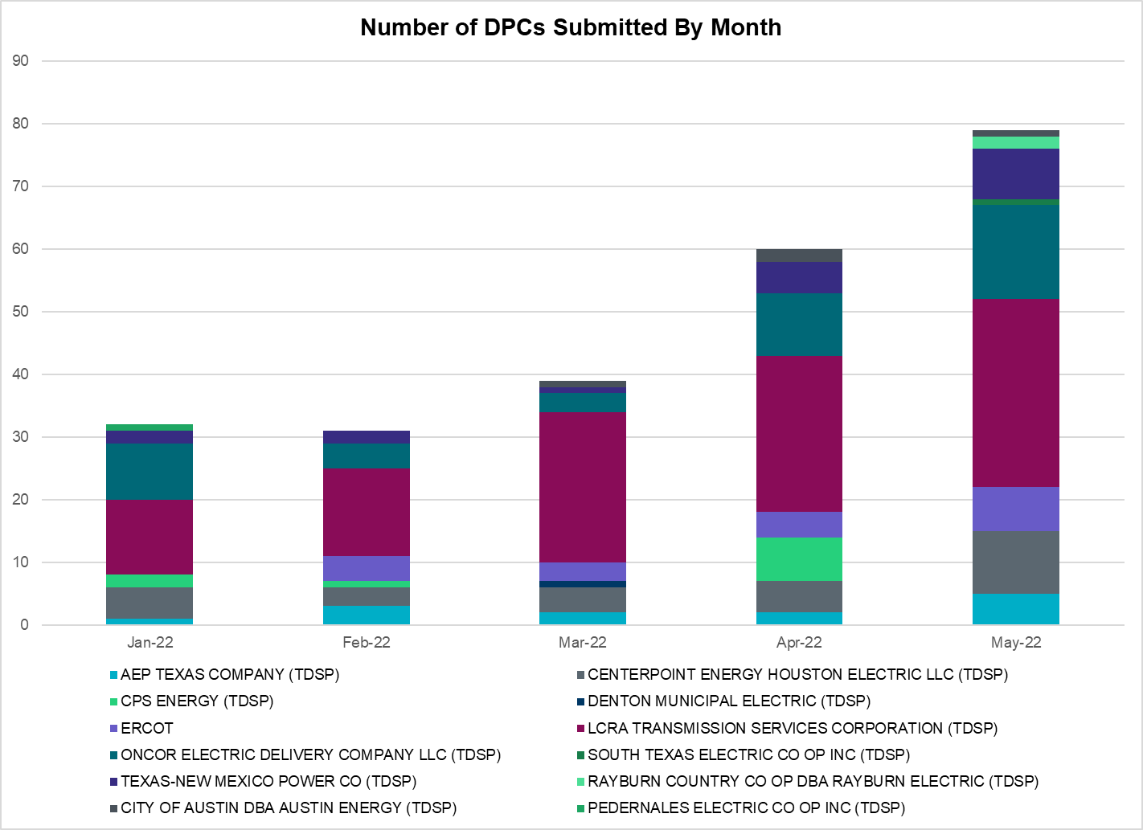

Transmission Operator | Number of DPCs
AEP TEXAS COMPANY (TDSP) | 5
BRAZOS ELECTRIC POWER CO OP INC (TDSP) | 0
BROWNSVILLE PUBLIC UTILITIES BOARD (TDSP) | 0
BRYAN TEXAS UTILITIES (TDSP) | 0
CENTERPOINT ENERGY HOUSTON ELECTRIC LLC (TDSP) | 10
CITY OF AUSTIN DBA AUSTIN ENERGY (TDSP) | 1
CITY OF COLLEGE STATION (TDSP) | 0
CITY OF GARLAND (TDSP) | 0
CPS ENERGY (TDSP) | 0
DENTON MUNICIPAL ELECTRIC (TDSP) | 0
ELECTRIC TRANSMISSION TEXAS LLC (TDSP) | 0
ERCOT | 7
LCRA TRANSMISSION SERVICES CORPORATION (TDSP) | 30
LONE STAR TRANSMISSION LLC (TSP) | 0
ONCOR ELECTRIC DELIVERY COMPANY LLC (TDSP) | 15
PEDERNALES ELECTRIC CO OP INC (TDSP) | 0
RAYBURN COUNTRY CO OP DBA RAYBURN ELECTRIC (TDSP) | 2
SHARYLAND UTILITIES LP (TDSP) | 0
SOUTH TEXAS ELECTRIC CO OP INC (TDSP) | 1
TEXAS MUNICIPAL POWER AGENCY (TDSP) | 0
TEXAS-NEW MEXICO POWER CO (TDSP) | 8

Appendix A: Real-Time Constraints
The following is a complete list of constraints activated in SCED. Full contingency descriptions can be found in the Standard Contingencies List located on the MIS secure site at Grid Generation Reliability Unit Commitment.

Contingency Name | Overloaded Element | From Station | To Station | Count of Days
BASE CASE | NE_LOB | n/a | n/a | 31
BASE CASE | N_TO_H | n/a | n/a | 30
BASE CASE | BRIGHT_CHARTE1_1 | BRIGHTSD | CHARTER | 30
DTOKJK_5 | 260_A_1 | JEWET | SNG | 30
BASE CASE | NELRIO | n/a | n/a | 28
BASE CASE | PNHNDL | n/a | n/a | 26
SLAQLOB8 | FALFUR_PREMON1_1 | FALFUR | PREMONT | 26
SSTABS18 | 6144__A | BSPRW | STASW | 25
BASE CASE | WESTEX | n/a | n/a | 25
SKINFAL8 | FALFUR_PREMON1_1 | FALFUR | PREMONT | 23
SBRAUVA8 | HAMILT_MAVERI1_1 | HAMILTON | MAVERICK | 21
SLOBSA25 | CATARI_PILONC1_1 | CATARINA | PILONCIL | 19
MHARNED5 | BURNS_RIOHONDO_1 | RIOHONDO | MV_BURNS | 19
SLOBSA25 | CATARI_PILONC1_1 | PILONCIL | CATARINA | 19
SN_SAJO5 | LASPUL_RAYMND1_1 | LASPULGA | RAYMND2 | 18
DSTEXP12 | BLESSI_LOLITA1_1 | LOLITA | BLESSING | 17
SMDOPHR5 | G138_10B_1 | SEMINOLE | MAGNO_TN | 17
SLOBSA25 | LARDVN_LASCRU1_1 | LARDVNTH | LASCRUCE | 17
DSTPRED5 | CKT_3124_1 | STP | HLJ | 16
DBIGKEN5 | HAMILT_MAXWEL1_1 | MAXWELL | HAMILTON | 16
SKLELOY8 | LOYOLA_69_1 | LOYOLA | LOYOLA | 16
BASE CASE | HHGTOM_1 | HHGT | OMEGA | 16
DCAGBRA5 | PAWNEE_SPRUCE_1 | PAWNEE | CALAVERS | 16
DCAGBRA5 | PAWNEE_SPRUCE_1 | CALAVERS | PAWNEE | 16
MFLCMDL5 | 6462__C | MCNSW | MKNGB | 16
SBTPBNT8 | MYRA_VAL_1 | MYRA | VALYVIEW | 15
DBIGKEN5 | TREADW_YELWJC1_1 | TREADWEL | YELWJCKT | 13
SSTPESP8 | BLESSI_PAVLOV1_1 | BLESSING | PAVLOV | 13
SLAQLOB8 | BRUNI_69_1 | BRUNI | BRUNI | 12
MHARNED5 | LASPUL_RAYMND1_1 | LASPULGA | RAYMND2 | 12
DWISALV8 | MYRA_VAL_1 | MYRA | VALYVIEW | 12
DCAGCO58 | 656T656_1 | KENDAL | BERGHE | 11
SFTLMES8 | CROSSO_NORTMC1_1 | NORTMC | CROSSOVE | 11
SVICCO28 | COLETO_VICTOR2_1 | COLETO | VICTORIA | 11
SHAYZO25 | 6T227_1 | HAYSEN | ZORN | 10
DODEMOS5 | ODEHV_MR1H | ODEHV | ODEHV | 10
DCAGCI58 | 255T279_1 | PIPECR | MEDILA | 10
SCMNCPS5 | 651__B | CMNSW | CMNTP | 10
DHECWHI8 | RINCON_WHITE_2_1 | WHITE_PT | RINCON | 10
DWHILON5 | BLESSI_LOLITA1_1 | LOLITA | BLESSING | 9
DJFSCGR8 | JFSSC_06_A | JFS | SC | 9
XCAG158 | CAGNON_MR4H | CAGNON | CAGNON | 9
SILLFTL8 | HAMILT_MAXWEL1_1 | MAXWELL | HAMILTON | 9
SLOBSA25 | ASHERT_CATARI1_1 | CATARINA | ASHERTON | 9
DRNS_TB5 | THWZEN71_A | ZEN | THW | 9
DSALKLN5 | KLNSW_MR2H | KLNSW | KLNSW | 9
SLOBSA25 | ASHERT_CATARI1_1 | ASHERTON | CATARINA | 9
DMTSCOS5 | 6437__F | SCRCV | KNAPP | 9
DREFSTP5 | CKT_3124_1 | STP | HLJ | 9
BASE CASE | BEARKT | n/a | n/a | 9
SBRAUVA8 | ESCOND_GANSO1_1 | GANSO | ESCONDID | 8
DGRMGRS8 | 6830__B | CRDSW | OLNEY | 8
DGRSPKR5 | 6377__A | BRTSW | ORANS | 8
SGARBAT8 | 15010__B | BLISS | ESTILES | 8
SGARBAT8 | 15010__B | ESTILES | BLISS | 8
DKENCA58 | 656T656_1 | KENDAL | BERGHE | 8
DRILTES5 | FARMLAND_LONGD_1 | FARMLAND | W_LD_345 | 8
XCAG158 | CAGNON_MR4L | CAGNON | CAGNON | 7
SBIGSCH5 | CROSSO_NORTMC1_1 | NORTMC | CROSSOVE | 7
SMADSAP8 | LVOK_PAW21_1 | LVOK | PAW2 | 7
SBRACAG5 | N5_R5_1 | CALAVERS | CAGNON | 7
DCALCAG5 | PAWNEE_XF1 | PAWNEE | PAWNEE | 7
DCAGCI58 | 656T656_1 | KENDAL | BERGHE | 7
DBEEPAL8 | 33T218_1 | WIRTZ | BURNET | 7
XMDL58 | 6462__C | MCNSW | MKNGB | 6
SMDLMOS5 | 6462__C | MCNSW | MKNGB | 6
DKG_NB_5 | BCVLY_03_A | BCV | LY | 6
SLOBSA25 | BRUNI_69_1 | BRUNI | BRUNI | 6
DFER_WI8 | 39T188_1 | FERGUS | WIRTZ | 6
SWHILON5 | PELICA_WHITE_1_1 | PELICAN | WHITE_PT | 6
DSALHUT5 | 270__A | KNBSW | TMPSW | 5
DMGSMDS5 | MDSSW_MR1H | MDSSW | MDSSW | 5
SENSENW8 | 943__B | SHKSW | ENWSW | 5
SN_SLON5 | CELANE_KLEBER1_1 | KLEBERG | CELANEBI | 5
DELMSAN5 | PAWNEE_SPRUCE_1 | PAWNEE | CALAVERS | 5
DWHILON5 | PAWNEE_TANGO1_1 | TANGO | PAWNEE | 5
SN_SLON5 | CELANE_KLEBER1_1 | CELANEBI | KLEBERG | 5
SHONMOO8 | BIG_FO_MOORE1_1 | MOORE | BIG_FOOT | 5
DLONOR58 | FALFUR_PREMON1_1 | FALFUR | PREMONT | 5
DVICEDN8 | FORMOS_JOSLIN1_1 | JOSLIN | FORMOSA | 5
DJFSFT_8 | JFSSC_06_A | JFS | SC | 5
DCALCAG5 | PAWNEE_SPRUCE_1 | CALAVERS | PAWNEE | 5
BASE CASE | WILBRN | n/a | n/a | 5
SLOBSA25 | FALFUR_PREMON1_1 | FALFUR | PREMONT | 5
SN_SLON5 | HOLLY4_SOUTH_1_1 | HOLLY4 | SOUTH_SI | 5
BASE CASE | ARAGORN_TIE_1 | ARAGORN | PINNAC | 5
DCAGBRA5 | COLETO_ROSATA1_1 | COLETO | ROSATA | 5
SBRAUVA8 | MAXWEL_WHITIN1_1 | MAXWELL | WHITING | 5
DELMSAN5 | PAWNEE_SPRUCE_1 | CALAVERS | PAWNEE | 5
DCAGBRA5 | PAWNEE_XF1 | PAWNEE | PAWNEE | 5
DFERSTA8 | 33T218_1 | WIRTZ | BURNET | 5
DCLECOU5 | FARMLAND_LONGD_1 | FARMLAND | W_LD_345 | 5
SBWDDBM5 | LPLMK_LPLNE_1 | LPLMK | LPLNE | 5
SENSENW8 | 943__B | ENWSW | SHKSW | 5
SNEDLON5 | FALFUR_PREMON1_1 | FALFUR | PREMONT | 5
SHCKRNK5 | 106__A | HCKSW | ALLNC | 5
DKENCA58 | 255T279_1 | PIPECR | MEDILA | 5
DTHSLCS5 | 282__A | LHLSW | LCSES | 5
SHASTNN8 | G138_8B_1 | HDNLAKES | LEAGCITY | 4
SBLSJAC8 | MYRA_VAL_1 | MYRA | VALYVIEW | 4
DMOLLO58 | PAWNEE_TANGO1_1 | TANGO | PAWNEE | 4
DLWSRNK5 | 587__A | ARGYL | LWSVH | 4
SSTPESP8 | LAN_CT_PAVLOV1_1 | PAVLOV | LAN_CTY | 4
DELMSAN5 | BIG_FO_MOORE1_1 | MOORE | BIG_FOOT | 4
SLOBSA25 | GATEWT_WORMSE1_1 | WORMSER | GATEWTP | 4
SMDOOAS5 | GN_PZ_08_A | GN | PZ | 4
DSALKLN5 | KLNSW_MR2L | KLNSW | KLNSW | 4
DWHILON5 | NCARBI_SEADRF1_1 | SEADRFTC | NCARBIDE | 4
SCOMKEN8 | 115T123_1 | KENDAL | KERRST | 4
DCAGCO58 | 583T583_1 | BANDER | MASOCR | 4
SBRAHAM8 | HAMILT_MAVERI1_1 | HAMILTON | MAVERICK | 4
SODLBRA8 | HAMILT_MAVERI1_1 | HAMILTON | MAVERICK | 4
SDBMFID5 | LPLHY_LPLDB_1 | LPLDB | LPLHY | 4
SVANRAY8 | RAYBURN_69_2 | RAYBURN | RAYBURN | 4
SWHILON5 | WHITE_PT_345A | WHITE_PT | WHITE_PT | 4
SOXYIN28 | I_DUPP_I_DUPS1_1 | I_DUPP1 | I_DUPSW | 4
SSPJFS8 | JFSSC_06_A | JFS | SC | 4
SRDOPEB8 | TRU_UAT1 | TRU | TRU | 4
SBCESND5 | 421__A | BCESW | SNDSW | 4
DPHRAL58 | G138_10B_1 | SEMINOLE | MAGNO_TN | 4
XVIC89 | GREENL_NCARBI1_1 | NCARBIDE | GREENLK | 4
BASE CASE | CULBSN | n/a | n/a | 4
SVANRAY8 | NUR_FORT_1 | NURSRYS | FORTRSW | 4
SSEWLEA8 | 33T218_1 | WIRTZ | BURNET | 3
MWAPCK25 | STPWAP39_1 | STP | WAP | 3
SCABWES8 | ARCADI_SOUTH_1_1 | ARCADIA | SOUTH_SI | 3
XKEN289 | BEEVIL_CHARTE1_1 | CHARTER | BEEVILLE | 3
SSANMAD8 | LVOK_PAW21_1 | LVOK | PAW2 | 3
SCARFRI8 | MADDUX_SAPOWE1_1 | MADDUX | SAPOWER | 3
DBUCKLN5 | 651__B | CMNSW | CMNTP | 3
DBIGKEN5 | CARVER_TINSLE1_1 | CARVER | TINSLEY | 3
DGIBTOK5 | 260_A_1 | JEWET | SNG | 3
DBT_SRB8 | BCVLY_03_A | BCV | LY | 3
DVICVI89 | COLETO_VICTOR2_1 | COLETO | VICTORIA | 3
DSWELNC5 | BLUF_C_MULBER1_1 | BLUF_CRK | MULBERRY | 3
SN_SAJO5 | FALFUR_PREMON1_1 | FALFUR | PREMONT | 3
MJOSFOR8 | LOLITA_VICTOR1_1 | VICTORIA | LOLITA | 3
BASE CASE | NEDIN_138H | NEDIN | NEDIN | 3
DELMSAN5 | BEEVIL_NORMAN1_1 | BEEVILLE | NORMANNA | 3
DVICCO89 | COLETO_VICTOR1_1 | COLETO | VICTORIA | 3
DWHILON5 | EDNA_VICTOR1_1 | VICTORIA | EDNA | 3
DWISALV8 | SPR_VALY_1 | VALYVIEW | SPR | 3
DKG_NB_5 | JFSSC_06_A | JFS | SC | 3
DVICEDN8 | LOOP_VICTORIA_1 | VICTORIA | L_463S | 3
DELMSAN5 | POT_OAKS_1 | POTEETS | OAKS9 | 3
SRICGRS8 | 6840__B | NVKSW | ANARN | 3
SILLFTL8 | CARVER_TINSLE1_1 | CARVER | TINSLEY | 3
SLCRCAS8 | LCRANE_RIOPEC1_1 | RIOPECOS | LCRANE | 3
SBTPBNT8 | SPR_VALY_1 | VALYVIEW | SPR | 3
SMCCCNR5 | 1390__F | MESFR | BCKHM | 3
SODLBRA8 | ESCOND_GANSO1_1 | GANSO | ESCONDID | 3
SDIMBEV8 | HAMILT_MAVERI1_1 | HAMILTON | MAVERICK | 3
BASE CASE | MCCAMY | n/a | n/a | 3
DWHILON5 | MELONC_RINCON1_1 | RINCON | MELONCRE | 3
SBRACAL5 | N5_R5_1 | CALAVERS | CAGNON | 3
DGRMGRS8 | 6840__B | NVKSW | ANARN | 3
SVEAW_L5 | 6217__A | WLVSW | GAILS | 2
SSIEMOL8 | DEL_MA_LAREDO1_1 | LAREDO | DEL_MAR | 2
DELMSAN5 | BLESSI_LOLITA1_1 | LOLITA | BLESSING | 2
SBLESTP5 | BROOKH_P_LAVA1_1 | P_LAVACA | BROOKHOL | 2
XTHR89 | CHARTE_THREER1_1 | CHARTER | THREER69 | 2
SSPUSLT8 | DKEC_GIRA_T1_1 | GIRA_TAP | DKEC | 2
DFRIILL8 | HAMILT_MAXWEL1_1 | MAXWELL | HAMILTON | 2
SZEPCMN8 | HLD_FMR1 | HLD | HLD | 2
SW_GODE5 | LUTHER_VEALMOR_1 | VEALMOOR | LUTHER | 2
DSTPANS5 | NCARBI_SEADRF1_1 | SEADRFTC | NCARBIDE | 2
BASE CASE | NEDIN_138L | NEDIN | NEDIN | 2
DLWSRNK5 | RNKSW_MR2L | RNKSW | RNKSW | 2
DMTSCOS5 | 6240__C | SACRC | DPCRK | 2
SSCLWF18 | 6840__B | NVKSW | ANARN | 2
SBONNED5 | BURNS_RIOHONDO_1 | RIOHONDO | MV_BURNS | 2
SHLJSTP5 | CKT_3124_1 | STP | HLJ | 2
SZEPCMN8 | CONAN_SANA1_1 | SANA_TAP | CONAN | 2
MWBAUVA8 | LAPRYO_UVALDE1_1 | UVALDE | LAPRYOR | 2
SCARLVO8 | MADDUX_SAPOWE1_1 | MADDUX | SAPOWER | 2
SVANRAY8 | VND_PLCE_1 | PLCEDOS | VANBLT69 | 2
DSALHUT5 | 1710__C | BELCNTY | SALSW | 2
SSAMTH35 | 505__B | FBRSW | THSES | 2
SENWSHK8 | 941__C | ENWSW | ENSSO | 2
SCARFRI8 | ATSO_SONR1_1 | SONR | ATSO | 2
DSTPANS5 | BLESSI_LOLITA1_1 | LOLITA | BLESSING | 2
STANPAW5 | CALLIC_LON_HI1_1 | LON_HILL | CALLICOA | 2
DKOCNUE8 | CHAMPL_WEIL_T1_1 | WEIL_TRC | CHAMPLIN | 2
SSPUSLT8 | ROBY_ROTN1_1 | ROTN | ROBY | 2
SSPUSLT8 | SPUR_69_1 | SPUR | SPUR | 2
DGBYCRN8 | BCVLY_03_A | BCV | LY | 2
DELMTEX5 | BLESSI_LOLITA1_1 | LOLITA | BLESSING | 2
SBUNLON8 | FALFUR_PREMON1_1 | FALFUR | PREMONT | 2
STRECFL8 | MADDUX_SAPOWE1_1 | MADDUX | SAPOWER | 2
DKENCA58 | 398T389_1 | BERGHE | HAYSEN | 2
DSALKLN5 | 630__B | KLNSW | HHSTH | 2
SCAGHIL5 | CAGNON_MR4L | CAGNON | CAGNON | 2
DGILHIW8 | GILA_MAYO1_1 | GILA | MAYO | 2
SLGEI_D8 | I_DUPS_LGE1_1 | LGE | I_DUPSW | 2
SCAGCA25 | R5_U3_1 | BRAUNIG | CAGNON | 2
DRNKLWS5 | RNKSW_MR2L | RNKSW | RNKSW | 2
XTHO88 | VICTORIA_69A2 | VICTORIA | VICTORIA | 2
DTHSLCS5 | 281__A | THSES | LHLSW | 2
MBUZKOC8 | 6217__A | WLVSW | GAILS | 2
DCLASCO5 | 6437__F | SCRCV | KNAPP | 2
XCA2G58 | CAGNON_MR3H | CAGNON | CAGNON | 2
DVANEDN8 | EDNA_VICTOR1_1 | VICTORIA | EDNA | 2
SBRAHAM8 | ESCOND_GANSO1_1 | GANSO | ESCONDID | 2
MWAPWL25 | STPWAP39_1 | STP | WAP | 2
DCAGCO58 | 398T389_1 | BERGHE | HAYSEN | 2
SMIDLO28 | FALFUR_PREMON1_1 | FALFUR | PREMONT | 2
SCABWES8 | HOLLY4_SOUTH_1_1 | HOLLY4 | SOUTH_SI | 2
MMADSP28 | MADDUX_SAPOWE1_1 | MADDUX | SAPOWER | 2
SMV_PAR8 | RIOHND_ERIOHND_1 | MV_RIOHO | RIOHONDO | 2
DODESLT8 | 6471__A | MGSES | MCDLD | 2
SSPUSLT8 | ASPM_69T2 | ASPM | ASPM | 2
DBLYWLF5 | BLESSI_PAVLOV1_1 | BLESSING | PAVLOV | 2
DCAGBRA5 | BLESSI_LOLITA1_1 | LOLITA | BLESSING | 2
DMBDBNB5 | 161__A | CMBSW | TVWSW | 1
DGIBSNG5 | 260_A_1 | JEWET | SNG | 1
DCAGCI58 | 398T389_1 | BERGHE | HAYSEN | 1
DWSHNAV5 | 6377__A | BRTSW | ORANS | 1
DCAGTA58 | 656T656_1 | KENDAL | BERGHE | 1
SBOMJC25 | 6626__F | BTTSW | HENWE | 1
SCM2DCS8 | 805__A | DCSES | CMBSW | 1
DSTEXP12 | BROOKH_P_LAVA1_1 | P_LAVACA | BROOKHOL | 1
MHARNED5 | BURNS_HEIDLBRG_1 | MV_BURNS | MV_HBRG4 | 1
DSTEXP12 | FORMOS_JOSLIN1_1 | JOSLIN | FORMOSA | 1
SORE2B8 | FOSPT_25_A | PT | FOS | 1
DBLYJCK5 | JCKREF27_A | REF | JCK | 1
SLOBSA25 | LASCRU_MILO1_1 | LASCRUCE | MILO | 1
DBIGKEN5 | MADDUX_SAPOWE1_1 | SAPOWER | MADDUX | 1
DCC1DUKE | NEDIN_138H | NEDIN | NEDIN | 1
SWHILON5 | NUECES_WHITE_2_1 | NUECES_B | WHITE_PT | 1
SSANFOW5 | SNMIG_AEPCHKCN_1 | SANMIGL | CHOKCNYN | 1
SDOWMOO8 | UVALDE_W_BATE1_1 | UVALDE | W_BATESV | 1
DCOLFA59 | VICTO_WARBU_1A_1 | VICTORIA | WARBURTN | 1
DMGSBTR5 | 6036__A | TKWSW | MGSES | 1
DSCOTKW5 | 6215__A | BCKSW | CGRSW | 1
SABNABN8 | ANSN_RADIUM1_1 | RADIUM | ANSN | 1
SHICGAR8 | CKT_962_1 | GARFIELD | STONEY_R | 1
SSTLEST8 | CRTVLE_EINSTEN_1 | EINSTEIN | CRTRVLLE | 1
SPOMNED5 | FREER_LOBO1_1 | LOBO | FREER | 1
DKG_NB_5 | GBYUV_03_A | GBY | UV | 1
DLCRKIN8 | LCRANE_RIOPEC1_1 | RIOPECOS | LCRANE | 1
DSTEXP12 | LOLITA_VICTOR1_1 | VICTORIA | LOLITA | 1
SLP2LPL9 | LPLER_LPLMK_1 | LPLMK | LPLER | 1
SMDSLNG5 | MGSES_MR4L | MGSES | MGSES | 1
DODESLT8 | PECNGRV_SMIDLA_1 | PECN_GRV | SMIDLAND | 1
BASE CASE | RIOHND_ERIOHND_1 | MV_RIOHO | RIOHONDO | 1
BASE CASE | THOMASTN_PS1 | THOMASTN | THOMASTN | 1
BASE CASE | VALEXP | n/a | n/a | 1
SELMTH25 | WEAST_XF1H | WEAST | WEAST | 1
SMARZOR5 | 419T419_1 | CLEASP | MARION | 1
DSWECCR5 | 6036__A | MGSES | TKWSW | 1
DCDHTVW5 | 6200__D | SHRSW | PRKRW | 1
SW_SDIV5 | 6216__B | WLVSW | SHRNE | 1
DCPSST58 | 651__B | CMNSW | CMNTP | 1
DRILKRW5 | 6626__F | BTTSW | HENWE | 1
DWSHNAV5 | 6626__F | BTTSW | HENWE | 1
DPRSVLS5 | 870__A | COMSW | COMSO | 1
SBLESTP5 | BLESSI_LOLITA1_1 | LOLITA | BLESSING | 1
SCBEDYN8 | BLESSI_LOLITA1_1 | LOLITA | BLESSING | 1
SVICCOL8 | COLETO_VICTOR1_1 | COLETO | VICTORIA | 1
SSTLEIN8 | CRTVLE_EINSTEN_1 | EINSTEIN | CRTRVLLE | 1
SILLFTL8 | CTHR_DOLAN1_1 | CTHR | DOLAN | 1
SN_SLON5 | LOYOLA_69_1 | LOYOLA | LOYOLA | 1
DJACALV8 | MYRA_VAL_1 | MYRA | VALYVIEW | 1
SNEDSTE5 | NEDIN_138L | NEDIN | NEDIN | 1
BASE CASE | N_SHARPE_PS3 | N_SHARPE | N_SHARPE | 1
SFTPFTP8 | RAINEY_WALNTT1_1 | WALNTTAP | RAINEYCR | 1
DELMSAN5 | RAY_VANB_1 | RAYBURN | VANBLTSS | 1
DBLYWLF5 | REFSTP27_A | STP | REF | 1
XSAP89 | SANORTH_69T1 | SANORTH | SANORTH | 1
DBWNAMO5 | SAPOWE_SAST1_1 | SAPOWER | SAST | 1
DCALCAG5 | SMG_ELMCRK1_1 | SANMIGL | ELMCREEK | 1
DBLYWLF5 | STPWAP39_1 | STP | WAP | 1
BASE CASE | SWEETWN3_XF31 | SWEETWN3 | SWEETWN3 | 1
DBBSJEW5 | 235__A | SJNSW | JEWET | 1
DFERGRM8 | 33T218_1 | WIRTZ | BURNET | 1
DSALKLN5 | 610__A | BLTON | TMSTH | 1
DSCOFAR5 | 6216__B | WLVSW | SHRNE | 1
SWDDMNS5 | 870__A | COMSW | COMSO | 1
SSTOGA28 | CKT_963_1 | GARFIELD | HICROSS | 1
XVIC89 | GREENL_WEAVER1_1 | GREENLK | WEAVERRD | 1
DZORHAY5 | H3_K0_1 | K0 | H3 | 1
SSCUBOZ8 | I20_RC_COMBI_1 | COMBINRC | I20_RC | 1
DBAKSOL5 | LYNX_TOMBST1_1 | LYNX | TOMBSTNE | 1
STANPAW5 | MELONC_SEADRF1_1 | MELONCRE | SEADRFTC | 1
SLOBSA25 | MILO_MINES_1_1 | MILO | MINES_RD | 1
SN_SAJO5 | MV_YUT_RAYMND1_1 | RAYMND2 | MV_YUTT | 1
DSTPANS5 | PAWNEE_TANGO1_1 | TANGO | PAWNEE | 1
DVICEDN8 | RAY_VANB_1 | RAYBURN | VANBLTSS | 1
DDUPHE18 | RINCON_WHITE_2_1 | RINCON | WHITE_PT | 1
DLWSRNK5 | RNKSW_MR2H | RNKSW | RNKSW | 1
BASE CASE | VALIMP | n/a | n/a | 1
SGRILON5 | VICTO_WARBU_1A_1 | VICTORIA | WARBURTN | 1
DSTEXP12 | 155T217_1 | BELLSO | PT | 1
SBBSJE25 | 50__A | BBSES | JEWET | 1
SGDNTEL5 | 6094__B | ANDNR | MSTNG | 1
DBUCBWN5 | 651__B | CMNSW | CMNTP | 1
SSANMAD8 | ARROTT_HULD1_1 | HULD | ARROTT | 1
SCOLBAL8 | BALLIN_HUMBLT1_1 | BALLINGE | HUMBLTAP | 1
SMDOOAS5 | BCVLY_03_A | BCV | LY | 1
DSTPHLJ5 | CKT_3124_1 | STP | HLJ | 1
SSTOGA28 | CKT_963_1 | HICROSS | GARFIELD | 1
DLONWEI8 | FALFUR_PREMON1_1 | FALFUR | PREMONT | 1
MTVWJON5 | HOOD_DECRDVA_1 | DCDAM | HOD | 1
SCRDJON5 | HOOD_DECRDVA_1 | DCDAM | HOD | 1
DRNKLWS5 | RNKSW_MR2H | RNKSW | RNKSW | 1
BASE CASE | RV_RH | n/a | n/a | 1
DABPAB98 | SOUTHA_VINSON1_1 | SOUTHABI | VINSON | 1
SPRAWAL8 | 155T217_1 | BELLSO | PT | 1
SFMRRYS5 | 400__A | FMRVL | RYSSW | 1
DCAGCO58 | 419T419_1 | CLEASP | MARION | 1
DKENCA58 | 419T419_1 | CLEASP | MARION | 1
SW_SW_L5 | 6216__B | WLVSW | SHRNE | 1
SGRMGRS8 | 6840__B | NVKSW | ANARN | 1
DMNSCHS5 | 690__C | SSPSW | LBRPD | 1
SNLSCRL8 | 710__A | CRLNW | NLSES | 1
STANPAW5 | CHARTE_THREER1_1 | CHARTER | THREER69 | 1
SOR2RS8 | FOSPT_25_A | PT | FOS | 1
SLOBSA25 | FREER_LOBO1_1 | LOBO | FREER | 1
SPHRHDN8 | G138_10B_1 | SEMINOLE | MAGNO_TN | 1
SCT2CAR8 | HAMILT_MAXWEL1_1 | MAXWELL | HAMILTON | 1
SN_SLON5 | HOLLY4_SERDEV1_1 | HOLLY4 | HOLLY4 | 1
DDUPHE18 | I_DUPS_MCCAMP2_1 | I_DUPSW | MCCAMPBE | 1
DBLYWLF5 | JCKREF27_A | REF | JCK | 1
SKELLA_8 | LASPUL_RAYMND1_1 | LASPULGA | RAYMND2 | 1
SNEDLON5 | LASPUL_RAYMND1_1 | LASPULGA | RAYMND2 | 1
DLCRCAS8 | LCRANE_RIOPEC1_1 | RIOPECOS | LCRANE | 1
DSTPANS5 | MELONC_RINCON1_1 | RINCON | MELONCRE | 1
DVANELT8 | NUR_FORT_1 | NURSRYS | FORTRSW | 1
SFTLMES8 | RIOPEC_SCROSS1_1 | RIOPECOS | SCROSSTP | 1
SCRTEIL8 | RKYROAD_ESTILE_1 | ESTILES | RCKYROAD | 1
DCDHTVW5 | 310__A | LIGSW | NORSW | 1
DCAGTA58 | 419T419_1 | CLEASP | MARION | 1
DMGSQAL5 | 6095__D | LMESA | JPPOI | 1
DMGSQAL5 | 6471__A | MGSES | MCDLD | 1
SSPUSLT8 | ASPM_CONA1_1 | ASPM | CONA | 1
DSTPRED5 | BLESSI_PAVLOV1_1 | BLESSING | PAVLOV | 1
SLOLBLE8 | BROOKH_P_LAVA1_1 | P_LAVACA | BROOKHOL | 1
DCAGTA58 | H3_K0_1 | K0 | H3 | 1
XHOC89 | HOCKR_53_A | KR | HOC | 1
DBLYWLF5 | JCKSTP18_A | STP | JCK | 1
DSCOTKW5 | KOCHTAP_VEALM_1 | VEALMOOR | KOCHTAP | 1
DLWSRNK5 | 570__A | CRNTH | ARGYL | 1
DCLECOU5 | 6216__B | WLVSW | SHRNE | 1
DSTEXP12 | ANGSTR_WHITE_1_1 | WHITE_PT | ANGSTROM | 1
BASE CASE | BLESSI_LOLITA1_1 | LOLITA | BLESSING | 1
SHICGAR8 | CKT_962_1 | STONEY_R | GARFIELD | 1
UFO1FOR1 | FORMOS_JOSLIN1_1 | JOSLIN | FORMOSA | 1
SLGEI_D8 | HECKER_I_DUPS2_1 | I_DUPSW | HECKER | 1
SW_SW_L5 | LUTHER_VEALMOR_1 | VEALMOOR | LUTHER | 1
SHLJST25 | MELONC_RINCON1_1 | RINCON | MELONCRE | 1
DSABRA89 | UVALDE_W_BATE1_1 | UVALDE | W_BATESV | 1

Current Wind Generation Record: 27,044 MW on 05/29/2022 at 21:36 | Current Wind Penetration Record: 69.15% on 04/10/2022 at 01:43 Current Solar Generation Record: 9,227 MW on 05/16/2022 at 12:09 | Current Solar Penetration Record: 23.85% on 03/19/2022 at 13:41
This is the hourly integrated peak demand as published in the ERCOT D&E report.

