Microsoft Edge Configuration Guide
Version 1.0

Document Revisions
Date | Version | Description | Author(s)
06/15/2022 | 1.0 | Initial posted version migrated from IE 11 Configuration Guide | Bob Blackard

Table of Contents
1. Introduction 1
2. Purpose 1
3. Scope 1
4. Configuration settings for Microsoft Edge 2
5. Browsing with Internet Explorer Compatibility Mode 5
6. Appendix – Managing digital certificates 7
6.1. Exporting a digital certificate 9
6.2. Importing a digital certificate 14
7. Appendix – Using profiles 17
7.1. Selecting profiles 17
7.2. Managing profiles 18
7.3. Changing a profile name or avatar 19
7.4. Removing a profile 19
7.5. Adding a profile 20

Introduction
The purpose of this document is to provide Market Participants with information about configuration settings for Microsoft’s Edge browser. These configuration settings are expected to provide better compatibility to access ERCOT’s external-facing browser-based applications using Edge. ERCOT used the configuration settings provided in this document as the baseline to test external-facing, browser-based applications using Edge. A list of ERCOT external-facing browser-based applications is included below.
ERCOT’s Enterprise Architecture manages the overall technology lifecycle for browsers, which includes platform compatibility.

Purpose
In May 2021, Microsoft announced the end of support for all versions of Internet Explorer (IE), including IE 11. The most detailed explanation, including retirement for their current Windows 10 Operating System, is covered in an FAQ:

“…the Internet Explorer 11 desktop application will go out of support and be retired on June 15, 2022 for certain versions of Windows 10.”

While the above statement is specific to Windows 10, the FAQ covers end-of-support information for other operating system versions, both end user and server.

Based on this, ERCOT has published a policy of ending support for IE 11 on all Market-facing applications as of June 15, 2022. ERCOT has decided to support Chromium-based browsers, specifically Microsoft Edge and Google Chrome.

ERCOT is publishing this Microsoft Edge configuration guide in response to the above announcement. The guide provides directions for those Market Participants who intend to deploy Microsoft Edge in their corporate environment.

Scope
The scope of this guide applies to the following applications:
- Market Management System (MMS)
- Renewable Energy Credit (REC)
- Retail
  - Market Data Transparency
  - MarkeTrak
  - (Create Enrollment)
  - (Create Move In)
  - (Create Move Out)
  - (Delete CSA)
  - (Establish CSA)
  - (Find ESIID)
  - (Find Transactions)
- Market Participant Identify Management (MPIM)
- Market Information System (MIS)
  - Application
  - Download
  - Portal
- Eenergy (Siebel UI)
  - Eservices (Service Requests)
  - Eservices (Settlement Disputes)
- ETOD
- Extract Subscriber
- PGC Extracts (Extract Subscriber)
- Report Explorer

Configuration settings for Microsoft Edge
The following are the minimum recommended settings for Microsoft Edge.

- In Microsoft Edge, click the ellipsis to open the menu.
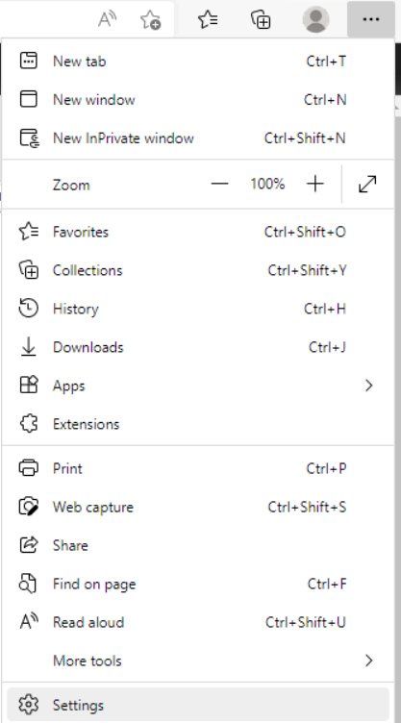
- Select Settings to open the Settings page.
- Select Privacy, search, and services from the navigation panel.
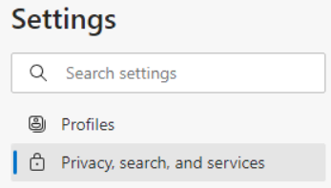
- Configure as follows.
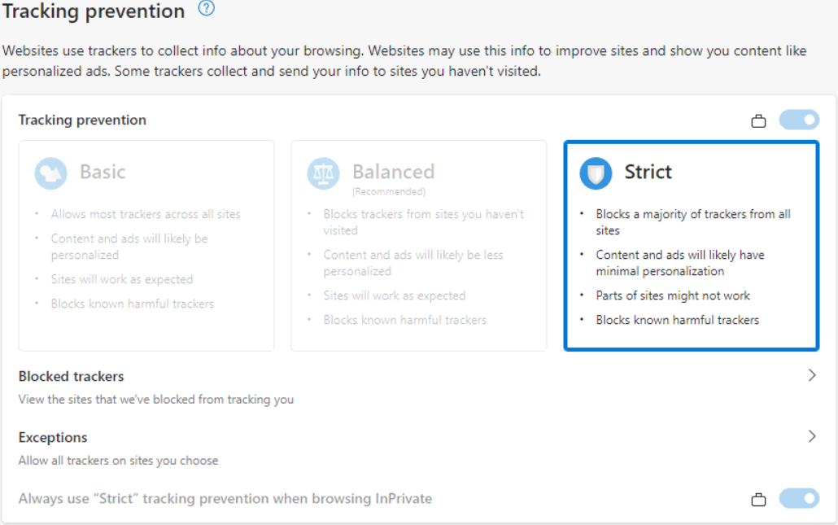
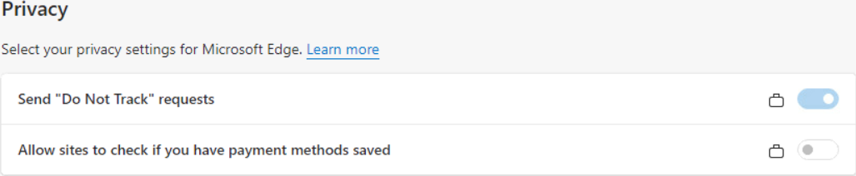
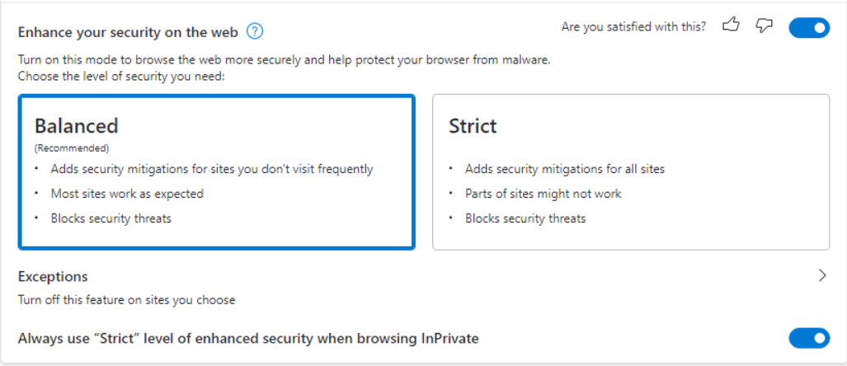
Optional

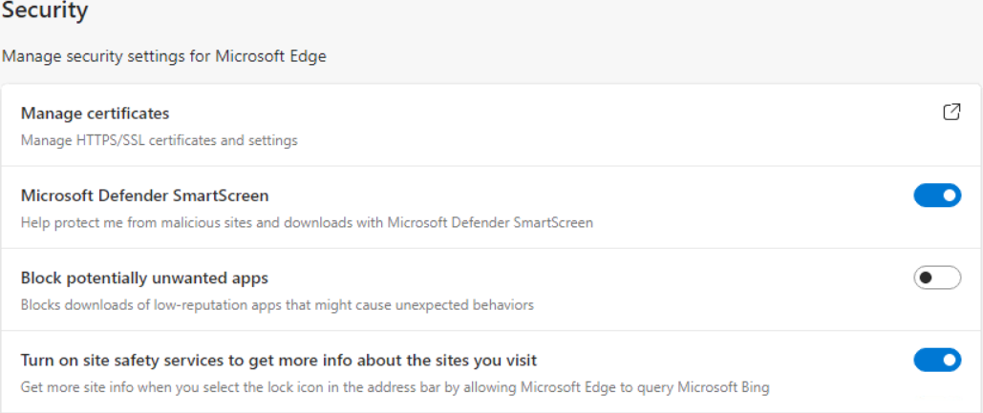

- Close the Settings page.
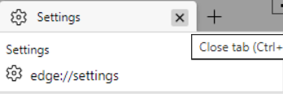

Browsing with Internet Explorer Compatibility Mode
Some non-ERCOT sites used by Market Participants may use systems that render best in the Internet Explorer compatibility mode of Microsoft Edge for a short time. While there are options such as plug-ins, Microsoft Edge provides an integrated configuration to support this.

- In Microsoft Edge, click the ellipsis to open the menu.
- Select Settings to open the Settings page.
- Select Default browser from the navigation panel.
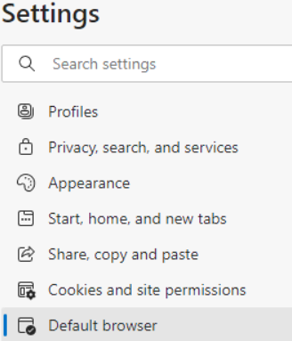
- Under Internet Explorer compatibility section, set the option to Allow sites to be loaded in Internet Explorer mode.
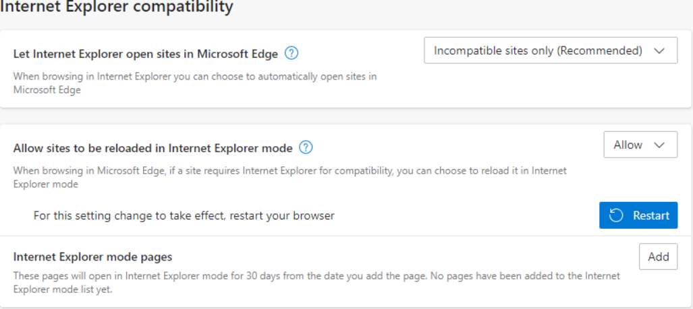
- Click to restart Microsoft Edge and enable these settings.
You can return to this page and click 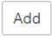 to add any sites that require this mode.

Appendix – Managing digital certificates
Market Participants use digital certificates to authenticate access to external applications. You may need to import your certificates into Microsoft Edge.

- In Microsoft Edge, click the ellipsis to open the menu.
- Select Settings to open the Settings page.
- Select Privacy, search, and services options from the navigation panel.
- Under the Security section, select Manage certificates.
- This will open the Certificates management window.
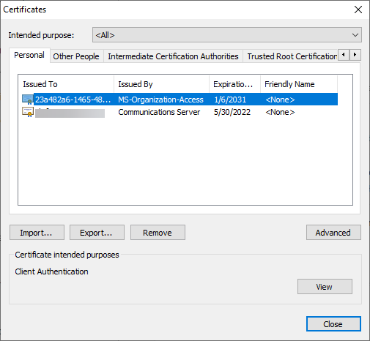
- Once complete, click
- Close the Settings page.

Exporting a digital certificate

- In the Certificates management window, select the certificate and click and the Certificate Export Wizard will open.
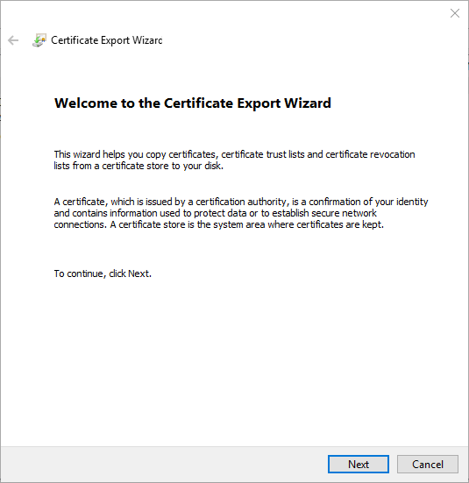
- Click and follow the wizard.

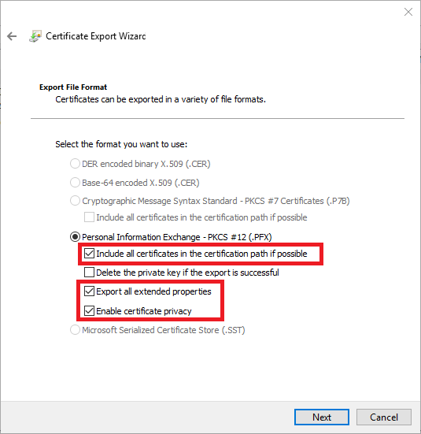
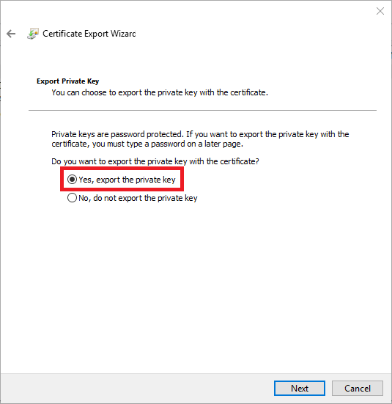

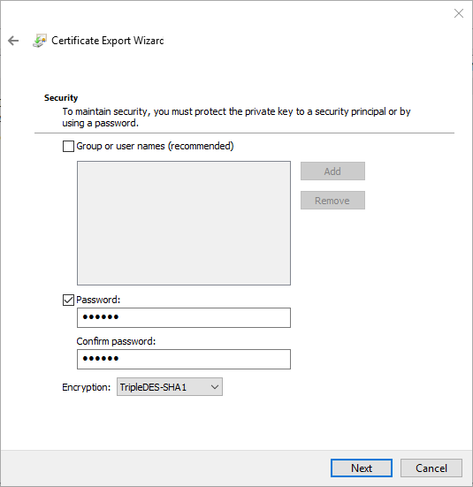
In order to keep your certificate safe, a password is required. Remember your password, as you will need it to import your certificate. Once created, click the Next button.

Name the certificate, giving it a meaningful name, and save it to a location you can remember, as you will need to go back this location to import. Click the Next button.
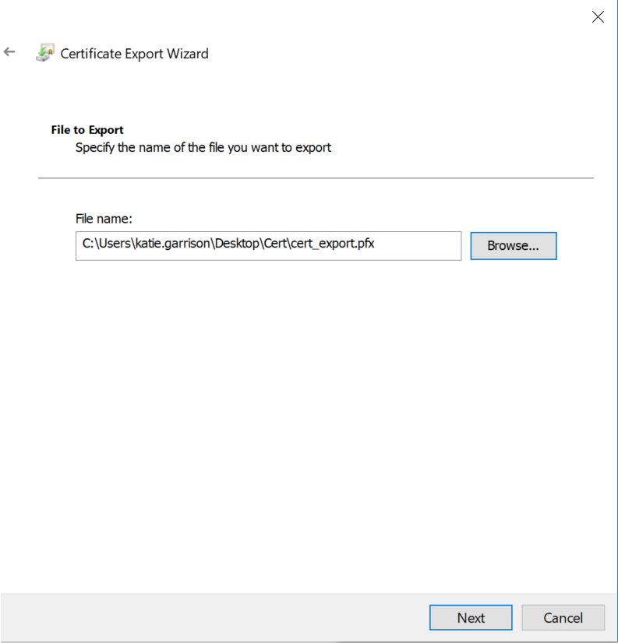

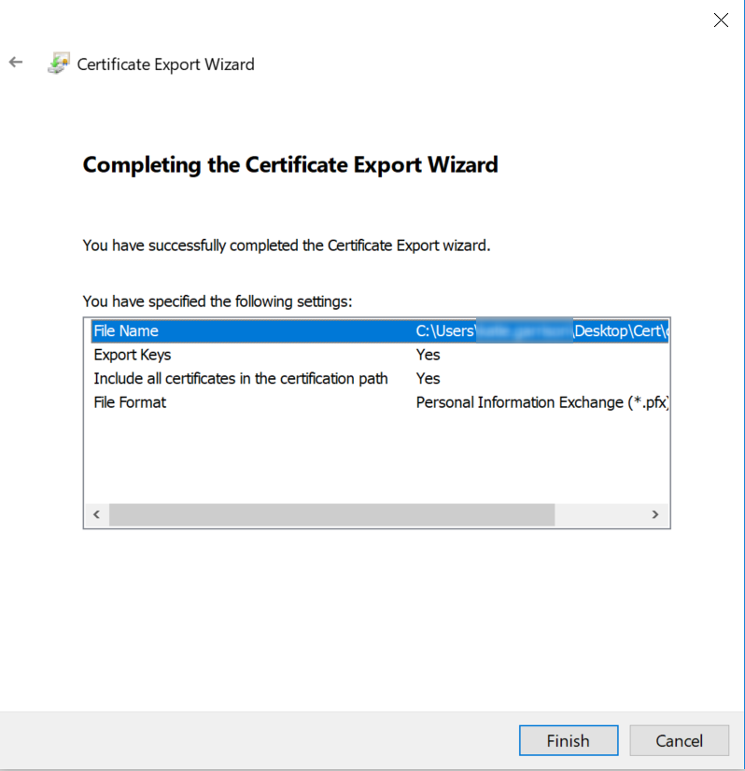

You will get a message stating, “The export was successful.”

Importing a digital certificate

- In the Certificates management window, select the certificate and click and the Certificate Import Wizard will open.
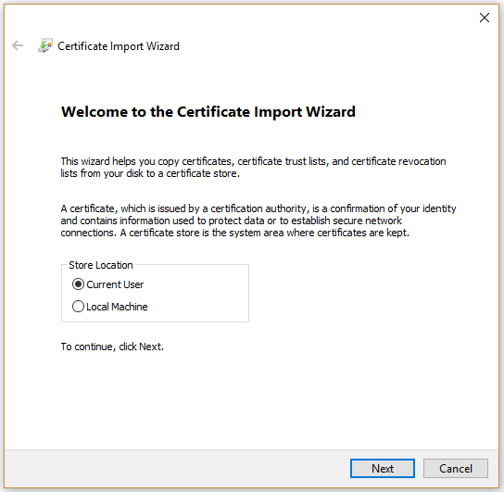
- Click and follow the wizard.

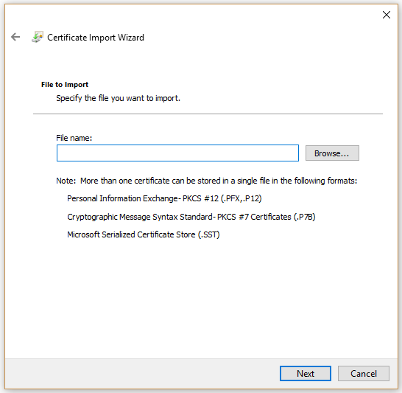
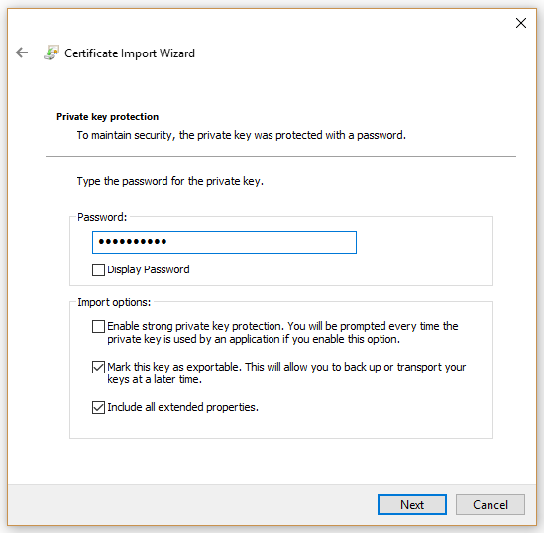

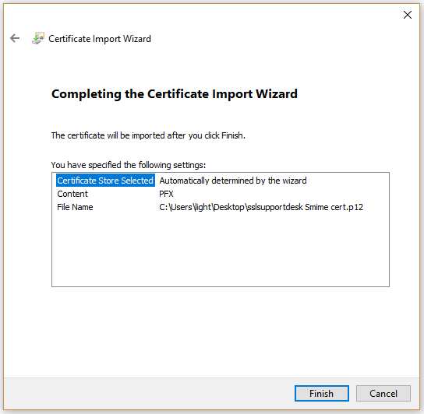
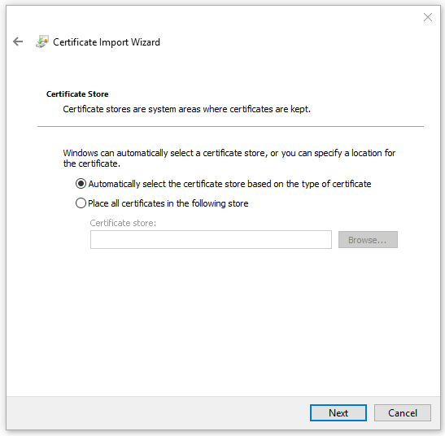
You will get a message stating, “The import was successful.”

Appendix – Using profiles
Some Market Participants use multiple digital certificates for certain ERCOT sites. ERCOT recommends using multiple profiles within Chromium-based browsers, such as Microsoft Edge, for easier use when utilizing multiple digital certificates. By opening different browser windows with different profiles, separate digital certificates can be used.
Microsoft Edge caches digital certificate bindings to respective profiles at the Microsoft Edge application level. This means that all windows and tabs with that profile will use the same digital certificate once one has been selected. When a browser window for any profile that is not bound to a digital certificate connects to a site that uses Digital Certificate Mutual Authentication, the user must select the digital certificate to use. Unbinding a digital certificate from any given profile requires all Microsoft Edge windows to be closed and for Microsoft Edge to be restarted.
This guide assumes very limited use of profiles specifically related to digital certificates. Many profile configuration options are excluded since they are not relevant.

Selecting profiles
Users select the profile by clicking the profile avatar next to the address bar.
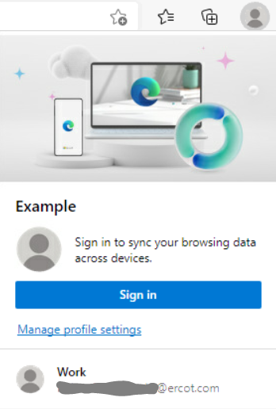
In this example, the current profile uses a default gray avatar and shows at the top, the example profile in this case. Other available profiles are shown below the active profile. In this view, the only other currently available option is Work.
By clicking on one of the available profiles, a new browser window will open and be bound to that profile.
In the event a browser window for the selected profile is already open, that browser window will be activated.

Managing profiles
Profiles are managed through the Microsoft Edge Settings page.

- In Microsoft Edge, click the ellipsis to open the menu.
- Select Settings to open the Settings page.
- Select Profiles from the navigation panel.
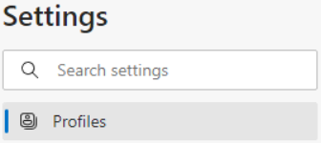
This will allow you to edit settings for the current profile, remove the current profile, switch between profiles, or create new profiles. Close the Settings page when done.

- Close the Settings page.

Changing a profile name or avatar
The profile name or avatar can be changed by switching to that profile and editing as follows.

- Click the ellipsis menu for the profile.
- Click 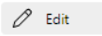
- Edit the name and select the avatar in the Edit profile pop-up.
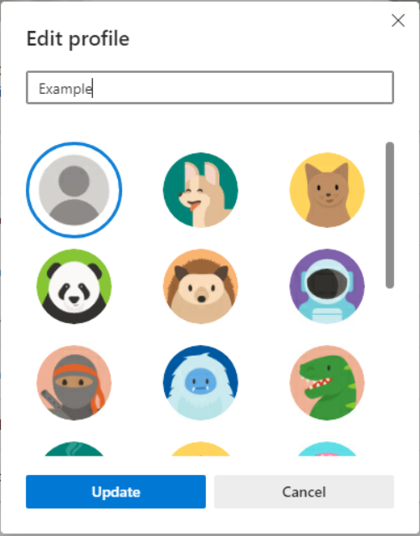
- Click to close the pop-up.

Removing a profile
Profiles can be removed by switching to that profile and removing as follows.

- Click the ellipsis menu for the profile.
- Click
- Confirm by clicking

This will remove the profile and close the browser window(s) associated with it.

Adding a profile
Profiles can be added as follows.

- Click to bring up the Add profile pop-up.
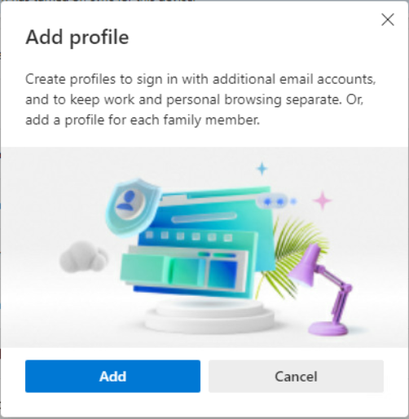
- Click to create the new profile and open a new browser window.
- Follow instructions in 7.2 Managing profiles and 7.3 Changing a profile name or avatar above as required.

Internet Explorer 11 desktop app retirement FAQ

