Methodology to Develop the High Impact Transmission Elements (HITEs) List

March 24, 2022

Background

The Outage Coordination Improvements Task Force (OCITF) was formed in February 2015 to determine the applicability and criteria for considering the economic impact of outages. The OCITF discussed several options to improve the outage coordination process related to the economic impact of outages, including items that were ultimately rejected after consulting with WMS and ROS (like developing tools to simulate and forecast the economic impact of outages and rejecting outages that were projected to have a high economic impact).
Following nine stakeholder meetings over the course of a year, ERCOT submitted the OCITF-developed NPRR758. Improved Transparency for Outages Potentially Having a High Economic Impact which introduced language to:
- Identify a list of Outages that are likely enough to result in high congestion costs that they will receive specific categorization and treatment. This list will be seeded based on historic congestion and finalized through a stakeholder review process to account for upgrades and other changes that would affect the predictive value of the list.
- Encourage earlier submission of these Outages.
- Formalize a rescheduling process when these Outages must be moved due to Forced Outages or later-arriving generator Outages.
- Provide improved transparency to Market Participants when Outages with this potential congestion impact are submitted with less than 90 days’ notice.
PRS and TAC approved NPRR758 in May 2016 and the ERCOT BOD approved it in June 2016. Although the recommended implementation date for NPRR758 was in September 2017, TAC requested ERCOT, along with WMS and ROS, to begin developing the High Impact Transmission Elements (HITEs) list for TAC approval, with the intent of posting this HITE list prior to the implementation of the rest of the NPRR. The purpose of this document is to describe the process by which ERCOT staff and stakeholders will identify the HITEs and develop the HITE list.
In 2017, the OCITF transitioned into a standing ERCOT Working Group, the Outage Coordination Working Group, (OCWG), a working group of ROS reporting jointly to both ROS and WMS in order to facilitate the stakeholder review described in this document. This provided a single working group where the level of detailed discussion needed for this review could occur, rather than having a similar discussion in a ROS working group and also in a WMS working group. In March 2019, ROS voted to amend the Operations Working Group (OWG) scope to absorb the HITE list process from OCWG.

methodology

Seed List of Potential HITEs
On an annual basis, ERCOT will produce a seed list beginning with the Major Transmission Elements (MTEs) on the currently approved HITE list. ERCOT will add any MTEs that are not included in the currently-approved HITE list from outages associated with significant congestion in the past, based on analyses to produce the Operations Report submitted to ROS each month, incorporating data from the previous 12-months, May 1st of the previous year to April 30th of the current year.
  - Significant congestion refers to congestion that incurred over $1 million of real-time congestion rent during any given month.
  - When multiple outages are attributed as causing significant congestion, perhaps in combination, up to three outages are included based on their sensitivities to the congestion.
  - Both forced and planned outages are included.
  - For each item on the seed list, ERCOT will specify a basis for that item’s inclusion.
There are many different Transmission Elements (breakers, switches, etc.) whose outage may interrupt flow on a particular line, transformer or bus (which, for the purpose of this procedure will be defined as Major Transmission Elements). Rather than include each of the Elements that interrupts flow on one of these MTEs, the seed list will only list the MTEs corresponding to the items listed on the sources above. This should facilitate the stakeholder discussion of which MTEs should be on the HITE list, rather than trying to use a more-detailed list. Once TAC has approved the list, as described below, ERCOT will process the list to identify each Transmission Element associated with interruption of flow on the approved set of MTEs on the HITE list to produce the final Detailed HITE List that will be posted and used for comparing to Outages in order to identify High Impact Outages.
Stakeholder Input and Review
By June 1st, ERCOT will provide the seed list of MTEs to the OWG for stakeholder review and input. This seed list will be provided in a format that facilitates clear discussion about individual items on the list. ERCOT may make non-substantive corrections to the seed list; for example, removing duplicate MTEs or correcting spelling errors.
Stakeholders may propose MTEs to be added to or removed from the seed list. A private submission process will be conducted initially whereby stakeholders may send proposed additions directly to ERCOT. ERCOT and the affected TDSPs will review the MTE additions during the private submissions timeframe for reasonableness. A revised MTE list will be published by ERCOT based on this review on or before July 20th of each calendar year. Stakeholders may then pursue additions or removals via a public submission process to be conducted between July 20th and August 1st of each calendar year. Public submissions will be sent by the proposer to the OWG list serve. OWG should attempt to reach a consensus decision about whether to add or remove each of these elements from the seed list.
Proposers should provide a detailed explanation of why each proposed element should be added to or removed from the list. For example, a stakeholder may propose to remove an element because the element will no longer result in congestion when outaged because a relevant transmission project has been (or will be) completed prior to the timeframe for which the HITE list will be used. For another example, a stakeholder may propose to add an element to the list because a new generating unit has come online that will cause the outage of the element to result in significant congestion that was not experienced for that outage in the past because the new unit was not injecting into the grid.
Timing
Two timing factors are considered while developing the HITE review process:
- Align the effective date of the HITEs list with the major outage seasons. In ERCOT, the majority of planned outages occur March to May and October to November.
- Provide adequate grace period for TDSPs to plan complex transmission projects. The proposed timeline allows a five-month grace period.
Annually, ERCOT will provide the MTE seed list by June 1st. This will allow Market Participants time to evaluate the proposed list prior to the June OWG meeting.
OWG will review the initial seed list in June. In August, OWG will also review elements proposed by stakeholders to be added or removed due to upgrades or other system changes. If OWG consensus is achieved, the OWG Chair will seek endorsement by ROS and WMS of the resulting list. If OWG cannot reach consensus on all of the proposed additions or removals, the Chair of OWG will seek a decision on the list, and the inclusion of any non-consensus elements, from ROS and WMS. The Chair of ROS will subsequently seek approval of the resulting MTE list, and a decision on any elements about whose inclusion ROS and WMS did not agree, from the TAC.
Upon TAC approval, the HITE list will take effect for outages scheduled to begin on or after March 1st of the following year. If TAC approval is obtained after September 30, the implementation date will be extended beyond March 1st on a day-for-day basis.
The “HITE List Timeline and Flowchart” document more fully describes the key dates for stakeholder input into this process. There are several guidelines related to this process:
- If a key deadline such as a private or public submission due date falls on a holiday or weekend, it will be considered received on time if provided to the OWG list serve on the following business day.
- The OWG Chair will attempt to schedule the August working group meeting such that the August 1st public submission requests will have been provided to the OWG list serve for review at least two weeks before the August working group meeting.
- Market participants should provide notice to the OWG list serve regarding MTE additions/removals submitted by another market participant that are disputed or that require discussion during an OWG meeting.

HITE List Process Timeline
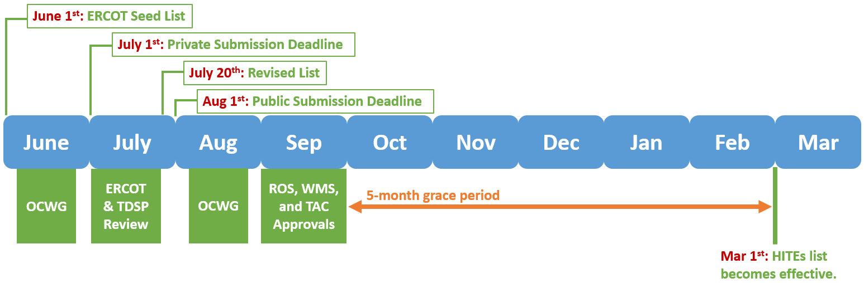
OWG
OWG
Posting
Once TAC has approved the MTE list, ERCOT will process the list to identify each Transmission Element associated with the approved set of MTEs on the HITE list to produce the final Detailed HITE List that will be posted on the MIS.

