

System Planning

**Monthly Status Report**

Report Highlights

* ERCOT is currently reviewing proposed transmission improvements with a total estimated cost of $1.345 3 billion as of May 31, 2022.
* Transmission Projects endorsed in 2022 total $739.97 million as of May 31, 2022.
* All projects (in engineering, routing, licensing, and construction) total approximately $8.03 billion[1] as of February 1, 2022.
* Transmission Projects energized in 2022 total approximately $105.48 million[2] (as of February 1, 2022).

Regional Planning Group Reviews

RPG Projects under Review:

* Oncor has submitted the Roanoke Area Upgrades Project (RPG Project ID: 22RPG003). This is a Tier 1 project that is estimated to cost $285.9 million. This project is currently under ERCOT’s independent review.
* LCRA TSC has submitted the Hays Energy – Kendall Corridor Transmission Line Rehabilitation Projects (RPG Project ID: 22RPG005). This is a Tier 1 project that is estimated to cost $399.9 million. This project is currently under ERCOT’s independent review.
* LCRA TSC, Oncor, and WETT have jointly submitted the Bearkat – North McCamey – Sand Lake 345-kV Transmission Line Addition Project (RPG Project ID: 22RPG010). This is a Tier 1 project that is estimated to cost $477.6 million. This project is currently in the RPG study mode.
* LCRA TSC has submitted the Fayetteville – Salem Transmission Line Rehabilitation Project (RPG Project ID: 22RPG011). This is a Tier 3 project that is estimated to cost $77.8 million. The RPG review of this project was completed on May 11. Pursuant to the Protocol Section 3.11.4.3.1 (d), this project has been reclassified as a Tier 4 neutral project.
* CNP has submitted the Partial Rebuild 69-kV Deepwater to Clinton Ckt 33 Project (RPG Project ID: 22RPG012). This is a Tier 3 project that is estimated to cost $55.91 million. The RPG review of this project was completed on May 19. Pursuant to the Protocol Section 3.11.4.3.1 (d), this project has been reclassified as a Tier 4 neutral project.
* Oncor has submitted the Wolf Switch - Moss Switch 138 kV Line Rebuild Project (RPG Project ID: 22RPG013). This is a Tier 3 project that is estimated to cost $56.2 million. The project is currently in the RPG comment period.
* Oncor has submitted the Red Oak Area Upgrades Project (RPG Project ID: 22RPG014). This is a Tier 3 project that is estimated to cost $63 million. The project is currently in the RPG comment period.
* Oncor has submitted the Tyler Switch – Forest Grove Switch 138 kV Line Project (RPG Project ID: 22RPG015). This is a Tier 3 project that is estimated to cost $62.7 million. The project is currently in the RPG comment period.

RPG Project Reviews Completed in 2022:

|  |  |  |  |  |  |
| --- | --- | --- | --- | --- | --- |
| RPG Project ID | RPG Project Name | Submitted Entity | Tier | Estimated Cost  ($ Millions) | Review Completion Month |
| 21RPG021 | Mulberry Creek 345 kV Station Improvements Project | AEPSC/Oncor | Reclassified from Tier 3 to Tier 4 per Protocol | 49.2 | January |
| 21RPG022 | Marshall Ford-Ruther Ford 138 kV Line Rebuild Project | PEC | Reclassified from Tier 3 to Tier 4 per Protocol | 28.8 | January |
| 21RPG023 | Barrilla Junction 69 kV loop Rebuild and Conversion Project | AEPSC | Tier 3 | 44 | January |
| 21RPG024 | Tungsten 138/69 kV Station Transmission Project | AEPSC | Reclassified from Tier 3 to Tier 4 per Protocol | 34.9 | January |
| 22RPG001 | Greens Bayou to Clinton 138 kV Conversion Project | CNP | Reclassified from Tier 3 to Tier 4 per Protocol | 88.5 | February |
| 22RPG002 | Abilene South to Putnam 138 kV Transmission Line Rebuild Project | AEPSC | Reclassified from Tier 3 to Tier 4 per Protocol | 31.5 | March |
| 22RPG004 | Pulsar to Victoria 138 kV Line Rebuild project | AEPSC | Reclassified from Tier 3 to Tier 4 per Protocol | 75.7 | March |
| 22RPG006 | Consavvy 345/138 kV Switch Project | Oncor | Tier 3 | 90.2 | April |
| 22RPG007 | Lenorah Area 345/138 kV Project | Oncor/WETT | Tier 3 | 45.2 | April |
| 20RPG019 | Nacogdoches Southeast Switch – Redland Switch – Lufkin Switch 345 kV Loop | Oncor | Tier 2 | 71.26 | April |
| 22RPG008 | Bowman Switch 345/138 kV Autotransformers Project | Oncor | Tier 3 | 13 | April |
| 22RPG009 | Eden to North Brady 69 kV Line Rebuild Project | AEPSC | Reclassified from Tier 3 to Tier 4 per Protocol | 34 | April |
| 22RPG011 | Fayetteville – Salem Transmission Line Rehabilitation Project | LCRA TSC | Reclassified from Tier 3 to Tier 4 per Protocol | 77.8 | May |
| 22RPG012 | Partial Rebuild 69 kV Deepwater to Clinton Ckt 33 Project | CNP | Reclassified from Tier 3 to Tier 4 per Protocol | 55.91 | May |

More information on current and past RPG projects can be found on the ERCOT MIS Secure (digital certificate required): https://mis.ercot.com/secure/data-products/grid/regional-planning

Past email communication on RPG projects can be found on the ERCOT listserv by signing up for the REGPLANGROUP list: <http://lists.ercot.com/scripts/wa-ERCOT.exe?A0=REGPLANGROUP>

Planning Model Activities

The short-term calendar of major planning model events is as follows:

* By July 1, 2022 22SSWG cases, in PSS/E 35, and TPIT will be posted
* By July 21, 2022 22SSWG Contingency definitions & Planning Data Dictionary will be posted

The following table shows interconnection projects that met Planning Guide section 6.9(1) and 6.9(2) and were modeled in the SSWG cases as a full model or as a simple model in accordance with Planning Guide section 6.9.



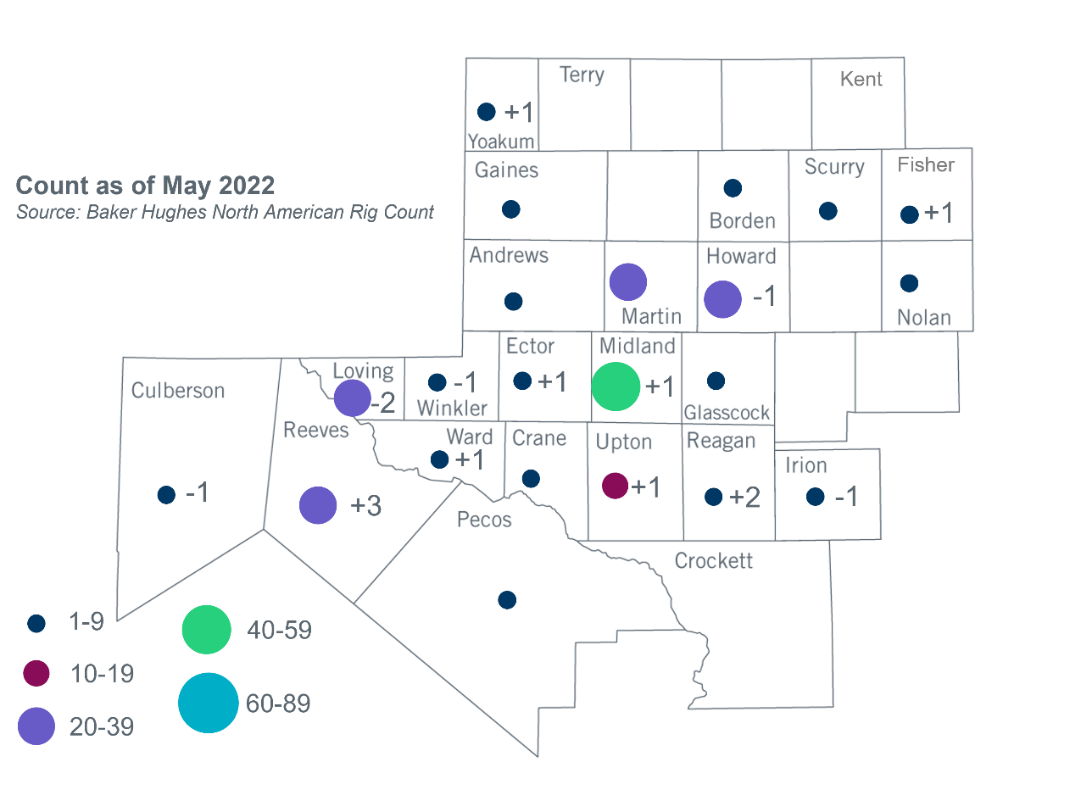Permian Basin Oil Rig Count[3]

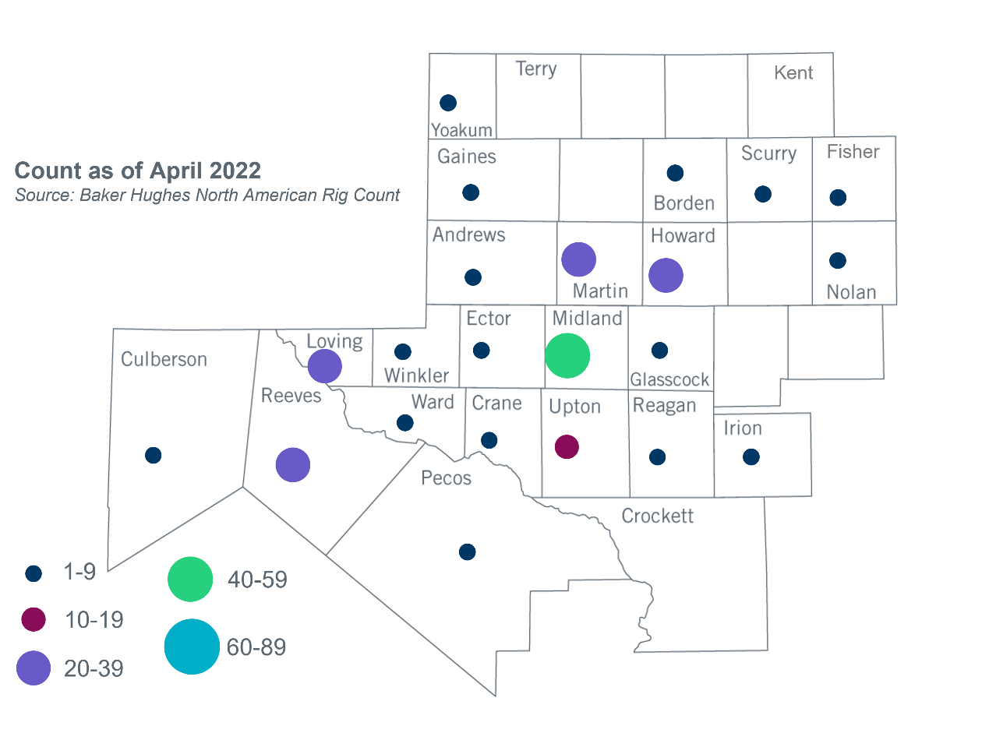

Other Notable Activities

* ERCOT presented the Permian Basin Area improvement updates to the RPG in May, whicn include the results of the oil and gas related electric load forecast study performed by the Bureau of Economic Geology in the University of Texas at Austin.
* ERCOT presented assumptions to be used in the 2022 RTP winter peak sensitivity analysis to the RPG in May.
* ERCOT presented an update on the economic assumptions to be used in the 2022 RTP which outlined the updated interface hourly profile methodology.
* The 2022 Subsynchronous Resonance (SSR) Annual Assessment Report was completed and posted to MIS Secure on May 25, 2022.

1. Based on the Total Project Estimated Cost for all future projects listed in the Transmission Project Information and Tracking (TPIT) report. TPIT is updated three times each year based on information TSPs provide in Model on Demand (MOD) as specified in the ERCOT Steady State Working Group Procedure Manual. The latest TPIT is available at https://www.ercot.com/gridinfo/planning.
2. Based on the Total Project Estimated Cost for all completed projects with Projected In-Service Dates in 2022 listed in the TPIT.
3. +/- symbol indicates the increase or decrease from the previous month in oil rigs present in each county. There are 243 rigs, including an increase of 5 oil rigs, in the Permian Basin from April to May 2022.