OBDRR Number | 041 | OBDRR Title | Updates to Requirements for Aggregate Load Participation in the ERCOT Markets
Date |  | June 15, 2022
Submitter’s Information
Name |  | James McGinniss
E-mail Address |  | james@davidenergy.com
Company |  | David Energy Supply (Texas) LLC
Phone Number |  | (917) 924-4095
Cell Number
Market Segment |  | Not applicable

Comments
David Energy unequivocally supports Other Binding Document Revision Request (OBDRR) 041 because it will enable energy providers to unlock a new wave of price-responsive, dispatchable MWs from distributed energy resources - and allow resources to be dispatched at the time where they have the highest value to the grid (for example, over the two highest value hours of the day when ERCOT prices indicate over five-minute intervals that the capacity is urgently needed).
At the ERCOT VPP Workshop hosted by Tesla on May 31st 2022, David Energy shared its perspective on why this is so crucial for a resilient energy grid in Texas (presentation linked here). Key takeaways from David Energy’s presentation below:
Context: The grid is rapidly decentralizing as customer demand for distributed energy resources (DERs) rises. Residential consumers are buying EVs, rooftop solar, smart thermostats, and batteries to reduce their energy costs and hedge against grid failures; commercial consumers are buying generators and batteries to protect their businesses from the negative impacts of outages.
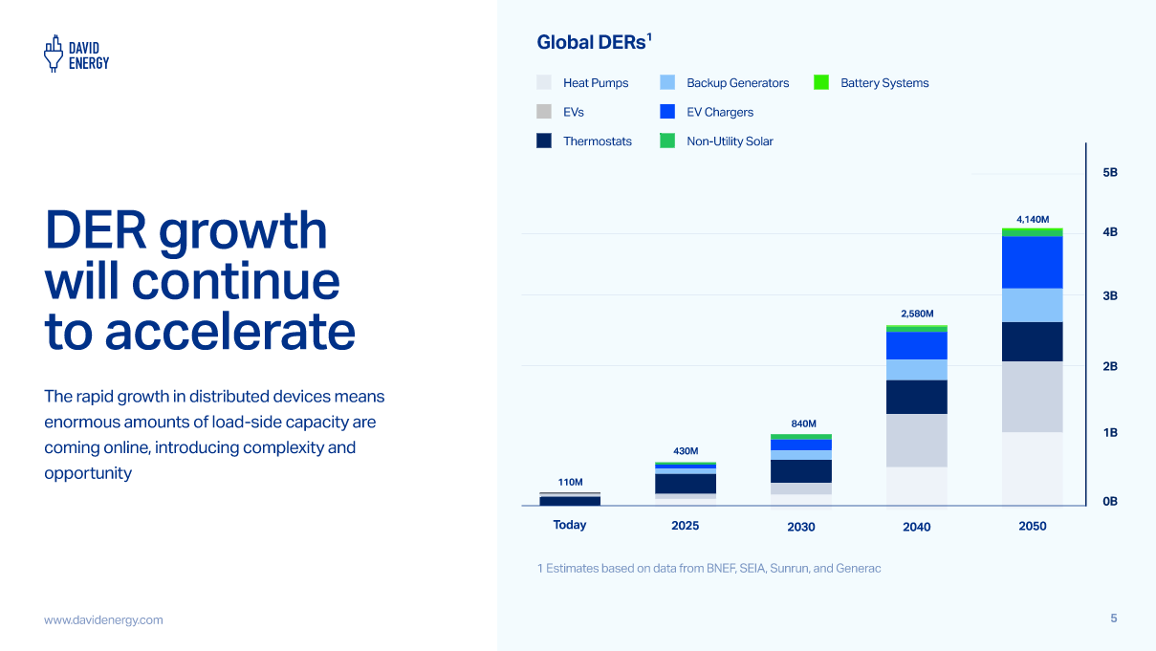
Our Model: David Energy is an innovative Retail Energy Provider bringing together load-serving capabilities with endpoint device management. We are vertically integrated from the purchasing and serving power up to distributed generation on the customer (or load) side, in contrast to legacy gentailers which are vertically integrated from purchasing and serving power to wholesale generation.
- We control devices to reduce demand when the grid is most stressed, avoiding outages and reducing costs. We do this via Demand Response, Demand Charge Management, and Arbitrage
- Overtime, we take performance data during these events and feed it into our pricing model to generate lower power prices for customers
- To effectively employ this strategy, we must be both an LSE and a QSE
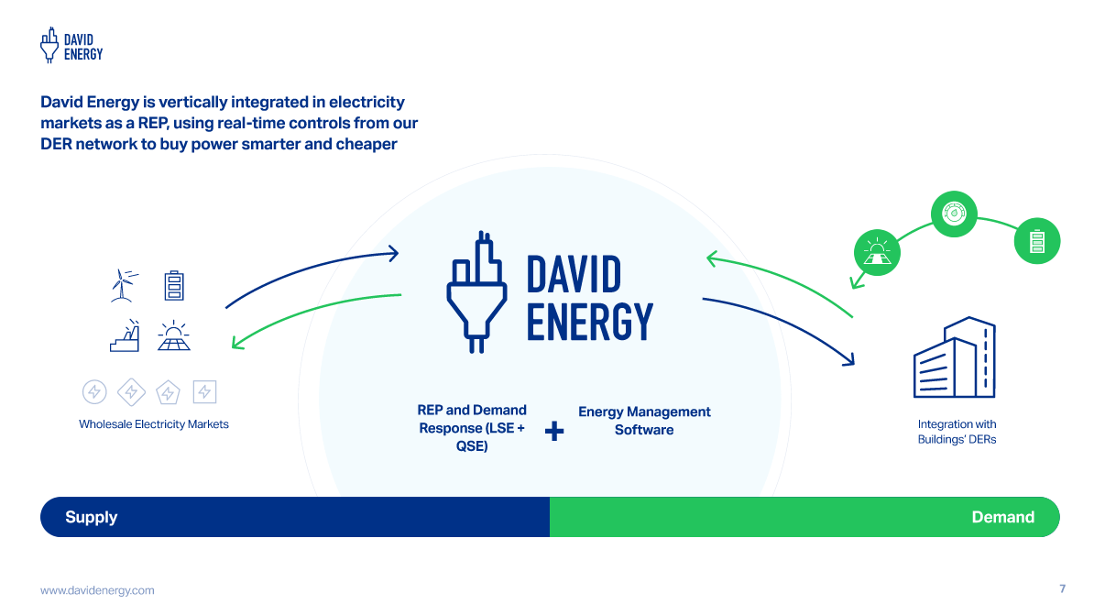

David Energy in Texas: David Energy will allow devices historically excluded from demand response to participate, enabling resiliency and economic compensation for the Residential, Small Business, and Mid-Market segments while also deepening and diversifying the reserves of flexible demand. This includes working with a wide range of device types and OEMs to enable as many DERs as possible to participate in our network, including devices that can export like residential generators and batteries. Today, we work with 5+ major thermostat brands, major generator OEMs, 5+ major EV companies, and the market’s leading solar and storage companies. We plan to broaden coverage by adding new device types (e.g. smart plugs, refrigeration, computer servers, lighting) and deepen by adding more brands under our existing device categories.
From a risk management perspective, we treat this controllable load as a legitimate physical hedge in our book – when prices spike, we dispatch the DERs in our network to “cover” our net open position. Despite the real impacts this has on our risk management strategy, the market at-large does not recognize or value these benefits correctly.
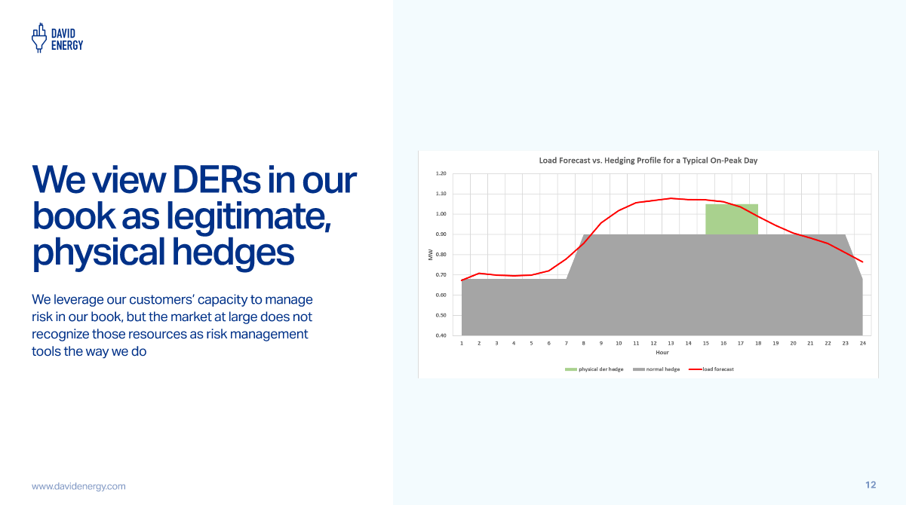

Why ALR is crucial for Texas:
- Post-Storm Uri, ERCOT began procuring more firm capacity. However, it’s unclear that sufficient firm capacity will come online to meet that demand based on the current state of the interconnection queue
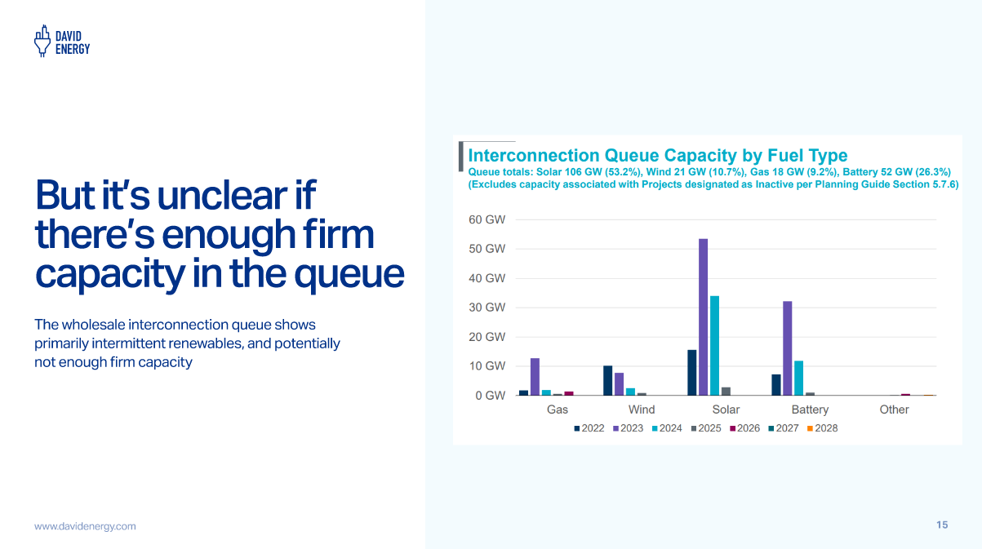
- And while ERCOT’s reserve margin today is healthy on paper, the unfortunate reality is that conditions are much tighter much more frequently than expected
- There is plenty of latent capacity that’s not being used today that could address these tight conditions. But, existing programs such as Emergency Response Service (ERS), Utility Commercial Load Management (CLM), and Load Resource (LR) don’t fairly compensate these resources for their value, creating little incentive for their participation. One reason is, for example, that the programs compel a longer duration dispatch over a band of hours that are not necessarily the highest and best use of small DER resources and that mode of dispatch wastes the capacity value of these smaller systems - you can send DERS price signals for daily peaks and superpeaks if you’re dispatching them directly in SCED, as we would normally in our book. These resources can be used for regular dispatching, not just for emergencies, and get far higher compensation than ERS as a result.
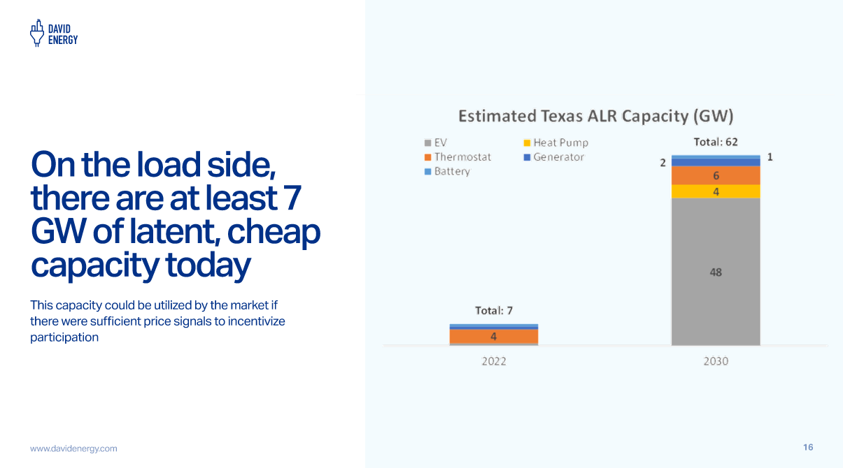

- Texas could unleash the power of this latent capacity by providing strong price signals and payout certainty to their developers and owners. This will enable the existing gigawatts of latent, demand-side capacity to actually benefit the market while providing economic incentives for customers to invest in distributed system equipment that takes the pressure off the centralized grid as load continues to grow at a hurtling pace in Texas ERCOT.

Revised Cover Page Language
None
Revised Proposed Other Binding Document Language
None

