Q & A – MarkeTrak Technical Refresh
Training Session Chat Questions
Will new certificates be required or will the existing certificates work come June 6th?
No new digital certificates will be required.

Will the admin functionality change as well? How would we enter or set up a new user?
Admin functionality will not change, only how you navigate to the Admin role. Admins will have a second “cube” on the tool bar. New users will be set up the same.
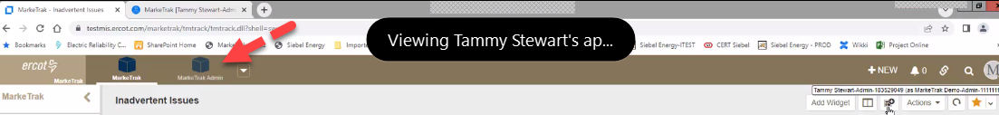
Will new version require us to re-create any of our existing reports?
All existing reports will transition to the new platform. Each user will need to set up their dashboards (aka homepage) with existing reports. Users are encouraged to document existing report names for an easier transition in setting up new dashboard.

Will access to multiple DUNs change with the new platform?
No, access will remain the same - users will need to log out of one DUNs and then log in under separate DUNs.

Will the already existing reports in " Reports > Find Reports > Find a report" still be there with the new version?
Yes, all reports will transition to the new platform.

My reports are located under quick links today, will I still be able to access them in that same location?
Yes, quick links functionality is not changing, only the location (now on the top tool bar).

Just to confirm, API's will not be affected?
Correct, as workflows are not changing, APIs will not be impacted for the technical refresh.

How do I access RMTE (Retail Market Testing Environment)?
Special testing digital certificates are required. See your USA to request access to RMTE.

Where is the icon to create a dashboard?
The icon to create a new dashboard is located at the top right of the My Dashboard screen next to the Actions drop down field:

Can you go over how to duplicate an existing dashboard?
Please see the tips and tricks document MarkeTrak Work Center Dashboard Setup
on the MarkeTrak Information page for details in how to set up a new dashboard. https://www.ercot.com/services/client_svcs/mktrk_info

In viewing multiple issues, does the “Back to Result” link exist if you have to “X” out of an existing issue?
When viewing multiple issues within a listing report, the “Back to Results” link is available. Also available are links to progress thru issues (Next Item), to go back to previous issues (Previous Item) or jump forward or back to the first or last issue within the list (First Item), (Last Item). When clicking on issues from a dashboard report, there is not a “Back to Results” link but the other navigational links are present. If you “pop-out” your dashboard listing report, you will then see the “Back to Results” link.

Can you open another tab within the chrome browser to be able to view the dashboard and an issue I am working on?
ERCOT Cyber and IT Web Ops prefer multiple instances against the same digital certificate are not executed.

If multiple meters from the same customer need a MarkeTrak, will we still need to open one MT for each?
Typically, each MarkeTrak issue will cover only one ESI, thus separate MTs should be submitted for each ESI. MarkeTraks may be linked for an easier resolution.

