April 2022 ERCOT Monthly Operations Report
Reliability and Operations Subcommittee Meeting
June 2, 2022

Table of Contents
1. Report Highlights 2
2. Frequency Control 3
2.1. Frequency Events 3
2.2. Responsive Reserve Events 4
2.3. Load Resource Events 4
3. Reliability Unit Commitment 4
4. IRR, Wind, and Solar Generation as a Percent of Load 7
5. Largest Net-Load Ramps 8
6. COP Error Analysis 9
7. Congestion Analysis 11
7.1. Notable Constraints 11
7.2. Generic Transmission Constraint Congestion 21
7.3. Manual Overrides 21
7.4. Congestion Costs for Calendar Year 2022 21
8. System Events 22
8.1. ERCOT Peak Load 22
8.2. Load Shed Events 22
8.3. Stability Events 22
8.4. Notable PMU Events 23
8.5. DC Tie Curtailment 23
8.6. TRE/DOE Reportable Events 23
8.7. New/Updated Constraint Management Plans 23
8.8. New/Modified/Removed RAS 23
8.9. New Procedures/Forms/Operating Bulletins 23
9. Emergency Conditions 24
9.1. OCNs 24
9.2. Advisories 24
9.3. Watches 24
9.4. Emergency Notices 24
10. Application Performance 24
10.1. TSAT/VSAT Performance Issues 24
10.2. Communication Issues 24
10.3. Market System Issues 24
11. Model Updates 25
Appendix A: Real-Time Constraints 27

Report Highlights
- The unofficial ERCOT peak load for the month was 58,362 MW and occurred on 04/05/2022, during hour ending 18:00.
- There were 5 frequency events.
- There were 3 instances where Responsive Reserves were deployed.
- There were 88 HRUC commitments.
- There were 26 days of congestion on the West Texas Export GTC, 27 days on the North Edinburg to Lobo GTC, 16 days on the Panhandle GTC, 28 days on the Nelson Sharpe to Rio Hondo GTC, 18 days on the Bearkat GTC, 9 days on the North to Houston GTC, 11 days on the Culberson GTC, 4 days on the McCamey GTC, 5 days on the Valley Export GTC, 8 days on the Treadwell GTC, and 1 day on the Valley Import GTC. There was no activity on the remaining GTCs during the month.
- There were 2 DC Tie Curtailments.
- A Wind Generation Record of 26,089 MW was set on 04/09/2022 at 21:15.
- A Wind Penetration Record of 69.15% was set on 04/10/2022 at 01:43.

Frequency Control

Frequency Events
The ERCOT Interconnection experienced 5 frequency events, which resulted from units’ trips. The average event duration was 00:07:14.

A summary of the frequency events is provided below. The reported frequency events meet one of the following criteria: Delta Frequency is 60 mHz or greater; the MW loss is 350 MW or greater; resource trip event triggered RRS deployment. Frequency events that have been identified as Frequency Measurable Events (FME) for purposes of BAL-001-TRE-2 analysis are highlighted in blue. When analyzing frequency events, ERCOT evaluates PMU data according to industry standards. Events with an oscillating frequency of less than 1 Hz are inter-area, while higher frequencies indicate local events. Industry standards specify that damping ratio for inter-area oscillations should be 3.0% or greater. For the frequency events listed below, the ERCOT system met these standards and transitioned well after each disturbance.

Date and Time | Delta Frequency | Max/Min Frequency | Duration of Event | PMU Data |  | MW Loss | Load | IRR | Inertia
 | (Hz) | (Hz) |  | Oscillation Mode (Hz) | Damping Ratio |  | (MW) | % | (GW-s)
04/13/2022 7:28:39 | 0.153 | 59.855 | 00:10:05 | 0.57 | 14% | 725 | 44,477 | 50% | 171,987
04/18/2022 2:48:46 | -0.120 | 60.098 | 00:19:08 | 0.61 | 15% | 388 | 35,068 | 33% | 180,367
04/19/2022 15:16:19 | 0.197 | 59.792 | 00:06:28 | 0.91 | 12% | 810.16 | 44,123 | 56% | 145,899
04/20/2022 9:04:53 | 0.084 | 59.932 | 00:02:58 | 0.61 | 9% | 383.74 | 43,020 | 52% | 174,650
04/22/2022 6:54:16 | -0.088 | 60.105 | 00:09:26 | 0.6 | 15% | 423 | 43,830 | 54% | 158,910

(Note: All data on this graph encompasses frequency event analysis based on BAL-001-TRE-1.)

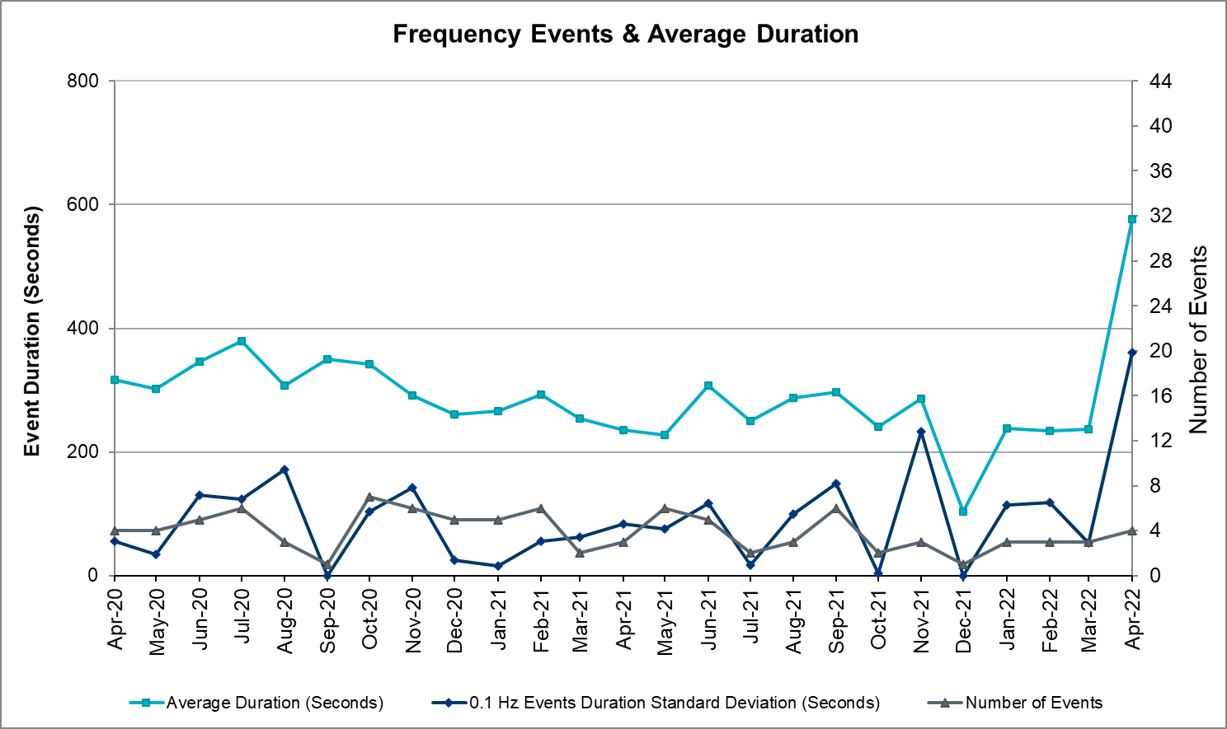

Responsive Reserve Events
There were 3 events where Responsive Reserve MWs were released to SCED. The events highlighted in blue were related to frequency events reported in Section 2.1 above.

Date and Time Released to SCED | Date and Time Recalled | Duration of Event | Maximum MWs Released | Comments
04/13/2022 7:28:48 | 04/13/2022 7:34:00 | 00:05:12 | 1040
04/19/2022 15:16:28 | 04/19/2022 15:20:56 | 00:04:28 | 1159
04/20/2022 19:31:53 | 04/20/2022 19:36:57 | 00:05:04 | 671

Load Resource Events
None.

Reliability Unit Commitment
ERCOT reports on Reliability Unit Commitments (RUC) monthly. Commitments are reported grouped by operating day and weather zone. The total number of hours committed is the sum of the hours for all the units in the specified region. Additional information on RUC commitments can be found on the MIS secure site at Grid Generation Reliability Unit Commitment.

There were no DRUC commitments.

There were 88 HRUC commitments

Resource Location | # of Resources | Operating Day | Total # of Hours Committed | Total MWhs | Reason for Commitment
NORTH_CENTRAL, SOUTH_CENTRAL | 5 | 04/04/2022 | 17 | 3,902.5 | System Capacity
NORTH, NORTH_CENTRAL | 10 | 04/05/2022 | 50 | 13,743.5 | DLWSRNK5, System Capacity, WESTEX
NORTH_CENTRAL | 1 | 04/06/2022 | 6 | 3,408.0 | Minimum Run Time
NORTH_CENTRAL | 3 | 04/09/2022 | 12 | 2,806.0 | WESTEX
SOUTHERN | 1 | 04/10/2022 | 8 | 4,988.0 | System Capacity
EAST, NORTH, NORTH_CENTRAL, SOUTHERN | 7 | 04/11/2022 | 49 | 14,346.4 | System Capacity
COAST, NORTH_CENTRAL, SOUTH_CENTRAL, SOUTHERN | 11 | 04/12/2022 | 90 | 23,262.0 | N_TO_H,  N_TO_ H, N_TO_H, WESTEX
NORTH_CENTRAL, SOUTH_CENTRAL | 11 | 04/13/2022 | 60 | 25,641.3 | WESTEX
COAST, NORTH_CENTRAL, SOUTH_CENTRAL, SOUTHERN | 12 | 04/21/2022 | 78 | 23,072.0 | WESTEX, WESTEX
COAST, EAST, NORTH, NORTH_CENTRAL, SOUTH_CENTRAL, SOUTHERN, WEST | 23 | 04/22/2022 | 136 | 48,083.8 | WESTEX, WESTEX
NORTH_CENTRAL | 2 | 04/26/2022 | 14 | 7,336.4 | System Capacity

IRR, Wind, and Solar Generation as a Percent of Load
The graph below shows the maximum, minimum and average aggregate solar, wind and IRR output as a percentage of total ERCOT load when evaluated as 10-minute averaged intervals, over the past 13 months. Current wind and solar generation and penetration records are listed in the footnote below. Maximum IRR penetration for the month was 71.3% on 04/10/2022 interval ending 09:10 and minimum IRR penetration for the month was 8.2% on 04/17/2022 interval ending 06:50.

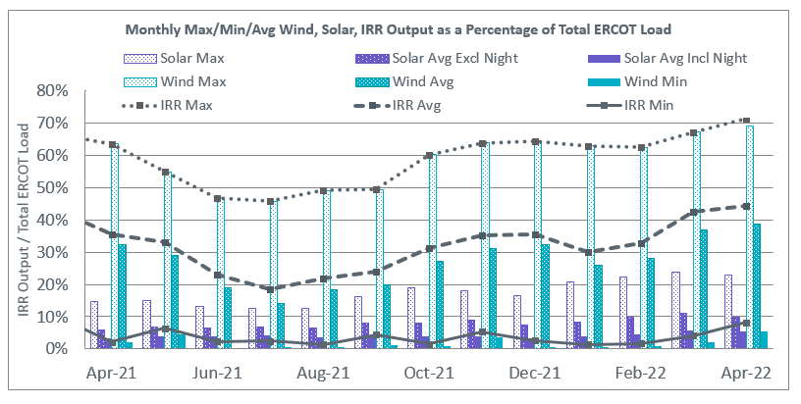

During the hour of peak load for the month, hourly integrated wind generation was 17,769 MW and solar generation was 2,734 MW. The graph below shows the wind and solar penetration percentage during the hour of the peak load in the last 13 months.

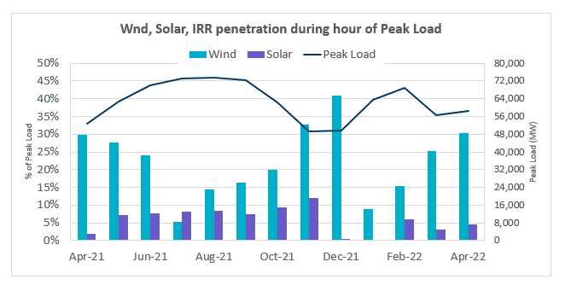

Lastly, the graph below shows the minimum wind, solar and IRR output during the peak load hour as a percentage of the daily peak load for every day in the month.

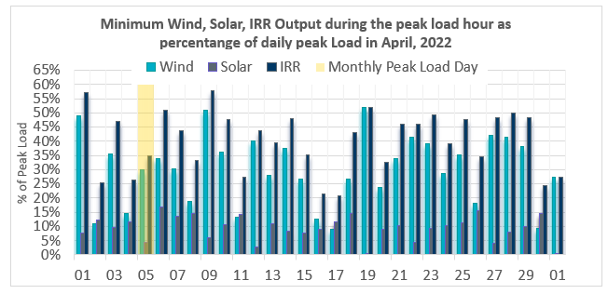

Largest Net-Load Ramps
The net-load ramp is defined as the change in net-load (load minus wind and PVGR generation) during the defined time horizon. Such a variation in net-load needs to be accommodated in grid operations to ensure that the reliability of the grid is satisfactorily maintained. The largest net-load ramp during 5-min, 10-min, 15-min, 30-min and 60-min in Apr 2022 is 1,218 MW, 1,594 MW, 2,179 MW, 4,191 MW, and 7,851 MW, respectively. The comparison with respect to the historical values is given in the table below.

Month and Year | 5 min | 10 min | 15 min | 30 min | 60 min
Apr 2014 | 796 MW | 1,358 MW | 1,868 MW | 3,445 MW | 6,274 MW
Apr 2015 | 835 MW | 1,482 MW | 1,985 MW | 3,216 MW | 5,330 MW
Apr 2016 | 1,183 MW | 1,666 MW | 2,394 MW | 3,804 MW | 5,101 MW
Apr 2017 | 914 MW | 1,492 MW | 2,315 MW | 3,779 MW | 6,385 MW
Apr 2018 | 947 MW | 1,366 MW | 1,710 MW | 3,303 MW | 5,030 MW
Apr 2019 | 1,147 MW | 1,778 MW | 1,866 MW | 2,866 MW | 4,856 MW
Apr 2020 | 1,189 MW | 1,655 MW | 1,578 MW | 2,773 MW | 4,948 MW
Apr 2021 | 1,414 MW | 1,664 MW | 1,967 MW | 2,874 MW | 4,860 MW
Apr 2022 | 1,218 MW | 1,594 MW | 2,179 MW | 4,191 MW | 7,851 MW
All Months in 2014-2022 | 1,494 MW | 2,155 MW | 3,015 MW | 5,882 MW | 10,750 MW

COP Error Analysis
COP Error is calculated as the capacity difference between the COP HSL and real-time HSL of the unit. Mean Absolute Error (MAE) stayed over 7,000 MW until Day-Ahead at 12:00, then dropped significantly to 4,144 MW by Day-Ahead at 13:00. In the following chart, Under-Scheduling Error indicates that COP had less generation capacity than real-time and Over-Scheduling Error indicates that COP had more generation capacity than real-time.

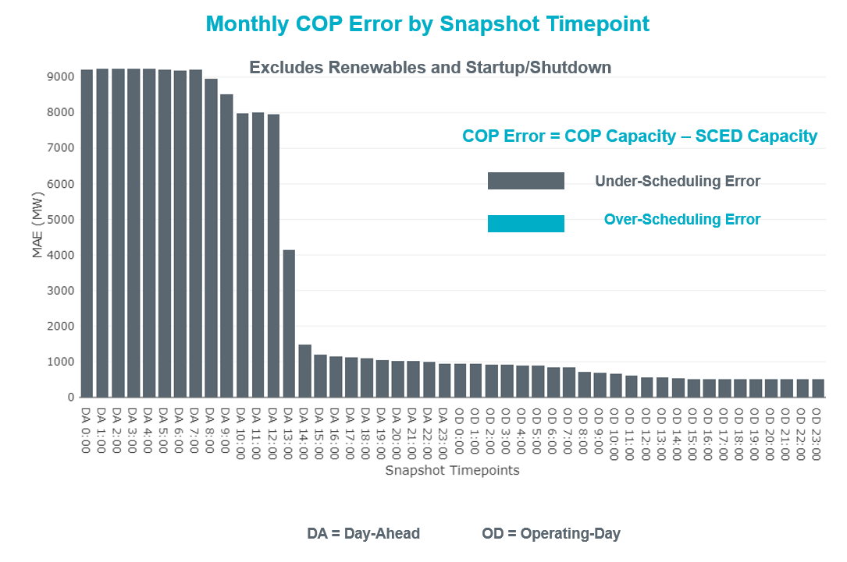

Monthly MAE for the Latest COP at the end of the Adjustment Period was 507 MW with median ranging from -691 MW for Hour-Ending (HE) 21 to 279.1 MW for HE 10. HE 12 on 04/18/2022 had the largest Over-Scheduling Error (1,830 MW) and HE 21 on 04/11/2022 had the largest Under-Scheduling Error (-2,707 MW).

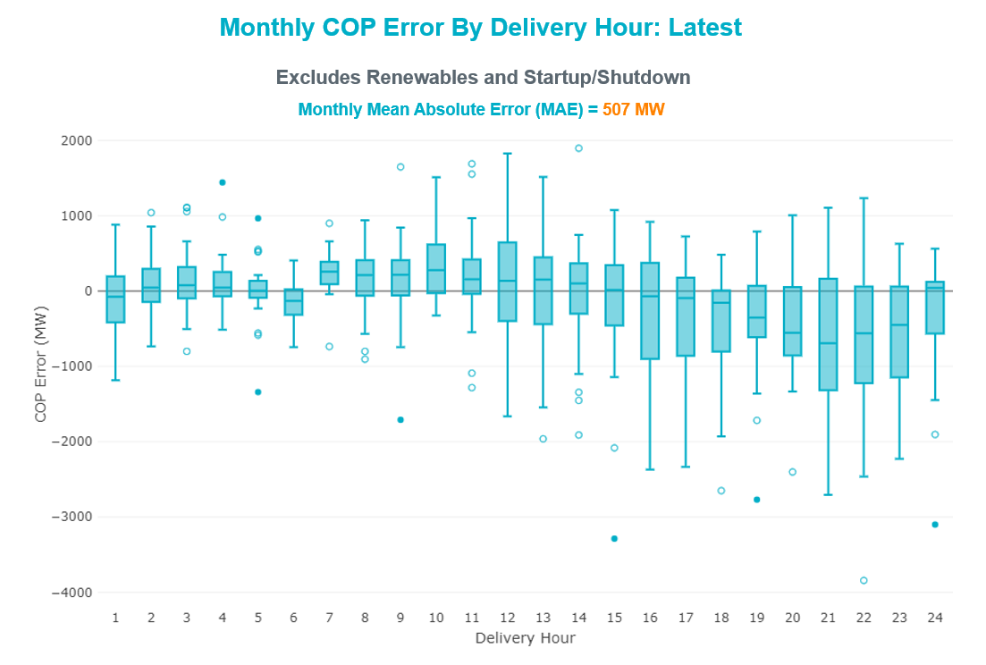

Monthly MAE for the Day-Ahead COP at 12:00 was 7,950 MW with median ranging from -11,947 MW for Hour-Ending (HE) 19 to -1,671 MW for HE 4. HE 15 on 04/11/2022 had the largest Under-Scheduling Error (-21,844 MW) and HE 24 on 04/19/2022 had the largest Over-Scheduling Error (1,575 MW).

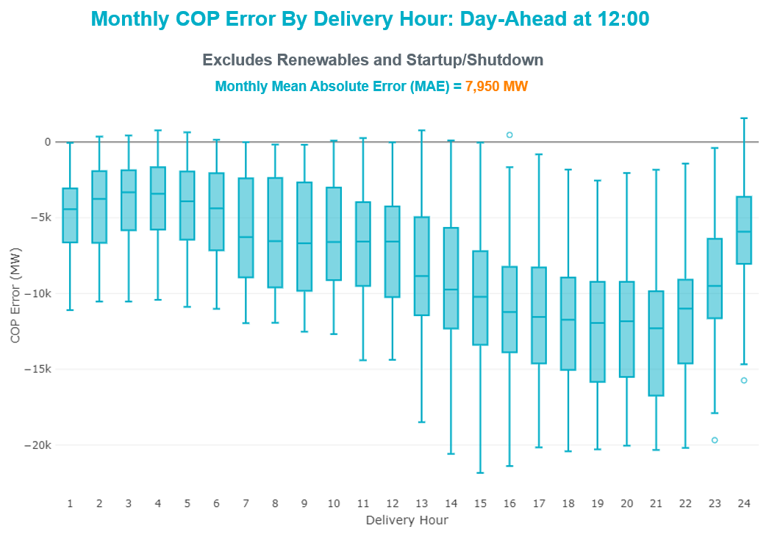

Congestion Analysis

Notable Constraints
Nodal protocol section 3.20 specifies that ERCOT shall identify transmission constraints that are binding in Real-Time three or more Operating Days within a calendar month. As part of this process, ERCOT reports congestion that meets this criterion to ROS. In addition, ERCOT also highlights notable constraints that have an estimated congestion rent exceeding $1,000 for a calendar month. These constraints are detailed in the table below, including approved transmission upgrades from TPIT that may provide some congestion relief based on ERCOT’s engineering judgement. Rows highlighted in blue indicate the congestion was affected by one or more outages. For a list of all constraints activated in SCED, please see Appendix A at the end of this report.

Contingency Name | Overloaded Element | # of Days Constraint Binding | Congestion Rent | Transmission Project
BASE CASE | WESTEX | 24 | $88,005,569.27
SMDOPHR5 | G138_10B_1 | 27 | $20,749,002.53 | Rebuild Magnolia - Seminole 138 kV Line (4010)
XBOM358 | 6558__B | 12 | $13,541,661.02
BASE CASE | NE_LOB | 23 | $12,918,810.93 | The Lower Rio Grande Valley (LRGV) System Enhancement Project (21RPG017) will improve but not eliminate the need for this GTC.
BASE CASE | PNHNDL | 16 | $12,746,389.05
MHARNED5 | BURNS_RIOHONDO_1 | 24 | $11,131,713.73
SLOBSA25 | GATEWT_WORMSE1_1 | 20 | $10,225,387.00
DHUTHUT5 | 1661__A | 5 | $10,038,936.66
DODEMOS5 | 6513__A | 3 | $8,699,614.93
SSTABS18 | 6144__A | 22 | $8,099,872.98
SCMNCPS5 | 651__B | 12 | $7,610,767.57
DSALKLN5 | KLNSW_MR2H | 10 | $7,469,362.18
DSNG_TB5 | THWZEN71_A | 4 | $7,373,862.27
SGILTRI8 | 211T147_1 | 3 | $6,614,838.58
SW_GODE5 | LUTHER_VEALMOR_1 | 5 | $6,178,359.15
DMGSMDS5 | MDSSW_MR1H | 4 | $5,880,317.19
DCAGCI58 | 255T279_1 | 6 | $5,562,511.58
SN_SLON5 | CELANE_KLEBER1_1 | 21 | $4,503,208.18
DMGSQAL5 | 14040__A | 3 | $4,345,871.16
DMGSQAL5 | 6471__A | 5 | $4,024,547.68
DLWSRNK5 | 587__A | 5 | $3,963,059.40
DWLDSCO5 | LUTHER_VEALMOR_1 | 14 | $3,908,794.57
DCAGBRA5 | PAWNEE_SPRUCE_1 | 2 | $3,830,388.10
SBRAUVA8 | HAMILT_MAVERI1_1 | 22 | $3,537,931.72
SSIEMOL8 | DEL_MA_LAREDO1_1 | 5 | $3,430,965.10 | Rebuild Laredo - DelMar (45511)
SCITNUE8 | MORRIS_NUECES1_1 | 1 | $3,393,513.38
DCAGCO58 | 583T583_1 | 1 | $3,295,964.82
DMGSQAL5 | 6217__A | 6 | $3,254,891.50
BASE CASE | NELRIO | 28 | $3,228,360.87 | The Lower Rio Grande Valley (LRGV) System Enhancement Project (21RPG017) will improve but not eliminate the need for this GTC.
DKENCA58 | 255T279_1 | 2 | $2,905,177.83
DBRABRA8 | V2_Z5_1 | 4 | $2,857,309.21 | CPSE Braunig to Brooks MLSE (4323)
DMGSQAL5 | 6046__A | 2 | $2,846,453.86
BASE CASE | SCHNDR_BIGHIL_1 | 3 | $2,799,436.09 | Schneeman Draw - Big Hill 345kV 2nd Circuit
BASE CASE | BEARKT | 14 | $2,557,372.82
DWLFWAP5 | STPWAP39_1 | 1 | $2,347,906.99
DKENCOM8 | 72T120_1 | 2 | $2,173,091.99
DODESLT8 | 6471__A | 2 | $2,138,950.04
SCELESP8 | BLESSI_PAVLOV1_1 | 1 | $2,023,918.70
BASE CASE | BCVPSA03_A | 1 | $2,000,833.07
DMGSLNG5 | 6471__A | 3 | $1,952,074.19
SBWDDBM5 | LPLMK_LPLNE_1 | 4 | $1,878,161.68
SSCLWF28 | 6830__B | 10 | $1,829,760.12
XNED258 | NEDIN_138H | 5 | $1,829,040.46
SVICCO28 | COLETO_VICTOR2_1 | 12 | $1,820,617.01
SLOBSA25 | NLARSW_PILONC1_1 | 5 | $1,803,908.24
SW_GW_L5 | LUTHER_VEALMOR_1 | 2 | $1,791,396.51
SMDOOAS5 | GN_PZ_08_A | 4 | $1,511,603.72
DMGSBTR5 | 6036__A | 1 | $1,421,640.82
BASE CASE | HHGTOM_1 | 7 | $1,420,768.32
MHARNED5 | LASPUL_RAYMND1_1 | 17 | $1,386,796.25
SHASTNN8 | G138_8B_1 | 4 | $1,334,224.84 | League City - Hidden Lakes Rebuild (66208)
DLONOR58 | FALFUR_PREMON1_1 | 17 | $1,313,553.48
SBRAUVA8 | ESCOND_GANSO1_1 | 12 | $1,309,216.01 | Escondido - Ganso 138 kV Line Rebuild (55624)
DTRIASH8 | 211T147_1 | 1 | $1,283,459.08
DELMSTP5 | CKT_3124_1 | 2 | $1,280,479.95
DBUCKLN5 | 651__B | 1 | $1,234,649.26
DDUPHE18 | I_DUPS_MCCAMP2_1 | 3 | $1,194,651.14
SFTLMES8 | CROSSO_NORTMC1_1 | 10 | $1,185,352.40
XCAG158 | CAGNON_MR4L | 2 | $1,158,900.25
DGBYCL89 | GBYGP_17_A | 1 | $1,129,342.65 | The Galena Park Area Conversion project (66221) removes this element and reconfigures the local transmission system.
SLOBSA25 | BRUNI_69_1 | 5 | $1,085,672.03
DMGSLNG5 | 6217__B | 1 | $1,080,343.12
SCARFRI8 | ATSO_SONR1_1 | 25 | $1,072,229.38
DSTPRED5 | BLESSI_PAVLOV1_1 | 3 | $1,055,527.21
DCAGBRA5 | COLETO_ROSATA1_1 | 1 | $1,035,784.97 | Upgrade Coleto Creek - Rosata (50870)
DBIGKEN5 | TREADW_YELWJC1_1 | 13 | $979,788.33
SBTPBNT8 | MYRA_VAL_1 | 11 | $917,597.49
SGBYSD25 | GBYLYD70_A | 5 | $902,236.81
SGARBAT8 | 15010__B | 6 | $888,415.39
SCOLPAW5 | COLETO_VICTOR1_1 | 7 | $886,725.75
SSTPESP8 | BLESSI_PAVLOV1_1 | 5 | $873,374.52
DRNS_TB5 | THWZEN71_A | 3 | $835,395.75
DCLECOU5 | FARMLAND_LONGD_1 | 4 | $834,982.18
DCAGBRA5 | PAWNEE_XF1 | 4 | $773,511.97
SLOBSA25 | NLARSW_UNITEC1_1 | 4 | $767,122.34
SN_SLON5 | HOLLY4_SOUTH_1_1 | 5 | $753,242.67 | Rebuild Holly - Southside (45566)
SN_SLON5 | CELANE_N_SHAR1_1 | 6 | $717,036.21
SN_SLON5 | HOLLY4_SERDEV1_1 | 3 | $672,310.35
BASE CASE | N_TO_H | 5 | $614,636.11
DCLASCO5 | 6437__F | 4 | $577,725.80
DLEOPAL8 | KARNES_KENEDS1_1 | 3 | $541,116.32
SSNGRNS5 | THWZEN98_A | 3 | $540,371.20
SNEDLON5 | LASPUL_RAYMND1_1 | 5 | $498,235.00
DPHRAL58 | G138_10B_1 | 5 | $457,315.13 | Rebuild Magnolia - Seminole 138 kV Line (4010)
DMTSCOS5 | 6437__F | 3 | $438,688.83
BASE CASE | CULBSN | 9 | $400,546.97
DMGSMDS5 | MDSSW_MR1L | 3 | $326,608.92
XVIC89 | GREENL_NCARBI1_1 | 4 | $287,736.68
BASE CASE | EGTL_1 | 3 | $284,042.61
SLOBSA25 | FALFUR_PREMON1_1 | 9 | $280,186.34
SSCLWF28 | 6850__B | 3 | $271,635.53 | The Holiday - Navy Kickapoo 69 kV Line Project (66194) removes this element and reconfigures the local transmission system.
SBRAHAM8 | HAMILT_MAVERI1_1 | 9 | $257,916.10
DCS_CHS8 | BCVLY_03_A | 3 | $232,092.57
SOXYIN28 | I_DUPP_I_DUPS1_1 | 3 | $204,374.72
SKLNSAL5 | 271__A | 4 | $197,557.99
DJACALV8 | MYRA_VAL_1 | 5 | $194,516.42
BASE CASE | LGD_SANTIA1_1 | 11 | $160,141.42
SCARFRI8 | HAMILT_MAXWEL1_1 | 6 | $140,081.53 | Hamilton Road to Maxwell: Line Rebuild (61396)
SCARFRI8 | FDR_OZNC_1 | 5 | $139,065.60
SBRAHAM8 | ESCOND_GANSO1_1 | 7 | $138,979.73 | Escondido - Ganso 138 kV Line Rebuild (55624)
SMDOOAS5 | BCVLY_03_A | 3 | $138,971.84
SFORYEL8 | HEXT_YELWJC1_1 | 10 | $136,622.26
SFORYEL8 | HEXT_MASONS1_1 | 9 | $132,771.19
DBBSJEW5 | 230__B | 3 | $84,449.73
DBIGKEN5 | CARVER_TINSLE1_1 | 3 | $83,754.78
SLAQLOB8 | FALFUR_PREMON1_1 | 5 | $81,192.48
SSCLWF28 | OLN_FMR2 | 5 | $80,881.95
BASE CASE | VALEXP | 5 | $50,617.61 | The Lower Rio Grande Valley (LRGV) System Enhancement Project (21RPG017) will improve but not eliminate the need for this GTC.
DGRSBOW5 | 6830__B | 4 | $44,561.95
SCOLBAL8 | BALLIN_HUMBLT1_1 | 6 | $43,897.13
SBLESTP5 | COLETO_VICTOR1_1 | 3 | $43,514.42
SLAQLOB8 | BRUNI_69_1 | 8 | $42,921.75
BASE CASE | BRIGHT_CHARTE1_1 | 12 | $41,156.67
SSCLWF18 | 6840__B | 6 | $25,387.19
SSTOGA28 | CKT_963_1 | 4 | $21,427.20
BASE CASE | TRDWEL | 6 | $18,680.09
BASE CASE | SWEETWN3_XF31 | 3 | $10,355.50
DBIGKEN5 | HAMILT_MAXWEL1_1 | 3 | $6,712.44 | Hamilton Road to Maxwell: Line Rebuild (61396)
SSPUSLT8 | SPUR_69_1 | 3 | $4,539.97
SSPUSLT8 | ROBY_ROTN1_1 | 3 | $1,762.12 | Roby - Rotan 69 kV Line Rebuild (63579)
SMV_PAR8 | RIOHND_ERIOHND_1 | 4 | $1,458.14 | Rebuild Rio Hondo to East Rio Hondo (6687)

Generic Transmission Constraint Congestion
There were 26 days of congestion on the West Texas Export GTC, 27 days on the North Edinburg to Lobo GTC, 16 days on the Panhandle GTC, 28 days on the Nelson Sharpe to Rio Hondo GTC, 18 days on the Bearkat GTC, 9 days on the North to Houston GTC, 11 days on the Culberson GTC, 4 days on the McCamey GTC, 5 days on the Valley Export GTC, 8 days on the Treadwell GTC, and 1 day on the Valley Import GTC. There was no activity on the remaining GTCs during the month.

Note: This is how many times a constraint has been activated to avoid exceeding a GTC limit, it does not imply an exceedance of the GTC occurred or that the GTC was binding.

Manual Overrides
None

Congestion Costs for Calendar Year 2022
The following table represents the top twenty active constraints for the calendar year based on the estimated congestion rent attributed to the congestion. ERCOT updates this list on a monthly basis.

Contingency | Overloaded Element | # of 5-min SCED | Estimated | Transmission Project
Basecase | WESTEX GTC | 11,598 | $121,265,071.24
SALSW TO KLNSW 345 DBLCKT | Killeen Switch 345kV | 9,104 | $63,312,944.71
Basecase | NE_LOB GTC | 14,599 | $37,215,452.13 | The Lower Rio Grande Valley (LRGV) System Enhancement Project (21RPG017) will improve but not eliminate the need for this GTC.
WDGSW TO MARSW 138 DBLCKT | Mistletoe Heights - Hemphill 138kV | 2,078 | $30,437,608.94
TWR(345) JCK-REF27 & JCK-STP18 | Hillje - South Texas Project 345kV | 3,964 | $30,332,705.54
PH ROBINSON to MEADOW LIN A | Magnolia Tnp - Seminole Tnp 138kV | 9,204 | $24,331,865.47 | Rebuild Magnolia - Seminole 138 kV Line (4010)
Manual dbl ckt for NEDIN-BONILLA 345kV & RIOH-PRIM138kV | Burns Sub - Rio Hondo 138kV | 8,673 | $22,415,084.02
LWSSW TO RNKSW AND LWSSW TO KRWSW 345 DBLCKT | Argyle - Highlands Tnp 138kV | 3,325 | $18,378,187.84
Basecase | PNHNDL GTC | 6,394 | $14,284,856.70
COMANCHE SWITCH (Oncor) to COMANCHE PEAK SES LIN _A | Comanche Tap - Comanche Switch (Oncor) 138kV | 6,977 | $14,199,274.39
BOWMAN SWITCH TRX BOMSW_3_2 345/138 | Fisher Road Switch - Wichita Falls 138kV | 1,899 | $13,541,661.02
CALF CREEK POI to NATURAL DAM LIN _A | Big Spring West - Stanton East 138kV | 5,193 | $13,158,154.48
Fowlerton to LOBO 345 LIN1 | North Laredo Switch - Piloncillo 138kV | 3,872 | $13,020,133.56
TWR(345) JOR-KG97 & JOR-NB99 | Bigvue - Lyondell 138kV | 2,734 | $12,138,190.41
STP SWITCH to Esperanza LIN 1 | Blessing - Pavlov 138kV | 4,727 | $11,706,554.00
BIG SPRING SWITCH to CHALK_69kV and McDonald Road_138kV | Morgan Creek Ses 345kV | 350 | $10,431,863.72
Fowlerton to LOBO 345 LIN1 | Wormser Road - Gateway West Tap 138kV | 2,942 | $10,225,387.00
Hutto-Zorn & Gillcr 345kV | Round Rock - Round Rock Northeast 138kV | 662 | $10,038,936.66
EVRSW TO HLSES 138 DBLCKT | Mistletoe Heights - Hemphill 138kV | 1,065 | $9,007,490.05
Sng-Tb&Rns 345kV | Th Wharton - Zenith 345kV | 1,566 | $8,712,149.78

System Events

ERCOT Peak Load
The unofficial ERCOT peak load for the month was 58,362 MW and occurred on 04/05/2022, during hour ending 18:00.

Load Shed Events
None.

Stability Events
None.

Notable PMU Events
ERCOT analyzes PMU data for any significant system disturbances that do not fall into the Frequency Events category reported in section 2.1. The results are summarized in this section once the analysis has been completed.

There were no PMU events outside of those reported in section 2.1.

DC Tie Curtailment
There were two DC tie curtailments.

Date | DC Tie | Curtailing Period | # of Tags Curtailed | Initiating Event | Curtailment Reason
4/8/2022 | DC-L | HE 20 – HE 24 | 5 | Unplanned Outage | Planned or Unplanned Outage
4/9/2022 | DC-L | HE 17 – HE 24 | 6 | Unplanned Outage | Planned or Unplanned Outage

TRE/DOE Reportable Events
- There were no TRE/DOE Reportable Events

New/Updated Constraint Management Plans
None.

New/Modified/Removed RAS
None.

New Procedures/Forms/Operating Bulletins
Date | Subject | Bulletin No.
04/06/2022 | DC Tie V1 Rev 70 | 1035
04/06/2022 | Reliability Risk Desk Operating Procedure V1 Rev 28 | 1036
04/06/2022 | Reliability Unit Commitment V1 Rev 68 | 1037
04/06/2022 | Shift Supervisor Desk V1 Rev 79 | 1038

Emergency Conditions

OCNs
Date and Time | Message
4/11/2022 13:23 CPT | ERCOT is issuing an OCN due to taking manual action on the WESTEX IROL due to a topology change.
4/11/2022 14:33 CPT | ERCOT is issuing an OCN due to taking manual action on the PNHNDL IROL due to a topology change.
4/12/2022 10:00 CPT | ERCOT issued an Advanced Action Notice (AAN) due to possible future emergency condition of reserve capacity deficiency beginning Saturday, April 16, 2022, HE 14 until Sunday, April 17, 2022, HE 22. ERCOT updated the AAN on April 13 and April 14. No additional capacity was needed in the AAN updated on April 14. No Outage Schedule Adjustment (OSA) was issued.
4/18/2022 8:55 | ERCOT is issuing an OCN due to taking manual action on the PNHNDL IROL due to a topology change.

Advisories
Date and Time | Message
4/10/2022 12:45 CPT | ERCOT issued an Advisory for a geomagnetic disturbance of K-7 or higher.
4/28/2022 13:30 CPT | ERCOT has postponed the deadline for the posting of the DAM solution for Operating Day 04/29/2022 due to delay in clearing DAM.

Watches
Date and Time | Message
4/03/2022 18:41 CPT | ERCOT issued a Watch for the failure of the SCED process.

Emergency Notices
None.

Application Performance

TSAT/VSAT Performance Issues
None.

Communication Issues
None.

Market System Issues
None.

Model Updates
The Downstream Production Change (DPC) process allows ERCOT to make changes in the on-line Network Operations Model without loading a completely new model. The purpose of this process is to allow for reliable grid operations as system conditions change between designated Network Operations Model database loads. The DPC process is limited in scope to just those items listed below, with equipment ratings updates being the most common. ERCOT has seen a rise in the use of the DPC process to make on-line updates to the Network Operations Model in recent years, instead of through the standard Network Operations Model Change Request process.

- Static Line ratings (Interim Update)
- Dynamic Line ratings (non-Interim Update)
- Autotransformer ratings (non-Interim Update)
- Breaker and Switch Normal status (Interim Update)
- Contingency Definitions (Interim Update)
- RAP and RAS changes or additions (Interim Update)
- Net Dependable and Reactive Capability (NDCRC) values (Interim Update)
- Impedance Updates (non-Interim)

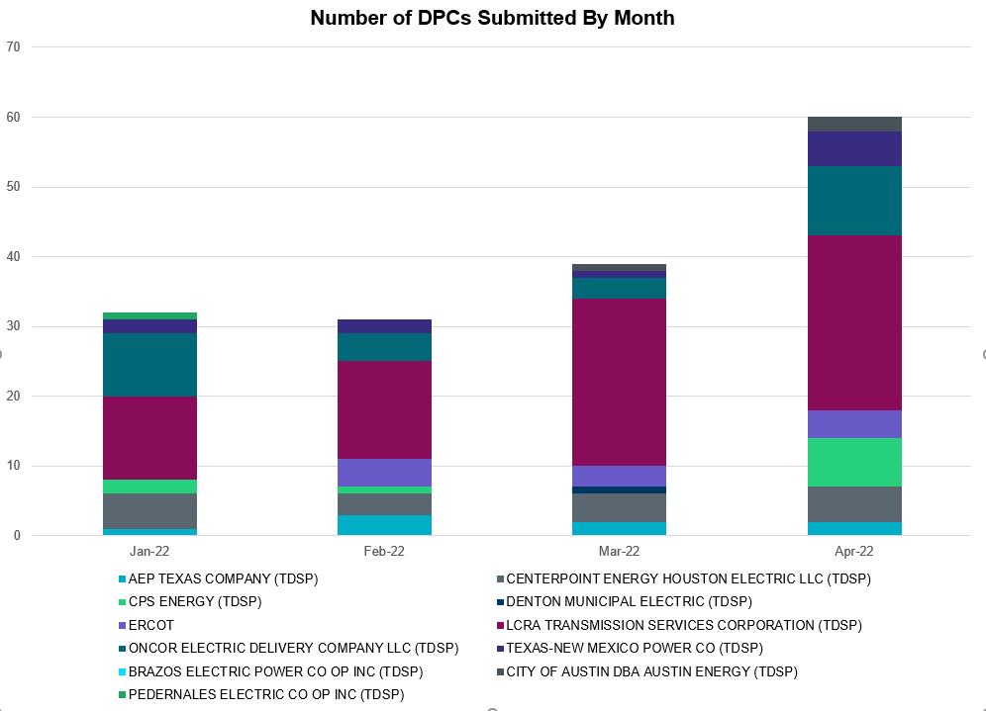

Transmission Operator | Number of DPCs
AEP TEXAS COMPANY (TDSP) | 2
BRAZOS ELECTRIC POWER CO OP INC (TDSP) | 0
BROWNSVILLE PUBLIC UTILITIES BOARD (TDSP) | 0
BRYAN TEXAS UTILITIES (TDSP) | 0
CENTERPOINT ENERGY HOUSTON ELECTRIC LLC (TDSP) | 5
CITY OF AUSTIN DBA AUSTIN ENERGY (TDSP) | 2
CITY OF COLLEGE STATION (TDSP) | 0
CITY OF GARLAND (TDSP) | 0
CPS ENERGY (TDSP) | 7
DENTON MUNICIPAL ELECTRIC (TDSP) | 0
ELECTRIC TRANSMISSION TEXAS LLC (TDSP) | 0
ERCOT | 4
LCRA TRANSMISSION SERVICES CORPORATION (TDSP) | 25
LONE STAR TRANSMISSION LLC (TSP) | 0
ONCOR ELECTRIC DELIVERY COMPANY LLC (TDSP) | 10
PEDERNALES ELECTRIC CO OP INC (TDSP) | 0
RAYBURN COUNTRY CO OP DBA RAYBURN ELECTRIC (TDSP) | 0
SHARYLAND UTILITIES LP (TDSP) | 0
SOUTH TEXAS ELECTRIC CO OP INC (TDSP) | 0
TEXAS MUNICIPAL POWER AGENCY (TDSP) | 0
TEXAS-NEW MEXICO POWER CO (TDSP) | 5

Appendix A: Real-Time Constraints
The following is a complete list of constraints activated in SCED. Full contingency descriptions can be found in the Standard Contingencies List located on the MIS secure site at Grid Generation Reliability Unit Commitment.

Contingency Name | Overloaded Element | From Station | To Station | Count of Days
SMDOPHR5 | G138_10B_1 | SEMINOLE | MAGNO_TN | 29
BASE CASE | NELRIO | n/a | n/a | 28
BASE CASE | NE_LOB | n/a | n/a | 27
BASE CASE | WESTEX | n/a | n/a | 26
MHARNED5 | BURNS_RIOHONDO_1 | MV_BURNS | RIOHONDO | 25
SCARFRI8 | ATSO_SONR1_1 | ATSO | SONR | 25
MHARNED5 | BURNS_RIOHONDO_1 | RIOHONDO | MV_BURNS | 25
SCARFRI8 | ATSO_SONR1_1 | SONR | ATSO | 25
SBRAUVA8 | HAMILT_MAVERI1_1 | HAMILTON | MAVERICK | 23
SSTABS18 | 6144__A | BSPRW | STASW | 22
SLOBSA25 | GATEWT_WORMSE1_1 | WORMSER | GATEWTP | 21
DLONOR58 | FALFUR_PREMON1_1 | FALFUR | PREMONT | 21
SN_SLON5 | CELANE_KLEBER1_1 | CELANEBI | KLEBERG | 21
DBIGKEN5 | TREADW_YELWJC1_1 | TREADWEL | YELWJCKT | 19
DPHRAL58 | G138_10B_1 | SEMINOLE | MAGNO_TN | 19
BASE CASE | BEARKT | n/a | n/a | 18
MHARNED5 | LASPUL_RAYMND1_1 | LASPULGA | RAYMND2 | 18
SGARBAT8 | 15010__B | ESTILES | BLISS | 17
SGARBAT8 | 15010__B | BLISS | ESTILES | 17
SCMNCPS5 | 651__B | CMNSW | CMNTP | 16
SBRAUVA8 | ESCOND_GANSO1_1 | GANSO | ESCONDID | 16
SFORYEL8 | HEXT_MASONS1_1 | MASONSW | HEXT | 16
SFORYEL8 | HEXT_MASONS1_1 | HEXT | MASONSW | 16
SLOBSA25 | FALFUR_PREMON1_1 | FALFUR | PREMONT | 16
BASE CASE | PNHNDL | n/a | n/a | 16
DWLDSCO5 | LUTHER_VEALMOR_1 | VEALMOOR | LUTHER | 16
BASE CASE | BRIGHT_CHARTE1_1 | CHARTER | BRIGHTSD | 14
BASE CASE | BRIGHT_CHARTE1_1 | BRIGHTSD | CHARTER | 14
XBOM358 | 6558__B | FSHSW | WFALS | 14
SVICCO28 | COLETO_VICTOR2_1 | COLETO | VICTORIA | 13
SBTPBNT8 | MYRA_VAL_1 | MYRA | VALYVIEW | 12
SLAQLOB8 | FALFUR_PREMON1_1 | FALFUR | PREMONT | 12
DSALKLN5 | KLNSW_MR2H | KLNSW | KLNSW | 12
SFORYEL8 | HEXT_YELWJC1_1 | YELWJCKT | HEXT | 11
BASE CASE | LGD_SANTIA1_1 | SANTIAGO | LGD | 11
SLAQLOB8 | BRUNI_69_1 | BRUNI | BRUNI | 11
BASE CASE | LGD_SANTIA1_1 | LGD | SANTIAGO | 11
SFTLMES8 | CROSSO_NORTMC1_1 | NORTMC | CROSSOVE | 11
BASE CASE | CULBSN | n/a | n/a | 11
SFORYEL8 | HEXT_YELWJC1_1 | HEXT | YELWJCKT | 11
SLOBSA25 | BRUNI_69_1 | BRUNI | BRUNI | 10
SNEDLON5 | LASPUL_RAYMND1_1 | LASPULGA | RAYMND2 | 10
SSCLWF28 | 6830__B | CRDSW | OLNEY | 10
SCARFRI8 | HAMILT_MAXWEL1_1 | MAXWELL | HAMILTON | 10
SBRAHAM8 | HAMILT_MAVERI1_1 | HAMILTON | MAVERICK | 10
SNEDLON5 | LASPUL_RAYMND1_1 | RAYMND2 | LASPULGA | 10
SCARFRI8 | FDR_OZNC_1 | FRIEND_R | OZNC | 9
DMGSQAL5 | 6217__A | WLVSW | GAILS | 9
SCARFRI8 | FDR_OZNC_1 | OZNC | FRIEND_R | 9
SBRAHAM8 | ESCOND_GANSO1_1 | GANSO | ESCONDID | 9
BASE CASE | N_TO_H | n/a | n/a | 9
SKLNSAL5 | 271__A | KLNSW | SALSW | 8
SBRAUVA8 | GANSO_MAVERI1_1 | MAVERICK | GANSO | 8
SBRAUVA8 | GANSO_MAVERI1_1 | GANSO | MAVERICK | 8
SN_SLON5 | CELANE_N_SHAR1_1 | N_SHARPE | CELANEBI | 8
DWISALV8 | MYRA_VAL_1 | MYRA | VALYVIEW | 8
BASE CASE | TRDWEL | n/a | n/a | 8
SKINFAL8 | FALFUR_PREMON1_1 | FALFUR | PREMONT | 8
SNEDLON5 | FALFUR_PREMON1_1 | FALFUR | PREMONT | 8
DCAGBRA5 | PAWNEE_XF1 | PAWNEE | PAWNEE | 8
SSIEMOL8 | DEL_MA_LAREDO1_1 | LAREDO | DEL_MAR | 8
SCOLPAW5 | COLETO_VICTOR1_1 | COLETO | VICTORIA | 7
BASE CASE | HHGTOM_1 | HHGT | OMEGA | 7
DJACALV8 | MYRA_VAL_1 | MYRA | VALYVIEW | 7
SN_SLON5 | HOLLY4_SOUTH_1_1 | HOLLY4 | SOUTH_SI | 7
SSTPESP8 | BLESSI_PAVLOV1_1 | BLESSING | PAVLOV | 7
DLWSRNK5 | 587__A | ARGYL | LWSVH | 7
SGBYSD25 | GBYLYD70_A | LYD | GBY | 6
SLOBSA25 | NLARSW_PILONC1_1 | NLARSW | PILONCIL | 6
SLOBSA25 | GATEWT_UNITEC1_1 | GATEWTP | UNITEC | 6
SODLBRA8 | HAMILT_MAVERI1_1 | HAMILTON | MAVERICK | 6
SBWDDBM5 | LPLMK_LPLNE_1 | LPLMK | LPLNE | 6
MHARNED5 | BURNS_HEIDLBRG_1 | MV_BURNS | MV_HBRG4 | 6
DCALCAG5 | COLETO_VICTOR1_1 | COLETO | VICTORIA | 6
SBLESTP5 | COLETO_VICTOR1_1 | COLETO | VICTORIA | 6
DCLECOU5 | FARMLAND_LONGD_1 | FARMLAND | W_LD_345 | 6
DLEOPAL8 | KARNES_KENEDS1_1 | KENEDSW | KARNESCI | 6
SMV_PAR8 | RIOHND_ERIOHND_1 | MV_RIOHO | RIOHONDO | 6
DCAGCI58 | 255T279_1 | PIPECR | MEDILA | 6
DMGSQAL5 | 14040__A | PCTSW | DEWTP | 6
DSTPRED5 | BLESSI_PAVLOV1_1 | BLESSING | PAVLOV | 6
DMGSQAL5 | 6471__A | MGSES | MCDLD | 6
SSCLWF18 | 6840__B | NVKSW | ANARN | 6
SCOLBAL8 | BALLIN_HUMBLT1_1 | BALLINGE | HUMBLTAP | 6
SLOBSA25 | GATEWT_UNITEC1_1 | UNITEC | GATEWTP | 6
SKLELOY8 | LOYOLA_69_1 | LOYOLA | LOYOLA | 6
DHUTHUT5 | 1661__A | RRNES | RNDRK | 6
SMDOOAS5 | GN_PZ_08_A | GN | PZ | 6
DBIGKEN5 | HAMILT_MAXWEL1_1 | MAXWELL | HAMILTON | 5
SLOBSA25 | NLARSW_UNITEC1_1 | UNITEC | NLARSW | 5
DRNS_TB5 | THWZEN71_A | ZEN | THW | 5
DGRSBOW5 | 6830__B | CRDSW | OLNEY | 5
BASE CASE | VALEXP | n/a | n/a | 5
DSCOTKW5 | 6217__A | WLVSW | GAILS | 5
DSNG_TB5 | THWZEN71_A | ZEN | THW | 5
DWHILON5 | COLETO_VICTOR1_1 | COLETO | VICTORIA | 5
SHASTNN8 | G138_8B_1 | HDNLAKES | LEAGCITY | 5
XNED258 | NEDIN_138H | NEDIN | NEDIN | 5
BASE CASE | SWEETWN3_XF31 | SWEETWN3 | SWEETWN3 | 5
DCS_CHS8 | BCVLY_03_A | BCV | LY | 5
SW_GODE5 | LUTHER_VEALMOR_1 | VEALMOOR | LUTHER | 5
DMGSMDS5 | MDSSW_MR1H | MDSSW | MDSSW | 5
SSCLWF28 | OLN_FMR2 | OLN | OLN | 5
SODLBRA8 | GANSO_MAVERI1_1 | GANSO | MAVERICK | 4
SSNGRNS5 | THWZEN98_A | ZEN | THW | 4
DLONOR58 | LASPUL_RAYMND1_1 | LASPULGA | RAYMND2 | 4
BASE CASE | SCHNDR_BIGHIL_1 | SCHNDR | BIGHIL | 4
DMGSLNG5 | 6471__A | MGSES | MCDLD | 4
SMDOOAS5 | BCVLY_03_A | BCV | LY | 4
BASE CASE | EGTL_1 | HORSCR | EGROVESL | 4
SN_SAJO5 | LASPUL_RAYMND1_1 | LASPULGA | RAYMND2 | 4
DAUSLOS5 | 190T152_1 | WINCHES | GIDEON | 4
SMV_RI28 | CP_MVCNT_1 | MV_CNTRA | COFFPORT | 4
BASE CASE | MCCAMY | n/a | n/a | 4
SSTOGA28 | CKT_963_1 | GARFIELD | HICROSS | 4
DLONOR58 | LASPUL_RAYMND1_1 | RAYMND2 | LASPULGA | 4
DBAKSOL5 | LYNX_TOMBST1_1 | LYNX | TOMBSTNE | 4
DBIGKEN5 | SAPOWE_TREADW1_1 | SAPOWER | TREADWEL | 4
DMGSMDS5 | MDSSW_MR1L | MDSSW | MDSSW | 4
SKDLRN25 | THWZEN98_A | ZEN | THW | 4
DMGSQAL5 | 6217__B | GAILS | KEYSB | 4
DSCOTKW5 | 6217__B | GAILS | KEYSB | 4
DCLASCO5 | 6437__F | SCRCV | KNAPP | 4
DLEOPAL8 | BIG_FO_PLEASA1_1 | BIG_FOOT | PLEASANT | 4
SBONNED5 | BURNS_RIOHONDO_1 | RIOHONDO | MV_BURNS | 4
DCAGBRA5 | COLETO_ROSATA1_1 | COLETO | ROSATA | 4
XVIC89 | GREENL_NCARBI1_1 | NCARBIDE | GREENLK | 4
DBRABRA8 | V2_Z5_1 | Z5 | V2 | 4
DODESLT8 | 14040__A | PCTSW | DEWTP | 4
BASE CASE | EGTL_1 | EGROVESL | HORSCR | 4
SODLBRA8 | GANSO_MAVERI1_1 | MAVERICK | GANSO | 4
SCRTEIL8 | 15010__B | BLISS | ESTILES | 3
DODEMOS5 | 6513__A | ODESA | ODNTH | 3
SBOMJC25 | 6830__B | CRDSW | OLNEY | 3
SBONNED5 | LASPUL_RAYMND1_1 | LASPULGA | RAYMND2 | 3
SW_SW_L5 | LUTHER_VEALMOR_1 | VEALMOOR | LUTHER | 3
DZEN_OB5 | THWZEN98_A | ZEN | THW | 3
DBBSJEW5 | 230__B | RRDSW | SJNSW | 3
DGRMGRS8 | 6830__B | CRDSW | OLNEY | 3
SVICCOL8 | COLETO_VICTOR1_1 | COLETO | VICTORIA | 3
SHOLWES8 | HOLLY4_SOUTH_1_1 | HOLLY4 | SOUTH_SI | 3
DCALCAG5 | PAWNEE_XF1 | PAWNEE | PAWNEE | 3
SCRTEIL8 | RKYROAD_ESTILE_1 | ESTILES | RCKYROAD | 3
DMGSQAL5 | 6046__A | MGSES | FLCNS | 3
SSCLWF28 | 6850__B | NVKSW | ARCTY | 3
DBIGKEN5 | CARVER_TINSLE1_1 | CARVER | TINSLEY | 3
DSTEXP12 | COLETO_VICTOR1_1 | COLETO | VICTORIA | 3
DMGSLNG5 | 6217__A | WLVSW | GAILS | 3
DKG_NB_5 | BCVLY_03_A | BCV | LY | 3
DCAGBRA5 | COLETO_VICTOR1_1 | COLETO | VICTORIA | 3
SSPUSLT8 | ROBY_ROTN1_1 | ROTN | ROBY | 3
SSPUSLT8 | SPUR_69_1 | SPUR | SPUR | 3
DTRIASH8 | 211T147_1 | GILLCR | MCNEIL_ | 3
SN_SLON5 | HOLLY4_SERDEV1_1 | HOLLY4 | HOLLY4 | 3
SOXYIN28 | I_DUPP_I_DUPS1_1 | I_DUPP1 | I_DUPSW | 3
DDUPHE18 | I_DUPS_MCCAMP2_1 | I_DUPSW | MCCAMPBE | 3
DODESLT8 | 6471__A | MGSES | MCDLD | 3
DCAGCO58 | 656T656_1 | KENDAL | BERGHE | 3
DELMSAN5 | COLETO_VICTOR1_1 | COLETO | VICTORIA | 3
SODLBRA8 | ESCOND_GANSO1_1 | GANSO | ESCONDID | 3
DFRIILL8 | HAMILT_MAXWEL1_1 | MAXWELL | HAMILTON | 3
SGILTRI8 | 211T147_1 | GILLCR | MCNEIL_ | 3
DMTSCOS5 | 6437__F | SCRCV | KNAPP | 3
DCPSST58 | 651__B | CMNSW | CMNTP | 3
SHICGAR8 | CKT_962_1 | GARFIELD | STONEY_R | 3
DVICVI89 | COLETO_VICTOR2_1 | COLETO | VICTORIA | 3
SSTLEIN8 | CRTVLE_EINSTEN_1 | EINSTEIN | CRTRVLLE | 3
DSTEXP12 | FORMOS_JOSLIN1_1 | JOSLIN | FORMOSA | 3
XOLN89 | 6840__B | NVKSW | ANARN | 2
BASE CASE | RIOHND_ERIOHND_1 | MV_RIOHO | RIOHONDO | 2
SFTLMES8 | DINNY_IRAAN1_1 | DINNY | IRAAN | 2
SSANFOW5 | FALFUR_PREMON1_1 | FALFUR | PREMONT | 2
DMOLLO58 | GODDAR_TANGO1_1 | GODDARD | TANGO | 2
STRESAP8 | HEXT_YELWJC1_1 | YELWJCKT | HEXT | 2
DNAVBBS5 | 235__A | SJNSW | JEWET | 2
DBUCKLN5 | 280__A | THSES | LCSES | 2
SFTSLEO8 | ALPINE_BRONCO1_1 | BRONCO | ALPINE | 2
SBLSJAC8 | MYRA_VAL_1 | MYRA | VALYVIEW | 2
DWAP_JN5 | BI_WAP50_A | WAP | BI | 2
SILLFTL8 | HAMILT_MAXWEL1_1 | MAXWELL | HAMILTON | 2
DWHILON5 | NCARBI_SEADRF1_1 | NCARBIDE | SEADRFTC | 2
DWHILON5 | NCARBI_SEADRF1_1 | SEADRFTC | NCARBIDE | 2
BASE CASE | RIOHND_ERIOHND_1 | RIOHONDO | MV_RIOHO | 2
DSNG_TB5 | THWZEN98_A | ZEN | THW | 2
SHAYZOR5 | 388T388_1 | HAYSEN | ZORN | 2
DCAGCO58 | 583T583_1 | BANDER | MASOCR | 2
SLANLAN8 | BLESSI_PAVLOV1_1 | BLESSING | PAVLOV | 2
SCOMHA38 | CARVER_TINSLE1_1 | CARVER | TINSLEY | 2
SKELLA_8 | LASPUL_RAYMND1_1 | LASPULGA | RAYMND2 | 2
DJACALV8 | SPR_VALY_1 | VALYVIEW | SPR | 2
DWISALV8 | SPR_VALY_1 | VALYVIEW | SPR | 2
DMGSQAL5 | 15010__B | BLISS | ESTILES | 2
SEILPCT8 | 15010__B | BLISS | ESTILES | 2
XCAG158 | CAGNON_MR4L | CAGNON | CAGNON | 2
SW_GW_L5 | LUTHER_VEALMOR_1 | VEALMOOR | LUTHER | 2
DODEMOS5 | ODEHV_MR1H | ODEHV | ODEHV | 2
SSPRHLS8 | 1320__B | HURST | DAVTP | 2
DKENCA58 | 255T279_1 | PIPECR | MEDILA | 2
DKENCA58 | 656T656_1 | KENDAL | BERGHE | 2
DKENCOM8 | 72T120_1 | KENDAL | HOLLMI | 2
DBIGKEN5 | BONDRO_SONR1_1 | SONR | BONDROAD | 2
SCARFRI8 | BONDRO_SONR1_1 | SONR | BONDROAD | 2
DBIGKEN5 | MADDUX_SAPOWE1_1 | SAPOWER | MADDUX | 2
SWHILON5 | NUECES_WHITE_2_1 | NUECES_B | WHITE_PT | 2
DSALHUT5 | 270__A | KNBSW | TMPSW | 2
SHLC6S8 | BCVPSA03_A | PSA | BCV | 2
SCELESP8 | BLESSI_PAVLOV1_1 | BLESSING | PAVLOV | 2
SCISPUT8 | ESTES_PECAN_1_1 | PECAN_BY | ESTES | 2
DCAGBRA5 | PAWNEE_SPRUCE_1 | CALAVERS | PAWNEE | 2
SBTPBNT8 | SPR_VALY_1 | VALYVIEW | SPR | 2
SZENTH35 | THWZEN71_A | ZEN | THW | 2
DBBSJEW5 | 235__A | SJNSW | JEWET | 2
DMGSQAL5 | 6095__D | LMESA | JPPOI | 2
DCAGCI58 | 656T656_1 | KENDAL | BERGHE | 2
DELMSTP5 | CKT_3124_1 | STP | HLJ | 2
SLOBSA25 | DEL_MA_LAREDO1_1 | LAREDO | DEL_MAR | 2
SBWDDBM5 | LPLNW_LPLMD_1 | LPLNW | LPLMD | 2
DLEOPAL8 | BIG_FO_MOORE1_1 | MOORE | BIG_FOOT | 2
SNORODE5 | LYNX_TOMBST1_1 | LYNX | TOMBSTNE | 1
XVI2C89 | MAGRUD_VICTOR2_1 | VICTORIA | MAGRUDER | 1
SVANRAY8 | RAYBURN_69_2 | RAYBURN | RAYBURN | 1
DWLFHLJ5 | STPWAP39_1 | STP | WAP | 1
SKDLRN25 | THWZEN71_A | ZEN | THW | 1
DRTWRNS5 | THWZEN98_A | ZEN | THW | 1
DMGSBTR5 | 6036__A | TKWSW | MGSES | 1
SBOMGRS8 | 6635__G | ESTLD | MRVLY | 1
XKEN289 | BEEVIL_CHARTE1_1 | CHARTER | BEEVILLE | 1
DSTEXP12 | BLESSI_LOLITA1_1 | LOLITA | BLESSING | 1
DREFSTP5 | BLESSI_PAVLOV1_1 | BLESSING | PAVLOV | 1
XHAM88 | BONDRO_SONR1_1 | SONR | BONDROAD | 1
SBIGSCH5 | CASSAV_MERR1_1 | CASSAVA | MERR | 1
SSANFOW5 | COTULL_REVEIL1_1 | REVEILLE | COTULLA | 1
SMOLLOB8 | DEL_MA_LAREDO1_1 | LAREDO | DEL_MAR | 1
SSTLEST8 | EILAND_CRTVLLE_1 | CRTRVLLE | EILAND | 1
DCENFAL5 | FREER_LOBO1_1 | LOBO | FREER | 1
SPOMNED5 | FREER_LOBO1_1 | LOBO | FREER | 1
DCENFAL5 | GODDAR_TANGO1_1 | GODDARD | TANGO | 1
XVIC89 | GRETA_REFUGI1_1 | REFUGIO | GRETA | 1
DCAGTA58 | H3_K0_1 | K0 | H3 | 1
DBIGKEN5 | HEXT_YELWJC1_1 | HEXT | YELWJCKT | 1
SNEDLON5 | MV_YUT_RAYMND1_1 | RAYMND2 | MV_YUTT | 1
DLOSWIN5 | 190T152_1 | WINCHES | GIDEON | 1
SKINODE5 | 421T441_1 | LCRANE | CRANEA | 1
SBOMJC25 | 6085__E | WFSSW | NSTAR | 1
DMTSCOS5 | 6438__A | GLDSW | SUNSW | 1
SBOMGRS8 | 6635__G | MRVLY | ESTLD | 1
DSWECBF5 | BLUF_C_MULBER1_1 | MULBERRY | BLUF_CRK | 1
DBIGKEN5 | HEXT_MASONS1_1 | HEXT | MASONSW | 1
SLGEI_D8 | I_DUPS_LGE1_1 | LGE | I_DUPSW | 1
DCALCAG5 | MAGRUD_VICTOR2_1 | VICTORIA | MAGRUDER | 1
DELMSAN5 | MAGRUD_VICTOR2_1 | VICTORIA | MAGRUDER | 1
XNED258 | NEDIN_138L | NEDIN | NEDIN | 1
SVANRAY8 | NUR_FORT_1 | NURSRYS | FORTRSW | 1
DRNS_TB5 | THWZEN98_A | ZEN | THW | 1
DSTEXP12 | VICTOR_V_DUPS1_1 | VICTORIA | V_DUPSW | 1
SKINODE5 | 138_FTS_LNC_1 | FTST | LEONCRK | 1
DCAGCO58 | 398T389_1 | BERGHE | HAYSEN | 1
DLWSRNK5 | 6020__B | TVWSW | CRTLD | 1
DMGSLNG5 | 6217__B | GAILS | KEYSB | 1
DMGSLNG5 | 6217__D | KEYSB | LMESA | 1
DGBYCRN8 | BCVLY_03_A | BCV | LY | 1
BASE CASE | BCVPSA03_A | PSA | BCV | 1
SBIGSCH5 | BIGLAK_RUSSEK1_1 | BIGLAKE | RUSSEKST | 1
SMDOOAS5 | BI_KB_37_A | BI | KB | 1
DSWELNC5 | BLUF_C_MULBER1_1 | BLUF_CRK | MULBERRY | 1
DMNSSSP5 | BL_WM_RC2_B | BLDSW_RC | WMUNS_RC | 1
SILLFTL8 | CARVER_TINSLE1_1 | CARVER | TINSLEY | 1
DCALCAG5 | COLETO_ROSATA1_1 | COLETO | ROSATA | 1
XHAM88 | FRIR_ROCKSP1_1 | FRIR | ROCKSPRS | 1
SSPUSLT8 | GIRA_T_SPUR1_1 | GIRA_TAP | SPUR | 1
SSPUSLT8 | GIRA_T_SPUR1_1 | SPUR | GIRA_TAP | 1
SLOBSA25 | GODDAR_TANGO1_1 | GODDARD | TANGO | 1
DBIGKEN5 | HEXT_YELWJC1_1 | YELWJCKT | HEXT | 1
BASE CASE | NEDIN_138H | NEDIN | NEDIN | 1
SGILHUT5 | 1661__A | RRNES | RNDRK | 1
DFERSTA8 | 33T218_1 | WIRTZ | BURNET | 1
DBUCBWN5 | 500__A | SAMSW | THSES | 1
SABRSPR8 | 584__A | KRMSW | ARGYL | 1
MSHRTVW5 | 6020__B | TVWSW | CRTLD | 1
SBONCHD8 | 895__D | WCITY | COMSW | 1
MRA2ARM8 | FALFUR_PREMON1_1 | FALFUR | PREMONT | 1
DCENRI35 | GODDAR_TANGO1_1 | GODDARD | TANGO | 1
MBLYWLF5 | JCKSTP18_A | STP | JCK | 1
SBWDDBM5 | LPLNE_LPLDB_1 | LPLDB | LPLNE | 1
DSCOFAR5 | LUTHER_VEALMOR_1 | VEALMOOR | LUTHER | 1
SKINODE5 | LYNX_TOMBST1_1 | LYNX | TOMBSTNE | 1
DCAGCI58 | 398T389_1 | BERGHE | HAYSEN | 1
DBUCKLN5 | 500__A | SAMSW | THSES | 1
DEVRHLS8 | 6405__C | HLSES | RMTPW | 1
SCMNCPS5 | 651__C | CMNTP | SHILO | 1
DABPAB98 | ALBNY__HUB1_T1_1 | HUB1_TAP | ALBNY_FD | 1
SNEDLON5 | ARMSTR_MV_YUT1_1 | MV_YUTT | ARMSTRON | 1
DBIGKEN5 | FORTMA_YELWJC1_1 | YELWJCKT | FORTMA | 1
SAIRNCA8 | GRETA_REFUGI1_1 | REFUGIO | GRETA | 1
MHARRIO5 | LASPUL_RAYMND1_1 | LASPULGA | RAYMND2 | 1
DWHILON5 | NORMAN_PETTUS1_1 | PETTUS | NORMANNA | 1
SN_SLON5 | N_SHARPE_PS3 | N_SHARPE | N_SHARPE | 1
SCISPUT8 | SOUTHA_VINSON1_1 | SOUTHABI | VINSON | 1
BASE CASE | VALIMP | n/a | n/a | 1
SV_DVI28 | VICTORIA_69A2 | VICTORIA | VICTORIA | 1
DTOKJK_5 | 260_A_1 | JEWET | SNG | 1
DMGSBIT5 | 6036__A | TKWSW | MGSES | 1
SGDNTEL5 | 6094__B | ANDNR | MSTNG | 1
STALTEL8 | 6462__C | MCNSW | MKNGB | 1
SEILELB8 | 6471__A | MGSES | MCDLD | 1
SLOBSA25 | CATARI_PILONC1_1 | PILONCIL | CATARINA | 1
DHICPIL8 | CKT_962_1 | GARFIELD | STONEY_R | 1
XBAL89 | CONCHO_VRBS1_1 | CONCHO | VRBS | 1
DBIGKEN5 | CTHR_DOLAN1_1 | CTHR | DOLAN | 1
DWHILON5 | FORMOS_JOSLIN1_1 | JOSLIN | FORMOSA | 1
DDELGA58 | FREER_LOBO1_1 | LOBO | FREER | 1
SLOBSA25 | FREER_LOBO1_1 | LOBO | FREER | 1
SGRICOL5 | GODDAR_TANGO1_1 | GODDARD | TANGO | 1
STRESAP8 | HEXT_MASONS1_1 | HEXT | MASONSW | 1
DKG_NB_5 | HL_PSA08_A | PSA | HL | 1
SSTPESP8 | LAN_CT_PAVLOV1_1 | PAVLOV | LAN_CTY | 1
SRIOKEL8 | LASPUL_RAYMND1_1 | LASPULGA | RAYMND2 | 1
XLP259 | LPLRR_LPLBR_1 | LPLRR | LPLBR | 1
DLONOR58 | MV_YUT_RAYMND1_1 | RAYMND2 | MV_YUTT | 1
MHARNED5 | SCARBI_STILLM1_1 | SCARBIDE | STILLMAN | 1
DWLFCCK5 | STPWAP39_1 | STP | WAP | 1
DWLFWAP5 | STPWAP39_1 | STP | WAP | 1
SBONNED5 | WESLCO_HIDLBRG_1 | MV_HBRG4 | MV_WESL4 | 1
DBWNAMO5 | 134T429_1 | SCHKAD | SAPOWER | 1
DBUCBWN5 | 280__A | THSES | LCSES | 1
DBEEPAL8 | 33T218_1 | WIRTZ | BURNET | 1
DWIRGRA8 | 33T218_1 | WIRTZ | BURNET | 1
DFER_WI8 | 39T188_1 | FERGUS | WIRTZ | 1
DCAGCI58 | 460T460_1 | MEDILA | W1 | 1
DHCKRNK5 | 6020__B | TVWSW | CRTLD | 1
DRNKLWS5 | 6020__B | TVWSW | CRTLD | 1
DSWECCR5 | 6036__A | TKWSW | MGSES | 1
DFLCMGS5 | 6217__A | WLVSW | GAILS | 1
SW_GW_L5 | 6217__A | WLVSW | GAILS | 1
DBUCKLN5 | 651__B | CMNSW | CMNTP | 1
DGBYCL89 | GBYGP_17_A | GBY | GP | 1
SCENLOB5 | GODDAR_TANGO1_1 | GODDARD | TANGO | 1
DSCOTKW5 | LUTHER_VEALMOR_1 | VEALMOOR | LUTHER | 1
DCAGBRA5 | MAGRUD_VICTOR2_1 | VICTORIA | MAGRUDER | 1
SCITNUE8 | MORRIS_NUECES1_1 | NUECES_B | MORRIS | 1
SPAWSAN5 | PAWNEE_XF1 | PAWNEE | PAWNEE | 1
DBRA_HI8 | V2_Z5_1 | Z5 | V2 | 1
DLONOR58 | ARMSTR_MV_YUT1_1 | MV_YUTT | ARMSTRON | 1
DHICPIL8 | CKT_1026_1 | STONEY_R | ONION | 1
SHICGAR8 | CKT_1026_1 | STONEY_R | ONION | 1
SWHILON5 | COLETO_VICTOR1_1 | COLETO | VICTORIA | 1
SBIGSCH5 | CROSSO_NORTMC1_1 | NORTMC | CROSSOVE | 1
DMGSQAL5 | HARGRO_TWINBU1_1 | TWINBU | HARGROVE | 1
XOD2E58 | ODEHV_MR3H | ODEHV | ODEHV | 1
SMV_RI28 | SCARBI_STILLM1_1 | SCARBIDE | STILLMAN | 1

Current Wind Generation Record: 26,089 MW on 04/09/2022 at 21:15 | Current Wind Penetration Record: 69.15% on 04/10/2022 at 01:43 Current Solar Generation Record: 9,227 MW on 05/16/2022 at 12:09 | Current Solar Penetration Record: 23.85% on 03/19/2022 at 13:41
This is the hourly integrated peak demand as published in the ERCOT D&E report.
All DC Tie Curtailments are posted publicly on the ERCOT Market Information System. See that posting for additional details for the event(s) in question.
See DC Tie Operating Procedure (http://www.ercot.com/mktrules/guides/procedures) for more details.

