**TDTMS**

**March 24th, 2022**

**MetCenter (in person) & WebEx**

|  |  |  |  |  |  |
| --- | --- | --- | --- | --- | --- |
| Attendee | Company | Attendee | Company | Attendee | Company |
| Diana Rehfeldt | TNMP | Dave Michelson | ERCOT | Kyle Patrick* | NRG |
| Sam Pak* | Oncor | Melinda Earnest | AEP | Monica Jones | CNP |
| Stephen Wilson | Vistra | Mick Hanna* | ERCOT | Eric Lotter | GridMonitor |
| Sheri Wiegand* | Vistra | Jordan Troublefield | ERCOT | Kathy Scott | CNP |
| Britney Taylor | Chariot | Angela Ghormley | Calpine | Carolyn Reed* | CNP |
| Jessica Hernandez | Chariot |  |  |  |  |

*Denotes in person

**Antitrust/Minutes**

* Antitrust Admonition was read by Sheri Wiegand
  + Minutes from 3/24/22 were reviewed and approved

**ERCOT System Instances & MarkeTrak Monthly Performance Review**

* Mick presented March performance reports
* All targets and SLOs were met as expected
* Discussion again on the 3/4/22 issue where system low level exceptions grew at the end of the day along with the volume of transactions. ERCOT acknowledged they missed on a market notice and committed to provide further notices should such another issue arise. ERCOT also indicated monitoring is in place for the low level exceptions thus this incident should not recur.
* Listserv activity below – as events occur, volume of posts increase

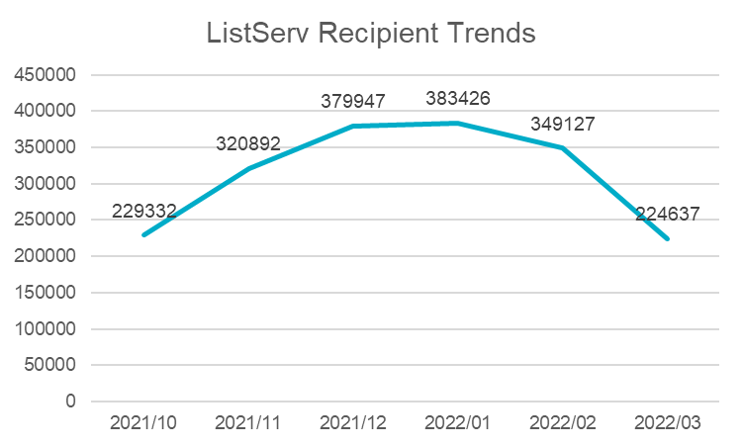

**ERCOT Help Desk Service Ticket Process**

* Mick outlined the current process when a Help Desk ticket is logged.
  + First of all, this process has been outsourced for ~3-4 years as it previously was ‘in house’. There is a rotating staff that is not specifically designated for ERCOT issues and agents. Agents rely on process/knowledge documents to properly route any tickets. (ERCOT acknowledged some documents need improvement/clarification)
  + If the ticket is deemed ‘critical’, a notification which must be acknowledged is sent to the primary contact at ERCOT, then if no response, the secondary contact followed by the entire IT team if an acknowledgement is not received.
  + For the 3/4/22 instance, no one saw the ticket.
* Mick highlighted his plans going forward to improve the process:
  + Generate reports for # of misaligned tickets and lost tickets
  + Reporting on overall volumes of tickets and those that are external vs internal tickets
  + Data will be provided at the next TDTMS meeting to determine a path forward
  + Mick commented with heightened cybersecurity, the market should plan for more frequent (monthly) patching which may be challenging to conduct testing and “get in place” during the scheduled outage potentially leading to other issues/problems

**MarkeTrak Upgrade and Demo**

* Testing continues for new version of MarkeTrak
* 5/16, the new version will be available in the RMTE – a market notice will be sent out 4/22 advising market participants
* 5/13, MarkeTrak in the RMTE will be unavailable as the new version is being loaded
* Nothing to publish just yet on the User’s Guide front
* Tammy Stewart continues to develop the “tips for creating your dashboard” which will be available by mid- May
* ACTION: Sheri will send a note to Art Deller solidifying training dates. TDTMS has offered the first part of the meeting for training on May 19th. The suggestion is to commence at 9:00 AM with the TDTMS meeting starting at 10:00 AM. The second training is tentatively scheduled for May 24th or 25th, Tuesday or Wednesday of the following week.

**SCR 817 MarkeTrak Validation Revisions Aligning w/ TXSET v5.0**

Approved by PUCT

**IAG Subtype Analysis**

Using the same structure/framework as last analysis in 2020, Sam Pak walked the working group through first an overall level set of the two data sets.

1. First analysis in 2020: IAS data from July 2019 to July 2020 (13 months)
   1. IAGs = 21025
   2. IALs = 23452
2. Second analysis in 2022: IAS data from July 2021 to December 2021 (6 months)
   1. IAGs = 8960
   2. IALs = 11908

The following framework was used comparing #s from both data sets. 

The team only reviewed IAGs and parts of IALs. In the past, where callouts were made, those stats were updated as well as any new callouts. All data will be confirmed, reviewed, and completed at the next meeting for presentation at the June RMS meeting.

**Other Business**

Carolyn pointed out for SCR815 – MarkeTrak Enhancements due in December, “archiving” of the subtypes means they will no longer exist and market participants will no longer have access to the subtype. The team decided this will be taken up again at our next meeting to ensure this is acceptable for stakeholders.

**NEXT MEETING AGENDA – May 19th 10:30 AM – WebEx only**

***First part of the morning will be MarkeTrak Refresh Training Session 9:00 – 10:30

1. ERCOT Updates
   1. Help Desk Ticket Process Update
2. MarkeTrak Upgrade
3. IAL Subtype Analysis – complete IALs and review IAG findings
4. SCR815 – “archiving” subtypes discussion