March 2022 ERCOT Monthly Operations Report
Reliability and Operations Subcommittee Meeting
May 5, 2022

Table of Contents
1. Report Highlights 2
2. Frequency Control 3
2.1. Frequency Events 3
2.2. Responsive Reserve Events 4
2.3. Load Resource Events 4
3. Reliability Unit Commitment 4
4. IRR, Wind, and Solar Generation as a Percent of Load 5
5. Largest Net-Load Ramps 7
6. COP Error Analysis 7
7. Congestion Analysis 10
7.1. Notable Constraints 10
7.2. Generic Transmission Constraint Congestion 16
7.3. Manual Overrides 16
7.4. Congestion Costs for Calendar Year 2022 16
8. System Events 18
8.1. ERCOT Peak Load 18
8.2. Load Shed Events 18
8.3. Stability Events 18
8.4. Notable PMU Events 18
8.5. DC Tie Curtailment 18
8.6. TRE/DOE Reportable Events 18
8.7. New/Updated Constraint Management Plans 18
8.8. New/Modified/Removed RAS 18
8.9. New Procedures/Forms/Operating Bulletins 19
9. Emergency Conditions 19
9.1. OCNs 19
9.2. Advisories 19
9.3. Watches 19
9.4. Emergency Notices 19
10. Application Performance 19
10.1. TSAT/VSAT Performance Issues 19
10.2. Communication Issues 19
10.3. Market System Issues 19
11. Model Updates 19
Appendix A: Real-Time Constraints 22

Report Highlights
- The unofficial ERCOT peak load for the month was 56,449 MW and occurred on 03/12/2022, during hour ending 08:00.
- There were 3 frequency events.
- There were 5 instances where Responsive Reserves were deployed.
- There were 64 HRUC commitments.
- There were 18 days of congestion on the West Texas Export GTC, 27 days on the North Edinburg to Lobo GTC, 1 day on the East Texas GTC, 4 days on the Bearkat GTC, 24 days on the Nelson Sharpe to Rio Hondo GTC, 12 days on the Valley Export GTC, 2 days on the Panhandle GTC, 4 days on the Culberson GTC, 5 days on the McCamey GTC, 5 days on the Treadwell GTC, and 1 day on the North to Houston GTC. There was no activity on the remaining GTCs during the month.
- There was 1 DC Tie Curtailment.
- A Solar Generation Record of 8,957 MW was set on 03/19/2022 at 12:42.
- A Solar Penetration Record of 23.85% was set on 03/19/2022 at 13:41.
- A Wind Penetration Record of 67.16% was set on 03/29/2022 at 03:49.

Frequency Control

Frequency Events
The ERCOT Interconnection experienced 3 frequency events, which resulted from units’ trips. The average event duration was 00:03:56.

A summary of the frequency events is provided below. The reported frequency events meet one of the following criteria: Delta Frequency is 60 mHz or greater; the MW loss is 350 MW or greater; resource trip event triggered RRS deployment. Frequency events that have been identified as Frequency Measurable Events (FME) for purposes of BAL-001-TRE-2 analysis are highlighted in blue. When analyzing frequency events, ERCOT evaluates PMU data according to industry standards. Events with an oscillating frequency of less than 1 Hz are inter-area, while higher frequencies indicate local events. Industry standards specify that damping ratio for inter-area oscillations should be 3.0% or greater. For the frequency events listed below, the ERCOT system met these standards and transitioned well after each disturbance.

Date and Time | Delta Frequency | Max/Min Frequency | Duration of Event | PMU Data |  | MW Loss | Load | IRR | Inertia
 | (Hz) | (Hz) |  | Oscillation Mode (Hz) | Damping Ratio |  | (MW) | % | (GW-s)
03/12/2022 10:21:03 | 0.104 | 59.882 | 00:04:23 | 0.61 | 11% | 747 | 49,842 | 42% | 242,446
03/14/2022 21:41:15 | 0.097 | 59.898 | 00:04:30 | 0.67 | 8% | 440 | 41,259 | 51% | 168,819
03/22/2022 4:16:26 | 0.119 | 59.889 | 00:02:56 | 2.05 | 4% | 703 | 34,421 | 61% | 130,435

(Note: All data on this graph encompasses frequency event analysis based on BAL-001-TRE-1.)

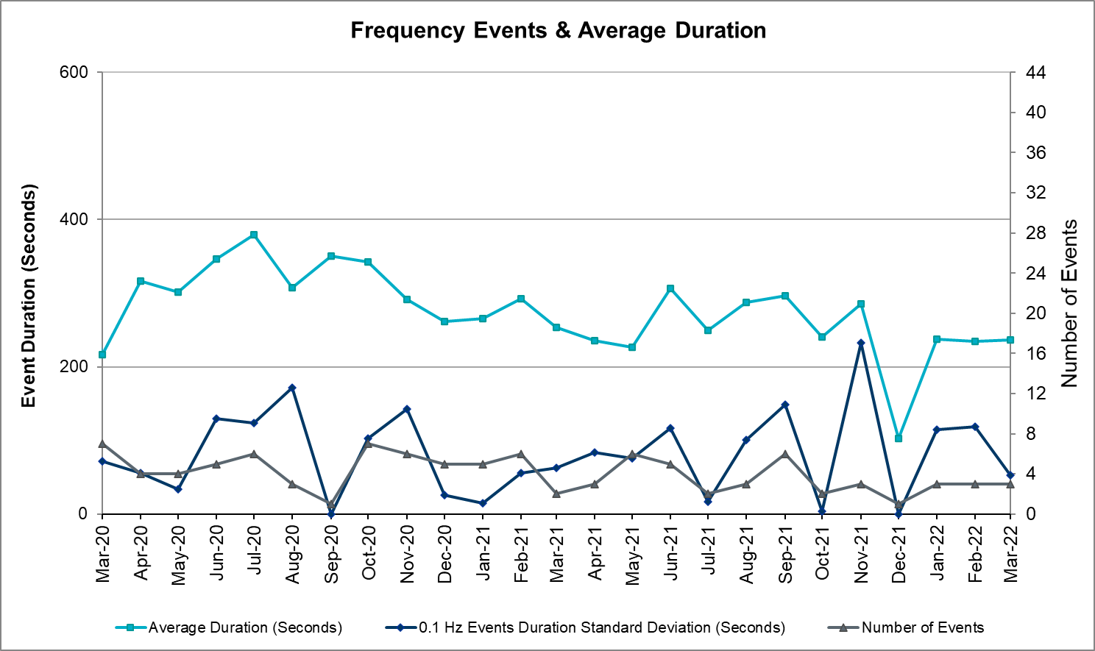

Responsive Reserve Events
There were 5 events where Responsive Reserve MWs were released to SCED. The events highlighted in blue were related to frequency events reported in Section 2.1 above.

Date and Time Released to SCED | Date and Time Recalled | Duration of Event | Maximum MWs Released | Comments
03/12/2022 10:21:10 | 03/12/2022 10:25:22 | 00:04:12 | 469
03/14/2022 21:41:22 | 03/14/2022 21:45:18 | 00:03:56 | 543
03/21/2022 13:50:38 | 03/21/2022 13:52:03 | 00:01:25 | 620
03/22/2022 4:16:34 | 03/22/2022 4:19:18 | 00:02:44 | 524
03/29/2022 23:58:58 | 03/30/2022 0:01:31 | 00:02:33 | 743

Load Resource Events
NONE.

Reliability Unit Commitment
ERCOT reports on Reliability Unit Commitments (RUC) monthly. Commitments are reported grouped by operating day and weather zone. The total number of hours committed is the sum of the hours for all the units in the specified region. Additional information on RUC commitments can be found on the MIS secure site at Grid Generation Reliability Unit Commitment.

There were no DRUC commitments.

There were 64 HRUC commitments

Resource Location | # of Resources | Operating Day | Total # of Hours Committed | Total MWhs | Reason for Commitment
COAST, EAST, NORTH_CENTRAL, SOUTH_CENTRAL | 8 | 03/01/2022 | 44 | 14,724.0 | Minimum Run Time, System Capacity
NORTH_CENTRAL, SOUTH_CENTRAL | 4 | 03/03/2022 | 19 | 10,210.3 | System Capacity
COAST, EAST, NORTH_CENTRAL, SOUTH_CENTRAL, SOUTHERN | 13 | 03/07/2022 | 67 | 19,348.0 | System Capacity
EAST, NORTH_CENTRAL | 3 | 03/08/2022 | 7 | 1,229.0 | System Capacity
EAST, NORTH_CENTRAL | 3 | 03/09/2022 | 6 | 1,194.0 | System Capacity
NORTH_CENTRAL, SOUTH_CENTRAL | 2 | 03/11/2022 | 11 | 2,730.0 | System Capacity
EAST, NORTH_CENTRAL | 2 | 03/14/2022 | 4 | 1,090.0 | System Capacity
SOUTH_CENTRAL | 5 | 03/15/2022 | 34 | 11,778.0 | System Capacity
NORTH_CENTRAL | 2 | 03/24/2022 | 5 | 2,353.0 | System Capacity
EAST, NORTH, NORTH_CENTRAL | 4 | 03/26/2022 | 6 | 2,978.2 | System Capacity
COAST, NORTH, NORTH_CENTRAL, SOUTH_CENTRAL | 10 | 03/29/2022 | 61 | 20,712.0 | DLWSRNK5, WESTEX
NORTH_CENTRAL | 2 | 3/30/2022 | 11 | 4,327.0 | WESTEX
COAST | 2 | 3/31/2022 | 6 | 1,936.0 | System Capacity

IRR, Wind, and Solar Generation as a Percent of Load
The graph below shows the maximum, minimum and average aggregate solar, wind and IRR output as a percentage of total ERCOT load when evaluated as 10-minute averaged intervals, over the past 13 months. Current wind and solar generation and penetration records are listed in the footnote below. Maximum IRR penetration for the month was 67.2% on 03/29/2022 interval ending 03:30 and minimum IRR penetration for the month was 4.1% on 03/08/2022 interval ending 19:00.

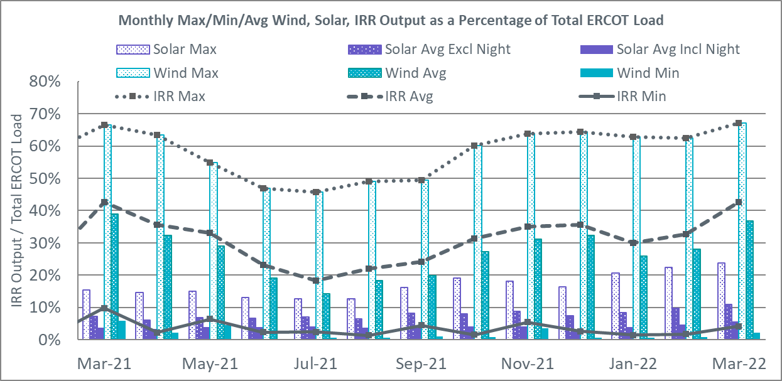

During the hour of peak load for the month, hourly integrated wind generation was 14,193 MW and solar generation was 1,721 MW. The graph below shows the wind and solar penetration percentage during the hour of the peak load in the last 13 months.

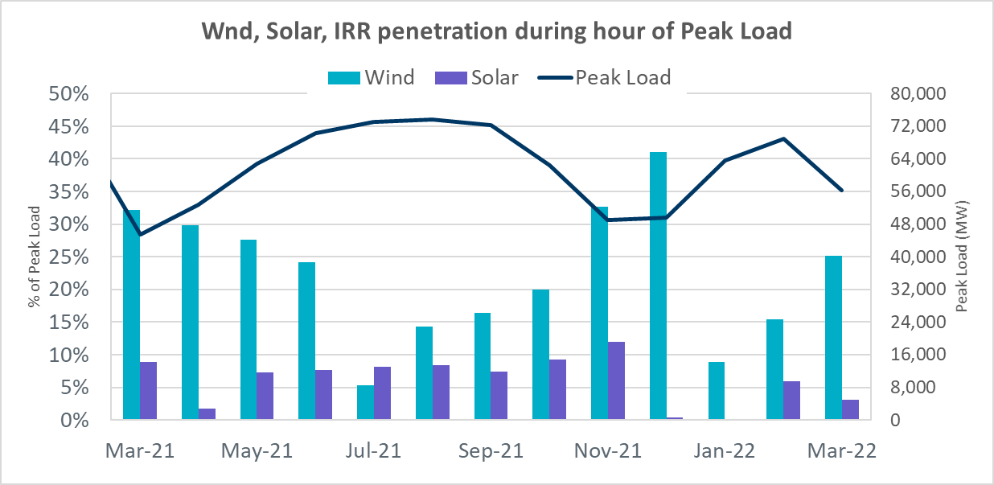

Lastly, the graph below shows the minimum wind, solar and IRR output during the peak load hour as a percentage of the daily peak load for every day in the month.

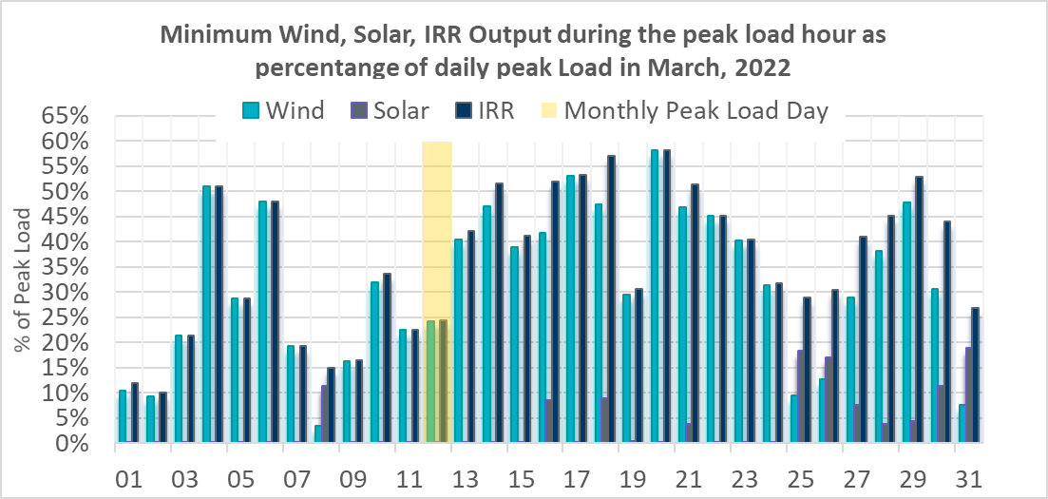

Largest Net-Load Ramps
The net-load ramp is defined as the change in net-load (load minus wind and PVGR generation) during the defined time horizon. Such a variation in net-load needs to be accommodated in grid operations to ensure that the reliability of the grid is satisfactorily maintained. The largest net-load ramp during 5-min, 10-min, 15-min, 30-min and 60-min in March 2022 is 1,192 MW, 2,155 MW, 3,015 MW, 5,714 MW, and 10,750 MW, respectively. The comparison with respect to the historical values is given in the table below.

Month and Year | 5 min | 10 min | 15 min | 30 min | 60 min
Mar 2014 | 822 MW | 1,381 MW | 1,895 MW | 3,237 MW | 5,257 MW
Mar 2015 | 956 MW | 1,615 MW | 2,146 MW | 3,341 MW | 5,661 MW
Mar 2016 | 979 MW | 1,635 MW | 2,149 MW | 2,967 MW | 5,070 MW
Mar 2017 | 888 MW | 1,522 MW | 1,838 MW | 3,321 MW | 5,395 MW
Mar 2018 | 1,375 MW | 1,688 MW | 2,069 MW | 3,576 MW | 5,957 MW
Mar 2019 | 919 MW | 1,511 MW | 1,932 MW | 3,194 MW | 5,596 MW
Mar 2020 | 979 MW | 1,406 MW | 1,650 MW | 2,642 MW | 4,660 MW
Mar 2021 | 926 MW | 1,556 MW | 1,945 MW | 3,282 MW | 6,104 MW
Mar 2022 | 1,192 MW | 2,155 MW | 3,015 MW | 5,714 MW | 10,750 MW
All Months in 2014-2022 | 1494 MW | 2,155 MW | 3,015 MW | 5,882 MW | 10,750 MW

COP Error Analysis
COP Error is calculated as the capacity difference between the COP HSL and real-time HSL of the unit. Mean Absolute Error (MAE) stayed over 7,000 MW until Day-Ahead at 12:00, then dropped significantly to 3,832 MW by Day-Ahead at 13:00. In the following chart, Under-Scheduling Error indicates that COP had less generation capacity than real-time and Over-Scheduling Error indicates that COP had more generation capacity than real-time.

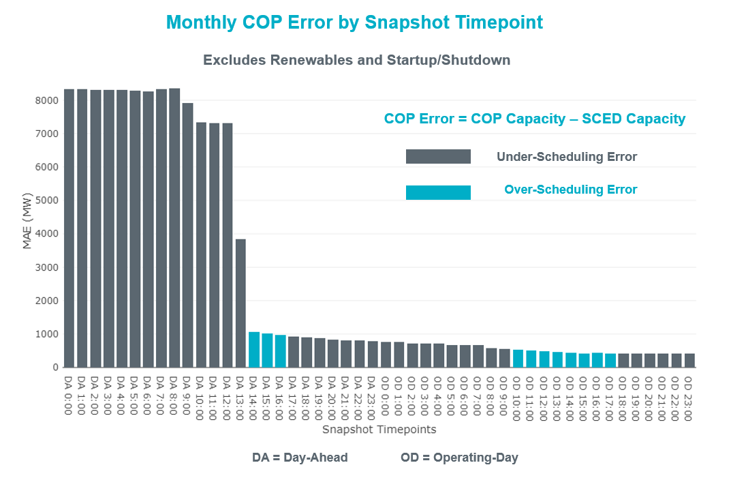

Monthly MAE for the Latest COP at the end of the Adjustment Period was 407 MW with median ranging from -301.1 MW for Hour-Ending (HE) 21 to 298.7 MW for HE 13. HE 15 on 03/10/2022 had the largest Over-Scheduling Error (1,848 MW) and HE 8 on 03/09/2022 had the largest Under-Scheduling Error (-2,613 MW).

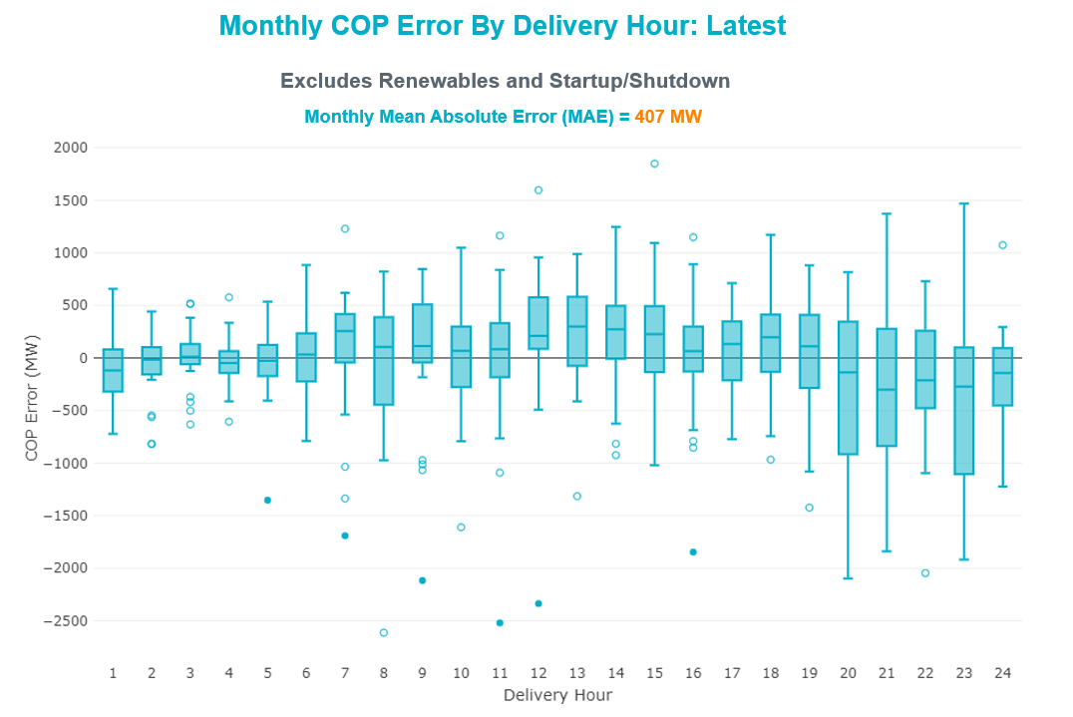

Monthly MAE for the Day-Ahead COP at 12:00 was 7,300 MW with median ranging from -11,167 MW for Hour-Ending (HE) 20 to -2,267 MW for HE 3. HE 20 on 03/07/2022 had the largest Under-Scheduling Error (-24,633 MW) and HE 3 on 03/16/2022 had the largest Over-Scheduling Error (483 MW).

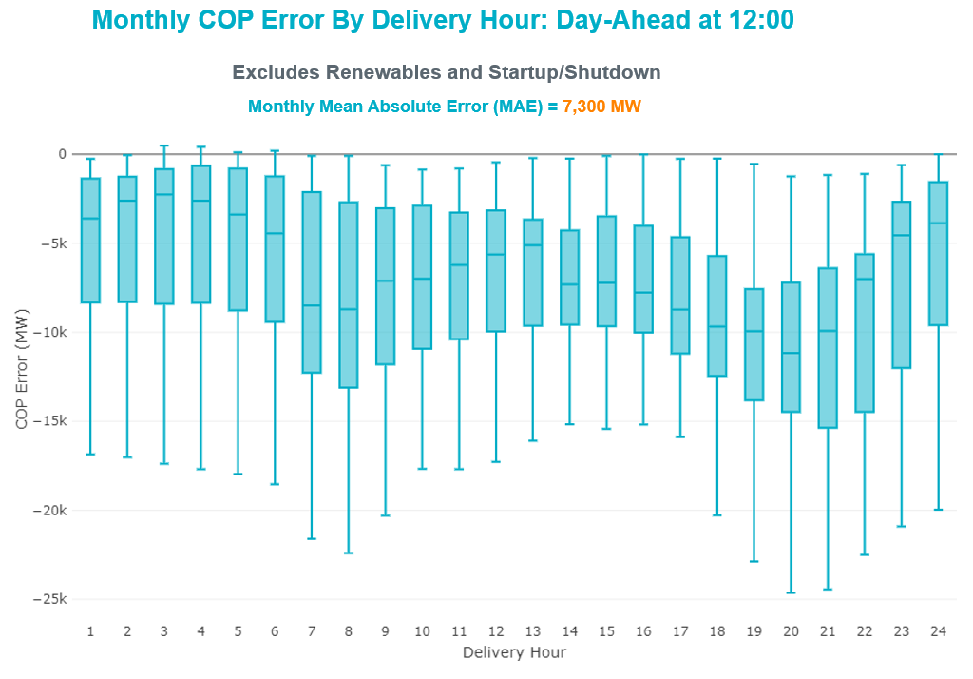

Congestion Analysis

Notable Constraints
Nodal protocol section 3.20 specifies that ERCOT shall identify transmission constraints that are binding in Real-Time three or more Operating Days within a calendar month. As part of this process, ERCOT reports congestion that meets this criterion to ROS. In addition, ERCOT also highlights notable constraints that have an estimated congestion rent exceeding $1,000 for a calendar month. These constraints are detailed in the table below, including approved transmission upgrades from TPIT that may provide some congestion relief based on ERCOT’s engineering judgement. Rows highlighted in blue indicate the congestion was affected by one or more outages. For a list of all constraints activated in SCED, please see Appendix A at the end of this report.

Contingency Name | Overloaded Element | # of Days Constraint Binding | Congestion Rent | Transmission Project
SALSW TO KLNSW 345 DBLCKT | KLNSW_MR2H | 21 | $41,079,868.60
TWR(345) JCK-REF27 & JCK-STP18 | CKT_3124_1 | 14 | $16,843,947.99
Basecase | NE_LOB | 25 | $12,381,235.76 | The Lower Rio Grande Valley (LRGV) System Enhancement Project (21RPG017) will improve but not eliminate the need for this GTC.
TWR(345) JOR-KG97 & JOR-NB99 | BCVLY_03_A | 10 | $11,732,488.06
BIG SPRING SWITCH to CHALK_69kV and McDonald Road_138kV | MGSES_MR1H | 4 | $10,431,863.72
LWSSW TO RNKSW AND LWSSW TO KRWSW 345 DBLCKT | 587__A | 3 | $9,526,872.24
Manual dbl ckt for NEDIN-BONILLA 345kV & RIOH-PRIM138kV | BURNS_RIOHONDO_1 | 19 | $7,940,149.74
LWSSW TO RNKSW AND LWSSW TO KRWSW 345 DBLCKT | 6020__B | 5 | $7,112,236.12 | Everman 345 kV Switching Station Rebuild (7118)
Fowlerton to LOBO 345 LIN1 | NLARSW_PILONC1_1 | 12 | $7,060,660.48
Basecase | WESTEX | 12 | $6,976,512.95
ODEHV-MOSSW 345&ODEHV-WLFSW 345_DBLCKT | ODEHV_MR3H | 2 | $6,884,584.30
JOHNSON SWITCH (ONCOR) to COMANCHE PEAK SES LIN _A | 160__D | 2 | $5,304,615.16 | Everman 345 kV Switching Station Rebuild (7118)
CALF CREEK POI to NATURAL DAM LIN _A | 6144__A | 7 | $5,048,357.53
CLBSW-CMBSW 138&VENSW-JONSW 345_DBLCKT | 160__D | 3 | $4,931,723.53 | Everman 345 kV Switching Station Rebuild (7118)
Basecase | HHGTOM_1 | 16 | $3,790,408.57
Falcon Seaboard TRX AMR1 345/138 | MGSES_MR1H | 2 | $3,632,436.72
TWR(345) JOR-KG97 & JOR-NB99 | JFSSC_06_A | 10 | $3,439,391.38
KRWSW TO WDENT 345 AND KRWSW TO LWSSW 345 DBLCKT | 6020__B | 1 | $3,152,065.31 | Everman 345 kV Switching Station Rebuild (7118)
COMANCHE SWITCH (Oncor) to COMANCHE PEAK SES LIN _A | 651__B | 14 | $3,089,829.61
PH ROBINSON to MEADOW LIN A | G138_10B_1 | 11 | $2,849,752.53 | Rebuild Magnolia - Seminole 138 kV Line (4010)
Cagnon-Calavers&Braunig 345kV | PAWNEE_SPRUCE_1 | 6 | $2,805,114.54
MANUAL TVW-CPS 345 & CPS-JON 345 DBLCKT | 6033__A | 2 | $2,410,911.51
Cagnon-Calavers&Braunig 345kV | COLETO_ROSATA1_1 | 5 | $2,282,588.43
STP SWITCH to Esperanza LIN 1 | BLESSI_PAVLOV1_1 | 8 | $2,281,853.45
LNGSW TO MDSSW 345 AND MGSES TO QALSW 345 DBLCKT | 14040__A | 2 | $2,103,068.69
ODEHV-MOSSW 345&ODEHV-WLFSW 345_DBLCKT | MDSSW_MR1H | 4 | $2,045,122.07
SALSW - HUTTO 345KV | KLNSW_MR2H | 1 | $2,041,764.25
Fowlerton to LOBO 345 LIN1 | BRUNI_69_1 | 13 | $1,882,420.71
Lostpi-Austro&Dunlap 345kV | 190T152_1 | 14 | $1,881,290.15
ODLAW SWITCHYARD to ASPHALT MINES LIN 1 | HAMILT_MAVERI1_1 | 18 | $1,823,186.05
Basecase | EASTEX | 1 | $1,659,911.07
Basecase | NELRIO | 24 | $1,565,676.76 | The Lower Rio Grande Valley (LRGV) System Enhancement Project (21RPG017) will improve but not eliminate the need for this GTC.
Sng-Tb&Rns 345kV | THWZEN71_A | 3 | $1,338,287.51
NORTH BELT to TH WHARTON LIN A | AN_WO_21_A | 2 | $1,335,426.22
HICKS SWITCH TRX HCKSW_3_1 345/138 | HCKSW_MR2L | 1 | $1,314,941.77
OASIS to MEADOW LIN A | BCVLY_03_A | 6 | $1,277,612.31
Fowlerton to LOBO 345 LIN1 | FALFUR_PREMON1_1 | 5 | $1,249,860.01
LNGSW TO MDSSW 345 AND MGSES TO QALSW 345 DBLCKT | 6217__A | 3 | $1,149,496.36
LON HILL to NELSON SHARPE LIN 1 | CELANE_KLEBER1_1 | 9 | $1,019,683.79
TWR (345) OB-ZEN71 & OB-ZEN99 | THWZEN71_A | 3 | $961,919.27
LON HILL to NORTH EDINBURG LIN 1 | FALFUR_PREMON1_1 | 3 | $959,920.49
LONG DRAW-FARADAY& SCOSW 345kV | LUTHER_VEALMOR_1 | 4 | $931,242.43
Manual dbl ckt for NEDIN-BONILLA 345kV & RIOH-PRIM138kV | LASPUL_RAYMND1_1 | 9 | $900,168.31
KLEBERG AEP to LOYOLA SUB LIN 1 | LOYOLA_69_1 | 12 | $873,764.14
Grissom to COLETO CREEK LIN 1 | GODDAR_TANGO1_1 | 3 | $826,773.08
TWR(345) JCK-STP18 & REF-STP27 | CKT_3124_1 | 6 | $790,542.82
ODLAW SWITCHYARD to ASPHALT MINES LIN 1 | ESCOND_GANSO1_1 | 15 | $759,871.50 | Escondido - Ganso 138 kV Line Rebuild (55624)
TWR(345) JCK-REF27 & JCK-STP18 | BLESSI_PAVLOV1_1 | 4 | $741,324.58
Bighil-Kendal 345kV | TREADW_YELWJC1_1 | 4 | $612,853.47
Lon_Hill-Nedin 345kV&Orngrov 138kV | FALFUR_PREMON1_1 | 8 | $609,659.10
SHELDON to GREENS BAYOU LIN A | GBYLYD70_A | 3 | $557,095.89
Lostpi-Austro&Dunlap 345kV | 197T171_1 | 5 | $538,648.62
TRADINGHOUSE SES to ELM MOTT LIN _A | 1020__A | 6 | $535,152.74
FORT MASON to YELLOW JACKET LIN 1 | HEXT_MASONS1_1 | 6 | $449,173.19
TWR(345) JOR-KG97 & JOR-NB99 | GBYUV_03_A | 4 | $438,828.11
JACKCNTY TO BOW 138 AND WISECNTY TO ALVRD 138 DBLCKT | MYRA_VAL_1 | 5 | $426,262.00
BRACKETTVILLE to ODLAW SWITCHYARD LIN 1 | GANSO_MAVERI1_1 | 3 | $426,004.17
Bighil-Kendal 345kV | SAPOWE_TREADW1_1 | 3 | $394,586.82
TWR(345) CHB-JOR97 & CBY-JOR99 | BCVLY_03_A | 6 | $362,719.54
AJO to NELSON SHARPE LIN 1 | LASPUL_RAYMND1_1 | 9 | $336,972.90
NORTH CARBIDE to AIRCO AEP LIN 1 | GRETA_REFUGI1_1 | 4 | $324,413.71
MESA VIEW SWITCH to FORT LANCASTER LIN 1 | CROSSO_NORTMC1_1 | 4 | $314,755.46
BENNETT ROAD SWITCH to WISE COUNTY LIN _B | MYRA_VAL_1 | 5 | $303,261.75
LON HILL to NELSON SHARPE LIN 1 | CELANE_N_SHAR1_1 | 3 | $294,857.17
COLEMAN LAKE IVIE TAP to EAST COLEMAN TAP LIN 1 | CONAN_SANA1_1 | 3 | $269,196.50
Basecase | VALEXP | 10 | $265,705.15 | The Lower Rio Grande Valley (LRGV) System Enhancement Project (21RPG017) will improve but not eliminate the need for this GTC.
LON HILL to NELSON SHARPE LIN 1 | LOYOLA_69_1 | 3 | $232,715.54
Lostpine-Fppyd1&Winches 345kV | 190T152_1 | 8 | $225,650.98
Carver to FRIEND RANCH LIN 1 | ATSO_SONR1_1 | 5 | $220,837.57
Basecase | BRIGHT_CHARTE1_1 | 27 | $204,471.62
SOUTH TEXAS PROJECT to BLESSING LIN 1 | COLETO_VICTOR1_1 | 3 | $199,348.95
Basecase | CULBSN | 4 | $170,987.54
Wirtz-Burnet&Starck 138kV | CORONA_AT4 | 8 | $169,524.65
FORT MASON to YELLOW JACKET LIN 1 | HEXT_YELWJC1_1 | 11 | $167,480.75
LON HILL to NORTH EDINBURG LIN 1 | MV_YUT_RAYMND1_1 | 3 | $153,629.56
HAMILTON ROAD to CORRAL LIN 1 | MAXWEL_WHITIN1_1 | 3 | $119,255.17
EAST BERNARD to ORCHARD LIN A | GEBSE_65_A | 3 | $110,773.74
FORT MASON to YELLOW JACKET LIN 1 | HEXT_MASONS1_1 | 12 | $99,430.23
COLETO CREEK to PAWNEE SWITCHING STATION LIN 1 | COLETO_VICTOR2_1 | 3 | $98,992.31
Bighil-Kendal 345kV | HAMILT_MAXWEL1_1 | 7 | $97,104.90 | Hamilton Road to Maxwell: Line Rebuild (61396)
TWR (138) QAB-SRB06 & DOL-SRB84 | JFSSC_06_A | 3 | $77,289.41
FIREROCK TO BRNWD 138 AND FIREROCK TO BANGS 69 DBLCKT | 6830__B | 3 | $74,682.52
COLETO CREEK to PAWNEE SWITCHING STATION LIN 1 | COLETO_VICTOR1_1 | 4 | $71,057.05
SAN ANGELO RED CREEK to Weiss LIN 1 | CONCHO_VRBS1_1 | 3 | $57,608.37 | Ballinger to Concho: 69 kV Line Rebuild (55421)
DYANN to SOUTH LANE CITY LIN A | GEBSE_65_A | 3 | $56,944.81
LAQUINTA to LOBO LIN 1 | FALFUR_PREMON1_1 | 6 | $50,124.79
JACKSBORO SWITCHING to COBB SWITCHING STATION LIN _A | 6085__E | 3 | $48,028.34
RIO HONDO to EAST RIO HONDO SUB LIN 1 | SCARBI_STILLM1_1 | 7 | $45,716.28
LAQUINTA to LOBO LIN 1 | BRUNI_69_1 | 5 | $36,929.63
Bwnsw-Bowwoo&Amosct 345kV | CONCHO_VRBS1_1 | 3 | $33,766.92 | Ballinger to Concho: 69 kV Line Rebuild (55421)
SOUTH TEXAS PROJECT to BLESSING LIN 1 | COLETO_VICTOR2_1 | 3 | $31,337.79
Basecase | TRDWEL | 4 | $9,156.86
SIGMOR to GEORGE WEST SWITCHING STATION LIN 1 | CHARTE_THREER1_1 | 3 | $2,011.29 | Poesta to Three Rivers (5166)

Generic Transmission Constraint Congestion
There were 18 days of congestion on the West Texas Export GTC, 27 days on the North Edinburg to Lobo GTC, 1 day on the East Texas GTC, 4 days on the Bearkat GTC, 24 days on the Nelson Sharpe to Rio Hondo GTC, 12 days on the Valley Export GTC, 2 days on the Panhandle GTC, 4 days on the Culberson GTC, 5 days on the McCamey GTC, 5 days on the Treadwell GTC, and 1 day on the North to Houston GTC. There was no activity on the remaining GTCs during the month.

Note: This is how many times a constraint has been activated to avoid exceeding a GTC limit, it does not imply an exceedance of the GTC occurred or that the GTC was binding.

Manual Overrides
None

Congestion Costs for Calendar Year 2022
The following table represents the top twenty active constraints for the calendar year based on the estimated congestion rent attributed to the congestion. ERCOT updates this list on a monthly basis.

Contingency | Overloaded Element | # of 5-min SCED | Estimated | Transmission Project
SALSW TO KLNSW 345 DBLCKT | Killeen Switch 345kV | 7337 | $55,843,582.53
Basecase | WESTEX GTC | 6696 | $33,259,501.98
WDGSW TO MARSW 138 DBLCKT | Mistletoe Heights - Hemphill 138kV | 2078 | $30,437,608.94
TWR(345) JCK-REF27 & JCK-STP18 | Hillje - South Texas Project 345kV | 3964 | $30,332,705.54
Basecase | NE_LOB GTC | 10314 | $24,296,641.19 | The Lower Rio Grande Valley (LRGV) System Enhancement Project (21RPG017) will improve but not eliminate the need for this GTC.
LWSSW TO RNKSW AND LWSSW TO KRWSW 345 DBLCKT | Argyle - Highlands Tnp 138kV | 2457 | $14,415,128.45
TWR(345) JOR-KG97 & JOR-NB99 | Bigvue - Lyondell 138kV | 2559 | $12,138,190.41
Manual dbl ckt for NEDIN-BONILLA 345kV & RIOH-PRIM138kV | Burns Sub - Rio Hondo 138kV | 4599 | $11,283,370.29
Fowlerton to LOBO 345 LIN1 | North Laredo Switch - Piloncillo 138kV | 3474 | $11,216,225.33
STP SWITCH to Esperanza LIN 1 | Blessing - Pavlov 138kV | 3659 | $10,833,179.48
BIG SPRING SWITCH to CHALK_69kV and McDonald Road_138kV | Morgan Creek Ses 345kV | 350 | $10,431,863.72
EVRSW TO HLSES 138 DBLCKT | Mistletoe Heights - Hemphill 138kV | 1065 | $9,007,490.05
Fowlerton to LOBO 345 LIN1 | Bruni Sub 138kV | 3785 | $7,344,873.18
LWSSW TO RNKSW AND LWSSW TO KRWSW 345 DBLCKT | Timberview Switch - Courtland 345kV | 779 | $7,112,236.12 | Everman 345 kV Switching Station Rebuild (7118)
ODEHV-MOSSW 345&ODEHV-WLFSW 345_DBLCKT | Odessa Ehv Switch 345kV | 209 | $6,884,584.30
Basecase | Omega - Horse Hollow Generation Tie 345kV | 3945 | $6,872,718.88
COMANCHE SWITCH (Oncor) to COMANCHE PEAK SES LIN _A | Comanche Tap - Comanche Switch (Oncor) 138kV | 4087 | $6,588,506.82
MTFSW TO TRSES 138 AND MTFSW TO CRSCN 138 DBLCKT | Desoto Switch - Red Oak 138kV | 67 | $6,231,596.29
FREDERICKSBURG TRX AT2 138/69 | Gillespie 138kV | 1122 | $5,733,841.31
JOHNSON SWITCH (ONCOR) to COMANCHE PEAK SES LIN _A | Timberview Switch - Kennedale 345kV | 381 | $5,304,615.16 | Everman 345 kV Switching Station Rebuild (7118)

System Events

ERCOT Peak Load
The unofficial ERCOT peak load for the month was 56,449 MW and occurred on 03/12/2022, during hour ending 08:00.

Load Shed Events
None.

Stability Events
None.

Notable PMU Events
ERCOT analyzes PMU data for any significant system disturbances that do not fall into the Frequency Events category reported in section 2.1. The results are summarized in this section once the analysis has been completed.

There were no PMU events outside of those reported in section 2.1.

DC Tie Curtailment
There was one DC tie curtailment.

Date | DC Tie | Curtailing Period | # of Tags Curtailed | Initiating Event | Curtailment Reason
03/25/2022 | DC-R | HE 14 | 1 | Unplanned Outage | Planned or Unplanned Outage

TRE/DOE Reportable Events
- BPUB submitted an OE-417 for 03/06/2022. Reportable Event Type: Cyber event.
- BPUB submitted an OE-417 for 03/11/2022. Reportable Event Type: Suspicious activity to its facility.
- BPUB submitted an OE-417 for 03/15/2022. Reportable Event Type: Suspicious activity to its facility.

New/Updated Constraint Management Plans
None.

New/Modified/Removed RAS
None.

New Procedures/Forms/Operating Bulletins
None.

Emergency Conditions

OCNs
Date and Time | Message
Mar 8, 2022  10:30 CPT | ERCOT issued an Advanced Action Notice (AAN) due to possible future emergency condition of reserve capacity deficiency beginning Saturday, March 12, 2022, HE 06 until Saturday, March 12, 2022, HE 09. ERCOT updated the AAN on March 9 and March 10. No additional capacity was needed in the AAN updated on March 10. No Outage Schedule Adjustment (OSA) was issued.
Mar 21, 2022 13:30 CPT | OCN issued due to the potential severe weather of high winds, and tornadoes in the Central, North Central and East Texas areas for Monday March 21, 2022.

Advisories
None.

Watches
None.

Emergency Notices
None.

Application Performance

TSAT/VSAT Performance Issues
None.

Communication Issues
None.

Market System Issues
None.

Model Updates
The Downstream Production Change (DPC) process allows ERCOT to make changes in the on-line Network Operations Model without loading a completely new model. The purpose of this process is to allow for reliable grid operations as system conditions change between designated Network Operations Model database loads. The DPC process is limited in scope to just those items listed below, with equipment ratings updates being the most common. ERCOT has seen a rise in the use of the DPC process to make on-line updates to the Network Operations Model in recent years, instead of through the standard Network Operations Model Change Request process.

- Static Line ratings (Interim Update)
- Dynamic Line ratings (non-Interim Update)
- Autotransformer ratings (non-Interim Update)
- Breaker and Switch Normal status (Interim Update)
- Contingency Definitions (Interim Update)
- RAP and RAS changes or additions (Interim Update)
- Net Dependable and Reactive Capability (NDCRC) values (Interim Update)
- Impedance Updates (non-Interim)

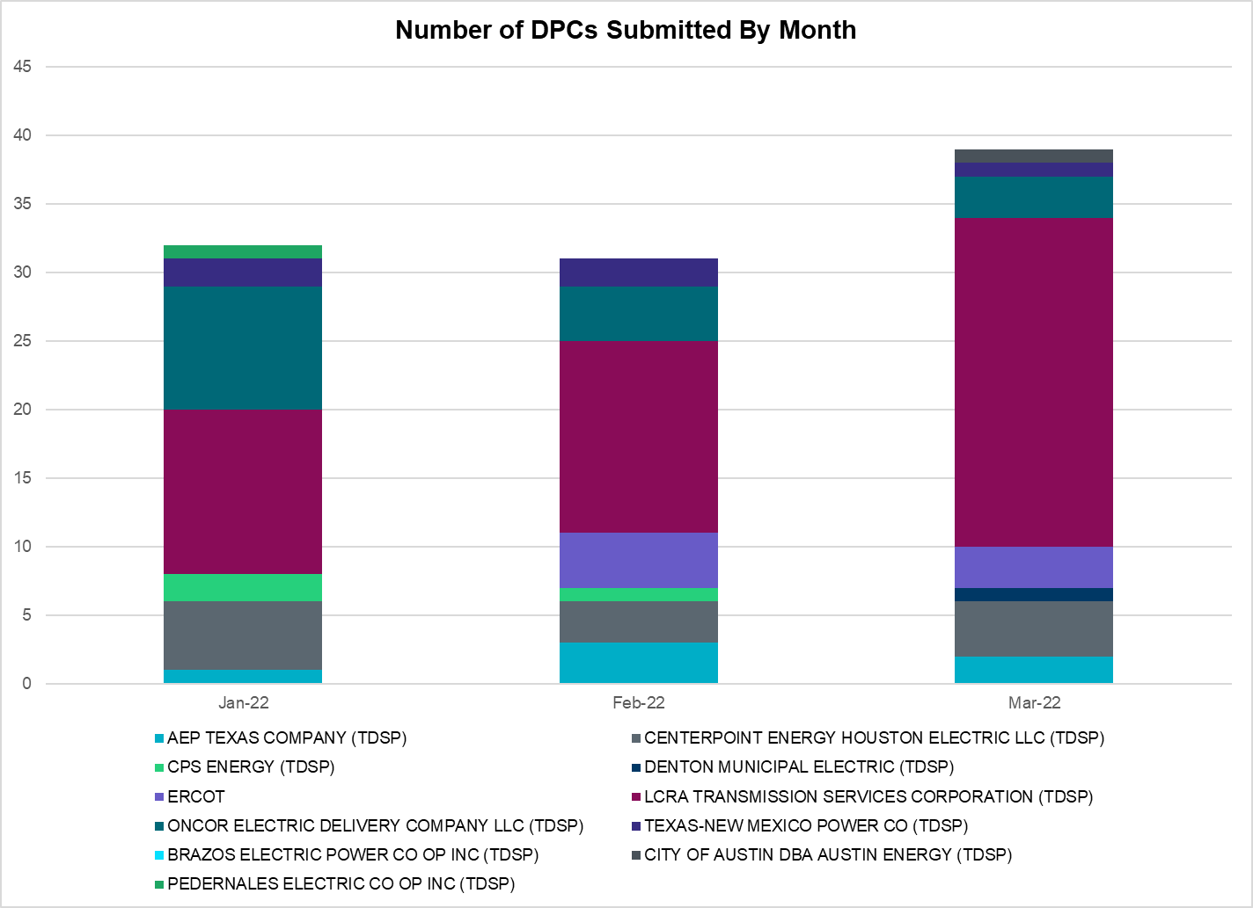

Transmission Operator | Number of DPCs
AEP TEXAS COMPANY (TDSP) | 2
BRAZOS ELECTRIC POWER CO OP INC (TDSP) | 0
BROWNSVILLE PUBLIC UTILITIES BOARD (TDSP) | 0
BRYAN TEXAS UTILITIES (TDSP)
CENTERPOINT ENERGY HOUSTON ELECTRIC LLC (TDSP) | 4
CITY OF AUSTIN DBA AUSTIN ENERGY (TDSP) | 1
CITY OF COLLEGE STATION (TDSP) | 0
CITY OF GARLAND (TDSP) | 0
CPS ENERGY (TDSP) | 0
DENTON MUNICIPAL ELECTRIC (TDSP) | 1
ELECTRIC TRANSMISSION TEXAS LLC (TDSP) | 0
ERCOT | 3
LCRA TRANSMISSION SERVICES CORPORATION (TDSP) | 24
LONE STAR TRANSMISSION LLC (TSP) | 0
ONCOR ELECTRIC DELIVERY COMPANY LLC (TDSP) | 3
PEDERNALES ELECTRIC CO OP INC (TDSP) | 0
RAYBURN COUNTRY CO OP DBA RAYBURN ELECTRIC (TDSP) | 0
SHARYLAND UTILITIES LP (TDSP) | 0
SOUTH TEXAS ELECTRIC CO OP INC (TDSP) | 0
TEXAS MUNICIPAL POWER AGENCY (TDSP) | 0
TEXAS-NEW MEXICO POWER CO (TDSP) | 1

Appendix A: Real-Time Constraints
The following is a complete list of constraints activated in SCED. Full contingency descriptions can be found in the Standard Contingencies List located on the MIS secure site at Grid Generation Reliability Unit Commitment.

Contingency Name | Overloaded Element | From Station | To Station | Count of Days
BASE CASE | NE_LOB | n/a | n/a | 27
BASE CASE | BRIGHT_CHARTE1_1 | BRIGHTSD | CHARTER | 27
BASE CASE | BRIGHT_CHARTE1_1 | CHARTER | BRIGHTSD | 27
BASE CASE | NELRIO | n/a | n/a | 24
DSALKLN5 | KLNSW_MR2H | KLNSW | KLNSW | 22
SFORYEL8 | HEXT_MASONS1_1 | MASONSW | HEXT | 19
MHARNED5 | BURNS_RIOHONDO_1 | RIOHONDO | MV_BURNS | 19
SFORYEL8 | HEXT_MASONS1_1 | HEXT | MASONSW | 19
SBRAUVA8 | HAMILT_MAVERI1_1 | HAMILTON | MAVERICK | 18
SCMNCPS5 | 651__B | CMNSW | CMNTP | 18
BASE CASE | WESTEX | n/a | n/a | 18
DAUSLOS5 | 190T152_1 | WINCHES | GIDEON | 17
SKLELOY8 | LOYOLA_69_1 | LOYOLA | LOYOLA | 16
BASE CASE | HHGTOM_1 | HHGT | OMEGA | 16
SBRAUVA8 | ESCOND_GANSO1_1 | GANSO | ESCONDID | 15
SFORYEL8 | HEXT_YELWJC1_1 | YELWJCKT | HEXT | 15
DKG_NB_5 | BCVLY_03_A | BCV | LY | 15
SFORYEL8 | HEXT_YELWJC1_1 | HEXT | YELWJCKT | 15
DSTPRED5 | CKT_3124_1 | STP | HLJ | 14
SMDOPHR5 | G138_10B_1 | SEMINOLE | MAGNO_TN | 14
SLOBSA25 | BRUNI_69_1 | BRUNI | BRUNI | 13
DREFSTP5 | CKT_3124_1 | STP | HLJ | 13
SLOBSA25 | NLARSW_PILONC1_1 | NLARSW | PILONCIL | 13
DKG_NB_5 | JFSSC_06_A | JFS | SC | 12
BASE CASE | VALEXP | n/a | n/a | 12
SMDOOAS5 | BCVLY_03_A | BCV | LY | 12
DLONOR58 | FALFUR_PREMON1_1 | FALFUR | PREMONT | 12
MHARNED5 | LASPUL_RAYMND1_1 | LASPULGA | RAYMND2 | 11
SSTPESP8 | BLESSI_PAVLOV1_1 | BLESSING | PAVLOV | 11
SN_SAJO5 | LASPUL_RAYMND1_1 | LASPULGA | RAYMND2 | 10
SN_SLON5 | CELANE_KLEBER1_1 | CELANEBI | KLEBERG | 10
DLOSWIN5 | 190T152_1 | WINCHES | GIDEON | 9
SNEDLON5 | FALFUR_PREMON1_1 | FALFUR | PREMONT | 9
SMV_RI28 | SCARBI_STILLM1_1 | SCARBIDE | STILLMAN | 9
SLAQLOB8 | BRUNI_69_1 | BRUNI | BRUNI | 9
DWIRSTA8 | CORONA_AT4 | CORONA | CORONA | 9
DSTPRED5 | BLESSI_PAVLOV1_1 | BLESSING | PAVLOV | 8
DJACALV8 | MYRA_VAL_1 | MYRA | VALYVIEW | 8
DBIGKEN5 | HAMILT_MAXWEL1_1 | MAXWELL | HAMILTON | 8
DCHBJO25 | BCVLY_03_A | BCV | LY | 7
DCAGBRA5 | COLETO_ROSATA1_1 | COLETO | ROSATA | 7
SLAQLOB8 | FALFUR_PREMON1_1 | FALFUR | PREMONT | 7
SLOBSA25 | FALFUR_PREMON1_1 | FALFUR | PREMONT | 7
XFL2C58 | MGSES_MR1H | MGSES | MGSES | 7
DFLCMGS5 | MGSES_MR1H | MGSES | MGSES | 7
SSTABS18 | 6144__A | BSPRW | STASW | 7
DCAGBRA5 | PAWNEE_SPRUCE_1 | PAWNEE | CALAVERS | 6
DCAGBRA5 | PAWNEE_SPRUCE_1 | CALAVERS | PAWNEE | 6
DODEMOS5 | MDSSW_MR1H | MDSSW | MDSSW | 6
SELMTH25 | 1020__A | ELMOT | MCTYE | 6
SCOLPAW5 | COLETO_VICTOR2_1 | COLETO | VICTORIA | 6
SBTPBNT8 | MYRA_VAL_1 | MYRA | VALYVIEW | 6
BASE CASE | MCCAMY | n/a | n/a | 5
DBWN_AM5 | CONCHO_VRBS1_1 | CONCHO | VRBS | 5
DLWSRNK5 | 6020__B | TVWSW | CRTLD | 5
DPHRAL58 | G138_10B_1 | SEMINOLE | MAGNO_TN | 5
DWLDSCO5 | LUTHER_VEALMOR_1 | VEALMOOR | LUTHER | 5
DQABSRB8 | JFSSC_06_A | JFS | SC | 5
DBIGKEN5 | TREADW_YELWJC1_1 | TREADWEL | YELWJCKT | 5
SBLESTP5 | COLETO_VICTOR2_1 | COLETO | VICTORIA | 5
SAIRNCA8 | GRETA_REFUGI1_1 | REFUGIO | GRETA | 5
BASE CASE | TRDWEL | n/a | n/a | 5
SCARFRI8 | ATSO_SONR1_1 | ATSO | SONR | 5
SCARFRI8 | ATSO_SONR1_1 | SONR | ATSO | 5
DAUSLOS5 | 197T171_1 | GIDEON | AUSTRO | 5
SCOLBAL8 | CONAN_SANA1_1 | SANA | CONAN | 4
DBIGKEN5 | SAPOWE_TREADW1_1 | TREADWEL | SAPOWER | 4
SBRAUVA8 | GANSO_MAVERI1_1 | GANSO | MAVERICK | 4
DKG_NB_5 | GBYUV_03_A | GBY | UV | 4
SILLFTL8 | HAMILT_MAXWEL1_1 | MAXWELL | HAMILTON | 4
DDUPHE18 | I_DUPS_MCCAMP2_1 | I_DUPSW | MCCAMPBE | 4
SLOBSA25 | LARDVN_LASCRU1_1 | LARDVNTH | LASCRUCE | 4
DCMBJON5 | 160__D | TVWSW | KNEDL | 4
SCRMSAR8 | CONCHO_VRBS1_1 | CONCHO | VRBS | 4
DDUPHE18 | I_DUPS_MCCAMP2_1 | MCCAMPBE | I_DUPSW | 4
SMV_PAR8 | RIOHND_ERIOHND_1 | MV_RIOHO | RIOHONDO | 4
SJONCPS5 | 160__D | TVWSW | KNEDL | 4
SBRAUVA8 | GANSO_MAVERI1_1 | MAVERICK | GANSO | 4
DLWSRNK5 | 587__A | ARGYL | LWSVH | 4
SN_SLON5 | CELANE_N_SHAR1_1 | N_SHARPE | CELANEBI | 4
SCOLPAW5 | COLETO_VICTOR1_1 | COLETO | VICTORIA | 4
BASE CASE | CULBSN | n/a | n/a | 4
SBLESTP5 | COLETO_VICTOR1_1 | COLETO | VICTORIA | 4
DBIGKEN5 | SAPOWE_TREADW1_1 | SAPOWER | TREADWEL | 4
SLOBSA25 | ASHERT_CATARI1_1 | CATARINA | ASHERTON | 4
BASE CASE | BEARKT | n/a | n/a | 4
SGEOSIG8 | CHARTE_THREER1_1 | CHARTER | THREER69 | 4
SFTLMES8 | CROSSO_NORTMC1_1 | NORTMC | CROSSOVE | 4
SPOMNED5 | FREER_LOBO1_1 | LOBO | FREER | 4
SNEDLON5 | MV_YUT_RAYMND1_1 | RAYMND2 | MV_YUTT | 4
SGRICOL5 | GODDAR_TANGO1_1 | GODDARD | TANGO | 4
DGRSPKR5 | 6377__A | BRTSW | ORANS | 3
DSNG_TB5 | THWZEN71_A | ZEN | THW | 3
DSTEXP12 | COLETO_VICTOR2_1 | COLETO | VICTORIA | 3
SODLBRA8 | GANSO_MAVERI1_1 | GANSO | MAVERICK | 3
SKELLA_8 | LASPUL_RAYMND1_1 | LASPULGA | RAYMND2 | 3
DMGSLNG5 | 6217__A | WLVSW | GAILS | 3
DGRMGRS8 | 6830__B | CRDSW | OLNEY | 3
DELMSAN5 | BIG_FO_MOORE1_1 | MOORE | BIG_FOOT | 3
SMV_RI28 | CP_MVCNT_1 | MV_CNTRA | COFFPORT | 3
SORE2B8 | GEBSE_65_A | SE | GEB | 3
SCOMHA38 | MAXWEL_WHITIN1_1 | MAXWELL | WHITING | 3
DZEN_OB5 | THWZEN71_A | ZEN | THW | 3
SNBTHW5 | AN_WO_21_A | WO | AN | 3
SKINFAL8 | FALFUR_PREMON1_1 | FALFUR | PREMONT | 3
DMGSQAL5 | 6217__A | WLVSW | GAILS | 3
SN_SLON5 | LOYOLA_69_1 | LOYOLA | LOYOLA | 3
SBRAHAM8 | GANSO_MAVERI1_1 | GANSO | MAVERICK | 3
SGBYSD25 | GBYLYD70_A | LYD | GBY | 3
DCOLFA59 | PAWNEE_TANGO1_1 | TANGO | PAWNEE | 3
DMGSQAL5 | 14040__A | PCTSW | DEWTP | 3
SBOMJC25 | 6085__E | WFSSW | NSTAR | 3
DMOLLO58 | PAWNEE_TANGO1_1 | TANGO | PAWNEE | 3
MSHRVEN5 | 6020__B | TVWSW | CRTLD | 3
SORE2B8 | GEBSE_65_A | GEB | SE | 3
DCOLFA59 | GODDAR_TANGO1_1 | GODDARD | TANGO | 3
SBRAUVA8 | MAXWEL_WHITIN1_1 | MAXWELL | WHITING | 3
DLOSWIN5 | 197T171_1 | GIDEON | AUSTRO | 3
BASE CASE | ARAGORN_TIE_1 | ARAGORN | PINNAC | 3
DWHILON5 | COLETO_VICTOR2_1 | COLETO | VICTORIA | 3
SLCDYN8 | GEBSE_65_A | GEB | SE | 3
DWISALV8 | MYRA_VAL_1 | MYRA | VALYVIEW | 3
MHARNED5 | BURNS_HEIDLBRG_1 | MV_BURNS | MV_HBRG4 | 3
SCO2EUL8 | COLETO_ROSATA1_1 | COLETO | ROSATA | 2
DJACALV8 | SPR_VALY_1 | VALYVIEW | SPR | 2
DMOLLO58 | GODDAR_TANGO1_1 | GODDARD | TANGO | 2
SLOBSA25 | GODDAR_TANGO1_1 | GODDARD | TANGO | 2
SCARFRI8 | HAMILT_MAXWEL1_1 | MAXWELL | HAMILTON | 2
MHARRIO5 | LASPUL_RAYMND1_1 | LASPULGA | RAYMND2 | 2
DMGSMDS5 | MDSSW_MR1H | MDSSW | MDSSW | 2
DODEMOS5 | ODEHV_MR3H | ODEHV | ODEHV | 2
DBWNAMO5 | SAPOWE_SAST1_1 | SAPOWER | SAST | 2
SBIGSCH5 | BIGLAK_RUSSEK1_1 | BIGLAKE | RUSSEKST | 2
SCAGHIL5 | CAGNON_MR4H | CAGNON | CAGNON | 2
SCISPUT8 | ESTES_PECAN_1_1 | PECAN_BY | ESTES | 2
DKG_NB_5 | EXSUV_03_A | UV | EXS | 2
SBRAHAM8 | HAMILT_MAVERI1_1 | HAMILTON | MAVERICK | 2
SN_SLON5 | HOLLY4_SOUTH_1_1 | HOLLY4 | SOUTH_SI | 2
SN_SLON5 | KINGSV_KLEBER1_1 | KLEBERG | KINGSVIL | 2
SELMTH25 | 1020__E | MCTYE | THSTP | 2
DBIGKEN5 | BONDRO_SONR1_1 | SONR | BONDROAD | 2
DKENNO89 | CHARTE_THREER1_1 | CHARTER | THREER69 | 2
DFRIILL8 | HAMILT_MAXWEL1_1 | MAXWELL | HAMILTON | 2
SGRICOL5 | PAWNEE_TANGO1_1 | TANGO | PAWNEE | 2
DTMPTHS5 | 1210__B | HUBRD | HAN1 | 2
DRILKRW5 | 35020__B | GRVSW | GRSES | 2
SBOMJC25 | 35020__B | GRVSW | GRSES | 2
DHCKRNK5 | 6020__B | TVWSW | CRTLD | 2
MTVWJON5 | 6033__A | CPSES | MBDSW | 2
SEILPCT8 | 6471__A | MGSES | MCDLD | 2
SW_BW_25 | 6471__A | MGSES | MCDLD | 2
DGRSBOW5 | 6560__A | RICSW | GRSES | 2
DELMSAN5 | BEEVIL_NORMAN1_1 | BEEVILLE | NORMANNA | 2
DCALCAG5 | COLETO_VICTOR1_1 | COLETO | VICTORIA | 2
DELMSAN5 | COLETO_VICTOR1_1 | COLETO | VICTORIA | 2
SODLBRA8 | ESCOND_GANSO1_1 | GANSO | ESCONDID | 2
DGBY_KG5 | GBYUV_03_A | GBY | UV | 2
SSANFOW5 | GEO_SIG_1 | GEOWEST | SIGMOR | 2
SBRAUVA8 | SANTIA_SAPOWE1_1 | SANTIAGO | SAPOWER | 2
DWSHNAV5 | 160__D | TVWSW | KNEDL | 2
SKINODE5 | 421T441_1 | LCRANE | CRANEA | 2
DRNKKRW5 | 587__A | ARGYL | LWSVH | 2
DSCOFAR5 | 6216__B | WLVSW | SHRNE | 2
XEIN58 | 6471__A | MGSES | MCDLD | 2
SSCLWF18 | 6840__B | NVKSW | ANARN | 2
DGBY_KG5 | BCVLY_03_A | BCV | LY | 2
SODLBRA8 | HAMILT_MAVERI1_1 | HAMILTON | MAVERICK | 2
SSALTMP5 | KLNSW_MR2H | KLNSW | KLNSW | 2
SBWDDBM5 | LPLNW_LPLMD_1 | LPLNW | LPLMD | 2
BASE CASE | PNHNDL | n/a | n/a | 2
DBIGKEN5 | YELWJCKT_PS_1 | YELWJCKT | YELWJCKT | 2
MSHRTVW5 | 6020__B | TVWSW | CRTLD | 2
DCBYJOR5 | BCVLY_03_A | BCV | LY | 2
DTMPBE58 | KLNSW_MR2H | KLNSW | KLNSW | 2
DCAGBRA5 | PAWNEE_XF1 | PAWNEE | PAWNEE | 2
MBLYWLF5 | BLESSI_PAVLOV1_1 | BLESSING | PAVLOV | 2
SLOBSA25 | CATARI_PILONC1_1 | PILONCIL | CATARINA | 2
SBRACAL5 | N5_R5_1 | CALAVERS | CAGNON | 2
DCALCAG5 | PAWNEE_XF1 | PAWNEE | PAWNEE | 2
SN_SLON5 | HOLLY4_SERDEV1_1 | HOLLY4 | HOLLY4 | 2
DSALHUT5 | KLNSW_MR2H | KLNSW | KLNSW | 2
SBIGSCH5 | SANTIA_SAPOWE1_1 | SANTIAGO | SAPOWER | 2
SCMNCPS5 | CONAN_SANA1_1 | SANA | CONAN | 2
DCMBJON5 | 160__A | KNEDL | CNTRY | 1
SBOMJC25 | 6040__A | GRSES | PKRSW | 1
DLWSRNK5 | 6200__D | SHRSW | PRKRW | 1
DFLCMGS5 | 6462__C | MCNSW | MKNGB | 1
SWRDYN8 | EL_CAM_LANCTY1_1 | LANCTYPM | EL_CAMPO | 1
DCOTDMT5 | FARMLAND_LONGD_1 | FARMLAND | W_LD_345 | 1
DMGSQAL5 | HARGRO_TWINBU1_1 | TWINBU | HARGROVE | 1
SBWDDBM5 | LPLMK_LPLNE_1 | LPLMK | LPLNE | 1
DWHILON5 | MELONC_SEADRF1_1 | MELONCRE | SEADRFTC | 1
SBOMJC25 | MYRA_VAL_1 | MYRA | VALYVIEW | 1
DFPPLOS5 | SALEM_AT4L | SALEM | SALEM | 1
SCOLBAL8 | SANA_FMR1 | SANA | SANA | 1
SJONCPS5 | SHRSW_MR1L | SHRSW | SHRSW | 1
SJONVEN5 | 160__A | KNEDL | CNTRY | 1
DKRWLWS5 | 3180__A | FCRSW | CDHSW | 1
DNAVLEG5 | 50__A | JEWET | BBSES | 1
DODEMOS5 | 6217__A | WLVSW | GAILS | 1
DSCOTKW5 | 6217__A | WLVSW | GAILS | 1
DFLCMDL5 | 6471__A | MGSES | MCDLD | 1
SSCLWF28 | 6830__B | CRDSW | OLNEY | 1
SSCLWF28 | 6850__B | NVKSW | ARCTY | 1
DLONOR58 | ASHERT_CATARI1_1 | ASHERTON | CATARINA | 1
SBONNED5 | BURNS_HEIDLBRG_1 | MV_BURNS | MV_HBRG4 | 1
DCAGBRA5 | COLETO_VICTOR2_1 | COLETO | VICTORIA | 1
SSANFOW5 | COTULL_REVEIL1_1 | REVEILLE | COTULLA | 1
SMIDLO28 | FALFUR_PREMON1_1 | FALFUR | PREMONT | 1
SGAFGRN8 | G138_2_1 | ATTWATER | PHR | 1
DCENFAL5 | GODDAR_TANGO1_1 | GODDARD | TANGO | 1
DKG_RTW5 | JFSSC_06_A | JFS | SC | 1
DSALKLN5 | KLNSW_MR2L | KLNSW | KLNSW | 1
SNEDLON5 | LASPUL_RAYMND1_1 | LASPULGA | RAYMND2 | 1
DSKYCAL5 | N5_R5_1 | CALAVERS | CAGNON | 1
BASE CASE | N_TO_H | n/a | n/a | 1
DCENFAL5 | PAWNEE_TANGO1_1 | TANGO | PAWNEE | 1
MHARNED5 | SCARBI_STILLM1_1 | SCARBIDE | STILLMAN | 1
SBOSELM5 | WHTNY_HT1L | WHTNY | WHTNY | 1
MTVWSHR5 | 495__B | TVWSW | VENSW | 1
DKRWLWS5 | 6020__B | TVWSW | CRTLD | 1
DFLCMGS5 | 6217__A | WLVSW | GAILS | 1
SMDLMOS5 | 6462__C | MCNSW | MKNGB | 1
XBOM58 | 6558__B | FSHSW | WFALS | 1
XESK189 | CAPELL_MERK1_1 | CAPELLA | MERK | 1
DBIGKEN5 | CARVER_TINSLE1_1 | CARVER | TINSLEY | 1
DWO5_EU8 | DV_HT_24_A | HT | DV | 1
BASE CASE | EASTEX | n/a | n/a | 1
DWHILON5 | GODDAR_TANGO1_1 | GODDARD | TANGO | 1
MHARNED5 | HAINE__LA_PAL1_1 | LA_PALMA | HAINE_DR | 1
DTWIDIV5 | HARGRO_TWINBU1_1 | TWINBU | HARGROVE | 1
SSCHNOE5 | HARGRO_TWINBU1_1 | TWINBU | HARGROVE | 1
SLGEI_D8 | I_DUPS_LGE1_1 | LGE | I_DUPSW | 1
SKGJOR5 | JFSSC_06_A | JFS | SC | 1
SES2FRI8 | MIDW_OZONA1_1 | OZONA | MIDW | 1
SSCLWF28 | OLN_FMR2 | OLN | OLN | 1
XSH2R58 | SHRSW_MR1L | SHRSW | SHRSW | 1
DWSHNAV5 | 6020__B | TVWSW | CRTLD | 1
XBOM358 | 6558__B | FSHSW | WFALS | 1
DGRSBOW5 | 6626__F | BTTSW | HENWE | 1
SRICGRS8 | 6840__B | NVKSW | ANARN | 1
DCAGBRA5 | BEEVIL_NORMAN1_1 | BEEVILLE | NORMANNA | 1
DELMSAN5 | COLETO_VICTOR2_1 | COLETO | VICTORIA | 1
SLOBSA25 | FREER_LOBO1_1 | LOBO | FREER | 1
BASE CASE | JFSSC_06_A | JFS | SC | 1
SLOBSA25 | LASCRU_MILO1_1 | LASCRUCE | MILO | 1
DWHILON5 | MELONC_RINCON1_1 | RINCON | MELONCRE | 1
SCRMSAR8 | MILES_ROWE1_1 | MILES | ROWE | 1
SBRACAG5 | N5_R5_1 | CALAVERS | CAGNON | 1
XCA2G58 | N5_R5_1 | CALAVERS | CAGNON | 1
STANPAW5 | NCARBI_SEADRF1_1 | SEADRFTC | NCARBIDE | 1
SSCLWF28 | NVKSW_FMR1 | NVKSW | NVKSW | 1
BASE CASE | RAMBLER_GENTIE_1 | RAMBLER | TWINBU | 1
DWISALV8 | SPR_VALY_1 | VALYVIEW | SPR | 1
DNAVLEG5 | 40__A | JEWET | BBSES | 1
DSWETKW5 | 6036__A | TKWSW | MGSES | 1
SBOMJC25 | 6085__B | NSTAR | LKARH | 1
DSCOTKW5 | 6215__A | BCKSW | CGRSW | 1
DSALKLN5 | 630__B | KLNSW | HHSTH | 1
DODEMOS5 | 6512__B | ODEHV | TROTP | 1
DCPSST58 | 651__B | CMNSW | CMNTP | 1
DBOMGRS8 | 6560__A | RICSW | GRSES | 1
SCAGHIL5 | CAGNON_MR4L | CAGNON | CAGNON | 1
BASE CASE | CFLATS_TLINE_1 | CFLATS | TREADWEL | 1
BASE CASE | EGTL_1 | EGROVESL | HORSCR | 1
SKINODE5 | HARGRO_TWINBU1_1 | TWINBU | HARGROVE | 1
DEAB_WR8 | LANCTY_LAN_CT1_1 | LAN_CTY | LANCTYPM | 1
DCPSES12 | MAXWEL_WHITIN1_1 | MAXWELL | WHITING | 1
SWHILON5 | REACTOR1_SEC_1 | WHITE_PT | WHITE_PT | 1
STBSNG5 | THWZEN71_A | ZEN | THW | 1
DWSHNAV5 | 495__B | TVWSW | VENSW | 1
SABRSPR8 | 584__A | KRMSW | ARGYL | 1
DMGSQAL5 | 6046__A | MGSES | FLCNS | 1
SCOBBOM5 | 6085__E | WFSSW | NSTAR | 1
SCMNCPS5 | 651__C | CMNTP | SHILO | 1
DREAPWE8 | APO_JUPI_1 | JUPITER | APOLLO | 1
DSWELNC5 | BLUF_C_MULBER1_1 | BLUF_CRK | MULBERRY | 1
DLONOR58 | CELANE_N_SHAR1_1 | CELANEBI | N_SHARPE | 1
SFPPLO25 | CKT_3132_1 | FPPYD1 | WINCHES | 1
DWCSH285 | HCKSW_MR2L | HCKSW | HCKSW | 1
SHOLWES8 | HOLLY4_SOUTH_1_1 | HOLLY4 | SOUTH_SI | 1
DCALCAG5 | KENEDS_ROSATA1_1 | ROSATA | KENEDSW | 1
SILLFTL8 | MAXWEL_WHITIN1_1 | MAXWELL | WHITING | 1
DMGSMDS5 | MDSSW_MR1L | MDSSW | MDSSW | 1
STANPAW5 | MELONC_RINCON1_1 | RINCON | MELONCRE | 1
SCAGCA25 | N5_U3_1 | CALAVERS | BRAUNIG | 1
DGRMGRS8 | OLN_FMR2 | OLN | OLN | 1
DCALCAG5 | PAWNEE_SPRUCE_1 | CALAVERS | PAWNEE | 1
SJONCPS5 | 160__A | KNEDL | CNTRY | 1
XSH1R58 | 3180__A | FCRSW | CDHSW | 1
DSALHUT5 | 630__B | KLNSW | HHSTH | 1
DCAGCO58 | 656T656_1 | KENDAL | BERGHE | 1
DCOLFA59 | BEEVIL_NORMAN1_1 | BEEVILLE | NORMANNA | 1
SOWLBIG8 | BISON_STRS1_1 | BISON | STRS | 1
DSWECBF5 | BLUF_C_MULBER1_1 | MULBERRY | BLUF_CRK | 1
XHAM88 | CARVER_LVOK1_1 | LVOK | CARVER | 1
DKOCNUE8 | CHAMPL_WEIL_T1_1 | WEIL_TRC | CHAMPLIN | 1
SCOLPAW5 | COLETO_ROSATA1_1 | COLETO | ROSATA | 1
DSTEXP12 | COLETO_VICTOR1_1 | COLETO | VICTORIA | 1
SWHILON5 | COLETO_VICTOR1_1 | COLETO | VICTORIA | 1
DCALCAG5 | COLETO_VICTOR2_1 | COLETO | VICTORIA | 1
SBURWIR8 | CORONA_AT4 | CORONA | CORONA | 1
DELMSAN5 | COYCTP_SUNNIL1_1 | SUNNILAN | COYCTP | 1
SCENLOB5 | GODDAR_TANGO1_1 | GODDARD | TANGO | 1
DMGSLNG5 | HARGRO_TWINBU1_1 | TWINBU | HARGROVE | 1
SNORODE5 | HARGRO_TWINBU1_1 | TWINBU | HARGROVE | 1
XHCK58 | HCKSW_MR2L | HCKSW | HCKSW | 1
UCBYCBY1 | JFSSC_06_A | JFS | SC | 1
SSTPESP8 | LAN_CT_PAVLOV1_1 | PAVLOV | LAN_CTY | 1
DLONOR58 | LASPUL_RAYMND1_1 | LASPULGA | RAYMND2 | 1
DCALCAG5 | POT_OAKS_1 | POTEETS | OAKS9 | 1
DCALCAG5 | SMG_ELMCRK1_1 | SANMIGL | ELMCREEK | 1
DREFSTP5 | STPWAP39_1 | STP | WAP | 1
SKDLRN25 | THWZEN71_A | ZEN | THW | 1
DMGSQAL5 | 6095__D | LMESA | JPPOI | 1
DGRMGRS8 | 6635__G | ESTLD | MRVLY | 1
SRICGRS8 | 6840__A | ANARN | CRDSW | 1
SSPUSLT8 | ASPM_69T2 | ASPM | ASPM | 1
SSPUSLT8 | ASPM_CONA1_1 | ASPM | CONA | 1
XKEN289 | BEEVIL_CHARTE1_1 | CHARTER | BEEVILLE | 1
DWSHNAV5 | EMSES_MR1H | EMSES | EMSES | 1
SCARFRI8 | FDR_OZNC_1 | OZNC | FRIEND_R | 1
SCOMHA38 | HAMILT_MAXWEL1_1 | MAXWELL | HAMILTON | 1
DLONOR58 | MV_YUT_RAYMND1_1 | RAYMND2 | MV_YUTT | 1
SPAWSAN5 | PAWNEE_XF1 | PAWNEE | PAWNEE | 1
DBERBO58 | R5_T5_1 | CAGNON | HILLCTRY | 1
BASE CASE | RIOHND_ERIOHND_1 | MV_RIOHO | RIOHONDO | 1
DWIRSTA8 | SANDCR_AT1 | SANDCR | SANDCR | 1
DSTPRED5 | STPWAP39_1 | STP | WAP | 1
DTESEDI5 | WHIT_RV_W_CW2_1 | WHIT_RVR | W_CW_345 | 1

Current Wind Generation Record: 25,408 MW on 02/22/2022 at 21:57 | Current Wind Penetration Record: 67.16% on 03/29/2022 at 03:49 Current Solar Generation Record: 8,957 MW on 03/19/2022 at 12:42 | Current Solar Penetration Record: 23.85% on 03/19/2022 at 13:41
This is the hourly integrated peak demand as published in the ERCOT D&E report.
All DC Tie Curtailments are posted publicly on the ERCOT Market Information System. See that posting for additional details for the event(s) in question.
See DC Tie Operating Procedure (http://www.ercot.com/mktrules/guides/procedures) for more details.

