From the ercot.com home page:
- Select: MIS Login

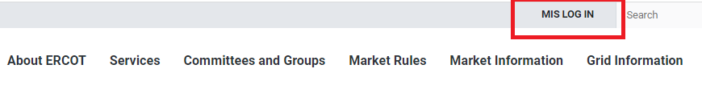
- Select: Applications
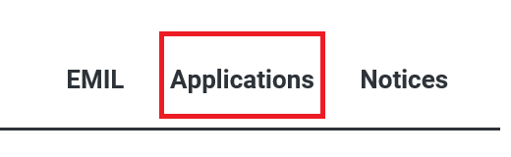
- Select: Service Requests
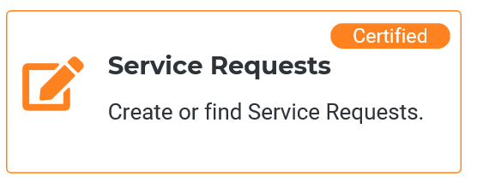
- Service Request Window
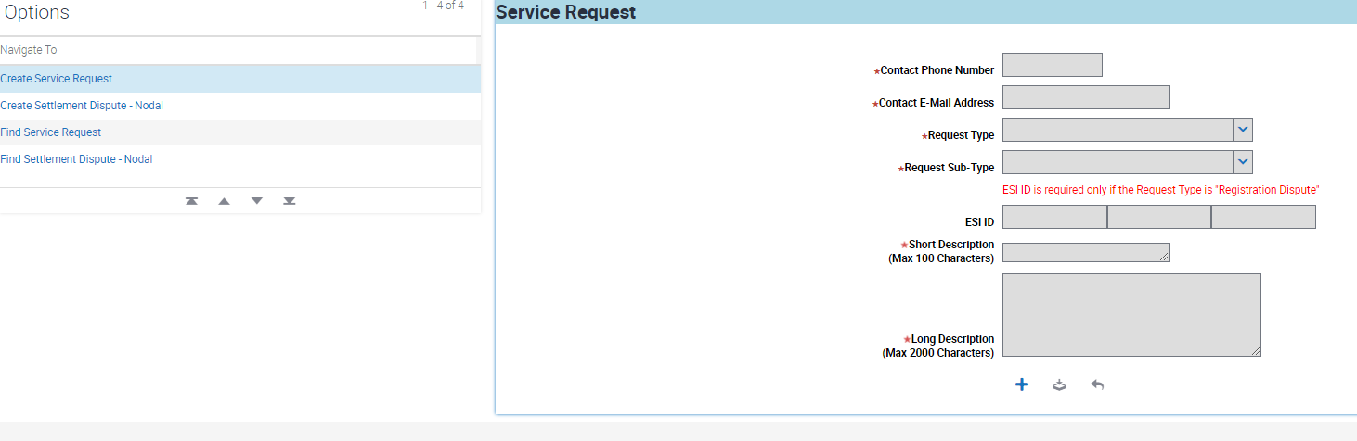

Service Request Window
- Select: the + and the fields will become editable
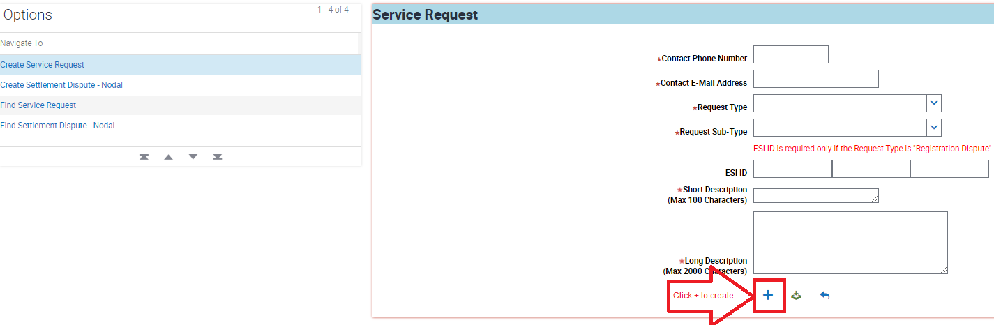

- Enter all red fields shown below
  - Short Description: “Rule 25.53 EOP Submission” and Entity Type (PGC, REP, TDU, MOU, EC, etc.)
  - Long Description:
    - Enter the full legal name of each entity for which the EOP is being submitted and the PUC registration category or entity type (e.g., “Utility Company LLC (TDU)”).
    - If the EOP is being submitted to satisfy a Resource Entity’s EOP-submission obligation under Section 3.21 of the ERCOT Protocols, include the additional information described in the Market Notice.

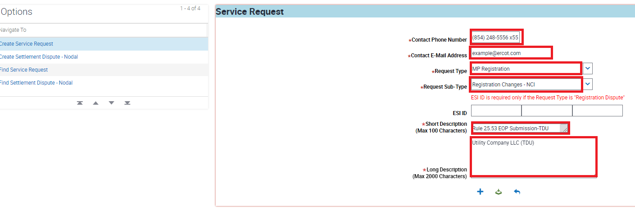

Service Request Window
- Submit using green button Note: this step is prior to attaching documents
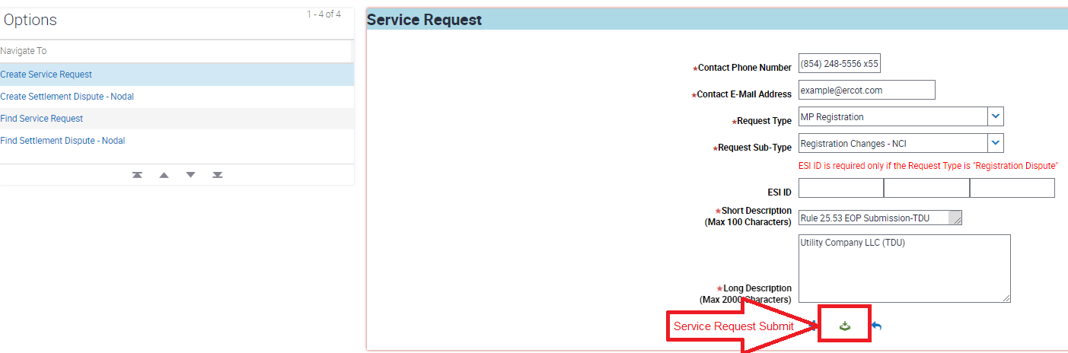

Scroll down to Attachments
- Select: the +
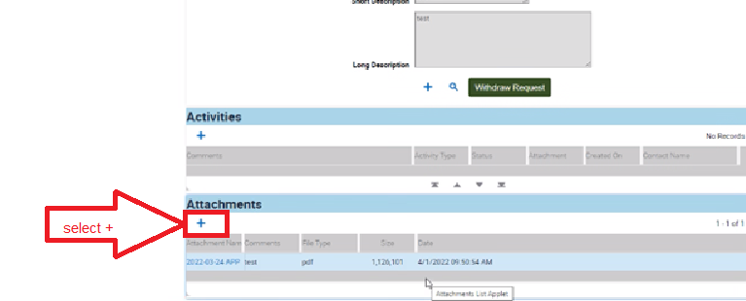

- Select document to attach and click green button
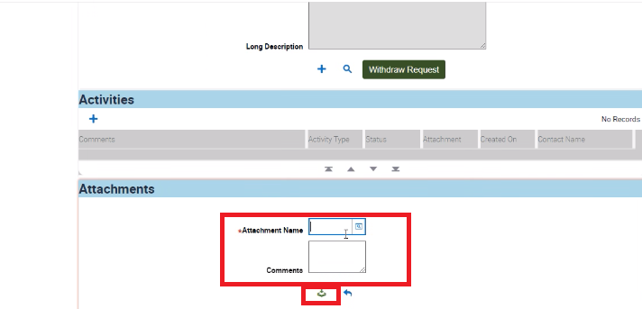
Upon completion you will see the attachment
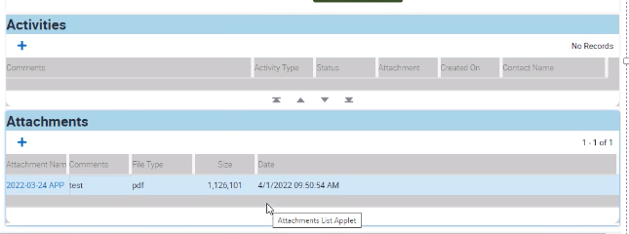

Once the Service Request has been reviewed and the EOP has been downloaded by ERCOT, the Market Participant will receive an email from noreply@ercot.com indicating that the Service Request has been closed.
Example:
