**TDTMS**

**March 24th, 2022**

**WebEx only**

|  |  |  |  |  |  |
| --- | --- | --- | --- | --- | --- |
| Attendee | Company | Attendee | Company | Attendee | Company |
| Diana Rehfeldt | TNMP | Dave Michelson | ERCOT | Birdie Cobb | CNP |
| Sam Pak | Oncor | Tammy Stewart | ERCOT | Carolyn Reed | CNP |
| Marina Grady | Oncor | Mick Hanna | ERCOT | Lysette Balance | CNP |
| Sheri Wiegand | Vistra | Mike Dameron | ERCOT | Kathy Scott | CNP |
| Steven Pliler | Vistra | Vikram Gupta | ERCOT | Polly Morgan | CNP |
| Stephen Wilson | Vistra | Jordan Troublefield | ERCOT | Angela Blakes | CNP |
| Glenn Robertson | Vistra | Eric Lotter | GridMonitor | Gerald Howard II | CNP |
| Angela Durham | Vistra - VBB | Jim Lee | TEC | Terrance Walker | CNP |
| Carla Strickland | Vistra | Kyle Patrick | NRG | Christopher Dominquez | CNP |
| Debbie Gossage | Vistra | Tomas Fernandez | NRG | Jason Abbott | CNP |
| Tracy Johnson | Vistra | Alain Martinez | NRG | Jill Bell | CNP |
| Jackie Buckner | Vistra | Sandra Belk | NRG | Monica Jones | CNP |
| Keshia Simmons | Vistra | Deb Belin | Earth Etch | Sonja Collins | CNP |
| Melinda Earnest | AEP | Tito Aguilar Hernandez | CNP | Kimaniece George | CNP |
|  |  | Yan Ng | CNP | Karen Malkey | CNP |

**Antitrust/Minutes**

* Antitrust Admonition was read by Sheri Wiegand
  + Minutes from 2/16/22 were reviewed and approved

**ERCOT System Instances & MarkeTrak Monthly Performance Review**

* Mick presented both January and February performance reports
* All targets and SLOs were met, 1 site failover in Jan, 2 in Feb
* Purpose of site failovers: Accelerated infrastructure patchwork due to heightened security warnings and elevate ERCOT system protection
* Listserv activity has no issues

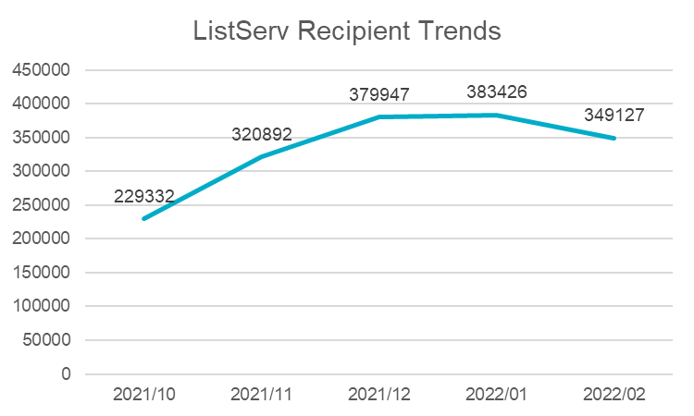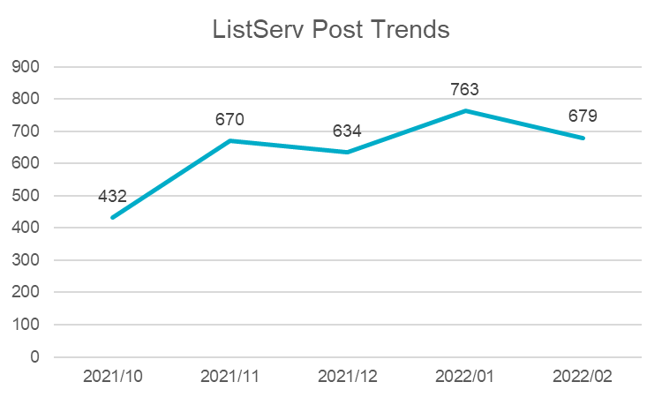

**ERCOT System Issue 3/4/22**

* ERCOT experienced a system processing issue late on 3/4/22 causing transactions to be delayed until the next day resulting in same day MVIs/MVOs (requested for 3/4 ) to be rejected by the TDSP (on 3/5) for Invalid backdating
* Per ERCOT, a “perfect storm” had occurred: increased patching (for security), increased volume as headed into evening hours, and increased exceptions that trickled in then flooded which did not clear as expected
* ERCOT monitoring alerted some activity and reprocessing occurred after midnight (next day)
* Question if volume was a concern causing the degradation – ERCOT indicated the system sees that volume frequently and is not a concern under optimal conditions.
* NEXT STEPS:
* New alerts have been added if there are large number of “low” exceptions to catch issue sooner. ERCOT has also committed to providing a market notice to the stakeholders should such conditions and issue recur. Market participants expressed the importance of sending the notice to eliminate any confusion on whose system was experiencing issues.

**MarkeTrak Upgrade and Demo**

* Dave Michelson provided a high-level status of the MarkeTrak refresh:
  + Currently in the testing environment – not ready for publication
  + the user interface is changing yet underlying functionality is not
  + New MT will be available in the RMTE on May 16th
  + GO LIVE is still planned for June 6th
  + Updated User’s Guide (lots of new screenshots) will be available mid-May. NOTE: Tammy did offer to make available different sections of the User’s Guide once updated. Prioritization will be on General Navigation section first, followed by more common subtypes such as IAGs and Other sections.
* Tammy Stewart presented a LIVE demo of the new MT tool. Below are a few of the tips presented:
  + “Welcome to SBM Work Center” will be first pop up – acknowledge
  + Home page/submit tree will be replaced with dashboards/toolbars
  + “new” button –“browse” first and will have all subtypes and then user can move to ‘favorites’ from ‘recent’ submittals
  + Dashboards will be made of widgets – widgets are URLs, reports, activities ACTION ITEM: Tammy is checking on limit of # of widgets on dashboard
  + IMPORTANT: Each user will need to set up their own dashboard – old dashboards will not carry over to new system. In the RMTE, users can practice setting up their dashboard so on June 6th, they will be prepared on how to establish
  + Report names should be documented to establish one’s new dashboard
  + All reports that exist today will move to new system, only not visible on the dashboard and will need to be set up to display
  + There will be system dashboards and custom dashboards
  + General links are available
  + Quick links is still available
  + Multiple screens will also be available - # of widgets
  + Activity will display a graphical view of the issue
  + ID Search is also available and will be a new icon at the top of the screen instead of on the tool bar
  + Same bookmarks should work
  + Same advance search feature
  + Will need to establish notifications, especially when background reports have completed
  + User Profile Settings – same, only under different link and will transition to new system
  + Manage Data was under ‘search’ and now will be under ‘user profile’ – same with Rolodex (all contacts will remain the same)
  + ‘X’ in the top right corner is used to exit current view and return to the dashboard
  + **SUMMARY**: MarkeTrak will function the same, only navigation will be different. All issues will transition to new system. The heaviest lift will be re-creating one’s own personal dashboard.
* Tammy has offered to assist in developing a new document for posting on the MarkeTrak Information page on “How to Set Up New Dashboards”

**SCR 817 MarkeTrak Validation Revisions Aligning w/ TXSET v5.0**

SCR is on the agenda for the 3/31 PUCT OM for approval

**IAG Subtype Analysis**

Reviewed the framework for the IAG deep dive analysis that the WG will begin next meeting. Results from last analysis will be compared to new report.



**NEXT MEETING AGENDA – April 21st 9:30 AM – New ERCOT Met Center – in person!!**

ERCOT Updates

IAG Subtype Analysis – deep dive

**Meeting will be held in person at the new ERCOT offices - 8000 Metropolis Drive (Building E), Suite 100 / Austin, Texas 78744**