NPRR Number | 1112 | NPRR Title | Reduction of Unsecured Credit Limits
Date |  | April 4, 2022
Submitter’s Information
Name |  | Terry Naulty, Alicia Loving, Alicia Hooks, Dan Baily, Katie Rich, Clif Lange, Bob Wittmeyer (on behalf of DME).
E-mail Address |  | Terrance.Naulty@cityofdenton.com; Alicia.Loving@austinenergy.com; ahooks@geus.org; DBailey@gpltexas.org; KRich@gsec.coop; clif@stec.org; bob@longhornpwr.com
Company |  | Denton Municipal Electric, Austin Energy, Greenville Electric Utility System, Garland Power and Light, Golden Spread Electric Coop., South Texas Electric Coop (Joint Commenters)
Phone Number
Cell Number |  | 512 762 8895
Market Segment |  | Municipal & Cooperative

Comments
Joint Commenters appreciate the efforts ERCOT, and Stakeholders have devoted to this effort, and the effort ERCOT has taken to reduce additional uplift charges to our customers.
Winter storm Uri was devastating to Texas both in loss of life and financial fallout. The storm caused tens of billions of dollars to be transferred between Market Participants and ERCOT. During Uri, there were (and still are) 37 Market Participants with a limited amount of unsecured credit. Of those 37 Market Participants 36 have fully paid ERCOT. Uri was the ultimate stress test for ERCOT credit policies and 36 of those 37 passed the test.
Those 36 Market Participants took a wide variety of measures to offset these extraordinary costs including raising rates, issuing bonds, drawing down cash reserves, adding surcharges to customer bills, or some combination of the above. All 36 parties made good on their payments to ERCOT. Clearly, ERCOT’s credit policies as they related to unsecured credit worked in 36 of 37 cases.
The one Market Participant that received unsecured credit and has failed to fully pay is challenging ERCOT on the validity of the charges it received. The assumed $50 million of unsecured credit that counterparty could have potentially been granted (actual amount is confidential) would not materially change the portion of the $1.9 billion amount currently in default with ERCOT.
Some Market Participants have suggested that while the State offered a securitization option following Uri, it would not do so again in the future should a similar event occur and therefore unsecured credit should now be eliminated. This suggestion fails to consider both the small scale of unsecured credit compared to the total obligations of the parties in such an event, and the actions the Public Utility Commission (PUC) and Legislature through Senate Bill 3 have taken to mitigate future exposures. Since Uri, the PUC has lowered the offer cap from $9,000 to $5,000 and SB3 requires that energy offers and Settlement be lowered to actual cost after 12 hours at the cap. It is estimated that during Uri, the effect of those two changes as well as adherence to the Low System-Wide Offer Cap (LCAP) prices (that no longer include a multiplier for fuel) would have reduced the cost by about 75%. This reduction in risk is before consideration of any other PUC changes which are currently under way.
Credit Work Group
Unlike most of the Working Groups in the stakeholder process, the Credit Work Group is a Board-level Working Group made up of credit professionals, who must prove to ERCOT’s satisfaction that the individual’s job functions, and professional experience warrant their participation in the Working Group. The Credit Work Group meets in conjunction with the Market Credit Work Group (MCWG) but only the Credit Work Group has a voting structure. The Credit Work Group has considered Nodal Protocol Revision Request (NPRR) 1112 on three different occasions, and Joint Commenters support the recommendation of the credit professionals to reduce the Unsecured Credit Limits from $50M to $30 million. As the 3/15/22 Credit Work Group comments state:
On March 14, 2022, the Credit WG reviewed Nodal Protocol Revision Request (NPRR) 1112. The Credit WG proposed the $30M limit as a compromise between the existing policy and ERCOT’s proposal of eliminating unsecured credit. Credit WG can support retaining the existing credit limit or a reduction to $30M. Based on information reviewed to date, Credit WG has not seen evidence of a material improvement in credit risk due to the reduction or elimination of unsecured credit.
Joint Commenters understand ERCOT prefers to eliminate unsecured credit, but it appears that the proposal to eliminate all unsecured credit is a solution looking for a problem. Today there are 37 Market Participants with unsecured credit. Eliminating unsecured credit to these 37 parties will add additional costs to the market and will naturally force the affected Counter-Parties to purchase credit support from a financial institution. Since there are a limited number of financial institutions currently offering letters of credit, requiring investment grade parties to use letters of credit from a limited number of financial institutions will effectively concentrate credit into fewer Entities. While that might be desirable if the financial institutions which were taking on that concentration had better credit than the exiting Counter-Parties, that does not seem to be the case.
The table below outlines the Fitch Credit ratings as of 4/02/22 between Counter-Parties to which ERCOT has extended unsecured credit and the financial institutions from which ERCOT accepts letters of credit.
As you will note in the table, many of the Market Participants currently extended unsecured credit have better credit ratings than the banks which are likely to be issuing letters of credit. It is also important to note that ERCOTs allowance of letters of credit from these institutions represents an issuance of unsecured credit by ERCOT to these institutions.
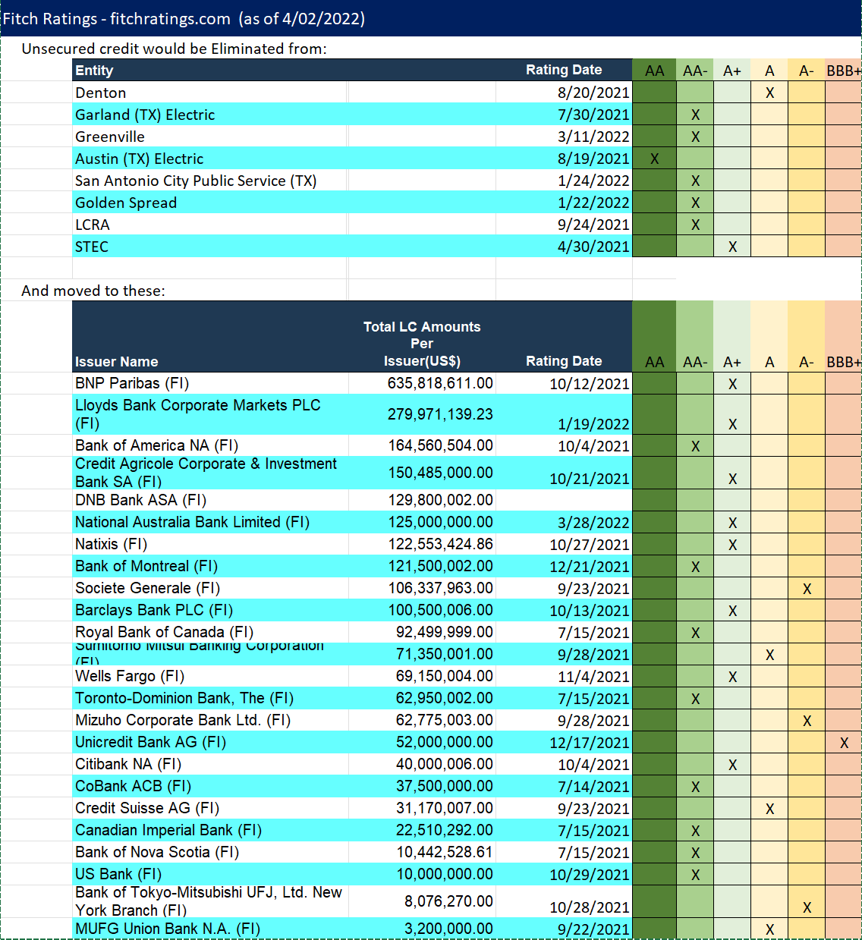

Based on the data above Joint Commenters support the efforts of the Credit Working Group and fail to see the benefits of eliminating unsecured credit as originally proposed by ERCOT.
ERCOT 3/18/22 Comments
In ERCOTs comments Joint Commenters agree that:
“In the event of a default by a Market Participant with an Unsecured Credit Limit that leads to default uplift, the Unsecured Credit Limit translates directly to a cost that must be borne by other Market Participants.”
However, as explained previously, 36 of 37 Counter-Parties with unsecured credit, or 97%, have fully paid ERCOT. Clearly, unsecured credit is not a significant issue in the ERCOT market. Furthermore, of the $1.9 B that remains in default, less than $50 million of that amount is attributable to unsecured credit. It is not unsecured credit that caused the default, but other factors not associated with unsecured credit.
To ERCOTs comment:
“ERCOT has pointed out in stakeholder meetings that exchanges other than ISOs (eg ICE) do not provide unsecured credit to their members. The Joint Commenters make the point that ERCOT is not acting in the same capacity as an exchange, because exchanges are for-profit entities that guarantee performance. While ERCOT may not provide a guarantee of delivery of power, and is a not-for-profit entity, it is unclear how these distinctions provide justification for the cross-subsidization of credit risk on behalf of some Market Participants.”
Joint Commenters agree the for profit/not for profit makes no difference, however there is a difference in market risk as Market Participants bear the risk for the lack of performance by other Counter-Parties, not ERCOT. If a Market Participant exits the market without resolving its obligations, it is other Market Participants that must pay, including the Customers of Non-Opt-In Entities (NOIEs). It is Market Participants, not ERCOT, that pay the default uplift charges. ERCOT, Inc. is not at risk of financial default as a result of extending credit to Market Participants that meet the appropriately determined unsecured credit criteria, and therefore ERCOT should be a neutral party to the extension of such credit on behalf of other Market Participants. To date, there have been no parties who have filed comments in support of ERCOT’s position to terminate the extension of unsecured credit.
Furthermore, it appears that there are no Entities with unsecured credit that availed themselves of the Subchapter ‘N’ Securitization offered by the state. Entities either adjusted rates, depleted reserves, or issued bonds, all of which are a testament to their financial strength and wherewithal, and why those Market Participants earned unsecured credit.
Impacts
- Failure to Differentiate Creditworthiness
  - Elimination of unsecured credit is ERCOT’s attempt to “provide a more level playing field”; however, this attempt eliminates the current process that recognizes a Market Participant’s creditworthiness and now effectively places an investment grade entity on par with a non-investment grade Entity. For example, assuming equal financial exposure under the proposed Protocol calculations, a Market Participant with a non-investment grade credit rating would only be required to post the same security as a Market Participant with a AAA credit rating. This does not seem to align with ERCOT’s comment that they are committed to “credit best practices to reduce the risk of future under-collateralization.” If ERCOT’s intent is to have all Market Participants post secured credit, then it seems that those with lower credit ratings or less financial wherewithal would need to post additional security relative to those with higher credit ratings or better financial wherewithal. This would most likely increase the cost to participate in the ERCOT market and could result in fewer participants in the ERCOT Market and additional cost passed along to electric consumers in ERCOT.
  - Although the Protocols currently give ERCOT the discretion to adjust a Market Participant’s potential financial exposure based on the calculations used by ERCOT to determine exposure, there are no specific or explicit calculations on how that adjustment is calculated; however, the current Protocols do provide recognition and specific determination of how Market Participants are differentiated based on creditworthiness.
- Increased Cost for Secured Credit
  - For Market Participants currently receiving unsecured credit, they will bear additional costs (with minimal to no benefit) which will most likely be passed through to electric consumers. These costs will be in addition to the costs they are already bearing because of winter storm Uri and on top of any default uplift that could potentially be allocated to them.
  - Additional financial security through letters of credit may cause a concentration of exposure for ERCOT from institutions providing letters of credit to Market Participants. This concentration may be further exacerbated by recent state legislation that limits state governmental Entities from conducting business with institutions who limit their business activities with firearms, ammunition, or oil and gas businesses. If this legislation reduces the number of institutions that are eligible to provide letters of credit to Market Participants, there will not only be an increase in concentration risk for ERCOT, but also the eligible institutions will experience an increase in concentration risk to ERCOT; these increases in risk for both ERCOT and institutions could lead to increase costs for Market Participants and electric consumers.
- Less Liquidity
  - Elimination of unsecured credit will reduce liquidity in the ERCOT market, which could increase cost of transacting in ERCOT for Market Participants and electric consumers in ERCOT.
  - When the Federal Energy Regulatory Commission (FERC) set the current $50 million unsecured credit limit for the other Independent System Operators (ISOs), FERC recognized that unsecured credit provides liquidity to wholesale energy markets and that the $50 million cap was an appropriate balance between the costs that would need to be incurred by Market Participants to provide this level of secured credit and the effects of potential market disruption under a Market Participant default event.
Joint Commenters urge PRS to continue to support the language it approved in March, and as recommended by the Credit Work Group. That language will reduce unsecured credit to $30 million (the lowest of any ISO in the country).
Revised Cover Page Language
None
Revised Proposed Protocol Language
None

While the list of Counter-Parties and the amount of unsecured credit is confidential information, this list is comprised of the Joint Commentors who are known to have been extended unsecured credit by ERCOT.

