February 2022 ERCOT Monthly Operations Report
Reliability and Operations Subcommittee Meeting
April 7, 2022

Table of Contents
1. Report Highlights 2
2. Frequency Control 3
2.1. Frequency Events 3
2.2. Responsive Reserve Events 4
2.3. Load Resource Events 4
3. Reliability Unit Commitment 4
4. IRR, Wind, and Solar Generation as a Percent of Load 7
5. Largest Net-Load Ramps 8
6. COP Error Analysis 9
7. Congestion Analysis 11
7.1. Notable Constraints 11
7.2. Generic Transmission Constraint Congestion 17
7.3. Manual Overrides 17
7.4. Congestion Costs for Calendar Year 2022 17
8. System Events 18
8.1. ERCOT Peak Load 18
8.2. Load Shed Events 18
8.3. Stability Events 18
8.4. Notable PMU Events 18
8.5. DC Tie Curtailment 18
8.6. TRE/DOE Reportable Events 19
8.7. New/Updated Constraint Management Plans 19
8.8. New/Modified/Removed RAS 19
8.9. New Procedures/Forms/Operating Bulletins 19
9. Emergency Conditions 19
9.1. OCNs 19
9.2. Advisories 20
9.3. Watches 20
9.4. Emergency Notices 20
10. Application Performance 20
10.1. TSAT/VSAT Performance Issues 20
10.2. Communication Issues 20
10.3. Market System Issues 20
11. Model Updates 20
Appendix A: Real-Time Constraints 23

Report Highlights
- The unofficial ERCOT peak load for the month was 68,954 MW and occurred on 02/04/2022, during hour ending 10:00.
- There were 3 frequency events.
- There were 2 instances where Responsive Reserves were deployed.
- There were 112 HRUC commitments.
- There were 13 days of congestion on the West Texas Export GTC, 21 days on the North Edinburg to Lobo GTC, 2 days on the Bearkat GTC, 17 days on the Nelson Sharpe to Rio Hondo GTC, 11 days on the Valley Export GTC, 17 days on the Panhandle GTC, and 4 days on the Raymondville to Rio Hondo GTC. There was no activity on the remaining GTCs during the month.
- There were 0 DC Tie Curtailments.
- A Solar Generation Record of 8,735 MW was set on 02/27/2022 at 15:47.
- A Solar Penetration Record of 22.40% was set on 02/19/2022 at 15:18.
- A Wind Generation Record of 25,408 MW was set on 02/22/2022 21:57.
- An OCN was issued at 01/27/2022, 13:00 CPT for the prediction of extreme cold weather for 02/02/2022 to 02/06/2022.
- An OCN was issued at 02/20/2022, 15:30 CPT for the prediction of extreme cold weather for 02/23/2022 to 02/25/2022.

Frequency Control

Frequency Events
The ERCOT Interconnection experienced 3 frequency events, which resulted from unit’s trips. The average event duration was 00:03:55.

A summary of the frequency events is provided below. The reported frequency events meet one of the following criteria: Delta Frequency is 60 mHz or greater; the MW loss is 350 MW or greater; resource trip event triggered RRS deployment. Frequency events that have been identified as Frequency Measurable Events (FME) for purposes of BAL-001-TRE-1 analysis are highlighted in blue. When analyzing frequency events, ERCOT evaluates PMU data according to industry standards. Events with an oscillating frequency of less than 1 Hz are inter-area, while higher frequencies indicate local events. Industry standards specify that damping ratio for inter-area oscillations should be 3.0% or greater. For the frequency events listed below, the ERCOT system met these standards and transitioned well after each disturbance.

Date and Time | Delta Frequency | Max/Min Frequency | Duration of Event | PMU Data |  | MW Loss | Load | IRR | Inertia
 | (Hz) | (Hz) |  | Oscillation Mode (Hz) | Damping Ratio |  | (MW) | % | (GW-s)
02/04/2022 18:21:26 | 0.128 | 59.851 | 00:06:01 | 0.72 | 11% | 1210 | 60,637 | 10% | 355,057
02/20/2022 10:13:02 | -0.143 | 60.109 | 00:03:38 | 0.91 | 11% | 467 | 41,996 | 51% | 154,655
02/22/2022 6:18:28 | 0.193 | 59.807 | 00:02:05 | 0.68 | 3% | 764 | 37,834 | 51% | 155,873

(Note: All data on this graph encompasses frequency event analysis based on BAL-001-TRE-1.)

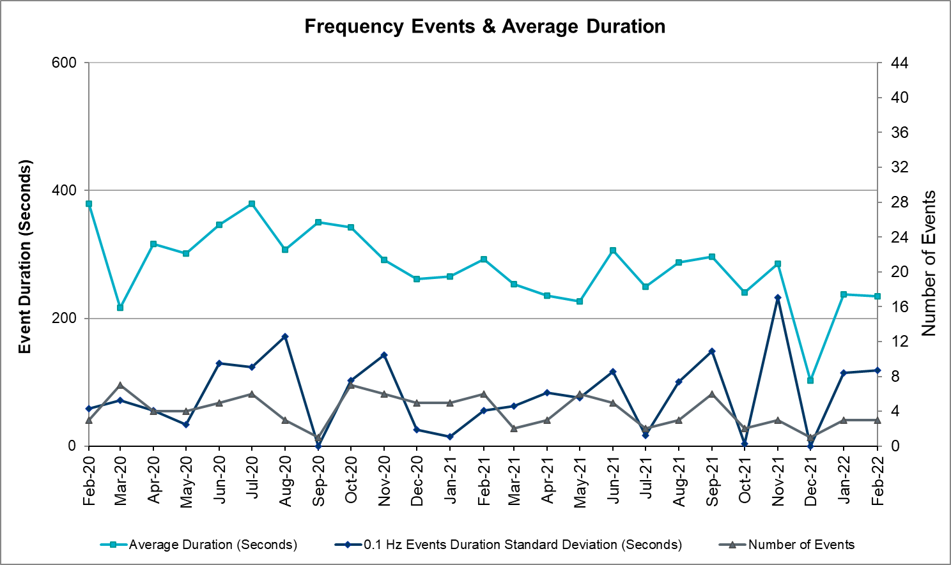

Responsive Reserve Events
There were 2 events where Responsive Reserve MWs were released to SCED. The events highlighted in blue were related to frequency events reported in Section 2.1 above.

Date and Time Released to SCED | Date and Time Recalled | Duration of Event | Maximum MWs Released | Comments
02/04/2022 18:21:40 | 02/04/2022 18:27:32 | 00:05:52 | 822
02/22/2022 6:18:36 | 02/22/2022 6:20:24 | 00:01:48 | 786

Load Resource Events
NONE.

Reliability Unit Commitment
ERCOT reports on Reliability Unit Commitments (RUC) monthly. Commitments are reported grouped by operating day and weather zone. The total number of hours committed is the sum of the hours for all the units in the specified region. Additional information on RUC commitments can be found on the MIS secure site at Grid Generation Reliability Unit Commitment.

There were no DRUC commitments.

There were 112 HRUC commitments

Resource Location | # of Resources | Operating Day | Total # of Hours Committed | Total MWhs | Reason for Commitment
EAST, NORTH_CENTRAL | 6 | 02/02/2022 | 41 | 15,058.0 | Capacity, Fuel oil capability
EAST, NORTH_CENTRAL, SOUTH_CENTRAL | 9 | 02/03/2022 | 207 | 60,887.0 | Capacity, Fuel oil capability
EAST, NORTH_CENTRAL | 5 | 02/04/2022 | 61 | 19,947.0 | Capacity, Fuel oil capability
EAST, NORTH_CENTRAL | 6 | 02/05/2022 | 60 | 19,110.0 | Capacity, Fuel oil capability
EAST, NORTH_CENTRAL | 3 | 02/12/2022 | 11 | 5,626.4 | Capacity
COAST, EAST, NORTH, NORTH_CENTRAL, SOUTH_CENTRAL, SOUTHERN | 27 | 02/23/2022 | 267 | 86,801.3 | Capacity, MSHKENW8, Honor Min Run Time
COAST, EAST, NORTH_CENTRAL, SOUTH_CENTRAL, SOUTHERN | 16 | 02/24/2022 | 238 | 70,318.3 | Capacity,  Honor Min Run Time
EAST, NORTH_CENTRAL | 6 | 02/25/2022 | 84 | 23,652.0 | Capacity, Honor Min Run Time
COAST, NORTH_CENTRAL, SOUTH_CENTRAL | 4 | 02/26/2022 | 45 | 7,508.0 | Capacity, Honor Min Run Time
COAST | 1 | 02/27/2022 | 4 | 640.0 | Capacity
COAST, EAST, NORTH_CENTRAL, SOUTH_CENTRAL | 6 | 03/01/2022 | 26 | 8,215.0 | Capacity

IRR, Wind, and Solar Generation as a Percent of Load
The graph below shows the maximum, minimum and average aggregate solar, wind and IRR output as a percentage of total ERCOT load when evaluated as 10-minute averaged intervals, over the past 13 months. Current wind and solar generation and penetration records are listed in the footnote below. Maximum IRR penetration for the month was 62.5% on 02/21/2022 interval ending 01:20 and minimum IRR penetration for the month was 1.8% on 02/24/2022 interval ending 08:00.

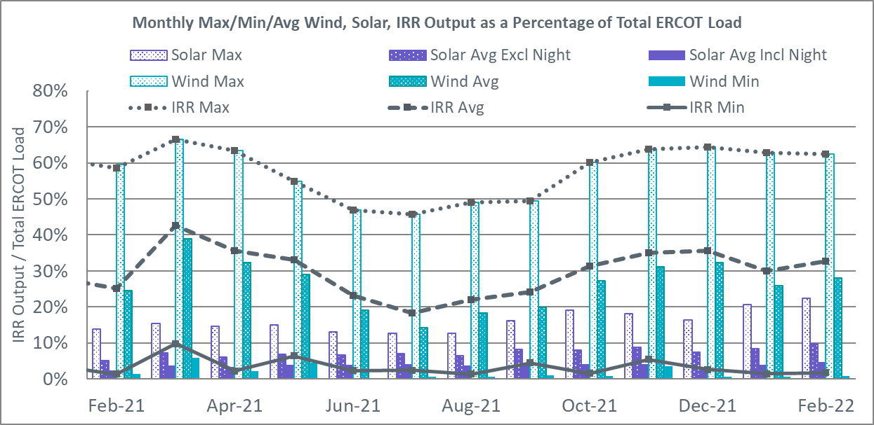

During the hour of peak load for the month, hourly integrated wind generation was 13,209 MW and solar generation was 2,283 MW. The graph below shows the wind and solar penetration percentage during the hour of the peak load in the last 13 months.

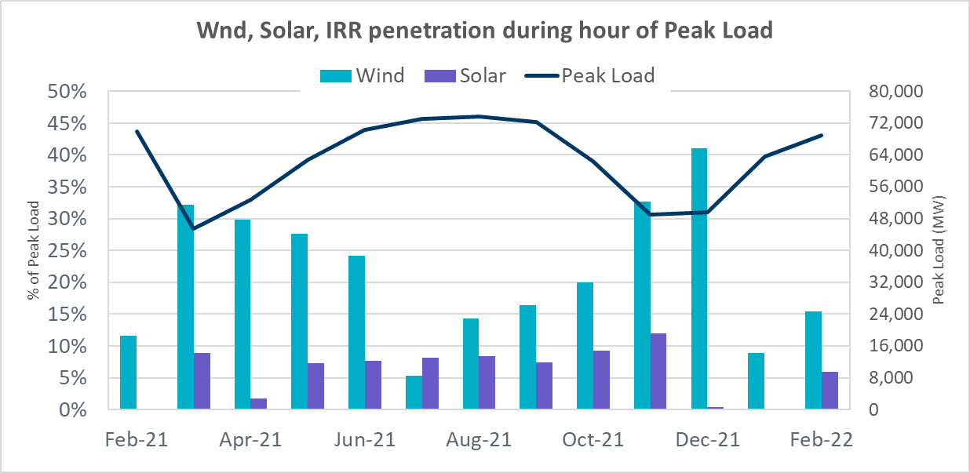

Lastly, the graph below shows the minimum wind, solar and IRR output during the peak load hour as a percentage of the daily peak load for every day in the month.

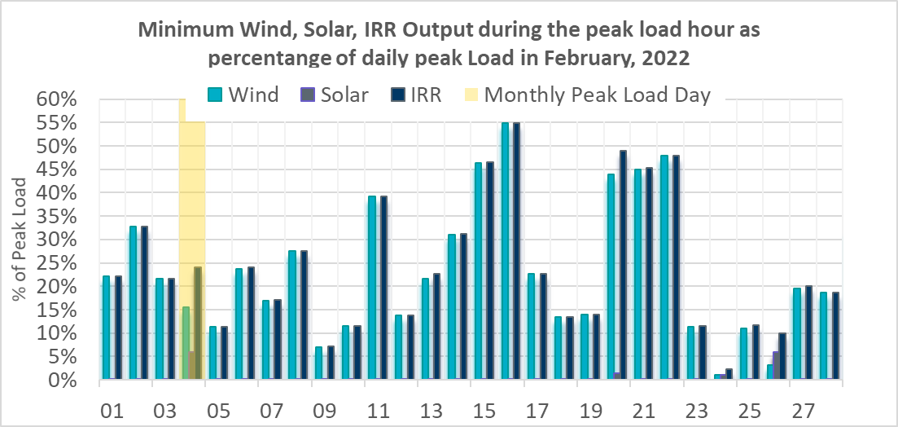

Largest Net-Load Ramps
The net-load ramp is defined as the change in net-load (load minus wind and PVGR generation) during the defined time horizon. Such a variation in net-load needs to be accommodated in grid operations to ensure that the reliability of the grid is satisfactorily maintained. The largest net-load ramp during 5-min, 10-min, 15-min, 30-min and 60-min in February 2022 was 1,086 MW, 2,006 MW, 2,887 MW, 5,257 MW, and 9,476 MW, respectively. The comparison with respect to the historical values is given in the table below.

Month and Year | 5 min | 10 min | 15 min | 30 min | 60 min
Feb 2014 | 971 MW | 1,610 MW | 2,164 MW | 3,516 MW | 5,960 MW
Feb 2015 | 1,131 MW | 1,763 MW | 2,469 MW | 4,031 MW | 6,910 MW
Feb 2016 | 999 MW | 1,658 MW | 2,144 MW | 3,504 MW | 5,923 MW
Feb 2017 | 1,051 MW | 1,744 MW | 2,268 MW | 3,228 MW | 5,346 MW
Feb 2018 | 1,494 MW | 1,706 MW | 2,003 MW | 3,419 MW | 5,628 MW
Feb 2019 | 1,094 MW | 1,793 MW | 2,388 MW | 3,718 MW | 6,540 MW
Feb 2020 | 1,173 MW | 1,777 MW | 2,198 MW | 4,107 MW | 7,430 MW
Feb 2021 | 933 MW | 1,661 MW | 2,374 MW | 4,479 MW | 8,079 MW
Feb 2022 | 1,086 MW | 2,006 MW | 2,887 MW | 5,257 MW | 9,476 MW
All Months in 2014-2022 | 1,494 MW | 2,006 MW | 2,887 MW | 5,882 MW | 10,364 MW

COP Error Analysis
COP Error is calculated as the capacity difference between the COP HSL and real-time HSL of the unit. Mean Absolute Error (MAE) stayed over 11,000 MW until Day-Ahead at 12:00, then dropped significantly to 2,367 MW by Day-Ahead at 14:00. In the following chart, Under-Scheduling Error indicates that COP had less generation capacity than real-time and Over-Scheduling Error indicates that COP had more generation capacity than real-time.

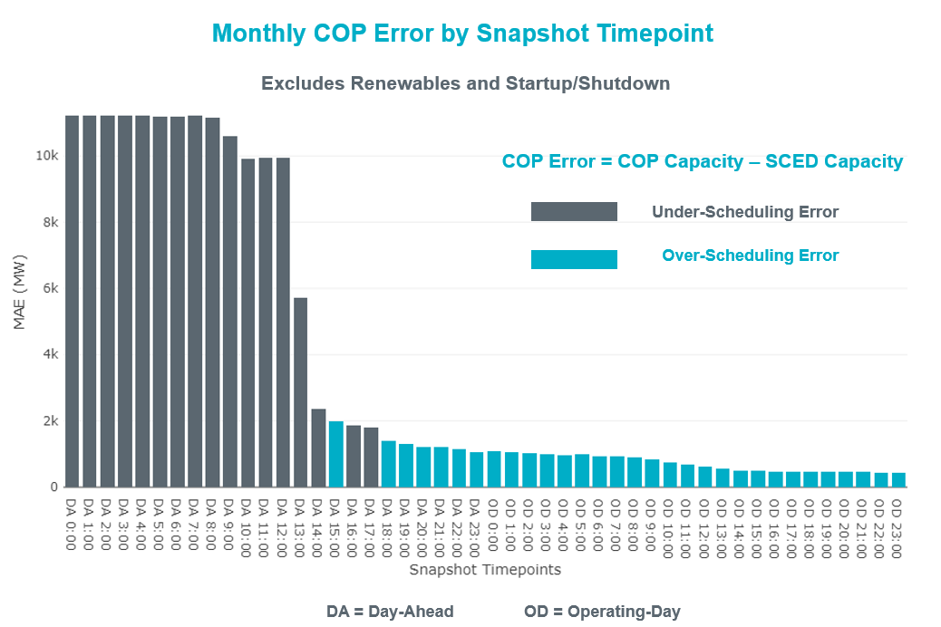

Monthly MAE for the Latest COP at the end of the Adjustment Period was 447 MW with median ranging from -116.25 MW for Hour-Ending (HE) 21 to 276.9 MW for HE 12. HE 1 on 02/22/2022 had the largest Over-Scheduling Error (2,053 MW) and HE 11 on 02/24/2022 had the largest Under-Scheduling Error (-2,418 MW).

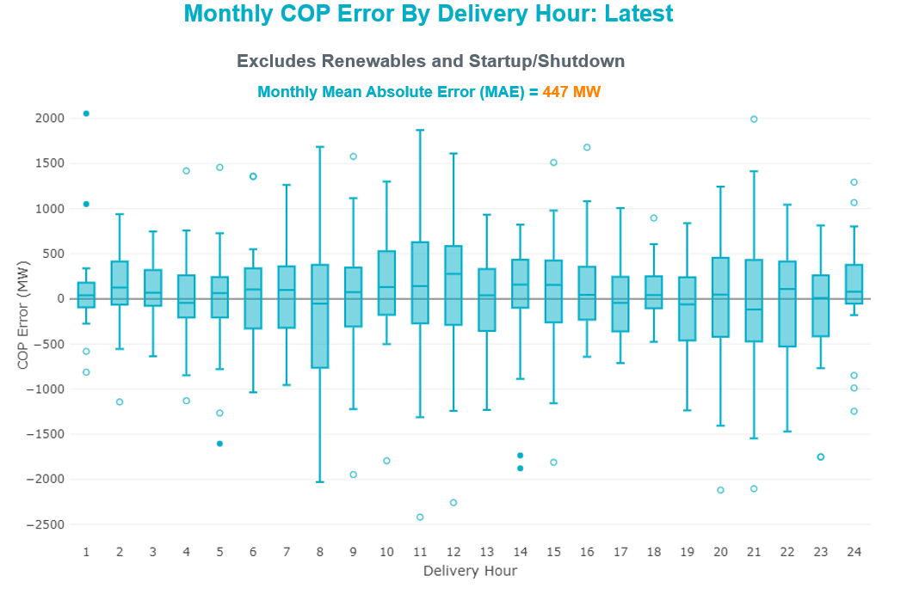

Monthly MAE for the Day-Ahead COP at 12:00 was 9,931 MW with median ranging from -13,134 MW for Hour-Ending (HE) 8 to -8,013 MW for HE 13. HE 7 on 02/24/2022 had the largest Under-Scheduling Error (-24,196 MW) and HE 3 on 02/21/2022 had the largest Over-Scheduling Error (1,263 MW).

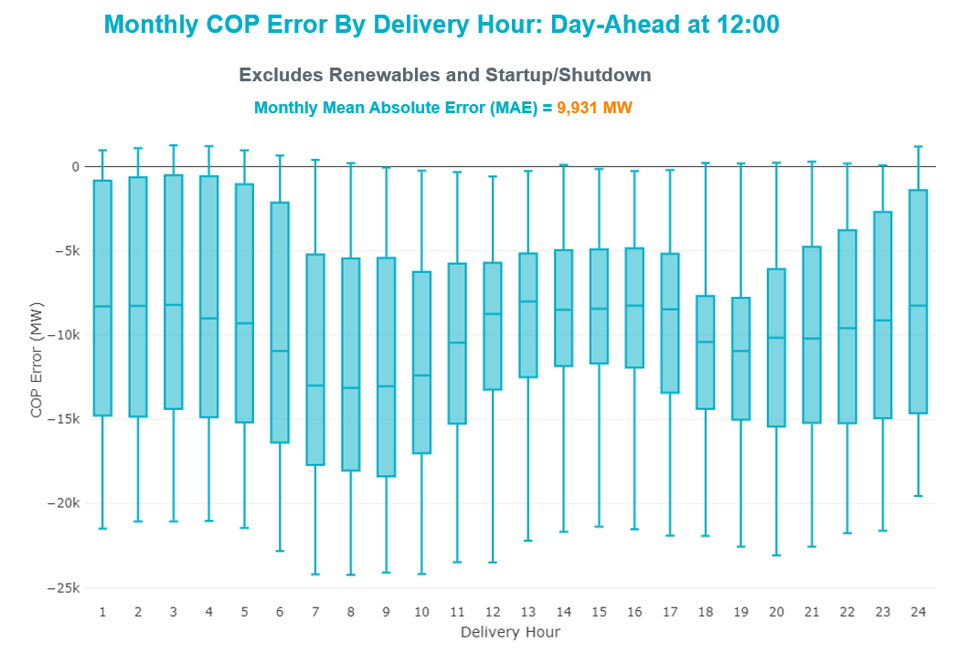

Congestion Analysis

Notable Constraints
Nodal protocol section 3.20 specifies that ERCOT shall identify transmission constraints that are binding in Real-Time three or more Operating Days within a calendar month. As part of this process, ERCOT reports congestion that meets this criterion to ROS. In addition, ERCOT also highlights notable constraints that have an estimated congestion rent exceeding $1,000 for a calendar month. These constraints are detailed in the table below, including approved transmission upgrades from TPIT that may provide some congestion relief based on ERCOT’s engineering judgement. Rows highlighted in blue indicate the congestion was affected by one or more outages. For a list of all constraints activated in SCED, please see Appendix A at the end of this report.

Contingency Name | Overloaded Element | # of Days Constraint Binding | Congestion Rent | Transmission Project
TWR(345) JCK-REF27 & JCK-STP18 | Hillje - South Texas Project 345kV | 9 | $13,488,757.54
EVRSW TO HLSES 138 DBLCKT | Mistletoe Heights - Hemphill 138kV | 6 | $9,007,490.05
Basecase | WESTEX GTC | 11 | $8,965,332.87
SALSW TO KLNSW 345 DBLCKT | Killeen Switch 345kV | 11 | $7,767,673.47
WDGSW TO MARSW 138 DBLCKT | Mistletoe Heights - Hemphill 138kV | 2 | $6,637,383.19
STP SWITCH to Esperanza LIN 1 | Blessing - Pavlov 138kV | 9 | $6,382,754.66
MTFSW TO TRSES 138 AND MTFSW TO CRSCN 138 DBLCKT | Desoto Switch - Red Oak 138kV | 1 | $6,231,596.29
FREDERICKSBURG TRX AT2 138/69 | Gillespie 138kV | 6 | $5,662,687.99
Basecase | NE_LOB GTC | 20 | $5,419,866.57 | The Lower Rio Grande Valley (LRGV) System Enhancement Project (21RPG017) will improve but not eliminate the need for this GTC.
LWSSW TO RNKSW AND LWSSW TO KRWSW 345 DBLCKT | Argyle - Highlands Tnp 138kV | 7 | $4,332,966.05
Fowlerton to LOBO 345 LIN1 | North Laredo Switch - Piloncillo 138kV | 15 | $3,956,729.75
MVEC (RANGERVILLE) to LA PALMA LIN 1 | Stewart Road - Vertrees 138kV | 1 | $3,350,935.39
GILLESPIE LCRA TRX AT1 138/69 | Fredericksburg 138kV | 3 | $2,772,350.45
CLBSW-CMBSW 138&VENSW-JONSW 345_DBLCKT | Everman Switch 345kV | 4 | $2,720,756.80
VICTORIA TRX 69A1 138/69 | Magruder - Victoria 138kV | 5 | $2,590,879.68
SAN MIGUEL GEN to FOWLERTON LIN 1 | San Miguel Gen - Choke Canyon Aep 138kV | 2 | $2,398,600.88
Manual dbl ckt for NEDIN-BONILLA 345kV & RIOH-PRIM138kV | Burns Sub - Rio Hondo 138kV | 7 | $2,088,150.17
COMANCHE SWITCH (Oncor) to COMANCHE PEAK SES LIN _A | Comanche Tap - Comanche Switch (Oncor) 138kV | 9 | $1,979,362.93
BOWEN TATE TAP to BOWEN LIN _K | Mistletoe Heights - Hemphill 138kV | 1 | $1,821,158.55
TWR(345) JCK-STP18 & REF-STP27 | Hillje - South Texas Project 345kV | 8 | $1,762,966.46
Fowlerton to LOBO 345 LIN1 | Laredo Vft North - Las Cruces 138kV | 3 | $1,652,489.24 | Laredo VFT North to North Laredo Switch: Rebuild 138 kV Line (58008)
HIWAY_9 - CITGO_NO & INDUSTRI 69kV & 138 kV | Morris Street - Nueces Bay 138kV | 3 | $1,558,485.76
Basecase | Omega - Horse Hollow Generation Tie 345kV | 9 | $1,450,471.22
KENEDSW - TULETA (138) & PETTUS - NORMANNA (69) | Coleto Creek - Rosata Tap 138kV | 4 | $1,293,484.27 | Upgrade Coleto Creek - Rosata (50870)
Grissom to LON HILL LIN 1 | Sea Drift Coke - North Carbide 138kV | 1 | $1,291,048.27
COLETO - GRISSOM (345) & VICTORIA - FANNINS (69) | Sea Drift Coke - North Carbide 138kV | 3 | $1,278,455.26
LON HILL to NELSON SHARPE LIN 1 | Loyola Sub 138kV | 2 | $1,145,821.47
Bighil-Kendal 345kV | Yellow Jacket - Treadwell 138kV | 9 | $1,083,382.25
Basecase | PNHNDL GTC | 10 | $936,053.58
PLUM to FLATONIA LIN 1 | Magruder - Victoria 138kV | 3 | $777,255.43
Grissom to COLETO CREEK LIN 1 | Beeville - Normanna 69kV | 6 | $730,070.04 | Poesta to Tuleta (5167) - NOTE: This project removes the overloaded element and reconfigures lines in the area, amongst other topology changes.
Wirtz-Burnet&Starck 138kV | Sandy Creek 138kV | 6 | $729,390.31 | Sandy Creek Autotransformer Upgrade (61591)
MOORE SWITCHING STATION to PEARSALL SWITCHING STATION LIN 1 | Uvalde Aep - West Batesville 138kV | 5 | $708,039.78
DYANN to CANEY LIN A | El Campo - Lane City Pump 138kV | 9 | $561,074.09 | Prairie Switch Wind Interconnection (66124)
Fowlerton to LOBO 345 LIN1 | Bruni Sub 138kV | 5 | $552,849.78
PH ROBINSON to MEADOW LIN A | Magnolia Tnp - Seminole Tnp 138kV | 4 | $550,829.71 | Rebuild Magnolia - Seminole 138 kV Line (4010)
SANDY CREEK SWITCHYARD to PITSBURG LIN 1 | Sandy Creek 138kV | 3 | $474,196.94 | Sandy Creek Autotransformer Upgrade (61591)
ODLAW SWITCHYARD to ASPHALT MINES LIN 1 | Hamilton Road - Maverick 138kV | 6 | $471,241.88
LON HILL to NELSON SHARPE LIN 1 | Kingsville - Kleberg Aep 138kV | 3 | $470,846.81
Basecase | VALEXP GTC | 10 | $457,869.47 | The Lower Rio Grande Valley (LRGV) System Enhancement Project (21RPG017) will improve but not eliminate the need for this GTC.
Basecase | NELRIO GTC | 14 | $451,442.45 | The Lower Rio Grande Valley (LRGV) System Enhancement Project (21RPG017) will improve but not eliminate the need for this GTC.
POMELO to NORTH EDINBURG LIN 1 | Lobo - Freer 69kV | 3 | $395,224.59
TWR (138) BCV-CV03 & GBY-PSA03 | Highlands - Power Systems Arco Cogen 138kV | 5 | $350,876.56
Basecase | Brightside Solar - Charter 69kV | 4 | $294,120.34
LON HILL to NELSON SHARPE LIN 1 | Celanese Bishop - Kleberg Aep 138kV | 3 | $223,696.30
AJO to NELSON SHARPE LIN 1 | Las Pulgas - Raymondville 2 138kV | 4 | $187,284.34
STILLMAN to SOUTH CARBIDE LIN 1 | Palo Alto Substation - Titan Substation 138kV | 4 | $151,273.62
I_DUPSW-MCCAMPBE #1 & HECKER | Dupont Switch - Ingleside - Mccampbell 138kV | 3 | $144,796.98
LAQUINTA to LOBO LIN 1 | Bruni Sub 138kV | 8 | $132,003.07
KLEBERG AEP to LOYOLA SUB LIN 1 | Loyola Sub 138kV | 3 | $128,485.87
MOLINA - LOBO 138 & LOBO - CENIZO 345 | Goddard - Tango 345kV | 3 | $105,441.26
GILA to MAYO LIN 1 | Whitepoint - Rincon 138kV | 3 | $97,405.50
COLETO CREEK to PAWNEE SWITCHING STATION LIN 1 | Coleto Creek - Rosata Tap 138kV | 3 | $84,606.21 | Upgrade Coleto Creek - Rosata (50870)
STP to HLJ & Anstrom345 KV DOUBLE | Blessing - Palacios 69kV | 3 | $80,712.25
Fowlerton to LOBO 345 LIN1 | Asherton - Catarina 138kV | 3 | $61,883.14
Manual dbl ckt for NEDIN-BONILLA 345kV & RIOH-PRIM138kV | South Carbide - Stillman 138kV | 3 | $52,196.82
Wshack-Samsw&Navarro 345kV | Barton Chapel Wind Farm - Oran Sub 138kV | 3 | $42,157.29
KENEDY SWITCH TRX 69A1 138/69 | Beeville - Charter 69kV | 8 | $36,901.93 | Poesta to Three Rivers (5166) - NOTE: This project removes the overloaded element and reconfigures lines in the area, amongst other topology changes.
THREE RIVERS TRX AUT3 138/69 | Beeville - Charter 69kV | 3 | $36,342.61 | Poesta to Three Rivers (5166) - NOTE: This project removes the overloaded element and reconfigures lines in the area, amongst other topology changes.
MANUAL PEBSW-DESSW 138 KV | Trumbull 138kV | 3 | $32,157.32
Basecase | RV_RH GTC | 4 | $27,369.54
SOUTH CARBIDE to TITAN SUBSTATION LIN 1 | South Carbide - Stillman 138kV | 3 | $25,022.90
SIGMOR to THREE RIVERS LIN 1 | Beeville - Charter 69kV | 12 | $20,450.87 | Poesta to Three Rivers (5166) - NOTE: This project removes the overloaded element and reconfigures lines in the area, amongst other topology changes.
Basecase | Sweetwater Wind 3 345kV | 4 | $17,910.24

Generic Transmission Constraint Congestion
There were 13 days of congestion on the West Texas Export GTC, 21 days on the North Edinburg to Lobo GTC, 2 days on the Bearkat GTC, 17 days on the Nelson Sharpe to Rio Hondo GTC, 11 days on the Valley Export GTC, 17 days on the Panhandle GTC, and 4 days on the Raymondville to Rio Hondo GTC. There was no activity on the remaining GTCs during the month.

Note: This is how many times a constraint has been activated to avoid exceeding a GTC limit, it does not imply an exceedance of the GTC occurred or that the GTC was binding.

Manual Overrides
None

Congestion Costs for Calendar Year 2022
The following table represents the top twenty active constraints for the calendar year based on the estimated congestion rent attributed to the congestion. ERCOT updates this list on a monthly basis.

Contingency | Overloaded Element | # of 5-min SCED | Estimated | Transmission Project
WDGSW TO MARSW 138 DBLCKT | Mistletoe Heights - Hemphill 138kV | 2078 | $30,437,608.94
Basecase | WESTEX GTC | 3514 | $26,282,989.02
SALSW TO KLNSW 345 DBLCKT | Killeen Switch 345kV | 2982 | $14,763,713.92
TWR(345) JCK-REF27 & JCK-STP18 | Hillje - South Texas Project 345kV | 1590 | $13,488,757.54
Basecase | NE_LOB GTC | 5841 | $11,915,405.44 | The Lower Rio Grande Valley (LRGV) System Enhancement Project (21RPG017) will improve but not eliminate the need for this GTC.
EVRSW TO HLSES 138 DBLCKT | Mistletoe Heights - Hemphill 138kV | 1065 | $9,007,490.05
STP SWITCH to Esperanza LIN 1 | Blessing - Pavlov 138kV | 2209 | $8,551,326.03
MTFSW TO TRSES 138 AND MTFSW TO CRSCN 138 DBLCKT | Desoto Switch - Red Oak 138kV | 67 | $6,231,596.29
FREDERICKSBURG TRX AT2 138/69 | Gillespie 138kV | 1122 | $5,733,841.31
Fowlerton to LOBO 345 LIN1 | Bruni Sub 138kV | 2362 | $5,462,452.47
LWSSW TO RNKSW AND LWSSW TO KRWSW 345 DBLCKT | Argyle - Highlands Tnp 138kV | 1864 | $4,888,256.21
SAN MIGUEL GEN to FOWLERTON LIN 1 | San Miguel Gen - Choke Canyon Aep 138kV | 828 | $4,551,620.90
Fowlerton to LOBO 345 LIN1 | North Laredo Switch - Piloncillo 138kV | 1787 | $4,155,564.84
Basecase | EASTEX GTC | 157 | $3,630,343.53
COMANCHE SWITCH (Oncor) to COMANCHE PEAK SES LIN _A | Comanche Tap - Comanche Switch (Oncor) 138kV | 1632 | $3,498,677.21
MVEC (RANGERVILLE) to LA PALMA LIN 1 | Stewart Road - Vertrees 138kV | 356 | $3,350,935.39
Manual dbl ckt for NEDIN-BONILLA 345kV & RIOH-PRIM138kV | Burns Sub - Rio Hondo 138kV | 1623 | $3,343,220.55
Basecase | Omega - Horse Hollow Generation Tie 345kV | 1800 | $3,082,310.31
Helotes-Anderson&Cagnon 138kV | Cagnon 345kV | 139 | $2,867,911.09
GILLESPIE LCRA TRX AT1 138/69 | Fredericksburg 138kV | 638 | $2,772,350.45

System Events

ERCOT Peak Load
The unofficial ERCOT peak load for the month was 68,954 MW and occurred on 02/04/2022, during hour ending 10:00.

Load Shed Events
None.

Stability Events
None.

Notable PMU Events
ERCOT analyzes PMU data for any significant system disturbances that do not fall into the Frequency Events category reported in section 2.1. The results are summarized in this section once the analysis has been completed.

There were no PMU events outside of those reported in section 2.1.

DC Tie Curtailment
None

TRE/DOE Reportable Events
- ERCOT ISO submitted an OE-417 for 02/04/2022. Reportable Event Type: Islanding.
- TNMP submitted an OE-417 for 02/04/2022. Reportable Event Type: Uncontrolled loss of 300MW or more.
- LCRA submitted an OE-417 for 02/22/2022. Reportable Event Type: Suspicious device or activity
- Loraine Windpark (Lonewolf) submitted an OE-417 for 2/28/2022. Reportable Event Type: Damage or destruction of its facility.

New/Updated Constraint Management Plans
There were three new MPs: MP_2022_02, MP_2022_03, MP_2022_04

There were two modified MPs: MP_2022_01, MP_2021_02

New/Modified/Removed RAS
None.

New Procedures/Forms/Operating Bulletins

Date | Subject | Bulletin No.
02/28/2022 | DC Tie V1 Rev 69 | 1028
02/28/2022 | Real Time Desk V1 Rev 80 | 1029
02/28/2022 | Reliability Risk Desk Operating Procedure V1 Rev 27 | 1030
02/28/2022 | Reliability Unit Commitment V1 Rev 67 | 1031
02/28/2022 | Resource Desk V1 Rev 68 | 1032
02/28/2022 | Shift Supervisor Desk V1 Rev 78 | 1033
02/28/2022 | Transmission and Security Desk V1 Rev 93 | 1034

Emergency Conditions

OCNs
Date and Time | Message
Jan 27, 2022 13:00CPT | OCN issued for the predicted extreme cold weather event for the ERCOT Region Wednesday evening, February 2, 2022 through Saturday, February 5, 2022.
Feb 20, 2022 15:30 CPT | OCN issued due to the increasing potential of freezing precipitation over the West Texas area and much of North Central area including the DFW area for Wednesday, February 23, 2022 thru Friday, February 25, 2022.

Advisories
Date and Time | Message
Jan 31, 2022 09:00CPT | Advisory issued for an extreme cold weather event with forecasted icing conditions for the ERCOT Region Wednesday evening, February 2, 2022 through Sunday, February 6, 2022.
Feb 1, 2022 13:30 CPT | ERCOT has postponed the deadline for the posting of the DAM solution for Operating Day 02/02/2022 due to delay in clearing DAM.
Feb 21, 2022 15:30 CPT | Advisory issued due to the potential of freezing precipitation has increased over the West Texas area and much of North Central area including the DFW area for Wednesday, February 23, 2022 thru Friday, February 25, 2022.

Watches
Date and Time | Message
Feb 1, 2022 09:00 CPT | Watch issued for an extreme cold weather event with forecasted icing conditions for the ERCOT Region Wednesday evening, February 2, 2022 through Sunday, February 6, 2022.
Feb 1, 2022 18:00 CPT | ERCOT has issued a Watch for DRUC timeline deviation.

Emergency Notices
None.

Application Performance

TSAT/VSAT Performance Issues
None.

Communication Issues
None.

Market System Issues
None.

Model Updates
The Downstream Production Change (DPC) process allows ERCOT to make changes in the on-line Network Operations Model without loading a completely new model. The purpose of this process is to allow for reliable grid operations as system conditions change between designated Network Operations Model database loads. The DPC process is limited in scope to just those items listed below, with equipment ratings updates being the most common. ERCOT has seen a rise in the use of the DPC process to make on-line updates to the Network Operations Model in recent years, instead of through the standard Network Operations Model Change Request process.

- Static Line ratings (Interim Update)
- Dynamic Line ratings (non-Interim Update)
- Autotransformer ratings (non-Interim Update)
- Breaker and Switch Normal status (Interim Update)
- Contingency Definitions (Interim Update)
- RAP and RAS changes or additions (Interim Update)
- Net Dependable and Reactive Capability (NDCRC) values (Interim Update)
- Impedance Updates (non-Interim)

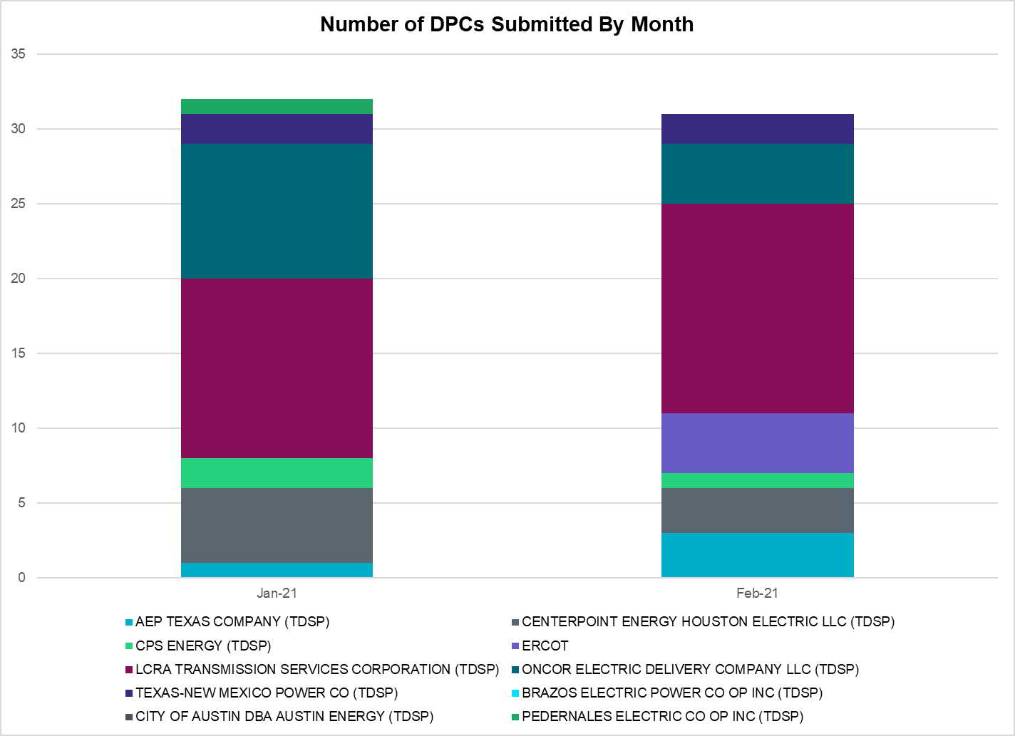

Transmission Operator | Number of DPCs
AEP TEXAS COMPANY (TDSP) | 3
BRAZOS ELECTRIC POWER CO OP INC (TDSP) | 0
BROWNSVILLE PUBLIC UTILITIES BOARD (TDSP) | 0
BRYAN TEXAS UTILITIES (TDSP) | 0
CENTERPOINT ENERGY HOUSTON ELECTRIC LLC (TDSP) | 3
CITY OF AUSTIN DBA AUSTIN ENERGY (TDSP) | 0
CITY OF COLLEGE STATION (TDSP) | 0
CITY OF GARLAND (TDSP) | 0
CPS ENERGY (TDSP) | 1
DENTON MUNICIPAL ELECTRIC (TDSP) | 0
ELECTRIC TRANSMISSION TEXAS LLC (TDSP) | 0
ERCOT | 4
LCRA TRANSMISSION SERVICES CORPORATION (TDSP) | 14
LONE STAR TRANSMISSION LLC (TSP) | 0
ONCOR ELECTRIC DELIVERY COMPANY LLC (TDSP) | 4
PEDERNALES ELECTRIC CO OP INC (TDSP) | 0
RAYBURN COUNTRY CO OP DBA RAYBURN ELECTRIC (TDSP) | 0
SHARYLAND UTILITIES LP (TDSP) | 0
SOUTH TEXAS ELECTRIC CO OP INC (TDSP) | 0
TEXAS MUNICIPAL POWER AGENCY (TDSP) | 0
TEXAS-NEW MEXICO POWER CO (TDSP) | 2

Appendix A: Real-Time Constraints
The following is a complete list of constraints activated in SCED. Full contingency descriptions can be found in the Standard Contingencies List located on the MIS secure site at Grid Generation Reliability Unit Commitment.

Contingency Name | Overloaded Element | From Station | To Station | Count of Days
BASE CASE | NE_LOB | n/a | n/a | 21
BASE CASE | PNHNDL | n/a | n/a | 17
BASE CASE | NELRIO | n/a | n/a | 17
BASE CASE | BRIGHT_CHARTE1_1 | BRIGHTSD | CHARTER | 15
SLOBSA25 | NLARSW_PILONC1_1 | PILONCIL | NLARSW | 15
SLOBSA25 | NLARSW_PILONC1_1 | NLARSW | PILONCIL | 15
BASE CASE | WESTEX | n/a | n/a | 13
DSALKLN5 | KLNSW_MR2H | KLNSW | KLNSW | 12
STHRSIG8 | BEEVIL_CHARTE1_1 | CHARTER | BEEVILLE | 12
STHRSIG8 | BEEVIL_CHARTE1_1 | BEEVILLE | CHARTER | 12
SSTPESP8 | BLESSI_PAVLOV1_1 | BLESSING | PAVLOV | 12
SCMNCPS5 | 651__B | CMNSW | CMNTP | 11
DBIGKEN5 | TREADW_YELWJC1_1 | TREADWEL | YELWJCKT | 11
BASE CASE | VALEXP | n/a | n/a | 11
SLAQLOB8 | BRUNI_69_1 | BRUNI | BRUNI | 11
XKEN289 | BEEVIL_CHARTE1_1 | CHARTER | BEEVILLE | 9
BASE CASE | HHGTOM_1 | HHGT | OMEGA | 9
DSTPRED5 | CKT_3124_1 | STP | HLJ | 9
SWRDYN8 | EL_CAM_LANCTY1_1 | LANCTYPM | EL_CAMPO | 9
DREFSTP5 | CKT_3124_1 | STP | HLJ | 8
DWIRSTA8 | SANDCR_AT1 | SANDCR | SANDCR | 8
SLOBSA25 | BRUNI_69_1 | BRUNI | BRUNI | 8
DLWSRNK5 | 587__A | ARGYL | LWSVH | 8
SMOOPEA8 | UVALDE_W_BATE1_1 | W_BATESV | UVALDE | 7
MHARNED5 | BURNS_RIOHONDO_1 | RIOHONDO | MV_BURNS | 7
DEVRHLS8 | 6125__C | MSTLT | HMPHL | 6
XFRE89 | GILLES_AT1 | GILLES | GILLES | 6
SLOBSA25 | ASHERT_CATARI1_1 | CATARINA | ASHERTON | 6
SBRAUVA8 | HAMILT_MAVERI1_1 | HAMILTON | MAVERICK | 6
SMDOPHR5 | G138_10B_1 | SEMINOLE | MAGNO_TN | 6
SLOBSA25 | ASHERT_CATARI1_1 | ASHERTON | CATARINA | 6
SGRICOL5 | BEEVIL_NORMAN1_1 | BEEVILLE | NORMANNA | 6
DWSHNAV5 | 6377__A | BRTSW | ORANS | 5
SN_SAJO5 | LASPUL_RAYMND1_1 | LASPULGA | RAYMND2 | 5
SKLELOY8 | LOYOLA_69_1 | LOYOLA | LOYOLA | 5
DCMBJON5 | EVRSW_MR3H | EVRSW | EVRSW | 5
XVI2C89 | MAGRUD_VICTOR2_1 | VICTORIA | MAGRUDER | 5
XTHR89 | BEEVIL_CHARTE1_1 | BEEVILLE | CHARTER | 5
SPLUFLA8 | MAGRUD_VICTOR2_1 | VICTORIA | MAGRUDER | 5
SBRAUVA8 | MAXWEL_WHITIN1_1 | MAXWELL | WHITING | 5
XTHR89 | BEEVIL_CHARTE1_1 | CHARTER | BEEVILLE | 5
DBCVPSA8 | HL_PSA08_A | PSA | HL | 5
SFORYEL8 | HEXT_MASONS1_1 | MASONSW | HEXT | 5
SFORYEL8 | HEXT_MASONS1_1 | HEXT | MASONSW | 5
SBTPBNT8 | MYRA_VAL_1 | MYRA | VALYVIEW | 4
STITSCA8 | SCARBI_STILLM1_1 | SCARBIDE | STILLMAN | 4
BASE CASE | RV_RH | n/a | n/a | 4
SSPJFS8 | JFSSC_06_A | JFS | SC | 4
SSTISCA8 | PALOAL_TITAN_1_1 | TITAN_SU | PALOALTO | 4
SN_SLON5 | CELANE_KLEBER1_1 | CELANEBI | KLEBERG | 4
SPOMNED5 | FREER_LOBO1_1 | LOBO | FREER | 4
DSTPANS5 | BLESSI_PALACI1_1 | BLESSING | PALACIOS | 4
SFORYEL8 | MASNPH_MASN1_1 | MASN | MASNPHT | 4
SSANPIT8 | SANDCR_AT1 | SANDCR | SANDCR | 4
BASE CASE | SWEETWN3_XF31 | SWEETWN3 | SWEETWN3 | 4
DKENNO89 | COLETO_ROSATA1_1 | COLETO | ROSATA | 4
SN_SLON5 | KINGSV_KLEBER1_1 | KLEBERG | KINGSVIL | 4
DCMBJON5 | 61__B | EVRSW | VENSW | 3
MHARNED5 | SCARBI_STILLM1_1 | SCARBIDE | STILLMAN | 3
SBRAHAM8 | HAMILT_MAVERI1_1 | HAMILTON | MAVERICK | 3
DEAB_WR8 | LANCTY_LAN_CT1_1 | LAN_CTY | LANCTYPM | 3
SLOBSA25 | LARDVN_LASCRU1_1 | LARDVNTH | LASCRUCE | 3
DCOLFA59 | NCARBI_SEADRF1_1 | NCARBIDE | SEADRFTC | 3
DDUPHE18 | I_DUPS_MCCAMP2_1 | I_DUPSW | MCCAMPBE | 3
SWRDYN8 | LANCTY_LAN_CT1_1 | LAN_CTY | LANCTYPM | 3
DHWIND89 | MORRIS_NUECES1_1 | NUECES_B | MORRIS | 3
SSANFOW5 | SNMIG_AEPCHKCN_1 | SANMIGL | CHOKCNYN | 3
SPALSCA8 | SCARBI_STILLM1_1 | SCARBIDE | STILLMAN | 3
MDESPEB8 | TRU_UAT1 | TRU | TRU | 3
DMGSBIT5 | 6036__A | TKWSW | MGSES | 3
SALIKIN8 | FALFUR_PREMON1_1 | FALFUR | PREMONT | 3
XGIL89 | FREDER_AT2 | FREDER | FREDER | 3
DMOLLO58 | GODDAR_TANGO1_1 | GODDARD | TANGO | 3
SGRILON5 | NCARBI_SEADRF1_1 | NCARBIDE | SEADRFTC | 3
SMAYWHI8 | RINCON_WHITE_2_1 | WHITE_PT | RINCON | 3
SCOLPAW5 | COLETO_ROSATA1_1 | COLETO | ROSATA | 3
DMGSBTR5 | 6036__A | TKWSW | MGSES | 3
SJONCPS5 | 61__B | EVRSW | VENSW | 3
BASE CASE | BEARKT | n/a | n/a | 2
DSTPRED5 | LAN_CT_PAVLOV1_1 | PAVLOV | LAN_CTY | 2
DCMBJON5 | TVBP1__A | TVWSW | EVRSW | 2
SELMTH25 | 1020__A | ELMOT | MCTYE | 2
SSANFOW5 | COTULL_REVEIL1_1 | REVEILLE | COTULLA | 2
SN_SLON5 | LOYOLA_69_1 | LOYOLA | LOYOLA | 2
DELMSAN5 | POT_OAKS_1 | POTEETS | OAKS9 | 2
MHARRIO5 | SCARBI_STILLM1_1 | SCARBIDE | STILLMAN | 2
DEVRWDG8 | 6125__C | MSTLT | HMPHL | 2
SGRICOL5 | CALLIC_LON_HI1_1 | LON_HILL | CALLICOA | 2
SBRAUVA8 | ESCOND_GANSO1_1 | GANSO | ESCONDID | 2
SJONCPS5 | EVRSW_MR3H | EVRSW | EVRSW | 2
SCT2CAR8 | HAMILT_MAXWEL1_1 | MAXWELL | HAMILTON | 2
SFORYEL8 | HEXT_YELWJC1_1 | YELWJCKT | HEXT | 2
SPAWCAL5 | POT_OAKS_1 | POTEETS | OAKS9 | 2
DBIGKEN5 | SAPOWE_TREADW1_1 | SAPOWER | TREADWEL | 2
DGRMGRS8 | 6830__B | CRDSW | OLNEY | 2
SBONNED5 | BURNS_RIOHONDO_1 | RIOHONDO | MV_BURNS | 2
SLGEI_D8 | I_DUPS_LGE1_1 | LGE | I_DUPSW | 2
SSTPESP8 | LAN_CT_PAVLOV1_1 | PAVLOV | LAN_CTY | 2
DCAGBRA5 | N5_P4_2_1 | CALAVERS | SKYLINE | 2
DCOMPRS8 | RYSSW_FMR2 | RYSSW | RYSSW | 2
SMVRLA_8 | STEWAR_VERTRE1_1 | STEWART | VERTREES | 2
DELMSAN5 | BEEVIL_NORMAN1_1 | BEEVILLE | NORMANNA | 2
BASE CASE | CP_MVCNT_1 | MV_CNTRA | COFFPORT | 2
DPHRAL58 | G138_10B_1 | SEMINOLE | MAGNO_TN | 2
SGRICOL5 | GODDAR_TANGO1_1 | GODDARD | TANGO | 2
DI_DRIN8 | INGLES_I_DUPS1_1 | I_DUPSW | INGLESID | 2
DELMSAN5 | MAGRUD_VICTOR2_1 | VICTORIA | MAGRUDER | 2
SCOLPAW5 | MAGRUD_VICTOR2_1 | VICTORIA | MAGRUDER | 2
SREAUVA8 | UVALDE_W_BATE1_1 | W_BATESV | UVALDE | 2
DCABFAL5 | BEEVIL_CHARTE1_1 | CHARTER | BEEVILLE | 2
SPOMNED5 | BEEVIL_CHARTE1_1 | CHARTER | BEEVILLE | 2
DHLJBLY5 | BLESSI_PAVLOV1_1 | BLESSING | PAVLOV | 2
DWIRSTA8 | PITSBU_AT1 | PITSBU | PITSBU | 2
SGARBAT8 | 15010__B | BLISS | ESTILES | 2
DKOCNUE8 | CHAMPL_WEIL_T1_1 | WEIL_TRC | CHAMPLIN | 2
SLOBSA25 | FALFUR_PREMON1_1 | FALFUR | PREMONT | 2
SGA2ROM8 | GARZA_69A1 | GARZA | GARZA | 2
DMGSMDS5 | MDSSW_MR1H | MDSSW | MDSSW | 2
DJACALV8 | MYRA_VAL_1 | MYRA | VALYVIEW | 2
DKG_NB_5 | BCVLY_03_A | BCV | LY | 2
SPAWCAL5 | BEEVIL_NORMAN1_1 | BEEVILLE | NORMANNA | 2
DCABFAL5 | FREER_LOBO1_1 | LOBO | FREER | 2
MHARNED5 | LASPUL_RAYMND1_1 | LASPULGA | RAYMND2 | 2
SMV_PAR8 | RIOHND_ERIOHND_1 | MV_RIOHO | RIOHONDO | 2
SJONCPS5 | TVBP1__A | TVWSW | EVRSW | 2
DSTEXP12 | BLESSI_LOLITA1_1 | LOLITA | BLESSING | 1
DWHILON5 | BLESSI_PALACI1_1 | BLESSING | PALACIOS | 1
DNUEGIL8 | CHAMPL_WEIL_T1_1 | WEIL_TRC | CHAMPLIN | 1
DCLEZOR5 | CLEASP_AT1H | CLEASP | CLEASP | 1
MWBAUVA8 | DOWNIE_READIN1_1 | DOWNIES | READING | 1
DCMBJON5 | EVRSW_MR3L | EVRSW | EVRSW | 1
SGAFPHR8 | G138_2_1 | ATTWATER | PHR | 1
SAIRNCA8 | GRETA_REFUGI1_1 | REFUGIO | GRETA | 1
SSEAMEL8 | GRETA_REFUGI1_1 | REFUGIO | GRETA | 1
SDIMBEV8 | HAMILT_MAVERI1_1 | HAMILTON | MAVERICK | 1
DMGSLNG5 | HARGRO_TWINBU1_1 | TWINBU | HARGROVE | 1
SSKYCAL5 | N5_P4_1_1 | CALAVERS | SKYLINE | 1
BASE CASE | THOMASTN_PS1 | THOMASTN | THOMASTN | 1
DD1RAZ_8 | UVALDE_W_BATE1_1 | W_BATESV | UVALDE | 1
SHUNMCC8 | 103T262_1 | RATTLE | REDWOO | 1
DLYTZOR5 | 106T200_1 | REDWOO | SANMAR | 1
DCAGCO58 | 122T122_1 | COMFOR | RAYBAR | 1
DWIRSTA8 | 34T267_1 | SANDMO | CTECBU | 1
DCAGCO58 | 584T584_1 | KENDAL | WELFAR | 1
SBWTBOW8 | 6125__C | MSTLT | HMPHL | 1
DDMTBCK8 | 6235__A | CGRSW | SNYDR | 1
SSKISIN9 | BEEVIL_CHARTE1_1 | CHARTER | BEEVILLE | 1
SSANFOW5 | BEEVIL_NORMAN1_1 | BEEVILLE | NORMANNA | 1
DWHILON5 | CALLIC_LON_HI1_1 | LON_HILL | CALLICOA | 1
SLOBSA25 | CATARI_PILONC1_1 | PILONCIL | CATARINA | 1
SN_SLON5 | CELANE_N_SHAR1_1 | N_SHARPE | CELANEBI | 1
SVICCO28 | COLETO_VICTOR2_1 | COLETO | VICTORIA | 1
DCENFAL5 | FREER_LOBO1_1 | LOBO | FREER | 1
DLONWAR5 | NCARBI_SEADRF1_1 | NCARBIDE | SEADRFTC | 1
STBSNG5 | THWZEN71_A | ZEN | THW | 1
DBUCKLN5 | TREADW_YELWJC1_1 | TREADWEL | YELWJCKT | 1
DCOLFA59 | VICTO_WARBU_1A_1 | VICTORIA | WARBURTN | 1
DCAGCI58 | 255T279_1 | PIPECR | MEDILA | 1
DCPSST58 | 651__C | CMNTP | SHILO | 1
DSTPANS5 | BLESSI_LOLITA1_1 | BLESSING | LOLITA | 1
DCOLFA59 | CALLIC_LON_HI1_1 | LON_HILL | CALLICOA | 1
MSCBER8 | CL_HG_33_A | CL | HG | 1
SPAWCAL5 | COLETO_ROSATA1_1 | COLETO | ROSATA | 1
SF2KEN8 | KARNES_KENEDS1_1 | KENEDSW | KARNESCI | 1
SCENLOB5 | PAWNEE_TANGO1_1 | TANGO | PAWNEE | 1
DLYTTUN8 | 103T262_1 | RATTLE | REDWOO | 1
STANPAW5 | CALLIC_LON_HI1_1 | LON_HILL | CALLICOA | 1
SMV_RI28 | CP_MVCNT_1 | MV_CNTRA | COFFPORT | 1
DELMMAR5 | E5_P4_2_1 | ELMCREEK | SKYLINE | 1
DEAB_WR8 | EL_CAM_LANCTY1_1 | LANCTYPM | EL_CAMPO | 1
MHARNED5 | HAINE__LA_PAL1_1 | LA_PALMA | HAINE_DR | 1
BASE CASE | HWY511_COFEPRT_1 | COFFPORT | MV_HW511 | 1
SCOLPAW5 | MAGRUD_THOMAS1_1 | MAGRUDER | THOMASTN | 1
SPAWCAL5 | MAGRUD_VICTOR2_1 | VICTORIA | MAGRUDER | 1
XARA89 | NAVALB_N_PADR1_1 | NAVALBAS | N_PADRE | 1
DCOLFA59 | NORMAN_PETTUS1_1 | PETTUS | NORMANNA | 1
SBIGSCH5 | SANTIA_SAPOWE1_1 | SANTIAGO | SAPOWER | 1
DSALTM58 | SEA_AAT1 | SEA | SEA | 1
DELMSAN5 | UVALDE_W_BATE1_1 | W_BATESV | UVALDE | 1
DCAGCO58 | 583T583_1 | BANDER | MASOCR | 1
MPEBSHK8 | 920__E | MTFSW | TLC | 1
DLONWAR5 | BEEVIL_NORMAN1_1 | BEEVILLE | NORMANNA | 1
SMOOPEA8 | KARNES_KENEDS1_1 | KENEDSW | KARNESCI | 1
SOBWAP5 | OB_WAP98_A | WAP | OB | 1
SMV_MV78 | RIOHND_ERIOHND_1 | MV_RIOHO | RIOHONDO | 1
DLYTZOR5 | 103T262_1 | RATTLE | REDWOO | 1
MSCBER8 | CL_HG_33_A | HG | CL | 1
SCO2EUL8 | COLETO_ROSATA1_1 | COLETO | ROSATA | 1
SWRCAC8 | EL_CAM_LANCTY1_1 | LANCTYPM | EL_CAMPO | 1
DDELGA58 | FREER_LOBO1_1 | LOBO | FREER | 1
DBIGKEN5 | FRIR_ROCKSP1_1 | FRIR | ROCKSPRS | 1
DSALHUT5 | GABRIE_AT1 | GABRIE | GABRIE | 1
DCOLFA59 | GODDAR_TANGO1_1 | GODDARD | TANGO | 1
DJFSFT_8 | JFSSC_06_A | JFS | SC | 1
MJFSCGR8 | JFSSC_06_A | JFS | SC | 1
SGRILON5 | NORMAN_PETTUS1_1 | NORMANNA | PETTUS | 1
SGRILON5 | NORMAN_PETTUS1_1 | PETTUS | NORMANNA | 1
DCOLFA59 | PAWNEE_TANGO1_1 | TANGO | PAWNEE | 1
DWHIGIB8 | RINCON_WHITE_2_1 | WHITE_PT | RINCON | 1
SECRDMT8 | 6235__A | CGRSW | SNYDR | 1
DMTSCOS5 | 6437__F | SCRCV | KNAPP | 1
SGEOSIG8 | BEEVIL_CHARTE1_1 | CHARTER | BEEVILLE | 1
SMOOPEA8 | DILLY_PEARSA1_1 | DILLY | PEARSAL1 | 1
DRAZHON8 | DOWNIE_READIN1_1 | DOWNIES | READING | 1
DWAP_OB5 | EU_SF_09_A | SF | EU | 1
DWHILON5 | NCARBI_SEADRF1_1 | NCARBIDE | SEADRFTC | 1
DELMSAN5 | NORMAN_PETTUS1_1 | NORMANNA | PETTUS | 1
SGRICOL5 | PAWNEE_TANGO1_1 | TANGO | PAWNEE | 1
SCRTEIL8 | RKYROAD_ESTILE_1 | ESTILES | RCKYROAD | 1
BASE CASE | SCARBI_STILLM1_1 | SCARBIDE | STILLMAN | 1
SSTABS18 | 6144__A | BSPRW | STASW | 1
SCOLBAL8 | BALLIN_HUMBLT1_1 | BALLINGE | HUMBLTAP | 1
BASE CASE | BEEVIL_CHARTE1_1 | CHARTER | BEEVILLE | 1
DELMTEX5 | BLESSI_PALACI1_1 | BLESSING | PALACIOS | 1
DSWELNC5 | BLUF_C_MULBER1_1 | BLUF_CRK | MULBERRY | 1
DBIGKEN5 | BONDRO_SONR1_1 | SONR | BONDROAD | 1
DTID_SC8 | CL_HG_33_A | CL | HG | 1
SODLBRA8 | HAMILT_MAVERI1_1 | HAMILTON | MAVERICK | 1
SILLFTL8 | HAMILT_MAXWEL1_1 | MAXWELL | HAMILTON | 1
DMGSQAL5 | HARGRO_TWINBU1_1 | TWINBU | HARGROVE | 1
SBWDDBM5 | LPLMK_LPLNE_1 | LPLMK | LPLNE | 1
SGRICOL5 | MELONC_RINCON1_1 | RINCON | MELONCRE | 1
DBWNAMO5 | SAPOWE_SAST1_1 | SAPOWER | SAST | 1
SBIGOR45 | TREADW_YELWJC1_1 | TREADWEL | YELWJCKT | 1
DAUSLOS5 | 355T255_1 | FPPYD2 | LYTTON_S | 1
DSALKLN5 | 610__B | TMPSW | TMPSE | 1
DSCOTKW5 | 6215__A | BCKSW | CGRSW | 1
DMTFCRS8 | 921__A | DESSW | RDOAK | 1
DGBY_KG5 | BCVLY_03_A | BCV | LY | 1

Current Wind Generation Record: 25,408 MW on 02/22/2022 at 21:57 | Current Wind Penetration Record: 66.47% on 03/22/2021 at 00:46 Current Solar Generation Record: 8,735 MW on 02/27/2022 at 15:47 | Current Solar Penetration Record: 22.40% on 02/19/2022 at 15:18
This is the hourly integrated peak demand as published in the ERCOT D&E report.

