NPRR Number | 1096 | NPRR Title | Require Sustained Six Hour Capability for ECRS and Non-Spin
Date |  | March 28, 2022
Submitter’s Information
Name |  | Caitlin Smith
E-mail Address |  | Caitlin.Smith@jupiterpower.io
Company |  | Jupiter Power LLC
Phone Number
Cell Number |  | 832-326-1238
Market Segment |  | Independent Generator

Comments
Jupiter Power LLC (Jupiter Power) appreciates the opportunity to submit these comments ahead of the March 30th, Technical Advisory Committee (TAC) meeting.
Nodal Protocol Revision Request (NPRR) 1096, as passed by the Protocol Revision Subcommittee (PRS) on March 9th, will require Resources that provide ERCOT Contingency Reserve Service (ECRS) to limit their responsibility of ECRS to a quantity of capacity that the Resource can sustain for two consecutive hours and require Resources that provide Non-Spinning Reserve (Non-Spin) to limit their responsibility of Non-Spin to a quantity of capacity that they can sustain for four consecutive hours.
Jupiter Power is energy storage developer and operator with current operating assets in ERCOT and thus would be directly affected by the passage of NPRR1096, as would other developers and operators of battery Energy Storage Systems (ESSs), as well as the Qualified Scheduling Entities (QSEs) that represent battery ESSs.
As stated in our January 5th comments (with Joint Commenters), Jupiter Power is accepting of a requirement to provide two hours of duration of capacity for ECRS. ECRS is a new Ancillary Service, yet to be implemented, and often discussed by the Public Utility Commission of Texas (PUCT) in the wake of Winter Storm Uri. ECRS is equipped to appropriately address two significant issues associated in particular ramp down of solar at sunset: the associated sudden frequency drop and the loss of capacity or change in net Load. A two-hour duration requirement for a new service that has become associated with a specific event (the evening solar ramp) is appropriate as the circumstance that causes solar ramp, increased penetration of solar resources, will only increase in the forecasted future.
However, Non-Spin is a long-existing product in ERCOT with an established procurement process. Introducing a four-hour duration requirement for capacity that can be offered for the existing one-hour Non-Spin product, would mean that a battery with a two-hour duration would have to derate their offering into Non-Spin to ½ their MWh capacity. A 40MW battery with two-hour duration would qualify only to provide 20MW of Non-Spin, even though Non-Spin is awarded and paid on a one-hour basis.
Jupiter Power is respectful of the March 9th PRS vote, but, as an affected party, registers the following concerns with a four-hour duration requirement on Non-Spin. We appreciate ERCOT’s time spent with us on NPRR1096 and continued willingness to discuss this issue in the future, and we look forward to participating in those discussions.
- An extended duration requirement for Non-Spin shifts the existing paradigm wherein a QSE or Resource manages their own risk for existing Ancillary Service Obligations.
Currently, in order to provide Non-Spin service, Resources offer into the Day-Ahead Market (DAM), to be awarded and paid on a basis of hourly awards. Thus, a Resource providing Non-Spin currently qualifies to provide Non-Spin by testing its capacity for one hour. If and when a Resource is awarded Non-Spin, that award is paid out on an hourly basis, by the hour it was awarded for, to ensure that the Resource is paid for providing Non-Spin for each hour that it does so. Passage of NPRR1096 implies that, for Non-Spin, a Resource may be required to carry four times the amount of capacity it is being paid to provide, in the hour it is awarded. This change will be made with no additional incentive or payment to carry capacity beyond that hour, although the past and current rules for Non-Spin require a Resource to carry one hour of capacity per one hour award.
Currently, a QSE scheduling its Resource(s) manages the risk associated with complying with their provision of Ancillary Services to that duration. For example, if a QSE were to offer four hours of Non-Spin, and those were called, but the QSE was only able to offer one hour of Non-Spin, there would be severe monetary and compliance penalties, via the Supplemental Ancillary Services Market (SASM) and/or subsequent enforcement investigations by the Independent Market Monitor (IMM), the reliability monitor, and the PUCT.
The benefit of a QSE or Resource managing the risk on their own behalf is the ability to optimize Resources in ERCOT. The NPRRs providing for Real-Time Co-optimization (RTC) in the ERCOT market were unanimously approved in 2020, but implementation has been stalled. Implementing RTC was a long-time recommendation of ERCOT’s IMM, who shortly before the PUCT’s approval of RTC, stated that:
“…economic benefits would be achieved by allowing all suppliers to participate fully in ERCOT’s ancillary service markets. Currently, QSEs without large resource portfolios are effectively precluded from participating in ancillary service markets because of the replacement risk they face having to rely on a supplemental ancillary services market (SASM). For all of these reasons, implementing real-time co-optimization of energy and ancillary services is our highest priority recommendation.”
The IMM acknowledged that the risk of non-performance, of then existing Ancillary Services, was high enough to effectively preclude participation by QSEs and Resources who could not adequately meet their Ancillary Service Obligations and awards. Without data that demonstrates that an increased presence of limited-duration Resources On-Line in ERCOT has led to a corresponding pattern of increased non-performance of Non-Spin obligation occurrences that threaten reliability, it is difficult to understand why a longer duration requirement would be imposed on QSEs and Resources who are already discouraged from participation.
ERCOT stated that, “relying on Market Participants to self-regulate this presents ERCOT with an unacceptable risk.” However, there are additionally NERC standards in place that monitor reliability risk. NERC’s BAL-002 requires ERCOT to recover Physical Responsive Capability (PRC) within 90 minutes. NERC BAL-002-3 requires that a Balancing Authority return its system area control error to zero or its pre-contingency value. To date NERC has a clear definition for Contingency Reserves but there is not a NERC standard addressing Non-Spin Reserves. The BAL-002 Standard requires that the Balancing Authority’s area control error be returned to zero or its pre-contingency value within 15 minutes and the BA’s contingency reserves be returned in 90 minutes. As such, a duration requirement longer than 90 minutes, such as two hours, seems relevant for Contingency Reserves, or ECRS. However, as ERCOT as a Balancing Authority has not been cited by the TRE for any violations of the BAL-002-3 Standard, it does not seem to reason that a requirement that is significantly much longer than 90 minutes is necessary for reserves provided by Non-Spin, especially in addition to a new specific Contingency Reserve Service.
- Requiring a longer duration for an existing service that is currently awarded on an hourly basis results in policy that is not technology neutral.
A four-hour duration requirement for Non-Spin service offered by QSEs representing limited duration resources creates a rule which adversely impacts QSEs which include limited duration resources in their portfolio, compared to QSEs which do not represent such Resources. Where a 40MW natural gas resource may be constrained by fuel supply for a certain number of hours, only a 40MW battery would have its offer derated as if it was a 10MW Resource.
ERCOT rules have always provided for a technology-neutral market, with targeted reliability services. Senate Bill 3, passed in 2021 at the end of the 87th Regular Session, recently enforced the idea of technology neutral procurement of Ancillary Services by stating that “the commission shall require the independent organization certified under Section 39.151 for the ERCOT power region to modify the design, procurement, and cost allocation of ancillary services for the region in a manner consistent with cost-causation principles and on a nondiscriminatory basis.”
- Narrowing the pool of Non-Spin suppliers further distorts a costly market
Following Winter Storm Uri, and beginning in June of 2021, ERCOT began “conservative operations” to ensure adequate reserves in the market. Jupiter Power does not oppose operations that are required for ERCOT to operate the market reliably. However, the ERCOT’s use of procuring “up reserves,” Non-Spin, and use of Reliability Unit Commitment (RUC) have been recognized as interim measure that deviate from the original or intended uses of those products. The below chart from the IMM’s “Wholesale Electricity Market Monthly Report – December 2021” demonstrates that procurement of Non-Spin beginning in the sixth month of 2021 was elevated, and since the August, procurement of Non-Spin has been at about ~5,000MW, as opposed to 1,500MW for the preceding year and a half.
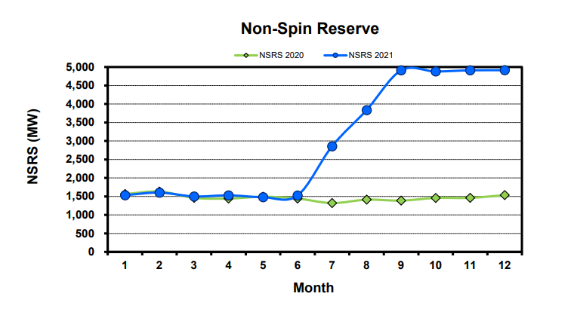
When desired supply of a product increases by over 300% and the number of suppliers stays the same, the result is an increased cost. The chart below shows that for the month of October in 2021, a Non-Spin procurement increase of 333.33% resulted in an average cost per MW increase of ~500%, indicating that the number of suppliers of Non-Spin has not been able to increase. The increased cost of the “conservative operations” continues to be a topic of public discussion, including at the March 9th, 2022, Senate Committee on Business & Commerce hearing and the March 10th, 2022, Public Utility Commission of Texas Open Meeting.
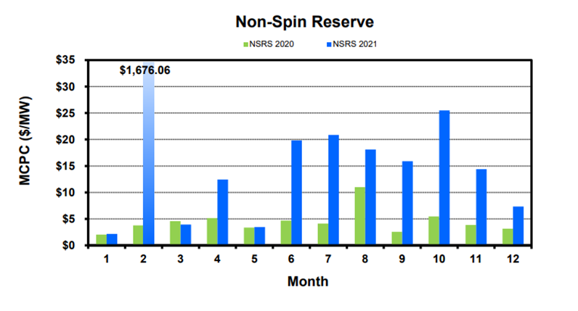
If “conservative operations” continue to dictate an elevated procurement of Non-Spin, the way to preserve both any added reliability and lessen harmful cost increases to consumers is to increase the pool of suppliers. To that end, NPRR1093, Load Resource Participation In Non-Spinning Reserve, introduced by ERCOT in September of 2021 and passed quickly by October of 2021, provides for adding supplies to the Non-Spin market. ERCOT stated in the business case of that NPRR that “by allowing for increased participation in Non-Spin, ERCOT can access additional capacity from Load Resource that otherwise would not be accessible. Additionally, allowing for increased participation in Non-Spin will improve Non-Spin offer liquidity and will allow ERCOT to more competitively procure the required quantities of Non-Spin.” To introduce one new subset of suppliers and then eliminate another subset of suppliers is contradictory and counter-productive to increasing suppliers and lowering the cost of a service. Competitive procurement of Non-Spin is necessary to maintain the lowest possible cost to consumers.
The graphic below from the 2020 State of the Market shows that the overall make up of Non-Spin procurement is provided in large quantities by a relatively small number of QSEs. Removing an entire pool of possible suppliers based on technology would result in larger market shares to single Entities and high costs.
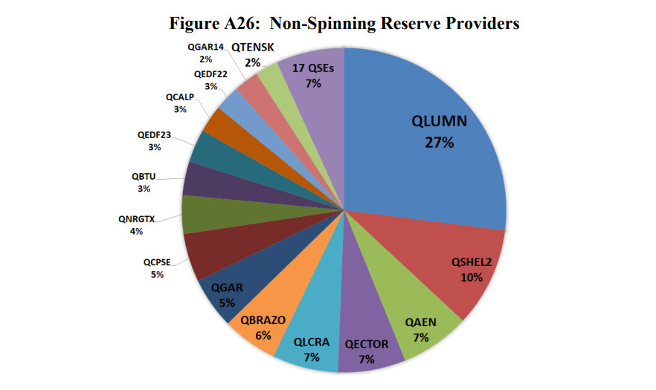
Conclusion and Request for TAC Action Item
While Jupiter Power respects both the vote of the PRS and ERCOT’s expressed desire to address their reliability need with an interim tool, we request that if and when NPRR1096 passes, that TAC take as an Action Item, the further consideration of method’s for ERCOT to manage limited-duration Resource offers, including those that may require ERCOT system-changes or larger scale market changes.
Jupiter Power also requests that the method of managing limited-duration Resource offers continue to be evaluated, with contemplation of a sunset for NPRR1096, as ERCOT changes their use of RUC, implements RTC, and has a larger data set for trends of non-compliance versus compliance in fulfilling Ancillary Service awards for a long-existing Ancillary Service like Non-Spin, in the wake of increasing penetration of limited duration Resources on the system.
In their November 3rd comments, ERCOT pointed out that “future design changes to Day-Ahead Market (DAM), Reliability Unit Commitment (RUC), and Real-Time Co-optimization (RTC) clearing engines to consider state of charge for ESRs could also lead to a reassessment of the proposed durations.” As the use of Non-Spin and risk of deployment changes as well as the prevalence of limited duration Resources, we reiterate the need to re-evaluate the most appropriate way to provide ensured reliability in a manner that is both non-discriminatory to generators and lowest cost to consumers.
Revised Cover Page Language
None
Revised Proposed Protocol Language
None

2017 State of the Market Report, Potomac Economics, page xxv https://www.potomaceconomics.com/wp-content/uploads/2018/05/2017-State-of-the-Market-Report.pdf
Senate Bill 3 Section 14 https://capitol.texas.gov/tlodocs/87R/billtext/pdf/SB00003F.pdf#navpanes=0 amending Utilities Code Section 14 (h)
Wholesale Electricity Market Monthly Report – December 2021, Potomac Economics, page 8. https://www.potomaceconomics.com/document-library/?filtermarket=ERCOT&filteryear=2022&filterorder=DESC
Wholesale Electricity Market Monthly Report – December 2021, Potomac Economics, page 9. https://www.potomaceconomics.com/document-library/?filtermarket=ERCOT&filteryear=2022&filterorder=DESC
2020 State of the Market Report, Potomac Economics, Figure A26, page A-31 https://www.potomaceconomics.com/wp-content/uploads/2021/06/2020-ERCOT-State-of-the-Market-Report.pdf

