PWG Meeting Notes – February 24, 2022
Via WebEx 9:30 AM
Attendees:
Sam Pak - Oncor | Jordan Troublefield – ERCOT | Eric Lotter – Grid Monitor | Diana Rehfeldt - TNMP
Sheri Wiegand - TXUE | Carolyn Reed - CNP | Mansoor Khanmohamed - EDF | Randy Roberts - ERCOT
Kathy Scott - CNP | Calvin Opheim - ERCOT | Jim Lee – TEC | Diana Rios - ERCOT
Norm Levine – NRG

- Meeting notes for Jan 12th were reviewed, revised with minor edits, and approved
  - Revised version will be posted to meeting page for Feb 24th

- 2021 Weather Sensitivity Progress
  - Below is the last report ERCOT posted as of 2/2/22. An updated report will be generated at the beginning of March
  - TNMP later reported they were still working with ERCOT on the one outstanding ESI
  - AEP later reported that their outstanding issue should be resolved.
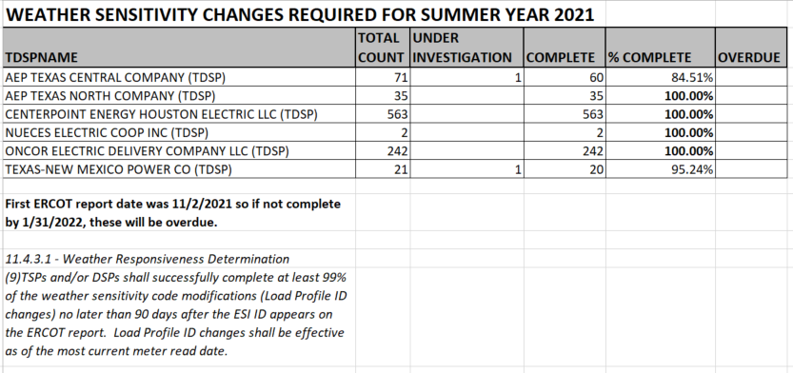

- Transition status of LPGRR068, Add BUSLRG and BUSLRGDG Profile Types
  - Transition Plans for BUSLRG profiles:
    - Oncor confirmed the market should see 814_20s transitioning impacted ESIs on March 7th that will be backdated to the beginning of the last read cycle.
    - CNP continues gather requirements for development on transitioning from IDR to AMS. May provide further update around 2nd Qtr on their transition plans.
    - AEP timeline for transition remains around April 2022, could potentially occur a little earlier
    - TNMP transition timeline continues to remain delayed primarily due to 3G remediation efforts. TNMP will provide further updates at future PWG meetings
  - Data Accessibility:
    - No changes in deployment plans for access to interval data transitioning from BUSIDDRQ to BUSLRG
  - See below matrix for ease of reading

- Reviewed 2021 Goals/Accomplishments
2021 PWG Goals as presented to RMS on February 2, 2021
- Accomplishments indicated in red below

- Identifying and supporting a transition plan for the proposed Revision Requests associated with the IDR/AMS effort
  - LPGRR068, Add BUSLRG and BUSLRGDG Profile Types
- Communicating to the market the proposed transition plan via RMS or a Workshop if necessary
  - AMS IDR Workshop III October 2021

- Completion of 2021 Annual Validation Process for both Business and Residential ESIs and review the potential impacts of COVID-19, if any
  - Completed September 2021

- Supporting ERCOT efforts on the Distributed Generation template
  - PWG helped facilitated a forum for multiple discussions on potential solutions for submitting additional generation related data for unregistered DG; TDSPs and ERCOT have elected to continue discussion outside of PWG
- Completion of 2020 and initiation of 2021 Weather Sensitivity Change Reports
- Completed 2020 WS changes in Feb 2021
- Initiated 2021 WS changes in Nov 2021 with expected completion date by Feb 2, 2022

Additional Tasks/Accomplishments:
  - Emergency Conditions Issue – IDR Data Expectations – RECTF - Issue was subset of C&I customers(BUSIDRRQ) being settled on high initial estimates during storm. PWG is already addressing vast majority with IDR to AMS effort. Smaller subset were discussed if ERCOT estimations needed to be reviewed. It was agreed implementing logic would be costly while impacting only a smaller number of customers. Need for resettlement should be directed by PUCT and not codified in protocols.
  - NPRR1102, ERCOT Discretion for Adjusting Non-Interval Data Recorder (NIDR) Backcasted- codified process for unmetered/NIDR customers to adjust profiles at ERCOT’s discretion should unusual circumstances necessitate the adjustments
  - Discussion on UFE reallocation – presented to RMS for suggested holistic review by WMS – recommendations were for the following considerations:
    - Utilize EMS transmission factors vs seasonal calculation for TLFs
    - Should NOIEs receive a % of allocation? Currently at 0, however, with AMS meters, competitive market is now at 99.5% interval data
    - What are appropriate UFE allocation factors? w/TLFs as primary driver, NOIEs are also subject to some transmission losses at boundary meters

- Goals for 2022
- Support market efforts for IDR/AMS transition plans
- Completion of 2022 Annual Validation Process
- Completion of 2021 and initiation of 2022 Weather Sensitivity Change Reports
- Initiate and review enhancements to Load Profiling Guide where applicable.
- Support market efforts related to Load Profiles (i.e., monitoring Lubbock Power & Light integrations).

- Business Annual Validation scheduled to commence in March

- Crypto Currency Specific Load Profile
  - Inquiry originated from NRG @ TAC regarding the creation of a new cryptocurrency load profile for use in pricing this segment
  - As noted in Chapter 18, creation of new profiles are based on multiple customers where loads are averaged and shaped over time
  - TAC is creating a new taskforce (scheduled to meet at the end of March) on Load Resource Issues which will likely cover cryptocurrency customers. PWG will support RMS direction from task force on any further action.
  - May need clarity on which segment of customer the profile is being requested – large facilities or residential premises operating out of garages. Per CNP, 90% of bitcoin operations are residential premises.
    - Is a profile desired for the residential level? Challenge for residential bit coin is that the profile would be based on customer and not the premise. This flag could be similar to Critical Care which is based on customer and not premise.

- Lubbock Power & Light Integration into ERCOT market
  - PWG will support any load profile impacts of integration and continue to monitor
  - Current plans are to bring ESIs in under the North profiles (not West)
  - ~120 MW will be added to ERCOT market
  - Not sure if LP&L will have AMS meters deployed or will load be settled on profiles
  - LP&L ESIs will be subject to AV and WS activities
  - LP&L will be required to provide 12 months of historical usage (867_02) if available

- LPGRR proposal converting Profile Decision Tree from Excel to Word format is moving forward per Jordan Troublefield

- DRAFT agenda for next meeting March 22nd, 2022
  - Weather Sensitivity wrap up
  - Business Annual Validation kick-off
  - IDR/AMS BUSLRG Updates from TDSPs
  - Other Business

