PWG Meeting Notes – January 12, 2022
Via WebEx 9:30 AM
Attendees:
To be Added

- 2022 PWG leadership elections:
  - Chair: Sam Pak, Oncor
  - Vice Chair: Sheri Wiegand, Vistra Energy

- A revised version of meeting notes for Nov 11th were reviewed and approved
  - This will replace the version posted

- 2021 Weather Sensitivity Progress
  - ERCOT provided an update as of January 2nd on the progress of Weather Sensitivity changes
  - Process ongoing for changes with a target completion by Jan 31 2022
  - ERCOT to provide additional update via PWG listserv in early Feb 2022

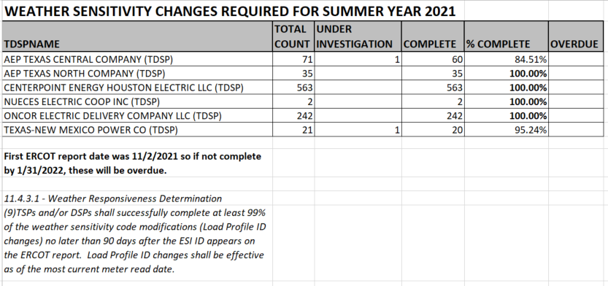

- Transition status of LPGRR068, Add BUSLRG and BUSLRGDG Profile Types
  - Transition Plans for BUSLRG profiles:
    - Oncor stated plans were for mid February for 814_20 profile changes. Will provide further updates at February’s PWG meeting.
    - CNP may provide further update around 2nd Qtr on their transition plans
    - AEP timeline for transition around April 2022
    - TNMP transition timeline has been delayed; will provide further updates at PWG in future meetings
  - Data Accessibility:
    - All TDSPs plan to have interval data available via CRIP/REP DESK tools
    - Oncor’s CRIP tool for interval data is currently in development with expectations of a mid 2022 rollout
  - ERCOT’s Proposals for additional Error Codes on respective TDSP’s 867_03 Activity Report and Interval Data LSE Activity Report have been agreed upon
    - Threshold kWh/KW amounts may be subject to change with possible individual values by TDSP as a possible option in future iterations

- Reviewed 2021 Goals/Accomplishments & 2022 Goals

- Parking Lot Item for future discussion:
  - Converting Appendix D, Profile Decision Tree, in Load Profiling Guide from Excel to Word Format

- Future Meeting Dates:
  - Cancelled Feb 9th and rescheduling for Feb 24th
  - Cancelled Mar 16th and rescheduling for Mar 22nd

