January 2022 ERCOT Monthly Operations Report
Reliability and Operations Subcommittee Meeting
March 3, 2022

Table of Contents
1. Report Highlights 2
2. Frequency Control 3
2.1. Frequency Events 3
2.2. Responsive Reserve Events 4
2.3. Load Resource Events 4
3. Reliability Unit Commitment 4
4. IRR, Wind, and Solar Generation as a Percent of Load 5
5. Largest Net-Load Ramps 7
6. COP Error Analysis 7
7. Congestion Analysis 10
7.1. Notable Constraints 10
7.2. Generic Transmission Constraint Congestion 13
7.3. Manual Overrides 13
7.4. Congestion Costs for Calendar Year 2022 13
8. System Events 15
8.1. ERCOT Peak Load 15
8.2. Load Shed Events 15
8.3. Stability Events 15
8.4. Notable PMU Events 15
8.5. DC Tie Curtailment 15
8.6. TRE/DOE Reportable Events 15
8.7. New/Updated Constraint Management Plans 15
8.8. New/Modified/Removed RAS 15
8.9. New Procedures/Forms/Operating Bulletins 16
9. Emergency Conditions 16
9.1. OCNs 16
9.2. Advisories 16
9.3. Watches 16
9.4. Emergency Notices 16
10. Application Performance 17
10.1. TSAT/VSAT Performance Issues 17
10.2. Communication Issues 17
10.3. Market System Issues 17
11. Model Updates 17
Appendix A: Real-Time Constraints 20

Report Highlights
- The unofficial ERCOT peak load for the month was 63,526 MW and occurred on the 21st, during hour ending 8:00.
- There were 3 frequency events.
- There were 4 instances where Responsive Reserves were deployed.
- There were 29 HRUC commitments.
- There were 12 days of congestion on the West Texas Export GTC, 23 days on the North Edinburg to Lobo GTC, 1 day on the East Texas GTC, 21 days on the Nelson Sharpe to Rio Hondo GTC, 16 days on the Valley Export GTC, 14 days on the Panhandle GTC, and 11 days on the Raymondville to Rio Hondo GTC. There was no activity on the remaining GTCs during the month.
- There were 0 DC Tie Curtailments.
- A Solar Generation Record of 7,899 MW was set on 01/28/2022 at 15:30.
- A Solar Penetration Record of 20.74% was set on 01/29/2022 at 15:34.
- An OCN was issued at 01/18/2022, 09:30 CPT for the prediction of extreme cold weather for 01/20/2022 to 01/21/2022.
- An OCN was issued at 01/27/2022, 13:00 CPT for the prediction of extreme cold weather for 02/02/2022 to 02/05/2022.

Frequency Control

Frequency Events
The ERCOT Interconnection experienced 3 frequency events, which resulted from unit’s trips. The average event duration was 00:03:58.

A summary of the frequency events is provided below. The reported frequency events meet one of the following criteria: Delta Frequency is 60 mHz or greater; the MW loss is 350 MW or greater; resource trip event triggered RRS deployment. Frequency events that have been identified as Frequency Measurable Events (FME) for purposes of BAL-001-TRE-1 analysis are highlighted in blue. When analyzing frequency events, ERCOT evaluates PMU data according to industry standards. Events with an oscillating frequency of less than 1 Hz are inter-area, while higher frequencies indicate local events. Industry standards specify that damping ratio for inter-area oscillations should be 3.0% or greater. For the frequency events listed below, the ERCOT system met these standards and transitioned well after each disturbance.

Date and Time | Delta Frequency | Max/Min Frequency | Duration of Event | PMU Data |  | MW Loss | Load | IRR | Inertia
 | (Hz) | (Hz) |  | Oscillation Mode (Hz) | Damping Ratio |  | (MW) | % | (GW-s)
1/13/2022 18:06:27 | 0.099 | 59.876 | 00:03:33 | 0.67 | 4% | 547.73 | 41,585 | 1% | 261,648
1/24/2022 18:02:15 | 0.094 | 59.923 | 00:02:18 | 0.56 | 9% | 393.11 | 47,902 | 7% | 275,960
1/26/2022 2:27:47 | 0.166 | 59.842 | 00:06:03 | 0.82 | 14% | 814.04 | 41,489 | 37% | 210,833

(Note: All data on this graph encompasses frequency event analysis based on BAL-001-TRE-1.)

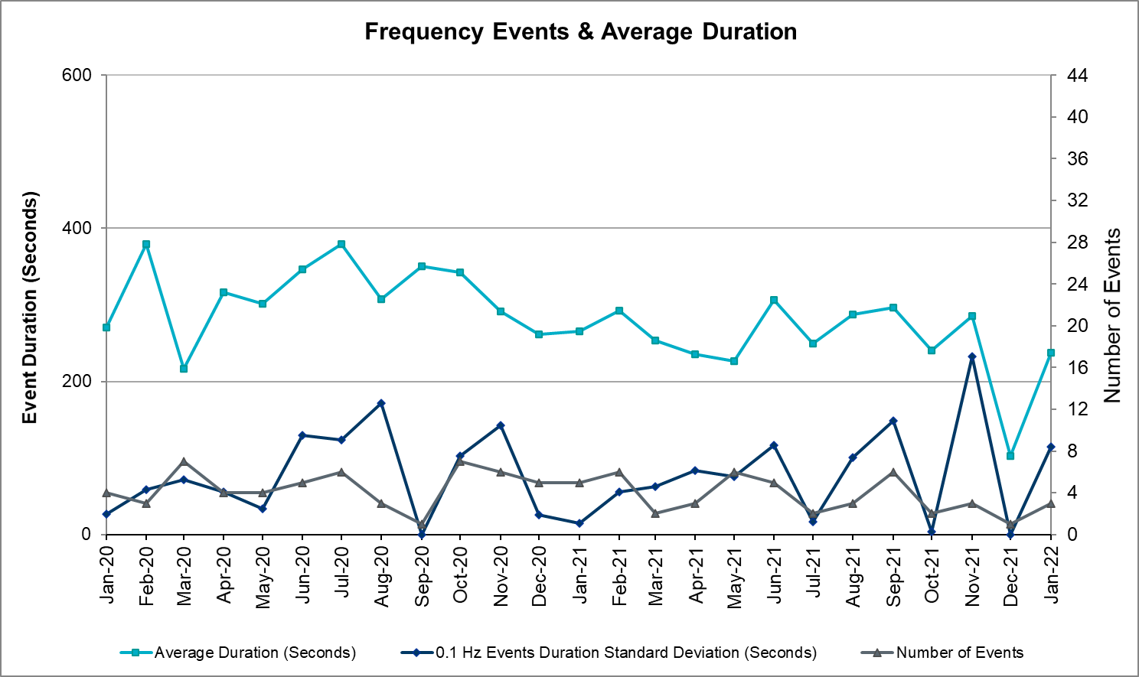

Responsive Reserve Events
There were 4 events where Responsive Reserve MWs were released to SCED. The events highlighted in blue were related to frequency events reported in Section 2.1 above.

Date and Time Released to SCED | Date and Time Recalled | Duration of Event | Maximum MWs Released | Comments
1/11/2022 9:15:04 | 1/11/2022 9:18:12 | 00:03:08 | 635
1/13/2022 18:06:40 | 1/13/2022 18:10:08 | 00:03:28 | 742
1/16/2022 19:03:20 | 1/16/2022 19:09:24 | 00:06:04 | 619
1/26/2022 2:28:00 | 1/26/2022 2:33:48 | 00:05:48 | 1053

Load Resource Events
NONE.

Reliability Unit Commitment
ERCOT reports on Reliability Unit Commitments (RUC) on a monthly basis. Commitments are reported grouped by operating day and weather zone. The total number of hours committed is the sum of the hours for all the units in the specified region. Additional information on RUC commitments can be found on the MIS secure site at Grid Generation Reliability Unit Commitment.

There were no DRUC commitments.

There were 29 HRUC commitments

Resource Location | # of Resources | Operating Day | Total # of Hours Committed | Total MWhs | Reason for Commitment
EAST, NORTH_CENTRAL, SOUTH_CENTRAL | 6 | January 3, 2022 | 23 | 7,593.0 | Capacity
COAST, EAST, FAR_WEST, NORTH_CENTRAL, SOUTH_CENTRAL, SOUTHERN | 11 | January 7, 2022 | 48 | 21,343.4 | Capacity
COAST, EAST, NORTH_CENTRAL | 3 | January 16, 2022 | 11 | 4,662.0 | Capacity
NORTH_CENTRAL | 1 | January 21, 2022 | 4 | 1,740.0 | Capacity
EAST, NORTH_CENTRAL | 2 | January 27, 2022 | 6 | 2,691.0 | Capacity
NORTH_CENTRAL, SOUTHERN | 3 | January 28, 2022 | 18 | 5,304.0 | Capacity
NORTH_CENTRAL | 3 | January 29, 2022 | 4 | 1,006.0 | Capacity

IRR, Wind, and Solar Generation as a Percent of Load
Graph below shows the maximum, minimum and average aggregate solar, wind and IRR output as a percentage of total ERCOT load when evaluated as 10-minute averaged intervals, over the past 13 months. Current wind, solar generation and penetration records are listed in the footnote below. Maximum IRR penetration for the month was 62.9% on January 15, 2022 interval ending 02:20 and minimum IRR penetration for the month was 1.5% on January 13, 2022 interval ending 18:10.

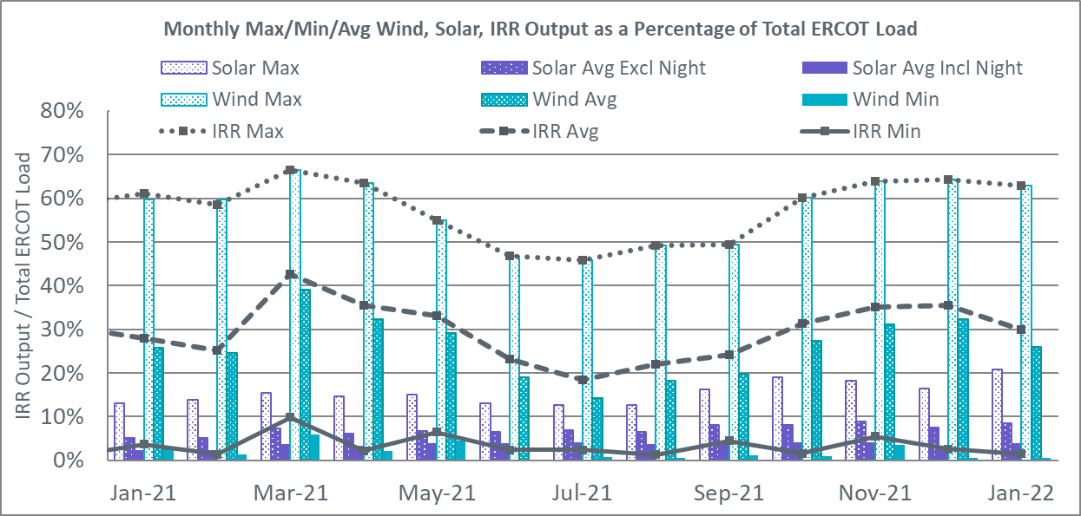

During the hour of peak load for the month, hourly integrated wind generation was 5,632 MW and solar generation was 0 MW. Graph below shows the wind and solar penetration percentage during the hour of the peak load in the last 13 months.

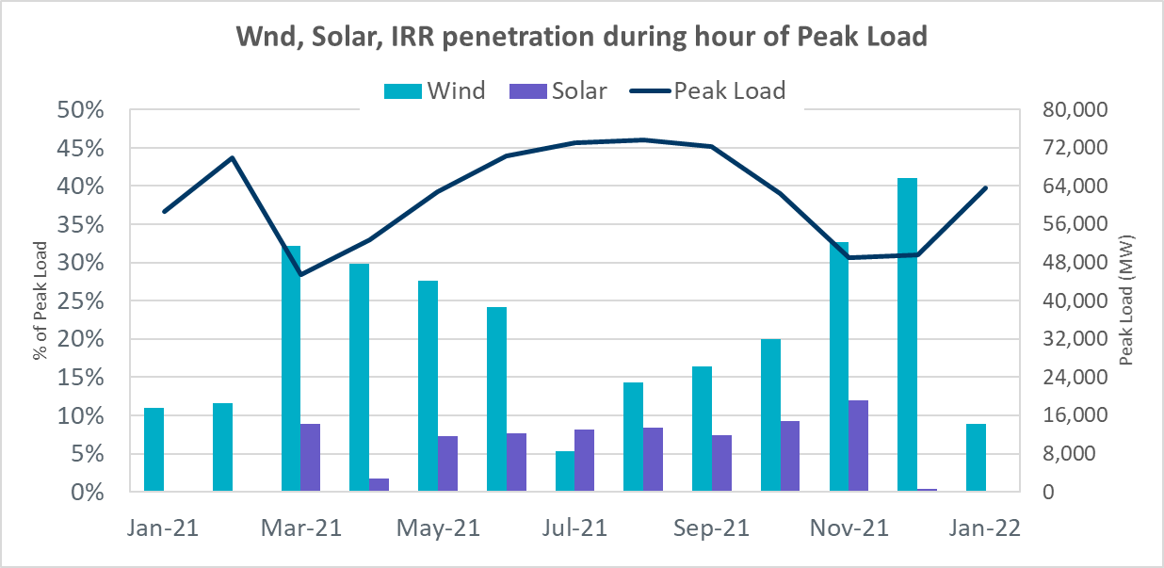

Lastly, the graph below shows the minimum wind, solar and IRR output during the peak load hour as a percentage of the daily peak load for every day in the month.

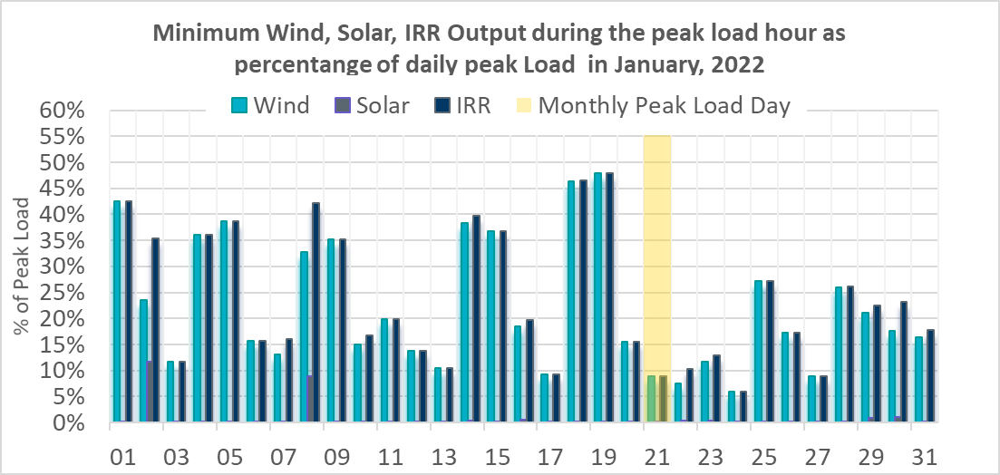

Largest Net-Load Ramps
The net-load ramp is defined as the change in net-load (load minus wind and PVGR generation) during the defined time horizon. Such a variation in net-load needs to be accommodated in grid operations to ensure that the reliability of the grid is satisfactorily maintained. The largest net-load ramp during 5-min, 10-min, 15-min, 30-min and 60-min in January 2022 was 1049 MW, 1879 MW, 2834 MW, 5455 MW, and 10333 MW, respectively. The comparison with respect to the historical values is given in the table below.

Month and Year | 5 min | 10 min | 15 min | 30 min | 60 min
Jan 2014 | 891 MW | 1603 MW | 2082 MW | 3607 MW | 6340 MW
Jan 2015 | 1025 MW | 1609 MW | 2150 MW | 3737 MW | 6496 MW
Jan 2016 | 950 MW | 1547 MW | 2076 MW | 3736 MW | 6213 MW
Jan 2017 | 959 MW | 1680 MW | 2160 MW | 3511 MW | 6181 MW
Jan 2018 | 1091 MW | 1824 MW | 2497 MW | 3901 MW | 6824 MW
Jan 2019 | 1087 MW | 1718 MW | 2308 MW | 4033 MW | 7786 MW
Jan 2020 | 1009 MW | 1610 MW | 2124 MW | 3700 MW | 6100 MW
Jan 2021 | 966 MW | 1744 MW | 2359 MW | 4458 MW | 7842 MW
Jan 2022 | 1049 MW | 1879 MW | 2834 MW | 5455 MW | 10333 MW
All Months in 2014-2022 | 1494 MW | 1991 MW | 2834 MW | 5882 MW | 10364 MW

COP Error Analysis
COP Error is calculated as the capacity difference between the COP HSL and real-time HSL of the unit. Mean Absolute Error (MAE) stayed over 9,600 MW until Day-Ahead at 12:00, then dropped significantly to 1288 MW by Day-Ahead at 14:00. In the following chart, Under-Scheduling Error indicates that COP had less generation capacity than real-time and Over-Scheduling Error indicates that COP had more generation capacity than real-time.

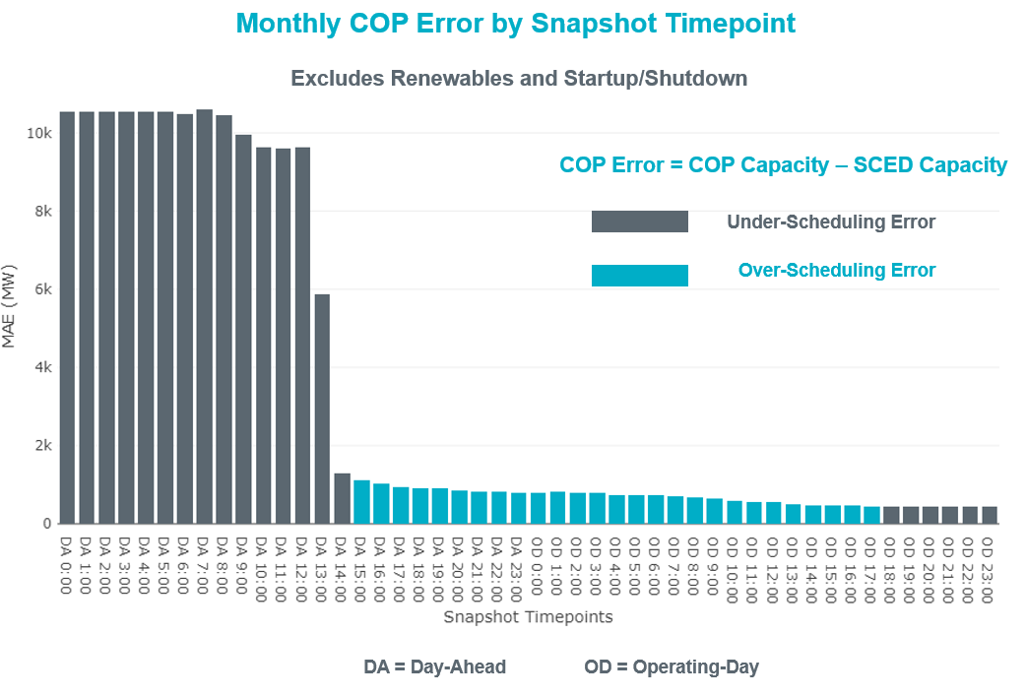

Monthly MAE for the Latest COP at the end of the Adjustment Period was 426 MW with median ranging from -143.0 MW for Hour-Ending (HE) 6 to 342 MW for HE 12. HE 12 on the 2nd had the largest Over-Scheduling Error (1,944 MW) and HE 11 on the 7th had the largest Under-Scheduling Error (-3,502 MW).

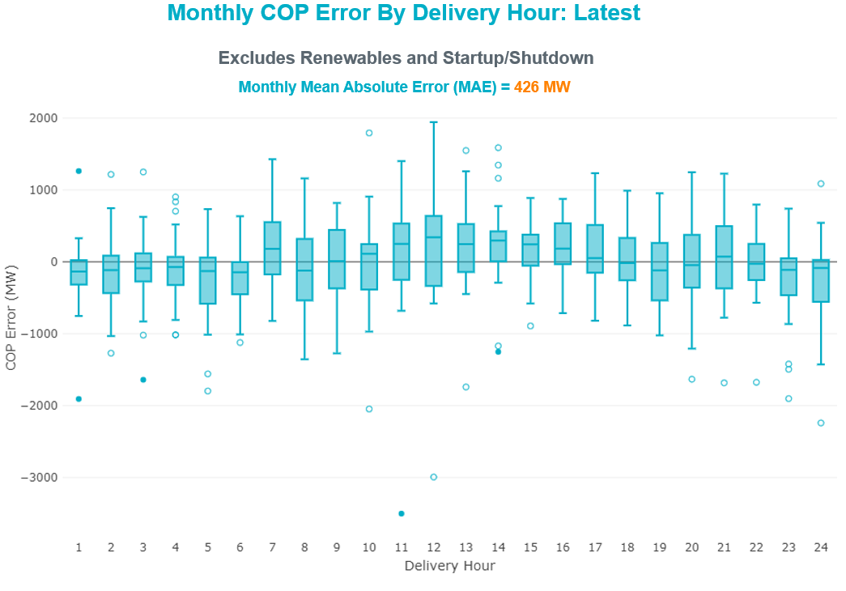

Monthly MAE for the Day-Ahead COP at 12:00 was 9,634 MW with median ranging from -6,415 MW for Hour-Ending (HE) 3 to -12,539 MW for HE 9. HE 8 on the 3rd had the largest Under-Scheduling Error (-22,876 MW) and HE 24 on the 17th had the largest Over-Scheduling Error (2,898 MW).

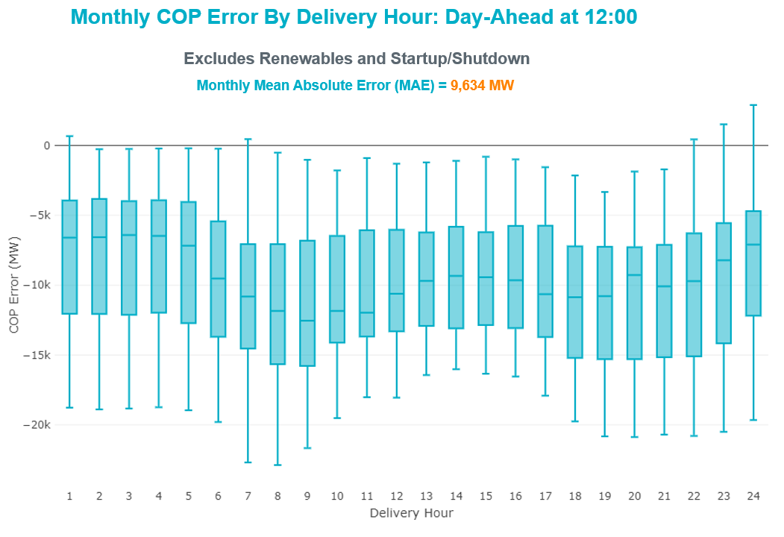

Congestion Analysis

Notable Constraints
Nodal protocol section 3.20 specifies that ERCOT shall identify transmission constraints that are binding in Real-Time three or more Operating Days within a calendar month. As part of this process, ERCOT reports congestion that meets this criterion to ROS. In addition, ERCOT also highlights notable constraints that have an estimated congestion rent exceeding $1,000 for a calendar month. These constraints are detailed in the table below, including approved transmission upgrades from TPIT that may provide some congestion relief based on ERCOT’s engineering judgement. Rows highlighted in blue indicate the congestion was affected by one or more outages. For a list of all constraints activated in SCED, please see Appendix A at the end of this report.

Contingency Name | Overloaded Element | # of Days Constraint Binding | Congestion Rent | Transmission Project
WDGSW TO MARSW 138 DBLCKT | Mistletoe Heights - Hemphill 138kV | 12 | $23,800,225.75
Basecase | WESTEX GTC | 9 | $17,317,656.15
SALSW TO KLNSW 345 DBLCKT | Killeen Switch 345kV | 9 | $6,996,040.45
Basecase | NE_LOB GTC | 21 | $6,495,538.87 | The Lower Rio Grande Valley (LRGV) System Enhancement Project (21RPG017) will improve but not eliminate the need for this GTC.
Fowlerton to LOBO 345 LIN1 | Bruni Sub 138kV | 15 | $4,909,602.69
Basecase | EASTEX GTC | 1 | $3,630,343.53
Helotes-Anderson&Cagnon 138kV | Cagnon 345kV | 2 | $2,867,911.09
Hutto-Zorn & Gillcr-Cleasp 345kV | Rattler - Redwood 138kV | 3 | $2,646,503.79
EVRSW TO CDHSW 345 AND EVRSW TO SHRSW 345 DBLCKT | Arlington - Sherry Switch 138kV | 2 | $2,341,877.66 | Handley - Pantego - Sherry 138kV Upgrade (2582)
STP SWITCH to Esperanza LIN 1 | Blessing - Pavlov 138kV | 4 | $2,168,571.37
SAN MIGUEL GEN to FOWLERTON LIN 1 | San Miguel Gen - Choke Canyon Aep 138kV | 6 | $2,153,020.02
VENSW TO LIGSW 345 TRPLCKT 1 OF 3 | Britton Road - Venus Switch 345kV | 3 | $1,937,599.67 | Venus - Webb/Cedar Hill Sw. Sta. (5492)
TWR (345) JN-WAP64 & JN-WAP72 | Bellaire - Wa Parish 345kV | 7 | $1,744,001.48 | Bellaire to Wa Parrish Upgrade (64493)
Manual contingency for Marion - Sherpo & GPISWI with Sherpo - Schuma | Cibolo - Marion 138kV | 5 | $1,692,677.67
Basecase | Omega - Horse Hollow Generation Tie 345kV | 10 | $1,631,839.09
COMANCHE SWITCH (Oncor) to COMANCHE PEAK SES LIN _A | Comanche Tap - Comanche Switch (Oncor) 138kV | 6 | $1,519,314.29
Manual dbl ckt for NEDIN-BONILLA 345kV & RIOH-PRIM138kV | Burns Sub - Rio Hondo 138kV | 8 | $1,255,070.38
WA PARISH to OBRIEN LIN A | Wa Parish - Obrien 345kV | 1 | $1,252,096.72
Basecase | NELRIO GTC | 19 | $1,208,880.75 | The Lower Rio Grande Valley (LRGV) System Enhancement Project (21RPG017) will improve but not eliminate the need for this GTC.
SAN MIGUEL GEN to FOWLERTON LIN 1 | Cotulla - Reveille 138kV | 3 | $1,204,422.16
COLETO CREEK to PAWNEE SWITCHING STATION LIN 1 | Coleto Creek - Rosata Tap 138kV | 8 | $962,594.74 | Upgrade Coleto Creek - Rosata (50870)
DYANN to CANEY LIN A | El Campo - Lane City Pump 138kV | 16 | $887,913.47 | Prairie Switch Wind Interconnection (66124)
TWR(345) CHB-JOR97 & CBY-JOR99 | Cedar Bayou Plant 345kV | 3 | $876,317.66
SANDY CREEK SWITCHYARD to PITSBURG LIN 1 | Sandy Creek 138kV | 8 | $703,911.21 | Sandy Creek Autotransformer Upgrade (61591)
BLACKWATER DRAW SWITCH to DOUBLE MOUNTAIN SWITCH LIN 1 | Mackenzie Substation - Northeast Substation 115kV | 4 | $691,026.00
KLEBERG AEP to LOYOLA SUB LIN 1 | Loyola Sub 138kV | 5 | $664,700.93
Basecase | VALEXP GTC | 16 | $648,892.40 | The Lower Rio Grande Valley (LRGV) System Enhancement Project (21RPG017) will improve but not eliminate the need for this GTC.
AJO to NELSON SHARPE LIN 1 | Loyola Sub 138kV | 6 | $641,939.76
LWSSW TO RNKSW AND LWSSW TO KRWSW 345 DBLCKT | Argyle - Highlands Tnp 138kV | 4 | $555,290.16
Basecase | PNHNDL GTC | 8 | $521,742.02
Grissom to COLETO CREEK LIN 1 | Beeville - Normanna 69kV | 5 | $484,261.47
Basecase | Emerald Grove Solar - Horse Crossing 138kV | 3 | $369,541.54
GARDENDALE SWITCH to TELEPHONE ROAD - Sharyland Utilities LIN _A | Andrews County South 345kV | 4 | $304,017.71
COLETO - GRISSOM (345) & VICTORIA - FANNINS (69) | Beeville - Normanna 69kV | 3 | $270,856.78
COLETO - GRISSOM (345) & VICTORIA - FANNINS (69) | Pettus - Normanna 69kV | 6 | $235,031.00
ODLAW SWITCHYARD to ASPHALT MINES LIN 1 | Hamilton Road - Maverick 138kV | 8 | $193,613.25
Basecase | RV_RH GTC | 9 | $186,398.97
PH ROBINSON to MEADOW LIN A | Magnolia Tnp - Seminole Tnp 138kV | 4 | $182,280.70 | Rebuild Magnolia - Seminole 138 kV Line (4010)
Grissom to COLETO CREEK LIN 1 | Melon Creek - Sea Drift Coke 138kV | 3 | $135,765.28
Grissom to COLETO CREEK LIN 1 | Sea Drift Coke - North Carbide 138kV | 5 | $119,850.21
KENEDY SWITCH TRX 69A1 138/69 | Beeville - Charter 69kV | 7 | $99,147.51
Bighil-Kendal 345kV | Yellow Jacket - Treadwell 138kV | 7 | $90,236.59
Wirtz-Burnet&Starck 138kV | Sandy Creek 138kV | 3 | $86,113.34 | Sandy Creek Autotransformer Upgrade (61591)
FREDERICKSBURG TRX AT2 138/69 | Gillespie 138kV | 3 | $71,153.32
HAMILTON ROAD TRX PS2 138/138 | Santiago - San Angelo Power Station 138kV | 3 | $56,932.92
HAMILTON ROAD to CORRAL LIN 1 | Maxwell - Whiting 138kV | 3 | $56,424.48
ODLAW SWITCHYARD to ASPHALT MINES LIN 1 | Escondido - Ganso 138kV | 5 | $55,968.83 | Escondido - Ganso 138 kV Line Rebuild (55624)
LAQUINTA to LOBO LIN 1 | Bruni Sub 138kV | 7 | $36,015.44
TOMBSTONE to Lynx LIN 1 | Alpine - Bronco 69kV | 3 | $30,853.87
STP to HLJ & Anstrom345 KV DOUBLE | Blessing - Palacios 69kV | 3 | $26,321.94
COLETO - GRISSOM (345) & VICTORIA - FANNINS (69) | Beeville - Normanna 69kV | 3 | $23,044.62
VICTORIA DUPONT SWITCH TO VICTORIA DOUBLE CKT 138KV | Greenlake - Weaver Road 69kV | 3 | $7,212.91
VICTORIA DUPONT SWITCH TO VICTORIA DOUBLE CKT 138KV | Greenlake - Weaver Road 69kV | 3 | $2,458.38

Generic Transmission Constraint Congestion
There were 12 days of congestion on the West Texas Export GTC, 23 days on the North Edinburg to Lobo GTC, 1 day on the East Texas GTC, 21 days on the Nelson Sharpe to Rio Hondo GTC, 16 days on the Valley Export GTC, 14 days on the Panhandle GTC, and 11 days on the Raymondville to Rio Hondo GTC. There was no activity on the remaining GTCs during the month.

Note: This is how many times a constraint has been activated to avoid exceeding a GTC limit, it does not imply an exceedance of the GTC occurred or that the GTC was binding.

Manual Overrides
None

Congestion Costs for Calendar Year 2022
The following table represents the top twenty active constraints for the calendar year based on the estimated congestion rent attributed to the congestion. ERCOT updates this list on a monthly basis.

Contingency | Overloaded Element | # of 5-min SCED | Estimated | Transmission Project
WDGSW TO MARSW 138 DBLCKT | Mistletoe Heights - Hemphill 138kV | 1690 | $23,800,225.75
Basecase | WESTEX GTC | 1610 | $17,317,656.15
SALSW TO KLNSW 345 DBLCKT | Killeen Switch 345kV | 1396 | $6,996,040.45
Basecase | NE_LOB GTC | 2743 | $6,495,538.87 | The Lower Rio Grande Valley (LRGV) System Enhancement Project (21RPG017) will improve but not eliminate the need for this GTC.
Fowlerton to LOBO 345 LIN1 | Bruni Sub 138kV | 1647 | $4,909,602.69
Basecase | EASTEX GTC | 157 | $3,630,343.53
Helotes-Anderson&Cagnon 138kV | Cagnon 345kV | 139 | $2,867,911.09
Hutto-Zorn & Gillcr-Cleasp 345kV | Rattler - Redwood 138kV | 328 | $2,646,503.79
EVRSW TO CDHSW 345 AND EVRSW TO SHRSW 345 DBLCKT | Arlington - Sherry Switch 138kV | 74 | $2,341,877.66 | Handley - Pantego - Sherry 138kV Upgrade (2582)
STP SWITCH to Esperanza LIN 1 | Blessing - Pavlov 138kV | 623 | $2,168,571.37
SAN MIGUEL GEN to FOWLERTON LIN 1 | San Miguel Gen - Choke Canyon Aep 138kV | 683 | $2,153,020.02
MGSES TO CCRSW 345 AND BTRCK TO MGSES 345 DBLCKT | Tonkawa Switch - Morgan Creek Ses 345kV | 171 | $2,121,592.81
VENSW TO LIGSW 345 TRPLCKT 1 OF 3 | Britton Road - Venus Switch 345kV | 206 | $1,937,599.67 | Venus - Webb/Cedar Hill Sw. Sta. (5492)
TWR (345) JN-WAP64 & JN-WAP72 | Bellaire - Wa Parish 345kV | 1187 | $1,744,001.48 | Bellaire to Wa Parrish Upgrade (64493)
Manual contingency for Marion - Sherpo & GPISWI with Sherpo - Schuma | Cibolo - Marion 138kV | 649 | $1,692,677.67
Basecase | Omega - Horse Hollow Generation Tie 345kV | 899 | $1,631,839.09
COMANCHE SWITCH (Oncor) to COMANCHE PEAK SES LIN _A | Comanche Tap - Comanche Switch (Oncor) 138kV | 784 | $1,519,314.29
Manual dbl ckt for NEDIN-BONILLA 345kV & RIOH-PRIM138kV | Burns Sub - Rio Hondo 138kV | 692 | $1,255,070.38
WA PARISH to OBRIEN LIN A | Wa Parish - Obrien 345kV | 96 | $1,252,096.72
Basecase | NELRIO GTC | 2694 | $1,208,880.75 | The Lower Rio Grande Valley (LRGV) System Enhancement Project (21RPG017) will improve but not eliminate the need for this GTC.

System Events

ERCOT Peak Load
The unofficial ERCOT peak load for the month was 63,526 MW and occurred on the 21st, during hour ending 8:00.

Load Shed Events
None.

Stability Events
None.

Notable PMU Events
ERCOT analyzes PMU data for any significant system disturbances that do not fall into the Frequency Events category reported in section 2.1. The results are summarized in this section once the analysis has been completed.

There were no PMU events outside of those reported in section 2.1.

DC Tie Curtailment
None

TRE/DOE Reportable Events
- AEP submitted an OE-417 for 1/08/2022. Reportable Event Type: Transmission Loss.
- Gridforce submitted an OE-417 for 1/18/2022. Reportable Event Type: Cyber Security Incident.

New/Updated Constraint Management Plans
There was one new MP: MP_2022_01
There were three modified MPs: MP_2016_12, MP_2013_27, MP_2021_09

New/Modified/Removed RAS
None.

New Procedures/Forms/Operating Bulletins

Date | Subject | Bulletin No.
01/31/2022 | Real Time Desk V1 Rev 79 | 1023
01/31/2022 | Reliability Risk Desk Operating Procedure V1 Rev 26 | 1024
01/31/2022 | Scripts V1 Rev 41 | 1025
01/31/2022 | Shift Supervisor Desk V1 Rev 77 | 1026
01/31/2022 | Transmission and Security Desk V1 Rev 92 | 1027

Emergency Conditions

OCNs
Date and Time | Message
Jan 18, 2022 09:30 CPT | OCN issued for the predicted extreme cold weather event for the ERCOT Region for Thursday, January 20, 2022 through Friday, January 21, 2022.
Jan 27, 2022 13:00 CPT | OCN issued for the predicted extreme cold weather event for the ERCOT Region for Wednesday evening, February 2, 2022 through Saturday, February 5, 2022.

Advisories
Date and Time | Message
Jan 1, 2022 11:30 CPT | Advisory issued for the predicted extreme cold weather event for the ERCOT Region.
Jan 10, 2022 02:56 CPT | Advisory issued due to ERCOT’s Voltage Security Assessment Tool is currently unavailable.
Jan 19, 2022 10:00 CPT | Advisory issued for the predicted extreme cold weather event for the ERCOT Region for Thursday, January 20, 2022 through Friday, January 21, 2022.
Jan 21, 2022 13:30 CPT | ERCOT has postponed the deadline for the posting of the DAM solution for Operating Day 01/22/2022 due to delay in clearing DAM.
Jan 31, 2022 09:00 CPT | Advisory issued for the predicted extreme cold weather event with potential icing conditions for the ERCOT Region for Wednesday evening, February 2, 2022 through Sunday, February 6, 2022.

Watches
None.

Emergency Notices
None.

Application Performance

TSAT/VSAT Performance Issues
None.

Communication Issues
None.

Market System Issues
None.

Model Updates
The Downstream Production Change (DPC) process allows ERCOT to make changes in the on-line Network Operations Model without loading a completely new model. The purpose of this process is to allow for reliable grid operations as system conditions change between designated Network Operations Model database loads. The DPC process is limited in scope to just those items listed below, with equipment ratings updates being the most common. ERCOT has seen a rise in the use of the DPC process to make on-line updates to the Network Operations Model in recent years, instead of through the standard Network Operations Model Change Request process.

- Static Line ratings (Interim Update)
- Dynamic Line ratings (non-Interim Update)
- Autotransformer ratings (non-Interim Update)
- Breaker and Switch Normal status (Interim Update)
- Contingency Definitions (Interim Update)
- RAP and RAS changes or additions (Interim Update)
- Net Dependable and Reactive Capability (NDCRC) values (Interim Update)
- Impedance Updates (non-Interim)

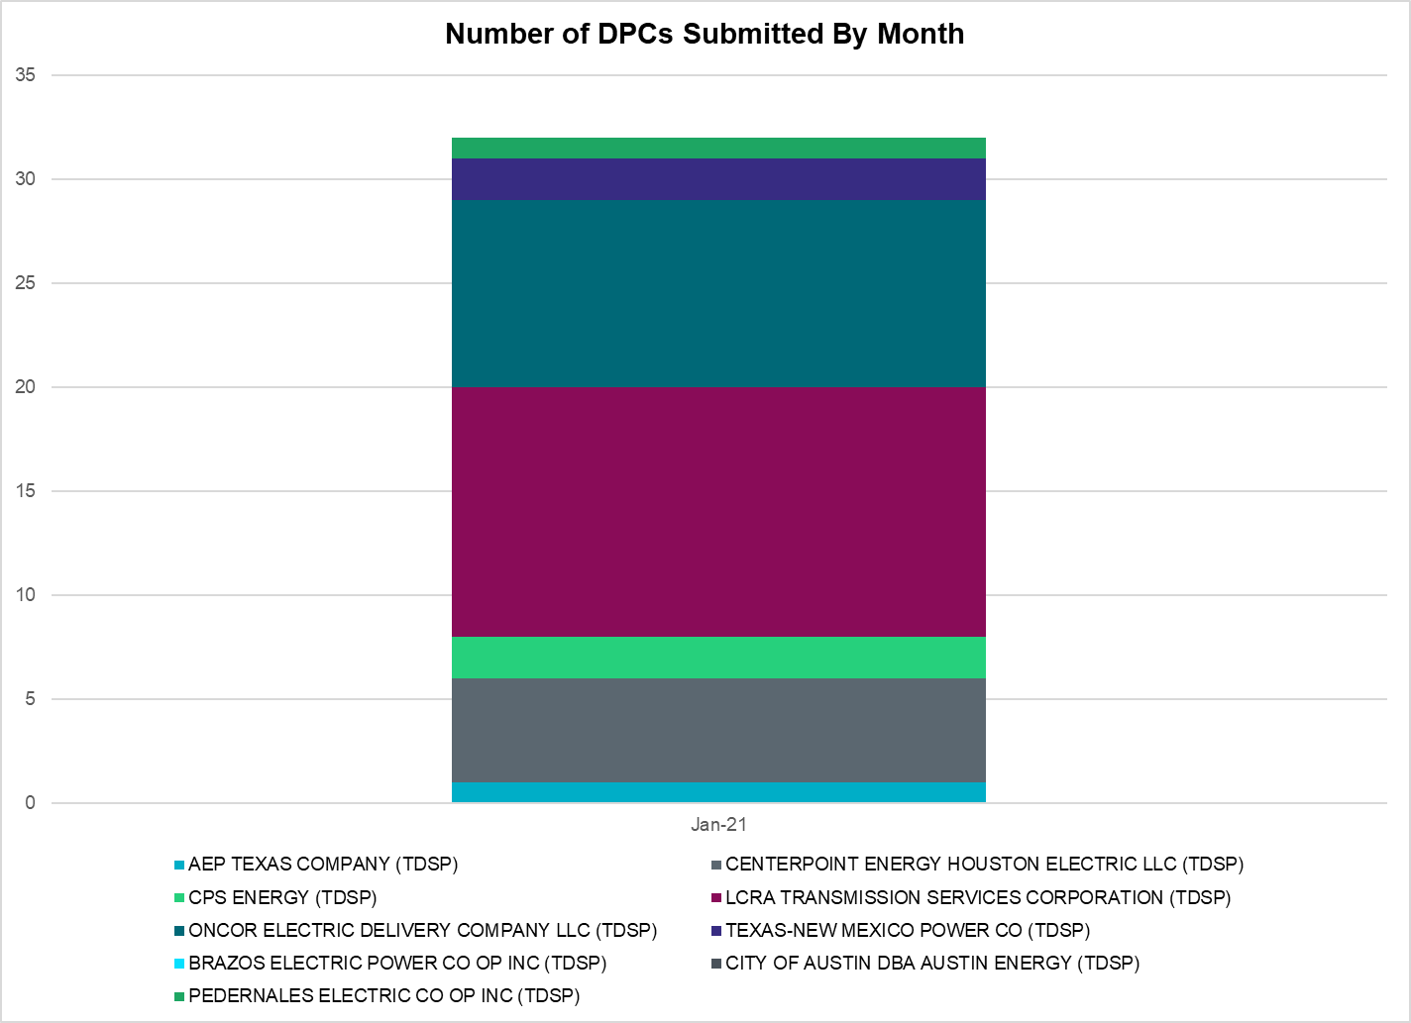

Transmission Operator | Number of DPCs
AEP TEXAS COMPANY (TDSP) | 1
BRAZOS ELECTRIC POWER CO OP INC (TDSP) | 0
BROWNSVILLE PUBLIC UTILITIES BOARD (TDSP) | 0
BRYAN TEXAS UTILITIES (TDSP) | 0
CENTERPOINT ENERGY HOUSTON ELECTRIC LLC (TDSP) | 5
CITY OF AUSTIN DBA AUSTIN ENERGY (TDSP) | 0
CITY OF COLLEGE STATION (TDSP) | 0
CITY OF GARLAND (TDSP) | 0
CPS ENERGY (TDSP) | 2
DENTON MUNICIPAL ELECTRIC (TDSP) | 0
ELECTRIC TRANSMISSION TEXAS LLC (TDSP) | 0
ERCOT | 6
LCRA TRANSMISSION SERVICES CORPORATION (TDSP) | 12
LONE STAR TRANSMISSION LLC (TSP) | 0
ONCOR ELECTRIC DELIVERY COMPANY LLC (TDSP) | 9
PEDERNALES ELECTRIC CO OP INC (TDSP) | 1
RAYBURN COUNTRY CO OP DBA RAYBURN ELECTRIC (TDSP) | 0
SHARYLAND UTILITIES LP (TDSP) | 0
SOUTH TEXAS ELECTRIC CO OP INC (TDSP) | 0
TEXAS MUNICIPAL POWER AGENCY (TDSP) | 0
TEXAS-NEW MEXICO POWER CO (TDSP) | 2

Appendix A: Real-Time Constraints
The following is a complete list of constraints activated in SCED. Full contingency descriptions can be found in the Standard Contingencies List located on the MIS secure site at Grid Generation Reliability Unit Commitment.

Contingency Name | Overloaded Element | From Station | To Station | Count of Days
BASE CASE | NE_LOB | n/a | n/a | 23
BASE CASE | NELRIO | n/a | n/a | 21
BASE CASE | VALEXP | n/a | n/a | 16
SWRDYN8 | EL_CAM_LANCTY1_1 | LANCTYPM | EL_CAMPO | 16
SLOBSA25 | BRUNI_69_1 | BRUNI | BRUNI | 15
BASE CASE | PNHNDL | n/a | n/a | 14
DEVRWDG8 | 6125__C | MSTLT | HMPHL | 13
BASE CASE | WESTEX | n/a | n/a | 12
SBRAUVA8 | HAMILT_MAVERI1_1 | HAMILTON | MAVERICK | 11
DSALKLN5 | KLNSW_MR2H | KLNSW | KLNSW | 11
BASE CASE | RV_RH | n/a | n/a | 11
DBIGKEN5 | TREADW_YELWJC1_1 | TREADWEL | YELWJCKT | 11
SSANFOW5 | SNMIG_AEPCHKCN_1 | SANMIGL | CHOKCNYN | 10
BASE CASE | HHGTOM_1 | HHGT | OMEGA | 10
SLAQLOB8 | BRUNI_69_1 | BRUNI | BRUNI | 9
SSANPIT8 | SANDCR_AT1 | SANDCR | SANDCR | 9
SCOLPAW5 | COLETO_ROSATA1_1 | COLETO | ROSATA | 9
MHARNED5 | BURNS_RIOHONDO_1 | RIOHONDO | MV_BURNS | 9
SCMNCPS5 | 651__B | CMNSW | CMNTP | 8
SSTPESP8 | BLESSI_PAVLOV1_1 | BLESSING | PAVLOV | 8
DWAP_JN5 | BI_WAP50_A | WAP | BI | 8
XKEN289 | BEEVIL_CHARTE1_1 | CHARTER | BEEVILLE | 7
SKLELOY8 | LOYOLA_69_1 | LOYOLA | LOYOLA | 7
SBRAUVA8 | ESCOND_GANSO1_1 | GANSO | ESCONDID | 7
SGRICOL5 | NCARBI_SEADRF1_1 | SEADRFTC | NCARBIDE | 6
SN_SAJO5 | LOYOLA_69_1 | LOYOLA | LOYOLA | 6
DCOLFA59 | NORMAN_PETTUS1_1 | PETTUS | NORMANNA | 6
SFORYEL8 | HEXT_YELWJC1_1 | YELWJCKT | HEXT | 6
SMDOPHR5 | G138_10B_1 | SEMINOLE | MAGNO_TN | 5
DVICDUP8 | GREENL_WEAVER1_1 | WEAVERRD | GREENLK | 5
DHUTGIL5 | 103T262_1 | RATTLE | REDWOO | 5
MMARGPI8 | 705T705_1 | MARION | CIBOLO | 5
DVICDUP8 | GREENL_WEAVER1_1 | GREENLK | WEAVERRD | 5
SGRICOL5 | BEEVIL_NORMAN1_1 | BEEVILLE | NORMANNA | 5
SGRICOL5 | BEEVIL_NORMAN1_1 | NORMANNA | BEEVILLE | 5
DLWSRNK5 | 587__A | ARGYL | LWSVH | 5
SSANFOW5 | COTULL_REVEIL1_1 | REVEILLE | COTULLA | 5
DCOLFA59 | MELONC_SEADRF1_1 | MELONCRE | SEADRFTC | 4
BASE CASE | BRIGHT_CHARTE1_1 | BRIGHTSD | CHARTER | 4
SCOMHA38 | MAXWEL_WHITIN1_1 | MAXWELL | WHITING | 4
DCOLFA59 | NCARBI_SEADRF1_1 | SEADRFTC | NCARBIDE | 4
DCOLFA59 | BEEVIL_NORMAN1_1 | BEEVILLE | NORMANNA | 4
DCOLFA59 | BEEVIL_NORMAN1_1 | NORMANNA | BEEVILLE | 4
SGRICOL5 | MELONC_SEADRF1_1 | MELONCRE | SEADRFTC | 4
SBWDDBM5 | LPLMK_LPLNE_1 | LPLMK | LPLNE | 4
DCOLFA59 | NCARBI_SEADRF1_1 | NCARBIDE | SEADRFTC | 4
SKLEKLE8 | LOYOLA_69_1 | LOYOLA | LOYOLA | 4
DCOLFA59 | MELONC_SEADRF1_1 | SEADRFTC | MELONCRE | 4
DWIRSTA8 | SANDCR_AT1 | SANDCR | SANDCR | 4
SGDNTEL5 | ACSSW_AX2H | ACSSW | ACSSW | 4
DCHBJO25 | CBY_AT1 | CBY | CBY | 4
SSANFOW5 | GEO_SIG_1 | GEOWEST | SIGMOR | 4
DMGSBIT5 | 6036__A | TKWSW | MGSES | 3
SMV_PAR8 | RIOHND_ERIOHND_1 | MV_RIOHO | RIOHONDO | 3
SFORYEL8 | HEXT_MASONS1_1 | HEXT | MASONSW | 3
SELMTH25 | 1020__A | ELMOT | MCTYE | 3
SN_SAJO5 | LASPUL_RAYMND1_1 | LASPULGA | RAYMND2 | 3
BASE CASE | SWEETWN3_XF31 | SWEETWN3 | SWEETWN3 | 3
DMGSBTR5 | 6036__A | TKWSW | MGSES | 3
XFRE89 | GILLES_AT1 | GILLES | GILLES | 3
DBIGKEN5 | HAMILT_MAXWEL1_1 | MAXWELL | HAMILTON | 3
SILLFTL8 | HAMILT_MAXWEL1_1 | MAXWELL | HAMILTON | 3
SWRDYN8 | LAN_CT_PAVLOV1_1 | LAN_CTY | PAVLOV | 3
SVICCO28 | COLETO_VICTOR2_1 | COLETO | VICTORIA | 3
DCAGTX_8 | KARNES_KENEDS1_1 | KENEDSW | KARNESCI | 3
SWRDYN8 | LANCTY_LAN_CT1_1 | LAN_CTY | LANCTYPM | 3
XHAM88 | SANTIA_SAPOWE1_1 | SANTIAGO | SAPOWER | 3
DVENLIG5 | 530__C | VENSW | BRTRD | 3
DSTPANS5 | BLESSI_PALACI1_1 | BLESSING | PALACIOS | 3
BASE CASE | EGTL_1 | EGROVESL | HORSCR | 3
BASE CASE | LGD_SANTIA1_1 | LGD | SANTIAGO | 3
SGRILON5 | NORMAN_PETTUS1_1 | PETTUS | NORMANNA | 3
DCRLLSW5 | 590__A | LWSSW | LWVJS | 3
STOMLYN8 | ALPINE_BRONCO1_1 | BRONCO | ALPINE | 3
STOMLYN8 | COCS_FTST1_1 | FTST | COCS | 2
SODLBRA8 | HAMILT_MAVERI1_1 | HAMILTON | MAVERICK | 2
DLONWAR5 | NCARBI_SEADRF1_1 | NCARBIDE | SEADRFTC | 2
DGRSPKR5 | 6377__A | BRTSW | ORANS | 2
SBRAHAM8 | ESCOND_GANSO1_1 | GANSO | ESCONDID | 2
SCOMHA38 | HAMILT_MAXWEL1_1 | MAXWELL | HAMILTON | 2
SCENLOB5 | LON_HI_ORNGRO1_1 | LON_HILL | ORNGROV | 2
SGRICOL5 | NORMAN_PETTUS1_1 | PETTUS | NORMANNA | 2
DABPAB98 | SOUTHA_VINSON1_1 | SOUTHABI | VINSON | 2
SLANLAN8 | BLESSI_PAVLOV1_1 | BLESSING | PAVLOV | 2
DSKYCAL5 | CAGNON_MR3H | CAGNON | CAGNON | 2
SGRICOL5 | CALLIC_HAISLE1_1 | CALLICOA | HAISLEY | 2
SCOLBAL8 | CONAN_SANA1_1 | SANA | CONAN | 2
SBRAHAM8 | HAMILT_MAVERI1_1 | HAMILTON | MAVERICK | 2
DDUPHE18 | I_DUPS_MCCAMP2_1 | I_DUPSW | MCCAMPBE | 2
DMOLLO58 | LON_HI_ORNGRO1_1 | LON_HILL | ORNGROV | 2
DCENRI35 | LOYOLA_69_1 | LOYOLA | LOYOLA | 2
DCPSST58 | 651__B | CMNSW | CMNTP | 2
BASE CASE | CHARTE_THREER1_1 | CHARTER | THREER69 | 2
DELMSAN5 | COLETO_ROSATA1_1 | COLETO | ROSATA | 2
SSEAMEL8 | GRETA_REFUGI1_1 | REFUGIO | GRETA | 2
DVICEDN8 | LOOP_VICTORIA_1 | VICTORIA | L_463S | 2
SRDOPEB8 | TRU_UAT1 | TRU | TRU | 2
DBNBMBD5 | 800__E | CMBSW | GODLY | 2
DELMSAN5 | BEEVIL_NORMAN1_1 | BEEVILLE | NORMANNA | 2
SBEVASH8 | BIG_COTU_1 | COTULAS | BIGWELS | 2
DHLJBLY5 | BLESSI_PAVLOV1_1 | BLESSING | PAVLOV | 2
DSTPRED5 | BLESSI_PAVLOV1_1 | BLESSING | PAVLOV | 2
SGRICOL5 | CALLIC_LON_HI1_1 | LON_HILL | CALLICOA | 2
BASE CASE | CAPRDG2_CAPRG1_1 | CAPRIDGE | CAPRIDGE | 2
SLOBSA25 | CHARTE_THREER1_1 | CHARTER | THREER69 | 2
SCO2EUL8 | COLETO_ROSATA1_1 | COLETO | ROSATA | 2
XBAL89 | CONCHO_VRBS1_1 | CONCHO | VRBS | 2
DVICEDN8 | FORMOS_JOSLIN1_1 | JOSLIN | FORMOSA | 2
SPOMNED5 | FREER_LOBO1_1 | LOBO | FREER | 2
DSALKLN5 | KLNSW_MR2L | KLNSW | KLNSW | 2
SLOBSA25 | LON_HI_ORNGRO1_1 | LON_HILL | ORNGROV | 2
SCOLPAW5 | LOOP_VICTORIA_1 | VICTORIA | L_463S | 2
DVICDUP8 | NCARBI_PV_TAP1_1 | NCARBIDE | PV_TAP | 2
DEVRCRT5 | 6415__B | SHRSW | ARLNG | 2
STHRSIG8 | BEEVIL_CHARTE1_1 | CHARTER | BEEVILLE | 2
DCAGTX_8 | BIG_FO_PLEASA1_1 | PLEASANT | BIG_FOOT | 2
DHELAND8 | CAGNON_MR3H | CAGNON | CAGNON | 2
SPAWCAL5 | COLETO_ROSATA1_1 | COLETO | ROSATA | 2
DDELGA58 | FREER_LOBO1_1 | LOBO | FREER | 2
SGARGA35 | GARFIELD_AT2 | GARFIELD | GARFIELD | 2
SSUTF18 | KARNES_KENEDS1_1 | KENEDSW | KARNESCI | 2
DLONWAR5 | MELONC_SEADRF1_1 | MELONCRE | SEADRFTC | 2
SKINFAL8 | FALFUR_PREMON1_1 | FALFUR | PREMONT | 2
DMGSMDS5 | MDSSW_MR1H | MDSSW | MDSSW | 2
DLONWAR5 | MELONC_SEADRF1_1 | SEADRFTC | MELONCRE | 2
SLOBSA25 | NLARSW_PILONC1_1 | NLARSW | PILONCIL | 2
MDESPEB8 | TRU_UAT1 | TRU | TRU | 2
SN_SLON5 | KINGSV_KLEBER1_1 | KLEBERG | KINGSVIL | 2
SMV_RI28 | SCARBI_STILLM1_1 | SCARBIDE | STILLMAN | 2
MRA2LAP8 | RAY_MV_R_1 | RAYMND2 | MV_RAYTP | 1
SKINKLE8 | RVI_LOYO_1 | LOYOLA | RVIERAS | 1
DBERNAR8 | SANDCR_AT1 | SANDCR | SANDCR | 1
SEBALAM8 | SANDCR_AT1 | SANDCR | SANDCR | 1
DFER_WI8 | 39T188_1 | FERGUS | WIRTZ | 1
DDUKCLO8 | ADERHO_HEC1_1 | HEC | ADERHOLD | 1
SILLFTL8 | CARVER_TINSLE1_1 | CARVER | TINSLEY | 1
SCRTCDH5 | EVRSW_MR3H | EVRSW | EVRSW | 1
SCRTCDH5 | EVRSW_MR3L | EVRSW | EVRSW | 1
DELMSAN5 | F2_11_1 | KENEDSW | F2 | 1
SLGEI_D8 | I_DUPS_LGE1_1 | LGE | I_DUPSW | 1
DJACALV8 | MYRA_VAL_1 | MYRA | VALYVIEW | 1
SGRILON5 | NCARBI_SEADRF1_1 | NCARBIDE | SEADRFTC | 1
MRA2LAP8 | RAY_MV_R_1 | MV_RAYTP | RAYMND2 | 1
DBIGKEN5 | SAPOWE_TREADW1_1 | SAPOWER | TREADWEL | 1
DCAGCI58 | 255T279_1 | PIPECR | MEDILA | 1
DBAKSOL5 | ALPINE_BRONCO1_1 | BRONCO | ALPINE | 1
SSANFOW5 | COTULA_COTULL1_1 | COTULLA | COTULAS | 1
XYEL88 | CRMW1T_EDEN1_1 | CRMW1TP | EDEN | 1
XYEL88 | CRMW1T_EDEN1_1 | EDEN | CRMW1TP | 1
DCAGTA58 | H3_K0_1 | H3 | K0 | 1
DWAP_OB5 | JN_WAP72_A | WAP | JN | 1
DCENREV5 | LON_HI_ORNGRO1_1 | LON_HILL | ORNGROV | 1
BASE CASE | MAXWEL_WHITIN1_1 | MAXWELL | WHITING | 1
DCOLFA59 | MELONC_RINCON1_1 | RINCON | MELONCRE | 1
SCOLPAW5 | RAY_L_46_1 | L_463S | RAYBURN | 1
DMTSCOS5 | 6437__F | SCRCV | KNAPP | 1
SREVDIL8 | BRUNI_69_1 | BRUNI | BRUNI | 1
DKOCNUE8 | CHAMPL_WEIL_T1_1 | WEIL_TRC | CHAMPLIN | 1
SMV_RI28 | CP_MVCNT_1 | MV_CNTRA | COFFPORT | 1
SLOBSA25 | FALFUR_PREMON1_1 | FALFUR | PREMONT | 1
DMOLLO58 | LOYOLA_69_1 | LOYOLA | LOYOLA | 1
DBIGKEN5 | MAXWEL_WHITIN1_1 | MAXWELL | WHITING | 1
DLONWAR5 | MELONC_RINCON1_1 | RINCON | MELONCRE | 1
SOBWAP5 | OB_WAP98_A | WAP | OB | 1
SOBWA2P5 | OB_WAP99_A | WAP | OB | 1
DLARAN89 | SCARBI_TITAN_1_1 | SCARBIDE | TITAN_SU | 1
DKENCA58 | 255T279_1 | PIPECR | MEDILA | 1
SLCSTH25 | 505__A | THSES | SAMSW | 1
DSWECCR5 | 6036__A | TKWSW | MGSES | 1
SLOBSA25 | ASHERT_CATARI1_1 | ASHERTON | CATARINA | 1
DSTPANS5 | BEEVIL_CHARTE1_1 | CHARTER | BEEVILLE | 1
DHELAND8 | CAGNON_MR3L | CAGNON | CAGNON | 1
DVICVI89 | COLETO_VICTOR2_1 | COLETO | VICTORIA | 1
SLAMNAR8 | CORONA_AT4 | CORONA | CORONA | 1
MWBAUVA8 | DOWNIE_READIN1_1 | DOWNIES | READING | 1
SODLBRA8 | ESCOND_GANSO1_1 | GANSO | ESCONDID | 1
SLONLON8 | LON_HI_SERDEV3_1 | LON_HILL | LON_HILL | 1
SGRILON5 | MELONC_SEADRF1_1 | SEADRFTC | MELONCRE | 1
SBTPBNT8 | MYRA_VAL_1 | MYRA | VALYVIEW | 1
DAUSLOS5 | 190T152_1 | WINCHES | GIDEON | 1
DBIGKEN5 | BALLIN_PAINTR1_1 | BALLINGE | PAINTROC | 1
DWHILON5 | BEEVIL_CHARTE1_1 | CHARTER | BEEVILLE | 1
STOMLYN8 | BELD_BRONCO1_1 | BELD | BRONCO | 1
DELMSTP5 | BLESSI_PAVLOV1_1 | BLESSING | PAVLOV | 1
DSKYCAL5 | N5_R5_1 | CALAVERS | CAGNON | 1
BASE CASE | THOMASTN_PS1 | THOMASTN | THOMASTN | 1
SZENTH35 | THWZEN71_A | ZEN | THW | 1
DELMSAN5 | UVALDE_W_BATE1_1 | W_BATESV | UVALDE | 1
DCAGCI58 | 656T656_1 | KENDAL | BERGHE | 1
DCAGCO58 | 656T656_1 | KENDAL | BERGHE | 1
SGEOSIG8 | BEEVIL_CHARTE1_1 | CHARTER | BEEVILLE | 1
DSKYCAL5 | CAGNON_MR3L | CAGNON | CAGNON | 1
SJNWA1P5 | CE_OB_73_A | OB | CE | 1
DMOLLO58 | CHARTE_THREER1_1 | CHARTER | THREER69 | 1
SORLPAU8 | CHLC_V_VERN1_1 | VERN | CHLC_VER | 1
DABPAB98 | ESTES_PECAN_1_1 | PECAN_BY | ESTES | 1
DCOLFA59 | GODDAR_PAWNEE1_1 | GODDARD | PAWNEE | 1
DLONWAR5 | LON_HI_ORNGRO1_1 | LON_HILL | ORNGROV | 1
SESCGAN8 | MAXWEL_WHITIN1_1 | MAXWELL | WHITING | 1
SGRILON5 | VICTO_WARBU_1A_1 | VICTORIA | WARBURTN | 1
DVENLIG5 | 320__A | WEBBS | CNTRY | 1
SSTABS18 | 6144__A | BSPRW | STASW | 1
DKENCA58 | 656T656_1 | KENDAL | BERGHE | 1
SGDNTEL5 | ACSSW_AX2L | ACSSW | ACSSW | 1
SDUKNE28 | ADERHO_ELSA1_1 | ADERHOLD | ELSA | 1
SWARVIC8 | ALO_WAR_1 | WARBURTN | ALOES | 1
DLONWAR5 | BEEVIL_NORMAN1_1 | NORMANNA | BEEVILLE | 1
SWRDYN8 | BLESSI_PAVLOV1_1 | PAVLOV | BLESSING | 1
DNUEGIL8 | CHAMPL_WEIL_T1_1 | WEIL_TRC | CHAMPLIN | 1
BASE CASE | EASTEX | n/a | n/a | 1
DEVRCRT5 | EVRSW_MR3H | EVRSW | EVRSW | 1
DEVRCRT5 | EVRSW_MR3L | EVRSW | EVRSW | 1
DELMSTP5 | LAN_CT_PAVLOV1_1 | PAVLOV | LAN_CTY | 1
DCENRI35 | LON_HI_ORNGRO1_1 | LON_HILL | ORNGROV | 1
DSTPANS5 | MELONC_SEADRF1_1 | MELONCRE | SEADRFTC | 1
SGODPAW5 | MELONC_SEADRF1_1 | MELONCRE | SEADRFTC | 1
DVICDUP8 | NCARBI_SEADRF1_1 | NCARBIDE | SEADRFTC | 1
XWHT58 | WHTNY_MR2L | WHTNY | WHTNY | 1
DCAGCO58 | 583T583_1 | BANDER | MASOCR | 1
SCRDJON5 | 915__E | CMBSW | DCDAM | 1
STRECFL8 | BALLIN_PAINTR1_1 | BALLINGE | PAINTROC | 1
STRESAP8 | BALLIN_PAINTR1_1 | BALLINGE | PAINTROC | 1
SGRILON5 | BEEVIL_NORMAN1_1 | NORMANNA | BEEVILLE | 1
DBIGKEN5 | CARVER_TINSLE1_1 | CARVER | TINSLEY | 1
SGEOSIG8 | CHARTE_THREER1_1 | CHARTER | THREER69 | 1
DMOLLO58 | GODDAR_PAWNEE1_1 | GODDARD | PAWNEE | 1
DREFSTP5 | LAN_CT_PAVLOV1_1 | PAVLOV | LAN_CTY | 1
SLANLAN8 | LAN_CT_PAVLOV1_1 | PAVLOV | LAN_CTY | 1
SCOLPAW5 | MAGRUD_THOMAS1_1 | THOMASTN | MAGRUDER | 1
DELMSAN5 | PAWNEE_SPRUCE_1 | PAWNEE | CALAVERS | 1

Current Wind Generation Record: 24,681 MW on 12/23/2021 at 20:53 | Current Wind Penetration Record: 66.47% on 03/22/2021 at 00:46 Current Solar Generation Record: 7,899 MW on 01/28/2022 at 15:30 | Current Solar Penetration Record: 20.74% on 01/29/2022 at 15:34
This is the hourly integrated peak demand as published in the ERCOT D&E report.

