**TDTMS**

**January 20th, 2022**

**WebEx only**

|  |  |  |  |  |  |
| --- | --- | --- | --- | --- | --- |
| Attendee | Company | Attendee | Company | Attendee | Company |
| Melinda Earnest | AEP | Dave Michelson | ERCOT | Mick Hanna | ERCOT |
| Sam Pak | Oncor | John Schatz | Vistra | Jordan Troublefield | ERCOT |
| Kathy Scott | CNP | Eric Lotter | GridMonitor | Cynthia Morrow | Gexa |
| Sheri Wiegand | TXU | Carolyn Reed | CNP | Diana Rehfeldt | TNMP |
| Kyle Patrick | NRG | Jesse Macias | AEP |  |  |
|  |  |  |  |  |  |

**Antitrust/Elections for 2022/Minutes**

* Antitrust Admonition was read by Jordan Troublefield
* Jordan conducted the 2022 TDTMS leadership elections
  + - Sheri Wiegand, Chair
    - Sam Pak, Vice Chair
  + Minutes from 12/8/21 were reviewed and approved
    - Jordan Troublefield noted ERCOT Met Center will not be open in February and is hopeful to be open in March, yet TBD

**ERCOT System Instances & MarkeTrak Monthly Performance Review**

* All Retail Market IT SLAs for December were met and noted a slower month with no releases nor failovers
* MarkeTrak performance metrics are good and are trending down
* Listerve activity was presented with the following graphics
* Mick reminded WG a site failover is planned for this Sunday, January 22nd

**ERCOT MarkeTrak Upgrade**

* Nothing new to report – on track for communicating to the market
* Dave M anticipates “show and tell” of the new MarkeTrak in Q1 2022 where Dave can click through screen shots and walk TDTMS through the new look of MarkeTrak – front page, where to click to send an email, etc.
* Once converted, all Issues will have the same ID# and same functionality, just will navigate differently
* New version will be available in RMTE mid-May timeframe for market participants to view and test the new user interface
* Training will be coordinated with RMTTF – it was suggested to record any workshop/training offered so market participants can circulate internally. KP suggested TDTMS promote using the RMTE to practice maneuvering through the training offered by RMTTF – early March – perhaps develop a couple slides showing some of the difference of the two systems (front page currently vs front page new) and quick steps on how to secure a digital certificate for the cert environment.

**SCR 817 MarkeTrak Validation Revisions Aligning w/ TXSET v5.0**

PRS approved the IA whose costs were ~$500K. Next stop is TAC on 1/31, early March Board meeting, PUCT open meeting March 31st.

**RMGRR166 Revised Timing for Switch Hold Extract Availability**

RMS endorsed ‘no impact’ IA. Will move to TAC on 1/31, then PUCT OM in February, with a 3/1/22 effective date. Oncor announced their SH files will be available by 5AM no later than Feb 1st.

**Biannual MarkeTrak Subtype Analysis**

Below is the “raw data” provided by Dave Michelson showing the top 20 or so subtypes with trend analysis…



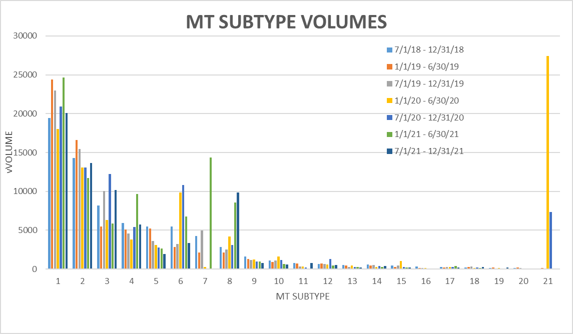

Summary of observations and follow up:

* *IALs* have dropped in last 6 months and are lower than same time last year
* *IAGs* have increased, yet not as much as IALs have dropped
* *SH removals* up significantly ~2x, likely due to hold over of DPPs due to Covid/Winter Storm Uri
* *Other* bucket much higher in all of 2021 likely due to Oncor IDR to AMS profile efforts (~5500-6000 ESIs impacted)
* *997s* are much higher in 2021, ~1.5x – ACTION: review larger data set to determine if isolated to a market participant or time frame signaling an outage or system issue
* *ERCOT Initiated* primarily represent special character issues – good to see these trending downward
* *Safety Net* and *MVO w/Meter Removal*  have both more than doubled over the last 6 months – ACTION: Sheri and Sam will request data points for these subtypes including CR/TDSP/ERCOT/relevant dates

**2021 Accomplishments/2022 Goals**

WG reviewed the attached 2021 Accomplishments and proposed 2022 Goals which will be presented at the next RMS meeting. Most of the goals are “boiler plate” YOY. The two additional goals are around conducting a second IAG analysis utilizing the framework built in 2020, and secondly, reviewing MT SLAs to determine if data supports efficiencies on stated SLAs.



Meeting adjourned around 11:15 AM.

**Next Meeting:**

**DRAFT Agenda**

1. Meeting Minutes
2. ERCOT Update
   1. MarkeTrak Upgrade progress
3. Biannual review of MT subtype volumes – deeper dive
   1. 997s, Safety Nets, MVO w/ Meter Removal
4. Review of monthly IAG numbers
5. Review of last quarter Retail Market Performance Measures report
6. Begin discussion of IAG subtype analysis

Next meeting is scheduled for **Wednesday, February 16th @ 9:30 AM via WebEx**.