NPRR Number | 1092 | NPRR Title | Reduce RUC Offer Floor and Remove RUC Opt-Out Provision
Date |  | February 16, 2022
Submitter’s Information
Name |  | Resmi Surendran
E-mail Address |  | Resmi.surendran@shell.com
Company |  | Shell Energy North America (US), L.P. (Shell Energy)
Phone Number |  | 512-289-7131 / 346-234-0691
Market Segment |  | Independent Power Marketer (IPM)

Comments
Shell Energy appreciates the opportunity to file comments on Nodal Protocol Revision Request (NPRR) 1092. Shell Energy respectfully requests that Technical Advisory Committee (TAC) members, before deciding on the path forward with this NPRR, carefully consider the unintended consequences of the proposed changes. Specifically, it is important to determine the need for the proposed changes in light of the impacts of, and expected Market Participant behavior changes that will result from, the market design changes that have already been directed by Public Utility Commission of Texas (PUCT).
In this filing, Shell Energy shows the following: why the reduction in the Reliability Unit Commitment (RUC) offer floor would have been a possible solution if Operating Reserve Demand Curve (ORDC) changes were not possible, why the reduction in RUC offer floor is not needed to address the incentive problem identified by the Independent Market Monitor (IMM) given the other changes, the unintended consequences resulting from a reduction in RUC offer floor; and, a possible alternative if $1500/MWh is considered a high offer floor for RUC Resources. Shell Energy shows that it is not logical to reduce the RUC offer floor from $1500/MWh to $75/MWh because:
- A $75/MWh offer floor does not reflect commitment cost and the IMM’s recommendation in 2019 concludes the RUC offers should reflect commitment cost. A $75/MWh RUC offer floor will not reflect commitment cost and therefore, won’t signal the need for commitment. Recommendation #7 in the 2019 IMM State of Market report says that the RUC offer floor was set to $1500/MWh to ensure that RUC does not have an inappropriate price-dampening effect on the market. The IMM recommended the RUC offer floor should not be reduced below $1500/MWh by mitigation so that the offer could reflect the commitment cost when ERCOT, and not the Resource Entity, made the commitment decision.
- RUC is not equivalent to Non-Spinning Reserve (Non-Spin). RUC commitments are not equivalent to Non-Spin after ORDC changes because RUC commitments after January 1st are not because Market Participants haven’t self-committed to provide the awarded Ancillary Services or because Market Participants are withholding to set higher prices. Non-Spin is flexible capacity that is procured via a market mechanism to provide reserves, whereas RUC is a commitment of both capacity and energy via an administrative mechanism that is used as a backstop for reliability. A RUC commitment should only be used as a last resort to prevent the system from falling into a local or system-wide emergency event so that out-of-market actions can be taken to reliably serve Load without adversely impacting the market. Hence, the RUC offer floor should not be linked to Non-Spin offer floor as they serve two completely different purposes.
- Increasing supply stack pricing layer at $75 distorts the price signals. A $75/MWh Non-Spin offer floor resulted in all Non-Spin energy offers at nearly $75/MWh which shows how setting a low floor increases the likelihood of all offers being at the floor.
- A $75/MWh offer floor will undercut market-based offers and drive revenue from fast dispatchable units. A $75/MWh RUC offer floor will undercut market-based offers, suppress prices and drive revenue from fast dispatchable units which contradicts the market design changes adopted by PUCT to incentivize dispatchable Resources. Quick-start offers are created based on the same fast-start pricing fundamentals that the Federal Energy Regulatory Commission (FERC) has directed other regional transmission organizations (RTOs) / independent system operators (ISOs) to implement to ensure the prices reflect the need for commitment when they are dispatched and provide cost recovery for meeting the systems reliability needs. Setting the RUC floor below quick start pricing is completely contrary to (1) the directions other markets have taken, (2) the concept of letting the price reflect the system’s reliability needs, and (3) the direction taken by regulators to create incentives for dispatchable Resources.
- A $75/MWh offer floor ignores the emissions limit. A $75/MWh RUC offer floor will cause RUC Resources to be dispatched more frequently to meet Load rather than preserving it to be used last when the system really needs the energy to serve Load. Given the increase in the average age of the RUCed Resources, this frequent dispatching will result in the system using up fuel and emissions limitations; potentially exceeding limits when the system really needs that capacity. Moreover, the current rules don’t contemplate compensating Resources or prices to reflect the lost opportunity of not having the capacity when real scarcity happens. These Resources can’t be expected to increase their Energy Offer Curve (“EOC”) to reflect these costs as they are subjective lost opportunity cost, not marginal, leading to potential claims of market manipulation. Even if the entities increase their EOC, since the current Mitigated Offer Cap (MOC) doesn’t include these costs, the Resource will get dispatched higher and lose money if the Resource gets mitigated. Even if the Resource is not dispatched higher than its Low Sustained Limit (LSL), the emissions limit reduces from LSL operation because it was forced to be On-Line. Not being able to preserve the emission limits to be used under scarcity events could drive down the economics of Resources, pushing these Resources closer to retirement.
- A $75/MWh offer floor will cause energy price suppression causing disincentive to respond to reliability needs: RUCs are out-of-market commitments to maintain reliability. When RUCed Resources are dispatched, the prices should reflect the level of the reliability concern for which the units were committed. A $75/MWh RUC offer floor will suppress the energy prices reflecting scarcity that is forcing ERCOT to rely on out-of-market commitments to maintain reliability. This would impact how price-responsive Demand, import/exports, switchable generators, Off-Line generators etc. respond to those reliability needs. If RUCs happen because ERCOT’s Load forecast is too conservative and Market Participants are not self-committing because they don’t believe the ERCOT Load forecast, then reducing the RUC offer floor and the resulting undercutting of market-based offers further suppresses the market prices and disincentivizes self-commitment. Ultimately, reducing the RUC offer floor changes market behavior in the opposite direction. Market Participants would conclude that if ERCOT over forecasts there will be many RUC commitments, suppressing prices which will reduce the economics for self-commitment, thereby creating the opposite effect of the NPRR intention resulting in ERCOT having to rely even more heavily on RUCing to ensure reliability.
- A $75/MWh offer floor will cause RUCs for congestion to suppress prices. A $75/MWh RUC offer floor will cause RUCs that are committed for resolving congestion to be dispatched for system-level Load resulting in suppression of system level energy prices.
- Setting RUC offer floor to $75/MWh contradicts ERCOT market design which creates price signals to incent operation to enhance reliability. The support for reducing the RUC floor seems to be based on the concept that price suppression caused by the reduction in RUC floor will reduce the impact to consumers from ERCOT’s conservative operation. ERCOT market design is intended to create the correct price signals to incent investment in resources and operation of those Resources in a way that enhances reliability. Reducing this price in the short run could impact the system’s ability to attract dispatchable units and negatively impact the long run Resource adequacy.
- It is not needed to address the incentive problem: Above all, the reduction in the RUC offer floor is not needed to address the incentive problem identified by IMM as it is resolved through other changes. The only scenario where there might be a slight perverse incentive is under conditions where market power exists. ORDC changes; however, have significantly reduced that incentive even under those conditions. In those scenarios, the prices would already be high so that any incentive for an Entity to withhold would be far outweighed t by factors like (1) potential for strict fines for market manipulation, (2) the potential for RUC capacity short charges, (3) the potential to be capacity-short if another Resource in the Entity’s portfolio tripped, and (4) the possibility of losing money if the system condition suddenly changes etc. The past decade of Nodal Market experience has proven that it is very rare that any Entity with market power would ignore the above warnings/other disincentives and purposefully withhold to manipulate the market. Shell Energy doesn’t believe the RUC floor should be reduced to address such a rare scenario and create unintended consequences when the IMM has already warned the market that this scenario is being watched; the main responsibility of the market-monitoring unit is to capture such market manipulation if it happens.
From our analysis, we conclude that a reduction in the RUC offer floor is not needed to address the incentive problem identified by IMM given the other changes. Hence, we recommend against it. However, if the concern is that $1500/MWh is not the appropriate RUC offer floor then we recommend it be set at or above the historic average offer price of Quick Start Generation Resources (QSGRs) to address the issues detailed herein.
Shell Energy respectfully request that TAC members take the time to think through and understand the impacts of the changes that have already been made, the expected market behavior that will result from the implemented changes, the need for the RUC floor reduction to address the incentive problem and the unintended consequences of reduction of RUC offer floor as Shell Energy has detailed herein

Detailed Explanations and Analysis

Why RUC floor reduction proposal was made
Shell Energy understands why IMM initially proposed the solution. Given the need for ERCOT to maintain higher operating reserves and the time needed to evaluate the appropriate ORDC adjustments, the real time prices during the last 6 months of 2021 were not reflective of the reserve levels that ERCOT maintained in real time. This increased the potential for Market Participants to lose money from self-commitment and hence, armed with a buyback option, Market Participants waited until closer to Real-Time to get a better estimate of Real-Time prices to make a determination of whether to self-commit or not. This resulted in the need for ERCOT to RUC Resources to provide the higher operating reserves that ERCOT wanted to maintain. These were genuine RUC commitments because, given the lower ORDC prices, Market Participants needed the RUC “make whole” to cover their start up and minimum Energy costs which is evident from the fact that a majority of the RUC commitments were not bought back as shown in the figure below.

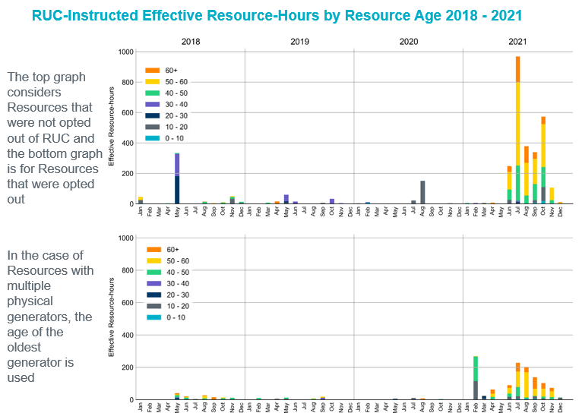

However, this system-wide lack of self-commitment also created the perverse incentive that Entities could withhold further to get RUCed and increase the potential for their RUCed capacity being needed for serving Load and setting the energy price at $1500/MWh which would in turn increase the profit for the rest of their fleet or increase the value of their trades in the bilateral markets. There are many ways to address this perverse incentive while achieving conservative operation without relying on RUCs:
- Increase the price signals to incent self-commitment: Market Participants won’t self-commit if they expect to have a low probability to recover their start-up and minimum energy cost, let alone make any profit. Market signals reflecting reliability needs are key to maintaining an efficient market. Modifying the ORDC in such a way to reflect the need for commitment at the ERCOT expected operating reserve level would incent self-commitment and reduce the need for RUC. Even if one Entity withholds, other Entities would self-commit and fill the need.
- Reduce buyback incentives: Buy back gives Market Participants the ability to wait and make self-commitment decision closer to Real-Time when they have a better estimate of whether unit commitment would be economic. Removing buyback would force Market Participants to take more risk and commit earlier and could potentially reduce RUCs. However, removing buyback would also reduce the flexibility that Market Participants have and could result in over-commitment inefficiencies.
- Reduce RUC floor: If (1) or (2) could not be done then reducing the RUC floor would be an alternative way to reduce the perverse incentive. However, it has unintended consequences as explained in the sections below.
Given the push backs on increasing ORDC and removing buybacks, Shell Energy understands why the IMM opted to propose reducing the RUC floor as a way to address the perverse incentive when they summitted the NPRR last summer.

Why RUC floor reduction proposal is not needed now
With PUCT-directed changes to ORDC, the Real-Time price now reflects the need for commitment to meet expected load forecast plus 6500MW reserve level. Under normal system conditions, with that pricing incentive, an Entity that tries to withhold their capacity in hopes of getting a RUC, will not be successful in getting their unit RUCed or in getting their RUCed Resources to set $1500/MWh price. This is because other Entities will self-commit based on the expected price and thereby meeting the system capacity needs and negating the need for further RUCing or the need for dispatching RUCed Resources. Under tight system conditions, the prices would already be high that any incentive for an Entity to withhold would be far outweighed by factors like (1) the possibility of losing money if the system condition suddenly changes, (2) the potential for RUC capacity short charges, (3) the potential to be capacity short if their other Resource tripped, or (4) the potential for being fined for market manipulation etc. If the intent of the change is to incent Market Participants to make the self-commitment decision earlier then that incentive could be created by removing buybacks. Reducing the RUC offer floor will not incent earlier self-commitment. Instead, it will have the incentive to further reduce self-commitment due to the price suppression caused by undercutting market-based offers.

Why RUCs in January won’t be addressed by reducing RUC offer floors
Even though PUCT-directed changes to ORDC would get the Real-Time prices to reflect the need for commitment, it will not prevent RUCs under all scenarios. RUCs will be there for the following reasons, which won’t be avoidable by reducing the RUC offer floor:
- Thermal or voltage constraints: ERCOT maintaining higher reserves or ORDC changes have not changed the incentive for self-commitment for expected thermal or voltage constraints. Hence, we should expect the RUCs for thermal/voltage constraints to be similar to how it was before the conservative operations began.
- RUC for capacity due to ERCOT forecasted load being much higher than Load level expected by Market Participants: It is understandable for ERCOT to use conservative forecasts. But self-commitment by Market Participants are based on their expected market economics which are based on the Load forecast that they expect to be reasonable. Hence, if ERCOT load forecast is much higher than what is expected by Market Participants then ERCOT will have to RUC as market-based self-commitments will only maintain the reserves under the load level that Market Participants expect. RUCs during January 2nd and 3rd seem to fall under this scenario.
- Unexpected scarcity causing ERCOT to be over conservative for future hours: When demand/wind/solar deviates in Real-Time unexpectedly from the forecast, it is understandable for ERCOT to take precautionary measures and RUC for future hours. But self-commitment by Market Participants would not reflect that conservatism as it would be based on their expected market economics. RUCs during January 6th and 7th seems to fall under this scenario.
- Few hours of near scarcity in the middle of otherwise very mild weekend: Since fuel purchase for weekends are done as a block, it might become uneconomic to buy gas for the whole weekend package, which includes Monday, and self-commit to cover for a few hours as they would lose money for the rest of the weekend. ERCOT might have to RUC under that situation to cover commitment cost for Resources. RUCs during January 16th seem to fall under this scenario.
- Resources having fuel issues making it uneconomic to run under expected Real-Time prices: The RUC commits after January 16th seem to be all for units of a single Entity that is having fuel issues.
Reducing RUC offer floor will not reduce any of the above listed types of RUCs as none of the above are caused by an incentive to potentially receive $1500/MWh. Instead, reduction in RUC offer floor further reduces incentive for generators to self-commitment and Loads to respond to prices because a RUC offer floor at $75/MWh will not reflect commitment costs and will cause price suppression by undercutting market-based offers.

Issues with reducing RUC offer floor from $1500/MWh to $75/MWh
There are many unintended consequences with reducing RUC offer floor to $75/MWh.
- The RUC offer floor will no longer reflect commitment cost and the IMM’s recommendation in 2019 concludes the RUC offers should reflect commitment cost. A $75/MWh RUC offer floor will not reflect commitment cost. Recommendation #7 in IMM’s 2019 State of Market report states that the $1500/MWh was set to ensure that it does not have an inappropriate price-dampening effect on the market. It also states that RUC offer mitigation results in offers that do not reflect the commitment cost and therefore, commitment costs (startup and no-load) should be factored into the mitigated offer - specifically in cases where ERCOT, and not the Resource Entity, has made the commitment decision. Currently system-wide energy prices are based on a $1500/MWh RUC offer. The IMM recommendation was not to reduce the mitigated offer for RUCs so that congestion prices will also be based on a RUC offer which includes commitment cost. A $75/MWh RUC floor not only doesn’t reflect the commitment cost in congestion pricing, but it also doesn’t reflect the commitment cost in system-wide energy pricing. Hence, RUC floor reduction works contrary to sending the price signal reflecting the need to incent self-commitment.
“Price formation when RUC Resources are mitigated. When a resource is committed via an ERCOT RUC instruction, its offer is set to a minimum of $1,500 per MWh to ensure that it does not have an inappropriate price-dampening effect on the market. However, should the resource be mitigated, its offer can be lowered significantly below $1,500 per MWh, down to its short run marginal costs. While the short run marginal costs are appropriate mitigated offers for resources for which the owner makes the commitment decision, the commitment costs (startup and no-load) should be factored into the mitigated offer specifically in cases where ERCOT has made the commitment decision.“
- RUC offer will undercut market-based offers and drive revenue from fast dispatchable units: A $75/MWh RUC offer floor will undercut market-based offers and suppress prices; driving revenue from fast dispatchable units which contradicts the market design changes adopted by PUCT to incentivize dispatchable Resources. Quick start offers are created based on the same fast start pricing fundamentals that FERC has directed other RTO/ISOs to implement to ensure that when those resources are dispatched the prices reflect the need for commitment and associated cost recovery for providing that energy fast to meet system reliability needs. Setting the RUC floor below quick start pricing is completely contrary to (1) the directions other markets have taken, (2) the concept of letting the price reflect the system reliability needs, and (3) the direction taken by regulators to create incentives for dispatchable Resources.
- Wasted emissions limit: A $75/MWh RUC offer floor will cause RUC Resources to be dispatched more frequently to meet Load and will not preserve the energy to be used last when the system really needs it to serve Load. Given the increase in the average age of the RUCed Resources as shown in figure below, this frequent dispatching of RUCed older units will result in the system exhausting fuel and emissions limits of these units so they are unavailable when the system really needs that capacity. Moreover, the current rules don’t contemplate compensating Resources (or energy prices to reflect) for the lost opportunity of not having the capacity when real scarcity happens. These Resources can’t be expected to increase their EOC to reflect these costs as they are subjective lost opportunity costs, not marginal cost, and could be questioned as market manipulation. Even if the Entities increase their EOC, since the current MOC doesn’t include these costs, if the Resource gets mitigated, it will get dispatched higher and will lose money. Even if the Resource is not dispatched higher than LSL, the emissions limit reduces from LSL operation because it was forced to be On-Line. Not being able to preserve the emission limits to be used under a scarcity event could drive down the economics of Resources, pushing these Resources closer to retirement.
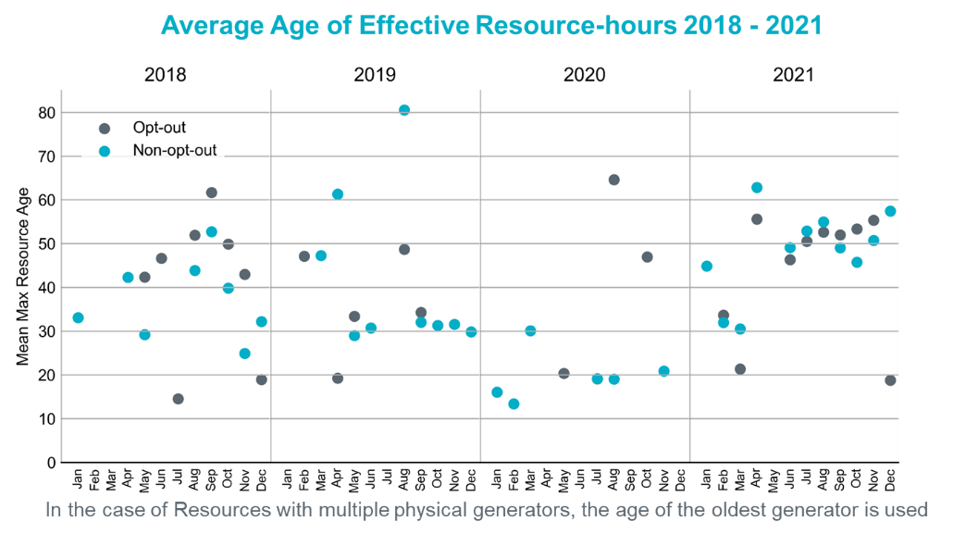
- Energy price suppression causes disincentive to respond to reliability needs: RUCs are out-of-market commitments to maintain reliability. Hence, when RUCed Resources are dispatched, the prices should reflect the level of the reliability concern for which the units were committed. A $75/MWh RUC offer floor suppresses the energy price from reflecting the scarcity that is forcing ERCOT to rely on out of market commitments to maintain reliability. This would impact how price-responsive Demand, import/exports, switchable generators, Off-Line generators etc. respond to those reliability needs. If RUCs happen because ERCOT’s Load forecast is too conservative and Market Participants are not self-committing, then reducing the RUC offer floor and an associated undercutting of market-based offers would further suppress the market prices and further disincentivize self-commitment. Reducing the RUC offer floor changes market behavior in the opposite direction. Market Participants would conclude that if ERCOT over forecasts there will be many RUC commitments suppressing prices which reduces the economics to incent self-commitment, creating the opposite effect of the NPRR intention, ultimately resulting in ERCOT having to rely further on RUCing to ensure reliability.
- Price suppression by RUCs for congestion: A $75/MWh RUC offer floor will cause RUCs that are committed for resolving congestion to be dispatched for system-level Load resulting in suppression of system level energy prices.
- It increases supply stack pricing layer at $75 distorting the price signals. A $75/MWh Non-Spin offer floor resulted in all Non-Spin energy offers at nearly $75/MWh which shows how setting a low floor increases the likelihood of all offers being at the floor.
Alternative solutions
If the self-commitments are not enough to maintain reserves, that implies that price signals are not high enough to make self-commitments economical. If that is the case, then ORDC needs to be increased further. As shown above, RUC commitments after January 1st are not a result of Market Participants not self-committing to maintain expected load plus 6500MW reserves or because Market Participants are withholding to set higher prices. Therefore, the reduction in RUC offer floor is not needed to address the incentive problem identified by IMM given the other changes.
However, if the concern is that the $1500/MWh is too high to set prices to reflect the reliability concern that necessitated the out-of-market RUC commitment, then Shell Energy recommends the following alternatives to reducing RUC offer floor:
- Programmatically set RUC offers behind all market-based offers; and
- If system changes need to be avoided, set the RUC offer floor at a level that reflects commitment cost and puts it behind most market-based offers. It could be achieved by putting the RUC floor slightly above the expected/historic average offer price of QSGRs.

Revised Cover Page Language
None
Revised Proposed Protocol Language
None

Slide 8 of TAC Item 15 - 2021 Annual Review of the Market Impacts of RUCs - 020722 update
Slide 7 of TAC Item 15 - 2021 Annual Review of the Market Impacts of RUCs - 020722 update

