December 2021 ERCOT Monthly Operations Report
Reliability and Operations Subcommittee Meeting
February 3, 2022

Table of Contents
1. Report Highlights 2
2. Frequency Control 3
2.1. Frequency Events 3
2.2. Responsive Reserve Events 4
2.3. Load Resource Events 4
3. Reliability Unit Commitment 4
4. IRR, Wind, and Solar Generation as a Percent of Load 5
5. Largest Net-Load Ramps 6
6. COP Error Analysis 7
7. Congestion Analysis 9
7.1. Notable Constraints 9
7.2. Generic Transmission Constraint Congestion 12
7.3. Manual Overrides 12
7.4. Congestion Costs for Calendar Year 2021 12
8. System Events 14
8.1. ERCOT Peak Load 14
8.2. Load Shed Events 14
8.3. Stability Events 14
8.4. Notable PMU Events 14
8.5. DC Tie Curtailment 14
8.6. TRE/DOE Reportable Events 14
8.7. New/Updated Constraint Management Plans 14
8.8. New/Modified/Removed RAS 15
8.9. New Procedures/Forms/Operating Bulletins 15
9. Emergency Conditions 15
9.1. OCNs 15
9.2. Advisories 15
9.3. Watches 15
9.4. Emergency Notices 16
10. Application Performance 16
10.1. TSAT/VSAT Performance Issues 16
10.2. Communication Issues 16
10.3. Market System Issues 16
11. Model Updates 16
Appendix A: Real-Time Constraints 19

Report Highlights
- The unofficial ERCOT peak load was 49,179 MW.
- There was 1 frequency event.
- There were 3 instances where Responsive Reserves were deployed.
- There were 10 HRUC commitments.
- There were 17 days of congestion on the West Texas Export GTC, 23 days on the Panhandle GTC, 24 days on the North Edinburg to Lobo GTC, 6 days on the Valley Export GTC, 23 days on the Raymondville to Rio Hondo, 20 days on the Nelson Sharpe to Rio Hondo GTC, 11 days on the North to Houston GTC, and 6 day on the East Texas GTC. There was no activity on the remaining GTCs during the month.
- There was 1 DC Tie Curtailment.
- The Current Wind Generation Record was set to 24,681 MW on 12/23/2021 at 20:53.

Frequency Control

Frequency Events

The ERCOT Interconnection experienced 1 frequency event, which resulted from unit’s trips. The average event duration was 00:01:43.

A summary of the frequency events is provided below. The reported frequency events meet one of the following criteria: Delta Frequency is 60 mHz or greater; the MW loss is 350 MW or greater; resource trip event triggered RRS deployment. Frequency events that have been identified as Frequency Measurable Events (FME) for purposes of BAL-001-TRE-1 analysis are highlighted in blue. When analyzing frequency events, ERCOT evaluates PMU data according to industry standards. Events with an oscillating frequency of less than 1 Hz are inter-area, while higher frequencies indicate local events. Industry standards specify that damping ratio for inter-area oscillations should be 3.0% or greater. For the frequency events listed below, the ERCOT system met these standards and transitioned well after each disturbance.

Date and Time | Delta Frequency | Max/Min Frequency | Duration of Event | PMU Data |  | MW Loss | Load | IRR | Inertia
 | (Hz) | (Hz) |  | Oscillation Mode (Hz) | Damping Ratio |  | (MW) | % | (GW-s)
12/30/2021 6:57:16 | 0.095 | 59.911 | 00:01:43 | .64 | 10% | 371.93 | 37,036 | 23% | 213,704
(Note: All data on this graph encompasses frequency event analysis based on BAL-001-TRE-1.)

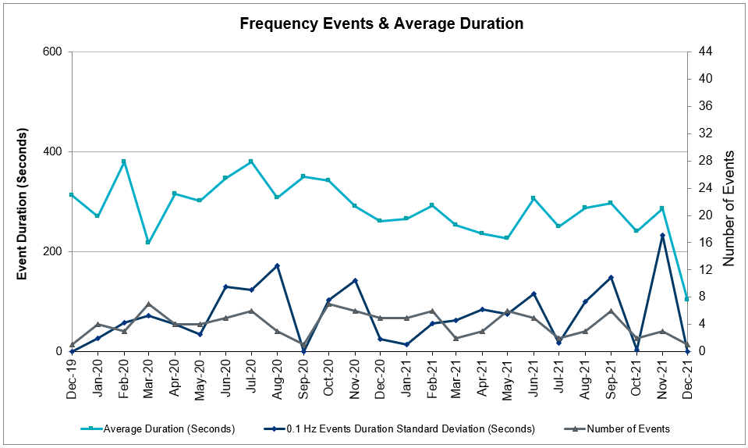

Responsive Reserve Events

There were 3 events where Responsive Reserve MWs were released to SCED. The events highlighted in blue were related to frequency events reported in Section 2.1 above.

Date and Time Released to SCED | Date and Time Recalled | Duration of Event | Maximum MWs Released | Comments
12/23/2021 9:33:24 | 12/23/2021 9:37:40 | 00:04:16 | 823
12/27/2021 9:57:32 | 12/27/2021 10:00:28 | 00:02:44 | 653
12/30/2021 12:41:40 | 12/30/2021 12:44:20 | 00:03:00 | 635

Load Resource Events
NONE.

Reliability Unit Commitment

ERCOT reports on Reliability Unit Commitments (RUC) on a monthly basis. Commitments are reported grouped by operating day and weather zone. The total number of hours committed is the sum of the hours for all the units in the specified region. Additional information on RUC commitments can be found on the MIS secure site at Grid Generation Reliability Unit Commitment.

There were no DRUC commitments.

There were 10 HRUC commitments

Resource Location | # of Resources | Operating Day | Total # of Hours Committed | Total MWhs | Reason for Commitment
EAST, NORTH_CENTRAL | 2 | December 1, 2021 | 4 | 950.0 | Capacity
EAST, NORTH_CENTRAL | 2 | December 3, 2021 | 4 | 1,386.0 | Capacity
EAST, NORTH_CENTRAL | 3 | December 4, 2021 | 6 | 1,740.0 | Capacity
EAST | 1 | December 8, 2021 | 3 | 708.0 | Capacity
COAST | 2 | December 15, 2021 | 12 | 2,028.0 | SSTPESP8

IRR, Wind, and Solar Generation as a Percent of Load
Graph below shows the maximum, minimum and average aggregate solar, wind and IRR output as a percentage of total ERCOT load when evaluated as 10-minute averaged intervals, over the past 13 months. Current wind, solar generation and penetration records are listed in the footnote below. Maximum IRR penetration for the month was 64.4% on December 24, 2021 interval ending 00:10 and minimum IRR penetration for the month was 2.6% on December 01, 2021 interval ending 17:30.

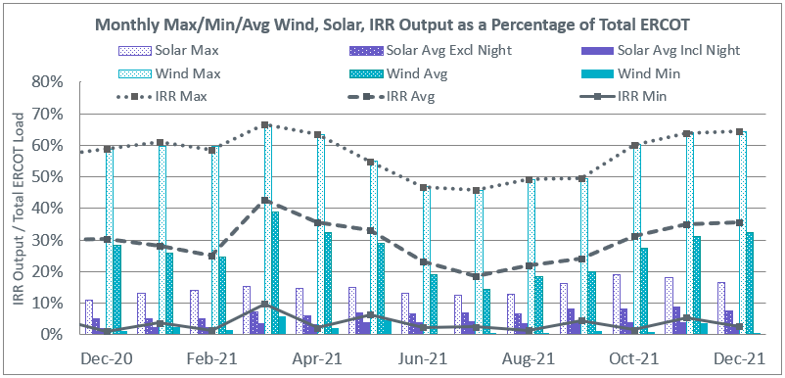

During the hour of peak load for the month, hourly integrated wind generation was 20,363 MW and solar generation was 198 MW. Graph below shows the wind and solar penetration percentage during the hour of the peak load in the last 13 months.

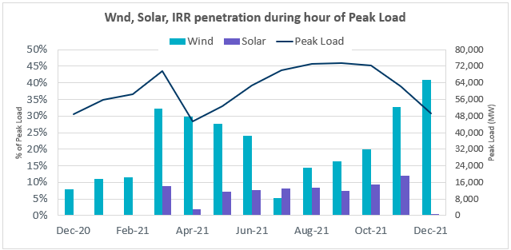

Lastly, the graph below shows the minimum wind, solar and IRR output during the peak load hour as a percentage of the daily peak load for every day in the month.
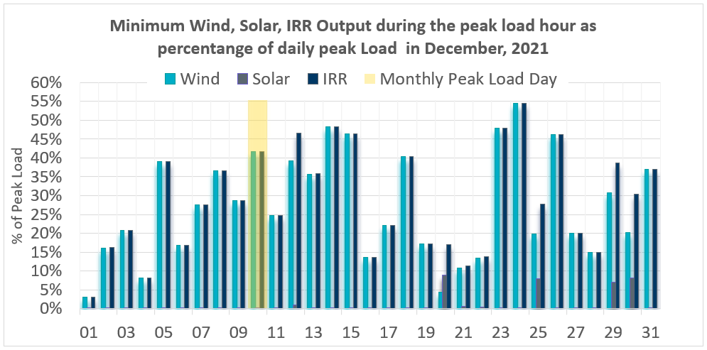

Largest Net-Load Ramps
The net-load ramp is defined as the change in net-load (load minus wind and PVGR generation) during the defined time horizon. Such a variation in net-load needs to be accommodated in grid operations to ensure that the reliability of the grid is satisfactorily maintained. The largest net-load ramp during 5-min, 10-min, 15-min, 30-min and 60-min in December 2021 are 933 MW, 1518 MW, 2154 MW, 4103 MW, and 7128 MW, respectively. The comparison with respect to the historical values is given in the table below.

Month and Year | 5 min | 10 min | 15 min | 30 min | 60 min
December 2021 | 933 MW | 1518 MW | 2154 MW | 4103 MW | 7128 MW
December 2020 | 1083 MW | 1780 MW | 2479 MW | 5882 MW | 10364 MW
December 2014 | 1014 MW | 1689 MW | 2112 MW | 3034 MW | 5296 MW
December 2015 | 962 MW | 1637 MW | 1995 MW | 3241 MW | 5516 MW
December 2016 | 857 MW | 1404 MW | 1827 MW | 3166 MW | 5866 MW
December 2017 | 964 MW | 1581 MW | 2078 MW | 3393 MW | 5708 MW
December 2018 | 923 MW | 1553 MW | 2148 MW | 4109 MW | 7218 MW
December 2019 | 1014 MW | 1689 MW | 2112 MW | 3034 MW | 5296 MW
All Months in 2014-2019 | 1494 MW | 1991 MW | 2780 MW | 4109 MW | 7786 MW

COP Error Analysis
COP Error is calculated as the capacity difference between the COP HSL and real-time HSL of the unit. Mean Absolute Error (MAE) stayed over 8,230 MW until Day-Ahead at 12:00, then dropped significantly to 967 MW by Day-Ahead at 14:00. In the following chart, Under-Scheduling Error indicates that COP had less generation capacity than real-time and Over-Scheduling Error indicates that COP had more generation capacity than real-time.

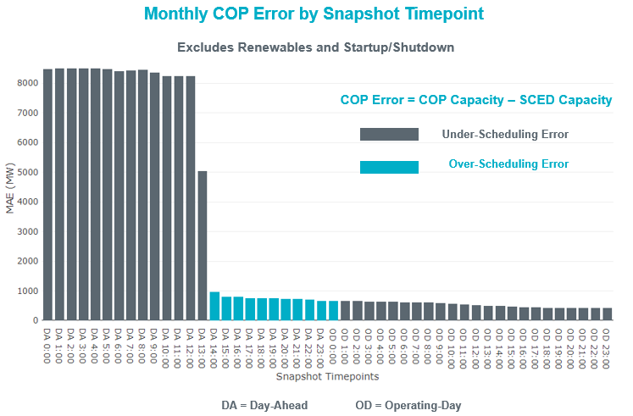
Monthly MAE for the Latest COP at the end of the Adjustment Period was 426 MW with median ranging from -452.7 MW for Hour-Ending (HE) 24 to 206 MW for HE 12. HE 13 on the 17th had the largest Over-Scheduling Error (2,258 MW) and HE 24 on the 24th had the largest Under-Scheduling Error (-2,517 MW).

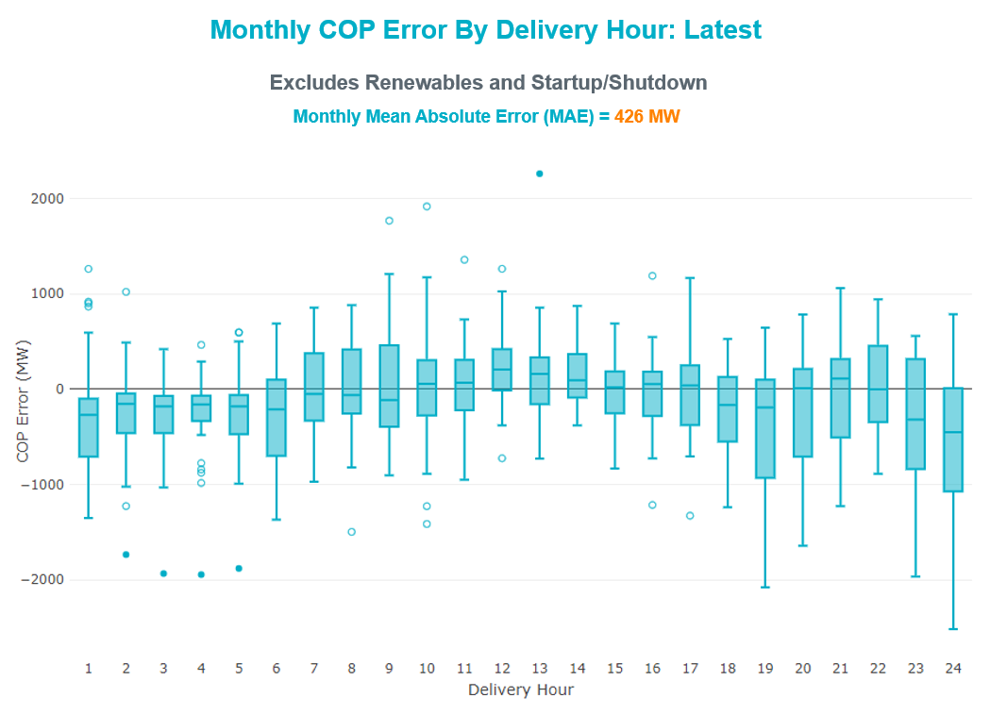

Monthly MAE for the Day-Ahead COP at 12:00 was 8,603 MW with median ranging from 206 MW for Hour-Ending (HE) 12 to -452.7 MW for HE 24. HE 24 on the 25th had the largest Under-Scheduling Error (-25,17 MW) and HE 13 on the 17th had the largest Over-Scheduling Error (2,258 MW).
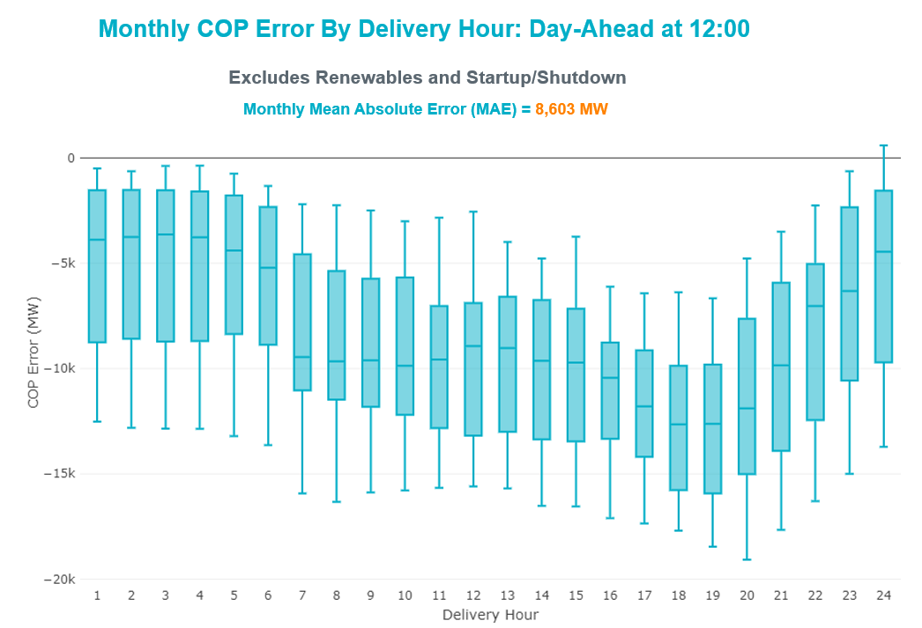

Congestion Analysis

Notable Constraints
Nodal protocol section 3.20 specifies that ERCOT shall identify transmission constraints that are binding in Real-Time three or more Operating Days within a calendar month. As part of this process, ERCOT reports congestion that meets this criterion to ROS. In addition, ERCOT also highlights notable constraints that have an estimated congestion rent exceeding $1,000 for a calendar month. These constraints are detailed in the table below, including approved transmission upgrades from TPIT that may provide some congestion relief based on ERCOT’s engineering judgement. Rows highlighted in blue indicate the congestion was affected by one or more outages. For a list of all constraints activated in SCED, please see Appendix A at the end of this report.

Contingency Name | Overloaded Element | # of Days Constraint Binding | Congestion Rent | Transmission Project
DCPSJON5 | Everman Switch - Carmichael Bend Switch 345kV | 7 | $13,348,033.17
BASE CASE | NE_LOB GTC | 23 | $10,906,469.97 | The Lower Rio Grande Valley (LRGV) System Enhancement Project (21RPG017) will improve but not eliminate the need for this GTC.
DCRLLSW5 | South Tnp - Carrollton Northwest 138kV | 6 | $10,091,918.65 | Carrollton Northwest 345/138-kV Autotransformer (57758)
BASE CASE | WESTEX GTC | 11 | $7,971,096.40
BASE CASE | PNHNDL GTC | 12 | $6,051,755.19
MHARNED5 | Haine Drive - La Palma 138kV | 9 | $5,738,330.91
DCRLLSW5 | Ti Tnp - South Tnp 138kV | 5 | $5,724,371.82 | Ti Tnp - South Tnp Rebuild (60530)
DSTPRED5 | Hillje - South Texas Project 345kV | 10 | $5,462,771.80
SMDOPHR5 | Magnolia Tnp - Seminole Tnp 138kV | 17 | $4,274,208.16 | Rebuild Magnolia - Seminole 138 kV Line (4010)
SSTPESP8 | Blessing - Pavlov 138kV | 2 | $3,960,188.93 | Blessing to Bay City Pumps: Rebuild 69 kV Line (52066)
SLOBSA25 | North Laredo Switch - Piloncillo 138kV | 10 | $3,246,812.84
DHCKDEN8 | Mistletoe Heights - Hemphill 138kV | 1 | $3,015,007.81
MHARNED5 | Burns Sub - Rio Hondo 138kV | 8 | $2,661,360.49
DLWSRNK5 | Argyle - Highlands Tnp 138kV | 5 | $2,616,017.71
SLKPCRL8 | South Tnp - Carrollton Northwest 138kV | 2 | $1,976,277.01 | Carrollton Northwest 345/138-kV Autotransformer (57758)
DCAGCI58 | Bergheim - Kendall 345kV | 6 | $1,920,076.56
DEVRWDG8 | Mistletoe Heights - Hemphill 138kV | 2 | $1,412,846.98
BASE CASE | Omega - Horse Hollow Generation Tie 345kV | 12 | $1,406,101.65
DMGSBTR5 | Tonkawa Switch - Morgan Creek Ses 345kV | 2 | $1,330,977.16
SLOBSA25 | Bruni Sub 138kV | 7 | $1,294,514.14
SBWDDBM5 | Mackenzie Substation - Northeast Substation 115kV | 4 | $1,137,980.41
BASE CASE | N_TO_H GTC | 4 | $1,106,395.83
BASE CASE | NELRIO GTC | 18 | $888,736.89 | The Lower Rio Grande Valley (LRGV) System Enhancement Project (21RPG017) will improve but not eliminate the need for this GTC.
DWAP_JN5 | Bellaire - Wa Parish 345kV | 3 | $647,001.91 | Bellaire to Wa Parrish Upgrade (64493)
SN_SAJO5 | Haine Drive - La Palma 138kV | 3 | $632,620.08
SBRAUVA8 | Hamilton Road - Maverick 138kV | 14 | $612,185.19 | Brackettville to Escondido: Construct 138 kV line (5206)
SKLELOY8 | Loyola Sub 138kV | 7 | $594,704.23
BASE CASE | EASTEX GTC | 5 | $573,299.19
SLAMNAR8 | Coronado 138kV | 8 | $395,463.24
SLOBSA25 | Asherton - Catarina 138kV | 6 | $359,777.96
DSALHUT5 | Sandow Switch - Austrop 345kV | 3 | $249,125.85
SDUKNED8 | Aderhold Sub - Elsa 138kV | 7 | $150,910.64
SVICCO28 | Coleto Creek - Victoria 138kV | 4 | $105,933.79
SBRAUVA8 | Escondido - Ganso 138kV | 4 | $64,907.95 | Escondido - Ganso 138 kV Line Rebuild (55624)
SEBALAM8 | Coronado 138kV | 3 | $61,022.62
BASE CASE | VALEXP GTC | 6 | $56,074.53 | The Lower Rio Grande Valley (LRGV) System Enhancement Project (21RPG017) will improve but not eliminate the need for this GTC.
SZENTH35 | Th Wharton - Zenith 345kV | 3 | $51,285.76
SLAQLOB8 | Bruni Sub 138kV | 6 | $42,808.09
SBRAHAM8 | Hamilton Road - Maverick 138kV | 3 | $33,110.82 | Brackettville to Escondido: Construct 138 kV line (5206)
BASE CASE | RV_RH GTC | 3 | $9,209.47

Generic Transmission Constraint Congestion
There were 17 days of congestion on the West Texas Export GTC, 23 days on the Panhandle GTC, 24 days on the North Edinburg to Lobo GTC, 6 days on the Valley Export GTC, 23 days on the Raymondville to Rio Hondo, 20 days on the Nelson Sharpe to Rio Hondo GTC, 11 days on the North to Houston GTC, and 6 day on the East Texas GTC. There was no activity on the remaining GTCs during the month.

Note: This is how many times a constraint has been activated to avoid exceeding a GTC limit, it does not imply an exceedance of the GTC occurred or that the GTC was binding.

Manual Overrides
None

Congestion Costs for Calendar Year 2021
The following table represents the top twenty active constraints for the calendar year based on the estimated congestion rent attributed to the congestion. ERCOT updates this list on a monthly basis.

Contingency | Overloaded Element | # of 5-min SCED | Estimated | Transmission Project
Basecase | PNHNDL GTC | 30925 | $122,891,208.51
Basecase | WESTEX GTC | 17387 | $103,997,706.28
Elmcreek-Sanmigl 345kV | Pawnee Switching Station - Calaveras 345kV | 2558 | $76,324,705.77
Basecase | NE_LOB GTC | 30515 | $74,399,522.79 | The Lower Rio Grande Valley (LRGV) System Enhancement Project (21RPG017) will improve but not eliminate the need for this GTC.
Manual dbl ckt for NEDIN-BONILLA 345kV & RIOH-PRIM138kV | Haine Drive - La Palma 138kV | 15396 | $68,228,904.51
LOST PINES AEN to FAYETTE PLANT 1 LIN 1 | Winchester - Fayette Plant 1 And 2 345kV | 415 | $51,438,867.64
JOHNSON SWITCH (ONCOR) to CONCORD LIN G1 | Decordova Dam - Carmichael Bend Switch 138kV | 726 | $46,614,977.07
TWR(345) JCK-REF27 & JCK-STP18 | Oasis - Dow Chemical 345kV | 524 | $46,495,190.60
Basecase | N_TO_H GTC | 3631 | $39,704,273.24
TWR(345) JCK-REF27 & JCK-STP18 | South Texas Project - Wa Parish 345kV | 1909 | $35,934,198.14
HCKSW TO DENSW 138 DBLCKT | #N/A | 5354 | $32,160,180.36
Hicross-Pilot & Garfield 138kV | Carson Creek - Pilot Knob 138kV | 803 | $30,600,531.85
MIDLAND EAST TRX MDLNE_3_1 345/138 | Tall City - Telephone Road 138kV | 5502 | $28,105,961.70 | The Tall City - Telephone Road 138 kV Line Rebuild (57915) has been listed in previous report but has since been upgraded.
TWR(345) JCK-REF27 & JCK-STP18 | Blessing - Pavlov 138kV | 6326 | $27,362,865.91 | Blessing to Bay City Pumps: Rebuild 69 kV Line (52066)
Basecase | Colorado Bend Energy Center - Dyann 138kV | 242 | $26,093,025.30
CRLNW TO LWSSW 345 DBLCKT | West Tnp - Highlands Tnp 138kV | 8701 | $23,171,860.68
CONCORD TRX CRD1 345/138 | Concord 345kV | 840 | $21,139,669.60
ODLAW SWITCHYARD to ASPHALT MINES LIN 1 | Hamilton Road - Maverick 138kV | 21431 | $20,819,758.87 | Brackettville to Escondido: Construct 138 kV line (5206)
Lostpi-Austro&Dunlap 345kV | Sim Gideon - Winchester 138kV | 779 | $20,596,822.07 | Sim Gideon - Tahitian Village Transmission Line Storm Hardening (61438), Bastrop West - Split Transmission Line Storm Hardening (61436)
Lytton_S-Slaughte&Turner 138kV | Mccarty Lane - Zorn 138kV | 245 | $20,185,815.81

System Events

ERCOT Peak Load
The unofficial ERCOT peak load for the month was 49,179 MW and occurred on the 10th, during hour ending 16:00.

Load Shed Events
None.

Stability Events
None.

Notable PMU Events
ERCOT analyzes PMU data for any significant system disturbances that do not fall into the Frequency Events category reported in section 2.1. The results are summarized in this section once the analysis has been completed.

There were no PMU events outside of those reported in section 2.1.

DC Tie Curtailment
Date | DC Tie | Curtailing Period | # of Tags Curtailed | Initiating Event | Curtailment Reason
12/3/2021 | DC-R | HE 17 – HE 18 | 2 | Unplanned Outage | Planned or Unplanned Outage

TRE/DOE Reportable Events
- Oncor submitted an OE-417 and EOP-004 for 12/02/2021. Reportable Event Type: Complete loss of monitoring or control capability.
- BPUB submitted an OE-417 for 12/19/2021. Reportable Event Type: Suspicious activity to its facility.
- AEP submitted an OE-417 for 12/21/2021. Reportable Event Type: Unexpected transmission loss.
- Oncor submitted an OE-417 and EOP-004 for 12/24/2021. Reportable Event Type: Unexpected transmission loss.

New/Updated Constraint Management Plans
None.

New/Modified/Removed RAS
None.

New Procedures/Forms/Operating Bulletins

Date | Subject | Bulletin No.
12/16/2021 | Scripts V1 Rev 39 | 1012
12/16/2021 | Shift Supervisor Desk V1 Rev 75 | 1013
12/16/2021 | Transmission and Security Desk V1 Rev 90 | 1014
12/30/2021 | DC Tie Desk V1 Rev 68 | 1015
12/30/2021 | Real Time Desk V1 Rev 78 | 1016
12/30/2021 | Reliability Risk Desk Operating Procedure V1 Rev 25 | 1017
12/30/2021 | Reliability Unit Commitment Desk V1 Rev 66 | 1018
12/30/2021 | Resource Desk Operating Procedure V1 Rev 67 | 1019
12/30/2021 | Scripts V1 Rev 40 | 1020
12/30/2021 | Shift Supervisor Desk V1 Rev 76 | 1021
12/30/2021 | Transmission and Security Desk V1 Rev 91 | 1022

Emergency Conditions

OCNs
None.

Advisories
None.

Watches
None.

Emergency Notices
None.

Application Performance

TSAT/VSAT Performance Issues
None.

Communication Issues
None.

Market System Issues
None.

Model Updates
The Downstream Production Change (DPC) process allows ERCOT to make changes in the on-line Network Operations Model without loading a completely new model. The purpose of this process is to allow for reliable grid operations as system conditions change between designated Network Operations Model database loads. The DPC process is limited in scope to just those items listed below, with equipment ratings updates being the most common. ERCOT has seen a rise in the use of the DPC process to make on-line updates to the Network Operations Model in recent years, instead of through the standard Network Operations Model Change Request process.

- Static Line ratings (Interim Update)
- Dynamic Line ratings (non-Interim Update)
- Autotransformer ratings (non-Interim Update)
- Breaker and Switch Normal status (Interim Update)
- Contingency Definitions (Interim Update)
- RAP and RAS changes or additions (Interim Update)
- Net Dependable and Reactive Capability (NDCRC) values (Interim Update)
- Impedance Updates (non-Interim)

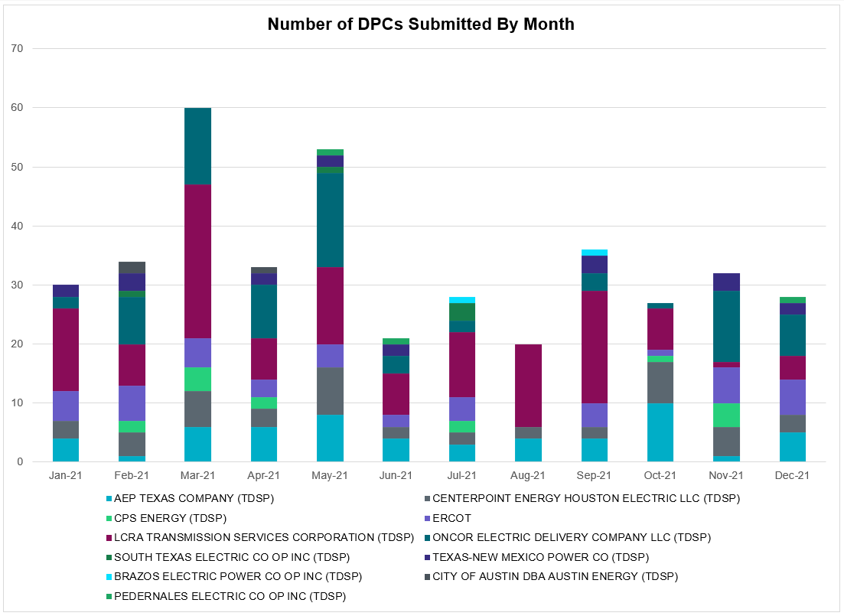

Transmission Operator | Number of DPCs
AEP TEXAS COMPANY (TDSP) | 5
BRAZOS ELECTRIC POWER CO OP INC (TDSP) | 0
BROWNSVILLE PUBLIC UTILITIES BOARD (TDSP) | 0
BRYAN TEXAS UTILITIES (TDSP) | 0
CENTERPOINT ENERGY HOUSTON ELECTRIC LLC (TDSP) | 3
CITY OF AUSTIN DBA AUSTIN ENERGY (TDSP) | 0
CITY OF COLLEGE STATION (TDSP) | 0
CITY OF GARLAND (TDSP) | 0
CPS ENERGY (TDSP) | 0
DENTON MUNICIPAL ELECTRIC (TDSP) | 0
ELECTRIC TRANSMISSION TEXAS LLC (TDSP) | 0
ERCOT | 6
LCRA TRANSMISSION SERVICES CORPORATION (TDSP) | 4
LONE STAR TRANSMISSION LLC (TSP) | 0
ONCOR ELECTRIC DELIVERY COMPANY LLC (TDSP) | 7
PEDERNALES ELECTRIC CO OP INC (TDSP) | 1
RAYBURN COUNTRY CO OP DBA RAYBURN ELECTRIC (TDSP) | 0
SHARYLAND UTILITIES LP (TDSP) | 0
SOUTH TEXAS ELECTRIC CO OP INC (TDSP) | 0
TEXAS MUNICIPAL POWER AGENCY (TDSP) | 0
TEXAS-NEW MEXICO POWER CO (TDSP) | 2

Appendix A: Real-Time Constraints
The following is a complete list of constraints activated in SCED. Full contingency descriptions can be found in the Standard Contingencies List located on the MIS secure site at Grid Generation Reliability Unit Commitment.

Contingency Name | Overloaded Element | From Station | To Station | Count of Days
BASE CASE | NE_LOB | n/a | n/a | 24
BASE CASE | RV_RH | n/a | n/a | 23
BASE CASE | PNHNDL | n/a | n/a | 23
BASE CASE | LGD_SANTIA1_1 | LGD | SANTIAGO | 23
SMDOPHR5 | G138_10B_1 | SEMINOLE | MAGNO_TN | 21
BASE CASE | NELRIO | n/a | n/a | 20
BASE CASE | WESTEX | n/a | n/a | 17
SBRAUVA8 | HAMILT_MAVERI1_1 | HAMILTON | MAVERICK | 17
SLOBSA25 | NLARSW_PILONC1_1 | NLARSW | PILONCIL | 14
SLOBSA25 | NLARSW_PILONC1_1 | PILONCIL | NLARSW | 14
BASE CASE | HHGTOM_1 | HHGT | OMEGA | 12
DSTPRED5 | CKT_3124_1 | STP | HLJ | 12
BASE CASE | N_TO_H | n/a | n/a | 11
DBIGKEN5 | HAMILT_MAXWEL1_1 | MAXWELL | HAMILTON | 11
MHARNED5 | BURNS_RIOHONDO_1 | RIOHONDO | MV_BURNS | 11
SDUKNED8 | ADERHO_ELSA1_1 | ADERHOLD | ELSA | 10
SMV_RI28 | SCARBI_STILLM1_1 | SCARBIDE | STILLMAN | 10
SBRAUVA8 | ESCOND_GANSO1_1 | GANSO | ESCONDID | 10
MHARNED5 | HAINE__LA_PAL1_1 | LA_PALMA | HAINE_DR | 10
SDUKNED8 | ADERHO_ELSA1_1 | ELSA | ADERHOLD | 10
SLAQLOB8 | BRUNI_69_1 | BRUNI | BRUNI | 10
DCPSJON5 | 161__B | CMBSW | EVRSW | 9
SLAMNAR8 | CORONA_AT4 | CORONA | CORONA | 9
SKLELOY8 | LOYOLA_69_1 | LOYOLA | LOYOLA | 8
SBRAHAM8 | HAMILT_MAVERI1_1 | HAMILTON | MAVERICK | 8
SLOBSA25 | BRUNI_69_1 | BRUNI | BRUNI | 8
DREFSTP5 | CKT_3124_1 | STP | HLJ | 8
DCAGCI58 | 656T656_1 | KENDAL | BERGHE | 7
SLOBSA25 | ASHERT_CATARI1_1 | CATARINA | ASHERTON | 7
SBWDDBM5 | LPLMK_LPLNE_1 | LPLMK | LPLNE | 7
DPHRAL58 | G138_10B_1 | SEMINOLE | MAGNO_TN | 7
SLOBSA25 | ASHERT_CATARI1_1 | ASHERTON | CATARINA | 7
DSALHUT5 | 440__A | SNDSW | AUSTRO | 7
DCRLLSW5 | 589_E_1 | LWVTI | LWSVS | 6
SVICCO28 | COLETO_VICTOR2_1 | COLETO | VICTORIA | 6
BASE CASE | VALEXP | n/a | n/a | 6
DLWSRNK5 | 587__A | ARGYL | LWSVH | 6
DCRLLSW5 | 589_C_1 | LWSVS | CRLNW | 6
BASE CASE | EASTEX | n/a | n/a | 6
DBIGKEN5 | TREADW_YELWJC1_1 | TREADWEL | YELWJCKT | 6
SW_GODE5 | 6217__A | WLVSW | GAILS | 5
DVICVI89 | COLETO_VICTOR2_1 | COLETO | VICTORIA | 5
DKENCA58 | 656T656_1 | KENDAL | BERGHE | 5
MSHKENW8 | 941__C | ENWSW | ENSSO | 4
SBRAHAM8 | ESCOND_GANSO1_1 | GANSO | ESCONDID | 4
MSHKENW8 | 941__C | ENSSO | ENWSW | 4
DWAP_JN5 | BI_WAP50_A | WAP | BI | 4
DJACALV8 | MYRA_VAL_1 | MYRA | VALYVIEW | 4
MNATBEA8 | 6144__A | BSPRW | STASW | 4
SDUKNED8 | ADERHO_HEC1_1 | HEC | ADERHOLD | 4
SGRICOL5 | CALLIC_LON_HI1_1 | LON_HILL | CALLICOA | 4
SODLBRA8 | HAMILT_MAVERI1_1 | HAMILTON | MAVERICK | 4
SEBALAM8 | CORONA_AT4 | CORONA | CORONA | 4
SN_SAJO5 | HAINE__LA_PAL1_1 | LA_PALMA | HAINE_DR | 4
DBUCBWN5 | 282__A | LHLSW | LCSES | 3
SZENTH35 | THWZEN71_A | ZEN | THW | 3
BASE CASE | ARAGORN_TIE_1 | ARAGORN | PINNAC | 3
SMV_RI28 | CP_MVCNT_1 | MV_CNTRA | COFFPORT | 3
SODLBRA8 | ESCOND_GANSO1_1 | GANSO | ESCONDID | 3
SLOBSA25 | LARDVN_LASCRU1_1 | LARDVNTH | LASCRUCE | 3
DRILKRW5 | 6626__F | BTTSW | HENWE | 3
MSHKESE8 | 943__B | ENWSW | SHKSW | 3
MSHKESE8 | 943__B | SHKSW | ENWSW | 3
DBERNAR8 | CORONA_AT4 | CORONA | CORONA | 3
SSTPESP8 | BLESSI_PAVLOV1_1 | BLESSING | PAVLOV | 3
DBUCKLN5 | 282__A | LHLSW | LCSES | 3
SBOMJC25 | 35020__B | GRVSW | GRSES | 3
SCMNCPS5 | 651__B | CMNSW | CMNTP | 3
SWRDYN8 | EL_CAM_LANCTY1_1 | LANCTYPM | EL_CAMPO | 3
DWHICOT5 | FARMLAND_LONGD_1 | FARMLAND | W_LD_345 | 3
SMV_PAR8 | RIOHND_ERIOHND_1 | MV_RIOHO | RIOHONDO | 3
DCPSJON5 | 6017__B | MBDSW | CMBSW | 3
DEVRWDG8 | 6125__C | MSTLT | HMPHL | 2
BASE CASE | SWEETWN3_XF31 | SWEETWN3 | SWEETWN3 | 2
DCAGCO58 | 656T656_1 | KENDAL | BERGHE | 2
DCRLNO25 | 710__A | CRLNW | NLSES | 2
BASE CASE | BRIGHT_CHARTE1_1 | BRIGHTSD | CHARTER | 2
SGODKAT5 | NORMAN_PETTUS1_1 | PETTUS | NORMANNA | 2
DBIGKEN5 | SAPOWE_TREADW1_1 | SAPOWER | TREADWEL | 2
SKATLON5 | VICTO_WARBU_1A_1 | VICTORIA | WARBURTN | 2
DCAGCO58 | 398T389_1 | BERGHE | HAYSEN | 2
DMGSBIT5 | 6036__A | TKWSW | MGSES | 2
DMTSCOS5 | 6437__F | SCRCV | KNAPP | 2
SWOADK5 | ADK_AT1 | ADK | ADK | 2
DBIGKEN5 | CORONA_AT4 | CORONA | CORONA | 2
DRILKRW5 | FARMLAND_LONGD_1 | FARMLAND | W_LD_345 | 2
SBONNED5 | HAINE__LA_PAL1_1 | LA_PALMA | HAINE_DR | 2
SVLGLO8 | SN_STR26_A | SN | STR | 2
DBYRBOW5 | 6011__B | RILEY | FSHSW | 2
DSCOFAR5 | 6216__B | WLVSW | SHRNE | 2
DJCKWCS5 | 6377__A | BRTSW | ORANS | 2
DCHSPSA8 | BCVLY_03_A | BCV | LY | 2
SSPUSLT8 | ROBY_ROTN1_1 | ROTN | ROBY | 2
DNAVLEG5 | 282__A | LHLSW | LCSES | 2
DNAVLEG5 | 50__A | BBSES | JEWET | 2
SLKPCRL8 | 589_C_1 | LWSVS | CRLNW | 2
SILLFTL8 | CARVER_TINSLE1_1 | CARVER | TINSLEY | 2
DBCVPSA8 | CHSMTS94_A | MTS | CHAMON | 2
DBYRBOW5 | FARMLAND_LONGD_1 | FARMLAND | W_LD_345 | 2
SILLFTL8 | HAMILT_MAXWEL1_1 | MAXWELL | HAMILTON | 2
DLONWAR5 | MELONC_SEADRF1_1 | MELONCRE | SEADRFTC | 2
SCOBBOM5 | 35020__B | GRVSW | GRSES | 2
SLOBSA25 | CATARI_PILONC1_1 | CATARINA | PILONCIL | 2
SGODKAT5 | NORMAN_PETTUS1_1 | NORMANNA | PETTUS | 2
SSPUSLT8 | ROBY_ROTN1_1 | ROBY | ROTN | 2
SGODKAT5 | VICTO_WARBU_1A_1 | VICTORIA | WARBURTN | 2
SHLJSTP5 | CKT_3124_1 | STP | HLJ | 2
SFORYEL8 | HEXT_MASONS1_1 | HEXT | MASONSW | 2
DRILEDI5 | FARMLAND_LONGD_1 | FARMLAND | W_LD_345 | 2
SBRAUVA8 | GANSO_MAVERI1_1 | MAVERICK | GANSO | 2
SHOLWES8 | HOLLY4_SOUTH_1_1 | HOLLY4 | SOUTH_SI | 2
DMGSBTR5 | 6036__A | TKWSW | MGSES | 2
DSTPANS5 | BLESSI_LOLITA1_1 | BLESSING | LOLITA | 2
SLAQLOB8 | FALFUR_PREMON1_1 | FALFUR | PREMONT | 2
DCOTDMT5 | FARMLAND_LONGD_1 | FARMLAND | W_LD_345 | 2
SHOLWES8 | HOLLY4_SOUTH_1_1 | SOUTH_SI | HOLLY4 | 2
DGRSBOW5 | 6560__A | RICSW | GRSES | 2
DLONWAR5 | GRETA_REFUGI1_1 | REFUGIO | GRETA | 1
SFORYEL8 | MASNPH_MASN1_1 | MASN | MASNPHT | 1
SCOMHA38 | MAXWEL_WHITIN1_1 | MAXWELL | WHITING | 1
DKENCA58 | 398T389_1 | BERGHE | HAYSEN | 1
SW_GW_L5 | 6217__D | KEYSB | LMESA | 1
DCRLLSW5 | 710__A | CRLNW | NLSES | 1
SSANFOW5 | ASHERT_CATARI1_1 | ASHERTON | CATARINA | 1
DADNPLW8 | BCVLY_03_A | BCV | LY | 1
SPOMNED5 | FREER_LOBO1_1 | LOBO | FREER | 1
DCC1DUKE | HAINE__LA_PAL1_1 | LA_PALMA | HAINE_DR | 1
SMV_RIO8 | HAINE__LA_PAL1_1 | LA_PALMA | HAINE_DR | 1
DHILMAR5 | 361T361_1 | SCHERT | PARKWA | 1
SSALFPP5 | 702T702_1 | LEXING | LYLEWO | 1
SCOLPAW5 | COLETO_ROSATA1_1 | COLETO | ROSATA | 1
DEAB_WR8 | EL_CAM_LANCTY1_1 | LANCTYPM | EL_CAMPO | 1
DKG_NB_5 | JFSSC_06_A | JFS | SC | 1
BASE CASE | MAXWEL_WHITIN1_1 | MAXWELL | WHITING | 1
DLONWAR5 | NCARBI_SEADRF1_1 | SEADRFTC | NCARBIDE | 1
DLONWAR5 | NORMAN_PETTUS1_1 | PETTUS | NORMANNA | 1
DNAVLEG5 | 40__A | BBSES | JEWET | 1
SSUNMGS8 | 6240__C | SACRC | DPCRK | 1
DDSNDSN8 | BCVLY_03_A | BCV | LY | 1
SCELESP8 | BLESSI_PAVLOV1_1 | BLESSING | PAVLOV | 1
DBIGKEN5 | CARVER_TINSLE1_1 | CARVER | TINSLEY | 1
SGO2KAR5 | CHARTE_THREER1_1 | THREER69 | CHARTER | 1
SDOBCOR8 | CORONA_AT4 | CORONA | CORONA | 1
SGODPAW5 | NCARBI_SEADRF1_1 | NCARBIDE | SEADRFTC | 1
XTRS258 | 1920__B | ATHNS | TRNDD | 1
SECRDMT8 | 6215__A | BCKSW | CGRSW | 1
DBIGKEN5 | 670__A | BRNWD | BRNSO | 1
DBAKSOL5 | ALPINE_BRONCO1_1 | BRONCO | ALPINE | 1
SGODPAW5 | CALLIC_LON_HI1_1 | LON_HILL | CALLICOA | 1
DVICDUP8 | GREENL_WEAVER1_1 | WEAVERRD | GREENLK | 1
BASE CASE | HAINE__LA_PAL1_1 | LA_PALMA | HAINE_DR | 1
DBIGKEN5 | HAMILT_MAVERI1_1 | HAMILTON | MAVERICK | 1
SGRICOL5 | MELONC_SEADRF1_1 | MELONCRE | SEADRFTC | 1
DCOLFA59 | NCARBI_SEADRF1_1 | SEADRFTC | NCARBIDE | 1
DELMSAN5 | PAWNEE_SPRUCE_1 | PAWNEE | CALAVERS | 1
SGODPAW5 | VICTO_WARBU_1A_1 | VICTORIA | WARBURTN | 1
DODESLT8 | 6465__C | MDLNE | MDDTN | 1
DBUCKLN5 | 670__A | BRNWD | BRNSO | 1
SJNWA3P5 | BI_WAP50_A | WAP | BI | 1
SSANFOW5 | CATARI_PILONC1_1 | CATARINA | PILONCIL | 1
SCOMHA38 | DOLAN_WHITIN1_1 | WHITING | DOLAN | 1
DCOLFA59 | GRETA_REFUGI1_1 | REFUGIO | GRETA | 1
SGODPAW5 | MELONC_SEADRF1_1 | SEADRFTC | MELONCRE | 1
SNBTHW5 | THW_AT3L | THW | THW | 1
DEVRHLS8 | 6125__C | MSTLT | HMPHL | 1
DHCKDEN8 | 6125__C | MSTLT | HMPHL | 1
SKEYWLV8 | 6137__C | GUNSW | HWPOD | 1
SSCLWF18 | 6840__B | NVKSW | ANARN | 1
DWHILON5 | BLESSI_LOLITA1_1 | BLESSING | LOLITA | 1
SDUKNED8 | ELSA_WESLAC1_1 | ELSA | WESLACO | 1
XPH258 | G138_10B_1 | SEMINOLE | MAGNO_TN | 1
SGRICOL5 | NCARBI_SEADRF1_1 | SEADRFTC | NCARBIDE | 1
SLWVLWS8 | 587__A | ARGYL | LWSVH | 1
SORLPAU8 | CHLC_V_VERN1_1 | VERN | CHLC_VER | 1
DBIGKEN5 | ESCOND_GANSO1_1 | GANSO | ESCONDID | 1
SGODPAW5 | NORMAN_PETTUS1_1 | PETTUS | NORMANNA | 1
DBIGKEN5 | 440__A | SNDSW | AUSTRO | 1
DTMEBLT8 | 610__B | TMPSW | TMPSE | 1
DGRSPKR5 | 6377__A | BRTSW | ORANS | 1
BASE CASE | CFLATS_TLINE_1 | CFLATS | TREADWEL | 1
DBEENOR9 | CHARTE_THREER1_1 | CHARTER | THREER69 | 1
XBSP89 | CRMW5T_STER1_1 | CRMW5TP | STER | 1
DDELGA58 | FREER_LOBO1_1 | LOBO | FREER | 1
DBIGKEN5 | FRIR_ROCKSP1_1 | FRIR | ROCKSPRS | 1

Current Wind Generation Record: 24,681 MW on 12/23/2021 at 20:53 | Current Wind Penetration Record: 66.47% on 03/22/2021 at 00:46 Current Solar Generation Record: 7,077 MW on 10/16/2021 at 15:29 | Current Solar Penetration Record: 19.01% on 10/30/2021 at 10:29
This is the hourly integrated peak demand as published in the ERCOT D&E report.
All DC Tie Curtailments are posted publicly on the ERCOT Market Information System. See that posting for additional details for the event(s) in question.
See DC Tie Operating Procedure (http://www.ercot.com/mktrules/guides/procedures) for more details.

