Mass Transition Testing Preparation

Scope:

- Test no more than 3,500 ESI IDs Drop to POLR (See TDSP allotment below)

- Test VREP (Volunteer) and POLR (LSP-Large Service Provider) allocation of Drop to POLR transactions

Allocation:

No more than 3500 ESI IDs still to be determined by ERCOT
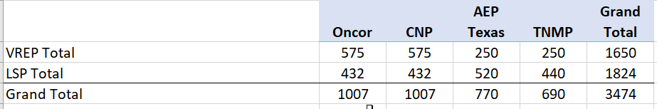

Setup Requirements
In order to minimize risks to the testing the following recommendations are suggested
Avoid:
- ERCOT release dates
- Spring Break dates

- April 15, 2022 due to conflict with Easter weekend including Good Friday
- It is recommended that Mass Transition Test should be initiated after Flight 0222 is concluded prior to Flight 0622

- TDSPs to identify and send list of ESI IDs to be used to ERCOT.
- ERCOT will verify all ESI IDs are available in the RMTE.
- For ESI IDs that are unavailable in the RMTE, TDSPs will send 814_20s.
- TDSPs may set up the Default CR DUNS in test systems, or coordinate with ERCOT to receive MVIs for any ESI IDs requiring their assistance.

ERCOT Communication of Mass Transition Activities to Market Participants

- Unless otherwise noted, ERCOT will follow the established market processes for communications during a Mass Transition as outlined in Retail Market Guide Section 7.11

Success Criteria:

- TDSPs to transition the Drop to POLR ESI IDs with the Mass Transition Date.

- TDSPs to send ERCOT 867_04 or 867_03F no later than day 5 of the Mass Transition event.

Mass Transition Timeline

RMG Section 9 Appendix F2 Timeline for Initiation of a Mass Transition

Calendar
Day -1

Notification Date
Default confirmed by ERCOT legal
Initial Notification sent
Initial Project Coordination Call scheduled
If default is on a Business Day before a weekend or ERCOT holiday, initial project coordination call to occur on same Business Day
Project Coordination Call
Mass Transition process:
- ESI ID allocations & lists are generated and sent to POLR and/or Designated CR and affected TDSPs by ERCOT
- 814_03s sent by ERCOT requesting Mass Transition Date.
- ERCOT requests Customer Billing Contact Information from Defaulting CR.
Project Coordination Call
- 867_02s from TDSP to ERCOT.
- 814_04s from TDSP to ERCOT.
- 814_11s from ERCOT to Losing CR.
- 814_14s from ERCOT to POLR and/or Designated CRs.
- Customer billing information sent by ERCOT to POLR and/or Designated CRs and affected TDSP(s).
- ERCOT sends PUCT mandated notifications to Customers
Project Coordination Call
- TDSP sends to ERCOT Final 867_03s and ERCOT forwards to Losing CR.
- TDSP sends 867_04s to ERCOT and ERCOT forwards to POLR and/or Designated CRs.
- Mass Transition completes at ERCOT.

Calendar
Day 0

Mass Transition Date
Project Coordination Call
- TDSP performs meter reads (actuals or estimates) for Mass Transition Date.
Calendar
Day 1
Calendar
Day 2
Calendar
Day 3 & 4
Calendar
Day 5

Document Revision History
Date | Description | Author(s)
1/22/2020 | Approved for 2020 | TXSET (Patrick)
1/19/2022 | Draft | TXSET (Patrick)

